**Automation**

**Parameter and Asset Model**

**Automation**

**Contents**

1. **Introduction**
2. **Excel Template Structure**

**2.1. Prerequisite**

**2.2. Unit Groups**

**2.3. Units**

**2.4. Parameter Categories**

**2.5. Parameter Groups**

**2.6. Parameters**

**2.7. Industry**

**2.8. Asset Model**

**2.9. Drop-Down**

1. **Automation Script**

**3.1. How to run the Automation script and its configuration**

# 1. Introduction

This automation script streamlines the creation of various configuration elements, including unit groups, units, parameter categories, parameter groups, and parameters. By simply preparing an Excel template and uploading it to the **parameter_template** directory, users can automatically generate the required configurations. This documentation provides a detailed overview of how to structure the Excel template for optimal results.

# 2. Excel Template Structure

The Excel template is comprised of nine essential worksheets, each serving a specific purpose in the automation process. Below is a detailed explanation of each worksheet and its requirements:

## 2.1. Prerequisites

Before using the automation script, ensure the following:

Certain parameters have optional fields that, although not mandatory, may be useful for specific configurations. If users choose to fill out these optional fields, they must also provide corresponding information in the related sheets (e.g., Unit Group, Unit, Parameter Category, Parameter Group) to ensure everything aligns correctly.

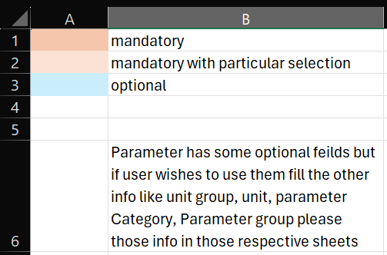

## 2.2. Unit Groups

**Purpose**: Define different categories under which units will be organized.

**Required Fields**:

* Unit Group Name
* Description   
  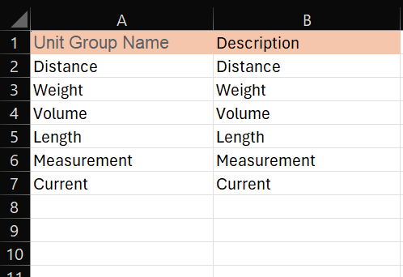

## 2.3. Units

**Purpose**: List individual units that will fall under the defined unit groups.

**Required Fields**:

* Name
* Unit Group (linked to the Unit Group defined earlier)
* Notation  
  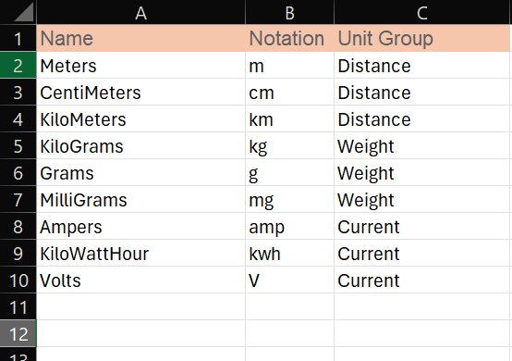

## 2.4. Parameter Categories

**Purpose**: Categorize parameters for better organization and accessibility.

**Required Field:**

* Parameter Category Name

**Optional Fields:**

* Description (optional)
* Icon (optional)

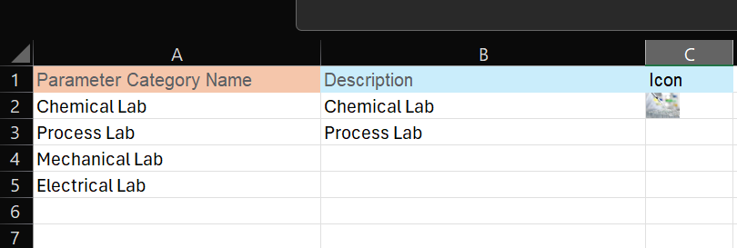

## 2.5. Parameter Groups

**Purpose**: Group related parameters together under their respective categories.

**Required Fields**:

* Parameter Group Name

**Optional Fields:**

* Parameter Category (linked to the Parameter Category defined earlier)
* Description (optional)  
  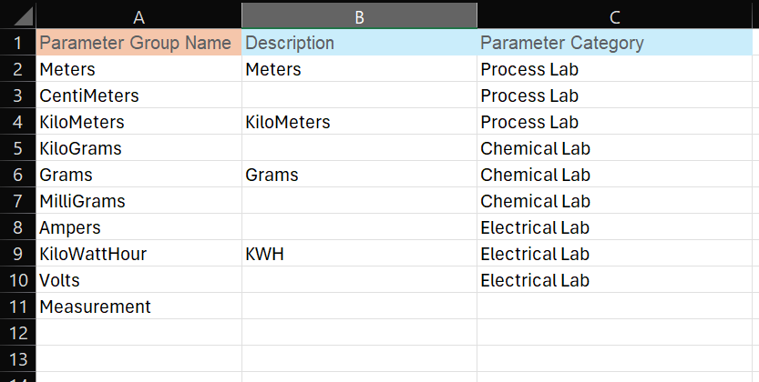

## 2.6. Parameters

**Purpose**: Specify the parameters to be associated with parameter groups.

**Required Fields**:

* Parameter Name
* Description
* Data Source

**Optional Fields:**

* Data Type
* UI Input Type
* Parameter Label
* Parameter Group (linked to the Parameter Group defined earlier)
* Parameter Category
* Numeric Limit
* String Length
* Default Value (optional)
* Input Required

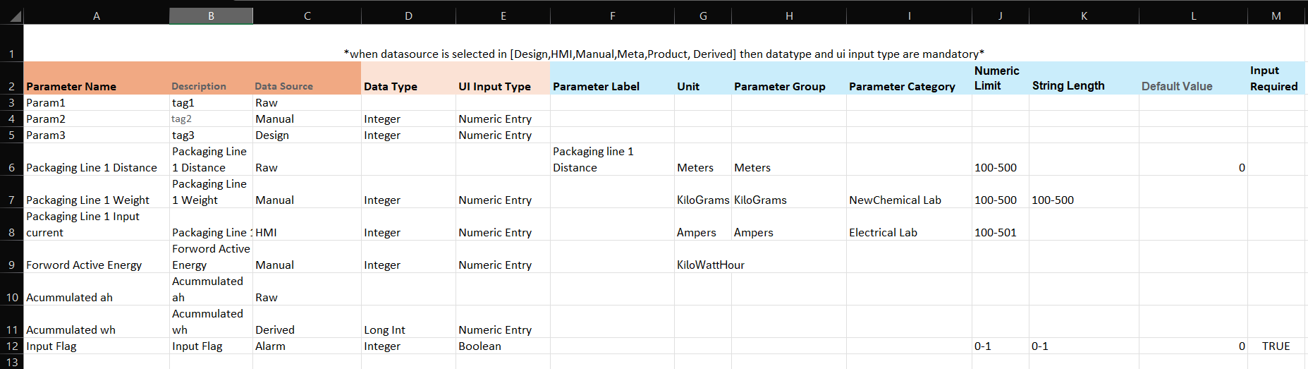

**Note: -**

When **Data Source** is selected in [Design,HMI,Manual,Meta,Product, Derived] then **Data Type** and **UI Input Type** are mandatory.

## 2.7. Industry

**Purpose:** Identify the industry for which the configurations are being created.

**Required Fields:**

* Industry Name
* Description

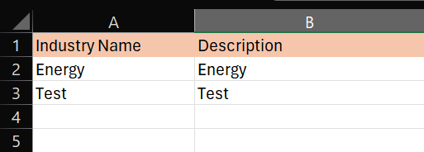

## 2.8. Asset Model

**Purpose:** Define the model of assets relevant to the parameters and units.

**Required Fields:**

* Asset Model Name
* Description (optional)
* Industry

**Optional Fields:**

* Select Type (Drop down data - Parameter Group/Parameter Category)
* Parameter Group/Parameter Category
* Increment Version (If the Asset model already exists then increment the version of the asset model)

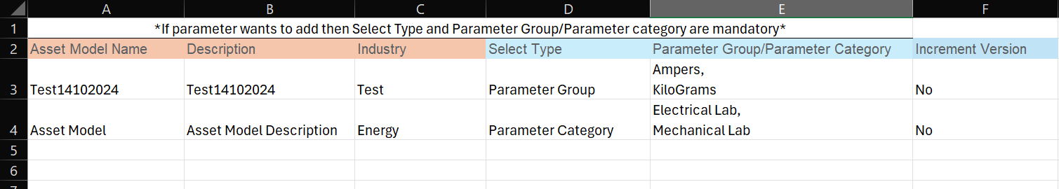

**Note: -**

If parameter wants to add then Select Type and Parameter Group/Parameter category are mandatory

## 2.9. Drop-Down

In this sheet Listed all the drop downs data.

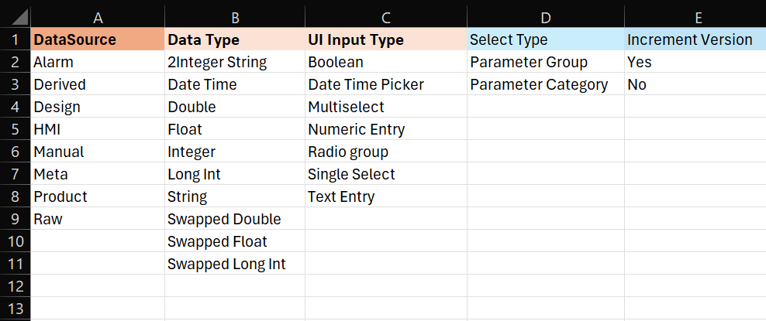

# 3. Automation Script

## 3.1. How to run the automation scripts and its configuration.

1. Script Details.

a. Git link:

<https://gitlab-pm.knowledgelens.com/KnowledgeLens/Products/iLens-2.0/ftdm-solution-hub/utilities/ftdm-automation/parameter-automation>

2. After the completion of excel creation add that excel to the **parameter_template** directory.

3. Update environment configuration if required

* 1. Navigate to conf/application.conf
  2. Update below configurations  
     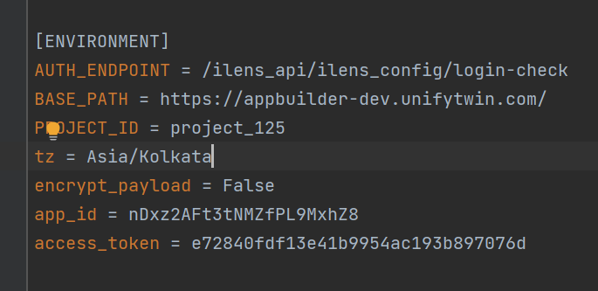

**AUTH_ENDPOINT:** Environment login check URL

**BASE_PATH:** Environment Base URL

**PROJECT_ID:** Associated Project Id

**tz:** Timezone

**encrypt_payload:** Configure True if payload for API is sent in encrypted format else make if False

**access_token:** To access the Automation Service, you'll need to authorize it with an access token. Follow the instructions below to obtain your access token and access Automation Services.

1. Click on Authorize at top right corner
2. Provide Access Token

**Note:** You can get Access Token from respective FTDM Application

* 1. Login
  2. Go to Setting (Top right corner)

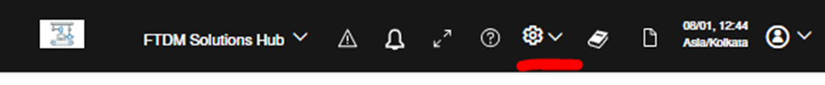

* 1. Go to Master Configuration
  2. Go to Access Tokens

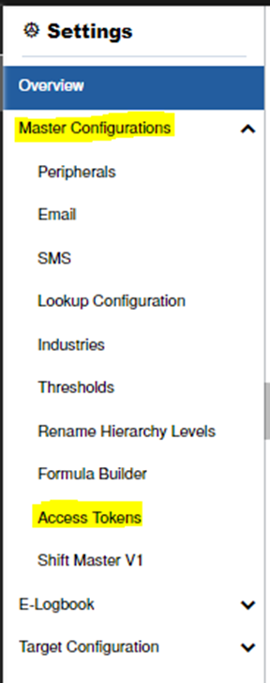

* 1. If the token already exists, copy the token and pass to Automation Service -> Authorize field
  2. If not create a new token and pass the same to Automation Service -> Authorize

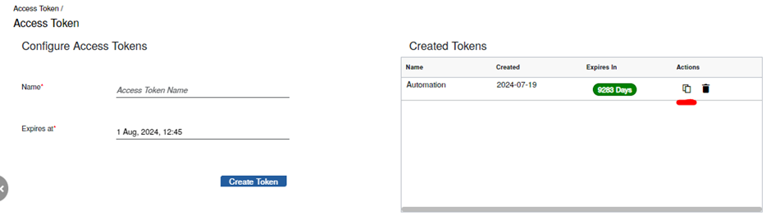

4. Install the required packages.

5. Run app.py file.