GLOBAL ACADEMY OF TECHNOLOGY

2019-2020



IMPLEMENTATION OF ELECTRICITY BILLING SYSTEM IN C

GUIDED BY,

DR. N GURUPRASAD

Prof.-Dept of CSE

GAT

DONE BY,

AKHILA DEVI M

ARPITHA N G

CHANDANASHREE K R

GLOBAL ACADEMY OF TECHNOLOGY

2019-2020



CERTIFICATE

CONTENTS

Chapter 1 Page No

Synopsis 05

Chapter 2

Introduction

2.1 C programming Language 06

2.2 General Introduction about Electricity Bill 07

Chapter 3

3.1 Program 08-14

3.2 Screenshot 15-19

Chapter 4

4.1 Future Enhancements 20

4.2 Bibiliograpy 21

ACKNOWLEDGEMENT

We wish to express our deep gratitude and sincere thanks to Dr N GURUPRASAD, Professor – Department of CSE for his guidance and all information facilities that he provided during the course of this project work. We take this opportunity to express our deep sense of gratitude for his valuable guidance, constant encouragement and constructive comments from him for the successful completion of our project. We also extend our sincere thanks to our beloved principal Dr RANA PRATAP REDDY for his encouragement and support and also to our beloved Dr VENUGEETHA Y – Head of the Department of CSE, for her guidance and assistance.

Chapter-1

SYNOPSIS

The main objective of Electricity Billing System is to reduce the cost of collection procedure.Our project is about the implementation of Electricity Billing System by using the basic programming language that is c language. In this bill we have two catagories namely:To calculate the Bill for Industrial Sector, To calculate the Bill for Household.The user can choose any of these two categories.This alternatively helps the customer to choose their choice for the generation of Electricity Bill.

Our project includes Functions and Arrays.These Arrays include array of structures and strings. The foundation of our project is switch and if else statements for displaying the final Electricity Bill.

We have used a separate function for each of the categories so that it avoids rewriting of code and also it reduces the lines of code,which facilitates the efficiency of the Project. The core concept of this c Functions are reusability, dividing a big task into small pieces to achieve the functionality and to improve understandability of C language.

As mentioned above we have two main modules. Firstly it generates the bill of two sectors based on the difference between previous and present units and displays the bill. Even the Total number of units consumed is zero the fixed charge is ₹200. We also included FAC which means Fuel Adjustment Charges,with all these considerations Bill gets generated.

Chapter 2

Introduction

2.1 C PROGRAMMING LANGUAGE

C is a general purpose, procedural computer programming language supporting structured programming, lexical variable scope and recursion. By design, C provides constructs that map efficiently to typical machine instructions and has found lasting use in applications previously coded in assembly language. Such applications include operating systems and various application software for computers, from supercomputers to embedded systems.

C was originally developed at Bell Labs by Dennis Ritchie between 1972 and 1973 to make utilities running on Unix. During the 1980s, C gradually gained popularity. It has become one of the most widely used programming languages with C compilers from various vendors available for the majority of existing computer architectures and operating systems. C has been standardized by the ANSI since 1989 and by the International Organization for Standardization.

It was designed to be compiled using a relatively straight forward compiler to provide low level access to memory and language with minimal run time support.

Despite its low-level capabilities, the language was designed to encourage cross-platform programming. The language is available on various platforms, from embedded microcontrollers to supercomputers.

2.2 GENERAL INFORMATION ABOUT ELECRICITY BILLING

Electronic billing is when a seller such as company, organization, or group sends its bills or invoices over the internet, and customers pay the bills electronically. It is somewhat vital to understand the electricity bill. Each customer's electricity bill is determined by three elements – the quantity of electricity used, the tariff for the category of customer, and the Fuel Surcharge Cost Adjustment Factor or fuel surcharge as it is commonly called.

It is very important to know the per-unit cost of electricity as it helps us in understanding how much we are spending per appliance at our home and Industry. It is important to understand the monetary impact of any electricity efficiency measure we take. It is also important to understand various components of electricity bills and what is their contribution to the total electricity bill. In a bid to help people understand the same, we have created this online electricity bill that will help people understand how much they spend on various appliances every month and how they can save by doing various activities. Please make sure that you read about the calculator below before using it.

About 65% of the electricity consumed in India is generated by thermal power plants, 22% by hydroelectric power plants, 3% by nuclear power plants and rest by 10% from other alternate sources like solar, wind, biomass etc. 53.7% of India's commercial energy demand is met through the country's vast coal reserves.

Chapter-3

3.1 PROGRAM

#include<stdio.h>

#include<stdlib.h>

void industrial_sector(float units,char temp,char iname[100],char inum[6],int cur,int pre,float Amount,float Tax);

void household(float units,char temp,char pname[100],char pnum[6],int cur,int pre,float Amount,float Tax);

int main()

{

int pre,cur,choice;

float units,Tax,fix,FAC,Amount,totalBill,sum=0.0;

char temp,iname[100],pname[100],inum[6],pnum[6],ch;

system("clear");

printf("\n\n\t\t\t\t\t\t\t\t<: WELCOME TO :>\n");

printf("\n\t\t\t\t\t\t<: MINI PROJECT ON ELECTRICITY BILLING SYSTEM :>\n");

printf("\n\n\t\t\t\t\t\t\t\t\t\t\t\t\t Developed by- Akhila devi M");

printf("\n\t\t\t\t\t\t\t\t\t\t\t\t\t\t\tArpitha N G");

printf("\n\t\t\t\t\t\t\t\t\t\t\t\t\t\t\tChandanashree K R");

menu:

printf("\n\n 1.To Calculate Electricity Bill For Industrial Sector.");

printf("\n\n 2.To Calculate Electricity Bill For Household.\n\n 3.Exit.");

printf("\n\n Enter your choice :");

scanf("%d",&choice);

switc:

switch(choice)

{

indus:

case 1:industrial_sector(units,temp,iname,inum,cur,pre,Amount,Tax);

con1:

printf("\n\nDo U Want To Continue.?(y/n)? ");

scanf("%c",&ch);

scanf("%c",&ch);

if(ch=='y')

goto indus;

else if(ch=='n')

goto menu1;

else

printf("\nEnter valid Choice\n");

goto con1;

break;

house:

case 2:household(units,temp,pname,pnum,cur,pre,Amount,Tax);

con2:

printf("\n\nDo U Want To Continue.?(y/n)? ");

scanf("%c",&ch);

scanf("%c",&ch);

if(ch=='y')

goto house;

else if(ch=='n')

goto menu1;

else

printf("\nEnter valid Choice\n");

goto con2;

break;

case 3:exit(0);

default:printf("\n\nPlease Enter Valid Choice.\n");

}

menu1:

system("clear");

printf("\n\n 1.To Calculate Electricity Bill For Industrial Sector.");

printf("\n\n 2.To Calculate Electricity Bill For Household.\n\n 3.Exit.");

printf("\n\n Enter your choice :");

scanf("%d",&choice);

goto switc;

}

void industrial_sector(float units,char temp,char iname[100],char inum[6],int cur,int pre,float Amount,float Tax)

{

system("clear");

printf("\n.....Industrial Sector.....\n\n");

printf("\n*** Industrial Details ***\n");

printf("\nEnter Industry Name:\n");

fflush(stdin);

scanf("%c",&temp);

scanf("%[^\n]",iname);

printf("\nEnter your RR No.:\n");

fflush(stdin);

scanf("%s",inum);

printf("\n*** Consumption Details ***\n");

printf("\nEnter your Current Reading:\n");

fflush(stdin);

scanf("%d",&cur);

printf("\nEnter your Previous Reading:\n");

fflush(stdin);

scanf("%d",&pre);

units=cur-pre;

if(units==0)

{

system("clear");

printf("\n\t\t\t\t\t\t\tELECTRICITY BILL\n");

printf("\n\t\t\t\t\t_________________________________________________\n");

printf("\n\t\t\t\t\t\t*** :Industrial Details: ***\n");

printf("\n\t\t\t\t\tIndustry Name :\t\t %s",iname);

printf("\n\t\t\t\t\tRR no :\t\t\t %s",inum);

printf("\n\t\t\t\t\t_________________________________________________\n");

printf("\n\t\t\t\t\t\t*** :Consumption Details: ***");

printf("\n\n\t\t\t\t\tCurrent Reading :\t\t\t %d",cur);

printf("\n\t\t\t\t\tPrevious Reading :\t\t\t %d",pre);

printf("\n\t\t\t\t\tTotal no. of units Consumed :\t\t %.2f",units);

printf("\n\t\t\t\t\tBill Amount :\t\t\t\t 200\n");

printf("\n\t\t\t\t\t_ _ _ _ _ _ _ _ _ _ _ _ _ _ _ _ _ _ _ _ _ _ _ _ _\n");

printf("\n\t\t\t\t\tNet Amt Due :\t\t\t\tâ‚¹ 200");

printf("\n\t\t\t\t\t_________________________________________________\n");

}

else

{

float sum1,sum2,sub2,FAC,fix=70;

float sum=0.0,totalBill=0.0;

if(units>=1 && units<=50)

{

sum=units*7.75;

}

else

{

sum=(50*7.75)+((units-50)*8.75);

}

FAC=units*0.12;

Amount=sum+FAC+fix;

Tax=Amount*0.09;

totalBill=Amount+Tax;

system("clear");

printf("\n\t\t\t\t\t\t\tELECTRICITY BILL\n");

printf("\n\t\t\t\t\t_________________________________________________\n");

printf("\n\t\t\t\t\t\t*** :Industrial Details: ***\n");

printf("\n\t\t\t\t\tIndustry Name :\t\t %s",iname);

printf("\n\t\t\t\t\tRR no :\t\t\t %s",inum);

printf("\n\t\t\t\t\t_________________________________________________\n");

printf("\n\t\t\t\t\t\t*** :Cosumption Details: ***\n");

printf("\n\t\t\t\t\tCurrent Reading :\t\t\t %d",cur);

printf("\n\t\t\t\t\tPrevious Reading :\t\t\t %d",pre);

printf("\n\t\t\t\t\tTotal no. of units Consumed :\t\t %.2f\n",units);

printf("\n\t\t\t\t\t_________________________________________________\n");

printf("\n\t\t\t\t\t\t *** :Energy Charges: ***\n");

printf("\n\t\t\t\t\tUnit\t\t Rate\t\t Amount\n\n");

if(units>=1 && units<=50)

{

sum1=units*7.75;

printf("\n\t\t\t\t\t%.2f\t\t 7.75\t\t% .2f\n",units,sum1);

}

else

{

sum1=50*7.75;

sub2=units-50;

sum2=sub2*8.75;

printf("\n\t\t\t\t\t50\t\t 7.75\t\t% .2f",sum1);

printf("\n\t\t\t\t\t%.2f\t\t 8.85\t\t% .2f\n",sub2,sum2);

}

printf("\n\t\t\t\t\t_ _ _ _ _ _ _ _ _ _ _ _ _ _ _ _ _ _ _ _ _ _ _ _ _\n");

printf("\n\t\t\t\t\tAmount :\t\t\t\t %.2f",sum);

printf("\n\t\t\t\t\t_________________________________________________\n");

printf("\n\t\t\t\t\t\t*** :Additional Charges: ***\n");

printf("\n\t\t\t\t\tFixed Charges :\t\t\t\t %.2f",fix);

printf("\n\t\t\t\t\tFAC(Fuel Adjustment Charges) :\t\t %.2f",FAC);

printf("\n\t\t\t\t\t_________________________________________________\n");

printf("\n\t\t\t\t\tBill Amount :\t\t\t\t %.2f\n",Amount);

printf("\n\t\t\t\t\tCollecting Tax of 0.09 on Total Amount of %.2f\n",Amount);

printf("\n\t\t\t\t\tTax:\t\t\t\t\t %.2f",Tax);

printf("\n\t\t\t\t\t_ _ _ _ _ _ _ _ _ _ _ _ _ _ _ _ _ _ _ _ _ _ _ _ _\n");

printf("\n\t\t\t\t\tNet Amt Due :\t\t\t\tâ‚¹ %.2f\n",totalBill);

printf("\n\t\t\t\t\t_________________________________________________\n");

}

}

void household(float units,char temp,char pname[100],char pnum[6],int cur,int pre,float Amount,float Tax)

{

system("clear");

printf("\n.....Household.....\n\n");

printf("\n*** Personal Details ***\n");

printf("\nEnter customer Name:\n");

fflush(stdin);

scanf("%c",&temp);

scanf("%[^\n]",pname);

printf("\nEnter your RR No.:\n");

fflush(stdin);

scanf("%s",pnum);

printf("\n*** Consumption Details ***\n");

printf("\nEnter your Current Reading:\n");

fflush(stdin);

scanf("%d",&cur);

printf("\nEnter your Previous Reading:\n");

fflush(stdin);

scanf("%d",&pre);

units=cur-pre;

if(units==0)

{

system("clear");

printf("\n\t\t\t\t\t\t\tELECTRICITY BILL\n");

printf("\n\t\t\t\t\t_________________________________________________\n");

printf("\n\t\t\t\t\t\t*** :personal Details: ***\n");

printf("\n\t\t\t\t\tCustomer Name :\t\t %s",pname);

printf("\n\t\t\t\t\tRR no :\t\t\t %s",pnum);

printf("\n\t\t\t\t\t_________________________________________________\n");

printf("\n\t\t\t\t\t\t*** :consumption Details: ***");

printf("\n\n\t\t\t\t\tCurrent Reading :\t\t\t %d",cur);

printf("\n\t\t\t\t\tPrevious Reading :\t\t\t %d",pre);

printf("\n\t\t\t\t\tTotal no. of units Consumed :\t\t %.2f",units);

printf("\n\t\t\t\t\tBill Amount :\t\t\t\t 200\n");

printf("\n\t\t\t\t\t_ _ _ _ _ _ _ _ _ _ _ _ _ _ _ _ _ _ _ _ _ _ _ _ _\n");

printf("\n\t\t\t\t\tNet Amt Due :\t\t\t\tâ‚¹ 200");

printf("\n\t\t\t\t\t_________________________________________________\n");

}

else

{

float sum3,sum4,sum5,sum6,sub4,sub5,sub6,FAC,fix=60;

float sum=0.0,totalBill;

if(units>=1 && units<=30)

{

sum=units*3.75;

}

else if(units>=31 && units<=100)

{

sum=(30*3.75)+((units-30)*5.2);

}

else if(units>=101 && units<=200)

{

sum=(30*3.75)+(70*5.2)+((units-100)*6.75);

}

else

{

sum=(30*3.75)+(70*5.2)+(100*6.75)+((units-200)*7.8);

}

FAC=units*0.12;

Amount=sum+FAC+fix;

Tax=Amount*0.09;

totalBill=Amount+Tax;

system("clear");

printf("\n\t\t\t\t\t\t\tELECTRICITY BILL\n");

printf("\n\t\t\t\t\t_________________________________________________\n");

printf("\n\t\t\t\t\t\t*** :Personal Details: ***\n");

printf("\n\t\t\t\t\tCustomer Name :\t\t %s",pname);

printf("\n\t\t\t\t\tRR no :\t\t\t %s",pnum);

printf("\n\t\t\t\t\t_________________________________________________\n");

printf("\n\t\t\t\t\t\t*** :Cosumption Details: ***\n");

printf("\n\t\t\t\t\tCurrent Reading :\t\t\t %d",cur);

printf("\n\t\t\t\t\tPrevious Reading :\t\t\t %d",pre);

printf("\n\t\t\t\t\tTotal no. of units Consumed :\t\t %.2f\n",units);

printf("\n\t\t\t\t\t_________________________________________________\n");

printf("\n\t\t\t\t\t\t *** :Energy Charge Details: ***\n");

printf("\n\t\t\t\t\tUnit\t\t Rate\t\t Amount\n\n");

if(units>=1 && units<=30)

{

sum3=units*3.75;

printf("\n\t\t\t\t\t%.2f\t\t 3.75\t\t% .2f\n",units,sum3);

}

else if(units>=31 && units<=100)

{

sum3=30*3.75;

sub4=units-30;

sum4=sub4*5.2;

printf("\n\t\t\t\t\t30\t\t 3.75\t\t% .2f\n",sum3);

printf("\t\t\t\t\t%.2f\t\t 5.2\t\t\t% .2f\n",sub4,sum4);

}

else if(units>=101 && units<=200)

{

sum3=30*3.75;

sum4=70*5.2;

sub5=units-100;

sum5=sub5*6.75;

printf("\n\t\t\t\t\t30\t\t 3.75\t\t% .2f",sum3);

printf("\n\t\t\t\t\t70\t\t 5.2\t\t\t% .2f",sum4);

printf("\n\t\t\t\t\t%.2f\t\t 6.75\t\t% .2f",sub5,sum5);

}

else

{

sum3=30*3.75;

sum4=70*5.2;

sum5=100*6.75;

sub6=units-200;

sum6=sub6*7.8;

printf("\n\t\t\t\t\t30\t\t 3.75\t\t% .2f",sum3);

printf("\n\t\t\t\t\t70\t\t 5.2\t\t\t% .2f",sum4);

printf("\n\t\t\t\t\t100\t\t 6.75\t\t% .2f",sum5);

printf("\n\t\t\t\t\t%.2f\t\t 7.8\t\t\t% .2f",sub6,sum6);

}

printf("\n\t\t\t\t\t_ _ _ _ _ _ _ _ _ _ _ _ _ _ _ _ _ _ _ _ _ _ _ _ _\n");

printf("\n\t\t\t\t\tAmount :\t\t\t\t %.2f",sum);

printf("\n\t\t\t\t\t_________________________________________________\n");

printf("\n\t\t\t\t\t\t*** :Additional Charges: ***\n");

printf("\n\t\t\t\t\tFixed Charges :\t\t\t\t %.2f",fix);

printf("\n\t\t\t\t\tFAC(Fuel Adjustment Charges) :\t\t %.2f",FAC);

printf("\n\t\t\t\t\t_________________________________________________\n");

printf("\n\t\t\t\t\tBill Amount :\t\t\t\t %.2f\n",Amount);

printf("\n\t\t\t\t\tCollecting Tax of 0.09 on Total Amount of %.2f\n",Amount);

printf("\n\t\t\t\t\tTax:\t\t\t\t\t %.2f",Tax);

printf("\n\t\t\t\t\t_ _ _ _ _ _ _ _ _ _ _ _ _ _ _ _ _ _ _ _ _ _ _ _ _\n");

printf("\n\t\t\t\t\tNet Amt Due :\t\t\t\tâ‚¹ %.2f\n",totalBill);

printf("\n\t\t\t\t\t_________________________________________________\n");

}

}

3.2 Screen Shots

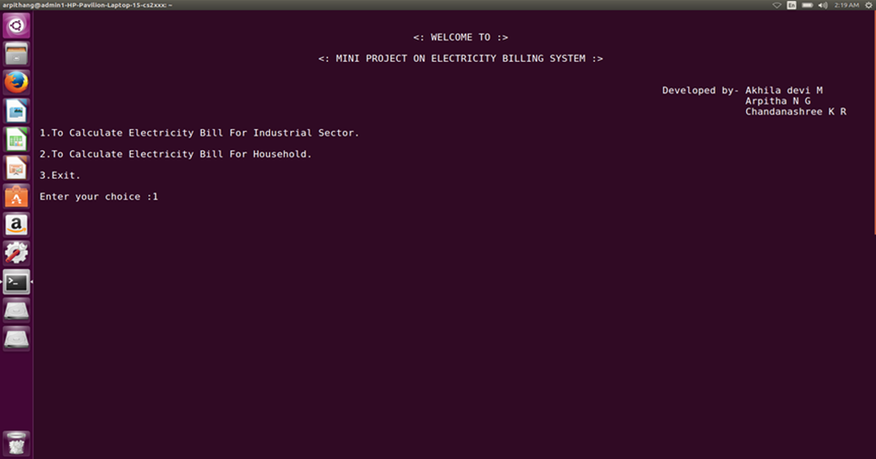

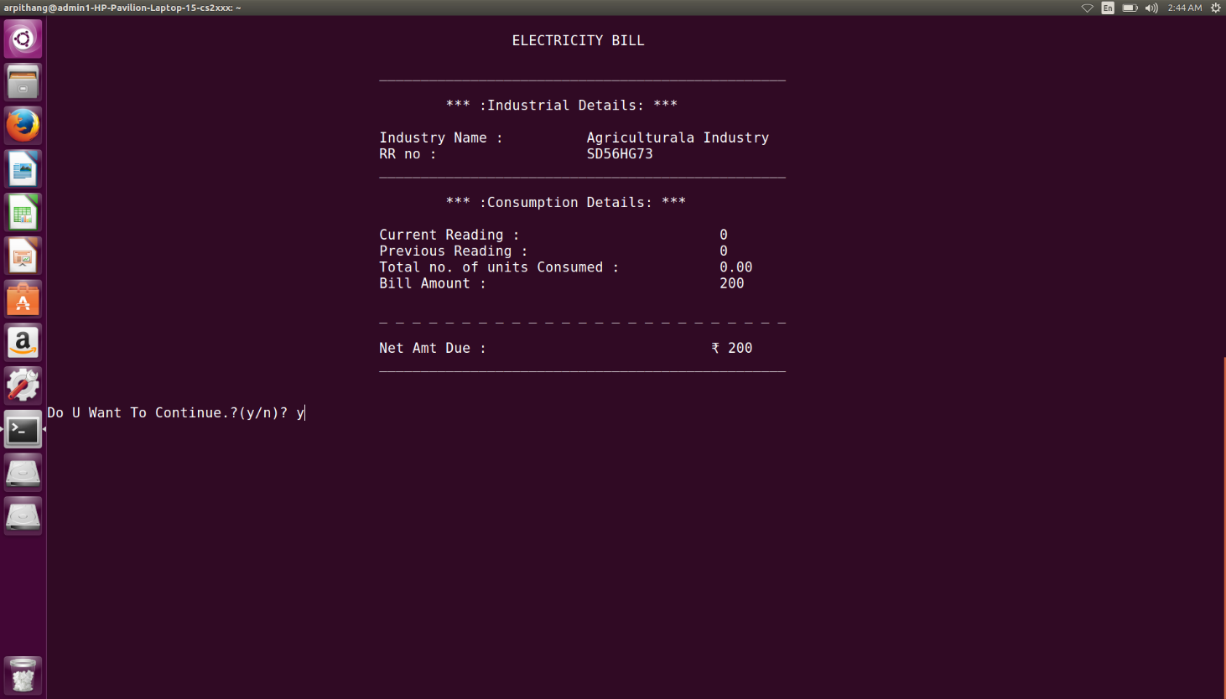

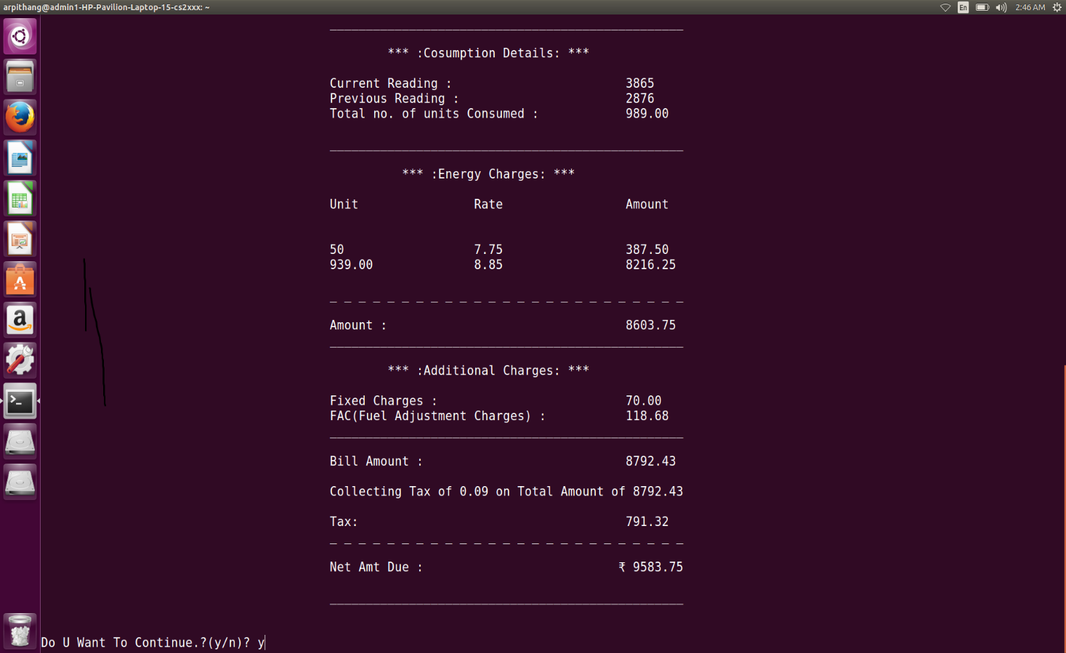

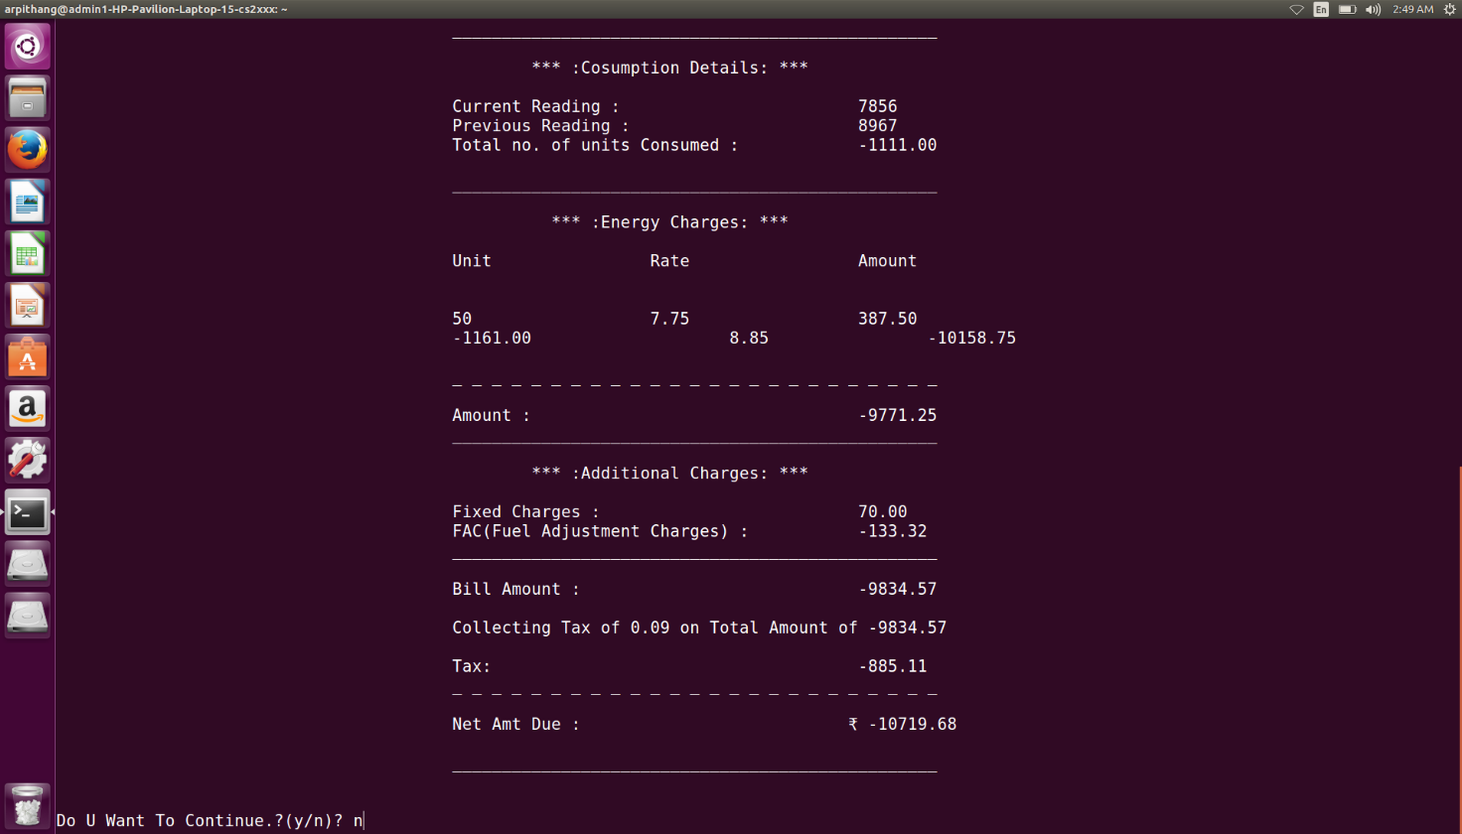

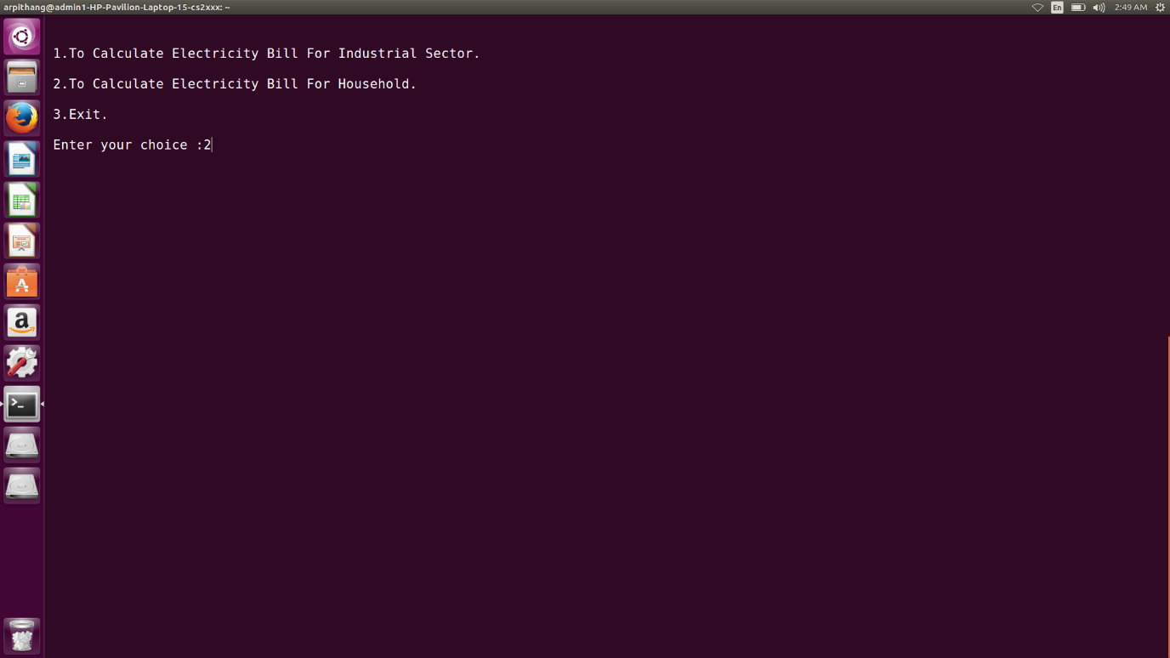

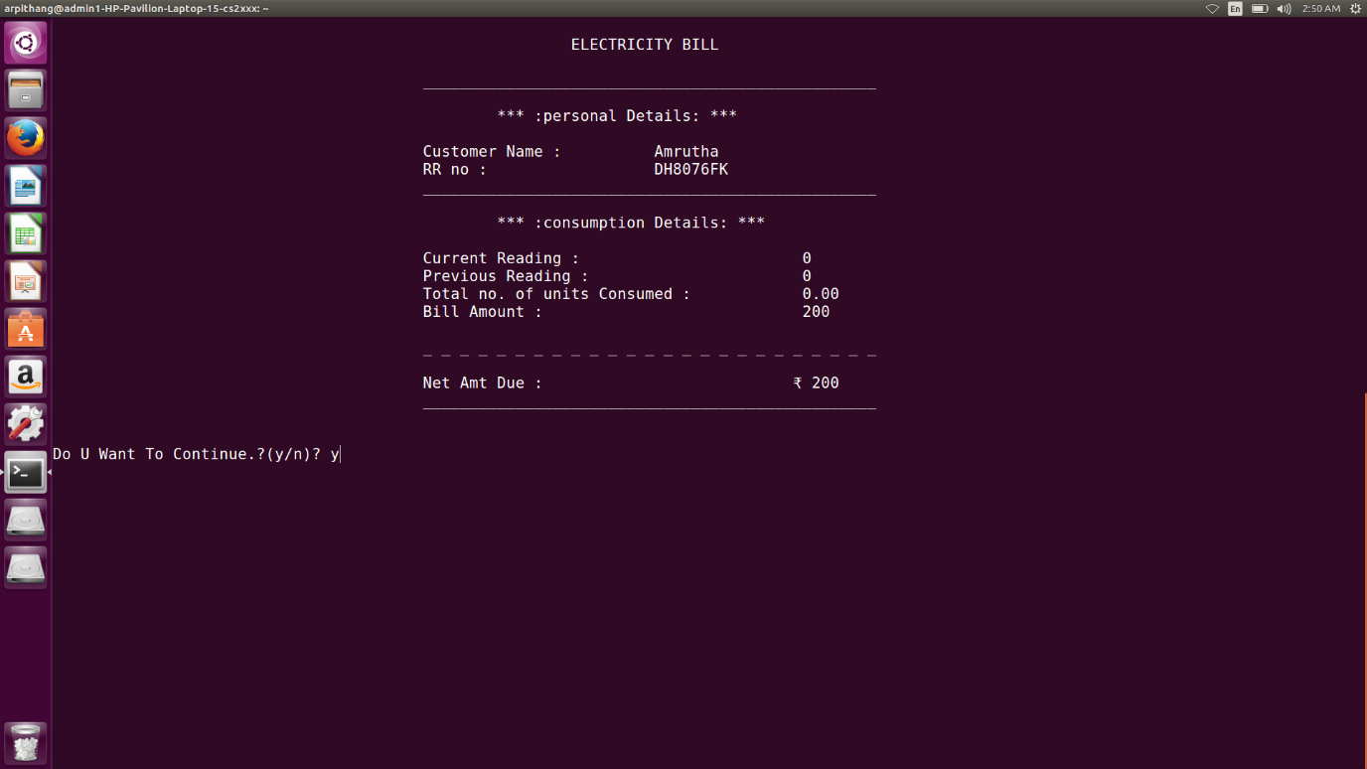

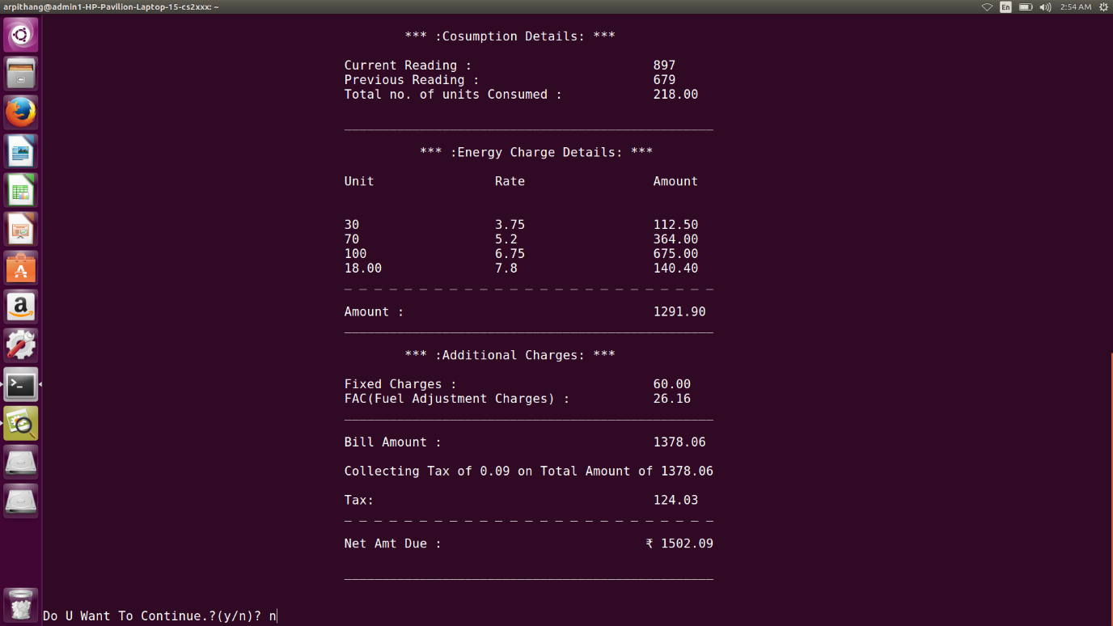

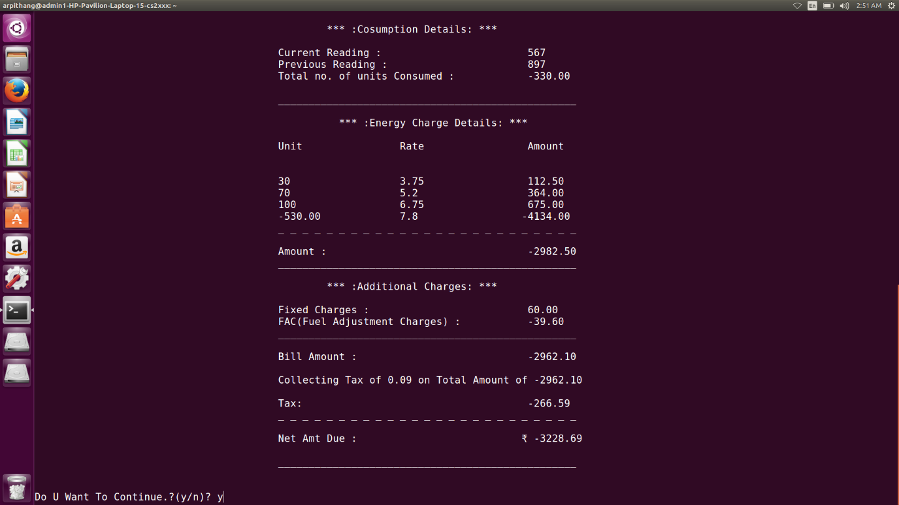

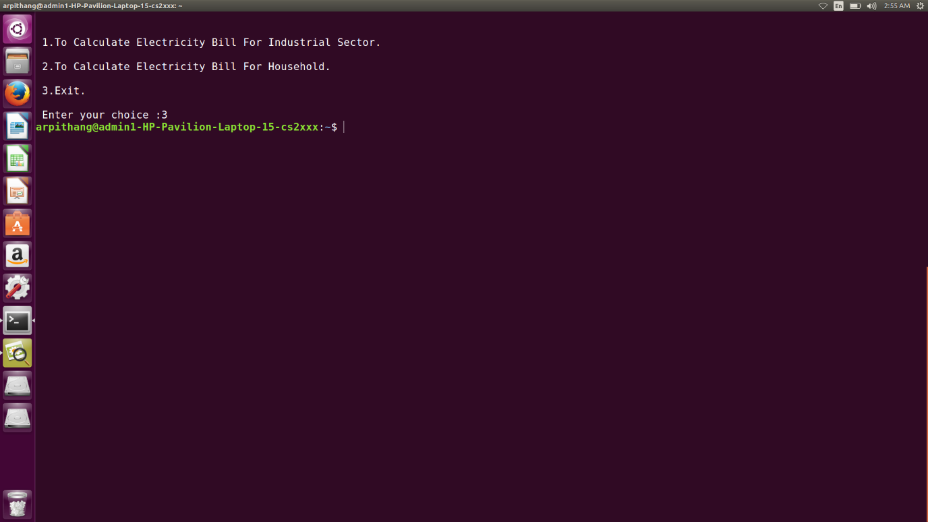

Chapter 4

4.1 FUTURE ENHANCEMENTS

There is no Database involved in this project for storing Customer data. so,the concepts of Database Management and Filehandling can be used for further implementation.

4.2 BIBILIOGRAPHY

• Dennis Ritchie and Brain Kernighan, “THE C PROGRAMMING LANGUAGE, TATA McGraw Hill, SECOND EDITION

• www.cprograms4future.com

[• www.Wikipedia.com](https://d.docs.live.net/1f2736b1ac4a9da3/Documents/•%20www.Wikipedia.com)

[• www.google.com](https://d.docs.live.net/1f2736b1ac4a9da3/Documents/•%20www.google.com)