Week 3 – Baseline Model Implementation for Text Classification
Hospital Email Threat Classification using NLP

1. Objective and Project Context
The objective of Week 3 is to implement a simple, interpretable baseline NLP model for the Hospital Email Threat Classification project. The system classifies email messages into three categories: Safe, Suspicious, and Dangerous. The baseline establishes a measurable starting point before more advanced models, feature engineering, or deep-learning methods are introduced.

2. Baseline Model Selection
Logistic Regression was selected as the baseline classifier. It is a strong and interpretable linear model for text classification, works efficiently with sparse TF-IDF features, and provides a useful reference point for later experiments. Naive Bayes was considered as an alternative, but Logistic Regression was preferred because its learned feature weights can help explain which words and phrases contribute to class predictions.

3. Feature Representation – TF-IDF
Raw email text cannot be given directly to a conventional Logistic Regression classifier. Therefore, the text is converted into numerical features using Term Frequency–Inverse Document Frequency (TF-IDF). The experiment uses lowercase normalization, English stop-word removal, and unigrams plus bigrams. Bigrams are useful because security meaning can depend on short phrases such as 'verify password', 'urgent action', or 'bank transfer'.

4. Experimental Dataset and Scope
For this baseline demonstration, a small synthetic, domain-specific dataset was created rather than redistributing public email corpora. It contains 45 simulated hospital-related messages: 15 Safe, 15 Suspicious, and 15 Dangerous. The examples are designed only to demonstrate the classification workflow and are not real patient or employee communications. The dataset was split into training and testing subsets using stratification, with 70% used for training and 30% for testing. This is a simulated baseline experiment; it should not be interpreted as a production performance estimate.

5. Implementation Process
- Prepare labeled email text with the three target classes.
- Split the data into training and test sets using stratification.
- Fit the TF-IDF vectorizer only on the training text to reduce data leakage.
- Transform training and test messages into sparse TF-IDF vectors.
- Train Logistic Regression on the training vectors.
- Generate predictions for the unseen test vectors.
- Calculate accuracy, precision, recall, and F1 score.
- Inspect the confusion matrix and misclassified messages for future error analysis.

6. Pseudocode
LOAD labeled emails → SPLIT into train/test → FIT TF-IDF on train → TRANSFORM train/test → TRAIN Logistic Regression → PREDICT test labels → CALCULATE metrics → ANALYZE errors.

7. Key Code Snippet
from sklearn.feature_extraction.text import TfidfVectorizer
from sklearn.linear_model import LogisticRegression
from sklearn.model_selection import train_test_split
from sklearn.metrics import accuracy_score, classification_report
X_train, X_test, y_train, y_test = train_test_split(
texts, labels, test_size=0.30, random_state=42, stratify=labels
)
vectorizer = TfidfVectorizer(
lowercase=True, stop_words="english", ngram_range=(1, 2)
)
X_train_tfidf = vectorizer.fit_transform(X_train)
X_test_tfidf = vectorizer.transform(X_test)
model = LogisticRegression(max_iter=1000, random_state=42)
model.fit(X_train_tfidf, y_train)
predictions = model.predict(X_test_tfidf)
print(accuracy_score(y_test, predictions))
print(classification_report(y_test, predictions))

8. Preliminary Performance Metrics
The following metrics were calculated on the held-out test portion of the simulated dataset. Because the dataset is small, the values are intended only as an initial baseline and should be revalidated on a larger, representative dataset.
Class | Precision | Recall | F1 Score | Support
Safe | 1.00 | 0.60 | 0.75 | 5
Suspicious | 0.50 | 0.60 | 0.55 | 5
Dangerous | 0.60 | 0.75 | 0.67 | 4
Overall / weighted | 0.71 | 0.64 | 0.65 | 14
Accuracy | 0.64 |  |  | 14
Observed test accuracy: 64.29%. Weighted precision: 70.71%; weighted recall: 64.29%; weighted F1: 65.31%.
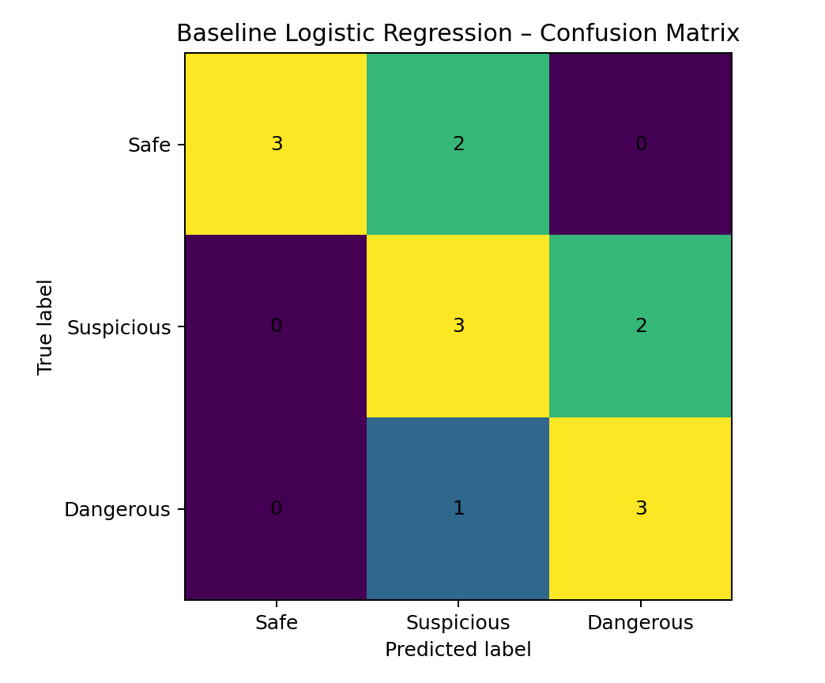
Figure 1. Confusion matrix for the baseline experiment.

9. Interpretation of Initial Results
The baseline provides a first quantitative reference for the three-class problem. Performance must be interpreted cautiously because the experiment uses a small synthetic dataset whose examples were intentionally constructed around recognizable security language. Such data can make the task easier than real-world email classification. In operational data, legitimate security notices, ambiguous billing messages, shortened URLs, attachments, impersonation, and domain-specific language can create much harder cases. Precision is important because incorrectly labeling a legitimate hospital message as dangerous can disrupt workflows, while recall for the Dangerous class is critical because missed phishing or credential-theft messages may create security risk.

10. Limitations and Challenges
- The synthetic dataset is very small and cannot represent real hospital email distributions.
- The three classes may contain overlapping language, especially between Suspicious and Dangerous.
- TF-IDF does not understand deep context, sender identity, intent, or semantic relationships.
- The model can learn superficial keywords such as 'urgent' rather than genuine threat evidence.
- Class distributions and performance may change when tested on another source or organization.
- Real deployment would require privacy controls, authorized data collection, robust validation, and security testing.

11. Future Directions
- Evaluate the baseline on a larger authorized/publicly usable dataset and a carefully designed hospital-domain test set.
- Compare Logistic Regression with Multinomial Naive Bayes and linear SVM.
- Add security-aware features such as URL characteristics, sender/domain signals, attachment indicators, and urgency patterns.
- Use cross-validation and hyperparameter tuning rather than relying on one train/test split.
- Perform detailed error analysis in Week 4 using confusion matrices and representative misclassifications.
- Experiment with contextual embeddings or transformer-based models after establishing strong classical baselines.
- Track precision and recall for the Dangerous class separately because security-risk errors are asymmetric.

12. Reproducibility and Responsible Use
The experiment should be reproducible by recording the random seed, preprocessing settings, model parameters, dataset version, class definitions, and train/test split strategy. Actual private emails, patient information, passwords, authentication tokens, or restricted datasets must not be uploaded to GitHub. Public datasets should only be used according to their licenses and redistribution terms. The synthetic examples used here contain no real personal information.

13. Conclusion
Week 3 establishes a transparent baseline for the Hospital Email Threat Classification project. The combination of TF-IDF and Logistic Regression is computationally simple, interpretable, and appropriate for a first text-classification experiment. The measured metrics and confusion matrix provide a reference against which later improvements can be compared. The next stage should focus on systematic error analysis, validation on more representative data, and improvements that address the limitations identified in this baseline.

14. Public Libraries / References
- scikit-learn – TfidfVectorizer documentation: https://scikit-learn.org/stable/modules/generated/sklearn.feature_extraction.text.TfidfVectorizer.html
- scikit-learn – LogisticRegression documentation: https://scikit-learn.org/stable/modules/generated/sklearn.linear_model.LogisticRegression.html
- scikit-learn – Model evaluation documentation: https://scikit-learn.org/stable/modules/model_evaluation.html
- NLTK documentation: https://www.nltk.org/

