Week 4 – Model Evaluation and Error Analysis in NLP
Hospital Email Threat Classification using NLP

1. Objective
Week 4 evaluates the Logistic Regression baseline developed in Week 3 and performs systematic error analysis. The goal is not only to report scores but also to understand why messages are misclassified, identify weaknesses in the current feature representation, and propose measurable improvements for the next project stage.

2. Baseline Reproduction
The evaluation reproduces the Week 3 experimental setup: a 45-message synthetic hospital-email dataset with 15 Safe, 15 Suspicious, and 15 Dangerous messages; a stratified 70/30 train-test split with random_state=42; TF-IDF features using lowercase text, English stop-word removal, and unigram/bigram features; and Logistic Regression with max_iter=1000. The synthetic dataset contains no real patient or employee information. Results are therefore preliminary and are not production claims.

3. Evaluation Metrics
Accuracy: The proportion of all test messages classified correctly. It is intuitive but can be misleading when class distributions are unequal.
Precision: For a class, the proportion of messages predicted as that class that are actually members of the class. It is useful for controlling false alarms.
Recall: For a class, the proportion of actual messages of that class that the model successfully detects. Recall for Dangerous is especially important in a security context.
F1 Score: The harmonic mean of precision and recall. It balances missed detections and false positives and is useful for comparing class-level performance.

4. Performance Results
The baseline achieved 64.29% accuracy, 70.71% weighted precision, 64.29% weighted recall, and 65.31% weighted F1 on the 14-message test set.
Class | Precision | Recall | F1 | Support
Safe | 1.00 | 0.60 | 0.75 | 5
Suspicious | 0.50 | 0.60 | 0.55 | 5
Dangerous | 0.60 | 0.75 | 0.67 | 4
Weighted average | 0.71 | 0.64 | 0.65 | 14
Accuracy | 0.64 |  |  | 14
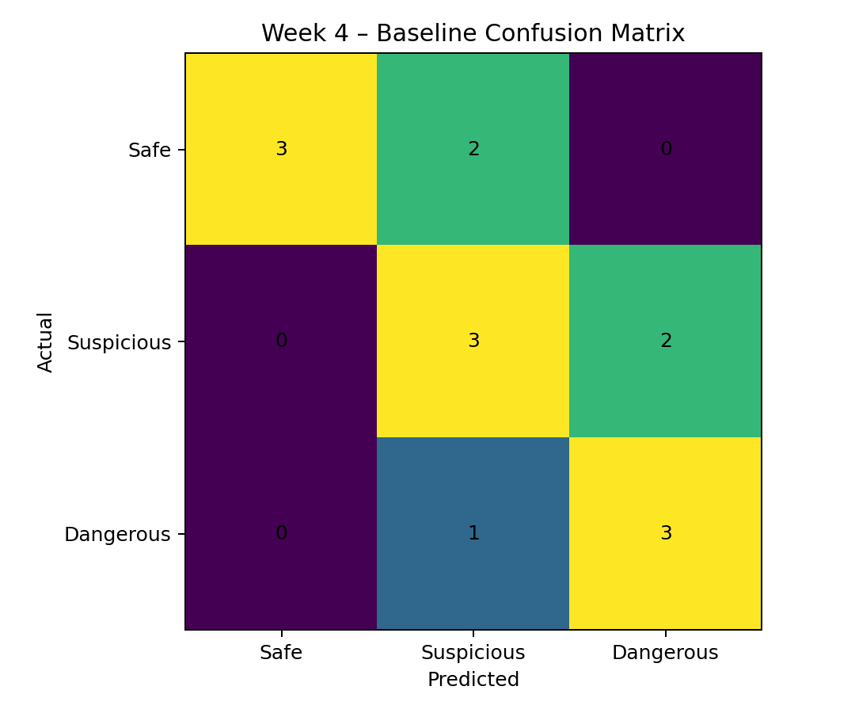
Figure 1. Confusion matrix generated from the Week 3 baseline on the held-out test set.

5. Confusion Matrix Interpretation
The confusion matrix shows how actual Safe, Suspicious, and Dangerous messages are distributed across the model's predictions. Correct predictions appear on the diagonal. Off-diagonal cells identify the specific class confusions that should be investigated. The most important concern is confusion involving Dangerous messages because a false negative can represent a missed phishing or credential-theft email. Confusion between Suspicious and Dangerous is also expected because these classes intentionally contain overlapping language such as account verification, urgency, and payment-related requests.

6. Error Analysis
The held-out test set contains 14 messages, of which 5 were misclassified. The errors were reviewed individually rather than relying only on aggregate scores.
Actual | Predicted | Example | Likely Cause
Safe | Suspicious | Please review the approved patient discharge instructions in the portal. | Security-related wording overlaps with threat language.
Safe | Suspicious | The laboratory has completed the requested blood test and updated the portal. | Security-related wording overlaps with threat language.
Suspicious | Dangerous | Please confirm the recipient details before the payment request is processed. | Urgency or verification language may be over-weighted.
Suspicious | Dangerous | A hospital service update requires you to verify some account details. | Urgency or verification language may be over-weighted.
Dangerous | Suspicious | Your hospital account has been compromised. Confirm your credentials using this link. | Threat intent is not fully captured by TF-IDF context.
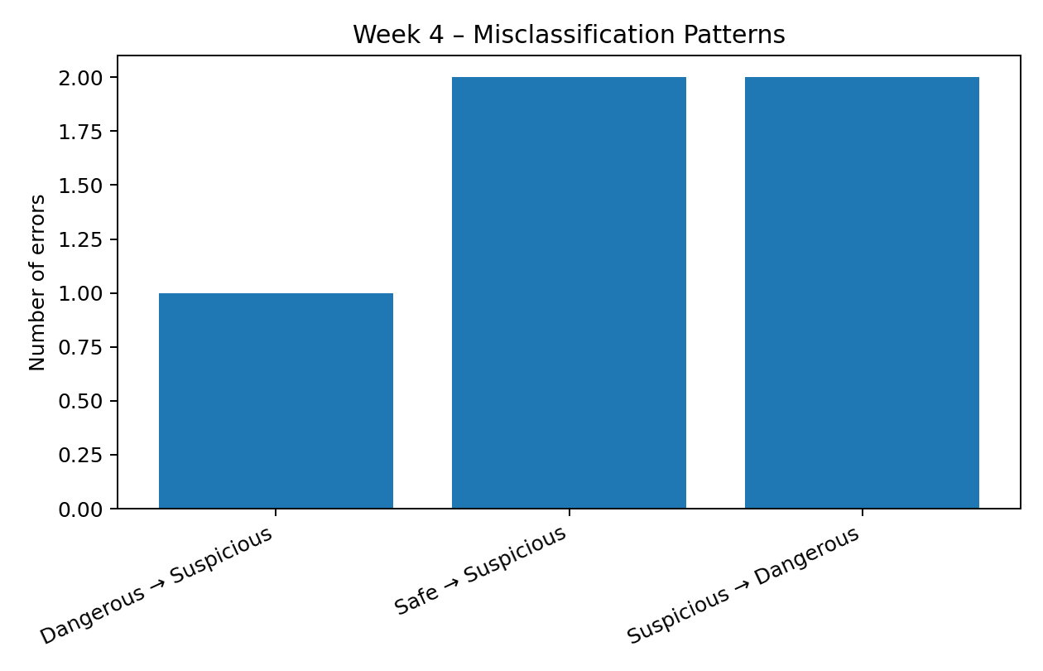
Figure 2. Distribution of observed misclassification patterns.

7. Systematic Error Patterns and Biases
- Keyword dependence: terms such as urgent, verify, account, password, payment, and link may dominate decisions even when context changes their meaning.
- Suspicious/Dangerous boundary: both classes contain verification and urgency language, so a bag-of-words representation can struggle to distinguish ambiguous behavior from confirmed malicious intent.
- Small-data instability: a few training examples can strongly influence the learned feature weights.
- Domain mismatch: real hospital emails may contain terminology, workflows, signatures, URLs, attachments, and sender information not represented in the synthetic data.
- Security asymmetry: all errors do not have equal cost; missing a Dangerous email can be more harmful than flagging a legitimate email for review.

8. Diagnostic Techniques
- Run stratified k-fold cross-validation to estimate score variability across different splits.
- Inspect the top Logistic Regression feature weights for each class.
- Review false negatives for Dangerous messages separately from false positives.
- Create a balanced validation set containing borderline Safe/Suspicious and Suspicious/Dangerous examples.
- Test performance on a second authorized dataset or a held-out domain-specific set to measure generalization.
- Compare results with a simple Naive Bayes or linear SVM baseline.
- Track precision-recall curves and class-specific recall, especially for Dangerous.

9. Improvement Strategies
- Increase the size and diversity of the labeled dataset while maintaining privacy and licensing compliance.
- Add security-aware features such as URL structure, sender/domain indicators, attachment type, impersonation cues, and credential-request patterns.
- Use class weighting or threshold tuning when the cost of missing Dangerous messages is higher than the cost of false alarms.
- Compare TF-IDF + Logistic Regression with Multinomial Naive Bayes, Linear SVM, and contextual transformer models.
- Use cross-validation and hyperparameter tuning rather than relying on one split.
- Introduce human-review handling for high-uncertainty messages instead of forcing every borderline message into a hard decision.
- Maintain an audit trail of preprocessing, labels, model versions, and evaluation results.

10. Conclusion
Week 4 demonstrates that evaluation should go beyond a single accuracy number. The baseline provides a measurable starting point, while the confusion matrix and individual error review reveal where the classifier is most likely to fail. The main limitations are the small synthetic dataset, overlapping class language, TF-IDF's limited contextual understanding, and the asymmetric risk of security errors. The proposed diagnostic experiments and feature/model improvements provide a practical path toward a more robust hospital email threat-classification system.

11. Reproducibility and Responsible Data Use
All Week 4 measurements use the same synthetic dataset and Week 3 configuration so that the comparison is reproducible. Real email datasets should only be used when their licenses and permissions allow the intended research use. Private hospital communications, patient information, credentials, and confidential attachments must never be placed in the public GitHub repository.

12. References
- scikit-learn Model Evaluation: https://scikit-learn.org/stable/modules/model_evaluation.html
- scikit-learn Logistic Regression: https://scikit-learn.org/stable/modules/generated/sklearn.linear_model.LogisticRegression.html
- scikit-learn TF-IDF: https://scikit-learn.org/stable/modules/generated/sklearn.feature_extraction.text.TfidfVectorizer.html

