WEEK 1 TASK
NLP PROJECT PLANNING & STRATEGY
Hospital Email Threat Classification using Natural Language Processing

Item | Details
Internship Task | Week 1 – Project Planning & Strategy
Project Type | NLP / Text Classification / Cybersecurity
Primary Task | Classify hospital emails as Safe, Suspicious, or Dangerous
Planned Duration | 30–35 hours for Week 1 planning and foundation
Technology | Python, Pandas, scikit-learn, NLTK/spaCy, Hugging Face Transformers, PyTorch

Prepared as a blueprint for subsequent internship stages

1. Executive Summary
This document presents the planning and strategy for an NLP-based Hospital Email Threat Classification system. The proposed solution will analyze the textual content of hospital-related emails and classify each message into three operational risk categories: Safe, Suspicious, or Dangerous. The project is designed as a supervised text-classification problem and will progress from a transparent machine-learning baseline to a transformer-based model if the data and computing budget support it.
The planning approach combines an iterative data-science lifecycle with NLP-specific practices. CRISP-DM provides a useful structure across business understanding, data understanding, data preparation, modeling, evaluation, and deployment; importantly, the phases are iterative rather than strictly linear. For NLP, the plan adds text cleaning, tokenization/vectorization, class-balance checks, error analysis, and model comparison. citeturn0search9turn0search14
The initial implementation will establish a TF-IDF + linear classifier baseline because it is fast, interpretable, and easy to benchmark. scikit-learn documents this general workflow for text classification, including feature extraction, classification, pipelines, and held-out evaluation. citeturn0search0turn0search1 A pretrained transformer such as BERT may then be fine-tuned if it provides meaningful improvement. BERT demonstrated the value of bidirectional contextual representations for a broad range of language tasks, while the Hugging Face workflow supports modern text-classification fine-tuning. citeturn0academia60turn0search5

2. Research and NLP Project Life Cycle

2.1 NLP Tasks Considered
NLP Task | Purpose | Example in this project | Priority
Text Classification | Assign predefined labels to text. | Safe / Suspicious / Dangerous email classification. | Primary
Sentiment Analysis | Identify positive/negative/neutral sentiment. | Could analyze customer or patient feedback in a future extension. | Secondary
Named Entity Recognition (NER) | Identify entities such as people, organizations, locations, dates, etc. | Extract hospital/vendor names, dates, invoice IDs, and other entities. | Future / Supporting
Text Similarity | Measure semantic similarity between texts. | Compare incoming emails with known phishing examples. | Future

Text classification is the central task because the project has a fixed set of operational labels. Modern NLP libraries treat text classification as a standard task, while token classification/NER is useful when entity-level information is needed. citeturn0search7turn0search11

2.2 Recommended Life-Cycle Principles
- Start with a clear real-world objective and define what a successful model must achieve.
- Understand the dataset before modeling: source, schema, label definitions, missing values, duplicates, and class distribution.
- Create a reproducible preprocessing and modeling pipeline so that training and inference use consistent transformations.
- Establish a simple baseline before trying complex deep-learning models.
- Use validation and held-out test data; avoid leakage between training and evaluation.
- Evaluate more than accuracy when classes are imbalanced; report precision, recall, F1-score, and the confusion matrix.
- Perform error analysis after every meaningful model iteration and document what changed.
- Treat deployment and monitoring as part of planning, not as an afterthought.
These principles align with CRISP-DM's iterative lifecycle and with established text-classification workflows. Hugging Face's NLP course also emphasizes preprocessing, dataset handling, training configuration, evaluation, and fine-tuning as core parts of the workflow. citeturn0search4turn0search5

3. Project Definition

3.1 Project Title
Hospital Email Threat Classification using NLP

3.2 Problem Statement
Hospitals receive large volumes of emails containing administrative messages, laboratory-related communication, vendor invoices, insurance information, account notifications, and external requests. Some messages may contain phishing or social-engineering language. Manual review is time-consuming and inconsistent. The proposed project will develop an NLP classifier that analyzes email text and assigns a risk category—Safe, Suspicious, or Dangerous—to support faster triage and security awareness.

3.3 Target Audience
- Hospital IT and cybersecurity teams.
- Email/security operations staff.
- Hospital administrative staff who handle external communication.
- Project supervisors and internship reviewers evaluating an end-to-end NLP workflow.

3.4 Expected Outcomes
- A cleaned and documented labeled text dataset.
- A reproducible preprocessing and feature-extraction pipeline.
- A baseline text-classification model and at least one improved model.
- Evaluation report with precision, recall, F1-score, confusion matrix, and error analysis.
- Risk-scoring logic suitable for a prototype interface.
- Documentation of limitations, ethical considerations, and future improvements.

3.5 Scope
In Scope | Out of Scope for Initial Version
Email subject/body text classification | Autonomous deletion of emails
Safe/Suspicious/Dangerous labels | Direct interaction with hospital email servers
Public/synthetic/anonymized datasets | Processing real patient records
Baseline ML + optional transformer comparison | Guaranteeing detection of every phishing attack
Explainable prototype risk score | Replacing human security review

4. Functional and Non-Functional Requirements

4.1 Functional Requirements
- Accept email subject and body as text input.
- Clean and normalize the text without destroying security-relevant tokens unnecessarily.
- Transform text into numerical representations.
- Predict one of the three threat classes.
- Return a confidence/probability score where supported.
- Store evaluation outputs for comparison across model versions.
- Display or export prediction results for the prototype.

4.2 Non-Functional Requirements
- Reproducibility: fixed seeds, documented preprocessing, versioned datasets/models.
- Privacy: no real patient-identifiable information should be required for the internship prototype.
- Interpretability: baseline model coefficients/features and error examples should be inspectable.
- Performance: inference should be fast enough for prototype interactive use.
- Maintainability: modular code structure for data, preprocessing, training, evaluation, and inference.

5. NLP Pipeline Design
The pipeline is intentionally staged. Each stage produces an artifact that can be inspected before the next stage begins. This reduces the risk of building a sophisticated model on poor-quality or incorrectly labeled data.
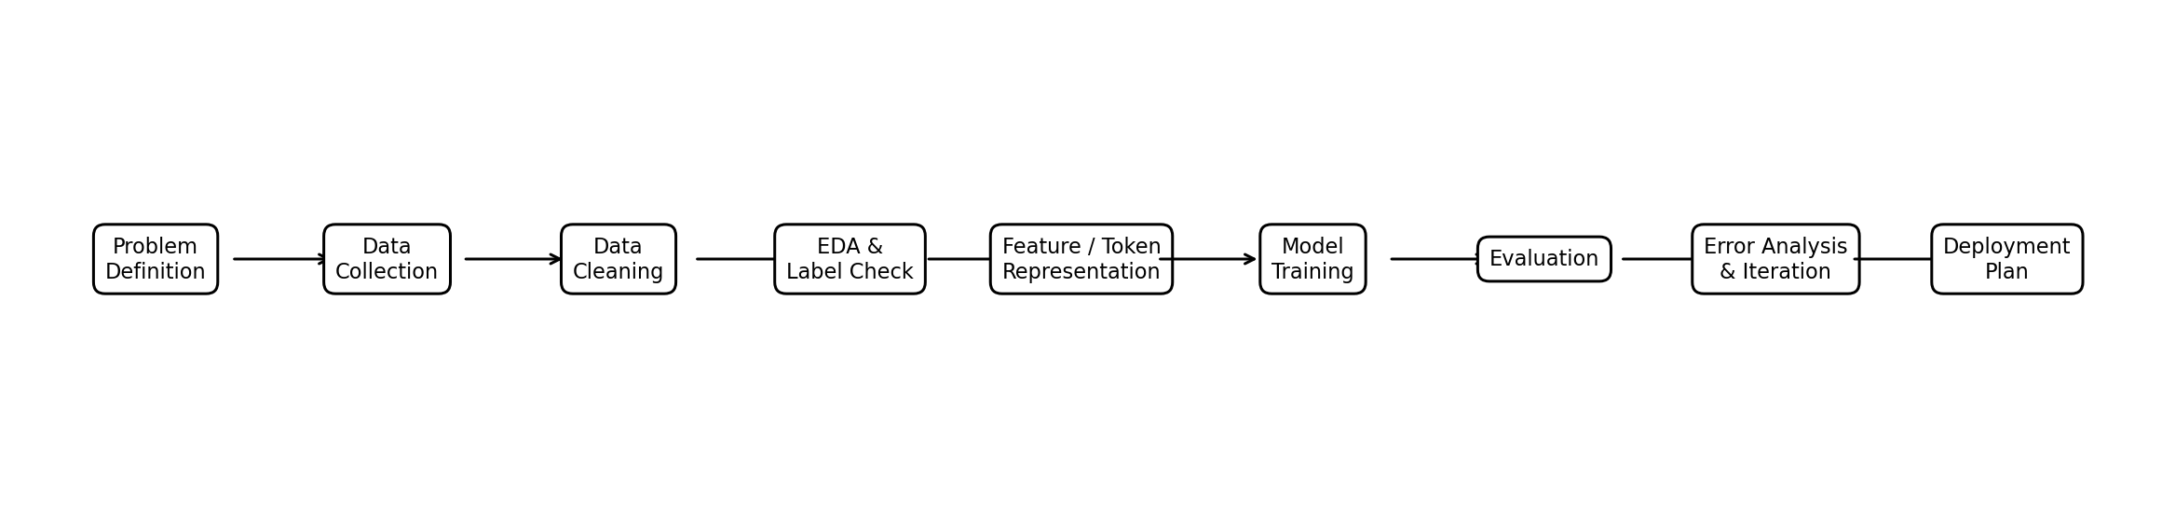
Figure 1. Proposed end-to-end NLP project pipeline.

5.1 Detailed Pipeline Stages
Stage | Activities | Output
1. Problem Definition | Define labels, users, success metrics, constraints. | Project specification
2. Data Collection | Acquire public/synthetic email text; document source and license. | Raw dataset
3. Data Validation | Check schema, duplicates, missing text, label quality, class balance. | Validated dataset
4. Preprocessing | Normalize whitespace/case; handle URLs, punctuation, HTML and special tokens carefully. | Clean text
5. Representation | TF-IDF baseline; optional word/character n-grams; transformer tokenization. | Feature/token dataset
6. Baseline Modeling | Train Logistic Regression / Linear SVM / Naive Bayes candidates. | Baseline model
7. Advanced Modeling | Fine-tune a pretrained transformer if justified. | Candidate advanced model
8. Evaluation | Test precision, recall, F1, confusion matrix, class-wise errors. | Evaluation report
9. Error Analysis | Inspect false positives/negatives and difficult examples. | Error log + improvement plan
10. Iteration | Refine data, preprocessing, features, thresholds or model. | Improved model
11. Prototype Deployment | Expose prediction through a simple application/API. | Prototype

6. Data Strategy

6.1 Data Sources
- Primary preference: publicly available email/phishing datasets with clear research or educational usage terms.
- Secondary option: synthetic hospital email examples created for development and testing.
- No real patient-identifiable or confidential hospital emails should be used for the internship prototype.
- Every dataset should be accompanied by source, license/usage notes, collection date, and label definitions.

6.2 Proposed Dataset Schema
Field | Type | Description
email_id | String | Unique anonymized identifier.
subject | Text | Email subject line.
body | Text | Email body.
label | Categorical | Safe, Suspicious, or Dangerous.
source | String | Dataset/source identifier.
notes | Text | Optional annotation or review notes.

6.3 Data Quality Checks
- Remove exact duplicates and investigate near-duplicates.
- Check for missing/empty subjects and bodies.
- Measure class distribution before and after splitting.
- Inspect unusually short/long messages.
- Identify possible label leakage, such as explicit class names inside the email text.
- Use stratified train/validation/test splits for classification.
- Keep the final test set untouched until model selection is complete.

7. Text Preprocessing and Representation

7.1 Preprocessing Plan
- Convert raw fields into a consistent text representation.
- Normalize whitespace and obvious formatting artifacts.
- Handle HTML and encoded content when present.
- Preserve useful security signals such as URLs, domains, unusual punctuation, and urgency-related terms where appropriate.
- Apply tokenization through the selected NLP library/model.
- Avoid aggressive stop-word removal or stemming until experiments demonstrate a benefit.
- Document every transformation so the same process can be applied at inference time.

7.2 Feature/Representation Strategy
Approach | Role | Why Use It
TF-IDF word n-grams | Baseline | Fast, interpretable, strong classical benchmark.
TF-IDF character n-grams | Optional baseline | Can capture obfuscation, spelling variation and URL-like patterns.
Word embeddings | Optional | Capture semantic relationships beyond sparse counts.
Pretrained transformer | Advanced candidate | Contextual representation; useful when enough labeled data is available.

The baseline follows the documented scikit-learn pattern of vectorization plus a classifier, while the advanced option follows the modern pretrained-transformer/fine-tuning workflow described by Hugging Face. citeturn0search0turn0search5

8. Model Selection Strategy
Model | Purpose | Expected Advantage | Decision Rule
Multinomial Naive Bayes | Quick baseline | Very fast and simple for count-based text features. | Keep if competitive and simple.
Logistic Regression | Primary baseline | Strong, interpretable linear text classifier. | Use as benchmark.
Linear SVM | Baseline comparison | Often strong for high-dimensional sparse text. | Compare using validation F1.
BERT-family transformer | Advanced model | Context-aware representation and fine-tuning. | Use if improvement justifies compute/time.

Model selection will not be based only on the highest accuracy. The preferred model should provide a good balance of class-wise recall, precision, F1-score, inference cost, interpretability, and implementation complexity.

9. Evaluation Strategy

9.1 Metrics
- Accuracy: overall proportion of correct predictions; useful but insufficient under class imbalance.
- Precision: proportion of predicted positives for a class that are actually that class.
- Recall: proportion of actual instances of a class that are correctly identified.
- F1-score: harmonic mean of precision and recall; especially useful for comparing class performance.
- Macro-F1: gives equal weight to each class and is useful when all threat categories matter.
- Confusion matrix: shows which classes are most frequently confused.
- Inference latency and model size: considered for prototype deployment.

9.2 Success Criteria
Criterion | Target for Prototype
Baseline established | At least one reproducible classical model.
Evaluation completeness | Accuracy + precision + recall + F1 + confusion matrix.
Class coverage | All three classes represented in training and evaluation.
Model improvement | Advanced model tested only if baseline/error analysis justifies it.
Documentation | Dataset, preprocessing, model, experiments and limitations recorded.
Prototype readiness | A text input can produce a risk class and confidence/result explanation.

10. Risk Analysis and Mitigation
Risk | Impact | Likelihood | Mitigation
Class imbalance | High | High | Stratified splits, class weights, macro-F1, targeted data collection.
Noisy/mislabeled data | High | Medium | Manual sample review, label guidelines, duplicate checks.
Data leakage | High | Medium | Separate preprocessing fit from test data; keep test set untouched.
Overfitting | High | Medium | Validation set, regularization, early stopping, error analysis.
Phishing patterns change | High | High | Plan periodic retraining and monitoring after deployment.
Adversarial/obfuscated text | Medium/High | Medium | Character features, robust preprocessing, adversarial examples in later iterations.
Limited compute | Medium | Medium | Start with TF-IDF baseline; use smaller pretrained models if needed.
Privacy/confidential data | Very High | Low for prototype | Use public/synthetic/anonymized data; exclude patient-identifiable information.
False positives | Medium | Medium | Human review for Suspicious/Dangerous cases; threshold tuning.
False negatives | Very High | Medium | Prioritize recall for dangerous class and perform targeted error analysis.

11. Iterative Development and Feedback Loop
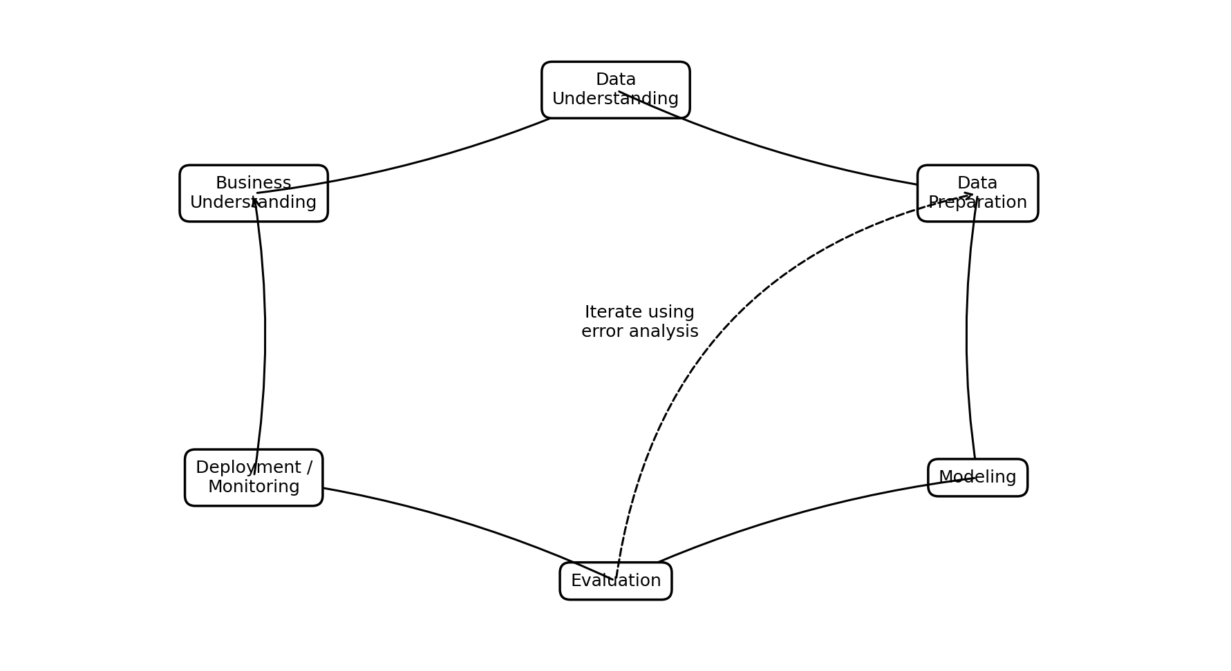
Figure 2. Iterative project lifecycle adapted for the NLP prototype.
The project will not treat evaluation as the final step. If errors reveal poor labels, missing examples, representation weaknesses, or threshold problems, the pipeline will return to the relevant earlier stage. This follows the iterative nature of CRISP-DM and modern NLP development workflows. citeturn0search9turn0search6

12. Week 1 Timeline and Milestones (30–35 Hours)
Phase | Hours | Activities | Milestone / Deliverable
1. Research & Problem Framing | 4 h | NLP tasks, lifecycle research, project selection, success criteria. | Project brief + references
2. Requirements & Scope | 3 h | Audience, objectives, functional/non-functional requirements, scope. | Requirements section
3. Data Strategy | 5 h | Dataset options, schema, labeling, quality checks, privacy considerations. | Data plan
4. Pipeline Architecture | 5 h | Preprocessing, features, model candidates, evaluation flow. | Pipeline design
5. Risk Analysis | 3 h | Identify technical, data, privacy, performance risks and mitigations. | Risk matrix
6. Timeline & Milestones | 2 h | Break future work into phases and deliverables. | Execution roadmap
7. Diagram & Documentation | 4 h | Create pipeline/lifecycle diagrams and integrate content. | Presentation-ready DOC
8. Review & Refinement | 4–6 h | Check consistency, formatting, references, feasibility and completeness. | Final submission

Total planned effort: approximately 30–35 hours.

12.1 Future Internship Execution Roadmap
Stage | Indicative Duration | Main Output
Week 1 | 30–35 hours | Planning document, architecture, risks, timeline.
Week 2 | 20–25 hours | Dataset acquisition, cleaning, labeling audit, EDA.
Week 3 | 20–25 hours | TF-IDF baselines, validation, initial error analysis.
Week 4 | 20–30 hours | Transformer experiment and model comparison.
Week 5 | 15–20 hours | Prototype interface/API, testing, documentation.
Week 6 | 10–15 hours | Final evaluation, presentation, limitations and future work.

13. Planned Deliverables
- Week 1 planning document (this document).
- Dataset source and data dictionary.
- Data preprocessing notebook/script.
- Baseline classification notebook/script.
- Advanced-model experiment, if feasible.
- Evaluation report and confusion matrix.
- Error-analysis log.
- Prototype prediction interface or API.
- Final project report and presentation materials.

14. Ethical, Privacy, and Security Considerations
- Do not use real patient records, confidential hospital communications, or personally identifiable information unless explicitly authorized and appropriately protected.
- Clearly communicate that the prototype is a decision-support tool, not a replacement for human security judgment.
- Document dataset licenses and permitted uses.
- Monitor class-wise errors because a high overall accuracy can hide poor performance on an important threat class.
- Avoid exposing raw sensitive email text in logs, screenshots, notebooks, or public repositories.
- For deployment, use access control, secure logging, model/version tracking, and a process for reporting incorrect predictions.

15. Key Challenges and Proposed Solutions
Challenge | Proposed Solution
Limited labeled hospital-specific emails | Combine suitable public/synthetic data and document domain limitations.
Vocabulary changes and obfuscation | Use word + character features and periodically refresh training examples.
Class imbalance | Stratification, class weighting, macro-F1 and targeted sampling.
Context-dependent language | Compare classical models with a transformer model.
Explainability | Retain interpretable baseline; analyze influential features and representative errors.
Operational risk from false negatives | Tune for high recall on dangerous messages and retain human review.
Resource constraints | Use a staged approach: classical baseline first, transformer only when justified.

16. Research References and Online Resources
IBM – CRISP-DM overview https://www.ibm.com/docs/en/spss-modeler/saas?topic=dm-crisp-help-overview
IBM – Understanding and preparing data https://www.ibm.com/docs/en/cloud-paks/cp-data/5.4.x?topic=modeler-understanding-preparing-data
scikit-learn – Working with text documents https://scikit-learn.org/stable/auto_examples/text/index.html
Hugging Face Course – Text classification and NLP tasks https://huggingface.co/docs/course/chapter1/5
Hugging Face Course – Fine-tuning BERT for text classification https://huggingface.co/docs/course/en/chapter3/1
Hugging Face Course – NLP task overview https://huggingface.co/docs/course/chapter7/1
spaCy – Linguistic features and Named Entity Recognition https://spacy.io/usage/linguistic-features
Devlin et al. – BERT: Pre-training of Deep Bidirectional Transformers for Language Understanding https://arxiv.org/abs/1810.04805
Note: Online resources were reviewed for lifecycle structure, text-classification workflow, transformer fine-tuning, and NER concepts. The project plan adapts those principles to the proposed hospital-email classification use case.

17. Conclusion
This plan provides a feasible blueprint for developing an NLP-based Hospital Email Threat Classification prototype. The strategy deliberately begins with a transparent baseline, validates data quality and evaluation methodology, and then introduces more advanced transformer methods only when they are justified by the evidence. The project also treats risk analysis, privacy, error analysis, documentation, and future monitoring as first-class components. Following this plan will create a strong foundation for the next internship stages: data preparation, model development, evaluation, deployment, and final demonstration.

