Quantum Annealing

Keshav Kasliwal Rahul V Rao   
*Electronics and Communication Engineering Electronics and Communication Engineering   
Rashtreeya Vidyalaya College of Engineering Rashtreeya Vidyalaya College of Engineering   
Bengaluru,India Bengaluru,India*  
[keshavkasliwal.ec18@rvce.edu.in](mailto:keshavkasliwal.ec18@rvce.edu.in) [rahulvrao.ec18@rvce.edu.in](mailto:rahulvrao.ec18@rvce.edu.in)

Shiwam Birajdar Arpitha Malavalli

*Computer Science and Engineering Computer Science and Engineering*

*Rashtreeya Vidyalaya College of Engineering International Institute of Information Technology,Bangalore*

*Bengaluru,India Bengaluru,India*

[birajdarshiwam@gmail.com](mailto:birajdarshiwam@gmail.com) [arpitha.malavalli@iiitb.org](mailto:arpitha.malavalli@iiitb.org)

Mentors:

Abeer Vaishnav Dr B. Satish Babu,

*Student,Computer Science and Engineering Professor,Computer Science and Engineering*

*Rashtreeya Vidyalaya College of Engineering Rashtreeya Vidyalaya College of Engineering*

*Bengaluru,India Bengaluru,India*

[abeer.vaishnav13@gmail.com](mailto:abeer.vaishnav13@gmail.com) [bsbabu@rvce.edu.in](mailto:bsbabu@rvce.edu.in)

Archit Srivastava Dr. Tribikram Gupta

*Student, Electronics and Instrumentation Engineering Assistant Professor,Department of Physics  
Rashtreeya Vidyalaya College of Engineering Rashtreeya Vidyalaya College of Engineering  
Bengaluru,India Bengaluru,India*[architsrivastava3115@gmail.com](mailto:architsrivastava3115@gmail.com) [tgupta@rvce.edu.in](mailto:tgupta@rvce.edu.in)

**Abstract**

Quantum Annealing is inspired by simulated annealing which is a classical, randomized algorithm that helps us to find solutions of hard optimization problems. Based on thermodynamic principles of annealing this algorithm is an example of correlation between classical and quantum computer science. In this chapter, we illustrate how hard combinatorial and optimization problems are dealt by quantum annealing.

**Key Terms**

Annealing, Simulated Annealing, Quantum Annealing, QUBO, Superposition, Entanglement, Quantum Tunneling ,Couplers , Hamiltonian, Eigen spectrum.

1. **Introduction**

Quantum Annealing is an algorithm class, similar to Simulated Annealing which uses a quantum field instead of a thermal gradient. In order to explore the optimization problem's landscape, Simulated Annealing takes a greater chance of thermal fluctuations associated with temperature gradients, while Quantum Annealing uses quantum fluctuations in this task.

A Quantum fluctuation is a change in the amount of energy at a point in space for extremely short time lapses, as a result of the uncertainty principle enunciated by Heisenberg . In the natural metaphor upon which meta states are based, they may correspond to those of a thermodynamical system, that is to Simulated Annealing, the one within which variations of temperature do exist, or either to metastates of a quantum system. The latter is the case for the wave function of the only electron that orbits an atom of the simplest chemical element: hydrogen.

Quantum annealing (QA) is a method for solving optimization problems derived from the principles of classical thermodynamics and quantum mechanics. QA operates by the Hamiltonian equation of an initial quantum state to a final state that represents the minimum energy configuration of an optimization problem . In the limit that the dynamics are strictly adiabatic and Hamiltonian sufficiently complex, this coincides with the universal model of adiabatic quantum computing. In practice, however, the adiabatic condition is rarely obtained and the guarantee that the true solution will be recovered is lost. Instead, these quasi-adiabatic dynamics yield the sought-after final state with some non-unit probability and it remains open as to when such behaviour can provide a computational advantage.

These problems usually consist of finding the maxima or minima for a cost function that comprises several independent variables and a large number of instances. The evaluation of cost in this context must necessarily be computed in probabilistic terms, as given the large amplitude of the space of configurations (frequently Hamiltonian matrices with the huge dimension of 2N rows), the most common case is that an explicit, exhaustive evaluation of them all cannot be performed because they are excessively numerous to be calculated in a reasonably practical time interval. Let's think that, for a glass network with only five nodes, a 2^5 *2^5 ~ 1000 elements matrix would need to be operated upon; with only ten nodes, this is boosted to over one million elements, and with sixteen nodes, to a whopping 4,300,000,000 (we dub this “the curse of dimensionality” or “**Hughes effect**”, due to Bellman). A single configuration is thus defined as a 'tuple' (or 'array') of values over the whole set of independent variables. The value of the cost function depends on the configurations, being the solution to the problem set as the definite optimal configuration which minimizes, or maximizes, the cost function with some arbitrarily chosen confidence level or probability.

Physical illustration of QA can be explained using the quantum tunneling effect. The energy barrier is crossed by tunneling effect which helps in determining the global optima.

It can be graphically represented as follows :

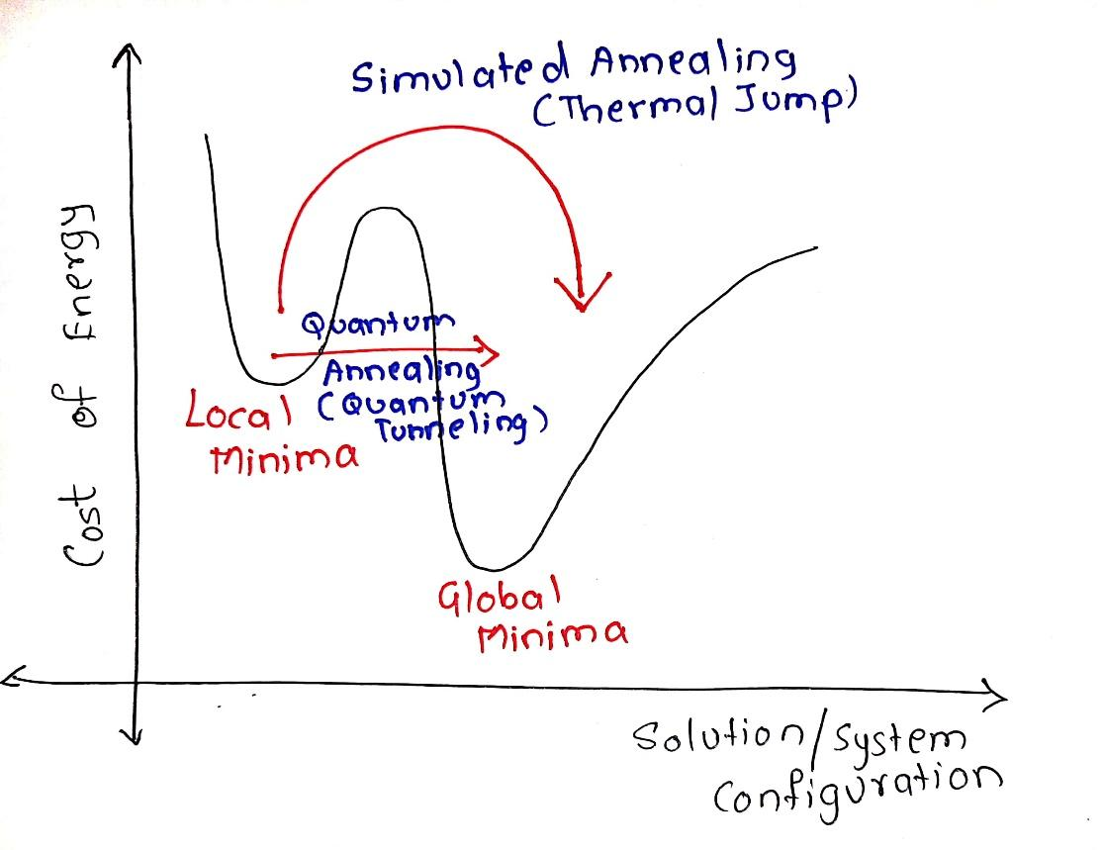

1. **Related Works and Literature Survey**

Simulated Annealing :

Simulated annealing is based on metallurgical practices by which a material is heated to a high temperature and cooled. At higher temperatures, atoms may shift unexpectedly, often eliminating impurities as the material cools into a pure crystal. This is replicated via the simulated annealing optimization algorithm, with energy state corresponding to the current  solution.

In this algorithm, we initialize the initial temperature to 1, and the minimum temperature to the order of 10^-4. The current temperature is multiplied by some fraction alpha and thus decreased until it reaches the minimum temperature. For each particular temperature value, we run the optimization a fixed number of times. The optimization routine consists of finding a neighbouring solution and accepting it with probability e^(f(c) – f(n)), where c is the current solution and n is the neighbouring solution. A neighbouring solution is found by applying a slight perturbation to the current solution. This randomness is useful to escape the common pitfall of optimization heuristics — getting trapped in local minima. By potentially accepting a less optimal solution than we currently have, and accepting it with probability inverse to the increase in cost, the algorithm is more likely to converge near the global optimum. Designing a neighbour function is quite tricky and must be done on a case by case basis, but below are some ideas for finding neighbours in locational optimization problems.

* Move all points 0 or 1 units in a random direction
* Shift input elements randomly
* Swap random elements in input sequence
* Permute input sequence
* Partition input sequence into a random number of segments and permute segments

One method is that we need to provide an initial solution so the algorithm knows where to start. This can be done in two ways:

* Using prior knowledge about the problem to input a good starting point and
* Generating a random solution.

Although generating a random solution is worse and can occasionally inhibit the success of the algorithm, it is the only option for problems where we know nothing about the landscape.

There are many other optimization techniques, although simulated annealing is a useful, stochastic optimization heuristic for large, discrete search spaces in which optimality is prioritized over time.

How Quantum Annealing works in Dwave systems:

The qubits are the lowest energy states of the superconducting loops which are in the D-Wave Quantum Processing unit. These states have a circulating current and a corresponding magnetic field. A qubit can be in state of 0 or 1. But because the qubit is a quantum object, it can also be in a superposition of the 0 and 1 state at the same time. At the end of the quantum annealing process, each qubit collapses from a superposition state into either 0 or 1 (i.e. a classical state).

The physics behind this process is shown with an energy diagram. This diagram changes over time, as we can see in (i), (ii), and (iii). To begin, there is just one valley (i), with a single minimum. When the quantum annealing process executes , the barrier is raised, and it turns the energy diagram into a double-well potential (ii). Here, the low point of the left side valley corresponds to the 0 state, and the low point of the right side valley corresponds to the 1 state. The qubit ends up in one of these valleys at the end of the annealing procedure.

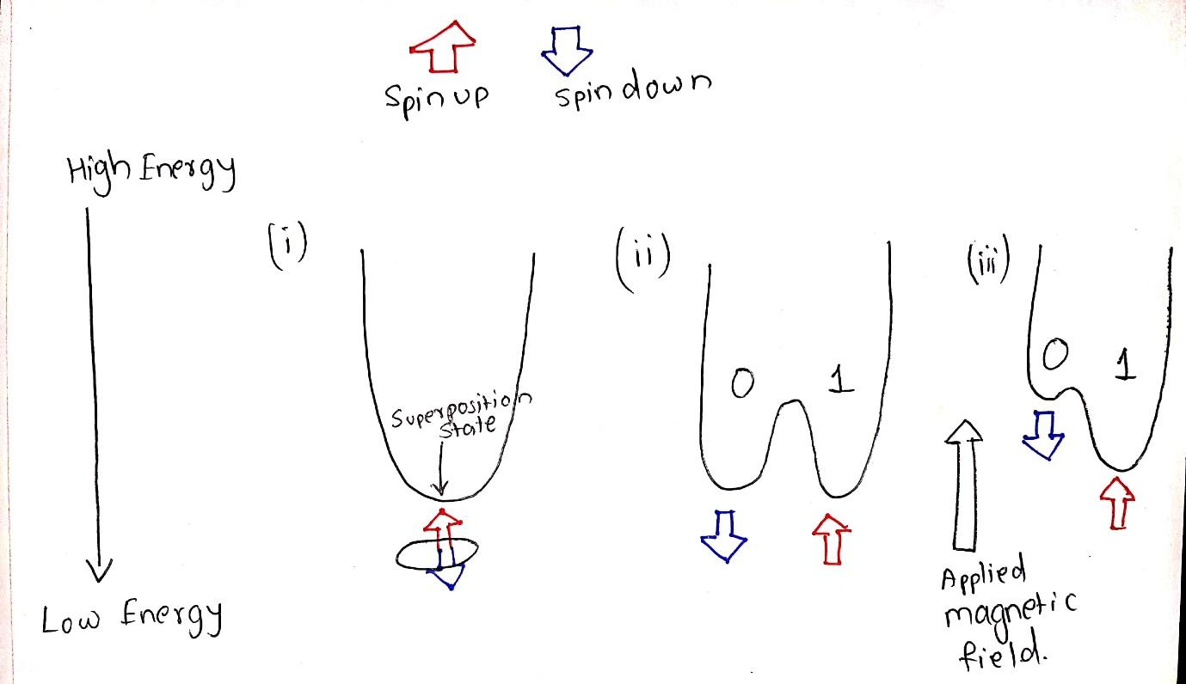

The probability of the qubit falling  in the 0 or the 1 state is equal in value. We can, however, control the probability of it falling into the 0 or the 1 state by applying an external magnetic field to the qubit (iii). This field tilts the double-well potential, increasing the probability of the qubit ending up in the lower well. The programmable quantity that controls the external magnetic field is called as a bias.

The bias alone is not the only responsible factor . The real power of the qubits comes when we link them together so they can affect each other. This is done with a device called a Coupler. A Coupler can make two qubits to end up in the same state both 0 or both 1 or it can make them to be in opposite states. Like a qubit bias, the correlation weights between coupled qubits can be programmed by setting a coupling strength. Together, the programmable biases and weights are the means by which a statement is defined in the DWave System.

When a coupler is used , we are using Quantum Entanglement. Entanglement can be referred to states such as their momentum, position, or polarisation. They could be thought of as a single object having four possible states. The diagram shows a potential with four states, each corresponding to a different combination of the two qubits: 00,01,10 and 11. The relative energy of each state depends on the biases of qubits and the coupling between them. During the annealing procedure , the qubit states are potentially delocalized in this energy landscape before finally settling into 11 at the end of the annealing procedure.

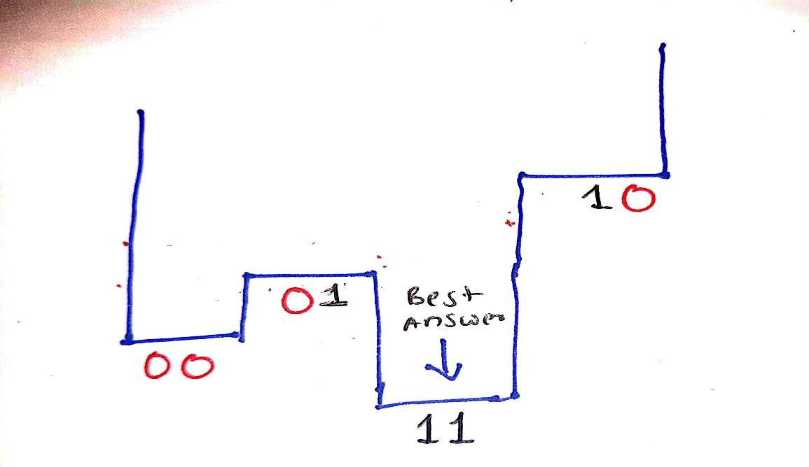

As the number of bits increase the complexity increases . With two qubits, we have four possible states over which we can make an energy landscape. At three qubits, we have eight. For each qubit we add, we double the number of states over which we can define the energy landscape: n qubits => 2^n possible states

In short, we start with a set of qubits, each in a superposition state of 0 and 1. They are yet to be coupled. When they undergo quantum annealing process, the couplers and biases are introduced and the qubits become entangled. At this point, the system is in an entangled state. By the end of the annealing procedure, each qubit is finally in a classical state that represents the minimum energy state of the problem, or one very close to it. All of this happens within micro seconds.

A Hamiltonian is a function that maps specific states, known as eigenstates, to energies . Only when it is in an eigenstate of the Hamiltonian is its energy well defined and called the eigenenergy. When the system is in any other state, its energy is not certain. The collection of eigenstates with defined eigen energies formulate the eigen spectrum.

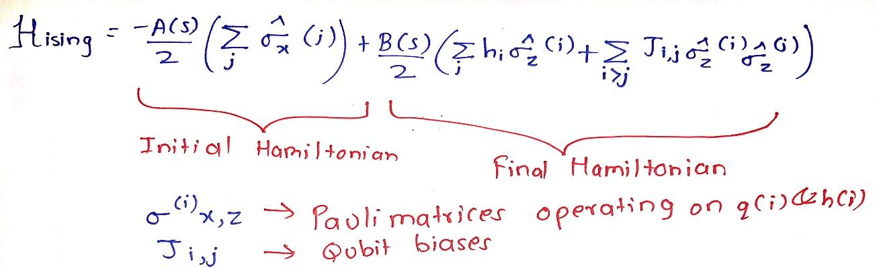

1. **Timetable Optimization Problem(Scheduling Problem)**

* 1. **Problem statement**

Optimization of complex timetables involving multiple variables by formulating the problem into a suitable quantum annealing model with reduced complexity.

* 1. **Methodology**

To generate an energy landscape for the given problem we need to develop a function, this is done by developing an “objective function” , which is a mathematical expression of a system as a function of the binary variables representing qubits.

QUBO - Quadratic unconstrained binary optimization refers to the method of minimising quadratic polynomials over a binary variable.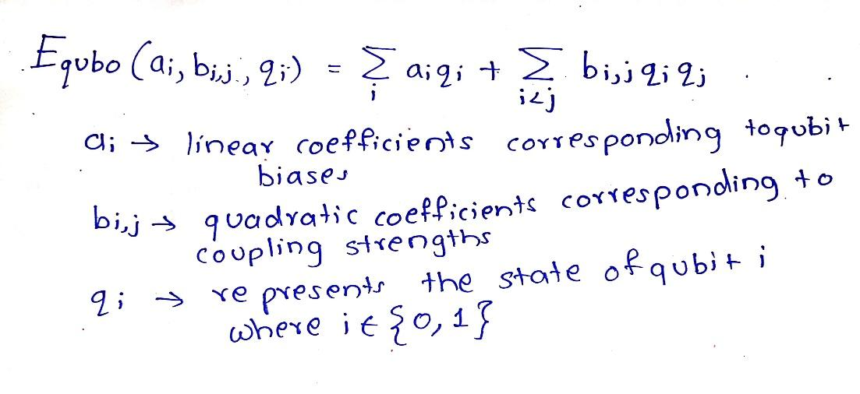

The methodology to build the quantum annealing model to the given problem statement can be divided into three main parts.

**a)    Preparation of objective and constraint functions**

The given timetable preparation and optimization problem can be condensed into a set of objectives and constraints which when satisfied shall present the solution for the given problem.

Objectives

1. A class should have all the subjects in the given set. This is the main objective to prepare a timetable. All the subjects of a class should be distributed to the slots of timetable
2. No collision for the same professor in two or more different classes. This objective restricts a single professor handling multiple classes to be assigned two or more different classes at the time slot.

Constraints

1. Least number of empty slots in the timetable. This constraint restricts the number of empty slots in timetables to improve the efficiency of distribution.
2. All the professors should get almost similar lecture hours per day. This constraint is used to distribute the work uniformly among the professors to avoid the burden on single professors.
3. Total hours per subject per week should not exceed the user input value. This constraint is used to assign slots or teaching hours to the subject based on the credit given to that subject.

**b) Formulation QUBO to the objective and constraint function**

The objective functions and the constraints must be formulated into a binary mathematical model before being optimized using D-Wave QPU. Two formulations are available for the task.

* 1. Ising Model :This model is used in statistical mechanics. Variables used in this model are spin up corresponding to +1 and spin down corresponding to -1. The objective function use is

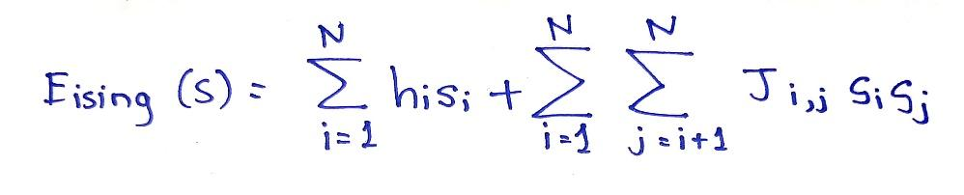

* 1. QUBO :

This model/problem is used in computer science problems. Variables used are True corresponding to 1 and False corresponding to 0. The objective function used is

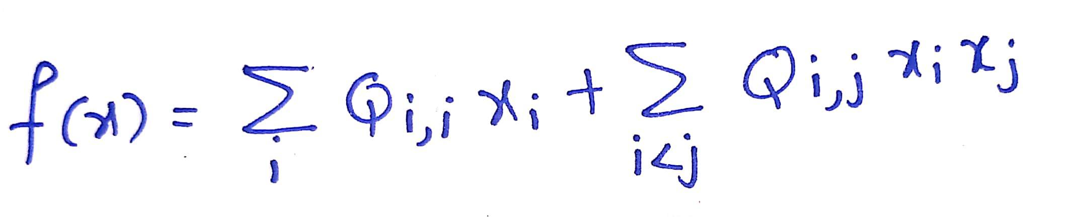

QUBO representation is used to represent the objective and constraint function

1. Representation of constraint 3 (total hours per subject per week should not exceed the user input value).Total hours of classes per week be T
2. Class hours for each subject be Xi
3. Credits for each subject entered by user be Ci .Total number of subjects be N

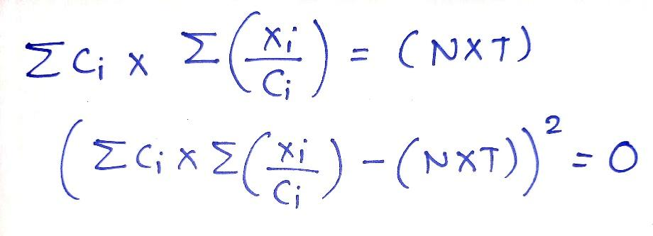

This is the final equation for the given constraint.

* 1. **Results**

Positive

* + 1. Proper segregation of required variables and constraints.
    2. A Quantum construct of the problem.
    3. Proper Scheduling of the classes

Negative

1. Classical construct was termed easier
2. Graph Theory approach pointed towards classical results and couldn’t be formulated for quantum approach.
3. Handling of variables became very difficult.
4. **Scope for future study**

Optimization problems are always arising in various aspects of computer science. Quantum Annealing would be the most modern and fastest approach for optimization.

This probabilistic approach can be used in many fields such as :

1. High complexity Scheduling problems.
2. Spanning Tree Problems
3. Quantum Machine Learning
4. Quantum Neural Networks
5. Routing Problems

Developing more optimized algorithms for QA is also a necessity.

1. **Conclusion**

We were able to understand and implement Simulated Annealing. We could formulate how the DWave processing unit works. Quantum Annealing can be used for finding the optimal solution , we were able to understand and procure the workings of the quantum annealing process. Apart from a few constraints we were able to formulate the problem statement and create a classical construct to be converted to a Quantum construct. We have apt knowledge on the Quantum Annealing procedure and the concept of Quantum Tunneling.

**References**

1. Michael A. Nielsen & Isaac L. Chuang , Quantum Computation and Quantum Information , 10th Anniversary edition , Cambridge University Press.
2. D-wave Systems , ‘What is Quantum Annealing?’ . <https://youtu.be/zvfkXjzzYOo>
3. D-wave Systems , ‘How the Quantum Annealing Process works’ <https://youtu.be/UV_RlCAc5Zs>
4. D-wave Systems , ‘Physics of Quantum Annealing- Hamiltonian and Eigen Spectrum’. <https://youtu.be/tnikftltqE0>
5. D-wave Systems , ‘Measuring Quantum Physics in a Quantum Annealer’ . <https://youtu.be/tnikftltqE0>
6. Up and Atom , ‘What is Quantum Tunneling , Exactly? ’ . <https://youtu.be/WPZLRtyvEqo>
7. Frank Liang , ‘Optimization Techniques – Simulated Annealing’ . Towards data science. <https://towardsdatascience.com/optimization-techniques-simulated-annealing-d6a4785a1de7>