**Machine Learning to predict the credit worthiness (“good” or “bad”) of loan applicants.**

|  |  |  |  |  |  |  |
| --- | --- | --- | --- | --- | --- | --- |
|  | **Accuracy** | **Precision** | **Recall** | **F1-Score** | **Support** | **AUC** |
| **Logistic Regression** | 0.73 | 0.70 | 0.73 | 0.70 | 300 | 0.746748691382 |
| **LinearSVC** | 0.75 | 0.73 | 0.75 | 0.72 | 300 | 0.748676190476 |
| **Decision Tree** | 0.71 | 0.69 | 0.71 | 0.70 | 300 | 0.700097134531 |
| **Random Forest** | 0.71 | 0.50 | 0.71 | 0.59 | 300 | 0.746775673196 |
| **MLPClassifier** | 0.72 | 0.70 | 0.72 | 0.71 | 300 | 0.730289784685 |

**Feature Ranking: (with Pre-processing)**

Feature ranking:

**1. feature checking_status (0.299473)**

**2. feature credit_history (0.253363)**

**3. feature savings_status (0.056199)**

**4. feature employment (0.050651)**

**5. feature job (0.048430)**

6. feature purpose_'domestic appliance' (0.045793)

7. feature purpose_'new car' (0.040876)

8. feature purpose_'used car' (0.035692)

9. feature purpose_business (0.032977)

10. feature purpose_education (0.027847)

11. feature purpose_furniture/equipment (0.027443)

12. feature purpose_other (0.027177)

13. feature purpose_radio/tv (0.025222)

14. feature purpose_repairs (0.022589)

15. feature purpose_retraining (0.004771)

16. feature personal_status_'female div/dep/mar' (0.001494)

17. feature personal_status_'male div/sep' (0.000000)

18. feature personal_status_'male mar/wid' (0.000000)

19. feature personal_status_'male single' (0.000000)

20. feature other_parties_'co applicant' (0.000000)

21. feature other_parties_guarantor (0.000000)

22. feature other_parties_none (0.000000)

23. feature property_magnitude_'life insurance' (0.000000)

24. feature property_magnitude_'no known property' (0.000000)

25. feature property_magnitude_'real estate' (0.000000)

26. feature property_magnitude_car (0.000000)

27. feature other_payment_plans_bank (0.000000)

28. feature other_payment_plans_none (0.000000)

29. feature other_payment_plans_stores (0.000000)

30. feature housing_'for free' (0.000000)

31. feature housing_own (0.000000)

32. feature housing_rent (0.000000)

33. feature own_telephone_none (0.000000)

34. feature own_telephone_yes (0.000000)

35. feature foreign_worker_no (0.000000)

36. feature foreign_worker_yes (0.000000)

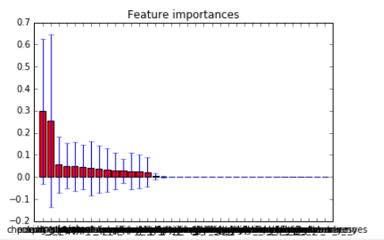

**Feature Ranking: (without Pre-processing)**

**1. feature checking_status (0.137962)**

**2. feature credit_history (0.090873)**

**3. feature purpose (0.078223)**

**4. feature savings_status (0.077632)**

**5. feature employment (0.076176)**

6. feature installment_commitment (0.071339)

7. feature personal_status (0.070415)

8. feature other_parties (0.070127)

9. feature residence_since (0.063511)

10. feature property_magnitude (0.063084)

11. feature other_payment_plans (0.048531)

12. feature housing (0.043538)

13. feature existing_credits (0.040969)

14. feature job (0.030621)

15. feature num_dependents (0.026710)

16. feature own_telephone (0.010288)

17. feature foreign_worker (0.000000)

