**Arpitha Anand (1001256428) ---- Output_Screenshot**

1. **Run the program on cmd window**

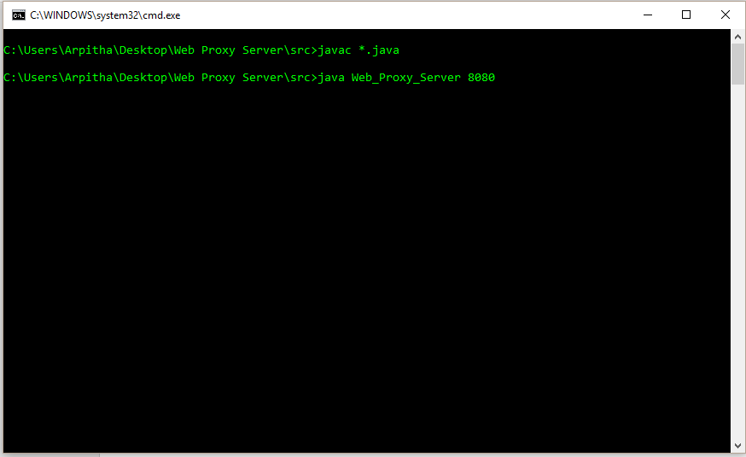

1. **Change Ethernet Settings:** 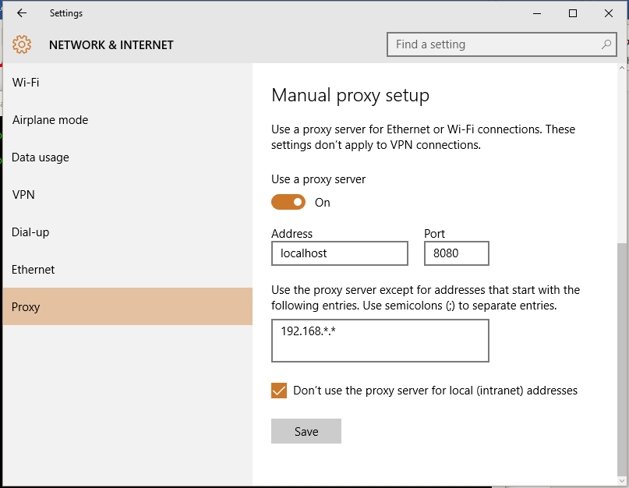
2. **Open browser (multiple – showing multithreading concept)**

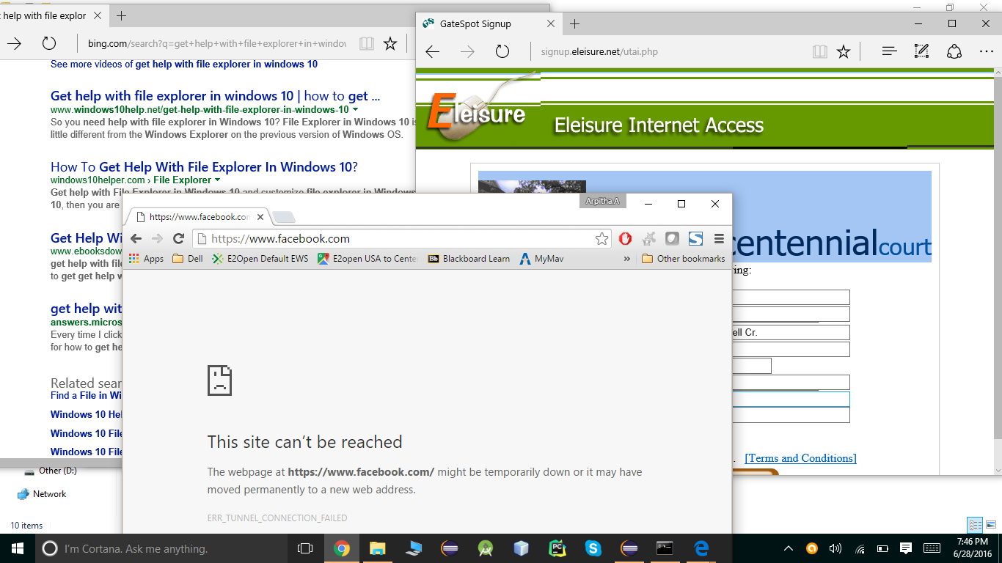

Accessing [https://*](https://*) websites cause error as program is created to handle http alone.

1. **Find cache and log files created in the workspace**

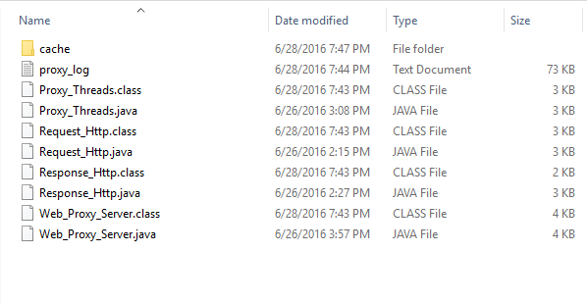

1. **Open Cache folder to find all the cached entries of all the http websites accessed, open it using Hex editor to cross check the contents of the request and response headers etc.**

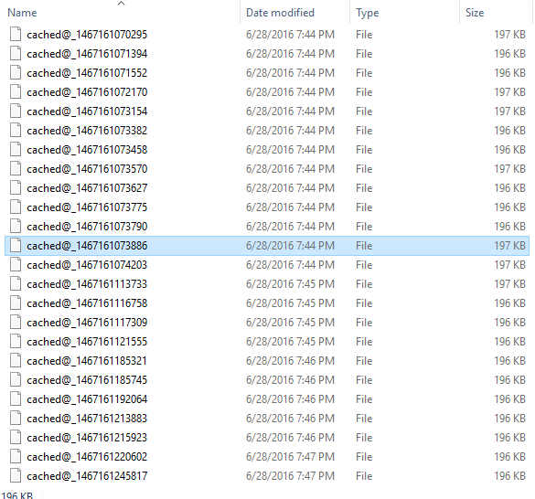

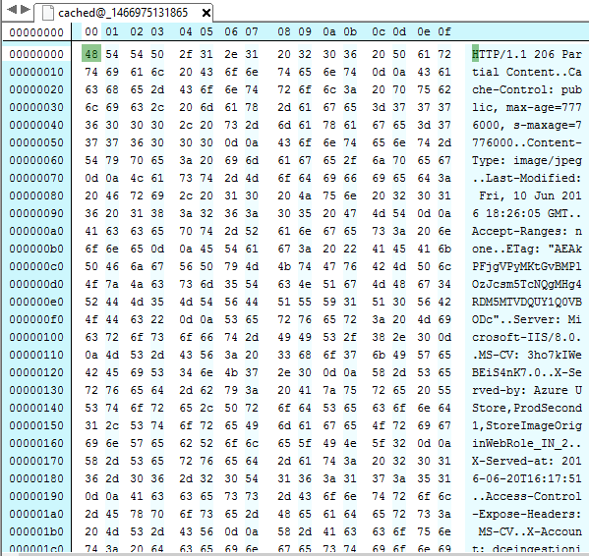

1. **Open the proxy_log.txt file to find appropriate interaction messaged using httprequest and httpresponse .**

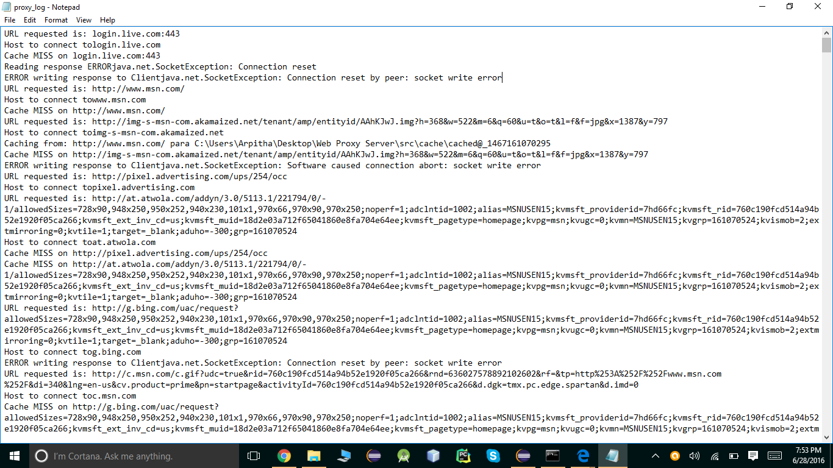

**On scrolling down the .txt file you can find valid cache hit and miss and other messages.**