**Artificial Intelligence Practical**

Q1

/*

Fibonnaci Series

generate_fib(+N, -T)

T = fib(N)

*/

generate_fib(N, T) :-

N > 2,

N1 is N - 1,

N2 is N - 2,

generate_fib(N1, T1),

generate_fib(N2, T2),

T is T1 + T2.

generate_fib(1,0).

generate_fib(2,1).

OUTPUT

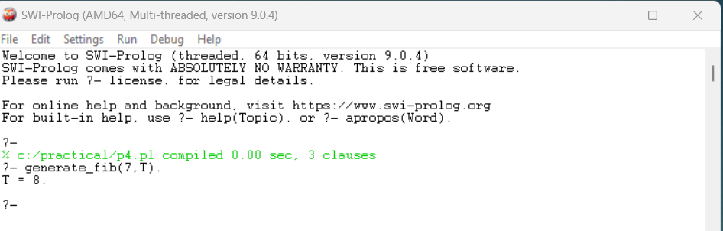

Q2

/*

GCD of two numbers

gcd(+X, +Y, -D)

D is gcd(X,Y).

*/

gcd(X,X,X).

gcd(X,Y,D):-X<Y,

Y1 is Y-X,

gcd(X,Y1,D).

gcd(X,Y,D):-Y<X,

gcd(Y,X,D).

OUTPUT

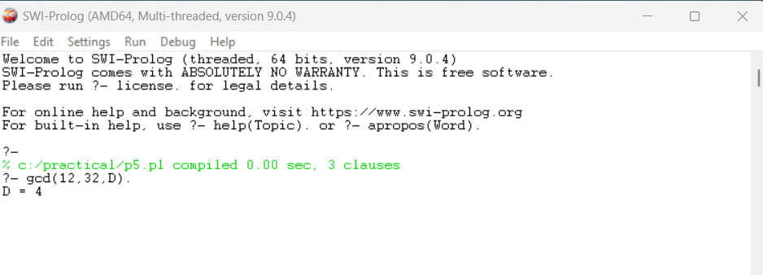

Q3

/*

Power of a number

power(+Num, +Pow, -Ans)

Ans is Num**Pow.

*/

power(Num, Pow, Ans) :- Ans is Num ** Pow.

OUTPUT

