MARIAN COLLEGE KUTTIKANAM (AUTONOMOUS)
Department of Computer Applications
MINI PROJECT REPORT
LEAF DISEASE SPOT SEGMENTATION USING
DIGITAL IMAGE PROCESSING
265DSEUBC302B – Digital Image Processing
Bachelor of Computer Applications, Semester 5
Submitted by
ARPPAN GEORGE BIJU
Roll No.: 24UBC219

1. Title
Leaf Disease Spot Segmentation Using Digital Image Processing (HSV Thresholding and Morphological Post-Processing).

2. Problem Statement
Early blight is one of the most common diseases seen in tomato cultivation. On the leaf it shows up as brown or dark brown spots, usually with a yellowish region around them, and the affected portion slowly spreads until the leaf dries up. When a farmer or a field assistant looks at a leaf, the decision is basically a visual one: how much of this leaf has turned brown, and how widely is it spread.
The problem I have taken up in this project is to separate those affected regions from the healthy part of the leaf automatically, using an image of the leaf as input. In image processing terms this is a segmentation problem, because the task is to divide the image into two meaningful regions, the diseased portion and everything else, and to produce a mask that marks exactly which pixels belong to the diseased portion.
The reason segmentation suits this problem is that the diseased area differs from the healthy area mainly in colour. A healthy tomato leaf is green with fairly high saturation, whereas a blighted region shifts towards brown, yellow-brown and dark grey. If the image is represented in a colour space where the colour itself can be isolated from its brightness, then a simple range selection is enough to pull out those pixels. HSV gives exactly that separation, which is why the project is built around HSV thresholding rather than working directly in RGB.
This project performs segmentation of the visually affected region. It does not attempt to classify which disease is present, and it should not be read as a diagnosis system.

3. Relevance of the Problem
Tomato is a widely grown crop in Kerala and early blight is a recurring problem in it. At present the severity of infection is judged by eye, which means two people looking at the same plant can come to two different conclusions, and there is no record left behind that can be compared with next week's condition.
A segmentation step like the one built here is useful in a few practical ways. It gives a repeatable number for how much of a leaf is affected, so the progress of the disease can be tracked over time. It can act as the first stage of a larger system, since most disease classification pipelines need the affected region isolated before any feature extraction or learning is done. And because the method needs no training data and very little computation, it is light enough to run on an ordinary phone or a low-cost field device, which matters when the intended user is a farmer and not a laboratory.
Farmers, agricultural extension officers and students working on plant pathology datasets are the people who would benefit from such a tool.

4. Objectives
The objectives set for this project were:
- To study how early blight appears in tomato leaf images and what makes the affected region visually different from the healthy region.
- To prepare a working image set from a public dataset and examine its characteristics.
- To convert the leaf images from BGR to the HSV colour space so that colour can be thresholded independently of brightness.
- To design an HSV threshold range that selects the diseased pixels and produces a binary mask.
- To clean the raw mask using morphological opening and closing so that isolated noise pixels and small holes are removed.
- To extract the diseased region from the original image using bitwise masking.
- To run the complete pipeline over all 120 images automatically and store the masks and segmented outputs.
- To measure the fraction of the leaf area that the method marks as diseased, and to use this as a quantitative basis for comparison.
- To compare three different HSV threshold ranges and justify the range finally used.
- To identify the cases where the method fails and to state the limitations honestly.

5. Dataset and Image Description
The images were taken from the Tomato Leaf Disease Detection dataset available on Kaggle, which is derived from the PlantVillage collection. Only one category was used, Tomato___Early_blight, because the aim was to study one disease pattern carefully rather than to cover many.
From that category 120 images were copied into a separate project folder and renamed in sequence from early_blight_001.jpg to early_blight_120.jpg, so that the batch processing code and the result files could be matched easily. The characteristics of the working set are given below.

Parameter | Details
Dataset | Tomato Leaf Disease Detection (PlantVillage)
Source | Kaggle
Category used | Tomato___Early_blight
Number of images | 120
Resolution | 256 x 256 pixels (uniform across all 120 images)
Channels | 3 (colour)
File format | JPG
Background | Plain uniform grey, single leaf per image
Ground-truth masks | Not provided
Noise | No artificial noise; mild JPEG compression artefacts present

Because every image is already 256 x 256, already cropped to a single leaf and already free of background clutter, no resizing, cropping or denoising was needed. The only preprocessing done is the colour space conversion, which is described in the next section. This was verified and not assumed: a separate cell in the notebook reads every image and prints the minimum and maximum width and height, and both came out as 256.
The main limitation of the dataset is that it carries no pixel-level ground truth. There is no reference mask saying which pixels are truly diseased, so the standard segmentation metrics IoU and Dice cannot be computed. A second limitation is that the images are studio-style, taken against a clean background under even lighting, so they are easier than a photograph taken in an actual field would be. Both of these are discussed again in the limitations section.

6. Methodology
The processing pipeline is as follows:
Input Image -> BGR to HSV -> HSV Thresholding -> Raw Mask
-> Morphological Opening -> Closing -> Cleaned Mask
-> Bitwise Masking -> Segmented Output -> Area Measurement

6.1 Colour Space Conversion
OpenCV reads an image in BGR order, so the image is converted to RGB before display and to HSV before processing. In HSV, hue carries the colour itself, saturation carries how pure or washed out that colour is, and value carries brightness.
The reason this helps is that in RGB a brown spot in shadow and a brown spot in light have completely different R, G and B values, so any fixed rule written in RGB breaks as soon as the lighting changes. In HSV the hue of both stays in roughly the same place and only the value changes, so the colour can be selected by hue and saturation while brightness is allowed to vary over a wide range. That is the property the whole method depends on.

6.2 HSV Thresholding
A lower and an upper HSV bound are defined and cv2.inRange() marks every pixel that falls inside both bounds as white and everything else as black, giving the raw binary mask. The bounds finally used are:

Channel | Lower bound | Upper bound
Hue | 5 | 35
Saturation | 40 | 255
Value | 20 | 220

In OpenCV the hue channel runs from 0 to 179 rather than 0 to 359, so the band from 5 to 35 corresponds to roughly 10 to 70 degrees on the normal colour wheel, which is the red-brown through orange to yellow region. That is where the early blight lesions sit. Healthy leaf tissue has a hue near 35 to 85 in the OpenCV scale and therefore falls outside the upper bound.
The saturation floor of 40 is what keeps the grey background out of the mask, since a neutral grey has saturation close to zero. The value floor of 20 discards near-black pixels where the hue reading is unreliable, and the ceiling of 220 removes specular highlights, which are bright, almost white and carry a meaningless hue.

6.3 Morphological Opening
The raw mask always contains scattered single pixels and tiny clusters, mostly from JPEG artefacts and from the slightly yellowed pixels along the leaf veins. Opening is erosion followed by dilation with the same structuring element. The erosion removes any white region thinner than the kernel, and the dilation restores the surviving regions to close to their original size. A 5 x 5 rectangular kernel was used, which means anything narrower than about five pixels is dropped.

6.4 Morphological Closing
Closing is the reverse order, dilation followed by erosion, applied to the opened mask with the same 5 x 5 kernel. A real lesion is not uniformly coloured; it often has a lighter centre or small gaps where the tissue has dried differently, and those gaps come out as holes in the mask. Closing fills the small holes and joins nearby fragments of the same lesion into one connected region, without letting the outer boundary of the lesion grow, because the erosion step undoes the dilation at the edges.
The order matters. Opening is done first so that the noise is removed before closing gets a chance to connect it into something larger. Doing it the other way round was tried informally and produced visibly worse masks.

6.5 Bitwise Masking
The cleaned mask is applied to the original image with cv2.bitwise_and(). Pixels where the mask is white keep their original colour and everything else becomes black, so the output shows the lesions cut out of the leaf with their real appearance preserved. This is the image a user would actually look at, while the binary mask is what any later measurement works on.

7. Implementation
The project is written in Python and was developed and executed in Google Colab. The dataset folder and the result folders are kept in Google Drive, which is mounted at the start of the notebook.

Component | Purpose
Python 3 | Implementation language
OpenCV (cv2) | Colour conversion, thresholding, morphology, masking, file I/O
NumPy | Threshold arrays, kernels, pixel counting
Matplotlib | Displaying originals, masks and segmented results side by side
Google Colab | Execution environment
Google Drive | Storage for the dataset and the generated results

The notebook is organised so that the method is first demonstrated step by step on a single image, early_blight_001.jpg, with the intermediate output shown after each stage. Once that is established, one batch cell repeats the same sequence over all 120 images and writes two files per image, the binary mask into Results/Masks and the segmented image into Results/Segmented, keeping the original file name so that the three versions of an image can be lined up later.
The key OpenCV calls used are cv2.cvtColor() for the BGR to HSV conversion, cv2.inRange() for the threshold, cv2.morphologyEx() with MORPH_OPEN and then MORPH_CLOSE for the cleanup, and cv2.bitwise_and() for the final masking. The structuring element is np.ones((5, 5), np.uint8).
The threshold values and the kernel size are defined once as variables at the top of the batch cell, so that changing a parameter and re-running affects the whole set consistently. This is what made the parameter comparison in Section 8.2 straightforward to carry out.

8. Results and Analysis
The pipeline ran successfully over all 120 images and produced 120 masks and 120 segmented images. For each input the system generates two outputs: a binary disease-spot mask showing the selected region in white, and a segmented image in which only the selected region of the original is retained.
Visually the results follow the lesions well on images where the blight is well developed and clearly brown. The lesion boundaries in the mask sit close to where the eye would place them, and the interior of each lesion comes out solid rather than speckled, which is the effect of the closing step. On images where the infection is at an early stage and the discolouration is still faint, the mask picks up only the darker core of the lesion and misses the pale halo around it.

8.1 Quantitative Measurement of Affected Area
Since the dataset provides no ground-truth masks, IoU and Dice cannot be calculated. To still have a number to reason about rather than only an opinion, the affected area was measured as a percentage of the leaf area:

Affected Area (%) = (diseased pixels / leaf pixels) x 100

The leaf region itself is separated from the grey background using a saturation threshold, since the background is close to neutral grey and therefore has very low saturation while any leaf tissue, healthy or diseased, has much higher saturation. This gives a denominator that reflects the actual leaf rather than the whole 256 x 256 frame, which would have made the percentages meaningless.
The statistic was computed over all 120 images. The results are summarised below.

Statistic (over 120 images) | Value
Mean affected area | 18.86 %
Minimum affected area | 0.00 %
Maximum affected area | 77.97 %
Standard deviation | 17.87 %
Images with affected area below 1 % | 8

This measurement is not an accuracy figure and should not be read as one. What it gives is a consistent, repeatable description of the output, which makes it possible to compare one parameter setting against another on the same footing and to spot the images where the method has behaved abnormally. The images at the very low end of the range are the ones where almost nothing was detected, and those were the images inspected in the failure case analysis.

8.2 Comparison of HSV Threshold Ranges
Three threshold ranges were tested on the same images to see how sensitive the method is to the choice of bounds.

Range | Lower HSV | Upper HSV | Mean affected area
Narrow | [8, 50, 30] | [30, 255, 210] | 9.92 %
Final | [5, 40, 20] | [35, 255, 220] | 18.86 %
Wide | [0, 30, 15] | [40, 255, 235] | 27.48 %

The trend is clear from both the mask images and the measured area. The narrow range produces clean masks with very little false detection, but it loses the lighter edges of the lesions and on the mildly infected images it detects almost nothing at all. The wide range catches the full extent of every lesion, but it also starts pulling in the yellowish tissue along the midrib and the slightly darker regions near the leaf edge that are not diseased, so the mask becomes larger than what is actually affected.
The final range was chosen as the setting that keeps most of the lesion without obviously bleeding into healthy tissue. The lower hue bound of 5 rather than 0 keeps the deepest reds out, the upper bound of 35 stops just short of the green region, and relaxing the saturation floor to 40 was what recovered the faint lesion edges that the narrow range was dropping. This choice was made by visual inspection supported by the area figures; without ground truth it cannot be claimed to be optimal, only reasonable.

8.3 Strengths Observed
- The method is simple enough to be explained fully and to be debugged stage by stage, since every intermediate output is an image that can be looked at.
- It requires no training data, no labelling and no model, which is what makes it usable on a dataset that has no ground truth.
- It is fast. All 120 images are processed in a few seconds, and a single image takes only a few milliseconds, so the approach would work in real time.
- Working in HSV makes the method considerably more tolerant of brightness variation than the same rule written in RGB would be.
- The morphological stage gives a visible improvement in mask quality, removing scattered noise and producing solid lesion regions instead of fragmented ones.

8.4 Failure Case Analysis
Two images, early_blight_095.jpg and early_blight_117.jpg, were examined closely as failure cases, and the problems they showed can be grouped as follows.
Under-detection on early infection. When the lesion is still forming, its colour has shifted only slightly from green and its saturation and hue stay partly inside the healthy range. The threshold then catches only the darkest centre and the mask badly understates the affected area.
False positives on natural leaf variation. A leaf that is ageing, or that has a yellowish midrib or a dried edge caused by something other than disease, has exactly the hue the threshold is looking for. The method has no way to tell such tissue apart from a lesion, because it uses colour alone and takes no account of shape, texture or where the region sits on the leaf.
Sensitivity to illumination. Where one part of the leaf is in shadow the value drops, and where a glossy surface reflects light the value rises and the saturation collapses. Both push pixels outside the bounds and produce gaps in the mask. Setting the value bounds wide at 20 to 220 reduces this but does not remove it.
Boundary imprecision. The transition from healthy to diseased tissue is gradual, not a sharp line, so a hard threshold has to cut somewhere inside that gradient. The result is that lesion boundaries in the mask are approximate, and the 5 x 5 morphological kernel smooths them further.
The common cause behind all four is that a single fixed global threshold is being applied to every image regardless of its content, while the images themselves vary in lighting, leaf age and infection stage.
The five images with the lowest detected segmented area using the final HSV range were:
Image | Detected Area
early_blight_095.jpg | 0.00 %
early_blight_117.jpg | 0.16 %
early_blight_085.jpg | 0.43 %
early_blight_070.jpg | 0.52 %
early_blight_118.jpg | 0.57 %

These images represent candidate low-detection cases. They were identified using the quantitative analysis rather than selected arbitrarily. The very low percentages indicate that the chosen HSV range detected little of the estimated leaf area in these images. This can occur when the visible lesion colour does not fall within the selected threshold range or when the affected regions are faint.

9. Limitations
- The HSV bounds are fixed and were chosen by inspection. They suit this dataset and would very likely need retuning for images captured under different conditions.
- No ground-truth masks exist for these images, so IoU, Dice and pixel accuracy could not be computed. The evaluation rests on visual assessment and on the area statistics, which describe the output but do not verify it.
- Only 120 images from a single disease category were used, so nothing here shows how the method behaves on other diseases or on healthy leaves.
- The dataset images are studio-style with a uniform background. A field photograph would contain soil, sky, other leaves and uneven light, and the saturation-based background removal used for the area calculation would not hold.
- The method uses colour only. Texture, shape and lesion arrangement, all of which a plant pathologist would use, are ignored.
- The system segments the visually affected region. It does not identify the disease and is not a diagnostic tool.

10. Future Scope
The most immediate improvement would be to hand-label the diseased region on a subset of the images, even twenty or thirty of them, so that IoU and Dice could be computed and the threshold could be tuned against a measured score instead of by eye.
On the method side, replacing the fixed bounds with an adaptive threshold such as Otsu applied to a single channel, or normalising each image for illumination before thresholding, would address the biggest weakness of the present approach. Adding a shape or texture check after the mask is formed would help reject the false positives caused by veins and dried edges, since those regions differ from real lesions in shape even when the colour matches.
Extending the dataset to other categories, including healthy leaves, would show whether the method generalises. Beyond that, a learned segmentation model such as U-Net would almost certainly handle the faint and ambiguous cases better, though it would need the labelled data that this project does not have. A practical end goal would be a mobile application that captures a leaf photograph and reports the affected percentage in the field.

11. Conclusion
This project built a complete segmentation pipeline for early blight lesions on tomato leaves using classical digital image processing. The image is converted to HSV, a threshold on hue, saturation and value produces a binary mask, morphological opening and closing clean that mask, and bitwise masking extracts the affected region from the original image. The pipeline was applied to all 120 images of the working set and the outputs were stored.
The evaluation covered three things: a quantitative measurement of affected leaf area across the full set, a comparison of three HSV threshold ranges, and a close look at the cases where the method fails. The comparison showed how strongly the output depends on the bounds chosen, and the failure analysis traced the main errors to the use of a single fixed global threshold on images that vary in lighting and infection stage.
What I take away from the work is that HSV thresholding with morphological post-processing is a reasonable and very cheap solution for this problem when the imaging conditions are controlled, and that its accuracy is limited not by the morphology or the masking but by the assumption that one threshold can serve every image. Understanding why each stage is there, and what each one can and cannot fix, was the more useful part of the exercise.

12. References
[1] Tomato Leaf Disease Detection Dataset, Kaggle. https://www.kaggle.com/datasets/kaustubhb999/tomatoleaf
[2] D. P. Hughes and M. Salathe, An open access repository of images on plant health, PlantVillage, 2015.
[3] R. C. Gonzalez and R. E. Woods, Digital Image Processing, 4th ed., Pearson. Chapters on image segmentation and morphological image processing.
[4] OpenCV Documentation. https://docs.opencv.org/
[5] NumPy Documentation. https://numpy.org/doc/
[6] Matplotlib Documentation. https://matplotlib.org/stable/

Appendix A – Project Structure
Leaf-Disease-Segmentation/
|
|-- code/
| |-- Leaf_Disease_Spot_Segmentation.ipynb
|
|-- screenshots/
|
|-- report/
| |-- Leaf_Disease_Spot_Segmentation_Report.docx
|
|-- README.md
|-- requirements.txt

GitHub repository: https://github.com/Arppan-George-Biju/Leaf-Disease-Segmentation

Appendix B – Parameters Used

Parameter | Value
Number of images | 120
Image size | 256 x 256 pixels
Colour space | HSV (OpenCV scale: H 0-179, S 0-255, V 0-255)
Lower HSV bound | [5, 40, 20]
Upper HSV bound | [35, 255, 220]
Morphological kernel | 5 x 5 rectangular, np.ones((5,5), np.uint8)
Morphological operations | Opening followed by Closing
Masking operation | cv2.bitwise_and()
Saturation threshold for leaf area | 40
Language | Python 3
Libraries | OpenCV, NumPy, Matplotlib
Platform | Google Colab
Storage | Google Drive

Appendix C – Screenshots

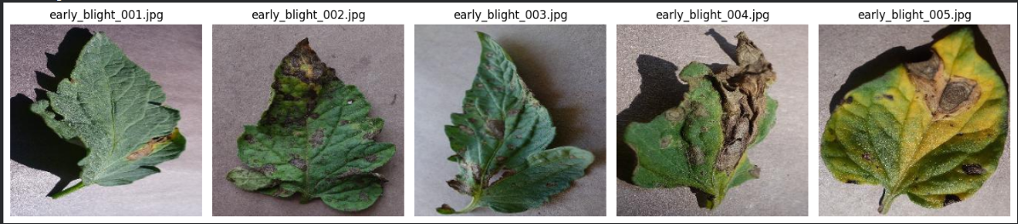 Figure 1 – Sample input images from the Early Blight category.

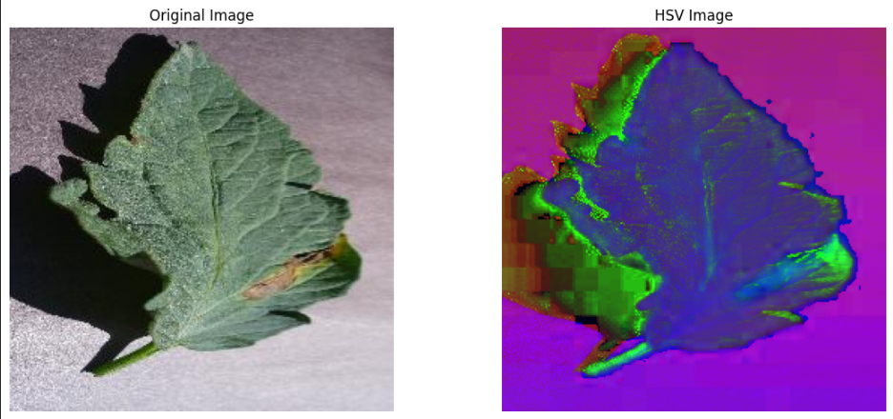 Figure 2 – Original image and its HSV representation.

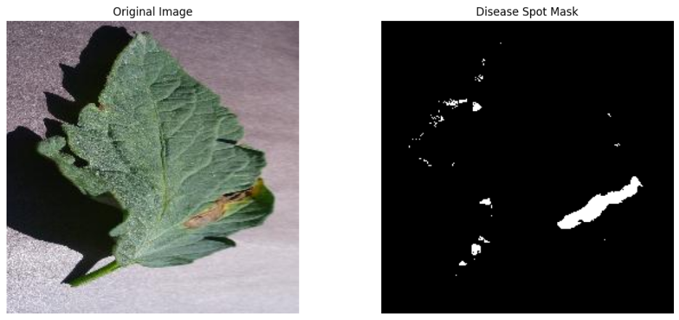
Figure 3 – Original image and the raw binary mask after HSV thresholding.
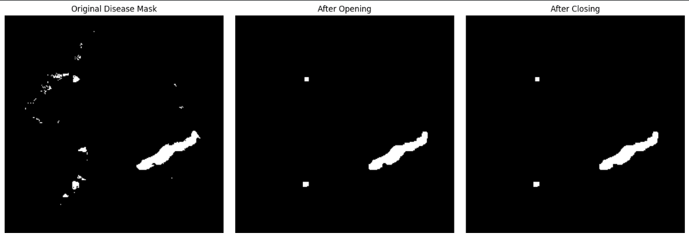
Figure 4 – Raw mask, mask after opening, and mask after closing.
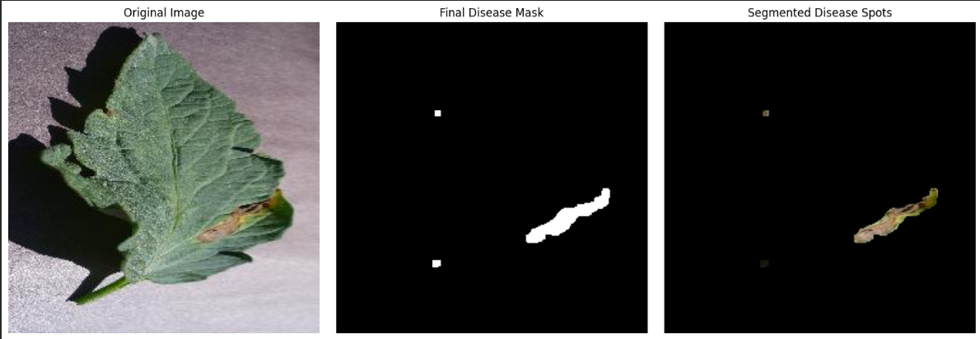
Figure 5 – Original, final mask and segmented output for a single image.
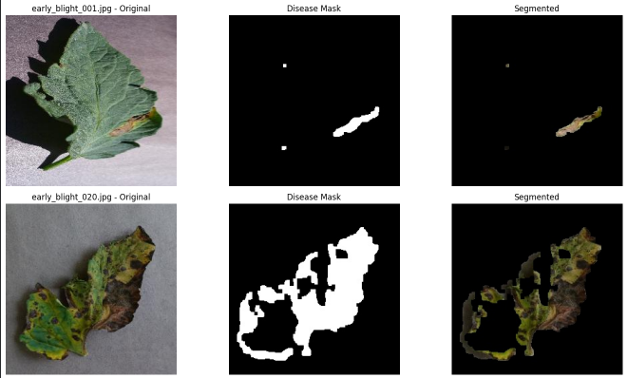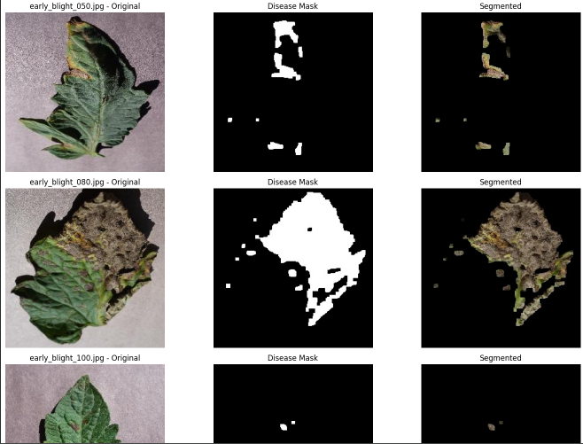
Figure 6 – Results for five representative images across the dataset.

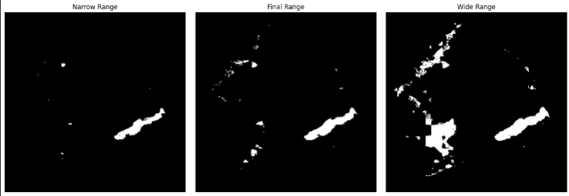
Figure 7 – Masks produced by the narrow, final and wide HSV ranges.

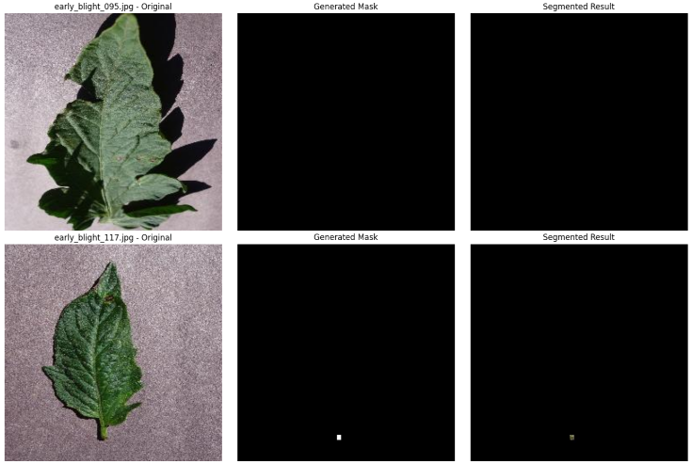
Figure 8 – Failure cases (early_blight_095.jpg and early_blight_117.jpg).

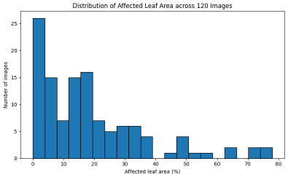
Figure 9 – Distribution of affected leaf area across the 120 images.

