LAB ASSIGNMENT-6.5
NAME:Anjali Aerpula
HALL TICKET:2303A51319
Task 1:
Prompt: “Generate Python code to check voting eligibility based on age and citizenship.”
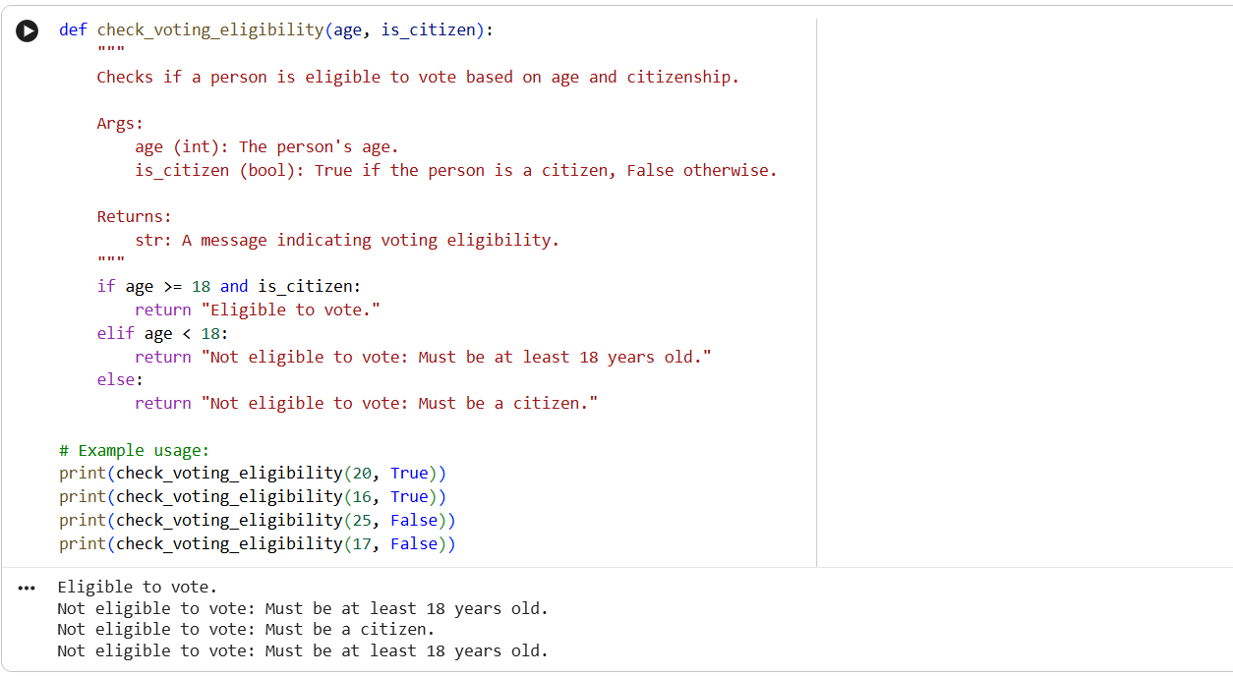
Output:
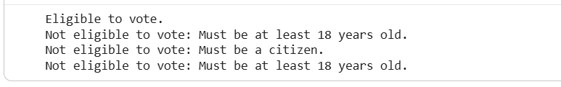
Analysis: The AI generates Python code using conditional statements to check voting eligibility.
It verifies whether the person’s age is 18 or above.
Citizenship status is checked using a boolean condition.
Both conditions are combined using the logical and operator.
If both conditions are true, the user is eligible to vote.
Otherwise, the program correctly declares the user ineligible.
Task 2:
Prompt: “Generate Python code to count vowels and consonants in a string using a loop.”
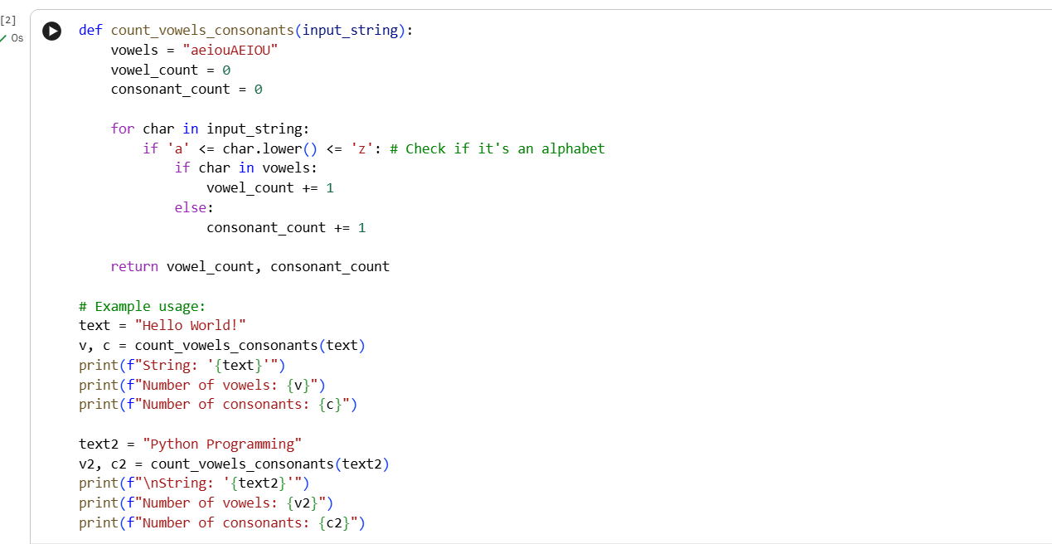
Output:
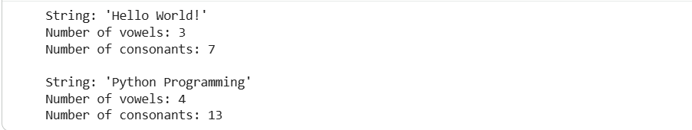
Analysis: The AI uses a loop to iterate through each character in the string.
Alphabetic characters are identified using built-in validation methods.
Vowels are checked against a predefined vowel list.
Characters not identified as vowels are counted as consonants.
Counters are updated during each loop iteration.
The final output accurately displays vowel and consonant counts.
Task 3:
Prompt: “Generate a Python program for a library management system using classes, loops, and conditional statements.”
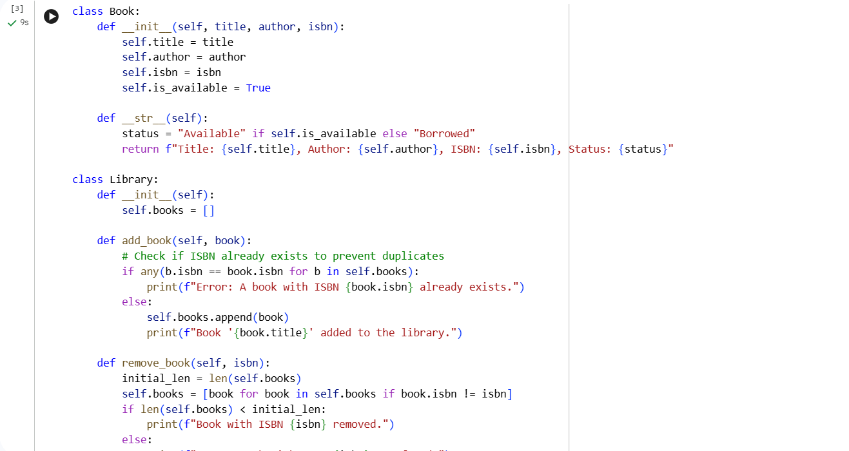
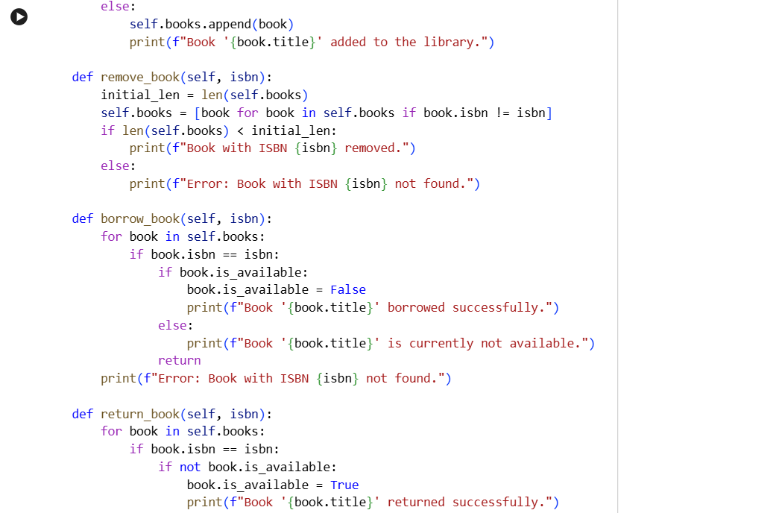
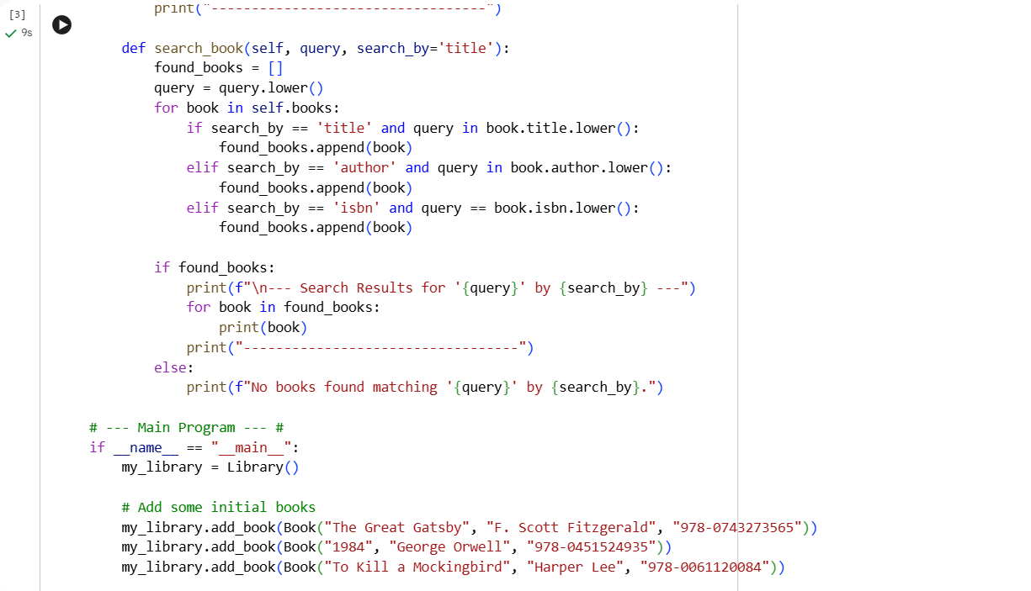
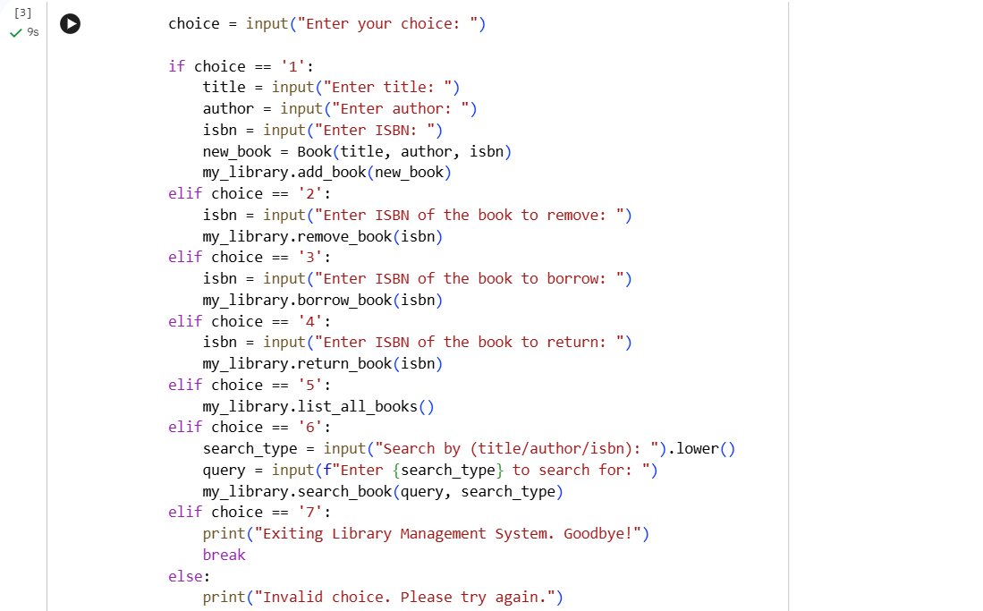
Output:
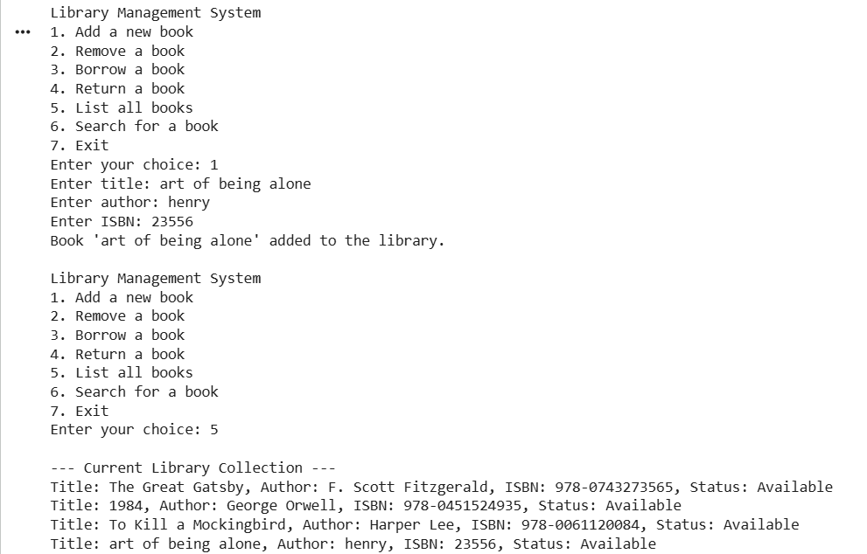
Analysis: The AI generates a complete program using classes for data organization.
A loop is used to display a menu repeatedly.
Conditional statements handle user choices such as adding or viewing books.
The class structure improves code readability and reusability.
The program demonstrates object-oriented programming concepts.
AI assistance simplifies complex program design for learners.
Task 4:
Prompt: “Generate a Python class to mark and display student attendance using loops.”
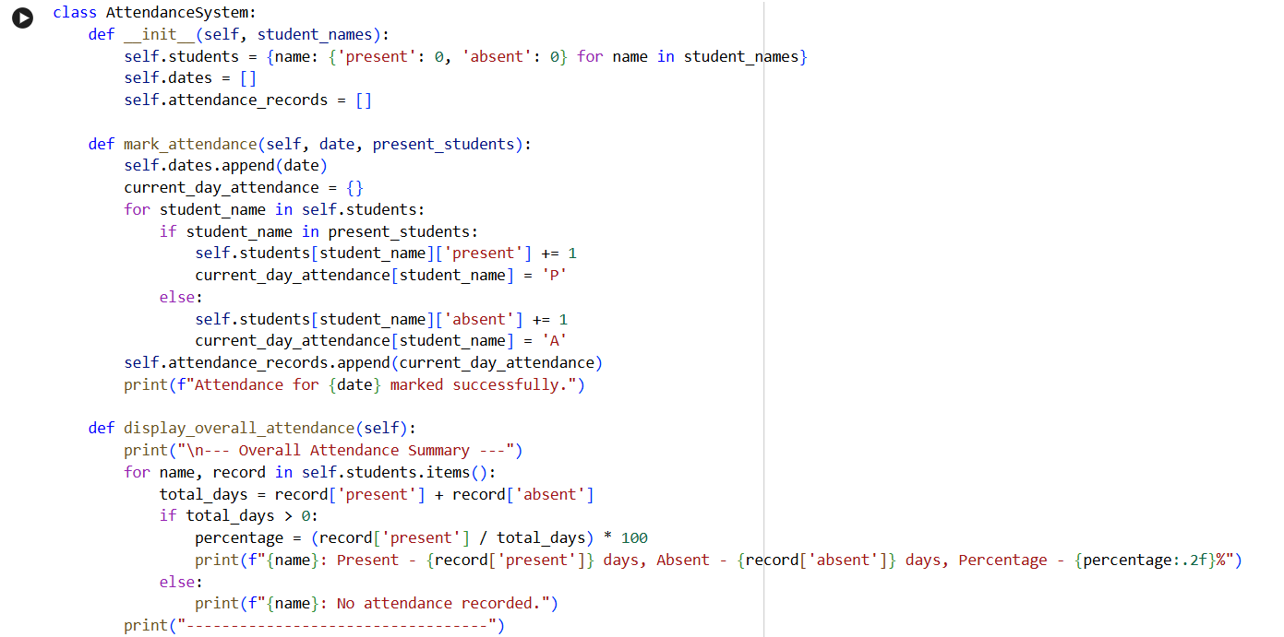
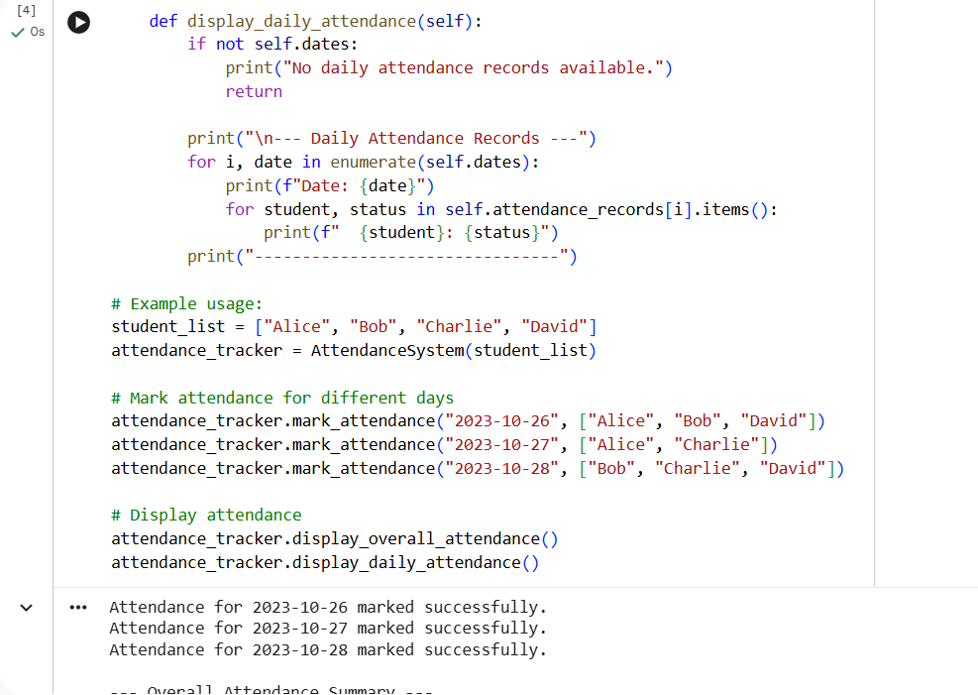
Output:
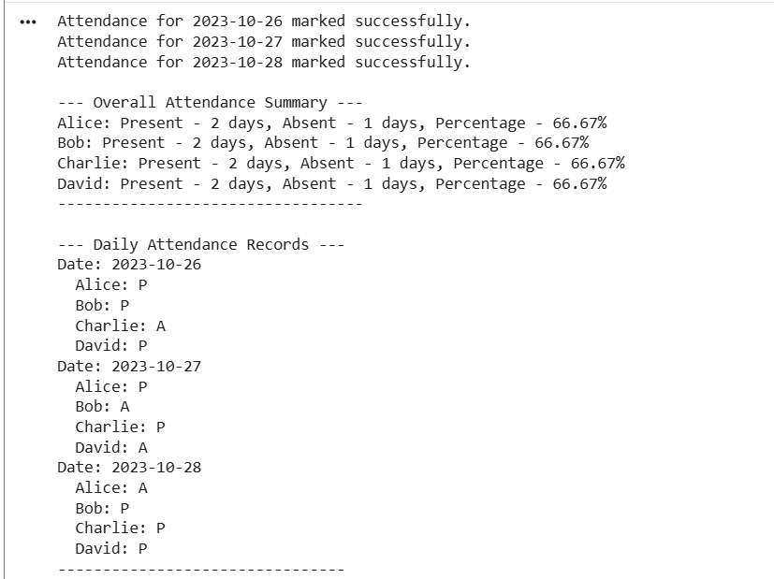
Analysis: The AI creates a class to store student attendance records.
Attendance data is maintained using a dictionary structure.
Methods are used to mark and update attendance.
A loop displays attendance records for all students.
Test cases verify correct attendance marking.
The logic ensures accurate and organized attendance management.
Task 5:
Prompt: “Generate a Python program using loops and conditionals to simulate an ATM menu.”
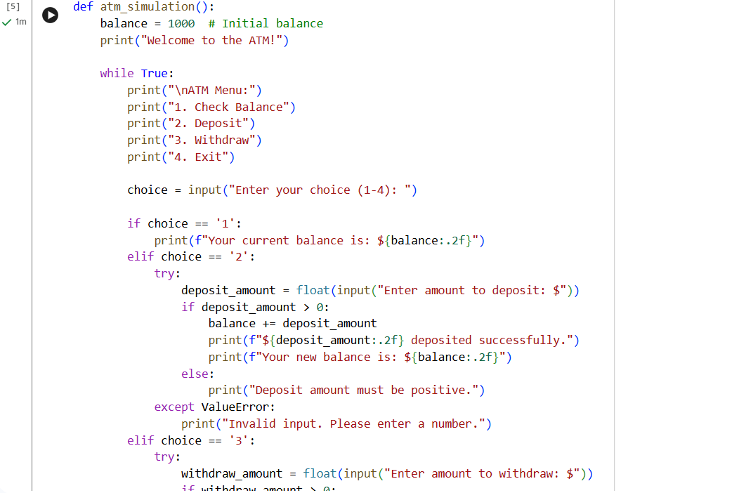
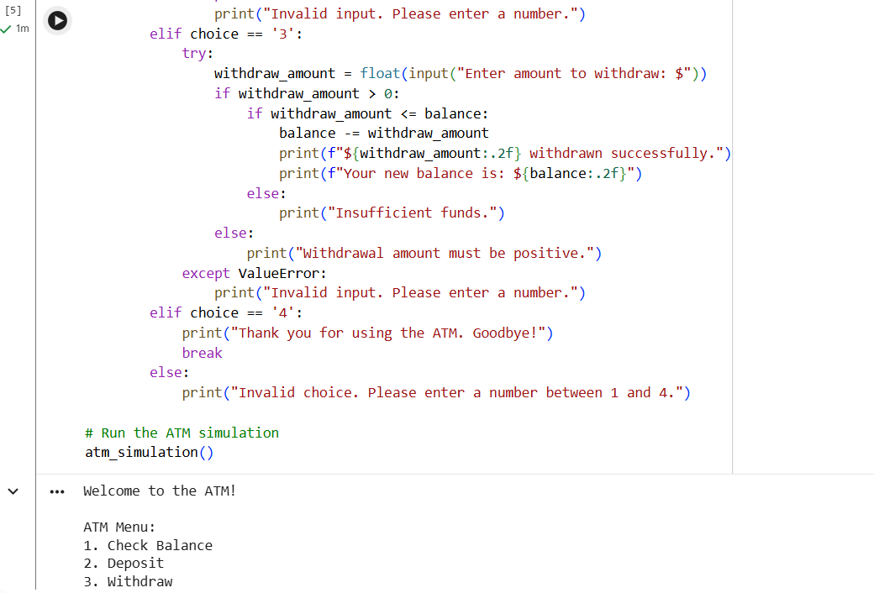
Output:
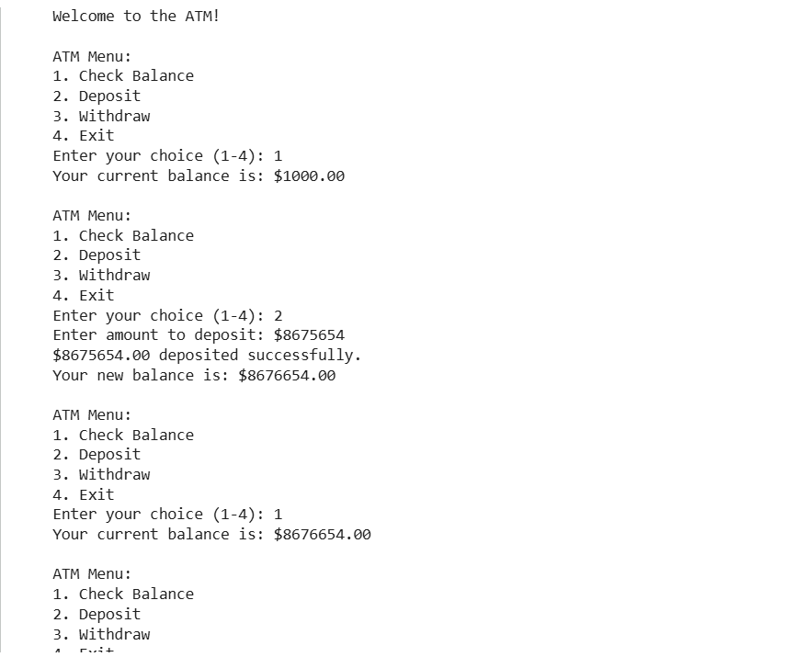
Analysis:
The AI generates a menu-driven program using a loop.
The loop allows repeated user interaction until exit.
Conditional statements process user-selected options.
The program supports balance checking, deposit, and withdrawal.
Validation prevents withdrawal beyond available balance.
The output confirms correct menu navigation and transactions.

