Pakistan, officially known as the Islamic Republic of Pakistan, is a country located in South Asia, sharing borders with India, Afghanistan, Iran, and China. It has a diverse landscape that ranges from the towering peaks of the Himalayas and Karakoram in the north to the vast deserts of Thar and the coastal shores along the Arabian Sea in the south. The country was established in 1947 as a result of the partition of British India, intended to create a separate homeland for Muslims. With a population exceeding 240 million, Pakistan is the fifth most populous country in the world and possesses a rich blend of ethnicities, languages, and cultures.

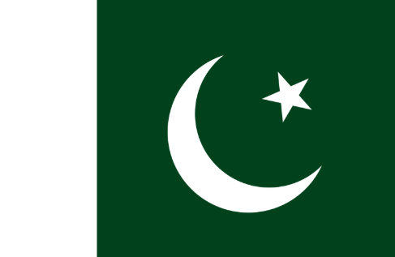

Pakistan’s economy is primarily based on agriculture, manufacturing, and services, with textiles and garments being its largest exports. In recent years, the country has also seen growth in its technology and startup sectors, particularly in cities like Karachi, Lahore, and Islamabad. Despite challenges such as political instability, energy shortages, and a fluctuating economy, Pakistan continues to push forward with infrastructure projects like the China-Pakistan Economic Corridor (CPEC), aiming to boost trade and economic growth. The country is also rich in natural resources, including coal, gas, and minerals, although much of its potential remains untapped.

Culturally, Pakistan is known for its vibrant traditions, delicious cuisine, and historical landmarks that date back thousands of years. Ancient civilizations like the Indus Valley left their mark in places such as Mohenjo-Daro, while the Mughal Empire’s influence is evident in stunning architectural feats like the Badshahi Mosque and Lahore Fort. Pakistan is also passionate about sports, with cricket being the most popular, followed by hockey and squash. Festivals such as Eid-ul-Fitr, Eid-ul-Adha, and Basant reflect the country's spirit of celebration and community. Despite facing numerous internal and external challenges, Pakistan remains a nation full of resilience, hospitality, and hope for a brighter future.