Department of Computing

School of Electrical Engineering and Computer Science
CS-250: Data Structure and Algorithms
Class: BSAI & BSDS

Lab 03: Classical Symmetric Stream Cipher – Rail Fence Cipher

CLO-3: Assembles information security solutions by applying key concepts using a variety of tools and techniques

Student Name | Arqam Waheed
CMS Id | 553514

Date: 24th September, 2026

Instructor: Ms. Hirra Anwar

Lab Engineer: Ms. Areeba Rameen

Lab-03: Classical Symmetric Stream Cipher – Rail Fence Cipher

Introduction

The railfence cipher is an easy-to-apply transposition cipher that jumbles up the order of the letters of a message in a quick convenient way. It also has the security of a key to make it a little bit harder to break.

The Rail Fence cipher works by writing your message on alternate lines across the page, and then reading off each line in turn. For example, the plaintext "defend the east wall" is written as shown below, with all spaces removed.

Objectives
You will be able to:
- Understand Railfence cipher
- Implement enciphering and deciphering in a suitable programming language
- Implement brute force attack using suitable programming language
- Break the cipher using any other method, if possible

Tools/Software Requirements
Students will require the following tools:
- Programming languages (C++ / Java / Python)
- Operating System: Windows / Linux / macOS

Description
Encryption:
To encrypt a message using the Rail Fence Cipher, you have to write your message in zigzag lines across the page, and then read off each row. Firstly, you need to have a key, which for this cipher is the number of rows you are going to have. You then start writing the letters of the plaintext diagonally down to the right until you reach the number of rows specified by the key. You then bounce back up diagonally until you hit the first row again. This continues until the end of the plaintext.
For the plaintext we used above, "defend the east wall", with a key of 3, we get the encryption process shown below.
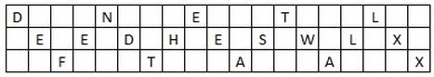
Note that at the end of the message we have inserted two "X"s. These are called nulls, and act as placeholders. We do this to make the message fit neatly in to the grid (so that there are the same number of letters on the top row, as on the bottom row. Although not necessary, it makes the decryption process a lot easier if the message has this layout.
The cipher-text is read off row by row to get "DNETLEEDHESWLXFTAAX".

Decryption:
The decryption process for the Rail Fence Cipher involves reconstructing the diagonal grid used to encrypt the message. We start writing the message, but leaving a dash in place of the spaces yet to be occupied. Gradually, you can replace all the dashes with the corresponding letters, and read off the plaintext from the table.
We start by making a grid with as many rows as the key is, and as many columns as the length of the ciphertext. We then place the first letter in the top left square, and dashes diagonally downwards where the letters will be. When we get back to the top row, we place the next letter in the ciphertext. Continue like this across the row, and start the next row when you reach the end.
For example, if you receive the ciphertext "TEKOOHRACIRMNREATANFTETYTGHH", encrypted with a key of 4, you start by placing the "T" in the first square. You then dash the diagonal down spaces until you get back to the top row, and place the "E" here. Continuing to fill the top row you get the pattern below.

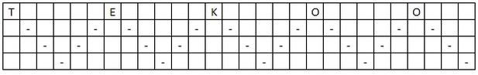
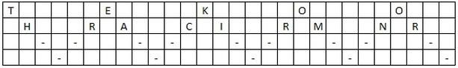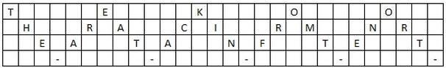
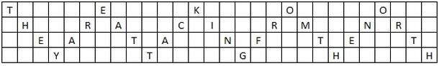
The plain-text read off in rail from top left towards bottom right to get "THEY ARE ATTACKING
FROM THE NORTH".
This lab involves researching and implementing the Rail fence cipher. Also, Brute forcing the rail fence Cipher.

Task 1 (Part-A): Implement the Encryption method
Implement the encryption method for the Rail Fence Cipher. Write a function rail_fence_encrypt(text, key) that:
- Takes a string text (the plaintext to encrypt) and an integer key (the number of rails)
- Returns the encrypted string using the Rail Fence Cipher technique
Solution box
Solution
Lab Task 1 (Part A): Code and Output Screenshots

I wrote the encryption in Python (railfence_encrypt.py). First the message is stripped: spaces and punctuation are removed and everything is made uppercase. Then X's are added at the end until the last letter falls on the bottom rail, the same way the manual pads its example. After that the letters are written on the rails in a zigzag and the rails are read off one after another.
Worked example (the one from the manual)
Actual message (plain text): defend the east wall
Stripped message: DEFENDTHEEASTWALL (17 letters, padded to DEFENDTHEEASTWALLXX)
Key: 3 rails
Matrix:
Rail 1: D . . . N . . . E . . . T . . . L . .
Rail 2: . E . E . D . H . E . S . W . L . X .
Rail 3: . . F . . . T . . . A . . . A . . . X

Reading each rail: Rail 1 = DNETL, Rail 2 = EEDHESWLX, Rail 3 = FTAAX
Encrypted message: DNETLEEDHESWLXFTAAX
This matches the ciphertext given in the manual. I also encrypted "they are attacking from the north" with key 4 and got TEKOOHRACIRMNREATANFTETYTGHH, which is the ciphertext used in the decryption example, so I used it again to test Part B.
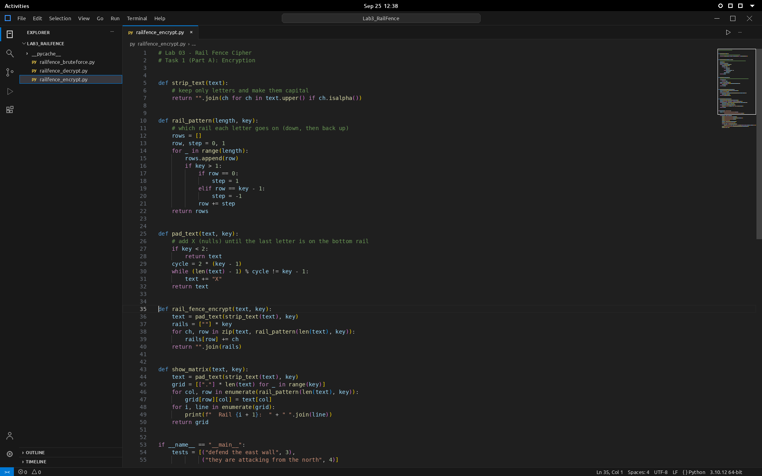
Figure 1: railfence_encrypt.py, lines 1 to 55
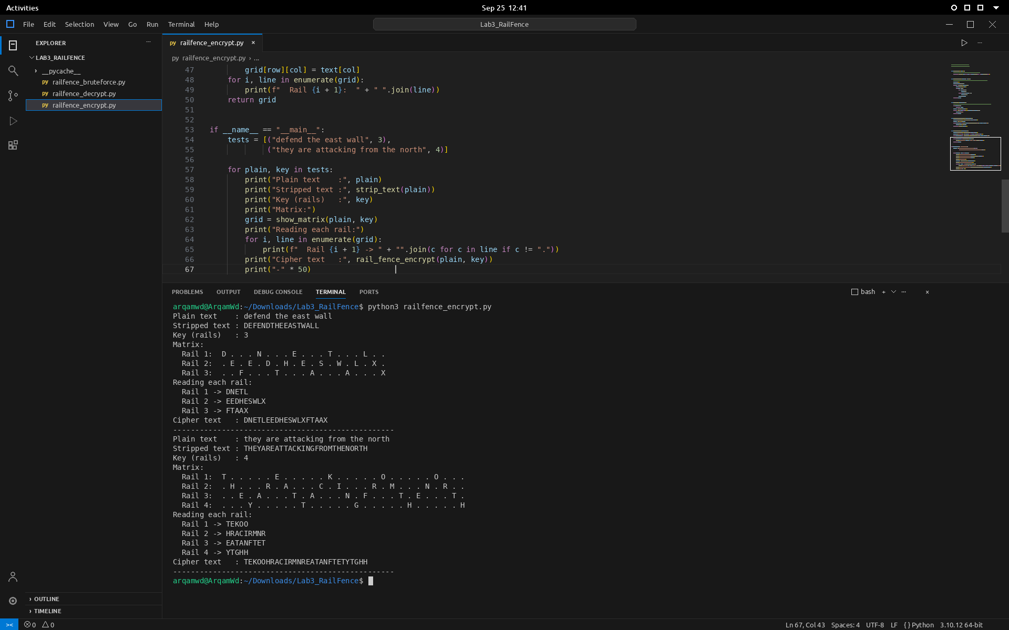
Figure 2: rest of the code and the output of railfence_encrypt.py

Task 1 (Part-B): Implement the Decryption method
Implement the decryption method for the Rail Fence Cipher. Write a function rail_fence_decrypt(ciphertext, key) that:
- Takes a string ciphertext (the encrypted text) and an integer key (the number of rails)
- Returns the original decrypted string (plaintext)
Solution box
Solution
Lab Task 1 (Part B): Code and Output Screenshots

Decryption (railfence_decrypt.py) reuses rail_pattern() from Part A. It builds the zigzag for the length of the ciphertext and counts how many letters land on each rail. The ciphertext is cut into pieces of those sizes, one piece per rail. Then the zigzag is walked again, and at each step the next unused letter is taken from whichever rail the pattern is on. The program also prints the empty grid with dashes, like the manual does, before filling it.
Ciphertext | Key | Decrypted text
TEKOOHRACIRMNREATANFTETYTGHH | 4 | THEYAREATTACKINGFROMTHENORTH
DNETLEEDHESWLXFTAAX | 3 | DEFENDTHEEASTWALLXX

The two X's at the end of the second one are just the nulls added during encryption. As a last check I encrypted "information security" with key 5 and decrypted it again, and got the same message back (with its padding).
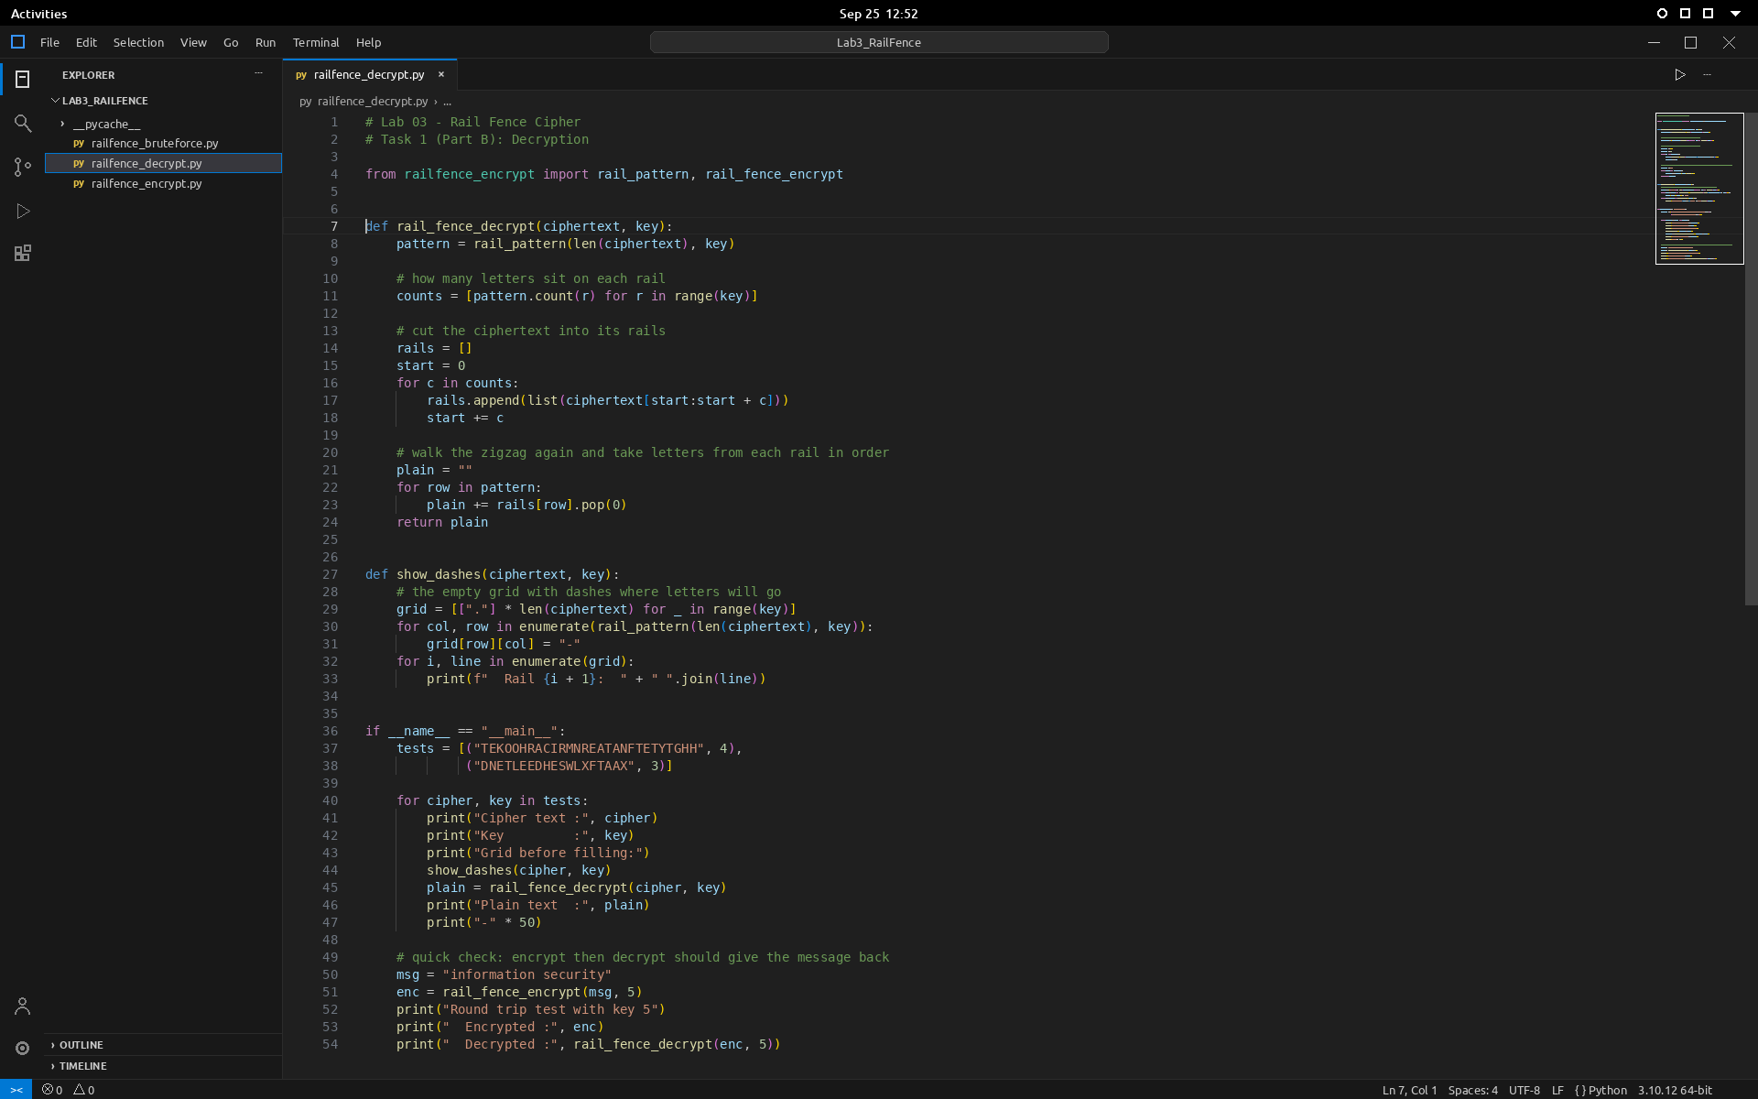
Figure 3: railfence_decrypt.py
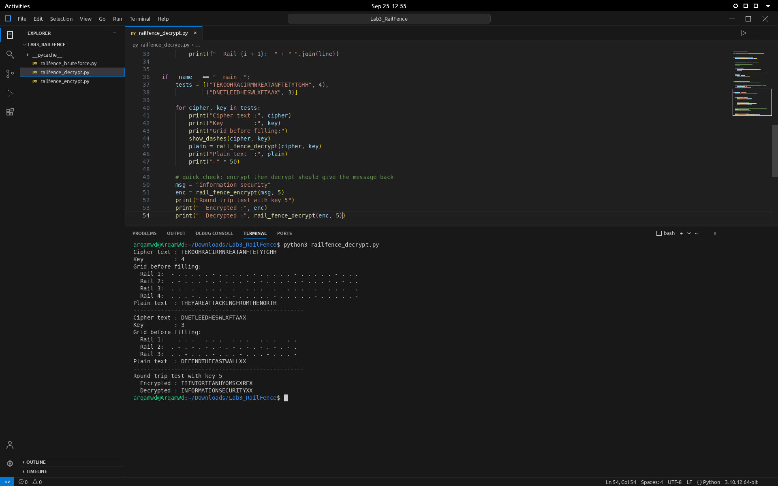
Figure 4: end of the code and the output of railfence_decrypt.py

Task 2: Brute Force Rail Fence Cipher Decryption
Implement a brute force method to decrypt the Rail Fence Cipher without knowing the key.
- Goal: Write a function rail_fence_brute_force(ciphertext) that:
  - Takes the ciphertext and attempts to decrypt it using different possible keys (from 2 upto the length of the ciphertext)
  - For each possible key, apply the decryption method and print or return the potential plain-texts
- Steps:
  - Loop through possible key values from 2 to the length of the ciphertext
  - Use the rail_fence_decrypt() function with each key
  - Print or store the decrypted strings for manual inspection to find the correct key
- Test Cases: Test the brute force method with different encrypted messages and manually identify the correct key.
  - Ciphertext: "HOLELWRDLOX"
  - Ciphertext: "AAXTKTNXTCDWXAAX", where the original plaintext is
"ATTACKATDAWN"
  - Ciphertext: "CYTGAHRPORPY", where the original plaintext is
"CRYPTOGRAPHY"
Solution box
Solution
Lab Task 2: Code and Output Screenshots

rail_fence_brute_force() tries every key from 2 up to the length of the ciphertext, decrypts with rail_fence_decrypt() and prints each result. I read through the list to find the one that makes sense. For (b) and (c) the plaintext was given, so the program also compares each result with it (ignoring the trailing X's) and prints the key that matches.
Ciphertext | Correct key | Decrypted text | Message
HOLELWRDLOX | 3 | HELLOWORLDX | HELLO WORLD
AAXTKTNXTCDWXAAX | 4 | ATTACKATDAWNXXXX | ATTACK AT DAWN
CYTGAHRPORPY | 2 | CRYPTOGRAPHY | CRYPTOGRAPHY

For (a) no plaintext was given, but key 3 is the only line that reads as English. The last key in every list gives back the ciphertext unchanged, because when the key equals the length each letter sits on its own rail. Since a message of n letters only has about n possible keys, the brute force finishes instantly, which is why the rail fence cipher is not secure on its own.
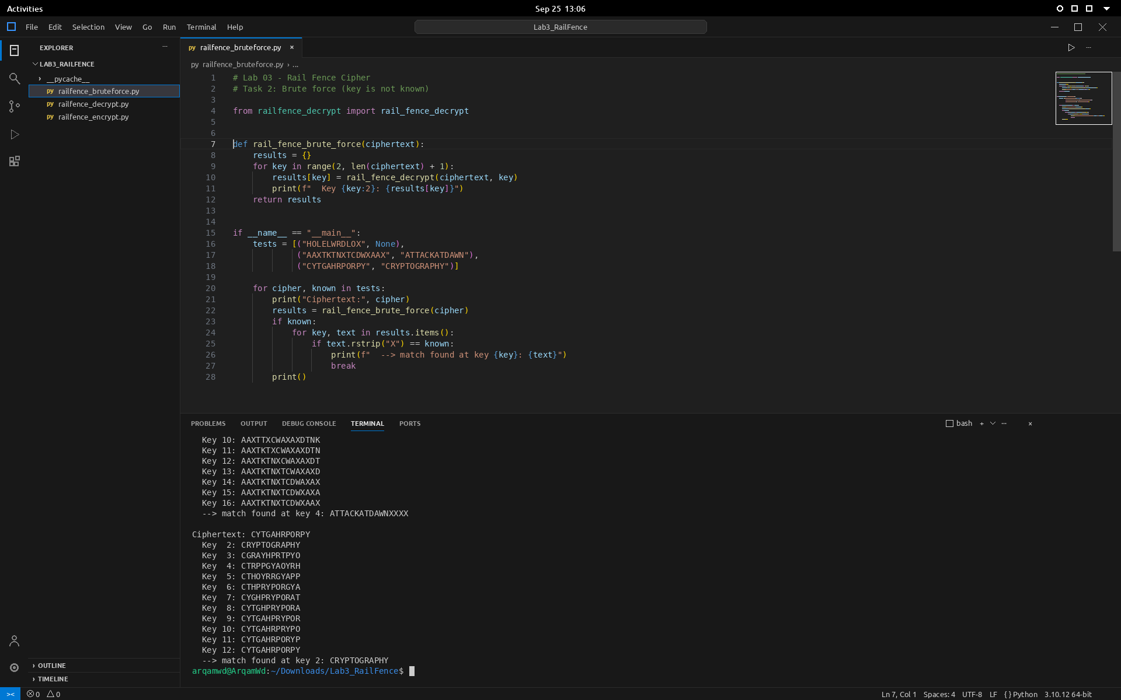
Figure 5: railfence_bruteforce.py and the end of its output
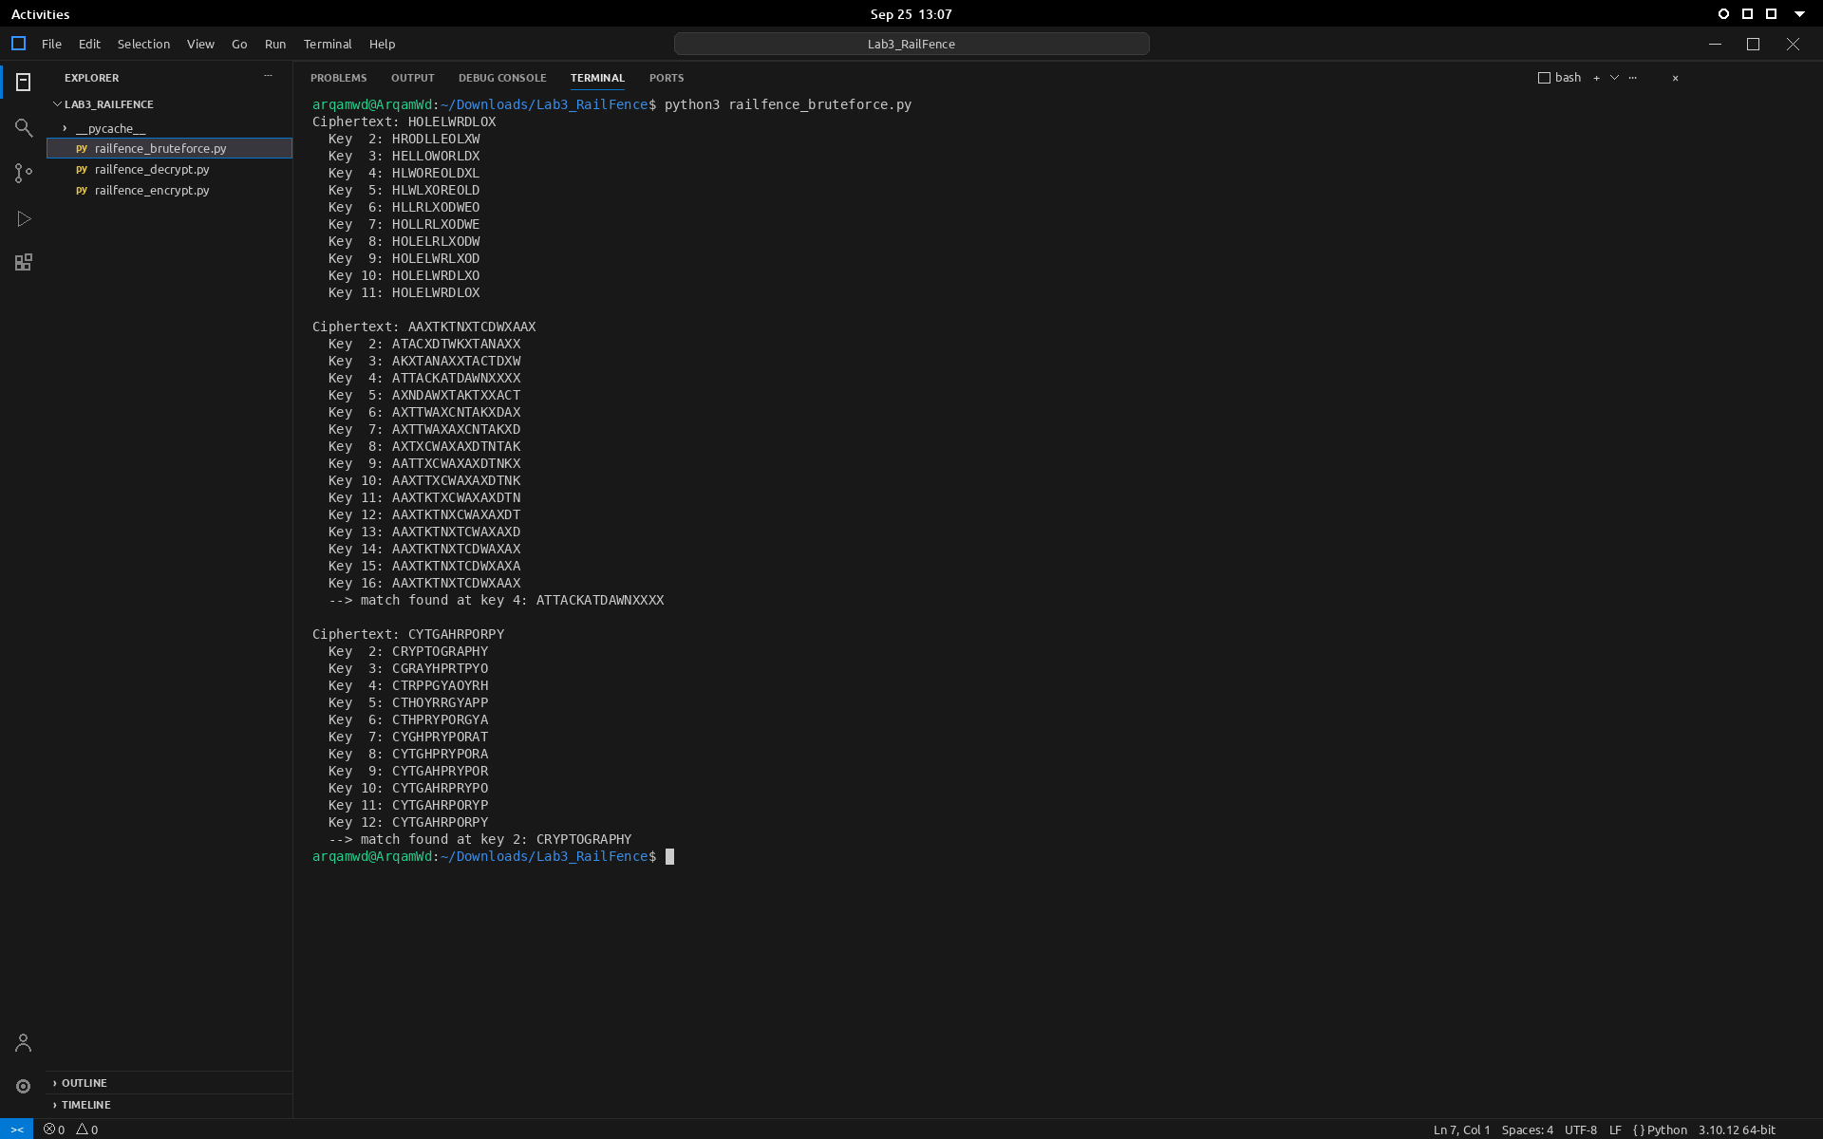
Figure 6: full output of railfence_bruteforce.py (terminal maximized)

Deliverable:
- Create a report which shows your solution for the task-1 which includes:
  - Matrix and key
  - Actual message (plain text) and stripped message
  - Pairing and encrypted message
  - Code screenshots including output after executing it (don’t crop any screenshot)
- Finalize the document in a well-structured manner. Save the file with your name and registration number and upload it on LMS under submission link before the deadline.

