Department of Computing

School of Electrical Engineering and Computer Science
CS-353: Information Security (2+1)
Class: BSAI & BSDS

Lab 04: Introduction of Feistel Structure - DES

CLO-3: Assembles information security solutions by applying key concepts using a variety of tools and techniques

Student Name | Arqam Waheed
CMS Id | 553514

Date: 2nd October, 2026

Instructor: Ms. Hirra Anwar

Lab Engineer: Ms. Areeba Rameen

Lab-04: Introduction of Feistel Structure - DES

Introduction
The Feistel structure is a symmetric structure used in the construction of block ciphers, including the well-known Data Encryption Standard (DES). Developed by Horst Feistel at IBM, it divides the plaintext into two halves and processes them through multiple rounds of substitution and permutation using round keys.
In DES, the Feistel structure ensures confusion and diffusion, two core principles of secure encryption. Each round transforms the data using an expansion function, substitution boxes (S-boxes), permutation, and key mixing. The structure’s unique property is that encryption and decryption operations are almost identical, simplifying implementation.
Therefore, understanding the Feistel structure is crucial for studying modern symmetric key cryptography.

Objectives
You will be able to:
- Understand the working principle of the Feistel structure
- Explain how DES implements the Feistel structure
- Implement a simplified Feistel cipher to understand the round-based process

Tools/Software Requirements
Students will require the following tools:
- Programming languages (C++ / Java / Python)
- Operating System: Windows / Linux / macOS

Description
The Feistel cipher operates by splitting input data (plaintext) into two halves: Left (L) and Right (R).
In each round:
- The right half is expanded and combined with a subkey (derived from the main key)
- The result is passed through substitution and permutation functions
- The output is XORed with the left half
- The left and right halves are swapped for the next round
So, after multiple rounds, the halves are concatenated to form the ciphertext. Decryption uses the same structure but applies round keys in reverse order.
While in DES (Data Encryption System):
- Block size: 64 bits
- Key size: 56 bits (effective, out of 64 bits)
- Number of rounds: 16
- Functions used: Expansion (E), S-box substitution, and permutation (P)
Background of DES
IBM initially developed the DEA (Data Encryption Algorithm) on the NIST call for proposals. They used concepts that had been described by Claude Shannon in the 1940s and called their technique “Lucifer”. Lucifer was refined, renamed as DEA and adopted as the standard in 1976.
Implementing DES
The DEA performs a transformation on a block of 64 bits using a 56-bit key. i.e. it takes 64 bits of the plaintext (data to be encrypted) and changes it into a different array of 64 bits (the ciphertext), using a key (known only to the person 'sending' the message and the person 'receiving' it). It does this in several steps, using several kinds of transformations. Crucial to the DEA is the concept of a permutation. This just means that the bits are put in a different order, i.e. jumbled up.
Firstly the Initial Permutation (the IP takes the 64 bits, and changes their order around according to a fixed permutation, so the 58th bit becomes the first bit, the 50th bit becomes the 2nd bit, etc) is applied to the 64-bit plaintext. The result is then divided into two 32-bit halves, named L0 and R0. Then, the following happens 16 times.
For Iteration Number i (see diagram below)
- Key transformation number i (a permutation, but dropping 8 bits off - defined in the specification) is applied to the key to produce 48 bits
- Let A be Li and J be the transformed key. Apply the function f(A,J) (explained below) to produce a 32 bit output
- XOR Ri and f(A,J), and call this Ri+1
- Make Li+1 = Ri
Next (see diagram), 16 iterations of a function f are applied. f takes 32 bits of the plaintext (A) and 48 bits of the key (J). An expansion function is applied to A, which swaps some of the bits around, and adds an extra 16 of them, which expands it out to 48 bits. The expanded A and J are then combined, using XOR. This 48-bit block is then put through some S boxes (explained soon) to produce an output of 32 bits. Finally another permutation called P is applied.
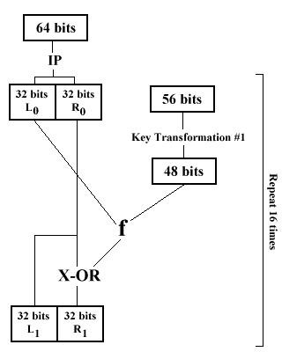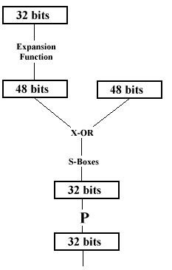

Explanation of the DES Tables & Concepts
DES (Data Encryption Standard) works by shuffling (permuting) and substituting bits over 16 rounds. The tables tell you which input bit goes to which output position.
- IP (Initial Permutation): Re-orders the 64 bits of the plaintext block before processing. The table lists 1-based bit indices. For instance, the first entry is 58, which means the 1st bit of the output will be the 58th bit of the input.
- FP (Final Permutation): Reverses the IP at the end of the 16 rounds to produce the ciphertext.
- PC1 (Permuted Choice 1): Takes a 64-bit key, strips away 8 parity bits to leave 56 bits, and reorders them.
- PC2 (Permuted Choice 2): Takes the shifted 56-bit key and compresses/selects 48 bits to form a specific round key.
- E (Expansion Permutation): Expands a 32-bit block to 48 bits so it can be XORed with the 48-bit round key.
- S-Boxes (S1​ to S8​): Non-linear lookup tables that compress 6-bit inputs down to 4-bit outputs.

PROCESS:
To encrypt a message, DES does two streams of work at the same time:
- The Data Path: Takes your message and scrambles it.
- The Key Schedule: Takes your main key and creates 16 smaller keys (one for each round of scrambling).
All these names—IP, PC1, PC2, Shift, E, S-Box—are just individual tools doing their jobs.

1. Key Processing Tables (PC1, Left Shift, PC2)
These three steps exist purely to create the 16 mini-keys from your 1 single password/key.
- PC1 (Permuted Choice 1):
  - What it does: Drops parity bits and re-orders the key.
  - Analogy: Imagine taking a 64-character password, throwing away 8 useless characters (parity bits), and shuffling the remaining 56 characters into a set order.
  - Input: 64 bits → Output: 56 bits.
- Left Shift (r1​…r16​):
  - What it does: Takes those 56 bits, splits them in half (28 bits each), and rotates them left.
  - Why: So every round of encryption uses a slightly different arrangement of your password.
- PC2 (Permuted Choice 2):
  - What it does: Picks 48 bits out of the 56 shifted bits to build the final key used for that specific round.
  - Input: 56 bits → Output: 48 bits (Round Key).

2. Message Processing Tables (IP, E, S-Box, P, FP)
These steps scramble your actual plaintext message.
- IP (Initial Permutation):
  - What it does: A fixed shuffle of your 64-bit plaintext block before any math starts.
  - Analogy: Shuffling a deck of 64 cards in a precise pre-set pattern before dealing.
- E (Expansion Permutation):
  - What it does: Expands 32 bits of your message into 48 bits by duplicating certain bits.
  - Why: Your round key is 48 bits long, so your message needs to be 48 bits long too so they can be XOR-ed together.
- S-Boxes (S1​…S8​):
  - What it does: The substitution stage. It turns a 6-bit input into a completely different 4-bit output using lookup tables. It enforces the confusion property.
- P (Round Permutation):
  - What it does: Shuffles the 32 bits coming out of the S-Boxes before passing them to the next round.
- FP (Final Permutation):
  - What it does: The exact inverse of IP. It un-shuffles the final round result to produce the actual ciphertext.

DES is a fairly weak encryption technique that uses 56-bit keys. It uses the same key to encrypt and decrypt. There is only one private key, which both sender and receiver must know. A personal computer could crack DES-encoded message within a year; a group of them could do it proportionately faster. This is the reason why DES is considered less secure than other encryption methods, and had evolved into the Advanced Encryption Standard (AES). The advantage DES has over public key encryption is that it is much faster to compute.
An overview of DES algorithm:
Input:
T: 64 bits of clear text k1, k2, ..., k16: 16 round keys
IP: Initial permutation FP: Final permutation f(): Round function
Output:
C: 64 bits of cipher text
Algorithm:
T' = IP(T), applying initial permutation
(L0, R0) = T', dividing T' into two 32-bit parts
(L1, R1) = (R0, L0 ^ f(R0, k1))
(L2, R2) = (R1, L1 ^ f(R1, k2))
......
C' = (R16, L16), swapping the two parts
C = FP(C'), applying final permutation
The round function f(R,k) is defined as:
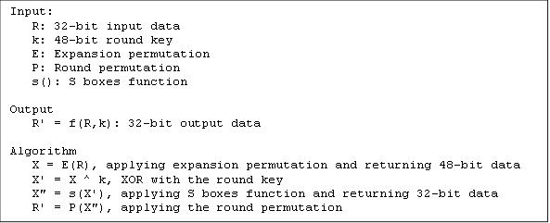

The S boxes function s(X) is defined as:
Input:
X: 48-bit input data
S1, S2, ..., S8: 8 S boxes - 4 x 16 tables
Output:
X' = s(X): 32-bit output data
Algorithm:
(X1, X2, ..., X8) = X, dividing X into 8 6-bit parts
X' = (S1(X1), S2(X2), ..., S8(X8)) where Si(Xi) is the value at row r and column c of S box i with r = b1 + b6 c = b2 + b3 + b4 + b5
b1, b2, b3, b4, b5, b6 are the 6 bits of the Xi
DES cipher algorithm supporting tables Initial Permutation - IP:
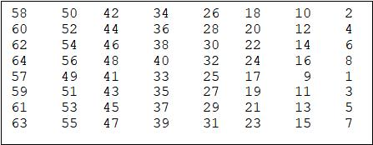
Final Permutation - FP:
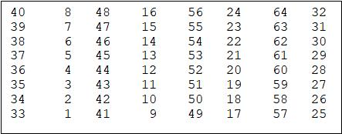
Expansion permutation - E:
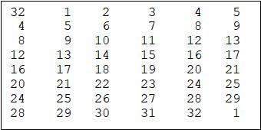
S boxes - S1, S2, ..., S8:
S1 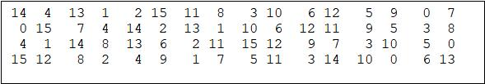
S2 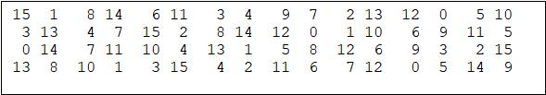S3 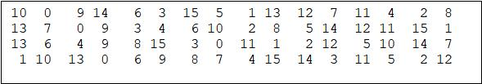
S4 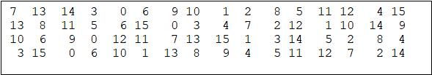
S5 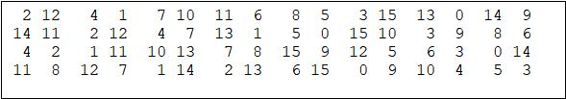
S6 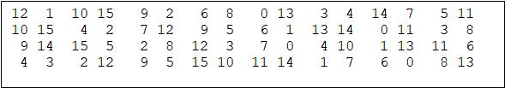
S7 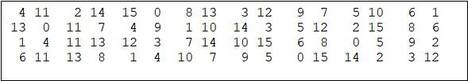
S8 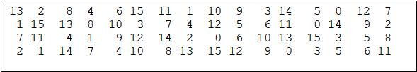
Round permutation - P:
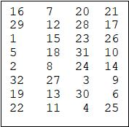
DES Key Schedule (Round Keys Generation) Algorithm:
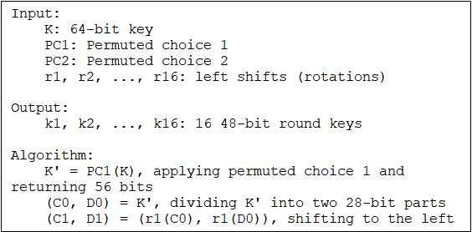
DES key schedule supporting tables Permuted Choice 1 - PC1:
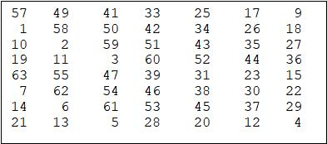
Permuted Choice 2 - PC2:
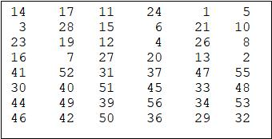
Left shifts (number of bits to rotate) - r1, r2, ..., r16:

Lab Tasks:

- Write a method called desPlaintextBlock that takes the plaintext as input and splits it up into 64 bit blocks. If the last block is less than 64 bits, pad it with 0s:
Solution
Code:
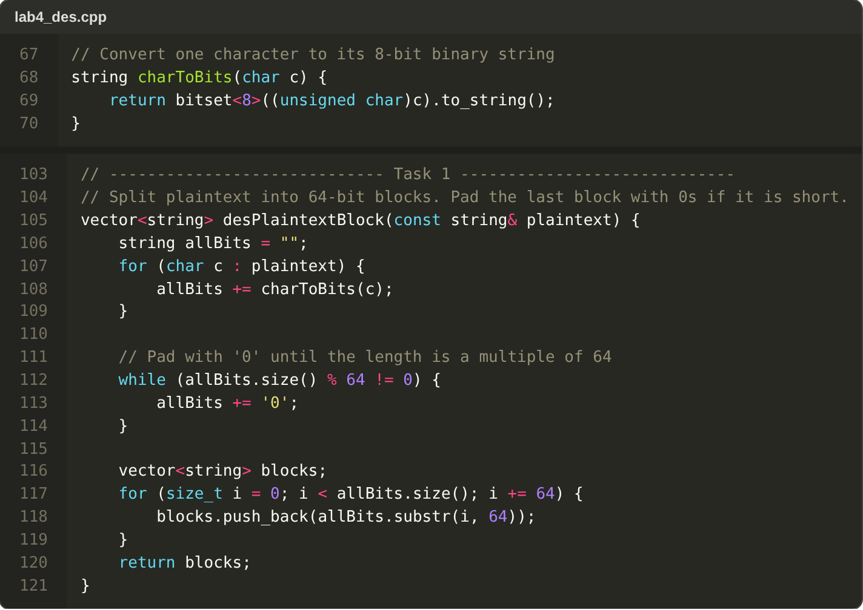
Output:
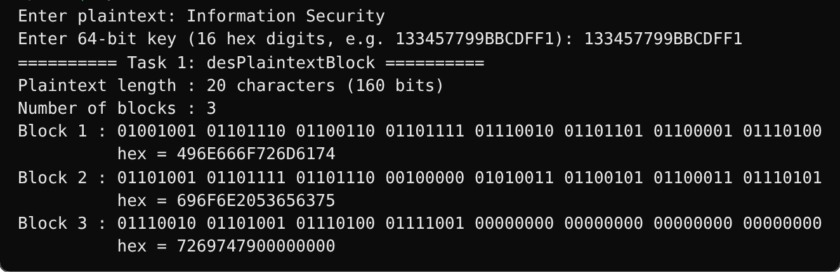
- Write a method called desInitialPermutation that takes a 64-bit block, performs permutation according to the 8 x 8 IP table and returns the permuted block:
Solution
Code:
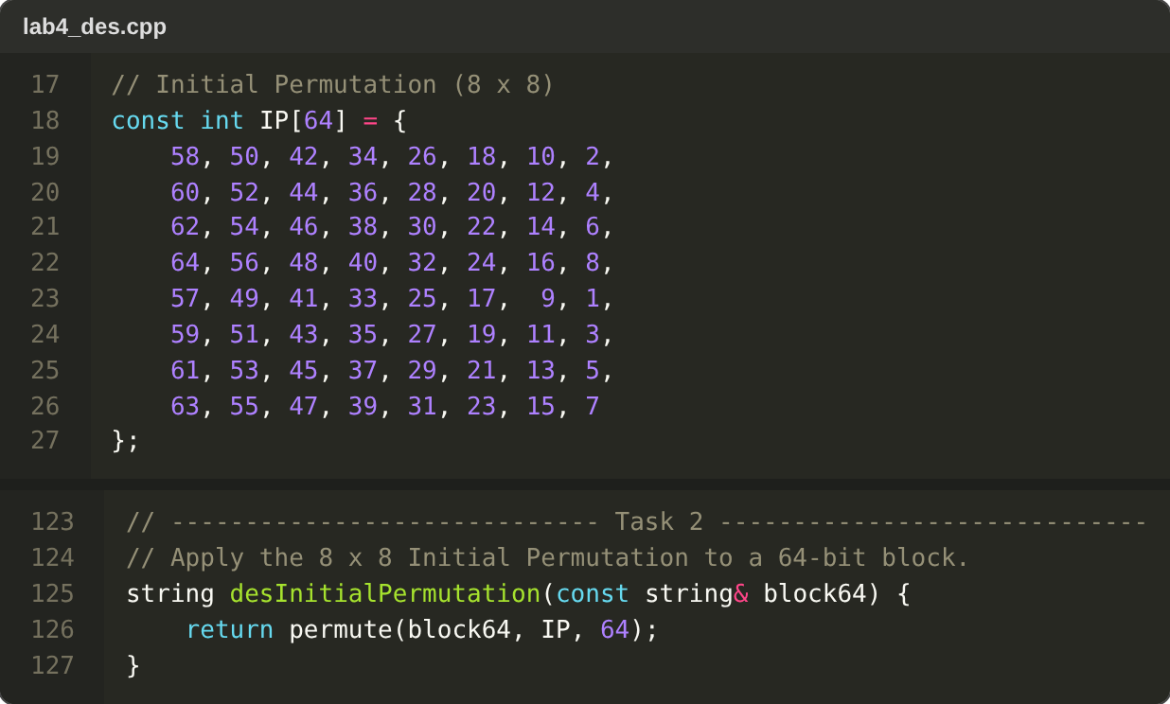
Output:
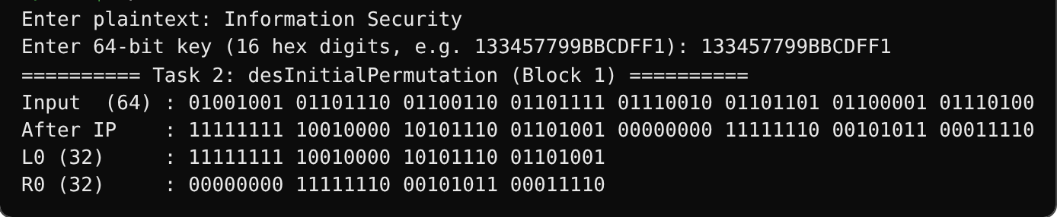
- Write a method called desPermutedChoice1 that takes a 64-bit block of key, performs permutation according to the 8 x 7 PC1 table and returns the permuted block of 56-bits:
Solution
Code:
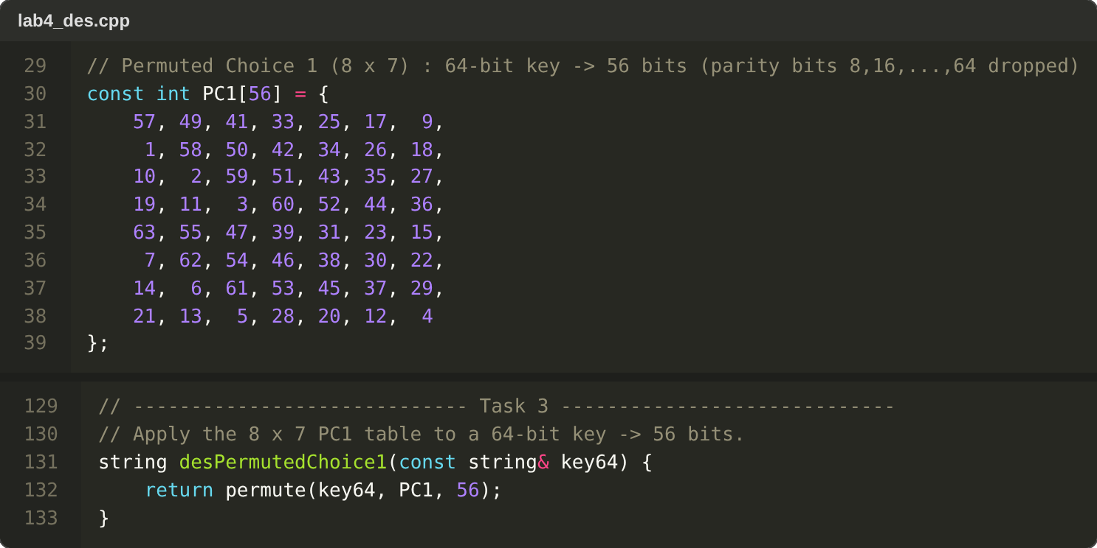
Output:
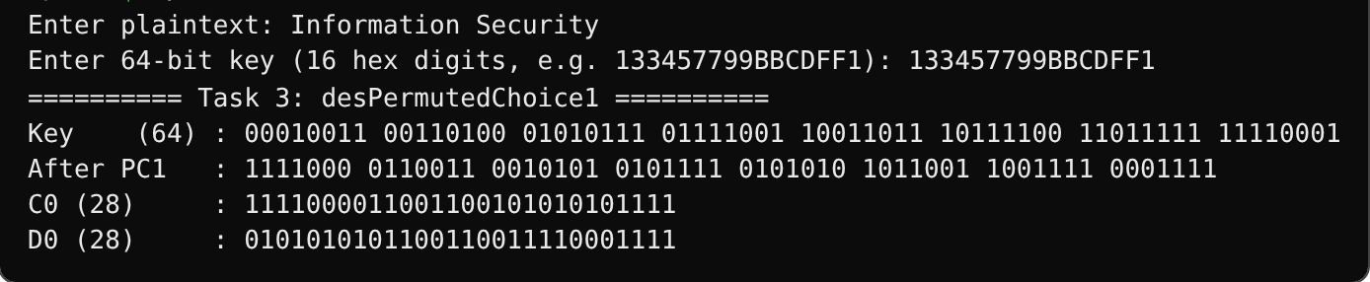
- Write a method called desLeftShift that takes a 28-bit block, performs left shift based on round number and returns the permuted block:
Solution
Code:
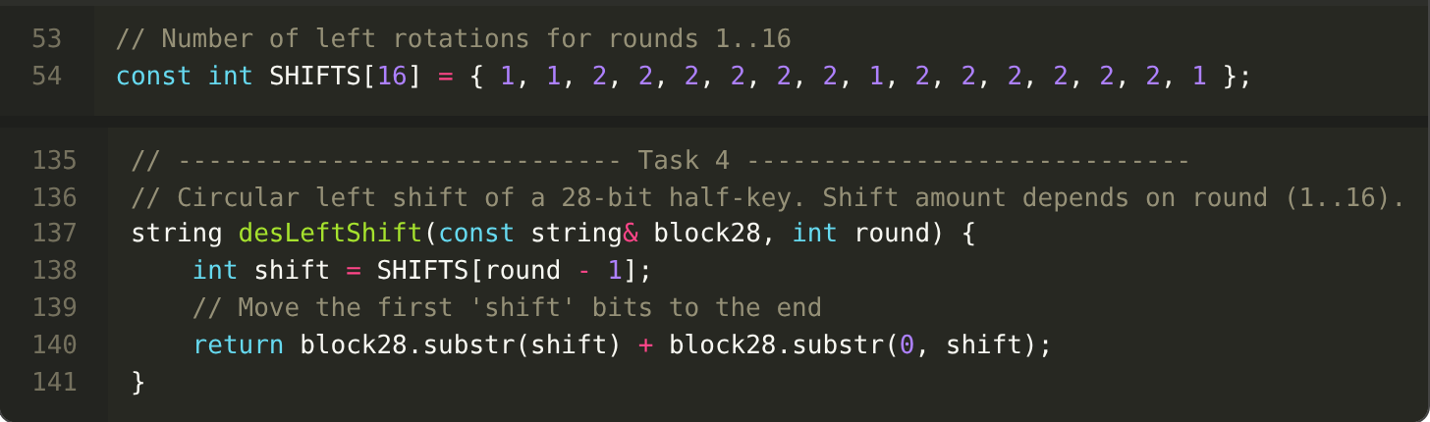
Output:
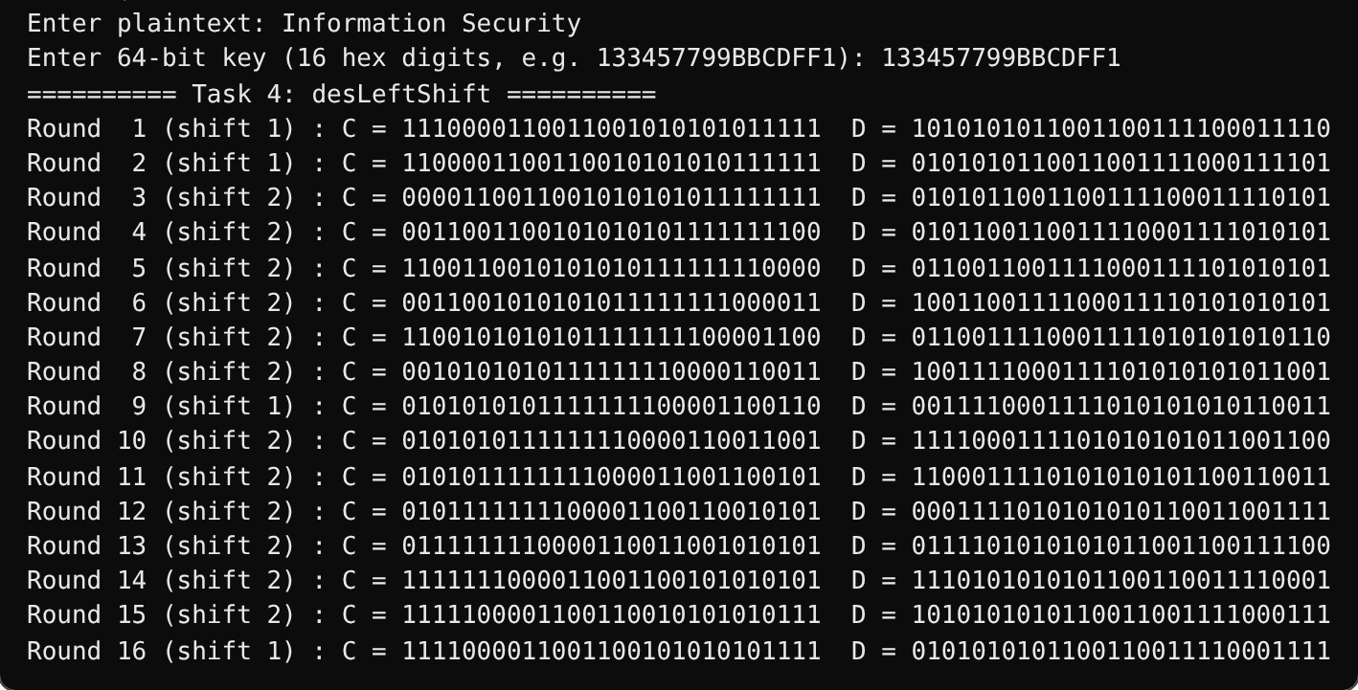
- Write a method called desPermutedChoice2 that takes a 56-bit block, performs permutation according to 8 x 6 PC2 table and returns the permuted block of 48-bits:
Solution
Code:
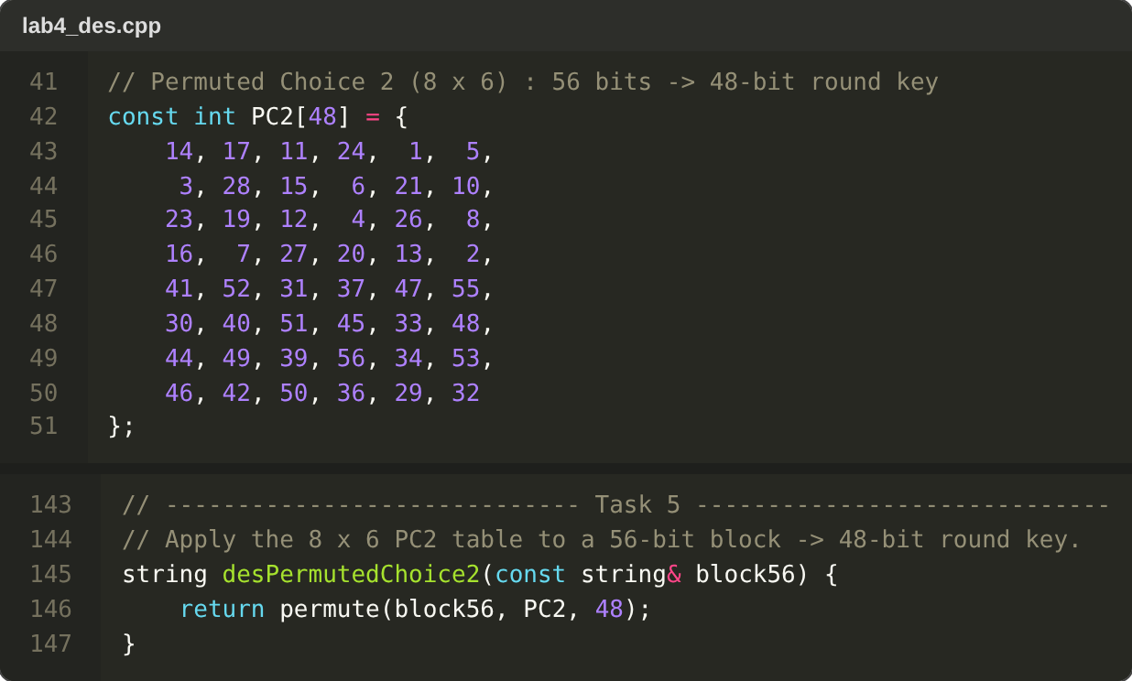
Output:
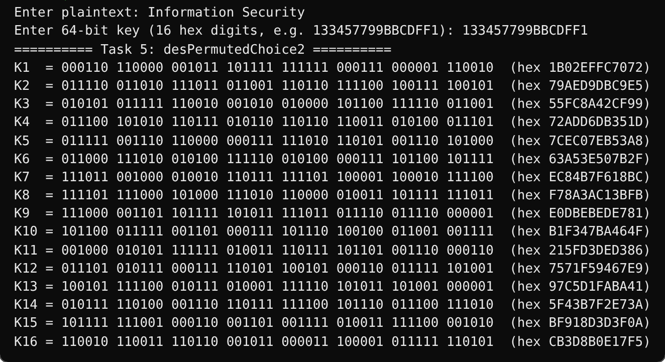
Tasks Execution:
Solution
Plaintext conversion, Initial Permutation and PC1 (single 64-bit block):
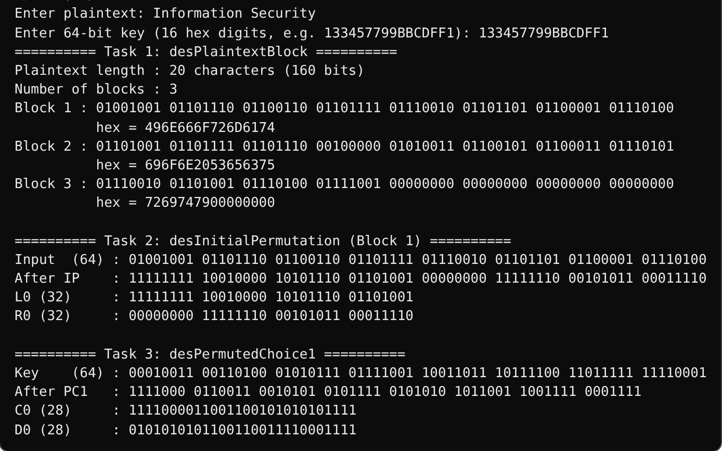
Left shifts and PC2 round keys:
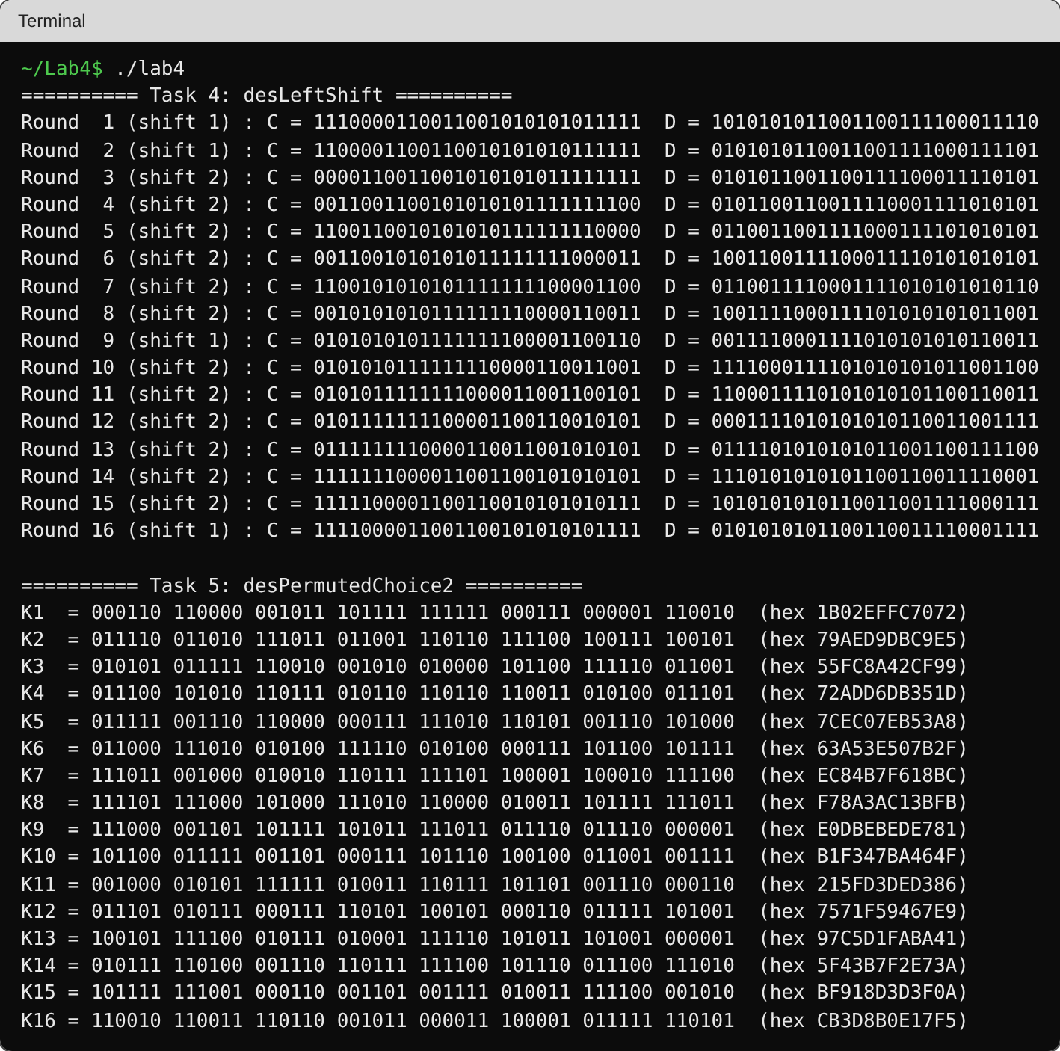

Deliverable:
- Compile a single report by filling in the solution/answer part (as directed) along with the screenshots of your code after executing it (don’t crop any screenshot).
- Finalize the document in a well structured manner. Save the file with your name and registration number and upload it on LMS under submission link before the deadline.

