Department of Computing

School of Electrical Engineering and Computer Science
CS-353: Information Security
Class: BSAI & BSDS

Lab 05: Implementation of DES

CLO-3: Assembles information security solutions by applying key concepts using a variety of tools and techniques

Student Name | Arqam Waheed
CMS Id | 553514

Date: 10th October, 2026

Instructor: Ms. Hirra Anwar

Lab Engineer: Ms. Areeba Rameen

Lab-05: Implementation of Data Encryption Standard

Introduction
In this lab, you will learn how symmetric encryption operates, and how sensitive information may be transmitted securely across a network. Most computer encryption systems belong in one of the two categories.
- Symmetric encryption (often referred to as secret-key, private or single-key encryption)
- Asymmetric encryption (also known as public-key or two-key encryption)
The most widely known instance of a symmetric cryptosystem is DES (Data Encryption Standard).

Objectives
You will be able to:
- Understand the complete working of DES including ExpansionPermutation (EP), S-box substitution, and PermutedChoice (PC)
- Demonstrate the difference between encryption and decryption using the same structure
- Relate theoretical concepts to practical implementation of DES

Tools/Software Requirements
Students will require the following tools:
- Programming languages (C++ / Java / Python)
- Operating System: Windows / Linux / macOS

Description
A block cipher is an encryption scheme in which "the clear text is broken up into blocks of fixed length, and encrypted one block at a time". Usually, a block cipher encrypts a block of clear text into a block of cipher text of the same length. In this case, a block cipher can be viewed as a simple substitution cipher with character size equal to the block size.
DES is a 64-bit block cipher. It comprises of 16 round keys which are derived from a single 64-bit key. Decryption algorithm is identical to the encryption algorithm except for the order of the round keys. As the Feistel Cipher is an iterative block cipher that uses the following algorithm:
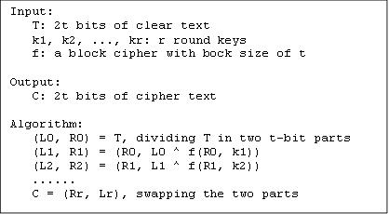
where ^ is the XOR operation
Implementing DES
The DEA performs a transformation on a block of 64 bits using a 56-bit key. i.e. it takes 64 bits of the plaintext (data to be encrypted) and changes it into a different array of 64 bits (the ciphertext), using a key (known only to the person 'sending' the message and the person 'receiving' it). It does this in several steps, using several kinds of transformations. Crucial to the DEA is the concept of a permutation. This just means that the bits are put in a different order, i.e. jumbled up.
Firstly the Initial Permutation (the IP takes the 64 bits, and changes their order around according to a fixed permutation, so the 58th bit becomes the first bit, the 50th bit becomes the 2nd bit, etc) is applied to the 64-bit plaintext. The result is then divided into two 32-bit halves, named L0 and R0. Then, the following happens 16 times.
For Iteration Number i (see diagram below)
- Key transformation number i (a permutation, but dropping 8 bits off - defined in the specification) is applied to the key to produce 48 bits
- Let A be Li and J be the transformed key. Apply the function f(A,J) (explained below) to produce a 32 bit output
- XOR Ri and f(A,J), and call this Ri+1
- Make Li+1 = Ri
Next (see diagram), 16 iterations of a function f are applied. f takes 32 bits of the plaintext (A) and 48 bits of the key (J). An expansion function is applied to A, which swaps some of the bits around, and adds an extra 16 of them, which expands it out to 48 bits. The expanded A and J are then combined, using XOR. This 48-bit block is then put through some S boxes (explained soon) to produce an output of 32 bits. Finally another permutation called P is applied.
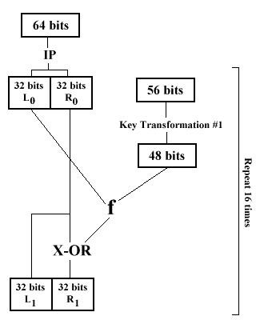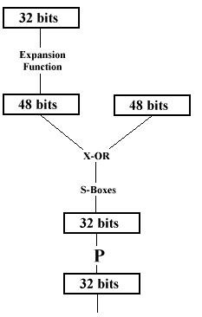
DES is a fairly weak encryption technique that uses 56-bit keys. It uses the same key to encrypt and decrypt. There is only one private key, which both sender and receiver must know. A personal computer could crack DES-encoded message within a year; a group of them could do it proportionately faster. This is the reason why DES is considered less secure than other encryption methods, and had evolved into the Advanced Encryption Standard (AES). The advantage DES has over public key encryption is that it is much faster to compute.
An overview of DES algorithm:
Input:
T: 64 bits of clear text k1, k2, ..., k16: 16 round keys
IP: Initial permutation FP: Final permutation f(): Round function
Output:
C: 64 bits of cipher text
Algorithm:
T' = IP(T), applying initial permutation
(L0, R0) = T', dividing T' into two 32-bit parts
(L1, R1) = (R0, L0 ^ f(R0, k1))
(L2, R2) = (R1, L1 ^ f(R1, k2))
......
C' = (R16, L16), swapping the two parts
C = FP(C'), applying final permutation
The round function f(R,k) is defined as:
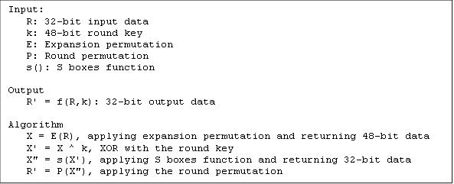
The S boxes function s(X) is defined as:
Input:
X: 48-bit input data
S1, S2, ..., S8: 8 S boxes - 4 x 16 tables
Output:
X' = s(X): 32-bit output data
Algorithm:
(X1, X2, ..., X8) = X, dividing X into 8 6-bit parts
X' = (S1(X1), S2(X2), ..., S8(X8)) where Si(Xi) is the value at row r and column c of S box i with r = b1 + b6 c = b2 + b3 + b4 + b5
b1, b2, b3, b4, b5, b6 are the 6 bits of the Xi
DES cipher algorithm supporting tables Initial Permutation - IP:
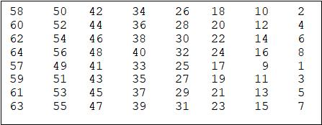
Final Permutation - FP:
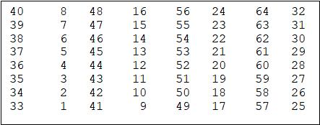
Expansion permutation - E:
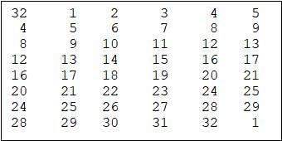
S boxes - S1, S2, ..., S8:
S1 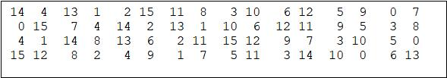
S2 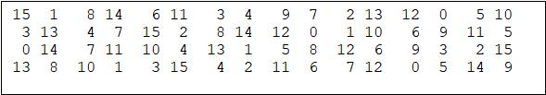S3 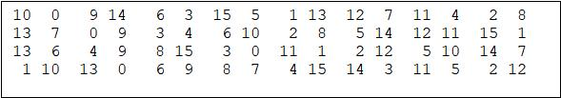
S4 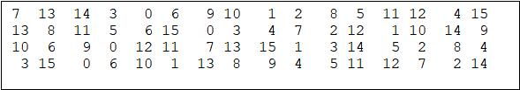
S5 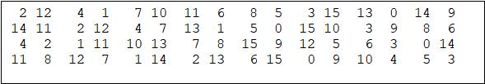
S6 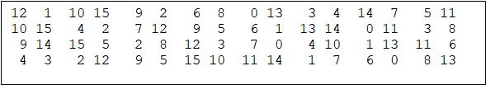
S7 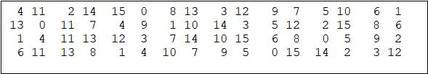
S8 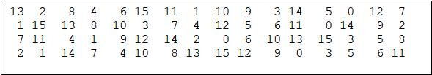
Round permutation - P:
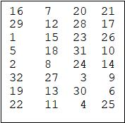
DES Key Schedule (Round Keys Generation) Algorithm:
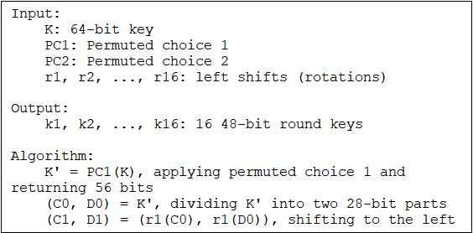
DES key schedule supporting tables Permuted Choice 1 - PC1:
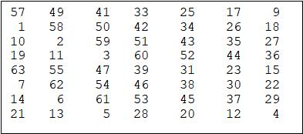
Permuted Choice 2 - PC2:
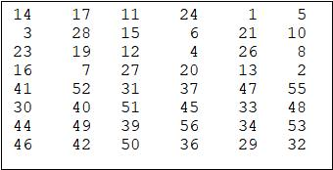
Left shifts (number of bits to rotate) - r1, r2, ..., r16:
DES Decryption Algorithm:
The decryption algorithm of a block cipher should be identical to encryption algorithm step by step in reverse order. But for DES cipher, the encryption algorithm is so well designed, that the decryption algorithm is identical to the encryption algorithm step by step in the same order, only with the sub keys applied in the reverse order.
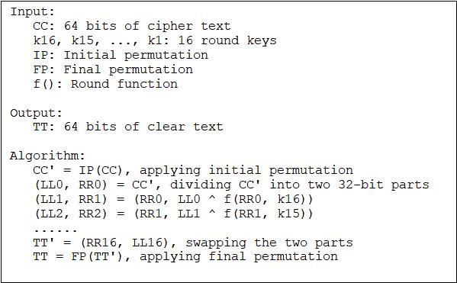
Lab Task 1:
- Write a method called desExpansionPermutation that takes a 32-bit block as input, performs permutation according to 8 x 6 EP table and returns 48-bits block as output:
Solution
Code:
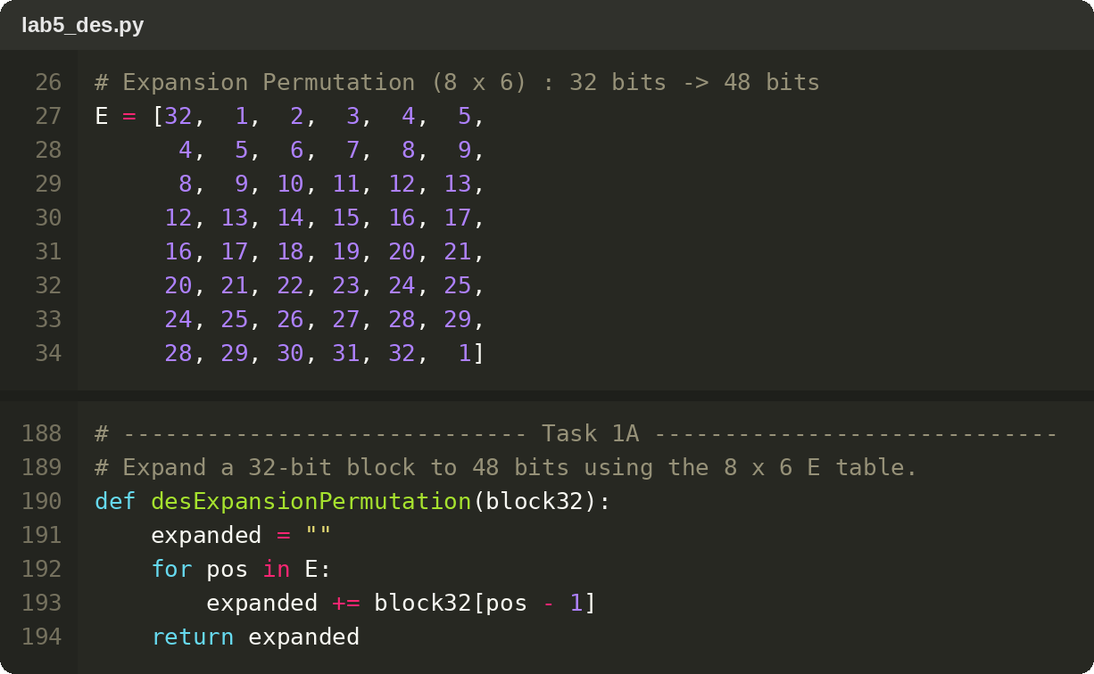
- Write a method called getSubBoxes that takes 48-bits as input, performs substitution according to 8 S-boxes and returns 32-bits of DES:
Solution
Code:
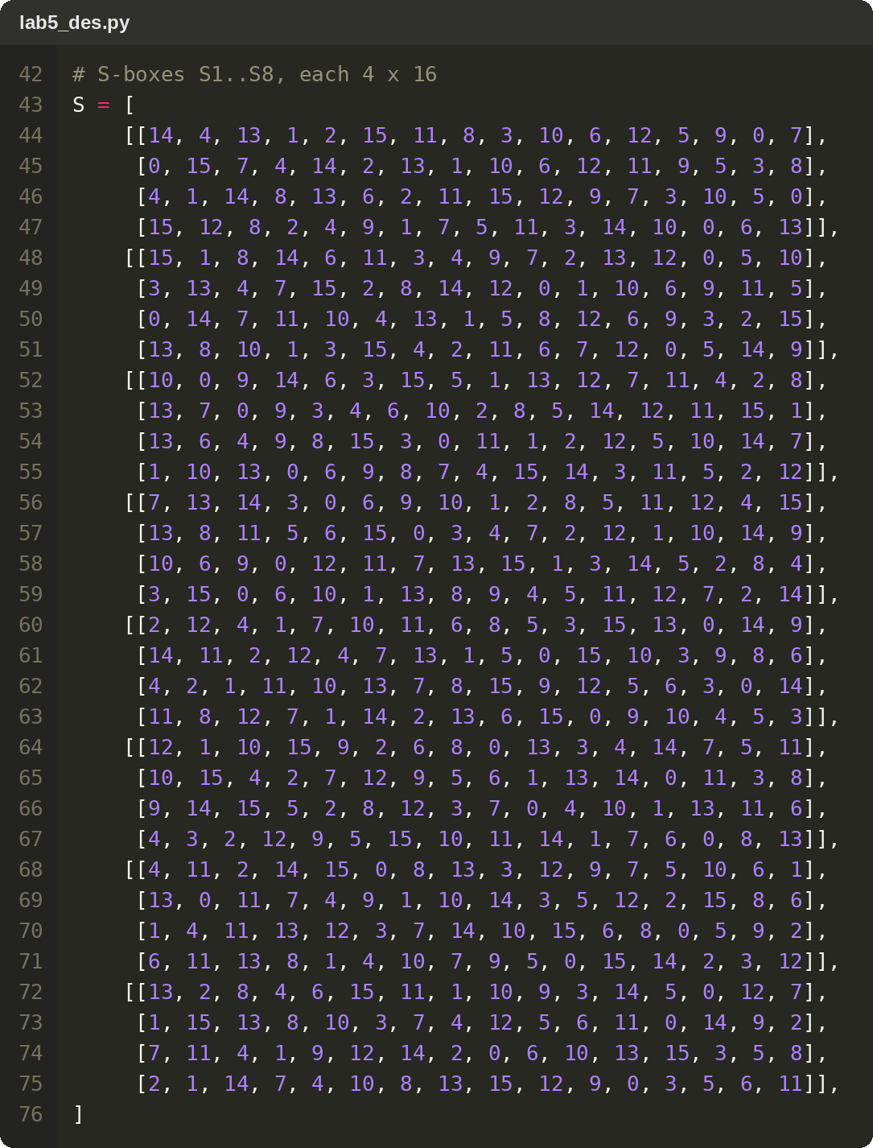
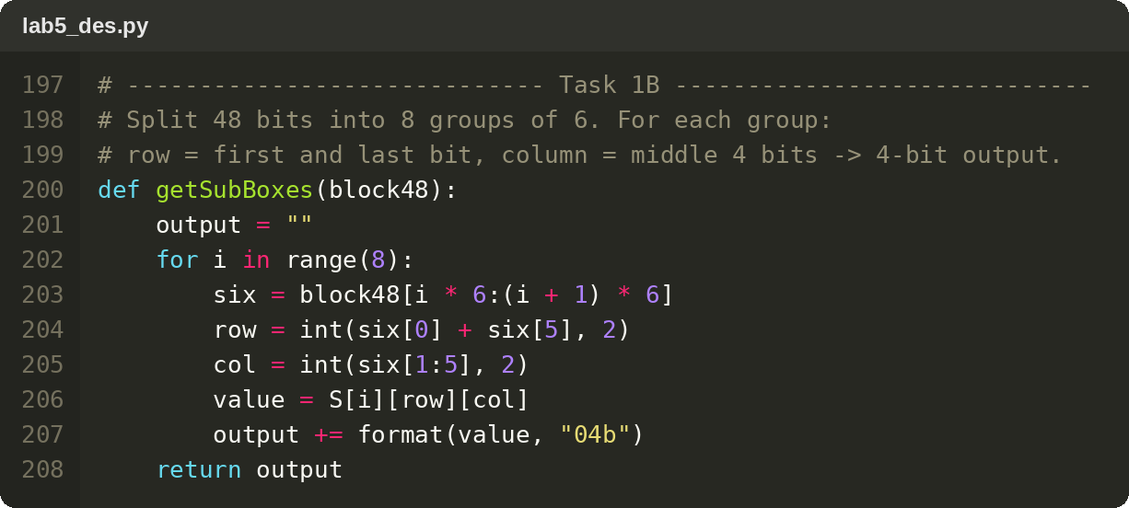
- Write a method called desRoundPermutation that takes a 32-bit block, performs permutation according to the 4 x 8 RP table and returns the permuted block:
Solution
Code:
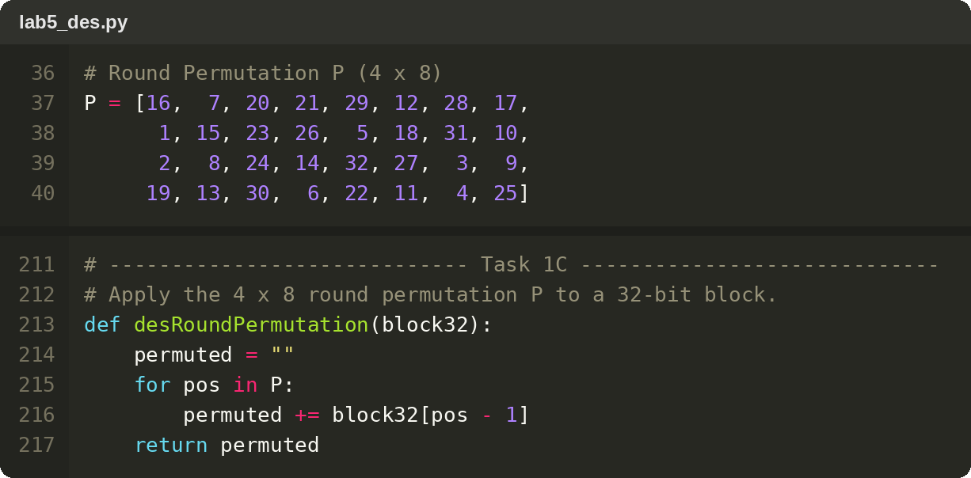
- Write a method called desFinalPermutation that takes a 64-bit block, performs permutation according to the 8 x 8 FP table and returns the permuted block:
Solution
Code:
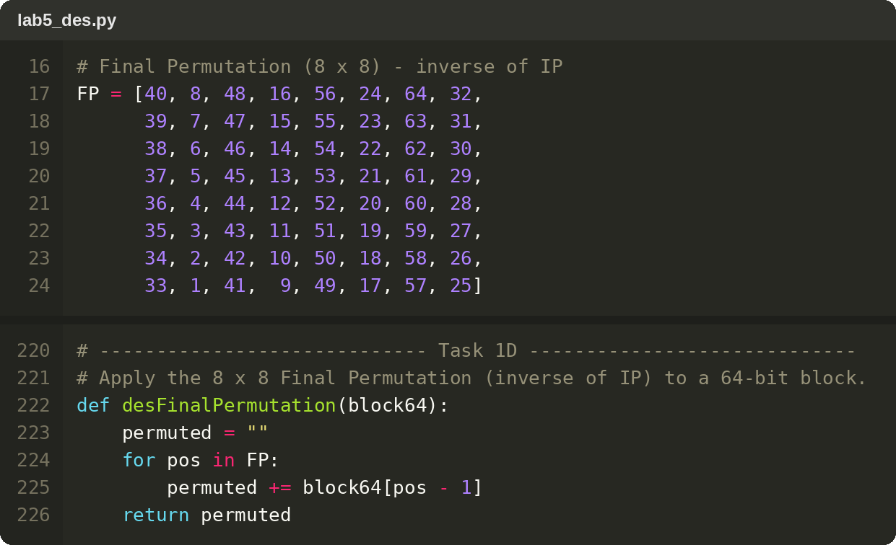
- Paste terminal SS of all above tasks with their inputs and outputs respective:
Solution
Expansion, key mixing with K1, S-box substitution, round permutation and final permutation (Block 1):
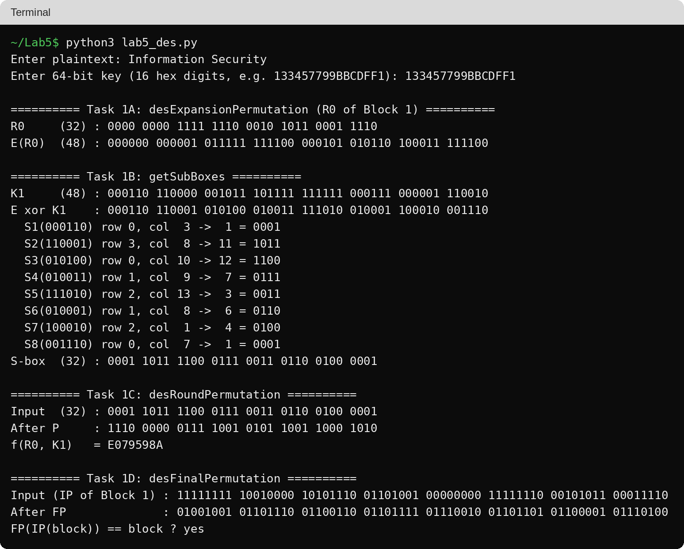

Lab Task 2:
- Encrypting DES: Use the plaintext block generation method, the round keys generation method and the initial/final permutation methods implemented in the previous labs to write a program with a method called desEncryption that encrypts the plaintext using DES encryption algorithm.
Note: Each 64-bit block goes through 16 rounds
- Write a method called desDecryption to implement the DES Decryption algorithm.
Hint: DES Decryption algorithm is same as encryption algorithm. You just have to reverse the keys
Solution
Code (round keys, round function f and one 64-bit block through 16 rounds):
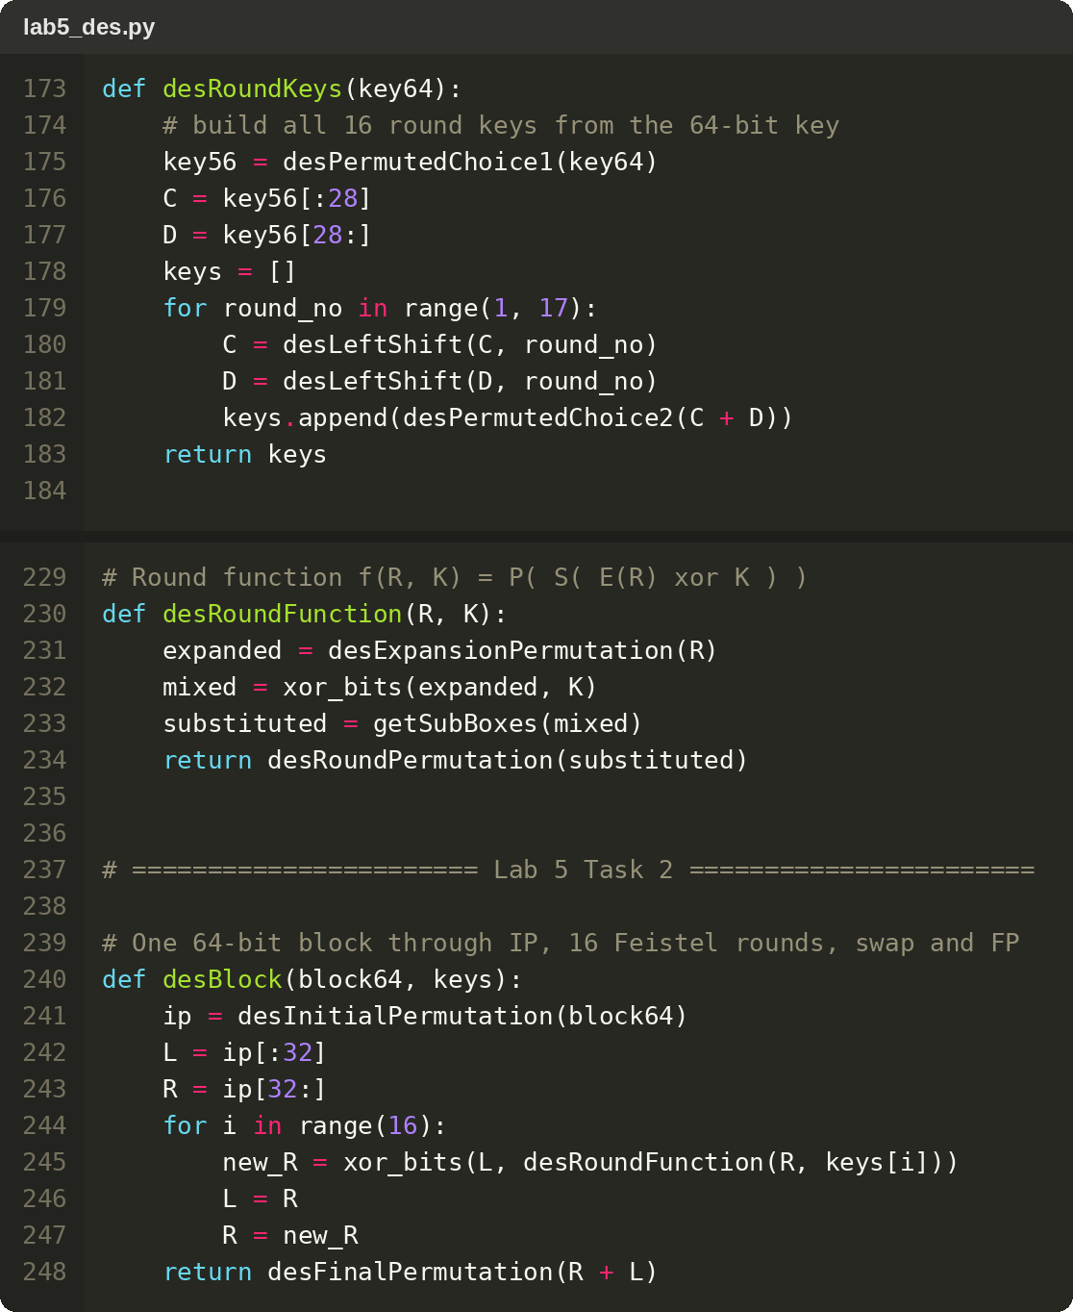
Code (desEncryption and desDecryption with reversed round keys):
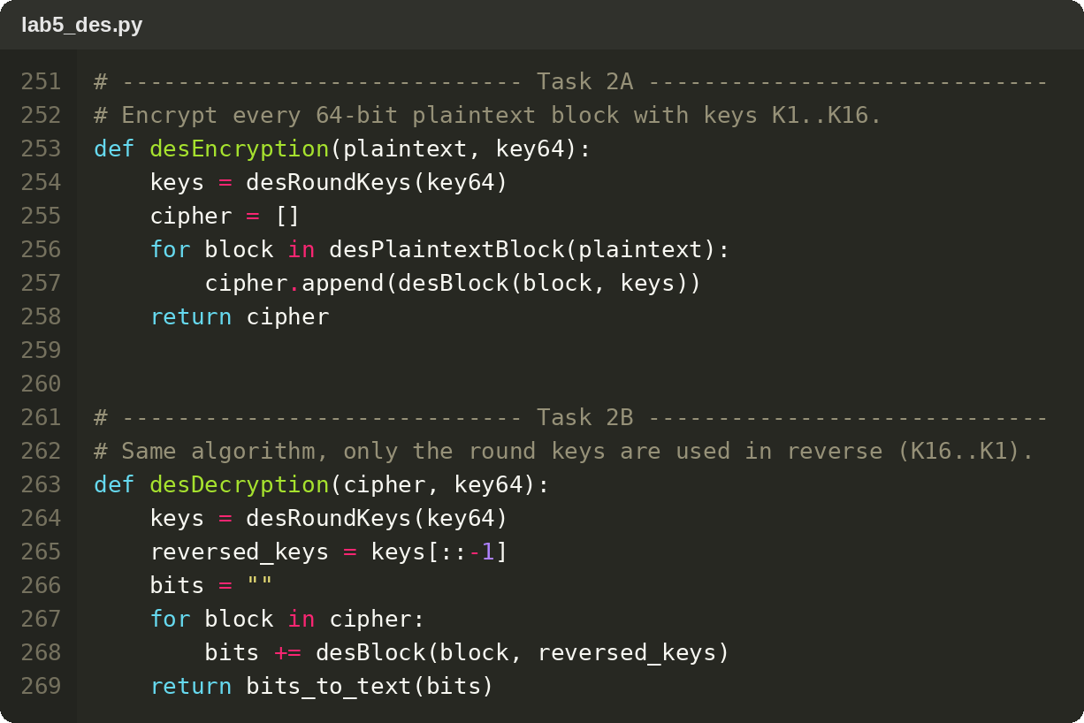
Output:
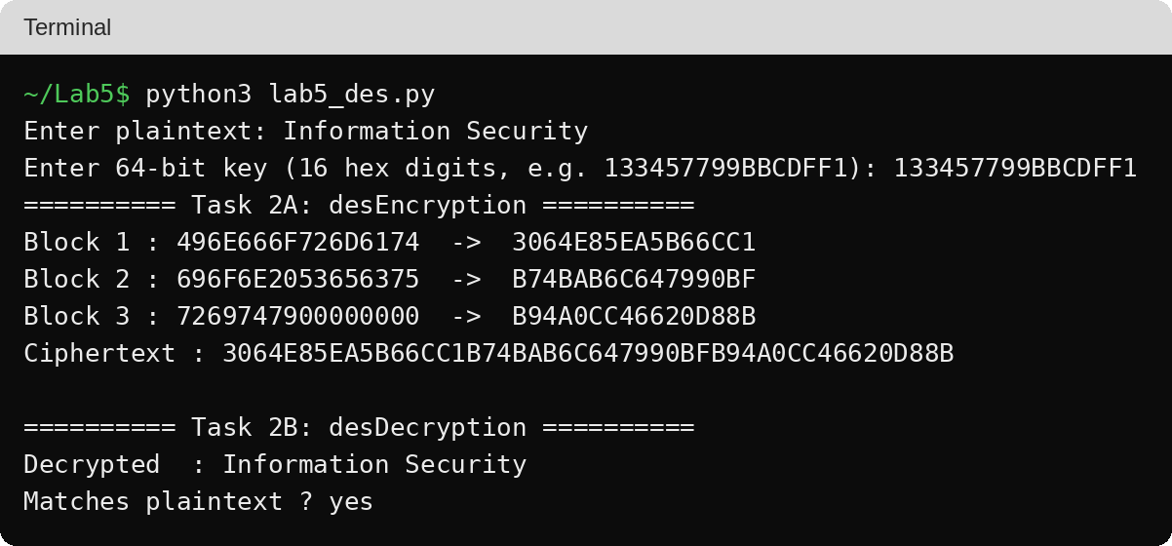

Deliverable:
- Compile a single report by filling in the solution/answer part (as directed) along with the screenshots of your code after executing it.
- Finalize the document in a well structured manner. Save the file with your name and registration number and upload it on LMS under submission link before the deadline.

