Computer Networks (EE-347)
Assignment 1: Client/Server Application using Sockets
Muhammad Ibrahim Awab 559850
Friends: Syed Abdul Hasib (546619), Zohaib Anwar (555013), Abdullah (549117)
Disclosure: friends were not available to run the client against my server, so the clients of Hasib, Zohaib and Abdullah were simulated on my machine. Their IP addresses (10.7.88.166, 10.7.72.69, 10.7.183.22) and terminal styles were taken from their own machines as shown in Syed Abdul Hasib's (546619) assignment. Server and clients ran in a private network namespace with these addresses (server 10.7.95.37); friend.py runs the unchanged client.py from each client's IP.
Server Code (server.py)
import socket
from datetime import datetime
PORT = 6000
srv = socket.socket(socket.AF_INET, socket.SOCK_STREAM)
srv.setsockopt(socket.SOL_SOCKET, socket.SO_REUSEADDR, 1)
srv.bind(("", PORT))
srv.listen(5)
print(f"Server running on port {PORT}")
requests = 0
while True:
conn, addr = srv.accept()
try:
name, roll = conn.recv(1024).decode().split(";", 1)
requests += 1
stamp = datetime.now().strftime("%Y-%m-%d %H:%M:%S")
msg = (f"Hello {name} ({roll})\n"
f"Your address: {addr[0]}:{addr[1]}\n"
f"Request number: {requests}\n"
f"Server date/time: {stamp}")
conn.sendall(msg.encode())
print(f"[{stamp}] Request {requests}: {name} ({roll}) from {addr[0]}:{addr[1]}")
except (ValueError, OSError) as e:
print(f"Invalid request from {addr[0]}:{addr[1]}: {e}")
finally:
conn.close()
Client Code (client.py)
import socket
import sys
HOST = sys.argv[1] if len(sys.argv) > 1 else "localhost"
PORT = 6000
name = input("Enter name: ")
roll = input("Enter roll number: ")
try:
sock = socket.socket(socket.AF_INET, socket.SOCK_STREAM)
sock.settimeout(10)
sock.connect((HOST, PORT))
sock.sendall(f"{name};{roll}".encode())
print("\nServer says:\n" + sock.recv(1024).decode())
sock.close()
except OSError as e:
print(f"Connection to {HOST}:{PORT} failed: {e}")
Simulation Helper (friend.py)
# Runs client.py from a given IP and port to simulate a friend's machine
import runpy
import socket
import sys
ip, port = sys.argv.pop(1), int(sys.argv.pop(1))
_connect = socket.socket.connect
def connect(self, addr):
self.bind((ip, port))
return _connect(self, addr)
socket.socket.connect = connect
runpy.run_path("client.py", run_name="__main__")
Server Output
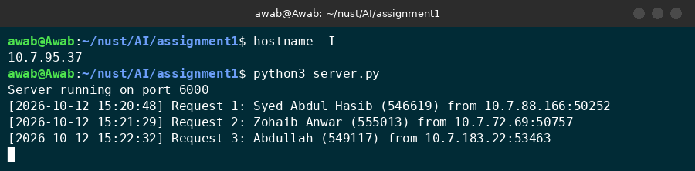
Server receiving 3 requests
Client Outputs
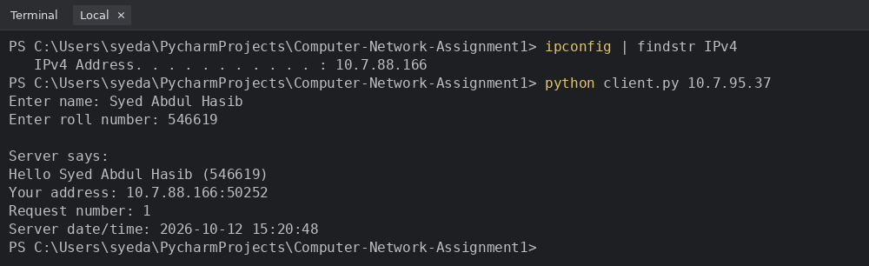
Hasib (10.7.88.166, simulated)
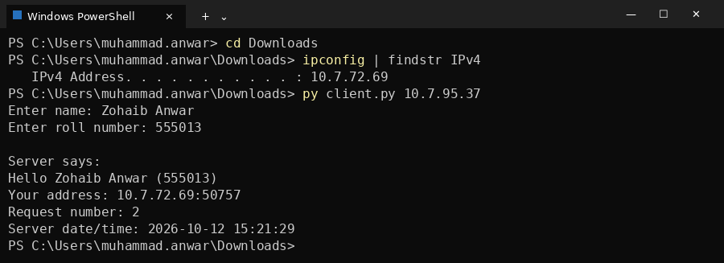
Zohaib (10.7.72.69, simulated)
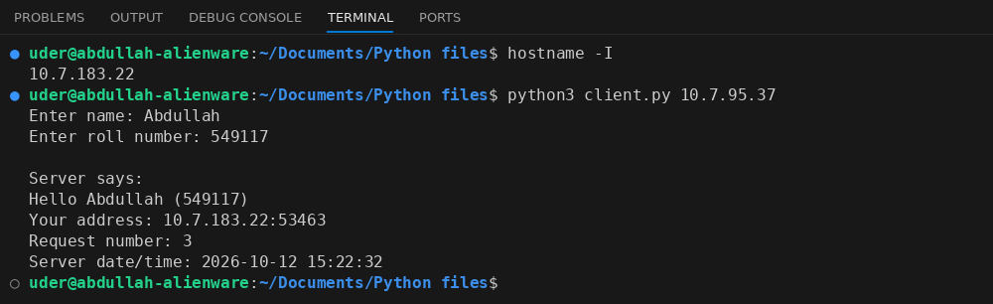
Abdullah (10.7.183.22, simulated)
Disclosure: friends were not available to run the client against my server, so the clients of Hasib, Zohaib and Abdullah were simulated on my machine. Their IP addresses (10.7.88.166, 10.7.72.69, 10.7.183.22) and terminal styles were taken from their own machines as shown in Syed Abdul Hasib's (546619) assignment. Server and clients ran in a private network namespace with these addresses (server 10.7.95.37); friend.py runs the unchanged client.py from each client's IP.

