CS-250: Data Structure and Algorithms
Lab 7: Binary Tree
Arqam Waheed 553514 BSDS 3A 20 October 2026
GitHub: https://github.com/ArqamWaheed/nust/tree/testbranch/dsa/lab7
Task 1) Binary Tree Representation and Operations
The string is parsed recursively into nodes. Inorder and postorder use a stack instead of recursion, and a string is validated before it is loaded.
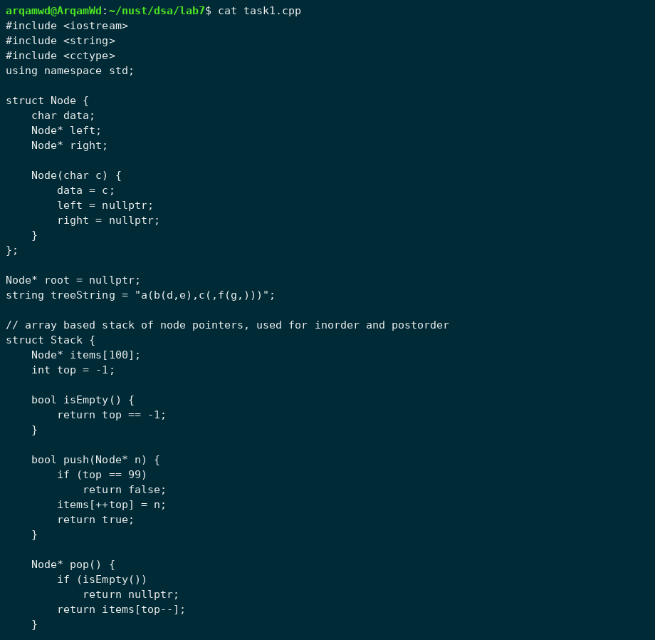
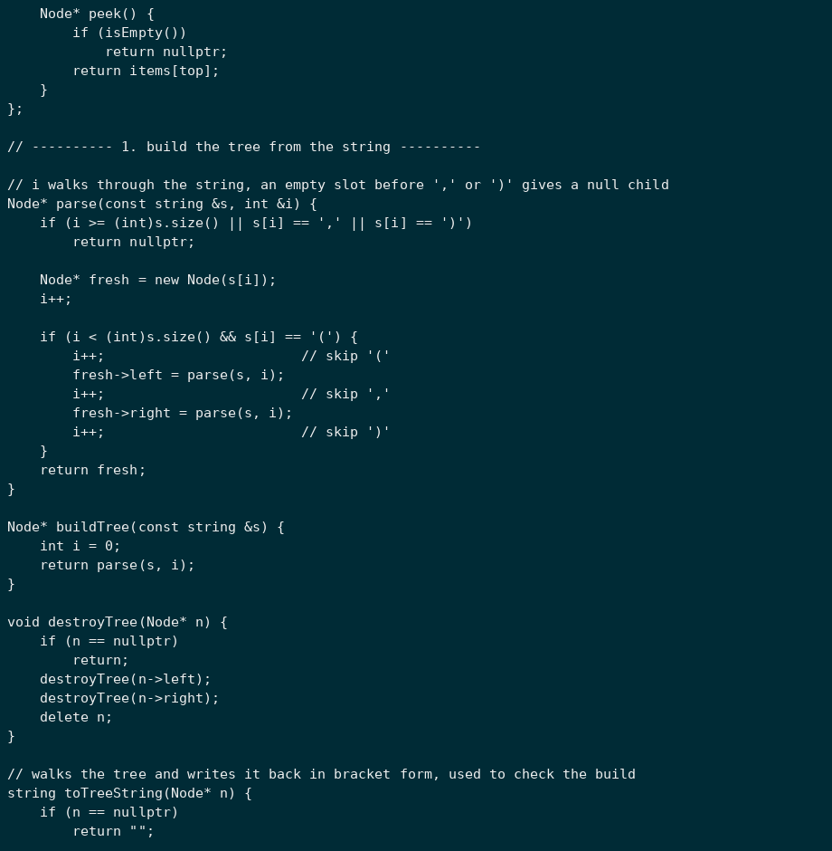
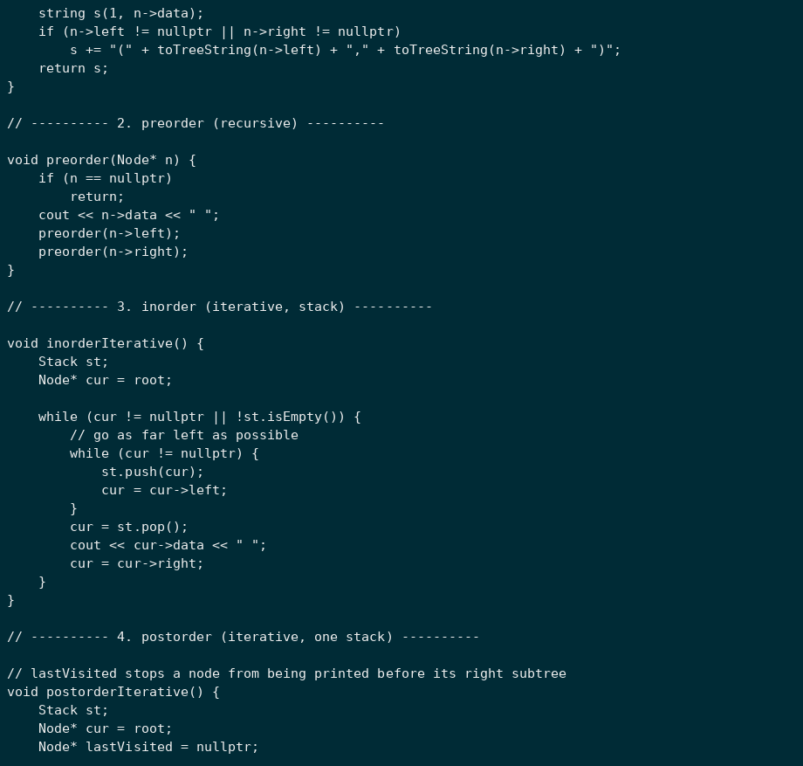
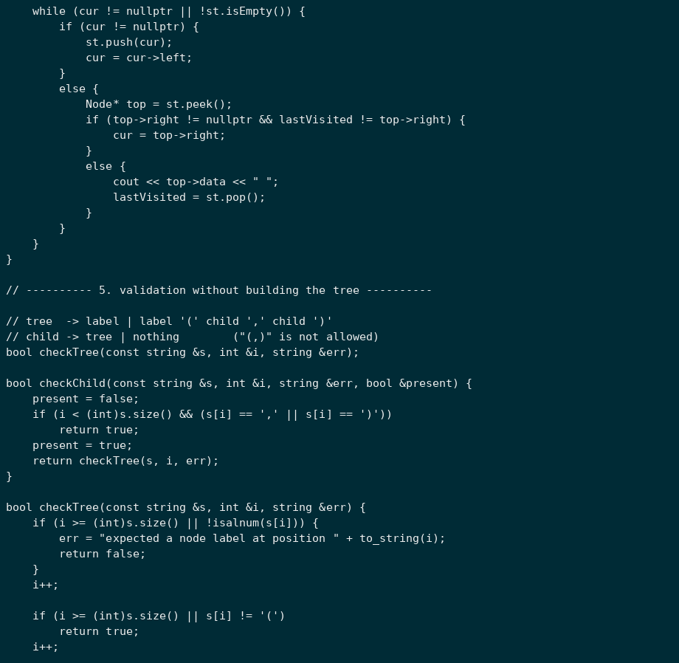
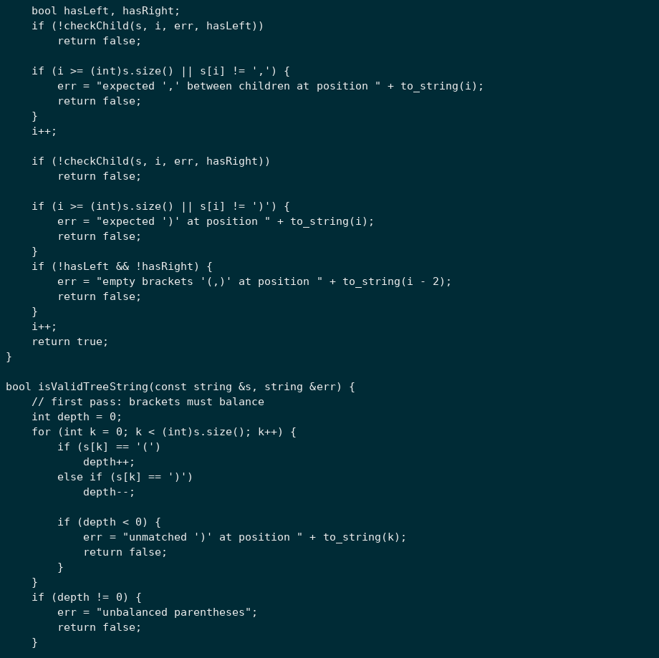
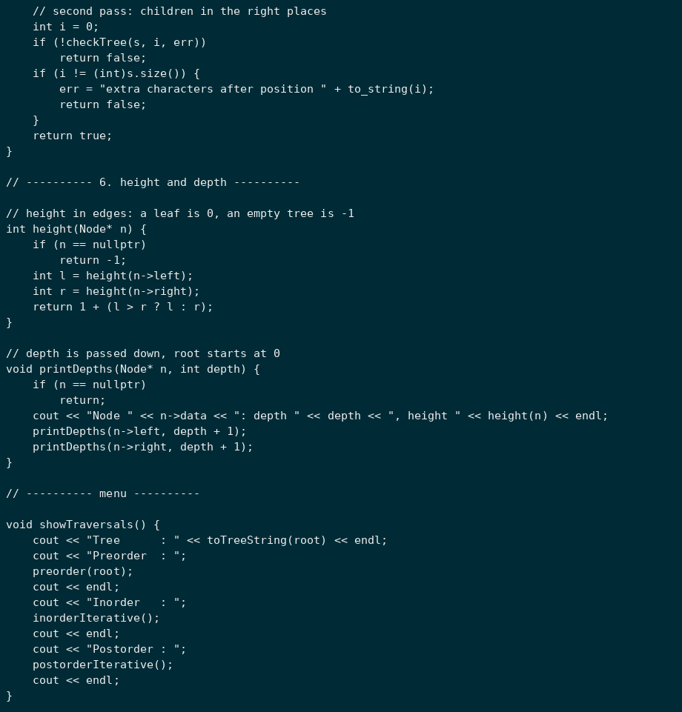
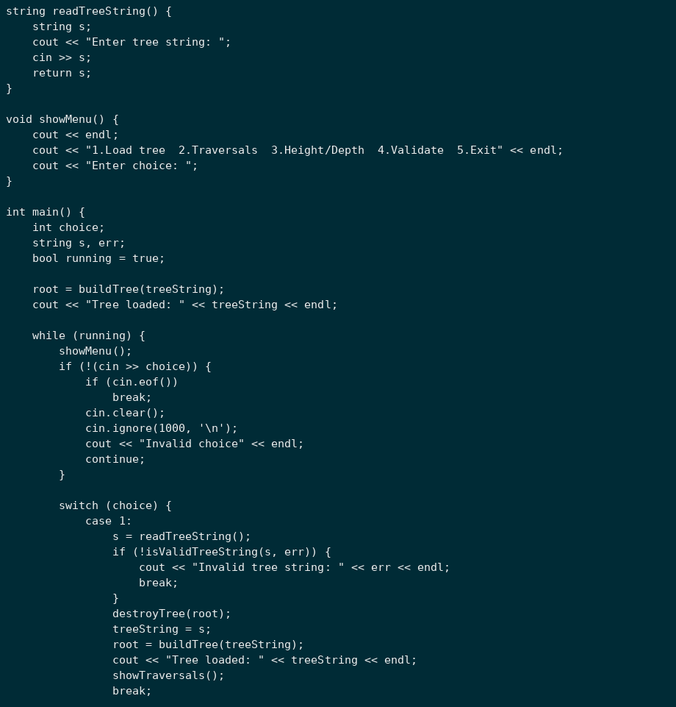
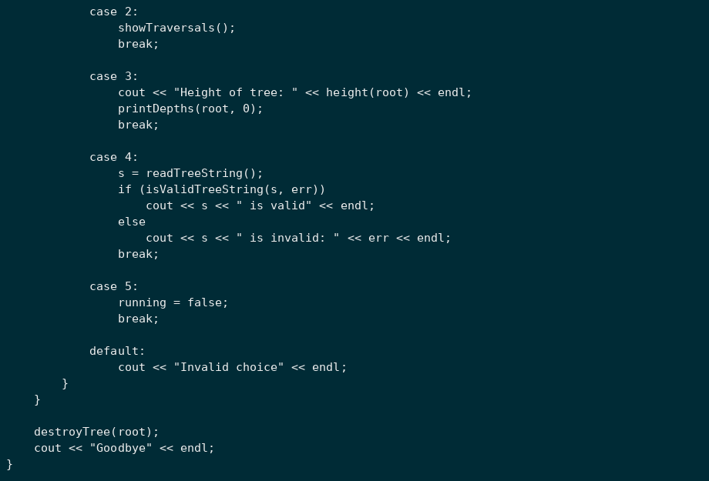
Output:
