CS-250: Data Structure and Algorithms
Lab 2: Pointers in C++
Arqam Waheed 553514 BSDS 3A 15 September 2026
Task 1) Memory Occupied by Data Types
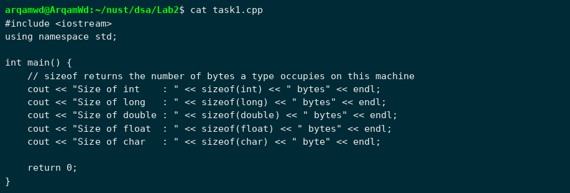
Output:
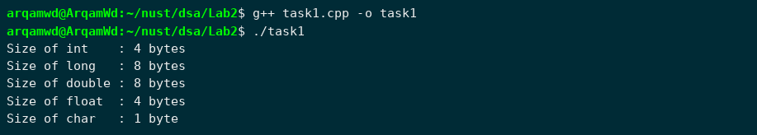

Task 2) Pointer Arithmetic
void main() gives an error in g++ ("'::main' must return 'int'"), so I used int main() and kept the rest of the program the same.
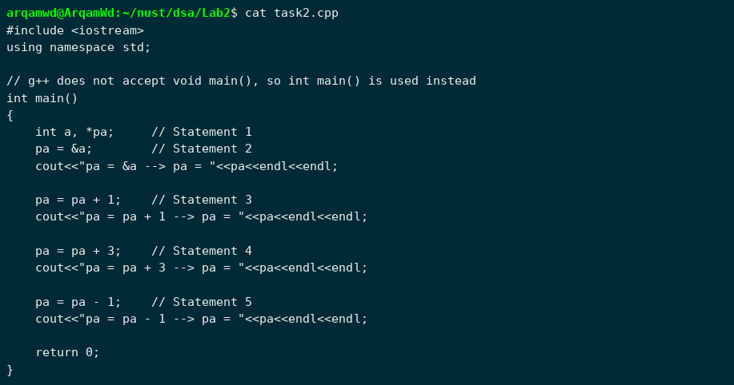
Output:
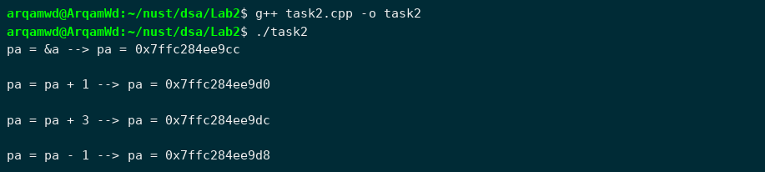
1) Why does the memory address stored in pointer "pa" vary by 4?
pa is a pointer to int, and an int takes 4 bytes on this machine (see Task 1). When a number is added to or subtracted from a pointer, the compiler multiplies it by the size of the type the pointer points to. So pa + 1 moves the address forward by 1 x sizeof(int) = 4 bytes, to where the next int would be stored. That is why statement 3 increases the address by 4, statement 4 by 12 (3 x 4) and statement 5 decreases it by 4.
2) Will the address still vary by 4 if the data type is changed from "int" to "long"?
Not necessarily. The step is always sizeof() of the pointed-to type, so it depends on how big long is on the compiler being used. On my system (64-bit Linux, g++) long is 8 bytes, so after changing int to long the address changes by 8, then 24 (3 x 8), then 8. On Windows with Visual Studio long is only 4 bytes, so there it would still vary by 4, same as int.
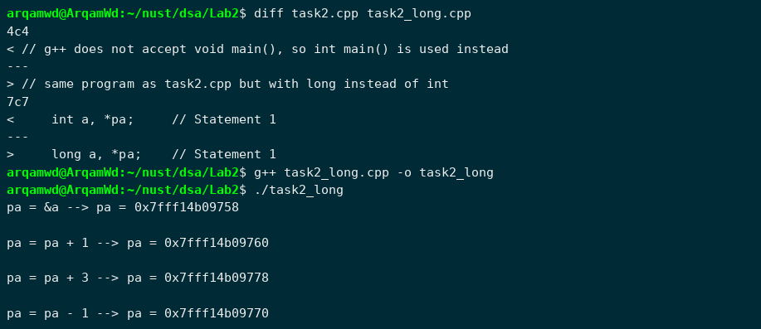
3) If we try to multiply the address pointed to by "pa" what will happen?
The program does not compile. C++ only allows adding or subtracting an integer to a pointer, and subtracting two pointers of the same type. Multiplying (or dividing) a pointer is not defined, so g++ gives "invalid operands of types 'int*' and 'int' to binary 'operator*'". It is not logically correct either, because an address multiplied by 2 does not point to anything meaningful in the program, it would just be some random location.
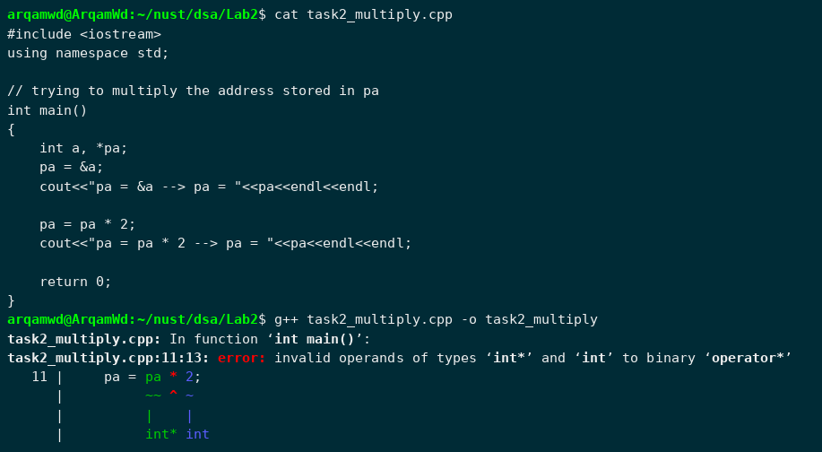

Task 3) Printing an Array Using Only a Pointer
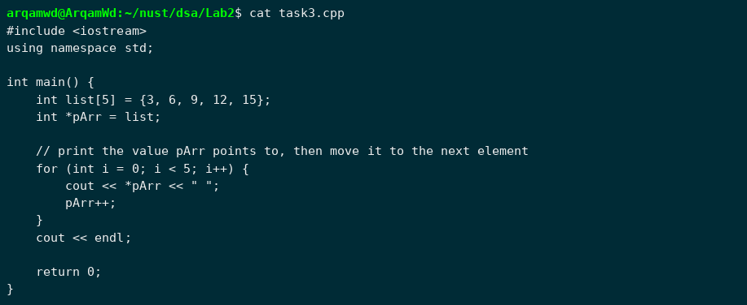
Output:
Task 4) Output Without Executing
Example code a)
Output:
1
4
7
9
Working: p = x so p points to x[0]. (*p)++ changes x[0] from 0 to 1, which is printed. *(p+1) is x[1] = 4. p++ moves p to x[1], then *p = *p + a makes x[1] = 4 + 3 = 7, which is printed.
p = p + 2 moves the pointer two elements forward, from x[1] to x[3]. It does not change any value, so *p prints x[3] = 9.
Example code b)
Output:
4 4 5 7
Working: p and q both point to arr[0], and *p = 4 makes arr[0] = 4. In the first loop:
i = 0: a = arr[0] = 4, p -> arr[1], arr[1] = 4 + 0 = 4
i = 1: a = arr[1] = 4, p -> arr[2], arr[2] = 4 + 1 = 5
i = 2: a = arr[2] = 5, p -> arr[3], arr[3] = 5 + 2 = 7
q was never moved so it still points to arr[0], and the second loop prints all four values with a space after each.
Task 5) Swapping Using Pointers and Pointers-to-Pointers
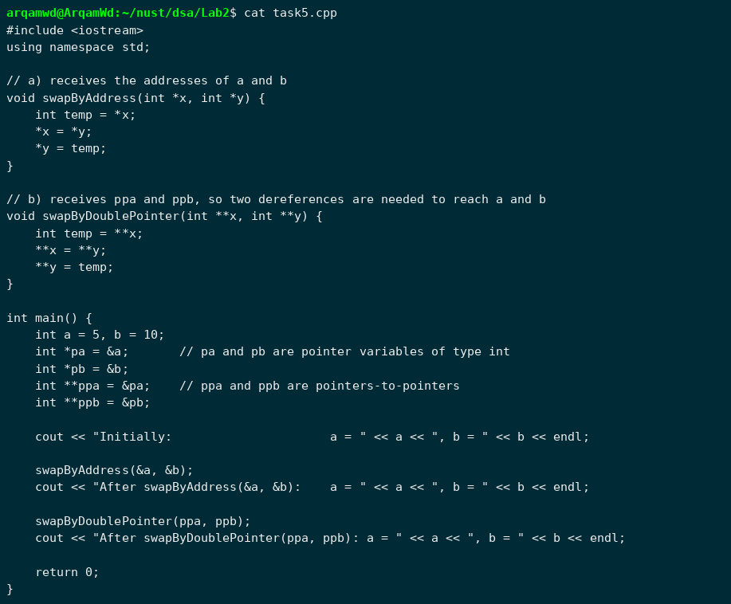
Output:
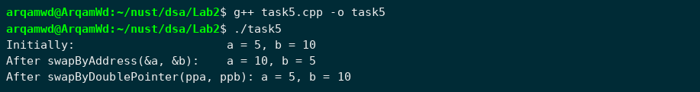
Both functions change a and b through their addresses so the change is visible in main. After the second call the values go back to 5 and 10 because they were already swapped once by the first function.

Task 6) Student Marks Using a Dynamic 2D Array
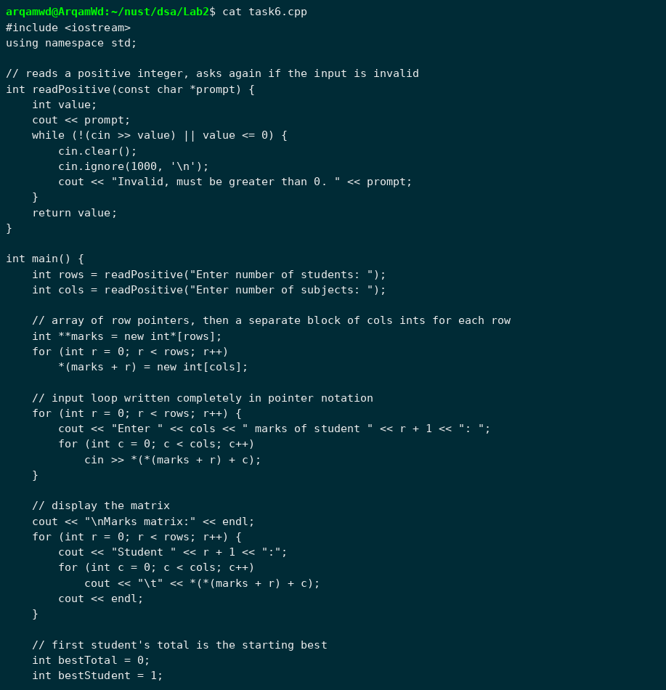
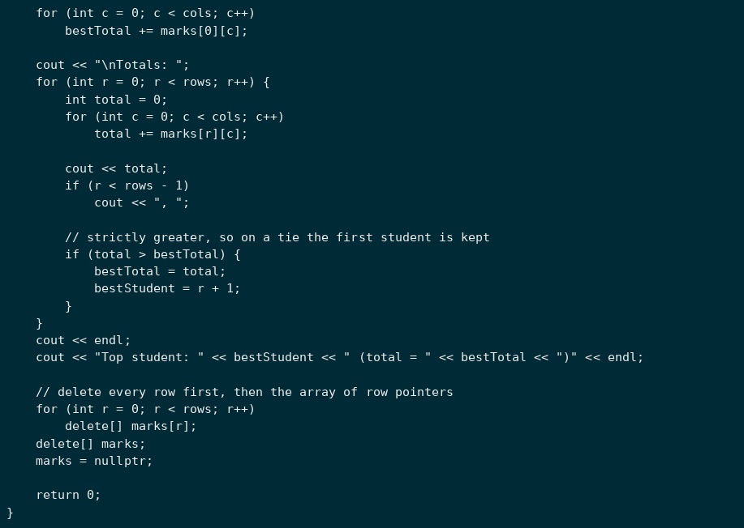
Test runs: 2 x 3 (an invalid size entered first), 2 x 2 (tie) and 1 x 1.
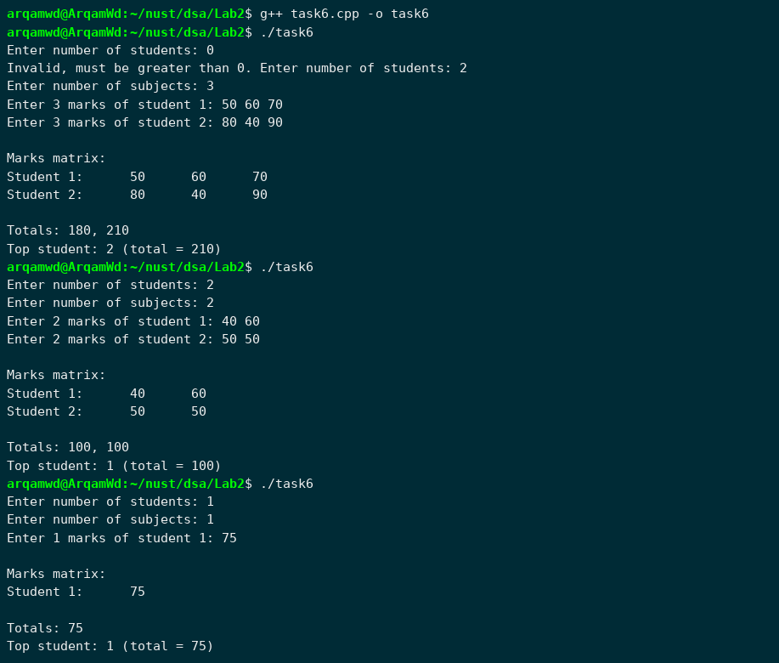
What would remain allocated if only delete[] marks; were executed?
Only the array of row pointers would be freed. The rows that were allocated separately with new int[cols] for each student would still be allocated, and the only pointers to them were stored inside the array that was just deleted, so there is no way to reach or free them anymore. That is a memory leak of rows x cols integers (6 ints for the 2 x 3 case). That is why every row is deleted first and the row-pointer array last.
Sketch for two students and three subjects:
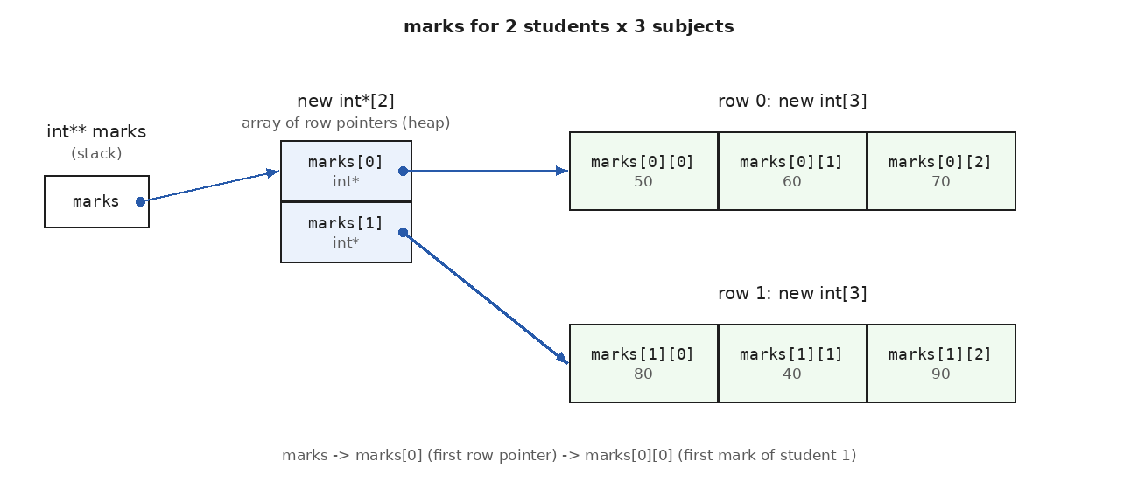

Task 7) Adding a Mark for a New Student
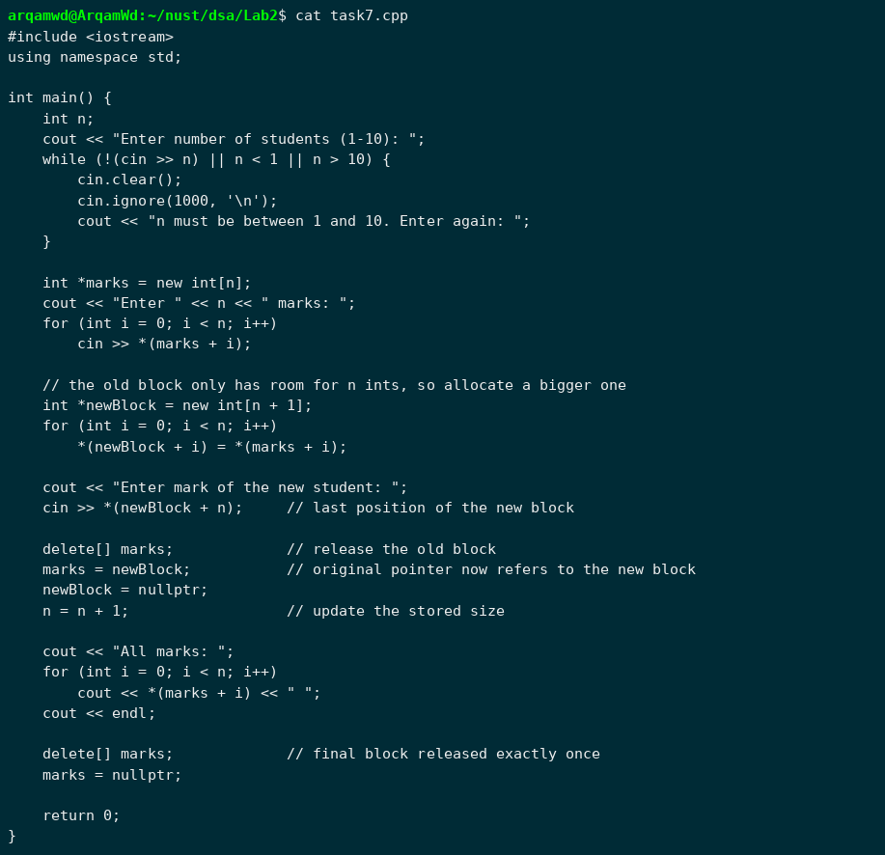
Test runs: n = 3 with 45 60 75 and new mark 90, then n = 1 (after an invalid n) with 0 and new mark 100.
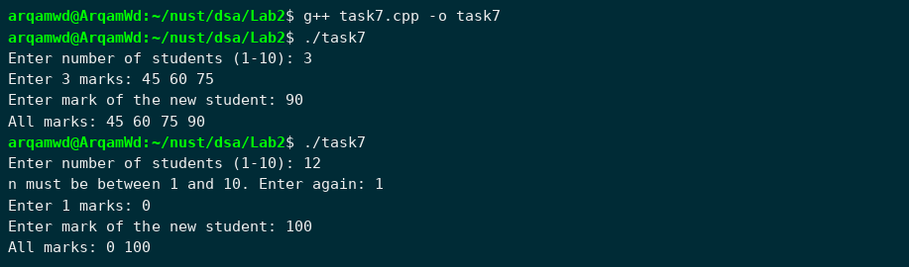
Why does changing n alone not increase the old block's capacity?
n is just an ordinary int variable that remembers how many elements I asked for. new int[n] reserved exactly n integers at the moment it ran, and the size of that block is fixed after allocation. Changing n later does not do anything to the memory on the heap, so writing to marks[n] would still be outside the old block. To get more space a new block has to be allocated, the old values copied into it, and the old block deleted. After that delete[], any other pointer that still holds the old address is dangling.
Task 8) Finding Memory Errors
1) Errors in the fragment
Error 1: for (int i = 0; i <= n; i++)
The valid indexes of a 3 element array are 0 to 2, but i <= n also runs the loop for i = 3, so cin >> values[3] writes past the end of the allocated block (out-of-bounds access). This can overwrite other heap data or the allocator's bookkeeping and cause a crash or wrong values later. It also makes the program wait for a fourth number when only three should be read.
Error 2: delete values;
The memory was allocated with new[], so it has to be released with delete[]. Mixing new[] with delete is undefined behaviour; for class types the destructors of the elements would not run and the heap can get corrupted. AddressSanitizer reports it as alloc-dealloc-mismatch (below).
Error 3: cout << values[0];
This reads the array after it has been deleted. values is now a dangling pointer, so this is a use-after-free. The memory may already be reused by the allocator, and in my run it printed a garbage number instead of 4. The pointer was also never set to nullptr after deleting.
Running the original fragment as it is. It compiled without warnings, waited for a fourth number, printed a garbage value and exited normally:
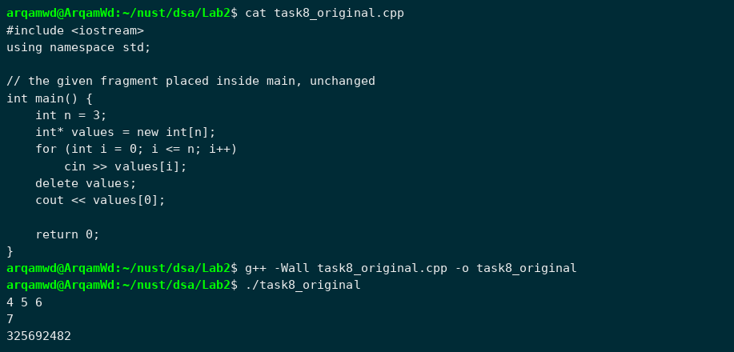
Compiling the same code with AddressSanitizer shows that the program is actually broken:
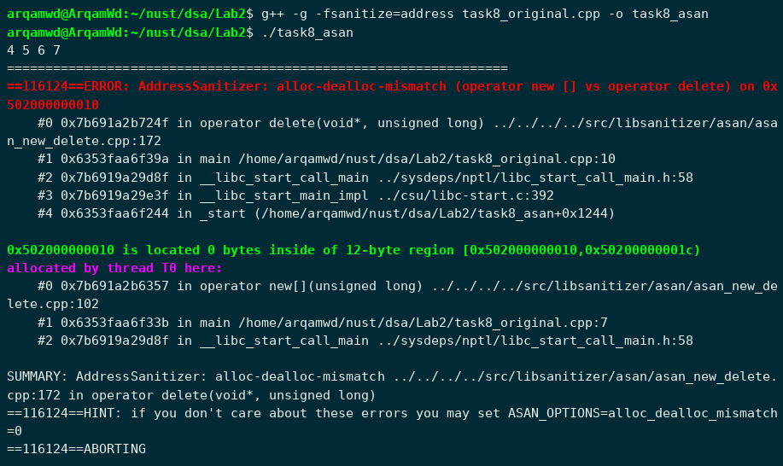
2) Corrected program
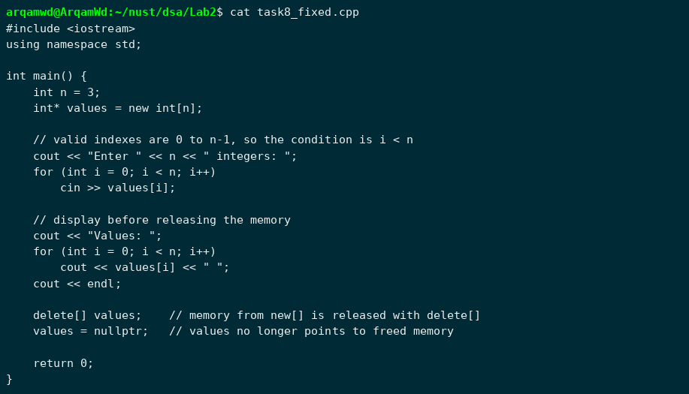
Output (tested with 4 5 6):
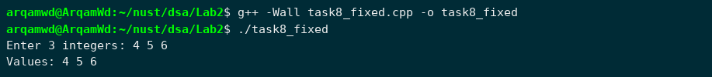
Out-of-bounds access vs dangling pointer vs memory leak
Out-of-bounds access: using an index outside the allocated range, like values[3] in a 3 element array. The memory there belongs to something else or to nothing.
Dangling pointer: a pointer that still holds the address of memory that has already been freed (or of a variable that went out of scope). The address looks normal but using it is invalid.
Memory leak: memory that was allocated but never freed, and no pointer refers to it anymore, so the program cannot release it. Memory usage keeps growing while the program runs.
A program that appears to run successfully does not prove its memory accesses are valid because these errors are undefined behaviour, and one possible result of undefined behaviour is that it looks like it works. The memory just past an array or a freed block usually still belongs to the process, so the operating system does not stop the program, and the damage shows up later, on a different input, or with a different compiler. The original fragment above is an example: it ran and exited normally, but the output was wrong and AddressSanitizer found an error straight away.

