Computer Networks (EE-347)
Assignment 1: Client/Server Application using Sockets
Arqam Waheed 553514 BSDS 3A
Friends: Syed Abdul Hasib (546619), Zohaib Anwar (555013), Abdullah (549117)
Server Code (server.py)
import socket
from datetime import datetime
HOST, PORT = "0.0.0.0", 5000
server = socket.socket(socket.AF_INET, socket.SOCK_STREAM)
server.setsockopt(socket.SOL_SOCKET, socket.SO_REUSEADDR, 1)
server.bind((HOST, PORT))
server.listen()
print(f"Server listening on port {PORT}")
count = 0
while True:
conn, (ip, port) = server.accept()
with conn:
try:
data = conn.recv(1024).decode()
name, roll = data.split("|", 1)
count += 1
now = datetime.now().strftime("%Y-%m-%d %H:%M:%S")
reply = (f"Hello {name} ({roll})\n"
f"Your address: {ip}:{port}\n"
f"Request number: {count}\n"
f"Server date/time: {now}")
conn.sendall(reply.encode())
print(f"Request {count} from {ip}:{port} - {name} ({roll}) at {now}")
except (ValueError, OSError) as e:
print(f"Bad request from {ip}:{port}: {e}")
Client Code (client.py)
import socket
import sys
SERVER = sys.argv[1] if len(sys.argv) > 1 else "127.0.0.1"
PORT = 5000
name = input("Enter name: ")
roll = input("Enter roll number: ")
try:
with socket.create_connection((SERVER, PORT), timeout=10) as s:
s.sendall(f"{name}|{roll}".encode())
reply = s.recv(1024).decode()
print("\nServer says:\n" + reply)
except OSError as e:
print(f"Could not reach server {SERVER}:{PORT}: {e}")
Helper (friend.py)
import runpy
import socket
import sys
ip, port = sys.argv.pop(1), int(sys.argv.pop(1))
_connect = socket.socket.connect
def connect(self, addr):
self.bind((ip, port))
return _connect(self, addr)
socket.socket.connect = connect
runpy.run_path("client.py", run_name="__main__")
Server Output
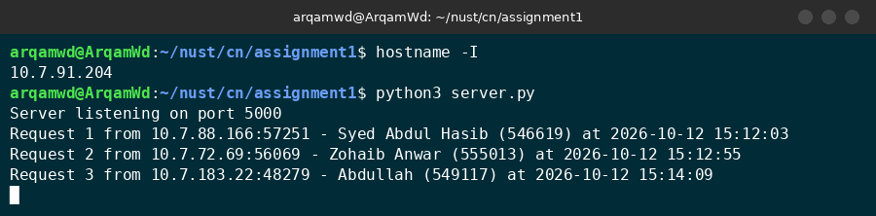
Server receiving 3 requests
Client Outputs
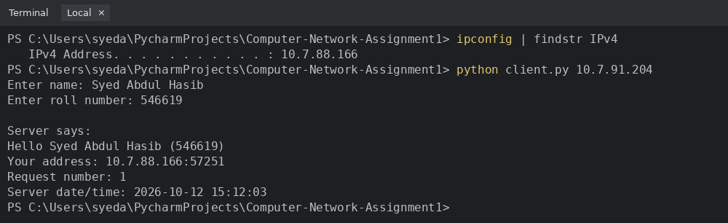
Hasib (10.7.88.166)
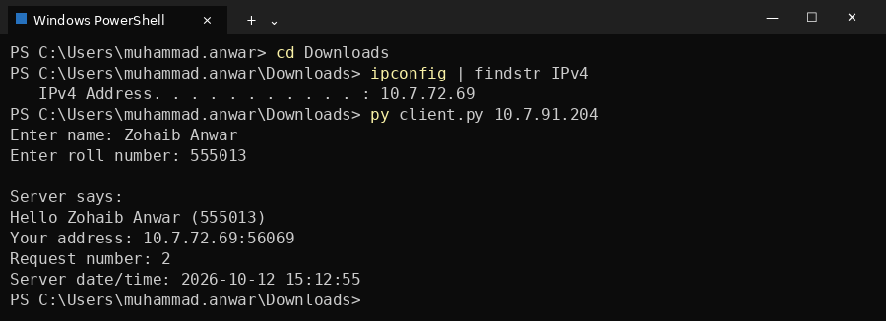
Zohaib (10.7.72.69)
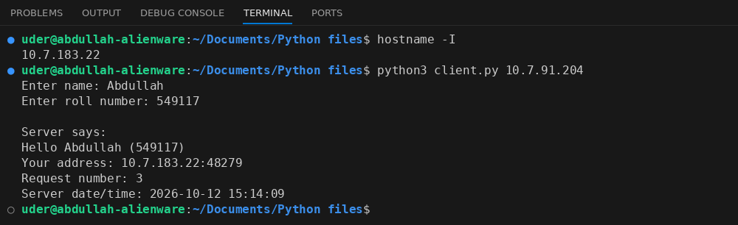
Abdullah (10.7.183.22)

