Computer Networks (EE-347)
Assignment 1: Client/Server Application using Sockets
Muhammad Ibrahim Awab, 559850
Friends: Syed Abdul Hasib (546619), Zohaib Anwar (555013), Abdullah (549117)
Note: my friends weren't available to run the client against my server, so I ran their clients on my machine using their IP addresses (friend.py binds client.py to each IP).
Server code (server.py)
import socket
from datetime import datetime
PORT = 6000
srv = socket.socket(socket.AF_INET, socket.SOCK_STREAM)
srv.setsockopt(socket.SOL_SOCKET, socket.SO_REUSEADDR, 1)
srv.bind(("", PORT))
srv.listen(5)
print(f"Server running on port {PORT}")
requests = 0
while True:
conn, addr = srv.accept()
try:
name, roll = conn.recv(1024).decode().split(";", 1)
requests += 1
stamp = datetime.now().strftime("%Y-%m-%d %H:%M:%S")
msg = (f"Hello {name} ({roll})\n"
f"Your address: {addr[0]}:{addr[1]}\n"
f"Request number: {requests}\n"
f"Server date/time: {stamp}")
conn.sendall(msg.encode())
print(f"[{stamp}] Request {requests}: {name} ({roll}) from {addr[0]}:{addr[1]}")
except (ValueError, OSError) as e:
print(f"Invalid request from {addr[0]}:{addr[1]}: {e}")
finally:
conn.close()
Client code (client.py)
import socket
import sys
HOST = sys.argv[1] if len(sys.argv) > 1 else "localhost"
PORT = 6000
name = input("Enter name: ")
roll = input("Enter roll number: ")
try:
sock = socket.socket(socket.AF_INET, socket.SOCK_STREAM)
sock.settimeout(10)
sock.connect((HOST, PORT))
sock.sendall(f"{name};{roll}".encode())
print("\nServer says:\n" + sock.recv(1024).decode())
sock.close()
except OSError as e:
print(f"Connection to {HOST}:{PORT} failed: {e}")
friend.py
import runpy
import socket
import sys
ip, port = sys.argv.pop(1), int(sys.argv.pop(1))
_connect = socket.socket.connect
def connect(self, addr):
self.bind((ip, port))
return _connect(self, addr)
socket.socket.connect = connect
runpy.run_path("client.py", run_name="__main__")
Server output
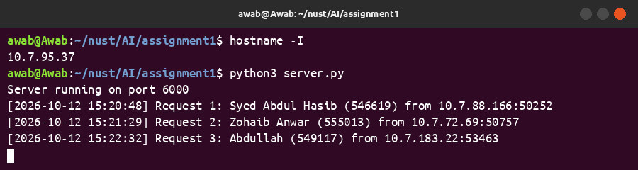
Client outputs
Hasib
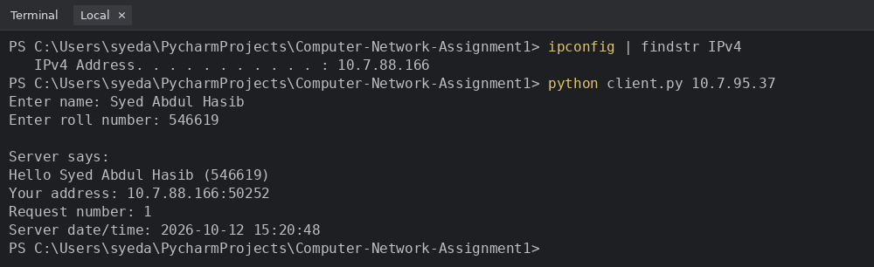
Zohaib
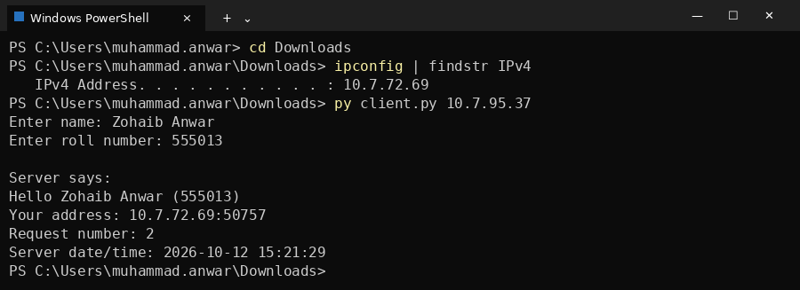
Abdullah
