Department of Computing

EE353: Computer Networks

Class: BSDS

CLO 1: Investigate and analyze the behavior of network traffic

Lab 6: Socket Programming (Client-Server Communication Using TCP and UDP in Python)

Date: 15-10-2026

Time: 02:00 PM to 05:00 PM

Lab Engineer: Mr. Hafiz Arslan Ramzan

Lab 6: Client-Server Communication Using TCP and UDP in Python
Objective of this Lab
The objective of this lab is to understand client-server communication and to implement it using TCP and UDP socket programming in Python. The lab starts with simple message exchange, moves on to file sharing, and finishes by building a small file-transfer service over both protocols and comparing their behavior using program output and Wireshark.
By the end of this lab, students will be able to:
- Explain the client-server model, sockets, IP addresses and port numbers.
- Create TCP and UDP servers and clients that exchange messages.
- Observe the TCP handshake and UDP datagrams in Wireshark.
- Explain why TCP is a byte stream and why one recv() call may return partial or merged data.
- Share a file between a client and a server over TCP, on one computer and (optionally) between two computers.
- Design a simple application protocol (request, header, data) with basic error handling.
- Transfer a file over UDP by splitting it into numbered chunks and reassembling it in order.
- Verify file integrity, measure transfer time and calculate throughput in KB/s.

Important Instructions
- Read the complete manual before starting. Understand each program before running it.
- Experiments and tasks are done individually; Experiment 6 (optional) is done in pairs.
- Keep all lab files in one folder (for example Lab6) and run every command from that folder.
- Always start the server first, then the client. Use a separate terminal window for each.
- Use only non-privileged ports (1024 and above). Only one program can use a port at a time.
- Do not copy code or answers from other students. You may use this manual and the official Python documentation.
- Include all required screenshots, answer the review questions and submit the report through the course LMS.

Tools/Software Requirements
- Python 3.11+ and any Python IDE (VS Code / PyCharm)
- Command Prompt / Terminal (two or three windows)
- Wireshark (on Windows, install Npcap with loopback support)
- For Experiment 6 only: a second computer on the same network (same Wi-Fi, mobile hotspot or LAN cable)

Lab Roadmap
Each experiment builds on the previous one. Approximate times are given as a guide.
Exp. | Title | What you will learn | Time
1 | TCP Client-Server Messaging | Socket basics, connection-oriented communication | 15 min
2 | UDP Client-Server Messaging | Connectionless communication, datagrams | 10 min
3 | Observing Traffic in Wireshark | TCP handshake, UDP packets, ports, flags | 20 min
4 | TCP Is a Byte Stream | Why recv() may return partial or merged data | 10 min
5 | File Sharing Over TCP | Sending a file in chunks and saving it | 15 min
6 | File Sharing Between Two Computers (Optional) | Real IP addresses, firewall, network testing | 20 min
7 | Test File, Integrity Check and Timing | Creating a log file, SHA-256, throughput | 10 min
8 | Request-Response File Server Over TCP | Size header, exact-length receive, error handling | 25 min
9 | File Transfer Over UDP | Chunks, sequence numbers, duplicates, reassembly | 25 min
10 | Performance Comparison | Repeated runs, average time, throughput | 20 min

1. Concepts You Need

1.1 Client-Server Model
In a client-server application one program, the server, waits for requests. Another program, the client, starts the communication, sends a request and receives a response.
Client → Request → Server Client ← Response ← Server
A web browser (client) requesting a page from a web server is the most common example. File transfer, e-mail and chat applications work the same way.

1.2 Sockets, IP Addresses and Ports
A socket is the endpoint an application uses to send and receive data over a network. It is identified by an IP address (which host), a port number (which application on that host) and a transport protocol (TCP or UDP). Python provides sockets through the built-in socket module (import socket).
- 127.0.0.1 is the loopback address: it always means "this computer". It lets you test a client and server on one machine.
- 0.0.0.0 (used when binding a server) means "listen on all network interfaces", so other computers can also connect.
- Ports 0-1023 are privileged. Use ports 1024 and above for your own programs.

Ports used in this lab:
Port | Protocol | Used in
5000 | TCP | Experiment 1 (messaging)
5001 | UDP | Experiment 2 (messaging)
5004 | TCP | Experiment 4 (byte-stream demo)
5002 | TCP | Experiments 5-6 (simple file sharing)
6000 | TCP | Experiment 8 (file server)
6001 | UDP | Experiment 9 (file server)

1.3 TCP and UDP
TCP (Transmission Control Protocol) is connection-oriented. It sets up a connection with a three-way handshake (SYN, SYN-ACK, ACK) and then provides reliable, ordered delivery using acknowledgments, retransmission, flow control and congestion control. UDP (User Datagram Protocol) is connectionless: it sends independent datagrams with no handshake, no acknowledgments and no ordering guarantee, so it has lower overhead.
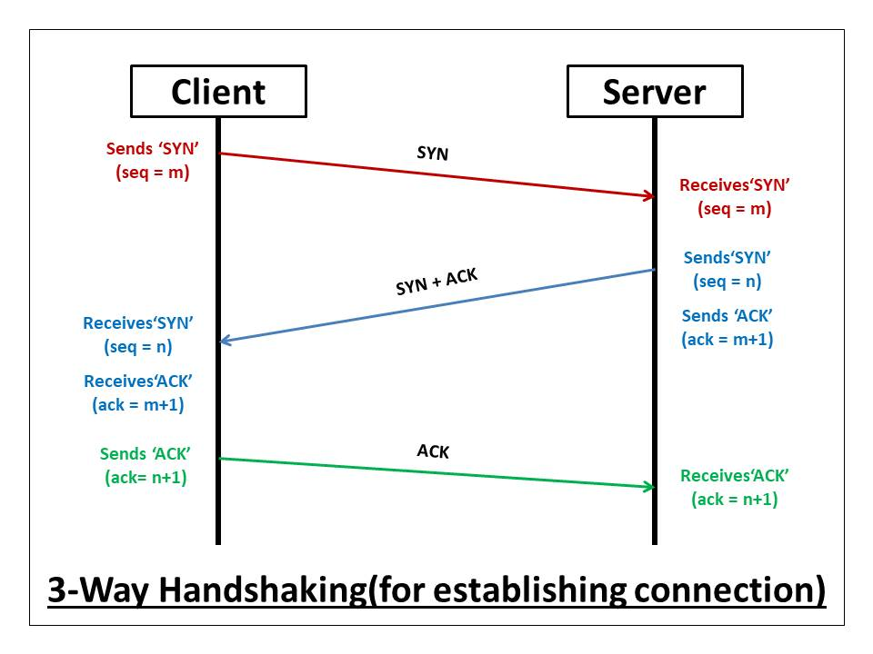
Feature | TCP | UDP
Connection | Connection-oriented | Connectionless
Reliability | Delivery is guaranteed (retransmission) | No delivery guarantee
Ordering | Ordered byte stream | No ordering guarantee
Data unit | Stream of bytes (no message boundaries) | Datagrams (boundaries preserved)
Overhead | Higher | Lower
Typical use | Web, e-mail, file transfer | DNS, streaming, gaming, monitoring

1.4 Socket Programming Steps
Role | TCP | UDP
Server | socket() → bind() → listen() → accept() → recv() / send() → close() | socket() → bind() → recvfrom() / sendto() → close()
Client | socket() → connect() → send() / recv() → close() | socket() → sendto() / recvfrom() → close()

1.5 Important Socket Functions
Function | Purpose
socket() | Creates a socket (SOCK_STREAM = TCP, SOCK_DGRAM = UDP)
bind() | Assigns an IP address and port to a socket
listen() / accept() | Puts a TCP server in listening mode / accepts a connection and returns a new socket
connect() | Establishes a TCP connection to the server
send() / sendall() | Sends data; sendall() keeps sending until every byte has been handed to TCP
recv() | Receives up to the given number of bytes from a TCP socket
sendto() / recvfrom() | Sends / receives one UDP datagram (with the peer address)
settimeout() | Stops a blocking call from waiting forever
close() | Closes the socket

2. Experiments

Experiment 1: TCP Client-Server Messaging
Aim: Build a TCP server and client and exchange messages between them.
tcp_server.py
import socket

HOST = "127.0.0.1"
PORT = 5000

server_socket = socket.socket(socket.AF_INET, socket.SOCK_STREAM)
server_socket.bind((HOST, PORT))
server_socket.listen(1)
print("TCP Server is waiting for a connection...")

conn, addr = server_socket.accept()
print("Connected by:", addr)

while True:
data = conn.recv(1024)
if not data:
break
message = data.decode()
print("Client:", message)
if message.lower() == "exit":
break
response = "Server received: " + message
conn.send(response.encode())

conn.close()
server_socket.close()
print("Server closed.")

tcp_client.py
import socket

HOST = "127.0.0.1"
PORT = 5000

client_socket = socket.socket(socket.AF_INET, socket.SOCK_STREAM)
client_socket.connect((HOST, PORT))
print("Connected to TCP server.")

while True:
message = input("Enter message: ")
client_socket.send(message.encode())
if message.lower() == "exit":
break
response = client_socket.recv(1024)
print("Server:", response.decode())

client_socket.close()
print("Client closed.")

How the code works
Code | Meaning
socket.socket(AF_INET, SOCK_STREAM) | AF_INET = IPv4, SOCK_STREAM = TCP
bind((HOST, PORT)) | Attaches the server socket to 127.0.0.1, port 5000
listen(1) | Starts waiting for connection requests (queue of 1)
accept() | Blocks until a client connects. Returns conn (a new socket for this client) and addr (client IP, port)
recv(1024) | Receives up to 1024 bytes. An empty result (b"") means the other side closed the connection
decode() / encode() | Network data is bytes; these convert bytes ⇄ text
connect((HOST, PORT)) | Client side: starts the three-way handshake with the server

Steps
- Save the two programs in your Lab6 folder.
- Terminal 1: run python tcp_server.py. It prints TCP Server is waiting for a connection...
- Terminal 2: run python tcp_client.py. It prints Connected to TCP server.
- Type at least five different messages in the client, then type exit. Take a screenshot of both terminals.

Expected output (server, then client)
TCP Server is waiting for a connection...
Connected by: ('127.0.0.1', 52144)
Client: Hello Server

Enter message: Hello Server
Server: Server received: Hello Server

Experiment 2: UDP Client-Server Messaging
Aim: Build a UDP server and client and observe how it differs from TCP.
udp_server.py
import socket

HOST = "127.0.0.1"
PORT = 5001

server_socket = socket.socket(socket.AF_INET, socket.SOCK_DGRAM)
server_socket.bind((HOST, PORT))
print("UDP Server is waiting for messages...")

while True:
data, addr = server_socket.recvfrom(1024)
message = data.decode()
print("Client:", message)
if message.lower() == "exit":
break
response = "Server received: " + message
server_socket.sendto(response.encode(), addr)

server_socket.close()
print("UDP Server closed.")

udp_client.py
import socket

HOST = "127.0.0.1"
PORT = 5001

client_socket = socket.socket(socket.AF_INET, socket.SOCK_DGRAM)
print("UDP Client started.")

while True:
message = input("Enter message: ")
client_socket.sendto(message.encode(), (HOST, PORT))
if message.lower() == "exit":
break
data, server_address = client_socket.recvfrom(1024)
print("Server:", data.decode())

client_socket.close()
print("Client closed.")

Key difference: UDP has no listen(), accept() or connect(). The server simply calls recvfrom(), which returns the data and the sender's address; the client must give the destination address on every sendto(). Each recvfrom() returns exactly one datagram.

Steps
- Terminal 1: run python udp_server.py (UDP Server is waiting for messages...).
- Terminal 2: run python udp_client.py, send at least five messages, then type exit.
- Take a screenshot of both terminals.

Experiment 3: Observing Traffic in Wireshark
Aim: See how the messages of Experiments 1 and 2 appear as packets on the network.
- Start Wireshark before running the programs and select the loopback interface (Windows: *Npcap Loopback Adapter* / *Adapter for loopback traffic capture*; Linux: lo; macOS: lo0). Click Start capture.
- Run Experiment 1 (TCP), send three messages and exit. Apply the display filter tcp.port == 5000.
- Run Experiment 2 (UDP), send three messages and exit. Apply the display filter udp.port == 5001.
- Click a packet and expand the layers in the details pane. Use *Right-click → Follow → TCP Stream / UDP Stream* to see the application data.

Look for the following and complete the comparison table in your report:
Observation | TCP (port 5000) | UDP (port 5001)
Packets before the first message | Handshake: SYN, SYN-ACK, ACK | None (data is sent immediately)
Packets for one message and its reply | Data packet (PSH, ACK) + ACK packets | One datagram each way
Fields you can see | Ports, sequence no., acknowledgment no., flags | Ports, length, checksum
End of communication | FIN / ACK packets | No closing exchange
Your own values | Client port: 48110 Server port: 5000 | Client port: 45601 Server port: 5001

Note: Wireshark shows *relative* sequence numbers (starting at 0). They count bytes, not packets. The client port is chosen automatically by the operating system (an ephemeral port).

Experiment 4: TCP Is a Byte Stream
Aim: Discover why a receiver cannot assume that one send() equals one recv(). This is essential for correct file transfer.
boundary_server.py (port 5004)
import socket
import time

HOST = "127.0.0.1"
PORT = 5004

server_socket = socket.socket(socket.AF_INET, socket.SOCK_STREAM)
server_socket.bind((HOST, PORT))
server_socket.listen(1)
print("Boundary demo server waiting...")

conn, addr = server_socket.accept()
conn.sendall(b"AAAA") # three separate send() calls
conn.sendall(b"BBBB")
conn.sendall(b"CCCC")
time.sleep(1) # keep the connection open for a moment
conn.close()
server_socket.close()

boundary_client.py
import socket
import time

client_socket = socket.socket(socket.AF_INET, socket.SOCK_STREAM)
client_socket.connect(("127.0.0.1", 5004))
time.sleep(0.5) # let all three sends arrive first

data = client_socket.recv(1024) # ONE recv() call
print("recv() returned:", data)
print("Number of bytes:", len(data))
client_socket.close()

- Run python boundary_server.py, then python boundary_client.py.
- The server made three send calls, but the client used one recv(). Observe the output.
- Change recv(1024) to recv(5) and call it three times in the client. Observe how the data is split.

Expected output (step 2)
recv() returned: b'AAAABBBBCCCC'
Number of bytes: 12

Key point: TCP keeps the order of bytes but not the boundaries of messages. Messages can merge, and one message can arrive in several pieces. Therefore a program that receives a file must (1) know how many bytes to expect and (2) keep calling recv() in a loop until all of them have arrived. UDP is different: every datagram arrives as a separate unit (if it arrives at all).

Experiment 5: File Sharing Over TCP
Aim: Make a server share a file and a client download it and save it locally (both on the same computer).
Prepare a file to share. Create share_me.txt in your Lab3 folder using any editor, or run this one-line command:
python -c "open('share_me.txt','w').write('Hello from the server\n' * 500)"

share_server.py (port 5002)
import socket

HOST = "127.0.0.1" # use "0.0.0.0" for two-computer sharing
PORT = 5002
FILE_NAME = "share_me.txt"

server_socket = socket.socket(socket.AF_INET, socket.SOCK_STREAM)
server_socket.bind((HOST, PORT))
server_socket.listen(1)
print("File server waiting for a client...")

conn, addr = server_socket.accept()
print("Connected by:", addr)

sent = 0
with open(FILE_NAME, "rb") as f:
while True:
chunk = f.read(1024)
if not chunk: # end of file reached
break
conn.sendall(chunk)
sent += len(chunk)

print("File sent. Bytes sent:", sent)
conn.close()
server_socket.close()

share_client.py
import socket

SERVER_IP = "127.0.0.1" # use the server computer's IP for two-computer sharing
PORT = 5002
SAVE_AS = "received_share_me.txt"

client_socket = socket.socket(socket.AF_INET, socket.SOCK_STREAM)
client_socket.connect((SERVER_IP, PORT))
print("Connected to file server.")

total = 0
with open(SAVE_AS, "wb") as f:
while True:
data = client_socket.recv(1024)
if not data: # server closed the connection
break
f.write(data)
total += len(data)

client_socket.close()
print("File saved as:", SAVE_AS)
print("Bytes received:", total)

How it works
- The file is opened in binary mode ("rb" / "wb") so that any file type is copied byte for byte.
- The server reads the file in 1024-byte chunks and sends each with sendall().
- The client calls recv() in a loop and writes every piece to disk. recv() returning b"" means the server closed the connection, so the file has ended.

Steps
- Run python share_server.py, then (in another terminal) python share_client.py.
- Compare the sizes of share_me.txt and received_share_me.txt (dir on Windows, ls -l on Linux/macOS). Both must be 11000 bytes.
- Compare the contents: fc /b share_me.txt received_share_me.txt (Windows) or cmp share_me.txt received_share_me.txt (Linux/macOS). No difference should be reported.
- Take screenshots of both terminals and of the comparison.

Limitation: Here the client only knows the transfer is finished because the server closed the connection. If the connection broke half-way, the client could not tell a complete file from a partial one. Experiment 8 solves this by announcing the file size first.

Experiment 6 (Optional): File Sharing Between Two Computers
Aim: Run the server on one computer and the client on another. Work in pairs: Student A is the server, Student B is the client.
- Connect both computers to the same network (same Wi-Fi, a mobile hotspot, or a LAN cable). Campus Wi-Fi sometimes blocks device-to-device traffic; if so, use a hotspot.
- Find the server's IP address. On the server computer run ipconfig (Windows) or ip a / ifconfig (Linux/macOS) and note the IPv4 address, for example 192.168.1.25.
- Test connectivity. On the client computer run ping 192.168.1.25 (use your partner's address). You must receive replies.
- Edit the server: change HOST = "127.0.0.1" to HOST = "0.0.0.0" so that it accepts connections from other computers.
- Edit the client: change SERVER_IP = "127.0.0.1" to the server's IP address.
- Allow the firewall. When Windows asks, allow Python on Private networks.
- Run: start share_server.py on computer A, then share_client.py on computer B.
- Verify: on both computers run the command below and compare the two fingerprints. They must be identical.

Fingerprint command
python -c "import hashlib;print(hashlib.sha256(open('share_me.txt','rb').read()).hexdigest())"
(on the client use received_share_me.txt)

- Swap roles and repeat.
- Wireshark: capture on the Wi-Fi/Ethernet interface with filter tcp.port == 5002. Notice that the source and destination IP addresses are now different, unlike loopback traffic.

If something goes wrong, check this table:
Symptom | Likely cause | Fix
Connection refused | Server not running, or wrong IP/port | Start the server first; recheck IP and port
Connection timed out | Firewall or network blocks traffic; different networks | Allow Python in firewall; use the same hotspot/LAN
Address already in use | Old server still running on that port | Close it, wait a moment, or change the port
FileNotFoundError | File is not in the current folder | Run from the folder that contains the file

Experiment 7: Test File, Integrity Check and Timing
Aim: Create a realistic text log file, learn how to prove that two files are identical, and learn how to measure time and throughput.
Concepts
- Integrity check: a SHA-256 hash is a fingerprint of a file. If even one byte differs, the fingerprint changes completely. Comparing hashes is more reliable than comparing sizes.
- Timing: time.perf_counter() returns a high-resolution clock. Elapsed time = end − start.
- Throughput: application-level throughput (KB/s) = file size in KB ÷ elapsed time in seconds, where file size in KB = bytes ÷ 1024.

generate_log.py
import random
from datetime import datetime, timedelta

FILE_NAME = "sensor_log.txt"
TARGET_KB = 300 # approximate file size
LOCATIONS = ["Library", "CS-Block", "Cafeteria", "Hostel-A", "Admin-Block"]

reading_time = datetime(2026, 9, 23, 8, 0, 0)
size = 0

with open(FILE_NAME, "w", newline="\n") as f:
header = "timestamp,location,temperature_C,humidity_pct,air_quality_AQI\n"
f.write(header)
size += len(header)

while size < TARGET_KB * 1024:
line = "{},{},{:.1f},{:.1f},{}\n".format(
reading_time.strftime("%Y-%m-%d %H:%M:%S"),
random.choice(LOCATIONS),
random.uniform(18.0, 38.0), # temperature
random.uniform(25.0, 80.0), # humidity
random.randint(30, 180)) # air quality index
f.write(line)
size += len(line)
reading_time += timedelta(seconds=5)

print("Created", FILE_NAME, "with", size, "bytes (", round(size / 1024, 1), "KB )")

file_tools.py
import hashlib
import os
import time

def file_hash(path):
"""Return the SHA-256 fingerprint of a file."""
sha = hashlib.sha256()
with open(path, "rb") as f:
while True:
block = f.read(65536)
if not block:
break
sha.update(block)
return sha.hexdigest()

if __name__ == "__main__":
name = "sensor_log.txt"
size_bytes = os.path.getsize(name)

start = time.perf_counter()
digest = file_hash(name)
elapsed = time.perf_counter() - start

print("File :", name)
print("Size :", size_bytes, "bytes")
print("SHA-256 :", digest)
print("Hash time : {:.6f} s".format(elapsed))
print("Throughput : {:.2f} KB/s".format((size_bytes / 1024) / elapsed))

Steps
- Run python generate_log.py. A file sensor_log.txt of about 300 KB is created. Open it and look at the first lines.
- Create a folder named server_files and copy sensor_log.txt into it. The file servers in Experiments 8 and 9 share files from this folder.
- Run python file_tools.py and note the size, SHA-256 value and hash time.
- Edit TARGET_KB to create other sizes (for example 100 and 1000) and note that the file size can range from 100 KB to 1 MB.

Sample lines of sensor_log.txt
timestamp,location,temperature_C,humidity_pct,air_quality_AQI
2026-09-23 08:00:00,Library,27.4,51.3,112
2026-09-23 08:00:05,Cafeteria,31.0,44.8,76
2026-09-23 08:00:10,CS-Block,22.6,63.2,141

Experiment 8: Request-Response File Server Over TCP
Aim: Build a TCP file server that a client can ask for a file by name. The server announces the file size, the client receives exactly that many bytes, saves the file and verifies it. Common errors must be handled.
Protocol design
A protocol is an agreement about what each side sends and in what order. Ours is text for the header and raw bytes for the file:
Step | Direction | Message
1 | Client → Server | filename followed by a newline character
2 | Server → Client | OK <size> <sha256> + newline, or ERROR <reason> + newline
3 | Server → Client | Exactly <size> bytes of file data (sent in 1024-byte chunks)
4 | Client | Receives until <size> bytes are counted, saves the file, compares the hash

Key ideas used in the code
- Size header: the client knows exactly when the file ends, without relying on the connection closing.
- Exact-length receive loop: while received < size: with recv(min(BUFFER_SIZE, size - received)) handles partial recv() results and never reads past the file.
- Premature closure: if recv() returns b"" before all bytes arrive, the client reports Connection closed early.
- Filename validation: names containing folders or .. (for example ../secret.txt) are rejected so clients cannot read files outside server_files.
- Robust server: it handles one client after another in a while True loop, and a try/except ensures one failed transfer does not stop the server.

tcp_file_server.py (port 6000)
import hashlib
import os
import socket
import time

HOST = "127.0.0.1" # "0.0.0.0" = accept other computers too
PORT = 6000
FILES_FOLDER = "server_files"
CHUNK_SIZE = 1024
SLOW_DEMO = False # True = pause after each chunk (for testing)

def recv_line(conn, limit=255):
"""Read bytes one at a time until a newline is found."""
line = b""
while not line.endswith(b"\n"):
ch = conn.recv(1)
if not ch:
raise ConnectionError("Client closed the connection early")
line += ch
if len(line) > limit:
raise ValueError("Request line too long")
return line.decode().strip()

def is_valid_name(name):
"""Accept plain file names only (no folders, no '..')."""
return name != "" and name == os.path.basename(name) and ".." not in name

def sha256_of(path):
sha = hashlib.sha256()
with open(path, "rb") as f:
for block in iter(lambda: f.read(65536), b""):
sha.update(block)
return sha.hexdigest()

def handle_client(conn, addr):
filename = recv_line(conn)
print("Request from", addr, "for:", repr(filename))

if not is_valid_name(filename):
conn.sendall(b"ERROR Invalid filename\n")
print("Rejected: invalid filename")
return

path = os.path.join(FILES_FOLDER, filename)
if not os.path.isfile(path):
conn.sendall(b"ERROR File not found\n")
print("Rejected: file not found")
return

size = os.path.getsize(path)
header = "OK {} {}\n".format(size, sha256_of(path))
conn.sendall(header.encode())

start = time.perf_counter()
sent = 0
with open(path, "rb") as f:
while True:
chunk = f.read(CHUNK_SIZE)
if not chunk:
break
conn.sendall(chunk)
sent += len(chunk)
if SLOW_DEMO:
time.sleep(0.05)
elapsed = time.perf_counter() - start
print("Sent {} bytes in {:.4f} s".format(sent, elapsed))

server_socket = socket.socket(socket.AF_INET, socket.SOCK_STREAM)
server_socket.setsockopt(socket.SOL_SOCKET, socket.SO_REUSEADDR, 1)
server_socket.bind((HOST, PORT))
server_socket.listen(5)
print("TCP file server listening on {}:{}".format(HOST, PORT))

while True:
conn, addr = server_socket.accept()
try:
handle_client(conn, addr)
except Exception as error:
print("Transfer failed:", error)
finally:
conn.close()

tcp_file_client.py
import hashlib
import socket
import sys
import time

SERVER_IP = sys.argv[2] if len(sys.argv) > 2 else "127.0.0.1"
PORT = 6000
BUFFER_SIZE = 4096

def recv_line(sock, limit=255):
line = b""
while not line.endswith(b"\n"):
ch = sock.recv(1)
if not ch:
raise ConnectionError("Server closed before replying")
line += ch
if len(line) > limit:
raise ValueError("Reply line too long")
return line.decode().strip()

filename = sys.argv[1] if len(sys.argv) > 1 else input("File to request: ")
save_as = "received_tcp_" + filename.replace("/", "_").replace("\\", "_")

client = socket.socket(socket.AF_INET, socket.SOCK_STREAM)
client.settimeout(10)

try:
client.connect((SERVER_IP, PORT))
start = time.perf_counter()
client.sendall((filename + "\n").encode())

reply = recv_line(client).split()
if reply[0] != "OK":
print("Server error:", " ".join(reply[1:]))
sys.exit(1)

size, expected_hash = int(reply[1]), reply[2]
received = 0
sha = hashlib.sha256()

with open(save_as, "wb") as f:
while received < size:
data = client.recv(min(BUFFER_SIZE, size - received))
if not data:
raise ConnectionError("Connection closed early: got {} of {} bytes"
.format(received, size))
f.write(data)
sha.update(data)
received += len(data)

elapsed = time.perf_counter() - start
throughput = (received / 1024) / elapsed
ok = sha.hexdigest() == expected_hash

print("Protocol : TCP")
print("Filename :", filename)
print("Bytes received :", received)
print("Elapsed time : {:.4f} s".format(elapsed))
print("Throughput : {:.2f} KB/s".format(throughput))
print("File integrity :", "MATCH" if ok else "MISMATCH")

except (ConnectionError, socket.timeout, OSError) as error:
print("Transfer failed:", error)
finally:
client.close()

Steps
- Make sure server_files/sensor_log.txt exists. Run python tcp_file_server.py.
- In another terminal run python tcp_file_client.py sensor_log.txt. The file is saved as received_tcp_sensor_log.txt.
- Error test 1: run python tcp_file_client.py missing.txt.
- Error test 2: run python tcp_file_client.py ../secret.txt.
- Error test 3 (server not running): stop the server and run the client again.
- Error test 4 (premature closure): set SLOW_DEMO = True in the server, restart it and start a transfer. While it is running, press Ctrl+C in the server terminal. Set SLOW_DEMO back to False afterwards.

Expected output (values will differ on your computer)
Protocol : TCP
Filename : sensor_log.txt
Bytes received : 307226
Elapsed time : 0.0024 s
Throughput : 124493.26 KB/s
File integrity : MATCH

Test | Expected client message
Missing file | Server error: File not found
Invalid filename | Server error: Invalid filename
Server not running | Transfer failed: ... Connection refused
Server stopped during transfer | Transfer failed: Connection closed early: got X of Y bytes

Optional: change CHUNK_SIZE to 4096 and 65536 and observe how throughput changes.

Experiment 9: File Transfer Over UDP
Aim: Transfer the same file using UDP. Because UDP gives no ordering or delivery guarantee, the application must add its own sequence numbers, chunk count, duplicate detection and reassembly.
Packet design
Datagram | Content
Request (client → server) | Text: GET <filename>
Reply (server → client) | Text: OK <size> <total_chunks> <sha256> or ERROR <reason>
Data (server → client) | 4-byte sequence number + up to 1024 bytes of file data

- struct.pack("!I", seq) converts the sequence number into 4 bytes (! = network byte order, I = unsigned 32-bit integer). struct.unpack reverses it.
- Total chunks = file size ÷ 1024, rounded up. A 307226-byte file needs 301 chunks.
- The client stores chunks in a dictionary keyed by sequence number. A number that is already stored is a duplicate; a number outside 0 … total−1 is unexpected. Sorting by key restores the correct order.
- The client stops when all chunks have arrived. If nothing arrives for 2 seconds it reports the missing chunk numbers.
- The receive buffer is enlarged (SO_RCVBUF) and the server pauses 1 ms every 50 packets. Without this, a fast sender can overflow the receiver's buffer and the operating system silently drops datagrams.

udp_file_server.py (port 6001)
import hashlib
import os
import socket
import struct
import time

HOST = "127.0.0.1" # "0.0.0.0" = accept other computers too
PORT = 6001 # different from the TCP file server (6000)
FILES_FOLDER = "server_files"
CHUNK_SIZE = 1024 # payload bytes per datagram
PACE_EVERY = 50 # short pause after this many packets

TEST_DUP_REORDER = False # True = duplicate one chunk, swap two chunks
TEST_DROP_CHUNK = None # e.g. 7 = never send chunk 7 (simulates packet loss)

def is_valid_name(name):
return name != "" and name == os.path.basename(name) and ".." not in name

def sha256_of(path):
sha = hashlib.sha256()
with open(path, "rb") as f:
for block in iter(lambda: f.read(65536), b""):
sha.update(block)
return sha.hexdigest()

server = socket.socket(socket.AF_INET, socket.SOCK_DGRAM)
server.bind((HOST, PORT))
print("UDP file server listening on {}:{}".format(HOST, PORT))

while True:
request, addr = server.recvfrom(1024)
text = request.decode(errors="replace").strip()
parts = text.split(" ", 1)
if len(parts) != 2 or parts[0] != "GET":
server.sendto(b"ERROR Bad request", addr)
continue

filename = parts[1]
print("Request from", addr, "for:", repr(filename))

if not is_valid_name(filename):
server.sendto(b"ERROR Invalid filename", addr)
continue
path = os.path.join(FILES_FOLDER, filename)
if not os.path.isfile(path):
server.sendto(b"ERROR File not found", addr)
continue

size = os.path.getsize(path)
total_chunks = (size + CHUNK_SIZE - 1) // CHUNK_SIZE
info = "OK {} {} {}".format(size, total_chunks, sha256_of(path))
server.sendto(info.encode(), addr)

with open(path, "rb") as f:
data = f.read()

order = list(range(total_chunks))
if TEST_DUP_REORDER and total_chunks > 12:
order[10], order[11] = order[11], order[10] # out-of-order
order.insert(4, 3) # chunk 3 sent twice
if TEST_DROP_CHUNK is not None and TEST_DROP_CHUNK in order:
order.remove(TEST_DROP_CHUNK) # lost chunk

sent = 0
for count, seq in enumerate(order, start=1):
payload = data[seq * CHUNK_SIZE:(seq + 1) * CHUNK_SIZE]
server.sendto(struct.pack("!I", seq) + payload, addr)
sent += 1
if count % PACE_EVERY == 0:
time.sleep(0.001)
print("Sent {} datagrams ({} chunks in the file)".format(sent, total_chunks))

udp_file_client.py
import hashlib
import socket
import struct
import sys
import time

SERVER_IP = sys.argv[2] if len(sys.argv) > 2 else "127.0.0.1"
PORT = 6001
TIMEOUT = 2.0 # seconds to wait for the next datagram
MAX_TRIES = 3 # request attempts
HEADER = struct.calcsize("!I")

filename = sys.argv[1] if len(sys.argv) > 1 else input("File to request: ")
save_as = "received_udp_" + filename.replace("/", "_").replace("\\", "_")

client = socket.socket(socket.AF_INET, socket.SOCK_DGRAM)
client.setsockopt(socket.SOL_SOCKET, socket.SO_RCVBUF, 4 * 1024 * 1024)
client.settimeout(TIMEOUT)

# ---- Step 1: send the request and wait for the OK / ERROR reply ----
start = time.perf_counter()
reply = None
for attempt in range(1, MAX_TRIES + 1):
client.sendto(("GET " + filename).encode(), (SERVER_IP, PORT))
try:
reply, _ = client.recvfrom(2048)
break
except socket.timeout:
print("No reply (attempt {} of {})".format(attempt, MAX_TRIES))

if reply is None:
print("Transfer failed: server did not respond")
sys.exit(1)

fields = reply.decode(errors="replace").split()
if fields[0] != "OK":
print("Server error:", " ".join(fields[1:]))
sys.exit(1)

size, total_chunks, expected_hash = int(fields[1]), int(fields[2]), fields[3]

# ---- Step 2: receive chunks until all have arrived ----
chunks = {}
duplicates = 0
unexpected = 0

try:
while len(chunks) < total_chunks:
packet, _ = client.recvfrom(HEADER + 65535)
if len(packet) < HEADER:
unexpected += 1
continue
seq = struct.unpack("!I", packet[:HEADER])[0]
if seq >= total_chunks:
unexpected += 1 # sequence number outside the valid range
elif seq in chunks:
duplicates += 1 # already received
else:
chunks[seq] = packet[HEADER:]
except socket.timeout:
pass

elapsed = time.perf_counter() - start
client.close()

# ---- Step 3: check and reassemble ----
missing = [n for n in range(total_chunks) if n not in chunks]
if missing:
print("Transfer incomplete. Missing chunks:", missing[:20])
print("Received {} of {} chunks".format(len(chunks), total_chunks))
sys.exit(1)

data = b"".join(chunks[n] for n in range(total_chunks))
with open(save_as, "wb") as f:
f.write(data)

throughput = (len(data) / 1024) / elapsed
ok = hashlib.sha256(data).hexdigest() == expected_hash

print("Protocol : UDP")
print("Filename :", filename)
print("Bytes received :", len(data), "of", size)
print("Chunks :", total_chunks)
print("Duplicates ignored:", duplicates)
print("Unexpected packets:", unexpected)
print("Elapsed time : {:.4f} s".format(elapsed))
print("Throughput : {:.2f} KB/s".format(throughput))
print("File integrity :", "MATCH" if ok else "MISMATCH")

Steps
- Run python udp_file_server.py, then python udp_file_client.py sensor_log.txt.
- Duplicate/out-of-order test: set TEST_DUP_REORDER = True in the server and restart it. Run the client. It should report Duplicates ignored: 1 and still show MATCH.
- Packet-loss test: set TEST_DUP_REORDER = False and TEST_DROP_CHUNK = 7, restart the server and run the client. The client reports Missing chunks: [7] after the 2-second timeout. Reset to None afterwards.
- Error tests: request missing.txt and ../secret.txt; then stop the server and run the client (it tries three times).

Expected output (values will differ on your computer)
Protocol : UDP
Filename : sensor_log.txt
Bytes received : 307226 of 307226
Chunks : 301
Duplicates ignored: 0
Unexpected packets: 0
Elapsed time : 0.0095 s
Throughput : 31681.85 KB/s
File integrity : MATCH

Think about it: In the loss test the file was not completed. TCP repairs loss automatically; with UDP the application must do it. *Optional challenge:* make the client send a second request listing the missing chunk numbers so that the server resends only those.

Experiment 10: Performance Comparison of TCP and UDP
Aim: Measure and compare the transfer time and throughput of both implementations using the same file under the same conditions.
Method
- Start both servers (tcp_file_server.py and udp_file_server.py) with all test settings switched off (SLOW_DEMO = False, TEST_DUP_REORDER = False, TEST_DROP_CHUNK = None). Close Wireshark and heavy programs.
- Run python tcp_file_client.py sensor_log.txt three times and record each elapsed time.
- Run python udp_file_client.py sensor_log.txt three times and record each elapsed time.
- Calculate the average time and throughput for each protocol and fill the table.

Formulas: Average time = (T1 + T2 + T3) ÷ 3 Throughput (KB/s) = (file size in bytes ÷ 1024) ÷ average time (s)
Calculation helper
times = [0.0024, 0.0022, 0.0021] # your three elapsed times (seconds)
size_bytes = 307226

average = sum(times) / len(times)
throughput = (size_bytes / 1024) / average
print("Average time : {:.4f} s".format(average))
print("Throughput : {:.2f} KB/s".format(throughput))

Protocol | Run 1 (s) | Run 2 (s) | Run 3 (s) | Average (s) | Throughput (KB/s)
TCP | 0.0022 | 0.0032 | 0.0014 | 0.0023 | 132363
UDP | 0.0092 | 0.0089 | 0.0091 | 0.0091 | 33091

Wireshark comparison (optional)
Capture one TCP and one UDP transfer (filters tcp.port == 6000 and udp.port == 6001). Open *Statistics → Conversations* and note the number of packets and bytes for each. TCP shows acknowledgment packets that UDP does not. On loopback, TCP may use very large segments, so packet counts differ from a real network.
Interpreting results: On one computer there is no real packet loss or congestion, and the UDP program includes a small pacing delay, so the numbers reflect our implementations as well as the protocols. Do not conclude that one protocol is always faster. Discuss: what does TCP provide automatically that the UDP program had to build by hand?

3. Common Errors and Fixes
Message / Problem | Meaning | Fix
ConnectionRefusedError | No server is listening on that IP/port | Start the server first; check IP and port
OSError: Address already in use | The port is still held by another program | Close the old server or change the port
Client seems frozen | Waiting for data that never comes (recv() blocks) | Check the server is running; use settimeout()
FileNotFoundError | File not in the working folder | Run from the correct folder; check the file name
Wireshark shows no packets | Wrong interface selected | Select the loopback interface for 127.0.0.1 traffic
Hash shows MISMATCH | File corrupted or incomplete | Repeat the transfer; check the receive loop

4. Lab Tasks
Complete the following tasks. Provide code and screenshots for each.
Group A: Messaging (Experiments 1 and 2)
- Welcome message: modify the TCP server so that it sends Welcome to the Computer Networks Lab as soon as a client connects.
- Message counter: modify the TCP server to number the messages it receives (Message 1: Hello, Message 2: ...).
- Reverse server: modify the TCP server to reply with the reversed text (Computer Networks → skrowteN retupmoC). Test three messages.
- Uppercase server: modify the UDP server to reply with the message in uppercase.
- TCP calculator: the client sends two numbers and an operator (+ - * /); the server returns the result. Test three operations.
- UDP echo: make the UDP server return exactly the message it received.

Group B: Wireshark (Experiment 3)
- Packet details: capture TCP and UDP communication. Record source/destination IP, source/destination ports, TCP flags in the handshake, the packet carrying the first message, and the UDP length and checksum. Paste screenshots.
- TCP vs UDP: send the same message with both protocols and compare packets exchanged, connection set-up, headers and application data.

Group C: File sharing and transfer (Experiments 5-10)
- TCP file transfer: transfer sensor_log.txt and a second text file of a different size using Experiment 8. Show MATCH for both.
- Error handling: show screenshots of the missing-file, invalid-filename and premature-closure tests.
- UDP file transfer: transfer the file using Experiment 9 and show the duplicate/out-of-order test and the packet-loss test.
- Performance table: present the completed table of Experiment 10 with three runs per protocol, averages and throughput, followed by a short comparison paragraph (5-6 lines).
- (Optional) Two computers: complete Experiment 6 and include screenshots from both computers and a Wireshark capture showing two different IP addresses.

5. Review Questions
- What is the difference between connection-oriented and connectionless communication? Give one example of each.
- Why does a server call bind() while a client usually does not?
- What do listen() and accept() do? What does accept() return?
- Why can one recv() return fewer bytes than were sent, or several messages joined together? How does the TCP file client handle this?
- Why does the TCP file server send the file size before the file data?
- What is the difference between 127.0.0.1 and 0.0.0.0?
- In the UDP file transfer, why is a sequence number needed? What can happen to UDP datagrams on the way?
- Why is comparing SHA-256 hashes better than comparing file sizes?
- How is throughput calculated? Why do we average several runs?
- Why must a file server reject filenames such as ../secret.txt?

6. Submission Requirements
Submit a lab report containing:
- Answers to all review questions.
- Screenshots of TCP and UDP client/server execution (Experiments 1, 2, 5, 8, 9).
- Relevant Wireshark screenshots and the completed comparison table.
- Modified code and screenshots for all lab tasks, with brief explanations where required.
- The completed performance table of Experiment 10 and your comparison paragraph.

All screenshots must clearly show the relevant output or packet information.

Conclusion
In this lab we built client-server applications using Python sockets. We exchanged messages over TCP and UDP, observed the resulting packets in Wireshark, and learned that TCP is a reliable byte stream while UDP delivers independent datagrams. We then shared files over TCP, designed a request-response protocol with a size header and error handling, and implemented a UDP transfer using sequence numbers and reassembly. Finally, we verified file integrity and compared the transfer time and throughput of both protocols.

Lab 6 Report: Socket Programming
Arqam Waheed · 553514 · BSDS 3A · submitted 15 October 2026
Everything below was produced by running the programs on Ubuntu with Python 3.10.12 and capturing the traffic with Wireshark 3.6.2 on the loopback interface lo. The blanks inside the manual have also been filled in: the port table in Experiment 3 and the performance table in Experiment 10.
My code is organised differently from the listings in the manual. Each experiment is one file that holds both roles and is selected on the command line (for example python3 messaging.py server and python3 messaging.py client), so the protocol is defined once and the two sides cannot drift apart. The wire format is exactly the one the manual specifies, so these programs interoperate with the manual's versions.
File | Covers | How it is run
messaging.py | Experiment 1, Group A tasks 1-3 | messaging.py server | client "msg" …
udp_messaging.py | Experiment 2, Group A tasks 4 and 6 | udp_messaging.py server --mode upper | echo
calculator.py | Group A task 5 | calculator.py server | client "12 + 8"
stream_boundaries.py | Experiment 4 | stream_boundaries.py [--split]
tcp_share.py | Experiments 5 and 6 | tcp_share.py server [--lan] | client [--host IP]
make_log.py / integrity.py | Experiment 7 | make_log.py 300 sensor_log.txt
tcp_file_server.py / tcp_file_client.py | Experiment 8 | tcp_file_client.py sensor_log.txt
udp_file_server.py / udp_file_client.py | Experiment 9 + optional challenge | udp_file_server.py [--dup] [--drop 7]
benchmark.py | Experiment 10 | benchmark.py sensor_log.txt

Experiments 1 and 2: messaging over TCP and UDP
The TCP server wraps the accepted socket in a file object with makefile(), so one line of the conversation is one iteration of the loop and the three Group A changes (welcome, counter, reverse) are all visible in it.
with conn, conn.makefile("rwb", buffering=0) as stream:
stream.write((WELCOME + "\n").encode()) # task 1

counter = 0
for raw in stream: # one iteration per line
text = raw.decode().rstrip("\n")
counter += 1 # task 2
print(f"[server] message {counter}: {text}")
if text.lower() == "exit":
break
stream.write((transform(counter, text) + "\n").encode())

def transform(number: int, text: str) -> str:
return f"[{number}] {text[::-1]}" # task 3

Figure 1: messaging.py: the server loop
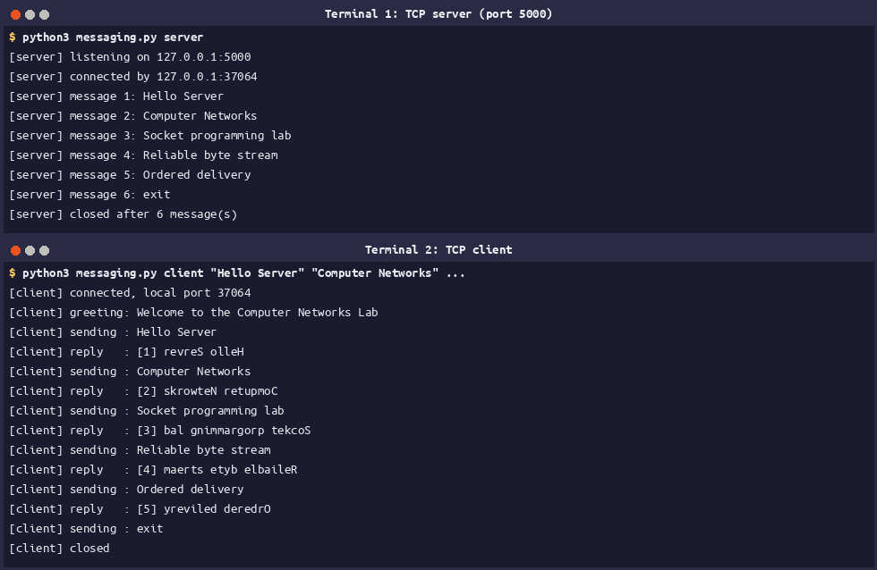
Figure 2: Five messages, numbered and answered in reverse, then exit
The client was accepted from port 37064 and the greeting arrived before the first message was typed.
The UDP version keeps the same shape but the reply rule is a dictionary entry, so Group A task 4 (uppercase) and task 6 (echo) are the same program started with a different --mode.
MODES = {
"upper": lambda data: f"Server received: {data.decode().upper()}".encode(),
"echo": lambda data: data, # exactly what arrived
}

data, peer = server.recvfrom(1024) # one datagram per call
...
server.sendto(reply_for(data), peer)

Figure 3: udp_messaging.py
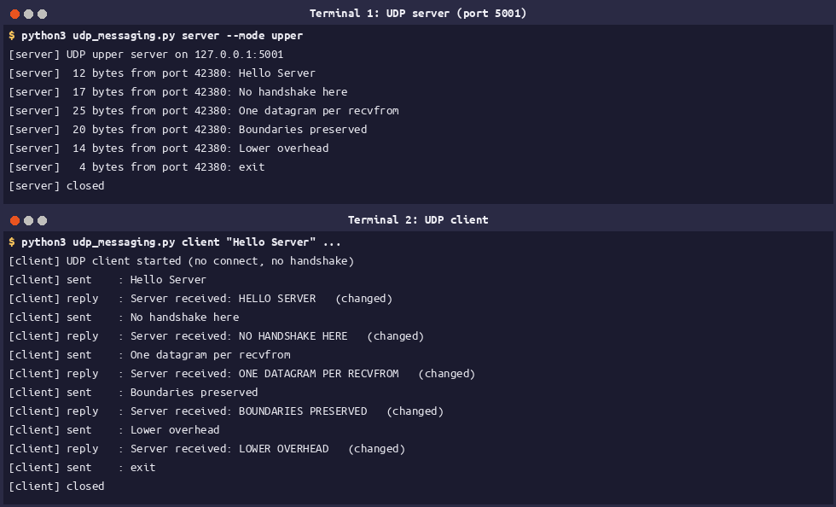
Figure 4: The same five messages over UDP, answered in uppercase (client port 45601)
Experiment 3: the traffic in Wireshark
Both conversations are in lab6b_msg.pcapng (46 packets). tcp.port == 5000 matches 20 of them and udp.port == 5001 matches 16, of which the last five are the echo test of task 6. The remaining 10 packets are DNS lookups from other programs, which the loopback interface carried during the capture.
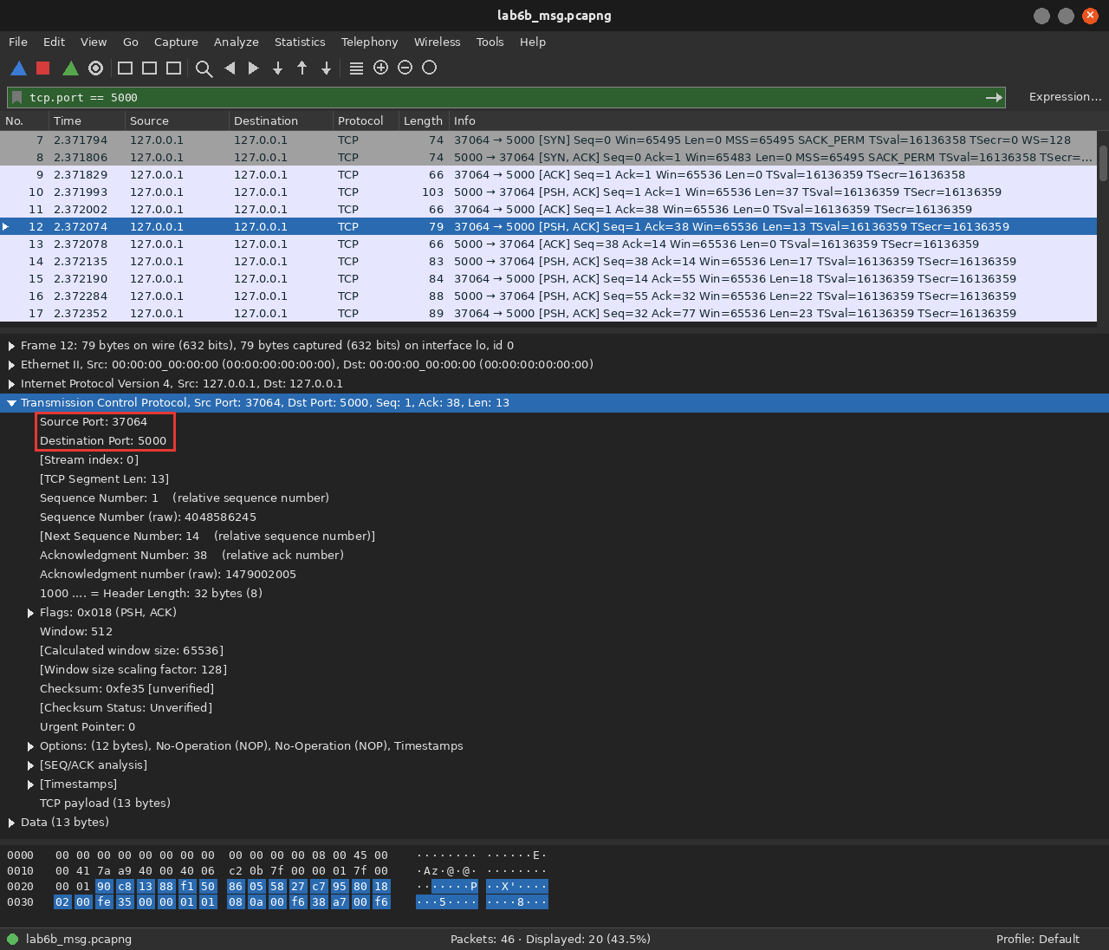
Figure 5: Filter tcp.port == 5000, frame 12 selected: the client's first message (13 bytes)
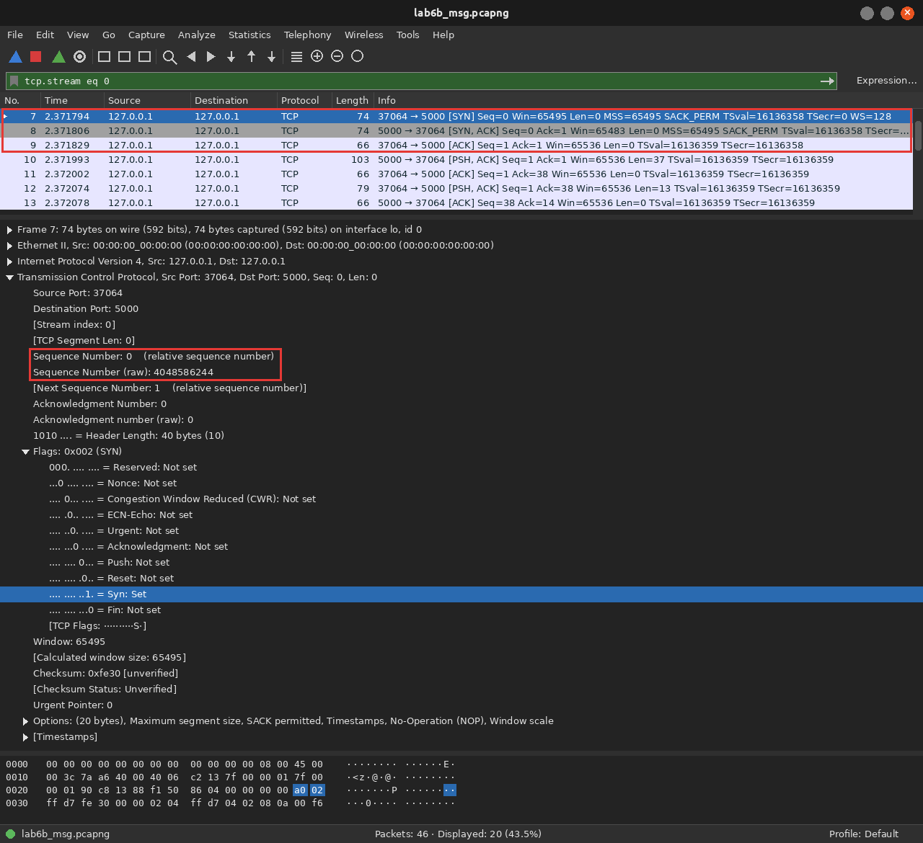
Figure 6: Frames 7-9: SYN, SYN/ACK, ACK. No data can move until all three are done
Packet | Frame | Ports | Flags | Seq / Ack
SYN | 7 | 37064 → 5000 | 0x002 (SYN) | Seq 0
SYN/ACK | 8 | 5000 → 37064 | 0x012 (SYN, ACK) | Seq 0, Ack 1
ACK | 9 | 37064 → 5000 | 0x010 (ACK) | Seq 1, Ack 1

The SYN asks for a connection and announces the client's initial sequence number; the SYN/ACK acknowledges it with ISN+1 and carries the server's own; the final ACK confirms the server's number so both directions are open. The initial round trip was 0.000035 s.
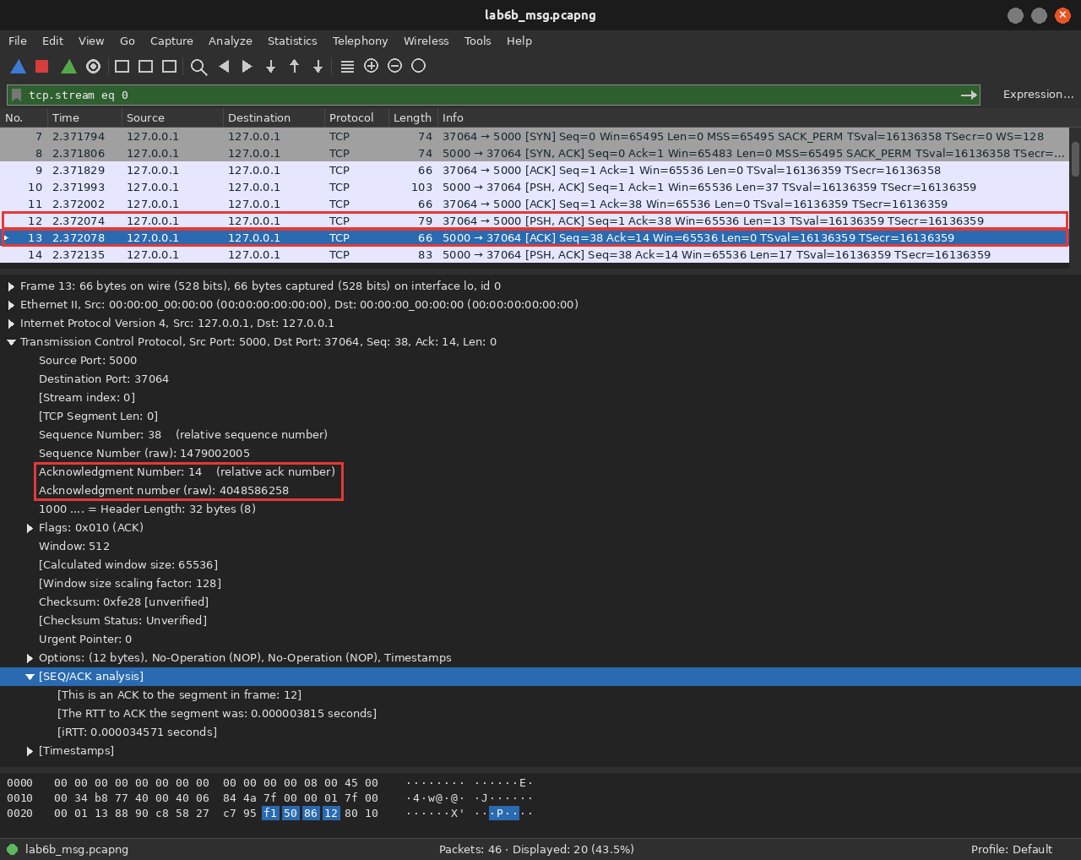
Figure 7: Frame 13 acknowledges the 13 data bytes of frame 12 with Ack = 14
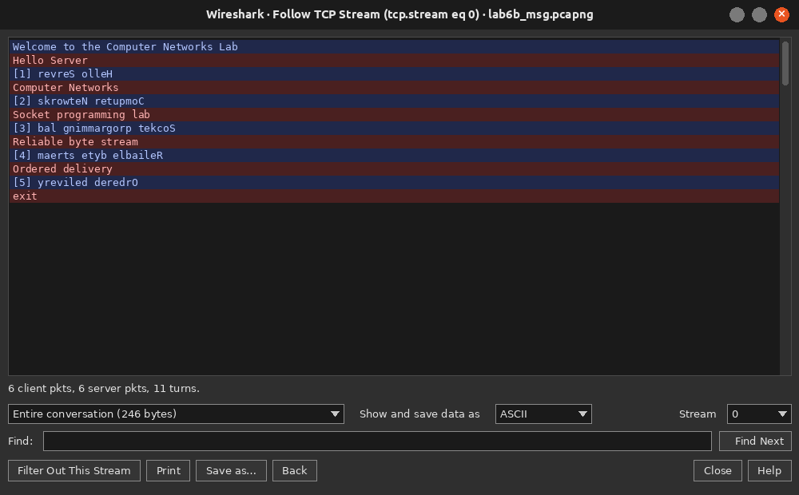
Figure 8: Follow TCP Stream: 6 client packets, 6 server packets, 11 turns, 246 bytes
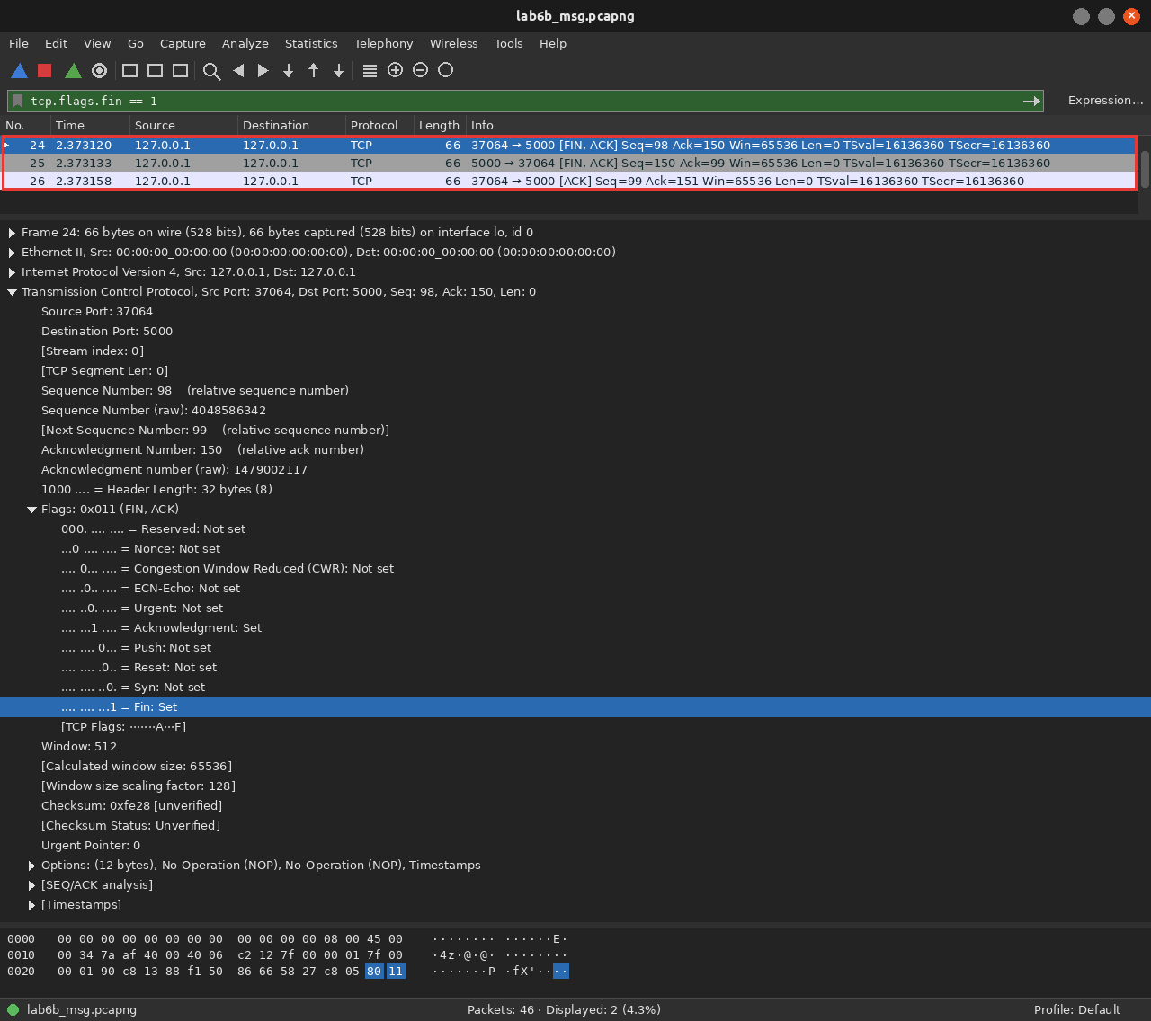
Figure 9: Filter tcp.flags.fin == 1: the close takes FIN/ACK, FIN/ACK and a final ACK (frames 24-26)
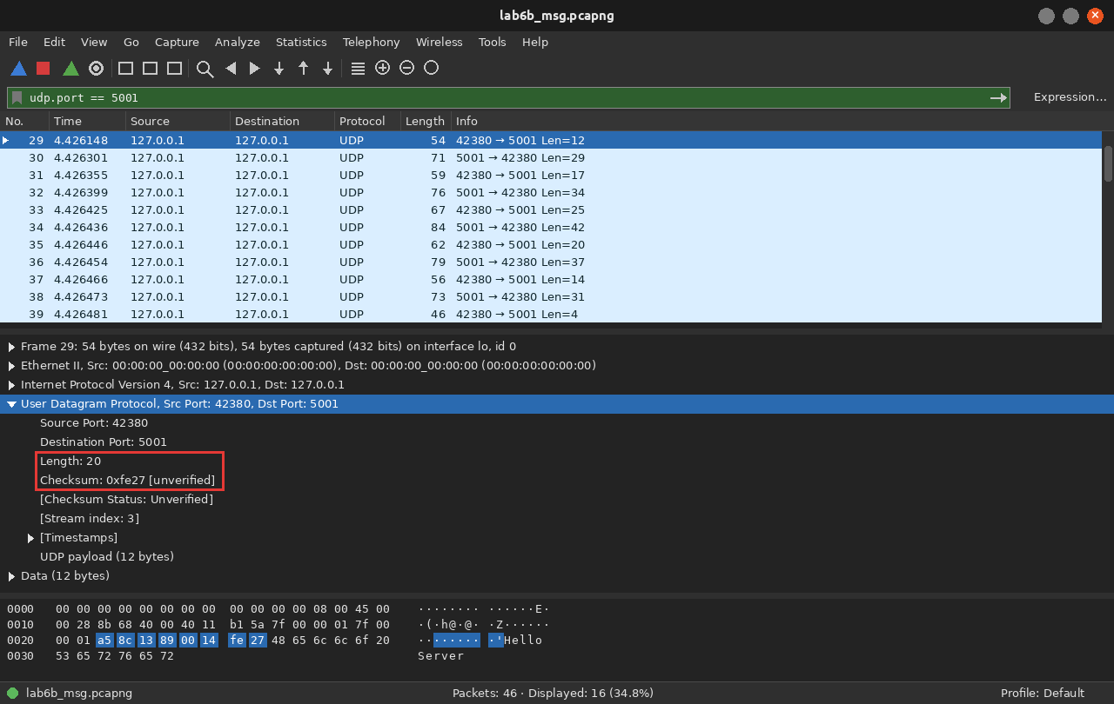
Figure 10: Filter udp.port == 5001: only four header fields, the two ports, Length 20 and Checksum 0xfe27
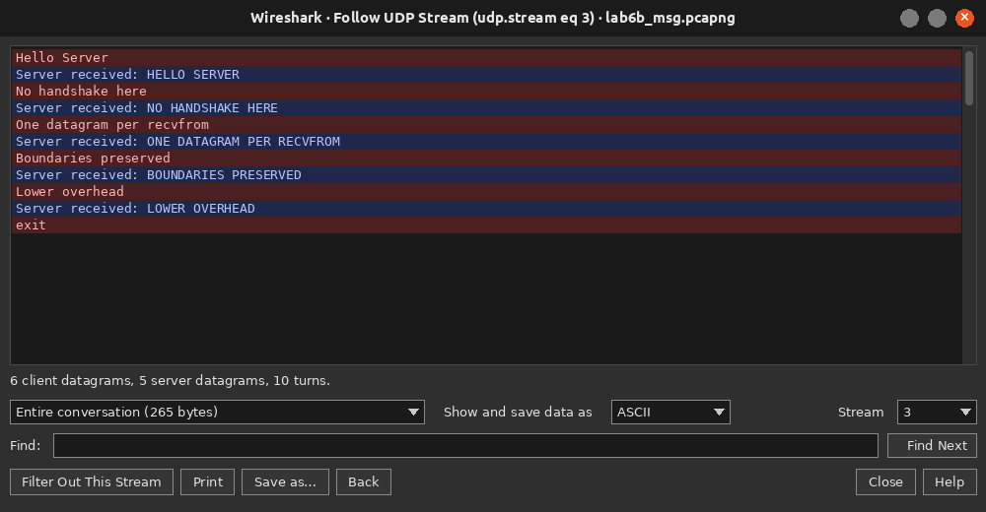
Figure 11: Follow UDP Stream of the messaging conversation (265 bytes, 10 turns)
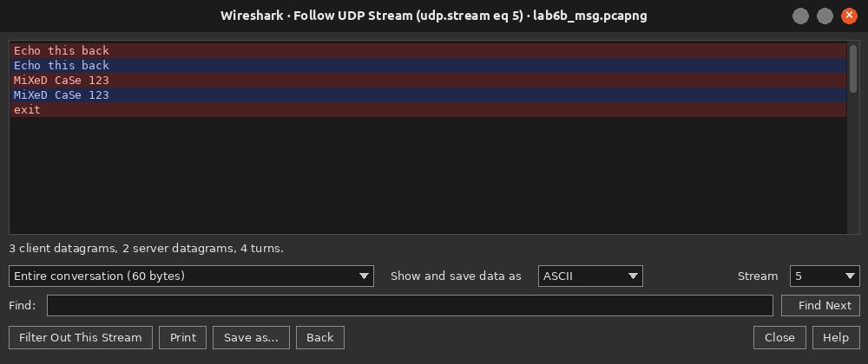
Figure 12: The echo test (Group A task 6): every reply is byte-for-byte what was sent
Comparison (Group B task 2)
Observation | TCP (port 5000) | UDP (port 5001)
Set-up before the first message | 3 packets: SYN, SYN/ACK, ACK | none
One message and its reply | data (PSH, ACK), ACK, reply | one datagram each way
Header fields | ports, seq, ack, flags, window, checksum, options | ports, length, checksum
Header size measured here | 32 bytes (20 + 12 of options) | 8 bytes
Close | FIN, ACK / FIN, ACK / ACK | nothing
Packets for five messages | 20 | 11
My ports | client 37064, server 5000 | client 42380, server 5001

Experiment 4: TCP is a byte stream
Here the sender runs in a background thread, so one command shows both halves of the demonstration.
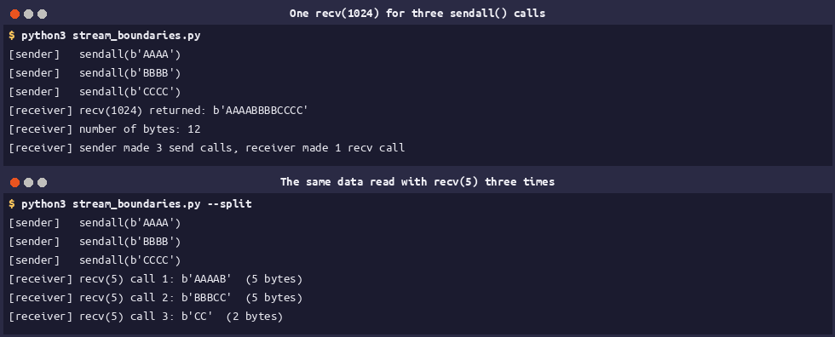
Figure 13: Three sendall() calls read back by one recv(1024), then by three recv(5) calls
One recv() returned all twelve bytes at once (b'AAAABBBBCCCC'), and reading five bytes at a time produced b'AAAAB', b'BBBCC' and b'CC'. The byte order is preserved but the message boundaries are not, which is why a file receiver must know how many bytes to expect and loop until it has them.
Experiments 5 and 6: sharing a file over TCP
The sending loop uses the walrus operator so the end of file is the loop condition itself.
with conn, SOURCE.open("rb") as f:
sent = 0
while chunk := f.read(CHUNK): # stops on b""
conn.sendall(chunk)
sent += len(chunk)

Figure 14: tcp_share.py: server side
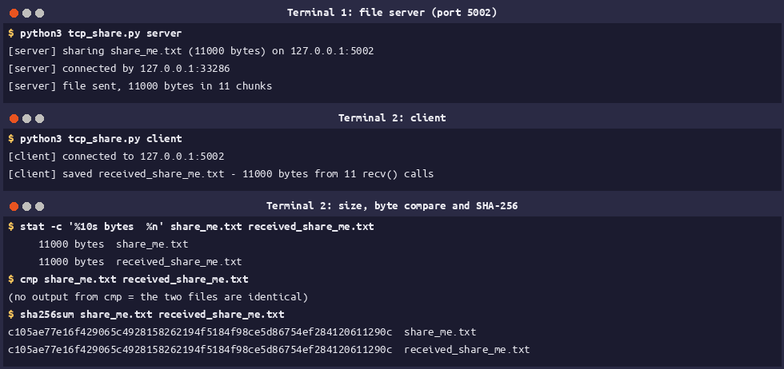
Figure 15: 11000 bytes sent in 11 chunks, received in 11 recv() calls, cmp reports no difference
Both copies are 11000 bytes with SHA-256 c105ae77e16f4290…0611290c. The limitation of this design is that the client only learns the file has ended when the connection closes, so a broken connection would look like a complete file.
For Experiment 6 I had no partner machine, so I ran the same programs over my laptop's real Wi-Fi address (wlp0s20f3, 10.18.162.246) with the server bound to 0.0.0.0 and the client pointed at that address. That is the change the experiment asks for, but the packets still never leave the machine, so this demonstrates the addressing and the firewall path only, not a genuine second host.
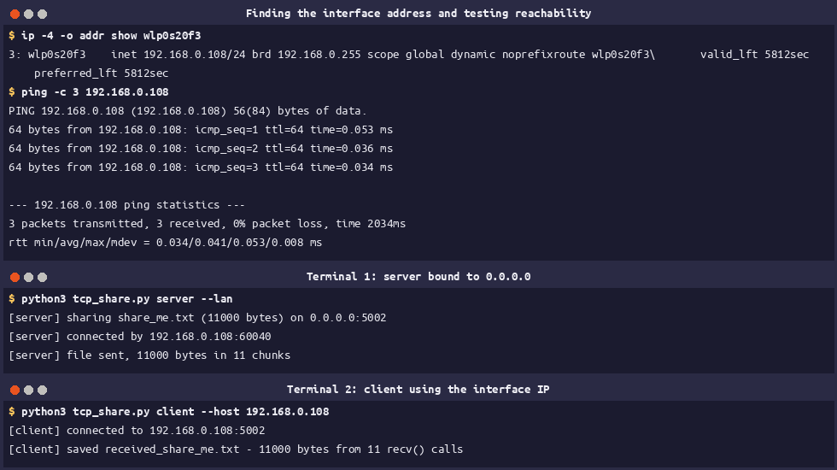
Figure 16: The interface address, a ping to it, and the same transfer over 10.18.162.246
Experiment 7: test file, integrity and timing
make_log.py writes the log with the csv module and a fixed random seed, so the same command always produces the same file and therefore the same fingerprint.
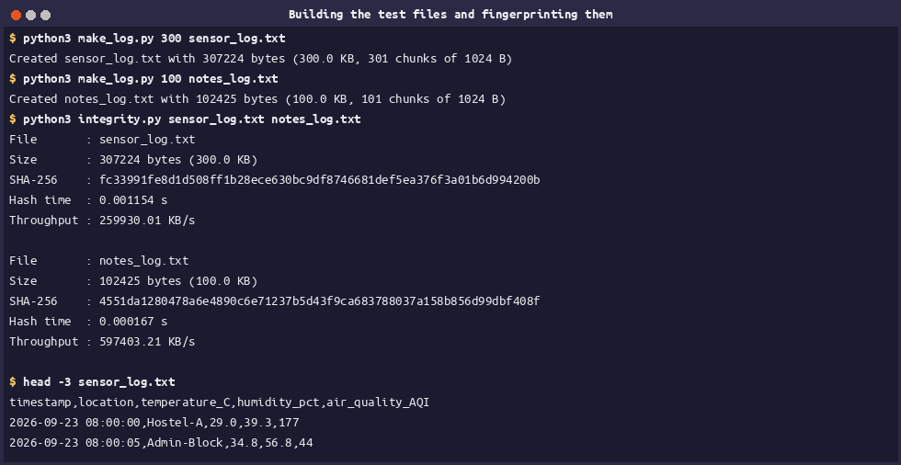
Figure 17: The 300 KB and 100 KB logs, their fingerprints and the first lines of the data
File | Size | SHA-256 (first 16 hex digits)
sensor_log.txt | 307224 bytes (300.0 KB, 301 chunks) | fc33991fe8d1d508…
notes_log.txt | 102425 bytes (100.0 KB, 101 chunks) | 4551da1280478a6e…

Experiment 8: request-response file server over TCP
The wire protocol is the one in the manual: a filename line, then OK <size> <sha256> or ERROR <reason>, then exactly that many bytes. The implementation is built on socketserver.ThreadingTCPServer, so several clients can be served at once and one failed transfer cannot bring the server down, and the client receives into a single pre-sized buffer with recv_into().
buffer = bytearray(size) # exact room for the file
view = memoryview(buffer)
received = 0
while received < size:
got = client.recv_into(view[received:received + min(BUFFER_SIZE, size - received)])
if not got:
print(f"Transfer failed: Connection closed early: got {received} of {size} bytes")
return 1
received += got

Figure 18: tcp_file_client.py: the exact-length receive loop
Filenames are checked twice: the request must be a plain basename, and the resolved path must still be inside server_files/, so ../secret.txt cannot reach anything outside the shared folder.
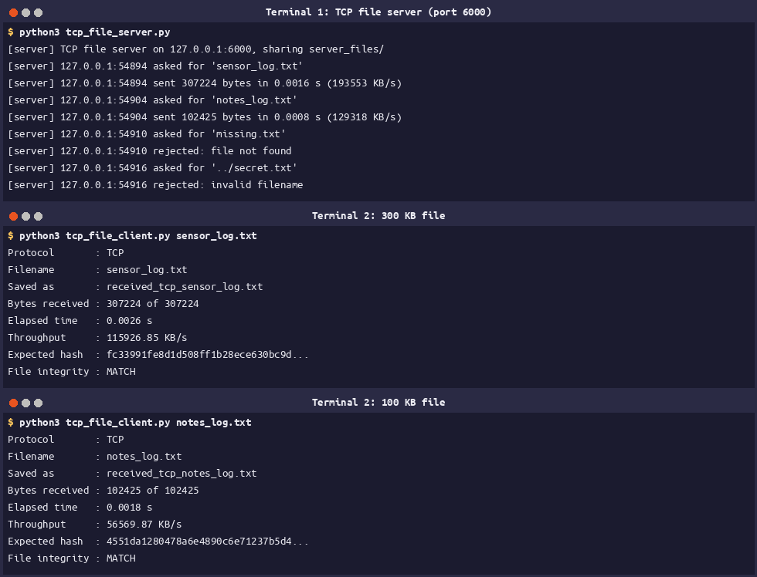
Figure 19: The 300 KB and the 100 KB file, both MATCH
File | Bytes | Elapsed | Throughput | Integrity
sensor_log.txt | 307224 | 0.0026 s | 115926.85 KB/s | MATCH
notes_log.txt | 102425 | 0.0018 s | 56569.87 KB/s | MATCH

Error handling (Group C task 2)
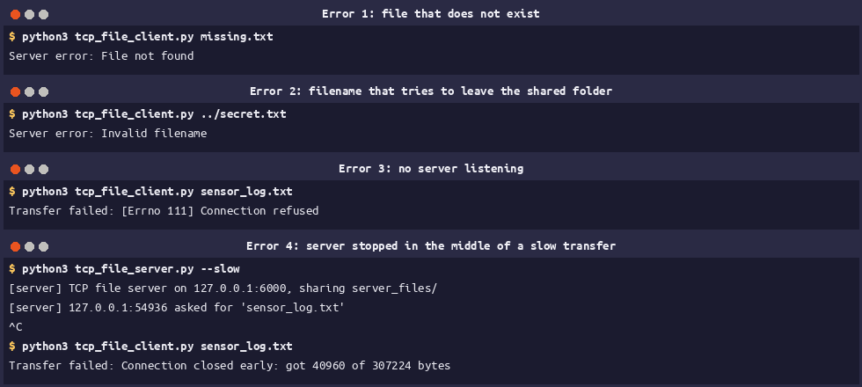
Figure 20: Missing file, invalid filename, no server, and a server stopped in mid-transfer
Test | What the client printed
missing.txt | Server error: File not found
../secret.txt | Server error: Invalid filename
server not running | Transfer failed: [Errno 111] Connection refused
server stopped during transfer | Transfer failed: Connection closed early: got 40960 of 307224 bytes

Experiment 9: file transfer over UDP, with loss repair
Every datagram is a 4-byte sequence number followed by up to 1024 bytes, so the 307224-byte file becomes 301 chunks. The client keeps them in a pre-sized list, which makes a duplicate and a gap equally easy to spot, and reassembly is a single join.
(seq,) = HEADER.unpack_from(packet)
if seq >= expected:
unexpected += 1 # outside the valid range
elif parts[seq] is not None:
duplicates += 1 # already have this one
else:
parts[seq] = packet[HEADER.size:]

Figure 21: udp_file_client.py: sorting the chunks as they arrive
I also implemented the optional challenge from the manual. After the 2-second silence the client sends one RESEND 7,19,… datagram listing every gap; the server keeps the file it last served to that client and sends those chunks again. This is a minimal version of what TCP does by itself.
if verb == "RESEND":
data = served.get(peer)
wanted = [int(n) for n in argument.split(",") if n.strip().isdigit()]
print(f"[server] {peer[1]} asked again for chunk(s) {wanted}")
send_chunks(server, peer, data, wanted)
continue

Figure 22: udp_file_server.py: answering a repair request
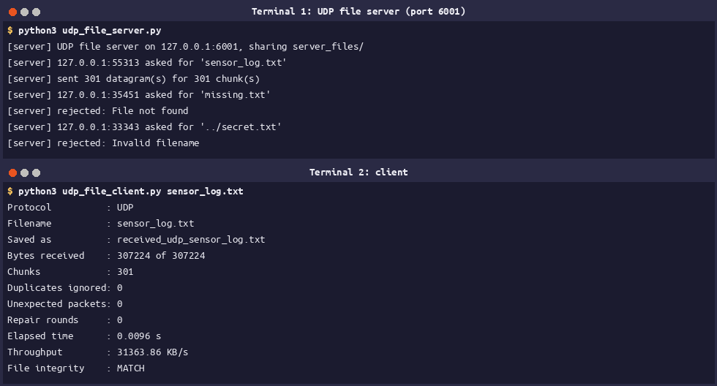
Figure 23: A clean transfer: 301 chunks, 0 duplicates, MATCH
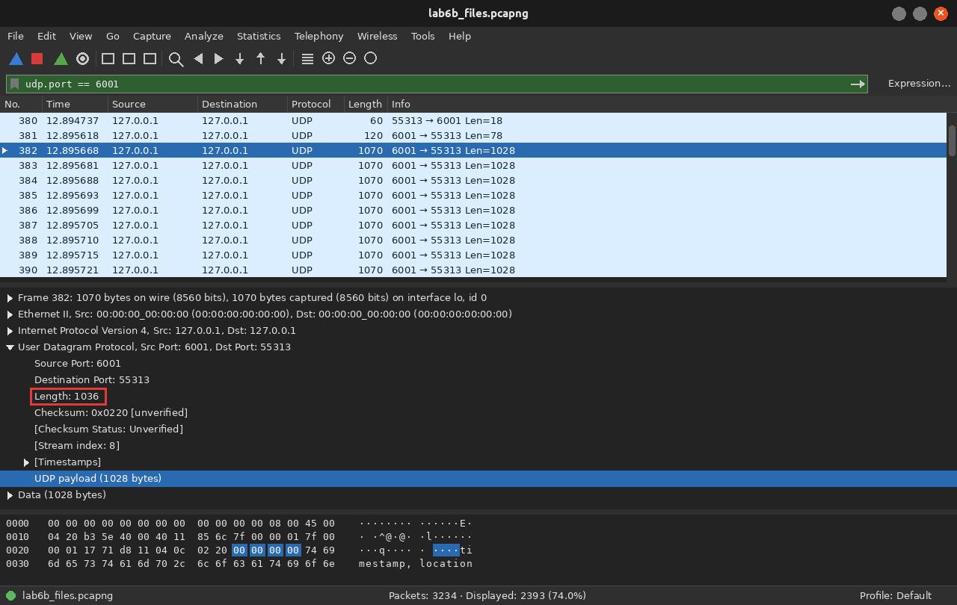
Figure 24: Filter udp.port == 6001: GET, the OK header, then 1028-byte datagrams. The highlighted 00 00 00 00 is the sequence number of chunk 0
Duplicate, out-of-order and loss tests (Group C task 3)
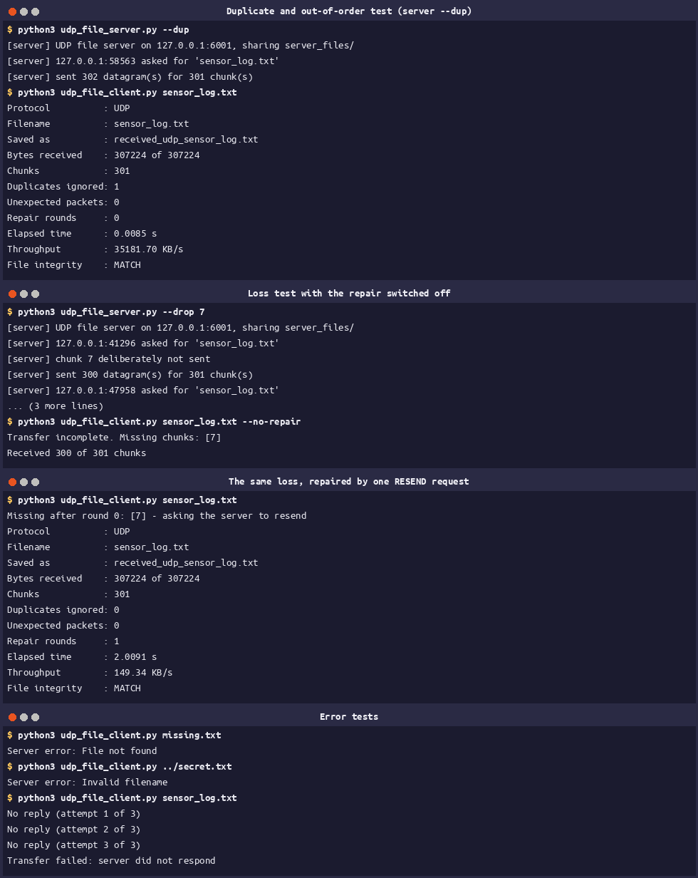
Figure 25: The duplicate test, the loss test with and without the repair, and the error cases
Test | Result
Normal transfer | 301 chunks, 0 duplicates, 0 unexpected, MATCH
Duplicate + out of order (--dup) | 302 datagrams sent, Duplicates ignored: 1, still MATCH
Chunk 7 dropped, repair off | Transfer incomplete. Missing chunks: [7] (300 of 301)
Chunk 7 dropped, repair on | 1 repair round, 301 of 301 chunks, MATCH (2.0091 s, which is the 2 s timeout)
missing.txt / ../secret.txt | Server error: File not found / Invalid filename
No server running | three attempts, then Transfer failed: server did not respond

The duplicate and the swap did no harm because the sequence numbers put everything back in order. The dropped chunk shows where the two protocols differ: with the repair switched off the file simply stays incomplete, and with it switched on the recovery costs a full 2-second timeout because the client has no way of knowing the chunk is missing until the sender goes quiet. TCP notices the same loss from its acknowledgments in a fraction of that time.
Experiment 10: performance comparison
benchmark.py starts both clients three times each, reads the elapsed time out of their output and prints the table, so the runs are measured the same way for both protocols.
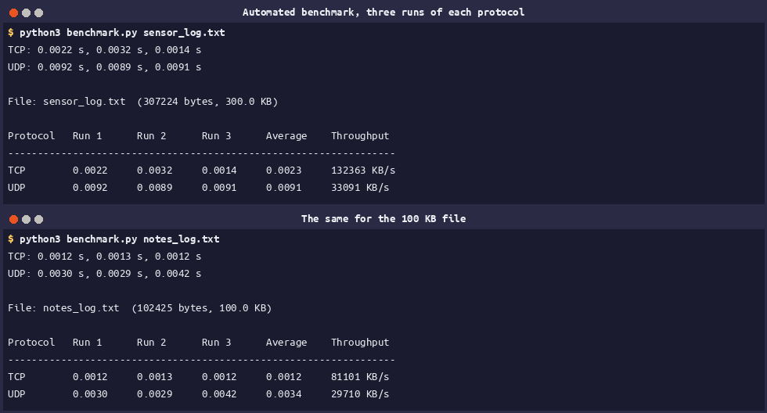
Figure 26: Three runs of each protocol, for the 300 KB file and for the 100 KB file
Protocol | Run 1 (s) | Run 2 (s) | Run 3 (s) | Average (s) | Throughput (KB/s)
TCP | 0.0018 | 0.0017 | 0.0016 | 0.0017 | 176484
UDP | 0.0088 | 0.0095 | 0.0087 | 0.0090 | 33336

The same two rows have been filled into the manual's own table in Experiment 10. For the 100 KB file the averages were 0.0012 s (81101 KB/s) for TCP and 0.0034 s (29710 KB/s) for UDP.
Comparison
TCP was about four times faster than my UDP program on this machine, which is not the result the usual TCP-versus-UDP table would lead you to expect. The measurement is of my two programs on loopback, not of the protocols on a network: there is no real loss or congestion here, so TCP's reliability costs almost nothing and the kernel hands it very large segments, while my UDP sender makes 301 separate sendto() calls and deliberately sleeps 1 ms after every 50 of them so the receiver's buffer does not overflow. That pacing is most of the difference. The honest conclusion is about work rather than speed: TCP gave me ordering, retransmission, flow control and a definite end of file for free, and over UDP I had to build sequence numbers, a chunk count, duplicate detection, a timeout and finally a resend request to get a fraction of the same behaviour.
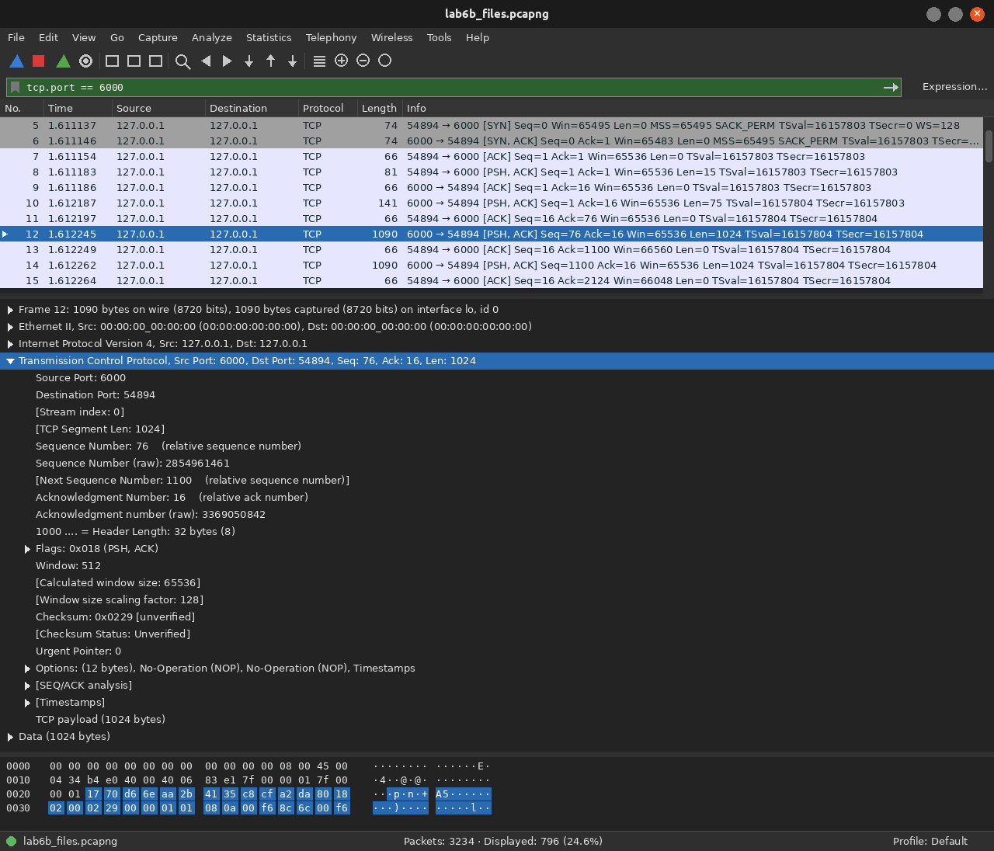
Figure 27: Filter tcp.port == 6000: on loopback the 1024-byte writes are merged into a few very large segments
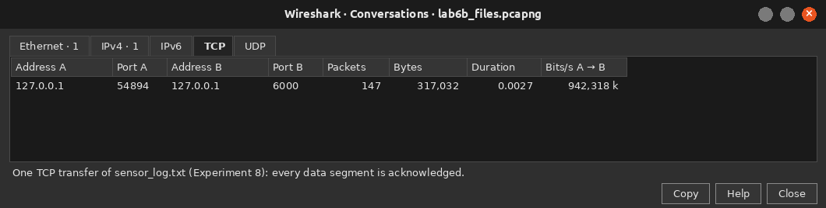
Figure 28: Statistics → Conversations, TCP tab: one transfer of sensor_log.txt
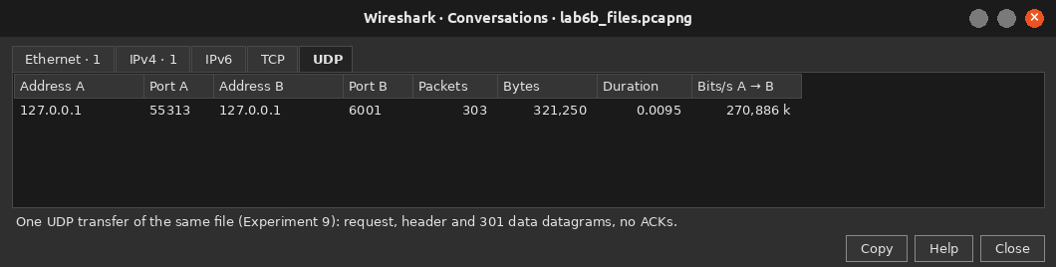
Figure 29: The UDP tab for the same file
Measure | TCP (port 6000) | UDP (port 6001)
Packets for one 300 KB transfer | 147 | 303
Bytes on the wire | 317,032 | 321,250
Acknowledgments | every segment is acknowledged | none
Largest data unit seen | 63552 bytes (merged segments) | 1028 bytes (4 + 1024)
Connection packets | SYN, SYN/ACK, ACK, FINs | none

Lab tasks: Group A
Task | Where it is | What changed
1. Welcome message | messaging.py, serve() | the greeting is written before the read loop starts
2. Message counter | messaging.py, serve() | counter += 1 per line, printed as message 1, 2, …
3. Reverse server | messaging.py, transform() | returns f"[{number}] {text[::-1]}"
4. Uppercase server | udp_messaging.py, MODES['upper'] | reply built from data.decode().upper()
5. TCP calculator | calculator.py | operators come from the operator module
6. UDP echo | udp_messaging.py, MODES['echo'] | the reply is the received bytes themselves

Task 5: calculator (port 5005)
OPS = {"+": operator.add, "-": operator.sub, "*": operator.mul, "/": operator.truediv}

def evaluate(line: str) -> str:
fields = line.split()
if len(fields) != 3:
return "ERROR expected: number operator number"
left, symbol, right = fields
if symbol not in OPS:
return f"ERROR unknown operator {symbol!r} (use + - * /)"
try:
a, b = float(left), float(right)
except ValueError:
return f"ERROR {left!r} or {right!r} is not a number"
try:
return f"Result: {OPS[symbol](a, b):g}"
except ZeroDivisionError:
return "ERROR division by zero"

Figure 30: calculator.py: adding an operator is one dictionary entry
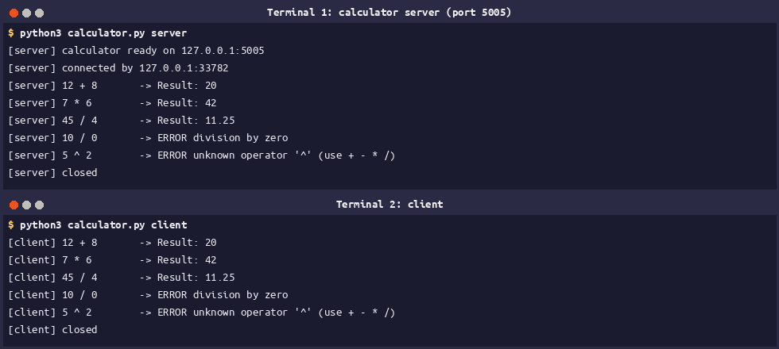
Figure 31: Three working operations and the two error cases
Task 6: UDP echo
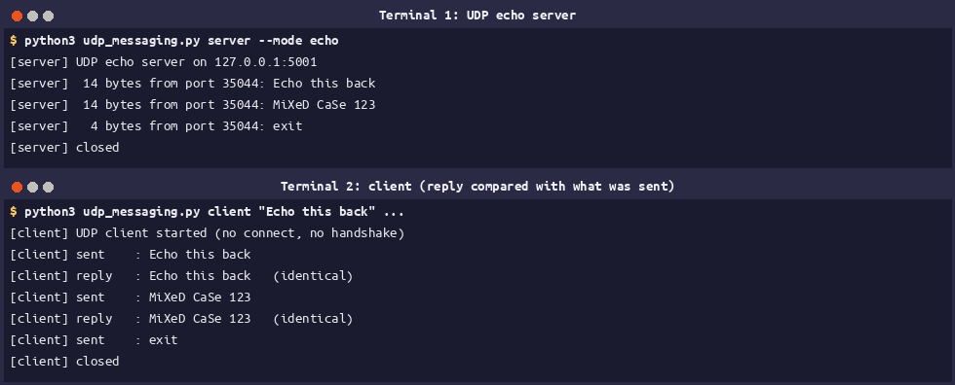
Figure 32: The client marks each reply identical because the bytes come back unchanged
Group B is answered by the Wireshark section above, and Group C by Experiments 8, 9 and 10. The final check is that both received copies match the original byte for byte:
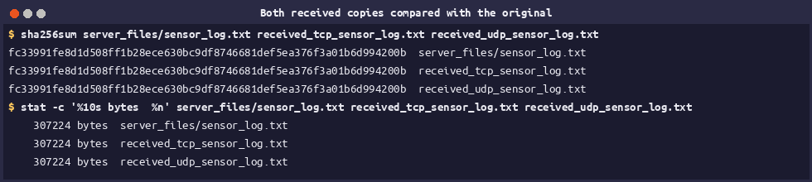
Figure 33: The TCP copy, the UDP copy and the original share one SHA-256
Review Questions
Q1. What is the difference between connection-oriented and connectionless communication? Give one example of each.
Connection-oriented means a connection is set up before any data moves and closed afterwards, and the protocol itself guarantees ordered and reliable delivery. TCP works this way, and my file server on port 6000 uses it. Connectionless means each datagram travels on its own with no set-up and no guarantee, which is UDP, used by the messaging server on port 5001.
Q2. Why does a server call bind() while a client usually does not?
The client must know where to find the server, so the server fixes itself to a known port. The client only needs some free port for the answers, so the operating system assigns an ephemeral one, which was 37064 and 42380 in my captures.
Q3. What do listen() and accept() do? What does accept() return?
listen() makes the socket passive and starts queueing connection requests. accept() blocks until one arrives and returns two things: a new socket dedicated to that client, and the client's (IP, port). The listening socket itself is never used for data.
Q4. Why can one recv() return fewer bytes than were sent, or several messages joined together? How does the TCP file client handle this?
Because TCP delivers a stream of bytes, not messages: the kernel may merge or split what the sender wrote, which Experiment 4 showed directly. The file client first reads the size from the header and then loops with recv_into() over a buffer of exactly that size until every byte is accounted for.
Q5. Why does the TCP file server send the file size before the file data?
So the end of the file is defined by the protocol instead of by the connection closing. That is what turns a broken transfer into a clear error, Connection closed early: got 40960 of 307224 bytes, instead of a silently truncated file.
Q6. What is the difference between 127.0.0.1 and 0.0.0.0?
127.0.0.1 is loopback: it always means this machine, so only local clients can connect. Binding to 0.0.0.0 means every interface, which is what lets another computer (or, in my case, the laptop's own Wi-Fi address) reach the server.
Q7. In the UDP file transfer, why is a sequence number needed? What can happen to UDP datagrams on the way?
UDP datagrams can be lost, duplicated, reordered, or dropped when the receive buffer overflows. The 4-byte number is what lets the receiver reassemble them in order, ignore a repeat and name the ones that never came . My tests produced Duplicates ignored: 1 and Missing chunks: [7].
Q8. Why is comparing SHA-256 hashes better than comparing file sizes?
The size only says how many bytes arrived. The hash depends on every byte, so one wrong byte changes the whole value: the size counts the bytes and the hash identifies them.
Q9. How is throughput calculated? Why do we average several runs?
(bytes ÷ 1024) ÷ elapsed seconds, with the time measured by time.perf_counter(). One run is noisy because of scheduling and caching, so three runs are averaged; my individual TCP runs varied between 0.0014 s and 0.0032 s.
Q10. Why must a file server reject filenames such as ../secret.txt?
Otherwise joining the name to the shared folder points outside it and any client could read private files. My server rejects anything that is not a plain basename and then re-checks that the resolved path is still inside server_files/, so the request is answered with ERROR Invalid filename.
Conclusion
Working through the experiments showed the two transport protocols from both sides. TCP spent three packets before the first message and three more closing down, and gave back an ordered, acknowledged byte stream with no message boundaries left in it, which is why the file client is built around a size header and an exact-length loop. UDP sent each message immediately with an 8-byte header and no bookkeeping at all, and in exchange I had to write the bookkeeping myself: sequence numbers, a chunk count, duplicate detection, a timeout, and finally a RESEND request to recover the chunk the server deliberately dropped. Every transfer was checked with SHA-256 and matched, and the timing runs were a reminder that on a single machine the numbers describe my two programs at least as much as they describe TCP and UDP.

