Department of Computing

School of Electrical Engineering and Computer Science

CS-250: Data Structure and Algorithms
Class: BSDS 3A

Lab 6: Stacks and Queues

Date: 12th October 2025
Time: 10:00 am – 12:50 pm

Instructor: Dr. Fahad Ahmed Satti

Lab Engineer: Hassan Mohtashim

Submitted by: Arqam Waheed (553514)

Lab 6: Stacks and Queues

Introduction
In this lab, we will study the implementation of Stacks and Queues, two fundamental linear data structures used in computer science. A Stack follows the Last In, First Out (LIFO) principle, where the most recently added element is removed first, while a Queue follows the First In, First Out (FIFO) principle, where the earliest added element is removed first.
Objectives
Objective of this lab is to enable students to build stack ADT using linked list and arrays, perform the following tasks on it and analyze the performance of each implementation.
Tools/Software Requirement

Visual Studio Code in Unix/Linux Environment.
Task 1: Expression Conversion and Evaluation
Write a program that converts arithmetic expressions between infix, postfix, and prefix forms, and evaluates them. You must implement the stack data structure yourselves (using arrays or linked lists). Use of built-in library is not allowed.
Functions to implement:
- string infix_to_postfix(string expr)
- string infix_to_prefix(string expr)
- string postfix_to_infix(string expr)
- double evaluate_postfix(string expr)
- double evaluate_prefix(string expr)
Solution
The stacks are array based: a string stack for operators and partial expressions, and a double stack for values. Infix to postfix is the shunting-yard method, where ^ is right associative. Infix to prefix reverses the tokens, swaps the brackets, runs the same routine with the associativity rule flipped and reverses the result. Prefix is evaluated by scanning from right to left.
Code: task1.cpp
#include <iostream>
#include <string>
#include <cmath>
#include <stdexcept>
using namespace std;

const int MAX = 100;

class StringStack {
string items[MAX];
int topIndex;

public:
StringStack() { topIndex = -1; }

bool empty() { return topIndex == -1; }

void push(string s) {
if (topIndex == MAX - 1)
throw runtime_error("stack overflow");
items[++topIndex] = s;
}

string pop() {
if (empty())
throw runtime_error("malformed expression");
return items[topIndex--];
}

string peek() {
if (empty())
throw runtime_error("malformed expression");
return items[topIndex];
}
};

class DoubleStack {
double items[MAX];
int topIndex;

public:
DoubleStack() { topIndex = -1; }

bool empty() { return topIndex == -1; }

void push(double d) {
if (topIndex == MAX - 1)
throw runtime_error("stack overflow");
items[++topIndex] = d;
}

double pop() {
if (empty())
throw runtime_error("malformed expression");
return items[topIndex--];
}
};

bool isOp(string t) {
return t == "+" || t == "-" || t == "*" || t == "/" || t == "^";
}

bool isValue(string t) {
return isdigit(t[0]) || t[0] == '.' || isalpha(t[0]);
}

int precedence(string op) {
if (op == "^") return 3;
if (op == "*" || op == "/") return 2;
if (op == "+" || op == "-") return 1;
return 0;
}

int tokenize(string expr, string tokens[]) {
int n = 0;
int i = 0;
while (i < (int)expr.length()) {
char c = expr[i];
if (c == ' ') {
i++;
}
else if (isdigit(c) || c == '.') {
string num;
while (i < (int)expr.length() && (isdigit(expr[i]) || expr[i] == '.'))
num += expr[i++];
tokens[n++] = num;
}
else if (isalpha(c) || c == '(' || c == ')' || isOp(string(1, c))) {
tokens[n++] = string(1, c);
i++;
}
else {
throw runtime_error(string("unknown symbol '") + c + "'");
}
if (n == MAX)
throw runtime_error("expression too long");
}
return n;
}

string join(string tokens[], int n) {
string result;
for (int i = 0; i < n; i++) {
if (i > 0)
result += " ";
result += tokens[i];
}
return result;
}

int shunt(string in[], int n, string out[], bool reversed) {
StringStack ops;
int m = 0;

for (int i = 0; i < n; i++) {
string t = in[i];
if (isValue(t)) {
out[m++] = t;
}
else if (t == "(") {
ops.push(t);
}
else if (t == ")") {
while (!ops.empty() && ops.peek() != "(")
out[m++] = ops.pop();
if (ops.empty())
throw runtime_error("unbalanced parentheses");
ops.pop();
}
else {
while (!ops.empty() && ops.peek() != "(") {
int top = precedence(ops.peek());
int cur = precedence(t);
bool rightAssoc = (t == "^");
bool popIt;
if (reversed)
popIt = top > cur || (top == cur && rightAssoc);
else
popIt = top > cur || (top == cur && !rightAssoc);
if (!popIt)
break;
out[m++] = ops.pop();
}
ops.push(t);
}
}

while (!ops.empty()) {
if (ops.peek() == "(")
throw runtime_error("unbalanced parentheses");
out[m++] = ops.pop();
}
return m;
}

string infix_to_postfix(string expr) {
string tokens[MAX], out[MAX];
int n = tokenize(expr, tokens);
int m = shunt(tokens, n, out, false);
return join(out, m);
}

string infix_to_prefix(string expr) {
string tokens[MAX], rev[MAX], out[MAX], pre[MAX];
int n = tokenize(expr, tokens);

for (int i = 0; i < n; i++) {
string t = tokens[n - 1 - i];
if (t == "(")
rev[i] = ")";
else if (t == ")")
rev[i] = "(";
else
rev[i] = t;
}

int m = shunt(rev, n, out, true);
for (int i = 0; i < m; i++)
pre[i] = out[m - 1 - i];
return join(pre, m);
}

string postfix_to_infix(string expr) {
string tokens[MAX];
int n = tokenize(expr, tokens);
StringStack st;

for (int i = 0; i < n; i++) {
if (isValue(tokens[i])) {
st.push(tokens[i]);
}
else if (isOp(tokens[i])) {
string right = st.pop();
string left = st.pop();
st.push("(" + left + " " + tokens[i] + " " + right + ")");
}
else {
throw runtime_error("parentheses are not allowed in postfix");
}
}

string result = st.pop();
if (!st.empty())
throw runtime_error("too many operands");
return result;
}

double calculate(double a, double b, string op) {
if (op == "+") return a + b;
if (op == "-") return a - b;
if (op == "*") return a * b;
if (op == "^") return pow(a, b);
if (b == 0)
throw runtime_error("division by zero");
return a / b;
}

double numberOf(string t) {
if (isalpha(t[0]))
throw runtime_error("variable '" + t + "' has no value");
return stod(t);
}

double evaluate_postfix(string expr) {
string tokens[MAX];
int n = tokenize(expr, tokens);
DoubleStack st;

for (int i = 0; i < n; i++) {
if (isValue(tokens[i])) {
st.push(numberOf(tokens[i]));
}
else if (isOp(tokens[i])) {
double b = st.pop();
double a = st.pop();
st.push(calculate(a, b, tokens[i]));
}
else {
throw runtime_error("parentheses are not allowed in postfix");
}
}

double result = st.pop();
if (!st.empty())
throw runtime_error("too many operands");
return result;
}

double evaluate_prefix(string expr) {
string tokens[MAX];
int n = tokenize(expr, tokens);
DoubleStack st;

for (int i = n - 1; i >= 0; i--) {
if (isValue(tokens[i])) {
st.push(numberOf(tokens[i]));
}
else if (isOp(tokens[i])) {
double a = st.pop();
double b = st.pop();
st.push(calculate(a, b, tokens[i]));
}
else {
throw runtime_error("parentheses are not allowed in prefix");
}
}

double result = st.pop();
if (!st.empty())
throw runtime_error("too many operands");
return result;
}

void analyse(string infix) {
string postfix = infix_to_postfix(infix);
string prefix = infix_to_prefix(infix);
cout << " Postfix : " << postfix << endl;
cout << " Prefix : " << prefix << endl;
cout << " Back to infix : " << postfix_to_infix(postfix) << endl;
try {
double fromPostfix = evaluate_postfix(postfix);
double fromPrefix = evaluate_prefix(prefix);
cout << " Postfix value : " << fromPostfix << endl;
cout << " Prefix value : " << fromPrefix << endl;
}
catch (runtime_error& e) {
cout << " Value : not evaluated, " << e.what() << endl;
}
}

int main() {
int choice = -1;
string line;

while (choice != 0) {
cout << "\n[1] Analyse infix [2] Postfix to infix [3] Evaluate postfix [4] Evaluate prefix [0] Exit" << endl;
cout << "Choice: ";

if (!(cin >> choice)) {
if (cin.eof())
break;
cin.clear();
cin.ignore(1000, '\n');
choice = -1;
cout << "Please enter a number" << endl;
continue;
}
if (choice == 0)
break;
if (choice < 0 || choice > 4) {
cout << "Please choose 0-4" << endl;
continue;
}

cout << "Expression: ";
cin.ignore(1000, '\n');
getline(cin, line);

try {
if (choice == 1) {
analyse(line);
}
else if (choice == 2) {
string infix = postfix_to_infix(line);
cout << " Infix : " << infix << endl;
}
else {
double value = (choice == 3) ? evaluate_postfix(line) : evaluate_prefix(line);
cout << " Value : " << value << endl;
}
}
catch (runtime_error& e) {
cout << " Error : " << e.what() << endl;
}
}

cout << "Goodbye" << endl;
}

Output
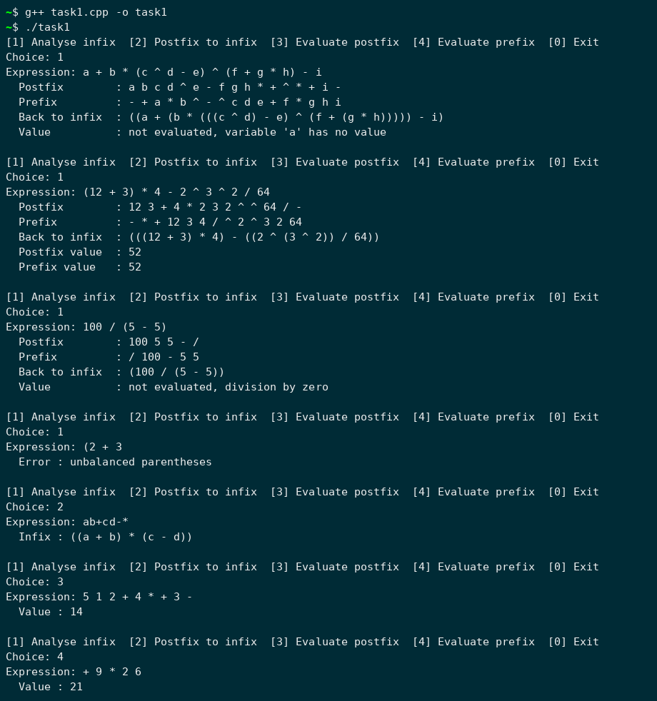
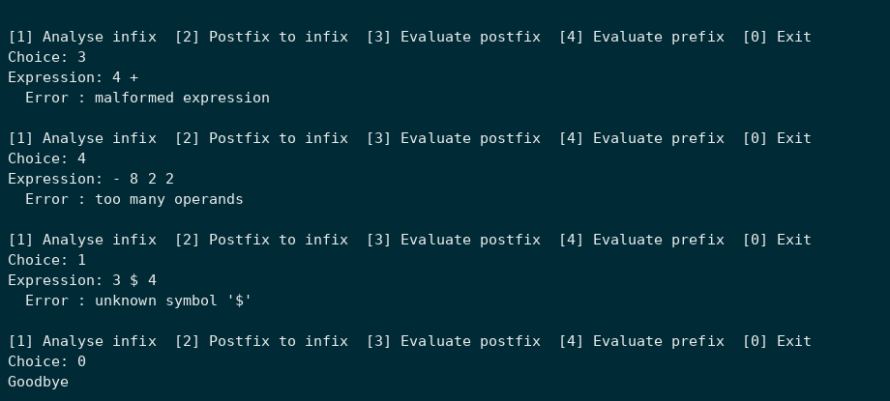

Task 2: Expression Validators Using Stack
Implement two stack-based validators to check the correctness of brackets and HTML/XML tag structures.
Part A — Bracket Validator
Write a program to verify if all types of brackets — (), {}, and [] — are balanced and correctly nested.
Function:
isValidBrackets(s: str) -> bool
Part B — HTML/XML Tag Validator
Validate a simplified HTML/XML string for proper nesting and closing of tags using a stack.
Function:
validate_markup(s: str) -> (bool, list_of_errors)
Solution
Brackets are checked with a character stack, where every closing bracket must match the most recent opening one. The markup validator pushes each opening tag with its position. Tag names are case-insensitive, and void tags such as <br> and <img> or self-closing tags such as <img/> are never pushed. Errors are collected in a MarkupResult that holds the (bool, list_of_errors) pair.
Code: task2.cpp
#include <iostream>
#include <string>
using namespace std;

const int MAX = 200;

class CharStack {
char items[MAX];
int topIndex;

public:
CharStack() { topIndex = -1; }
bool empty() { return topIndex == -1; }
bool full() { return topIndex == MAX - 1; }
void push(char c) { items[++topIndex] = c; }
char pop() { return items[topIndex--]; }
};

class TagStack {
string names[MAX];
int positions[MAX];
int topIndex;

public:
TagStack() { topIndex = -1; }
bool empty() { return topIndex == -1; }
bool full() { return topIndex == MAX - 1; }
int size() { return topIndex + 1; }

void push(string name, int pos) {
topIndex++;
names[topIndex] = name;
positions[topIndex] = pos;
}

void pop() { topIndex--; }
string topName() { return names[topIndex]; }
int topPos() { return positions[topIndex]; }
string nameBelowTop() { return names[topIndex - 1]; }
};

struct MarkupResult {
bool valid;
string errors[MAX];
int errorCount;
};

char matching(char close) {
if (close == ')') return '(';
if (close == ']') return '[';
return '{';
}

bool isValidBrackets(string s) {
CharStack st;
for (int i = 0; i < (int)s.length(); i++) {
char c = s[i];
if (c == '(' || c == '[' || c == '{') {
if (st.full())
return false;
st.push(c);
}
else if (c == ')' || c == ']' || c == '}') {
if (st.empty() || st.pop() != matching(c))
return false;
}
}
return st.empty();
}

string lower(string s) {
for (int i = 0; i < (int)s.length(); i++)
s[i] = tolower(s[i]);
return s;
}

bool isVoidTag(string name) {
string voids[] = {"br", "hr", "img", "input", "meta", "link"};
for (int i = 0; i < 6; i++)
if (name == voids[i])
return true;
return false;
}

void report(MarkupResult& r, string msg) {
if (r.errorCount < MAX)
r.errors[r.errorCount++] = msg;
}

MarkupResult validate_markup(string s) {
MarkupResult r;
r.errorCount = 0;
TagStack st;
int i = 0;

while (i < (int)s.length()) {
if (s[i] != '<') {
i++;
continue;
}

int start = i;
int end = s.find('>', i);
if (end == -1) {
report(r, "char " + to_string(start) + ": '<' has no closing '>'");
break;
}
string body = s.substr(start + 1, end - start - 1);
i = end + 1;

bool isClosing = body.length() > 0 && body[0] == '/';
bool selfClosing = body.length() > 0 && body[body.length() - 1] == '/';
if (isClosing)
body = body.substr(1);

string name;
int k = 0;
while (k < (int)body.length() && isalnum(body[k]))
name += body[k++];
name = lower(name);

if (name == "") {
report(r, "char " + to_string(start) + ": tag has no name");
continue;
}

if (isClosing) {
if (isVoidTag(name)) {
report(r, "char " + to_string(start) + ": <" + name + "> never needs a closing tag");
}
else if (st.empty()) {
report(r, "char " + to_string(start) + ": </" + name + "> has no opening tag");
}
else if (st.topName() == name) {
st.pop();
}
else {
report(r, "char " + to_string(start) + ": expected </" + st.topName() + "> but found </" + name + ">");
if (st.size() > 1 && st.nameBelowTop() == name) {
st.pop();
st.pop();
}
}
}
else if (!selfClosing && !isVoidTag(name)) {
if (st.full()) {
report(r, "too many nested tags");
break;
}
st.push(name, start);
}
}

while (!st.empty()) {
report(r, "char " + to_string(st.topPos()) + ": <" + st.topName() + "> is never closed");
st.pop();
}

r.valid = (r.errorCount == 0);
return r;
}

int main() {
int choice = -1;
string line;

while (choice != 0) {
cout << "\n[1] Check brackets [2] Check HTML/XML markup [0] Exit" << endl;
cout << "Choice: ";

if (!(cin >> choice)) {
if (cin.eof())
break;
cin.clear();
cin.ignore(1000, '\n');
choice = -1;
cout << "Please enter a number" << endl;
continue;
}
if (choice == 0)
break;
if (choice != 1 && choice != 2) {
cout << "Please choose 0-2" << endl;
continue;
}

cout << "Input: ";
cin.ignore(1000, '\n');
getline(cin, line);

if (choice == 1) {
cout << " " << (isValidBrackets(line) ? "true (balanced)" : "false (not balanced)") << endl;
}
else {
MarkupResult r = validate_markup(line);
if (r.valid) {
cout << " true, no errors" << endl;
}
else {
cout << " false, " << r.errorCount << " error(s)" << endl;
for (int j = 0; j < r.errorCount; j++)
cout << " - " << r.errors[j] << endl;
}
}
}

cout << "Goodbye" << endl;
}

Output
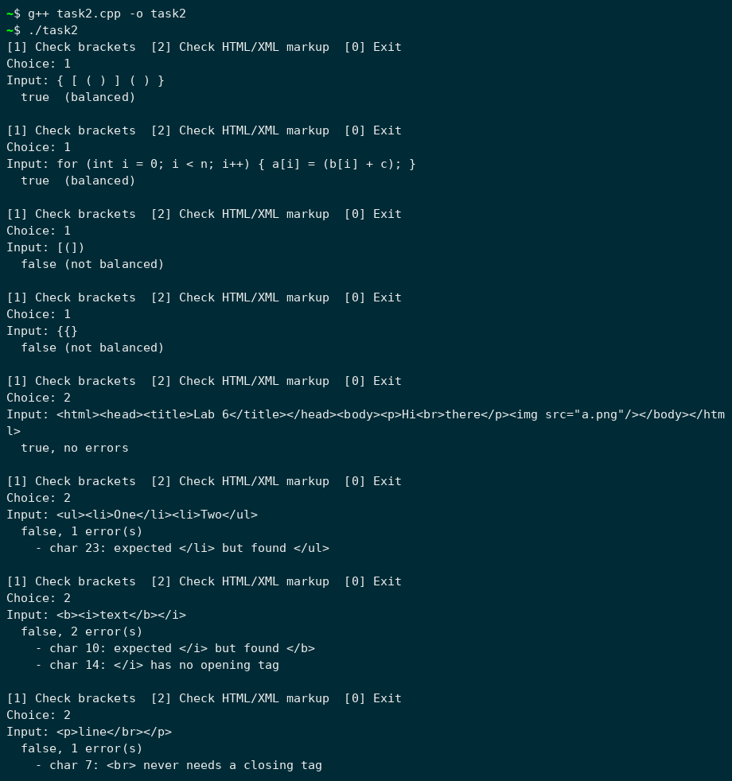
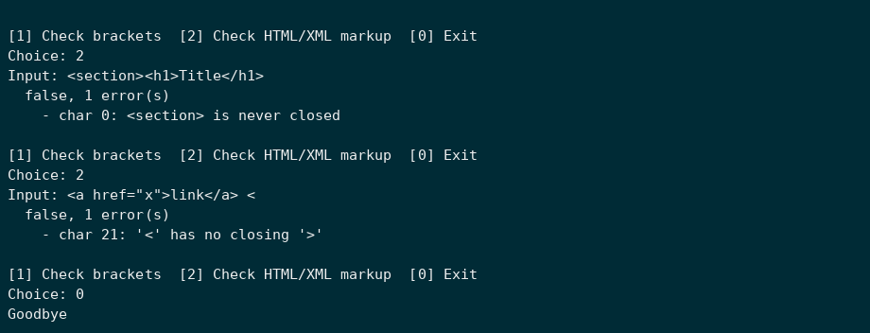

Task 3: Print Server Request Handling System
Implement a circular queue with dynamic resizing to simulate a Print Server Request Handling System.
Functions to implement:
- enqueue(x)
- dequeue() -> x
- front() -> x
- isEmpty() -> bool
- isFull() -> bool
- resize(new_capacity) (auto-triggered when full or too sparse)
Simulate the scenario where each print request has an ID, arrival time, and processing time. Display the queue state after each enqueue and dequeue operation, ensuring that no request data is lost during resizing.
Test the system by enqueuing and dequeuing multiple requests and calculating the average waiting time for all processed requests.
Solution
The print queue is a circular array that starts with capacity 2. It doubles when full and halves when fewer than a quarter of the slots are used. Resize copies the jobs starting from front, so the order is kept even when the queue has wrapped around. The simulation moves a clock forward one unit at a time: jobs that arrive are enqueued, and when the printer is idle the front job is dequeued. Waiting time is start time minus arrival time.
Code: task3.cpp
#include <iostream>
#include <iomanip>
using namespace std;

struct Job {
int id;
int arrival;
int duration;
};

class PrintQueue {
Job* buffer;
int capacity;
int frontIdx;
int rearIdx;
int count;

public:
PrintQueue() {
capacity = 2;
buffer = new Job[capacity];
frontIdx = 0;
rearIdx = -1;
count = 0;
}

~PrintQueue() { delete[] buffer; }

bool isEmpty() { return count == 0; }
bool isFull() { return count == capacity; }

void resize(int newCapacity) {
Job* bigger = new Job[newCapacity];
int idx = frontIdx;
for (int i = 0; i < count; i++) {
bigger[i] = buffer[idx];
idx = (idx + 1) % capacity;
}
cout << " [resize " << capacity << " -> " << newCapacity << "]" << endl;
delete[] buffer;
buffer = bigger;
capacity = newCapacity;
frontIdx = 0;
rearIdx = count - 1;
}

void enqueue(Job j) {
if (isFull())
resize(capacity * 2);
rearIdx = (rearIdx + 1) % capacity;
buffer[rearIdx] = j;
count++;
}

Job dequeue() {
Job j = buffer[frontIdx];
frontIdx = (frontIdx + 1) % capacity;
count--;
if (capacity > 2 && count < capacity / 4)
resize(capacity / 2);
return j;
}

Job front() { return buffer[frontIdx]; }

void print() {
cout << " queue (cap " << capacity << "): ";
if (isEmpty()) {
cout << "<empty>" << endl;
return;
}
int idx = frontIdx;
for (int i = 0; i < count; i++) {
cout << "J" << buffer[idx].id << " ";
idx = (idx + 1) % capacity;
}
cout << " front=" << frontIdx << " rear=" << rearIdx << endl;
}
};

void simulate(Job jobs[], int n) {
PrintQueue q;
int next = 0;
int done = 0;
int busyUntil = 0;
int printing = -1;
int totalWait = 0;
int clock = 0;

cout << "\n--- Simulation ---" << endl;
while (done < n) {
if (printing != -1 && clock == busyUntil) {
cout << "t=" << setw(2) << clock << " J" << printing << " finished" << endl;
printing = -1;
done++;
if (done == n)
break;
}

while (next < n && jobs[next].arrival == clock) {
cout << "t=" << setw(2) << clock << " J" << jobs[next].id << " arrives (needs " << jobs[next].duration << ")" << endl;
q.enqueue(jobs[next]);
q.print();
next++;
}

if (printing == -1 && !q.isEmpty()) {
Job j = q.front();
int wait = clock - j.arrival;
totalWait += wait;
printing = j.id;
busyUntil = clock + j.duration;
cout << "t=" << setw(2) << clock << " J" << j.id << " starts printing, waited " << wait << endl;
q.dequeue();
q.print();
}

clock++;
}

cout << "\nAll " << n << " jobs printed by t=" << clock << endl;
cout << "Average waiting time = " << totalWait << " / " << n << " = " << fixed << setprecision(2) << (double)totalWait / n << endl;
cout.unsetf(ios::fixed);
}

int main() {
char again = 'y';

while (again == 'y' || again == 'Y') {
int n;
cout << "Number of print requests: ";
if (!(cin >> n) || n <= 0) {
cout << "Invalid number" << endl;
return 0;
}

Job* jobs = new Job[n];
cout << "Enter ID, arrival time and processing time for each request (arrival in increasing order)" << endl;
for (int i = 0; i < n; i++) {
cout << "Request " << i + 1 << ": ";
if (!(cin >> jobs[i].id >> jobs[i].arrival >> jobs[i].duration)) {
cout << "Invalid input" << endl;
delete[] jobs;
return 0;
}
bool badOrder = i > 0 && jobs[i].arrival < jobs[i - 1].arrival;
if (jobs[i].arrival < 0 || jobs[i].duration <= 0 || badOrder) {
cout << " invalid request, try again" << endl;
i--;
}
}

simulate(jobs, n);
delete[] jobs;

cout << "\nRun another simulation? (y/n): ";
cin >> again;
}

cout << "Goodbye" << endl;
}

Output
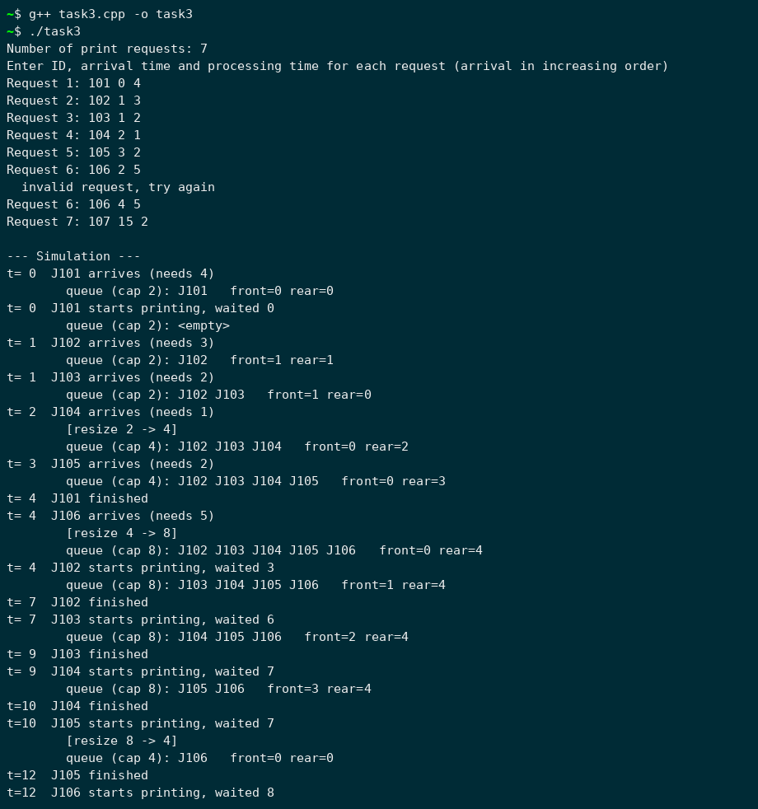
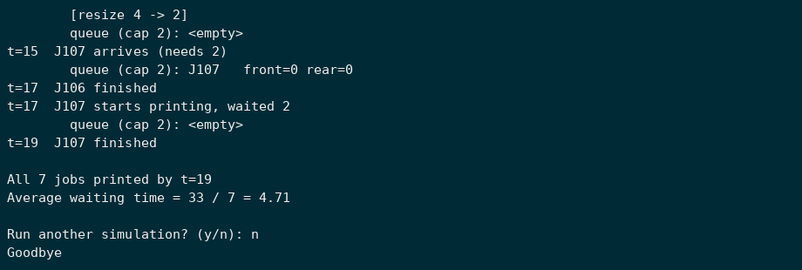

Task 4: Waiting Room Management System
You are required to implement a Waiting Room Management System for an emergency ward using an array-based queue.
Scenario:
Patients arrive at the hospital and are registered in a first-come, first-served manner. Each patient is assigned a unique auto-generated ID (starting from 1). Patients are served according to their registration order.
Functional Requirements:
Your program will contain the following methods:
RegisterPatient(): This method assigns an Id (which is auto generated) to a patient and register him/her to the system.
ServePatient(): This method calls a patient to provide hospital service to him/her.
CancelAll(): This method cancels all appointments of the patients so that the doctor can go to lunch.
CanDoctorGoHome(): This method returns true if no one is waiting, otherwise, returns false.
ShowAllPatient(): This method shows all ids of the waiting patients in SORTED order.

Solution
The waiting room is a circular array queue with 6 seats, using front and rear indices. Each patient gets the next ID automatically. ShowAllPatient copies the waiting patients into a temporary array and selection sorts it by ID, so the queue itself is not changed.
Code: task4.cpp
#include <iostream>
#include <string>
using namespace std;

const int ROOM_SIZE = 6;

struct Patient {
int id;
string name;
};

class WaitingRoom {
Patient seats[ROOM_SIZE];
int frontIdx;
int rearIdx;
int waiting;
int lastId;

public:
WaitingRoom() {
frontIdx = 0;
rearIdx = -1;
waiting = 0;
lastId = 0;
}

bool isFull() { return waiting == ROOM_SIZE; }

void RegisterPatient(string name) {
if (isFull()) {
cout << " Sorry " << name << ", the waiting room is full" << endl;
return;
}
lastId++;
rearIdx = (rearIdx + 1) % ROOM_SIZE;
seats[rearIdx].id = lastId;
seats[rearIdx].name = name;
waiting++;
cout << " " << name << " registered with ID " << lastId << endl;
}

void ServePatient() {
if (waiting == 0) {
cout << " Nobody to serve" << endl;
return;
}
Patient p = seats[frontIdx];
frontIdx = (frontIdx + 1) % ROOM_SIZE;
waiting--;
cout << " Doctor is now seeing patient " << p.id << " (" << p.name << ")" << endl;
}

void CancelAll() {
cout << " Cancelled " << waiting << " appointment(s), doctor is off to lunch" << endl;
frontIdx = 0;
rearIdx = -1;
waiting = 0;
}

bool CanDoctorGoHome() {
return waiting == 0;
}

void ShowAllPatient() {
if (waiting == 0) {
cout << " Waiting room is empty" << endl;
return;
}

Patient list[ROOM_SIZE];
for (int i = 0; i < waiting; i++)
list[i] = seats[(frontIdx + i) % ROOM_SIZE];

for (int i = 0; i < waiting - 1; i++) {
int smallest = i;
for (int j = i + 1; j < waiting; j++)
if (list[j].id < list[smallest].id)
smallest = j;
Patient tmp = list[i];
list[i] = list[smallest];
list[smallest] = tmp;
}

cout << " " << waiting << " waiting (sorted by ID):" << endl;
for (int i = 0; i < waiting; i++)
cout << " " << list[i].id << " " << list[i].name << endl;
}
};

int main() {
WaitingRoom room;
int choice = -1;
string name;

while (choice != 0) {
cout << "\n[1] Register [2] Serve [3] Cancel all [4] Can doctor go home [5] Show all [0] Exit" << endl;
cout << "Choice: ";

if (!(cin >> choice)) {
if (cin.eof())
break;
cin.clear();
cin.ignore(1000, '\n');
choice = -1;
cout << "Please enter a number" << endl;
continue;
}

switch (choice) {
case 1:
cout << "Patient name: ";
cin.ignore(1000, '\n');
getline(cin, name);
room.RegisterPatient(name);
break;
case 2:
room.ServePatient();
break;
case 3:
room.CancelAll();
break;
case 4:
cout << (room.CanDoctorGoHome() ? " true, nobody is waiting" : " false, patients are still waiting") << endl;
break;
case 5:
room.ShowAllPatient();
break;
case 0:
break;
default:
cout << "Please choose 0-5" << endl;
}
}

cout << "Goodbye" << endl;
}

Output
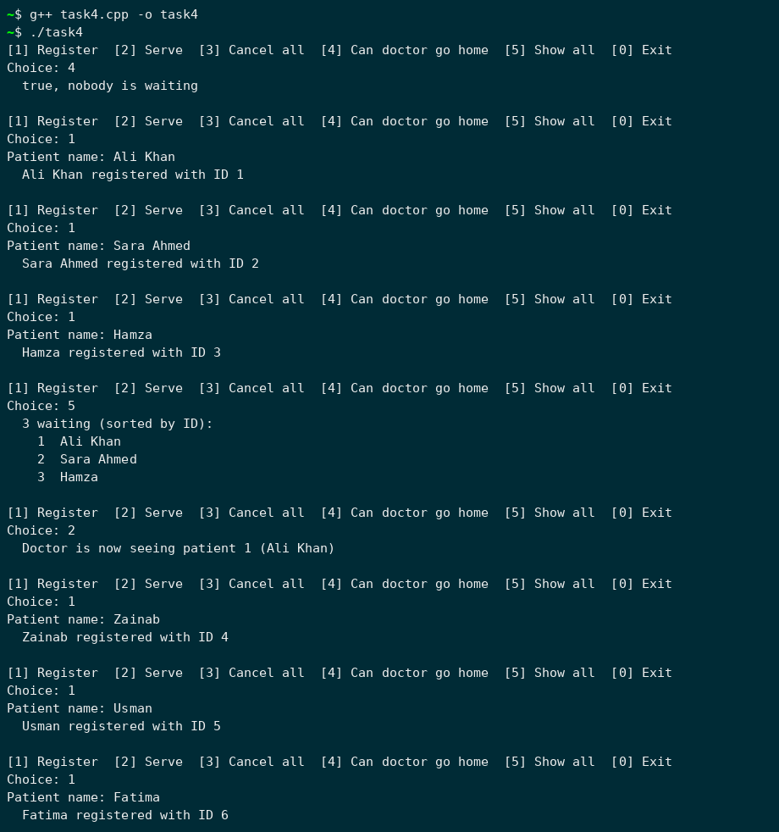
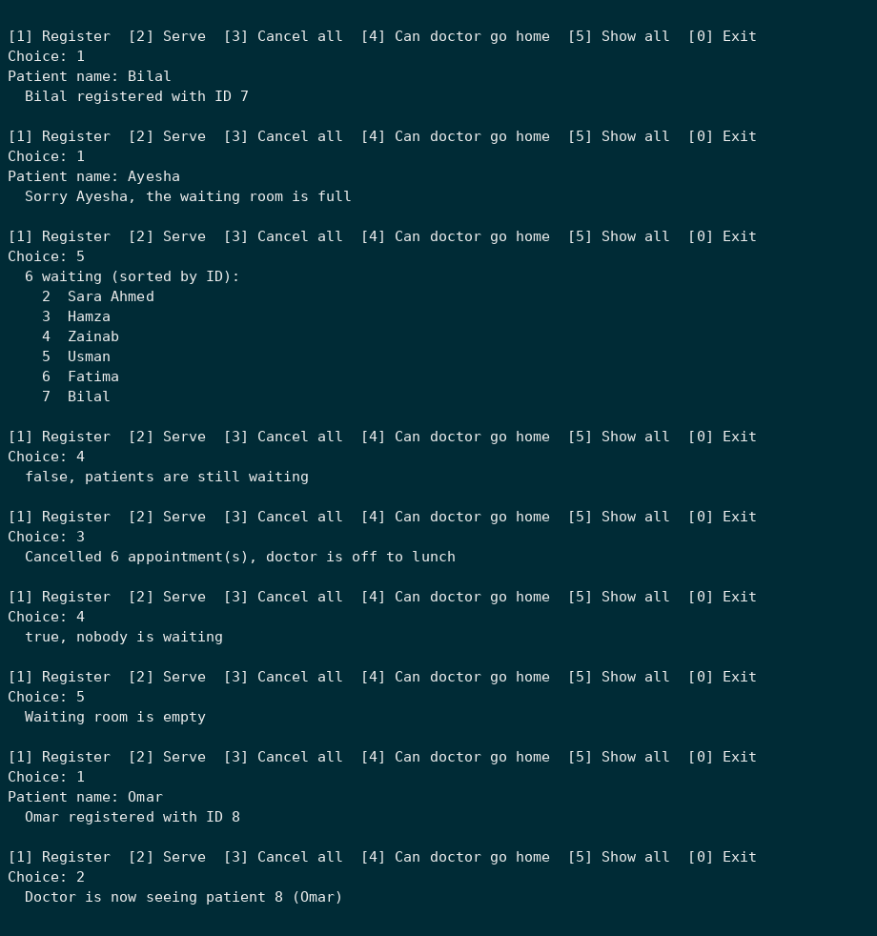
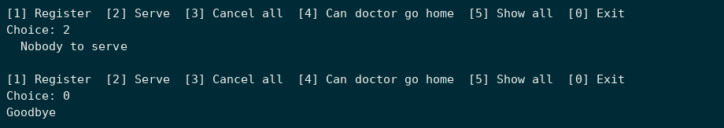

Grading Rubrics:
Assessment Criteria | CLO | Activity | Exceeds Expectations (5) | Satisfactory (4) | Meets Expectations (3) | Needs Improvement (2) | Unsatisfactory (1)
Expression Conversion and Evaluation | CLO 2 | Implementing expression conversion (Infix ↔ Postfix ↔ Prefix) and evaluation | All conversions and evaluations implemented correctly and efficiently for all cases | All functions correct with minor inefficiencies | Basic conversions correct, some evaluation errors | Major logical flaws or partial implementation | Incorrect or missing conversion/evaluation
 | CLO 3 | Applying stack operations to expression parsing and evaluation | Uses stack optimally for parsing and evaluation; demonstrates strong understanding | Correct use of stack with minor logical redundancy | Basic stack use, limited understanding | Stack logic incorrect or inefficient | No correct stack use demonstrated
 | CLO 4 | Code clarity, documentation, and ethical practices | Fully documented, clear, efficient, plagiarism-free code | Well-structured with minor lapses in clarity or commenting | Basic structure, minimal documentation | Poorly formatted, weak documentation | No coding standards, unethical practices
Expression Validators (Bracket + Markup) | CLO 2 | Implementing bracket and HTML/XML tag validation | Correctly validates all brackets/tags; handles nested, self-closing, and edge cases accurately | Works for most cases, minor missed conditions | Works for simple cases, limited error handling | Frequent validation errors | Incorrect or incomplete validation logic
 | CLO 3 | Applying stack-based parsing for structured text validation | Efficient use of stack; correctly tracks open/close structures | Correct use of stack, minor inefficiencies | Partial stack use, redundant or unclear logic | Inefficient or incorrect use of stack | No use of stack logic shown
 | CLO 4 | Code clarity, documentation, and ethical practices | Fully documented, clear, efficient, plagiarism-free | Generally well-documented and structured | Basic commenting and structure | Poor documentation, inconsistent formatting | No coding standards, unethical practices
Circular Queue with Dynamic Resizing and Print Server Simulation | CLO 2
  Implementing dynamic circular queue with resizing and simulation features
  Fully dynamic implementation; no data loss; correct resizing and simulation results
  Correct implementation with minor logical or display issues
  Basic enqueue/dequeue correct, limited resizing verification
  Frequent errors in resizing or logic
  Implementing dynamic circular queue with resizing and simulation features
 | CLO 3 | Applying circular queue logic in system simulations | Accurate use of front/rear logic and efficient resizing; shows deep understanding | Correct logic with occasional inefficiencies | Functional but limited handling of resizing or tracking | Incorrect or inconsistent queue behavior | No valid circular queue concept applied
 | CLO 4 | Code clarity, documentation, and ethical practices | Fully documented, clear, efficient | Well-structured, few documentation gaps | Minimal documentation, acceptable clarity | Poor documentation, inconsistent style | Lacks clarity, poor standards, or unethical code
Emergency Ward Waiting Room Management System (Queue) | CLO 2
  Implementing array-based queue for real-world patient scheduling
  Fully functional queue; correctly handles all operations and edge cases
  Correct implementation with minor inefficiencies
  Basic functionality works, limited testing
  Logical or boundary errors in enqueue/dequeue
  Queue not functioning or missing core logic
 | CLO 3 | Applying queue logic for real-time service management | Efficient and realistic queue simulation demonstrating strong understanding | Correct application with minor inefficiencies | Inefficient or inconsistent handling | Incorrect or inconsistent queue behavior | No valid queue logic demonstrated
 | CLO 4 | Code clarity, documentation, and ethical practices | Fully documented, clear, efficient | Well-structured, few documentation gaps | Minimal documentation, acceptable clarity | Poor documentation, inconsistent style | Lacks clarity, poor standards, or unethical code

