Department of Computing

School of Electrical Engineering and Computer Science

CS-250: Data Structure and Algorithms
Class: BSDS 3A

Lab 8: Binary Tree

Date: 20th October 2026
Time: 10:00 am – 12:50 pm

Instructor: Dr. Fahad Ahmed Satti

Lab Engineer: Hassan Mohtashim

Submitted by: Arqam Waheed (553514)

Lab 8: Binary Tree

Introduction
This lab focuses on advanced implementations and applications of binary trees and binary search trees (BSTs). We represent a binary tree as a bracketed string, validate it, build it with nodes and pointers and traverse it recursively and iteratively. A BST is then used to build a student record management system with insertion, search, deletion and GPA based analysis.
Objectives
Understand and implement binary trees and BSTs, construct and validate trees from string representations, implement preorder, inorder and postorder traversals using recursion and a stack, and apply BST concepts for efficient data storage, searching and record management.
Tools/Software Requirement
Visual Studio Code in Unix/Linux Environment.
Task 1: Binary Tree Representation and Operations
Given the string representation of a binary tree a(b(d,e),c(,f(g,))), perform the following tasks:
1. Generate a binary tree from the given string using nodes and pointers.
2. Generate the preorder form using a recursive function.
3. Generate the inorder form iteratively using a stack (linear ADT) instead of recursion.
4. Generate the postorder form iteratively using a stack.
5. Validate the tree string (balanced parentheses, correct child placement) without building the tree.
6. Calculate the height of the tree and the depth of each node recursively.
7. Generate a BST from a sequence of integers (e.g. 50, 30, 70, 20, 40, 60, 80) and display its inorder traversal.
Solution
The string is parsed recursively: a label creates a node, and if it is followed by "(" the left child is parsed up to the comma and the right child up to ")". An empty slot before "," or ")" gives a null child. Preorder is recursive and the tree is also printed back in bracket form. Inorder and postorder use an array based template stack. Inorder pushes the left spine, pops a node and moves to its right child. Postorder uses a single stack and a lastVisited pointer so a node is only printed once its right subtree is finished. Validation is done in two passes over the string without creating any node: a counter checks bracket balance, then a recursive descent checks that each node is a label optionally followed by (left,right), with empty children allowed but not "(,)". Height is counted in edges (leaf = 0), depth is passed down from the root. The BST takes the first value as root and ignores duplicates. For the given tree: preorder a b d e c f g, inorder d b e a c g f, postorder d e b g f c a, height 3.
Code: task1.cpp
#include <iostream>
#include <string>
#include <stdexcept>
using namespace std;

struct Node {
char data;
Node* left;
Node* right;
Node(char c) { data = c; left = right = nullptr; }
};

// array based stack, used instead of recursion for inorder and postorder
template <typename T>
class Stack {
T* items;
int capacity;
int topIndex;

public:
Stack(int cap = 100) {
capacity = cap;
items = new T[capacity];
topIndex = -1;
}
~Stack() { delete[] items; }

bool empty() { return topIndex == -1; }
void push(T x) {
if (topIndex == capacity - 1)
throw runtime_error("stack overflow");
items[++topIndex] = x;
}
T pop() {
if (empty())
throw runtime_error("stack underflow");
return items[topIndex--];
}
T peek() {
if (empty())
throw runtime_error("stack underflow");
return items[topIndex];
}
};

// ---------- 5. validation without building the tree ----------
// grammar: tree -> letter | letter '(' child ',' child ')'
// child -> tree | empty
bool checkTree(const string& s, int& i, string& err);

bool checkChild(const string& s, int& i, string& err, bool& present) {
present = false;
if (i < (int)s.size() && (s[i] == ',' || s[i] == ')'))
return true;
present = true;
return checkTree(s, i, err);
}

bool checkTree(const string& s, int& i, string& err) {
if (i >= (int)s.size() || !isalnum(s[i])) {
err = "expected a node label at position " + to_string(i);
return false;
}
i++;
if (i >= (int)s.size() || s[i] != '(')
return true;
i++;
bool hasLeft, hasRight;
if (!checkChild(s, i, err, hasLeft))
return false;
if (i >= (int)s.size() || s[i] != ',') {
err = "expected ',' between children at position " + to_string(i);
return false;
}
i++;
if (!checkChild(s, i, err, hasRight))
return false;
if (i >= (int)s.size() || s[i] != ')') {
err = "expected ')' at position " + to_string(i);
return false;
}
if (!hasLeft && !hasRight) {
err = "empty brackets '(,)' at position " + to_string(i - 2);
return false;
}
i++;
return true;
}

bool isValidTreeString(const string& s, string& err) {
// first pass: brackets must balance
int depth = 0;
for (int k = 0; k < (int)s.size(); k++) {
if (s[k] == '(') depth++;
else if (s[k] == ')') depth--;
if (depth < 0) {
err = "unmatched ')' at position " + to_string(k);
return false;
}
}
if (depth != 0) {
err = "unbalanced parentheses";
return false;
}
// second pass: correct child placement
int i = 0;
if (!checkTree(s, i, err))
return false;
if (i != (int)s.size()) {
err = "extra characters after position " + to_string(i);
return false;
}
return true;
}

// ---------- 1. build the tree from the string ----------
Node* parse(const string& s, int& i) {
if (i >= (int)s.size() || s[i] == ',' || s[i] == ')')
return nullptr;
Node* n = new Node(s[i++]);
if (i < (int)s.size() && s[i] == '(') {
i++;
n->left = parse(s, i);
i++; // skip ','
n->right = parse(s, i);
i++; // skip ')'
}
return n;
}

Node* buildTree(const string& s) {
int i = 0;
return parse(s, i);
}

void destroy(Node* n) {
if (!n) return;
destroy(n->left);
destroy(n->right);
delete n;
}

// ---------- 2. preorder (recursive) ----------
void preorder(Node* n, string& out) {
if (!n) return;
out += n->data;
out += ' ';
preorder(n->left, out);
preorder(n->right, out);
}

// rebuilds the bracket form by walking the tree in preorder
string toTreeString(Node* n) {
if (!n) return "";
string s(1, n->data);
if (n->left || n->right)
s += "(" + toTreeString(n->left) + "," + toTreeString(n->right) + ")";
return s;
}

// ---------- 3. inorder (iterative, stack) ----------
string inorderIterative(Node* root) {
string out;
Stack<Node*> st;
Node* cur = root;
while (cur || !st.empty()) {
while (cur) { // go as far left as possible
st.push(cur);
cur = cur->left;
}
cur = st.pop();
out += cur->data;
out += ' ';
cur = cur->right;
}
return out;
}

// ---------- 4. postorder (iterative, one stack) ----------
string postorderIterative(Node* root) {
string out;
Stack<Node*> st;
Node* cur = root;
Node* lastVisited = nullptr;
while (cur || !st.empty()) {
if (cur) {
st.push(cur);
cur = cur->left;
} else {
Node* top = st.peek();
// right subtree exists and has not been printed yet
if (top->right && lastVisited != top->right) {
cur = top->right;
} else {
out += top->data;
out += ' ';
lastVisited = st.pop();
}
}
}
return out;
}

// ---------- 6. height and depth ----------
// height counted in edges: a single node has height 0, an empty tree -1
int height(Node* n) {
if (!n) return -1;
int l = height(n->left);
int r = height(n->right);
return 1 + (l > r ? l : r);
}

void printDepths(Node* n, int depth) {
if (!n) return;
cout << " node " << n->data << " : depth " << depth << ", height " << height(n) << endl;
printDepths(n->left, depth + 1);
printDepths(n->right, depth + 1);
}

// ---------- 7. BST from a sequence of integers ----------
struct BSTNode {
int key;
BSTNode* left;
BSTNode* right;
BSTNode(int k) { key = k; left = right = nullptr; }
};

BSTNode* bstInsert(BSTNode* n, int key) {
if (!n) return new BSTNode(key);
if (key < n->key)
n->left = bstInsert(n->left, key);
else if (key > n->key)
n->right = bstInsert(n->right, key);
else
cout << " duplicate " << key << " ignored" << endl;
return n;
}

void bstInorder(BSTNode* n) {
if (!n) return;
bstInorder(n->left);
cout << n->key << " ";
bstInorder(n->right);
}

void bstPrint(BSTNode* n, int indent) {
if (!n) return;
bstPrint(n->right, indent + 6);
cout << string(indent + 4, ' ') << n->key << endl;
bstPrint(n->left, indent + 6);
}

void bstDestroy(BSTNode* n) {
if (!n) return;
bstDestroy(n->left);
bstDestroy(n->right);
delete n;
}

// ---------- menu ----------
void showTraversals(Node* root) {
string pre;
preorder(root, pre);
cout << " Tree form : " << toTreeString(root) << endl;
cout << " Preorder (recursive): " << pre << endl;
cout << " Inorder (stack) : " << inorderIterative(root) << endl;
cout << " Postorder (stack) : " << postorderIterative(root) << endl;
}

void showHeight(Node* root) {
cout << " Height of tree = " << height(root) << " (edges on longest root-to-leaf path)" << endl;
printDepths(root, 0);
}

int main() {
string treeStr = "a(b(d,e),c(,f(g,)))";
string err;
Node* root = buildTree(treeStr);
cout << "Loaded tree: " << treeStr << endl;

int choice = -1;
while (choice != 0) {
cout << "\n[1] Load tree string [2] Traversals [3] Height/depth [4] Validate string [5] Build BST [0] Exit" << endl;
cout << "Choice: ";
if (!(cin >> choice)) break;

if (choice == 1 || choice == 4) {
string s;
cout << "Tree string: ";
cin >> s;
bool ok = isValidTreeString(s, err);
if (choice == 4) {
cout << " " << s << " -> " << (ok ? "VALID" : "INVALID (" + err + ")") << endl;
} else if (!ok) {
cout << " Error : " << err << ", tree not changed" << endl;
} else {
destroy(root);
root = buildTree(s);
cout << " Tree built from " << s << endl;
showTraversals(root);
}
} else if (choice == 2) {
showTraversals(root);
} else if (choice == 3) {
showHeight(root);
} else if (choice == 5) {
int n;
cout << "How many integers: ";
if (!(cin >> n) || n <= 0) {
cout << " Invalid number" << endl;
cin.clear();
cin.ignore(1000, '\n');
continue;
}
cout << "Values: ";
BSTNode* bst = nullptr;
for (int k = 0; k < n; k++) {
int v;
cin >> v;
bst = bstInsert(bst, v);
}
cout << " Root = " << bst->key << endl;
cout << " Inorder: ";
bstInorder(bst);
cout << endl << " Tree (rotated, root on the left):" << endl;
bstPrint(bst, 0);
bstDestroy(bst);
} else if (choice != 0) {
cout << " Invalid choice" << endl;
}
}

destroy(root);
cout << "Goodbye" << endl;
}
Output
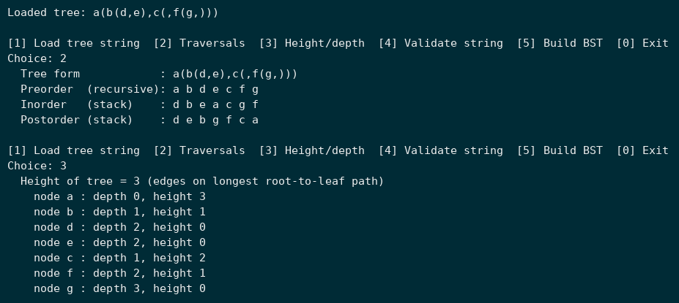
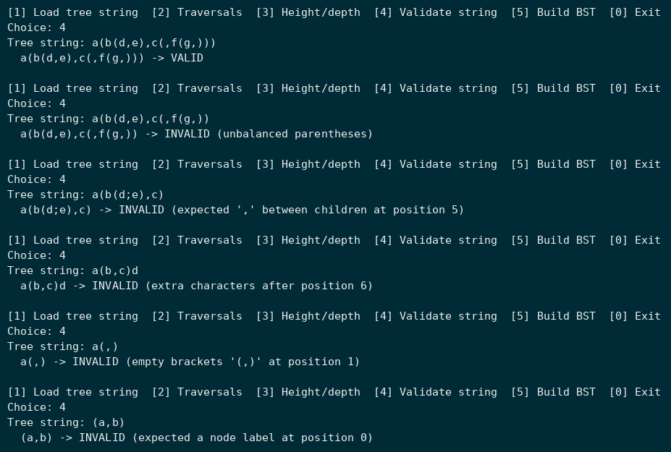
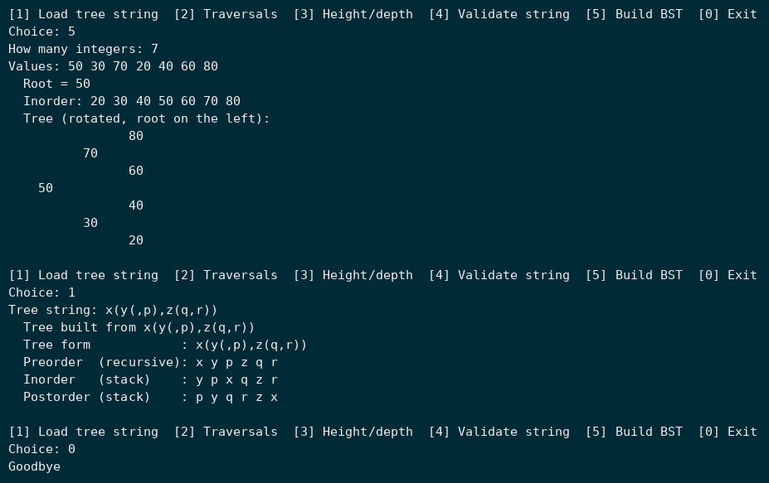

Task 2: Student Record Management System using Binary Search Tree
Design and implement a Student Record Management System using a BST. Each node represents a student record (studentID, name, GPA, left, right) ordered by Student ID for efficient searching, insertion and deletion.
Requirements:
1. Define a structure Student with studentID, name, GPA, left and right pointers.
2. Insert multiple student records into the BST, maintaining order by studentID.
3. Implement Insert(), Search() and Delete() by ID.
4. Use inorder traversal to list students sorted by ID.
5. Count total students, find highest and lowest GPA, and display all students with GPA above a user-defined threshold.
Solution
The Student struct from the manual is used as the tree node and the StudentBST class keeps the root private. Insert walks down by ID and rejects duplicate IDs. Search is iterative and runs in O(h). Delete handles all three cases: a leaf is removed, a node with one child is replaced by that child, and a node with two children copies its inorder successor (minimum of the right subtree) and then deletes the successor. Inorder traversal lists the records sorted by ID. Since the tree is ordered by ID and not GPA, highest/lowest GPA and the threshold filter visit every node. Seven records are loaded at start and the menu lets the user insert, search, delete and analyse them.
Code: task2.cpp
#include <iostream>
#include <iomanip>
#include <string>
using namespace std;

struct Student {
int studentID;
string name;
float GPA;
Student* left;
Student* right;
};

// BST of students, ordered by studentID
class StudentBST {
Student* root;

Student* makeNode(int id, string name, float gpa) {
Student* s = new Student;
s->studentID = id;
s->name = name;
s->GPA = gpa;
s->left = s->right = nullptr;
return s;
}

Student* insert(Student* n, int id, string name, float gpa, bool& added) {
if (!n) {
added = true;
return makeNode(id, name, gpa);
}
if (id < n->studentID)
n->left = insert(n->left, id, name, gpa, added);
else if (id > n->studentID)
n->right = insert(n->right, id, name, gpa, added);
return n;
}

Student* minNode(Student* n) {
while (n->left)
n = n->left;
return n;
}

Student* remove(Student* n, int id, bool& removed) {
if (!n) return nullptr;
if (id < n->studentID) {
n->left = remove(n->left, id, removed);
} else if (id > n->studentID) {
n->right = remove(n->right, id, removed);
} else {
removed = true;
// leaf or one child: replace node by its only child
if (!n->left || !n->right) {
Student* child = n->left ? n->left : n->right;
delete n;
return child;
}
// two children: copy inorder successor, then delete it from the right subtree
Student* succ = minNode(n->right);
n->studentID = succ->studentID;
n->name = succ->name;
n->GPA = succ->GPA;
bool dummy;
n->right = remove(n->right, succ->studentID, dummy);
}
return n;
}

void inorder(Student* n) {
if (!n) return;
inorder(n->left);
printRow(n);
inorder(n->right);
}

int count(Student* n) {
if (!n) return 0;
return 1 + count(n->left) + count(n->right);
}

// tree is ordered by ID, so GPA extremes need a full traversal
void extremes(Student* n, Student*& hi, Student*& lo) {
if (!n) return;
if (!hi || n->GPA > hi->GPA) hi = n;
if (!lo || n->GPA < lo->GPA) lo = n;
extremes(n->left, hi, lo);
extremes(n->right, hi, lo);
}

void above(Student* n, float t, int& found) {
if (!n) return;
above(n->left, t, found);
if (n->GPA > t) {
printRow(n);
found++;
}
above(n->right, t, found);
}

void destroy(Student* n) {
if (!n) return;
destroy(n->left);
destroy(n->right);
delete n;
}

public:
StudentBST() { root = nullptr; }
~StudentBST() { destroy(root); }

static void printHeader() {
cout << " " << left << setw(8) << "ID" << setw(18) << "Name" << "GPA" << endl;
cout << " " << string(30, '-') << endl;
}

static void printRow(Student* s) {
cout << " " << left << setw(8) << s->studentID << setw(18) << s->name
<< fixed << setprecision(2) << s->GPA << endl;
cout.unsetf(ios::fixed);
}

bool Insert(int id, string name, float gpa) {
bool added = false;
root = insert(root, id, name, gpa, added);
return added;
}

Student* Search(int id) {
Student* cur = root;
while (cur && cur->studentID != id)
cur = id < cur->studentID ? cur->left : cur->right;
return cur;
}

bool Delete(int id) {
bool removed = false;
root = remove(root, id, removed);
return removed;
}

void ListSorted() {
if (!root) {
cout << " <no records>" << endl;
return;
}
printHeader();
inorder(root);
}

int Count() { return count(root); }

void HighestLowest() {
if (!root) {
cout << " <no records>" << endl;
return;
}
Student* hi = nullptr;
Student* lo = nullptr;
extremes(root, hi, lo);
cout << " Highest GPA:" << endl;
printRow(hi);
cout << " Lowest GPA:" << endl;
printRow(lo);
}

void AboveThreshold(float t) {
int found = 0;
printHeader();
above(root, t, found);
if (found == 0)
cout << " <none>" << endl;
cout << " " << found << " student(s) with GPA above " << t << endl;
}
};

int main() {
StudentBST bst;

// initial records, inserted in an order that gives a balanced tree
int ids[] = {50, 30, 70, 20, 40, 60, 80};
string names[] = {"Arqam Waheed", "Ali Raza", "Sara Khan", "Hamza Ali", "Ayesha Noor", "Bilal Ahmed", "Zainab Iqbal"};
float gpas[] = {3.45f, 2.80f, 3.90f, 3.10f, 2.55f, 3.62f, 3.05f};
for (int i = 0; i < 7; i++)
bst.Insert(ids[i], names[i], gpas[i]);
cout << "Loaded 7 student records" << endl;

int choice = -1;
while (choice != 0) {
cout << "\n[1] Insert [2] Search [3] Delete [4] List by ID [5] Count [6] Highest/Lowest GPA [7] GPA above [0] Exit" << endl;
cout << "Choice: ";
if (!(cin >> choice)) break;

if (choice == 1) {
int id;
string name;
float gpa;
cout << "ID: ";
cin >> id;
cout << "Name: ";
cin.ignore(1000, '\n');
getline(cin, name);
cout << "GPA: ";
cin >> gpa;
if (!cin || gpa < 0 || gpa > 4) {
cout << " Error : GPA must be between 0 and 4" << endl;
cin.clear();
cin.ignore(1000, '\n');
} else if (bst.Insert(id, name, gpa)) {
cout << " Student " << id << " inserted" << endl;
} else {
cout << " Error : ID " << id << " already exists" << endl;
}
} else if (choice == 2) {
int id;
cout << "ID: ";
cin >> id;
Student* s = bst.Search(id);
if (s) {
StudentBST::printHeader();
StudentBST::printRow(s);
} else {
cout << " Student " << id << " not found" << endl;
}
} else if (choice == 3) {
int id;
cout << "ID: ";
cin >> id;
if (bst.Delete(id))
cout << " Student " << id << " deleted" << endl;
else
cout << " Student " << id << " not found" << endl;
} else if (choice == 4) {
bst.ListSorted();
} else if (choice == 5) {
cout << " Total students = " << bst.Count() << endl;
} else if (choice == 6) {
bst.HighestLowest();
} else if (choice == 7) {
float t;
cout << "Threshold: ";
cin >> t;
bst.AboveThreshold(t);
} else if (choice != 0) {
cout << " Invalid choice" << endl;
}
}

cout << "Goodbye" << endl;
}
Output
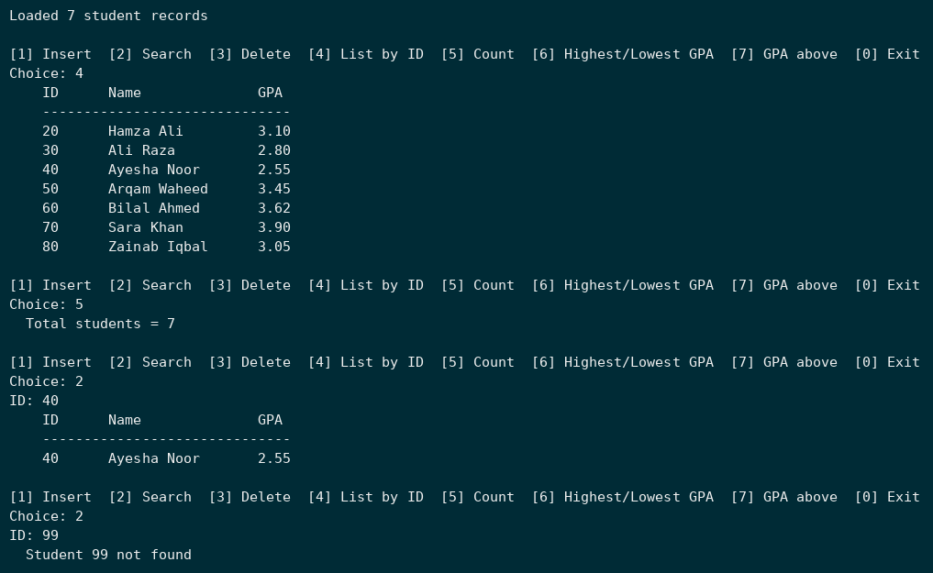
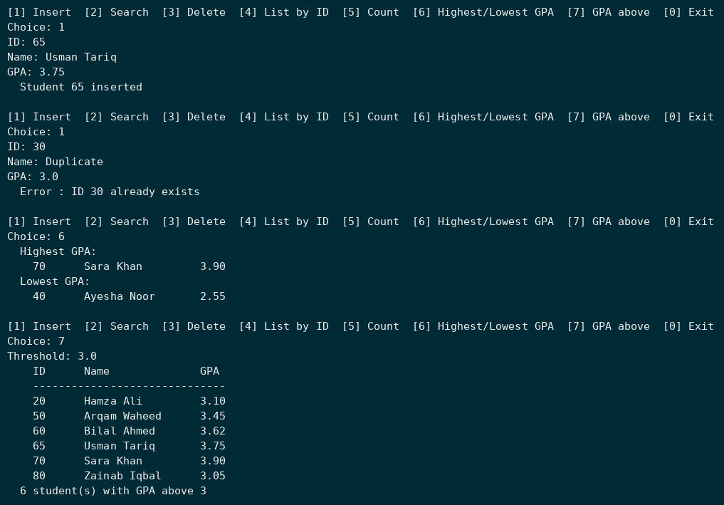
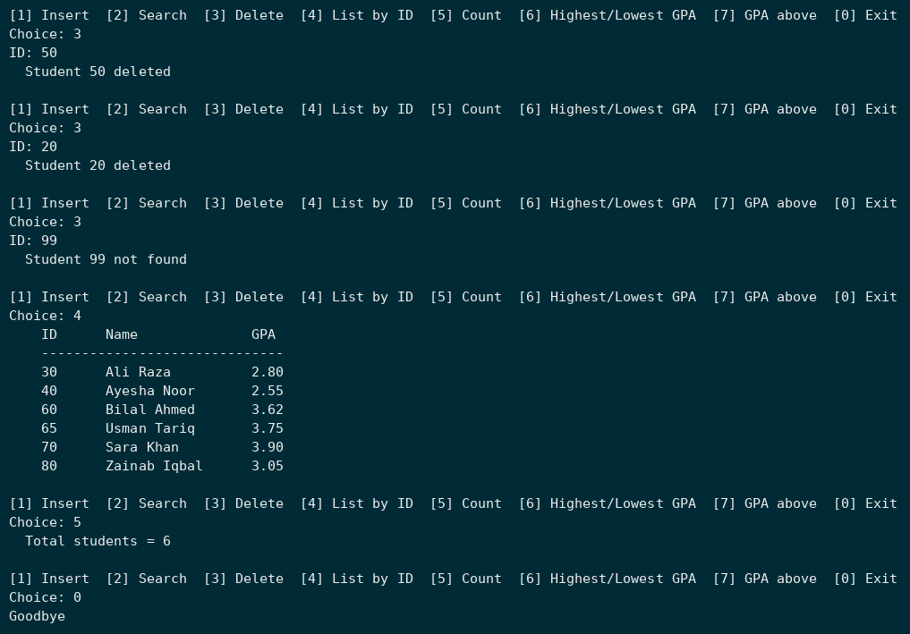

Grading Rubrics:
Assessment Criteria | CLO | Activity | Exceeds Expectations (5) | Satisfactory (4) | Meets Expectations (3) | Needs Improvement (2) | Unsatisfactory (1)
Binary Tree Representation and Operations | CLO 2 | Implementing tree construction, traversal, and validation from string-based representation | Correctly builds and validates binary tree; all traversals (preorder, inorder using stack, postorder iterative) and BST generation fully functional | All core operations implemented with minor logic or formatting issues | Basic construction and traversal work; limited validation accuracy | Partial functionality or incorrect traversal logic | No valid implementation or incorrect algorithm
 | CLO 3 | Applying recursive and iterative traversal logic using linear ADTs | Efficient and optimized use of recursion and stacks; demonstrates strong conceptual understanding | Traversal and validation logic correct with minor inefficiencies | Functional code but limited depth in recursive/iterative handling | Incorrect or inefficient traversal/stack usage | No correct traversal logic shown
 | CLO 4 | Code clarity, documentation, and ethical practices | Fully documented, modular, efficient, and plagiarism-free code | Well-structured code with adequate documentation and minor lapses | Acceptable readability and commenting | Poor documentation or inconsistent formatting | Unclear, disorganized, or unethical code
Student Record Management using Binary Search Tree (BST) | CLO 2 | Implementing BST to store, search, and manage student records | Fully functional BST; correct insertion, search, delete, and traversal operations; accurate GPA-based analysis | All major operations correct with minor inefficiencies or missing edge cases | Basic insert/search works; partial delete or traversal logic | Frequent logical or runtime errors in BST operations | No valid BST functionality implemented
 | CLO 3 | Applying BST logic for efficient searching and record analysis | Correct and efficient use of recursive traversal logic; demonstrates clear conceptual understanding | Logical implementation with few inefficiencies | Basic traversal/search functionality achieved | Inefficient recursion or traversal logic | Incorrect BST logic or missing application
 | CLO 4 | Code clarity, documentation, and ethical practices | Fully documented, modular, and plagiarism-free; clear separation of logic and display | Clear structure and documentation with few gaps | Acceptable readability; limited commenting | Poor documentation or inconsistent formatting | Unclear code or unethical practices

