Asad Naeem
Lab task 12
Data base :
First installing java and other dependencies:
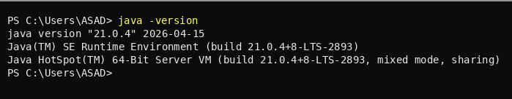
I also downloaded mysql-connector-j-9.6.0.jar and pasted it into the same folder which has my java file

Now this is the lab 11 schema (Issue Tracker) that is normalized:
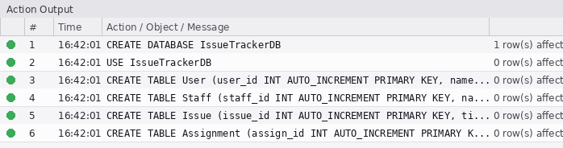
Now connecting the database using java :
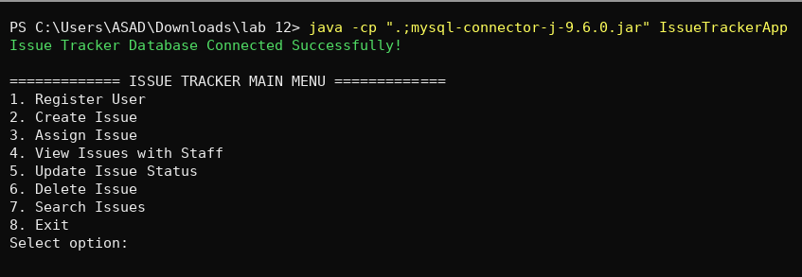
Now registering users:
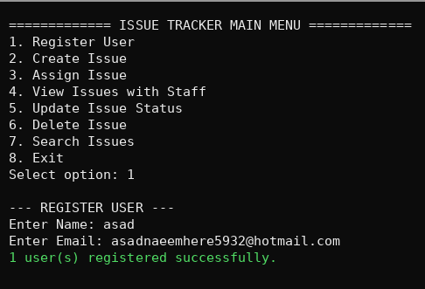

Issues:
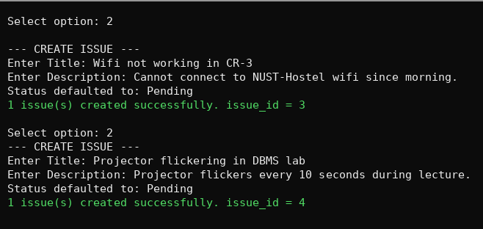
Assignments:
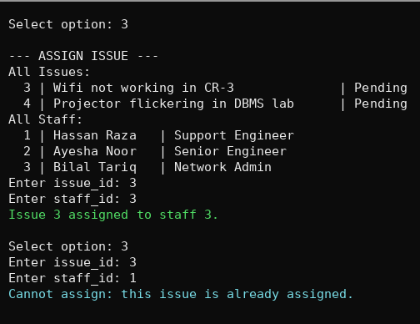

Deleting issue:
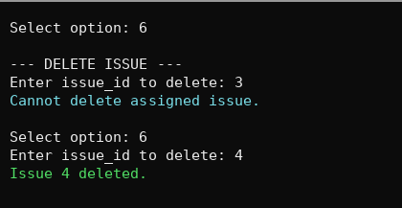
Viewing issues with assigned staff:
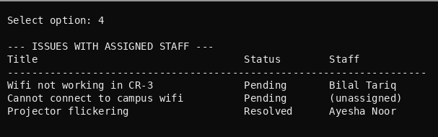

Updating issue status:
