CS220 – Database Systems
Lab 12: Advanced JDBC – Issue Tracker
Name: Arqam Waheed Roll: 553514 Class: BSDS
Date: April 27, 2026

Schema (Normalized – 3NF)
- User(user_id PK, name, email UNIQUE)
- Staff(staff_id PK, name, role)
- Issue(issue_id PK, title, description, status DEFAULT 'Pending')
- Assignment(assign_id PK, issue_id UNIQUE → Issue, staff_id → Staff)

Task – Database Connection & Menu
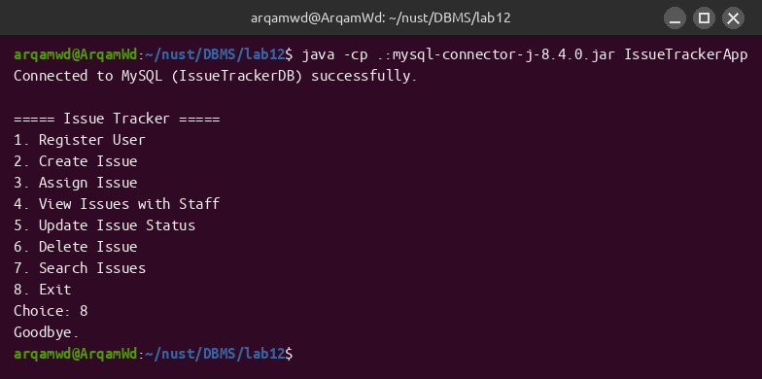

Task 1 – Register a User

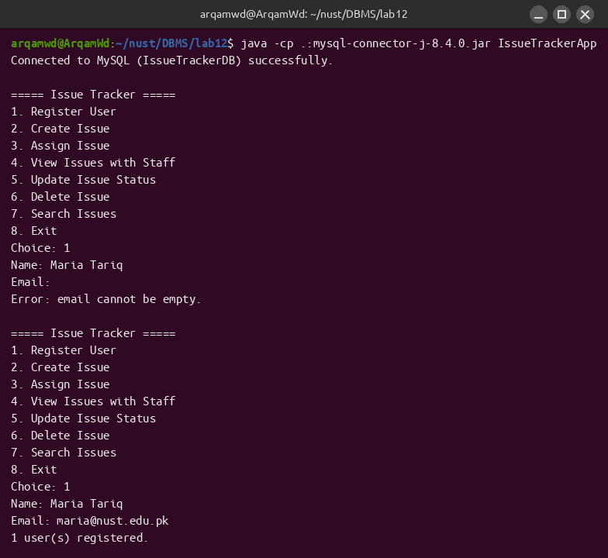

Task 2 – Create an Issue
A new Issue row is inserted with status defaulted to 'Pending' inside the SQL itself, so no extra prompt is needed.
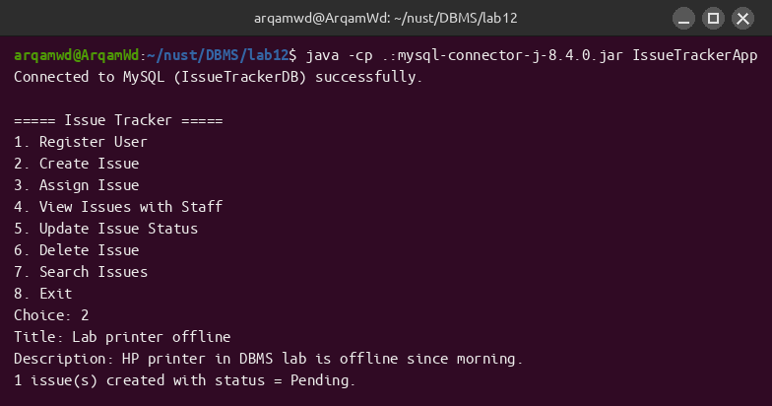

Task 3 – Assign Issue to Staff (with constraint)
The program first lists all issues and all staff so the user can pick valid IDs, then inserts into Assignment. The UNIQUE constraint on issue_id makes a second assignment of the same issue fail – the SQLException is caught and printed.
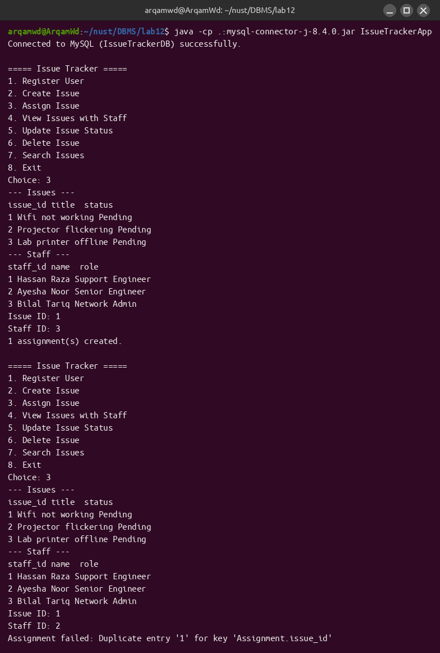

Task 4 – View All Issues with Assigned Staff

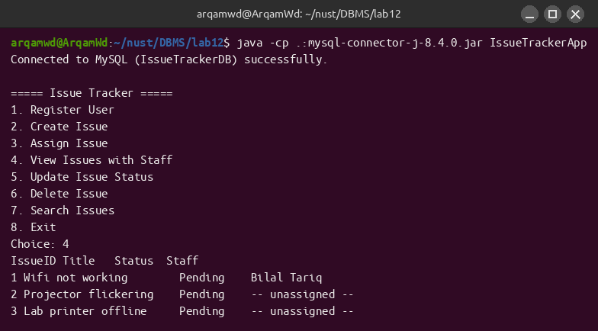

Task 5 – Update Issue Status

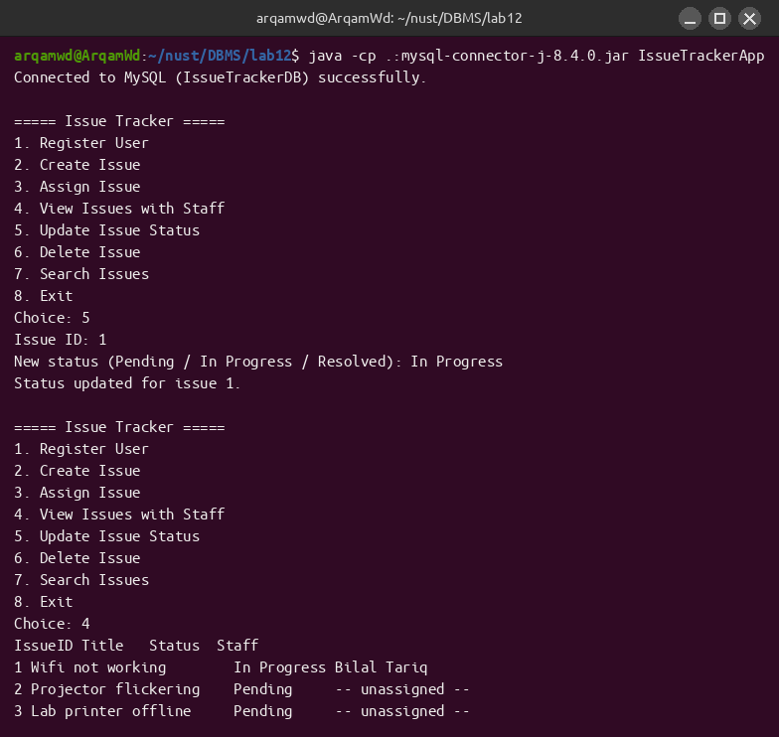

Task 6 – Delete Issue (Controlled)
Before deleting, the program checks Assignment for any row referencing the issue. If found, the delete is refused with “Cannot delete assigned issue.”; otherwise the DELETE runs successfully.
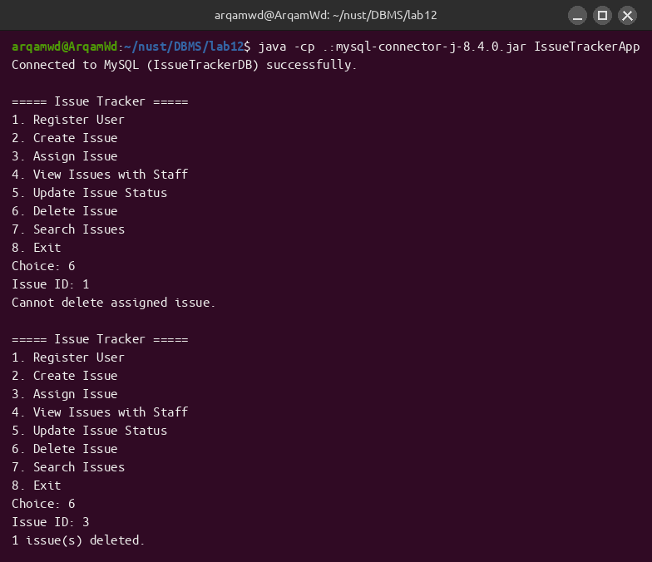

Task 7 – Search Issues
Issues can be searched either by status (e.g. Pending) or by issue_id, both via PreparedStatement parameters.
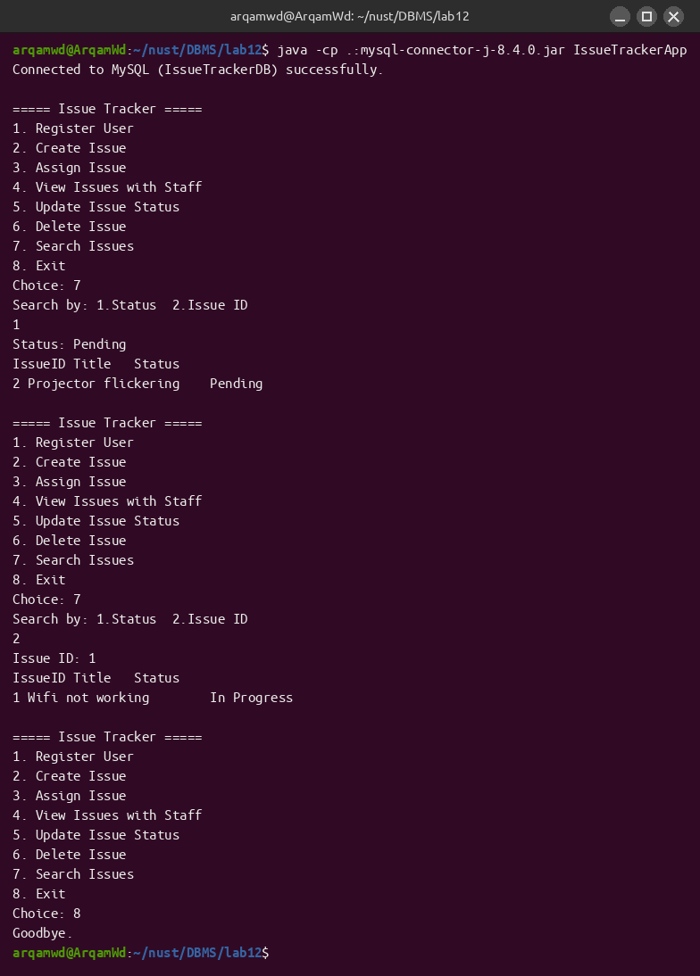

Constraints (Exception Handling & Resource Closing)
Every JDBC call is inside try-with-resources, so Connection, PreparedStatement, ResultSet and Scanner auto-close even when an exception is thrown. Each SQL call is additionally wrapped in a try/catch that prints the SQLException message and returns to the menu, as demonstrated by the empty-email error, the duplicate-assignment error, and the “Cannot delete assigned issue.” guard.

Source Code

schema.sql
-- Lab 12 – Advanced JDBC: Issue Tracker
-- Normalized schema (3NF) with referential integrity
DROP DATABASE IF EXISTS IssueTrackerDB;
CREATE DATABASE IssueTrackerDB;
USE IssueTrackerDB;
CREATE TABLE User (
user_id INT AUTO_INCREMENT PRIMARY KEY,
name VARCHAR(60) NOT NULL,
email VARCHAR(80) NOT NULL UNIQUE
);
CREATE TABLE Staff (
staff_id INT AUTO_INCREMENT PRIMARY KEY,
name VARCHAR(60) NOT NULL,
role VARCHAR(40) NOT NULL
);
CREATE TABLE Issue (
issue_id INT AUTO_INCREMENT PRIMARY KEY,
title VARCHAR(120) NOT NULL,
description TEXT,
status VARCHAR(20) NOT NULL DEFAULT 'Pending'
);
CREATE TABLE Assignment (
assign_id INT AUTO_INCREMENT PRIMARY KEY,
issue_id INT NOT NULL UNIQUE,
staff_id INT NOT NULL,
CONSTRAINT fk_assign_issue FOREIGN KEY (issue_id) REFERENCES Issue(issue_id),
CONSTRAINT fk_assign_staff FOREIGN KEY (staff_id) REFERENCES Staff(staff_id)
);
-- Sample staff
INSERT INTO Staff (name, role) VALUES
('Hassan Raza', 'Support Engineer'),
('Ayesha Noor', 'Senior Engineer'),
('Bilal Tariq', 'Network Admin');
-- Sample users
INSERT INTO User (name, email) VALUES
('Ali Khan', 'ali@nust.edu.pk'),
('Sara Ahmed', 'sara@nust.edu.pk');
-- Sample issues
INSERT INTO Issue (title, description, status) VALUES
('Wifi not working', 'Cannot connect to campus wifi from CR-1.', 'Pending'),
('Projector flickering', 'Projector in lab flickers every 10s.', 'Pending');

IssueTrackerApp.java
import java.sql.*;
import java.util.Scanner;
/**
* Lab 12 – Advanced JDBC
* Issue Tracker (User / Issue / Staff / Assignment)
*
* - try-with-resources for Connection / PreparedStatement / ResultSet / Scanner
* - try/catch around every SQL call (errors print and return to menu)
* - PreparedStatement everywhere (no SQL injection)
*/
public class IssueTrackerApp {
static final String URL = "jdbc:mysql://localhost:3306/IssueTrackerDB";
static final String USER = "root";
static final String PASS = "root";
public static void main(String[] args) {
try (Connection con = DriverManager.getConnection(URL, USER, PASS);
Scanner sc = new Scanner(System.in)) {
System.out.println("Connected to MySQL (IssueTrackerDB) successfully.");
while (true) {
System.out.println();
System.out.println("===== Issue Tracker =====");
System.out.println("1. Register User");
System.out.println("2. Create Issue");
System.out.println("3. Assign Issue");
System.out.println("4. View Issues with Staff");
System.out.println("5. Update Issue Status");
System.out.println("6. Delete Issue");
System.out.println("7. Search Issues");
System.out.println("8. Exit");
System.out.print("Choice: ");
String choice = sc.nextLine().trim();
switch (choice) {
case "1": registerUser(con, sc); break;
case "2": createIssue(con, sc); break;
case "3": assignIssue(con, sc); break;
case "4": viewIssuesWithStaff(con); break;
case "5": updateIssueStatus(con, sc);break;
case "6": deleteIssue(con, sc); break;
case "7": searchIssues(con, sc); break;
case "8": System.out.println("Goodbye."); return;
default : System.out.println("Invalid choice.");
}
}
} catch (SQLException e) {
System.out.println("Connection failed: " + e.getMessage());
}
}
// ---------- 1. Register User ----------
static void registerUser(Connection con, Scanner sc) {
System.out.print("Name: ");
String name = sc.nextLine().trim();
System.out.print("Email: ");
String email = sc.nextLine().trim();
if (email.isEmpty()) {
System.out.println("Error: email cannot be empty.");
return;
}
String sql = "INSERT INTO User(name, email) VALUES(?,?)";
try (PreparedStatement ps = con.prepareStatement(sql)) {
ps.setString(1, name);
ps.setString(2, email);
int n = ps.executeUpdate();
System.out.println(n + " user(s) registered.");
} catch (SQLException e) {
System.out.println("Insert failed: " + e.getMessage());
}
}
// ---------- 2. Create Issue ----------
static void createIssue(Connection con, Scanner sc) {
System.out.print("Title: ");
String title = sc.nextLine().trim();
System.out.print("Description: ");
String desc = sc.nextLine().trim();
String sql = "INSERT INTO Issue(title, description, status) VALUES(?,?, 'Pending')";
try (PreparedStatement ps = con.prepareStatement(sql)) {
ps.setString(1, title);
ps.setString(2, desc);
int n = ps.executeUpdate();
System.out.println(n + " issue(s) created with status = Pending.");
} catch (SQLException e) {
System.out.println("Insert failed: " + e.getMessage());
}
}
// ---------- 3. Assign Issue ----------
static void assignIssue(Connection con, Scanner sc) {
System.out.println("--- Issues ---");
runReadQuery(con, "SELECT issue_id, title, status FROM Issue");
System.out.println("--- Staff ---");
runReadQuery(con, "SELECT staff_id, name, role FROM Staff");
System.out.print("Issue ID: ");
int issueId = Integer.parseInt(sc.nextLine().trim());
System.out.print("Staff ID: ");
int staffId = Integer.parseInt(sc.nextLine().trim());
String sql = "INSERT INTO Assignment(issue_id, staff_id) VALUES(?,?)";
try (PreparedStatement ps = con.prepareStatement(sql)) {
ps.setInt(1, issueId);
ps.setInt(2, staffId);
int n = ps.executeUpdate();
System.out.println(n + " assignment(s) created.");
} catch (SQLException e) {
System.out.println("Assignment failed: " + e.getMessage());
}
}
// ---------- 4. View Issues + Staff (JOIN) ----------
static void viewIssuesWithStaff(Connection con) {
String sql =
"SELECT i.issue_id, i.title, i.status, " +
" COALESCE(s.name,'-- unassigned --') AS staff_name " +
"FROM Issue i " +
"LEFT JOIN Assignment a ON a.issue_id = i.issue_id " +
"LEFT JOIN Staff s ON s.staff_id = a.staff_id";
try (PreparedStatement ps = con.prepareStatement(sql);
ResultSet rs = ps.executeQuery()) {
System.out.println("IssueID\tTitle\t\t\tStatus\t\tStaff");
while (rs.next()) {
System.out.printf("%d\t%-22s\t%-10s\t%s%n",
rs.getInt("issue_id"),
rs.getString("title"),
rs.getString("status"),
rs.getString("staff_name"));
}
} catch (SQLException e) {
System.out.println("Read failed: " + e.getMessage());
}
}
// ---------- 5. Update Issue Status ----------
static void updateIssueStatus(Connection con, Scanner sc) {
System.out.print("Issue ID: ");
int id = Integer.parseInt(sc.nextLine().trim());
System.out.print("New status (Pending / In Progress / Resolved): ");
String status = sc.nextLine().trim();
String sql = "UPDATE Issue SET status = ? WHERE issue_id = ?";
try (PreparedStatement ps = con.prepareStatement(sql)) {
ps.setString(1, status);
ps.setInt(2, id);
int n = ps.executeUpdate();
if (n == 0) System.out.println("No issue with that ID.");
else System.out.println("Status updated for issue " + id + ".");
} catch (SQLException e) {
System.out.println("Update failed: " + e.getMessage());
}
}
// ---------- 6. Delete Issue (controlled) ----------
static void deleteIssue(Connection con, Scanner sc) {
System.out.print("Issue ID: ");
int id = Integer.parseInt(sc.nextLine().trim());
// refuse if assigned
String check = "SELECT COUNT(*) FROM Assignment WHERE issue_id = ?";
try (PreparedStatement ps = con.prepareStatement(check)) {
ps.setInt(1, id);
try (ResultSet rs = ps.executeQuery()) {
if (rs.next() && rs.getInt(1) > 0) {
System.out.println("Cannot delete assigned issue.");
return;
}
}
} catch (SQLException e) {
System.out.println("Check failed: " + e.getMessage());
return;
}
String sql = "DELETE FROM Issue WHERE issue_id = ?";
try (PreparedStatement ps = con.prepareStatement(sql)) {
ps.setInt(1, id);
int n = ps.executeUpdate();
if (n == 0) System.out.println("No issue with that ID.");
else System.out.println(n + " issue(s) deleted.");
} catch (SQLException e) {
System.out.println("Delete failed: " + e.getMessage());
}
}
// ---------- 7. Search ----------
static void searchIssues(Connection con, Scanner sc) {
System.out.println("Search by: 1.Status 2.Issue ID");
String mode = sc.nextLine().trim();
if (mode.equals("1")) {
System.out.print("Status: ");
String st = sc.nextLine().trim();
String sql = "SELECT issue_id, title, status FROM Issue WHERE status = ?";
try (PreparedStatement ps = con.prepareStatement(sql)) {
ps.setString(1, st);
printIssueRs(ps);
} catch (SQLException e) {
System.out.println("Search failed: " + e.getMessage());
}
} else if (mode.equals("2")) {
System.out.print("Issue ID: ");
int id = Integer.parseInt(sc.nextLine().trim());
String sql = "SELECT issue_id, title, status FROM Issue WHERE issue_id = ?";
try (PreparedStatement ps = con.prepareStatement(sql)) {
ps.setInt(1, id);
printIssueRs(ps);
} catch (SQLException e) {
System.out.println("Search failed: " + e.getMessage());
}
} else {
System.out.println("Invalid option.");
}
}
// ---------- helpers ----------
static void printIssueRs(PreparedStatement ps) throws SQLException {
try (ResultSet rs = ps.executeQuery()) {
System.out.println("IssueID\tTitle\t\t\tStatus");
int count = 0;
while (rs.next()) {
count++;
System.out.printf("%d\t%-22s\t%s%n",
rs.getInt(1), rs.getString(2), rs.getString(3));
}
if (count == 0) System.out.println("(no rows)");
}
}
static void runReadQuery(Connection con, String sql) {
try (PreparedStatement ps = con.prepareStatement(sql);
ResultSet rs = ps.executeQuery()) {
ResultSetMetaData md = rs.getMetaData();
int cols = md.getColumnCount();
for (int i = 1; i <= cols; i++)
System.out.print(md.getColumnLabel(i) + (i < cols ? "\t" : "\n"));
while (rs.next()) {
for (int i = 1; i <= cols; i++)
System.out.print(rs.getString(i) + (i < cols ? "\t" : "\n"));
}
} catch (SQLException e) {
System.out.println("Read failed: " + e.getMessage());
}
}
}

