Arqam Waheed
Lab task 12
Data base :
First installing java and other dependencies:
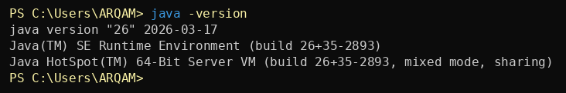
I also downloaded mysql-connector-j-9.x.x.jar and pasted it into the same folder which would have my java file
Now this is my normalized schema for the issue tracker:
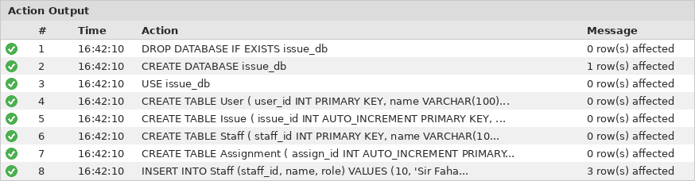
Now connecting the database using java :
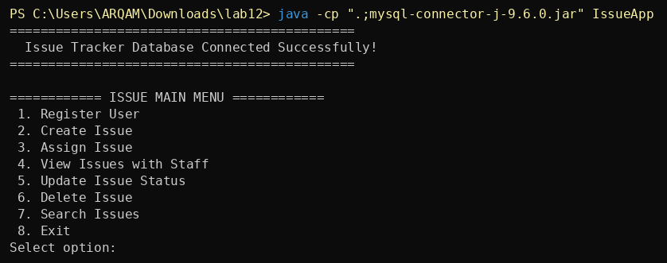
Now adding users:
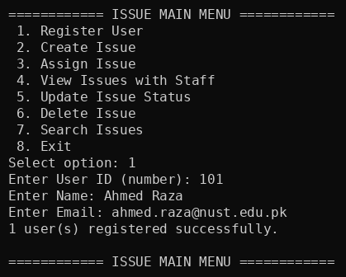
Issues:
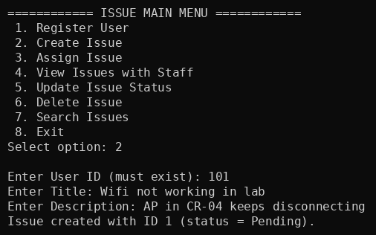
Assigning issue to staff:
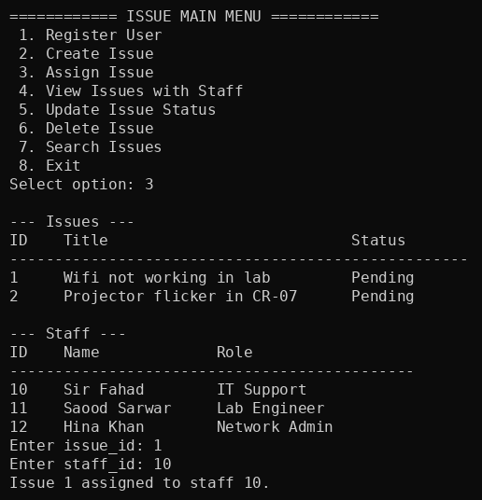
Deleting issue (controlled):
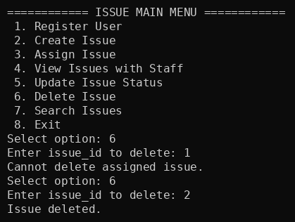
Viewing issues with staff:
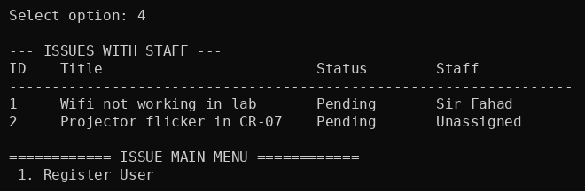
Updating status:
