Department of Computing

CS 212: Object Oriented Programming

Lab : Advanced Exception Handling using Custom Exceptions in Java

Arqam Waheed - 553514

Lab Task 1: University Admission System

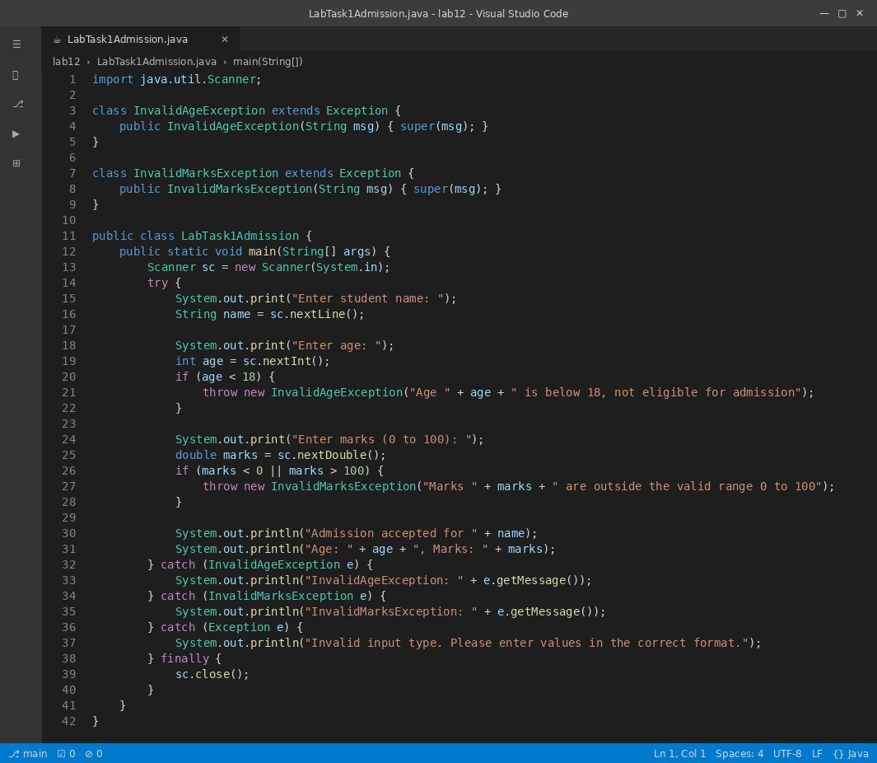

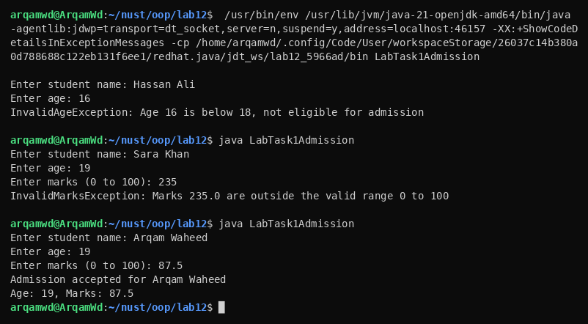

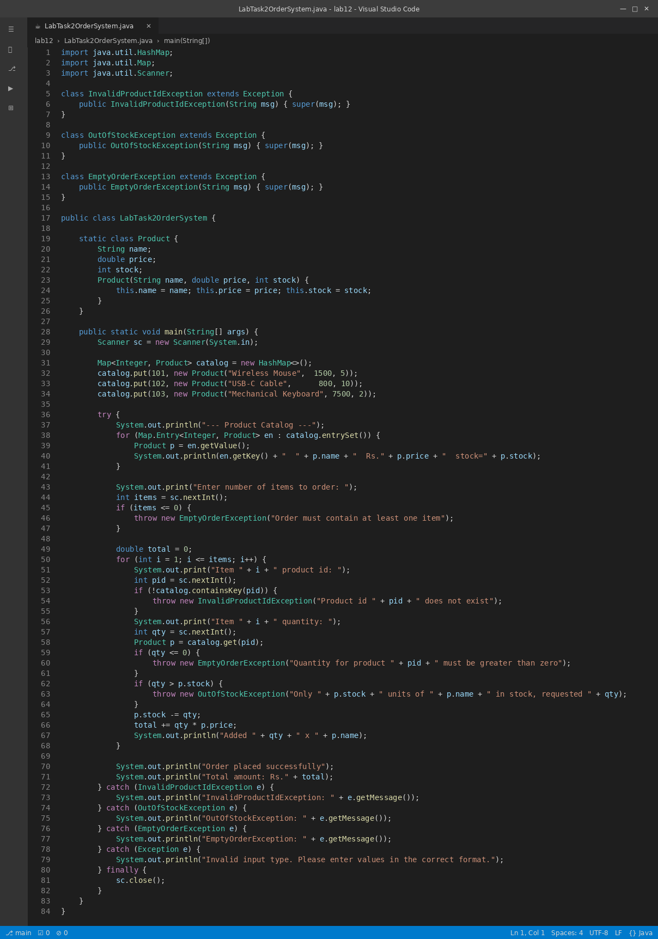
Lab Task 2: E-Commerce Order Processing System
