Task 1
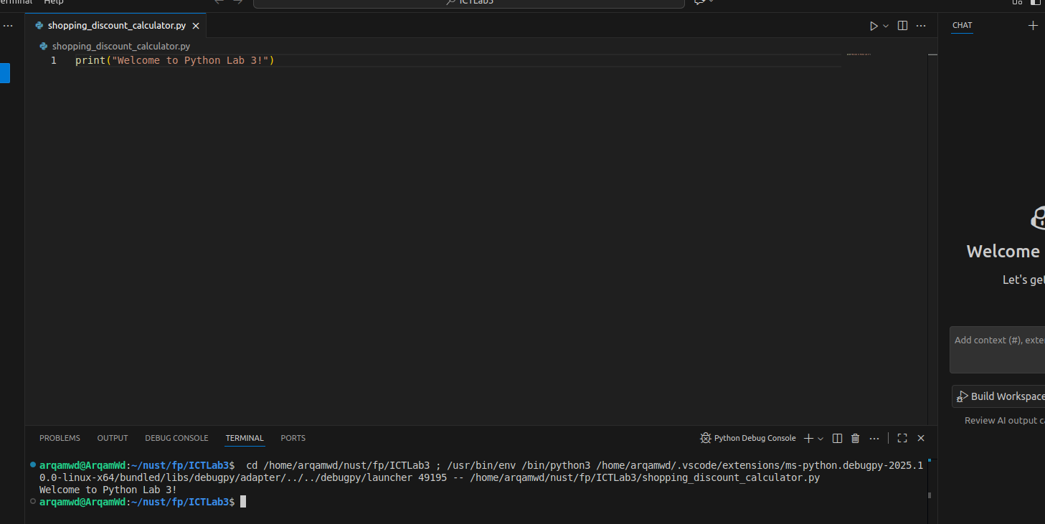
I see output “Welcome to Python Lab 3!”.

