CS220 – Database Systems
Lab 11: JDBC CRUD Implementation on Normalized Library DB
Name: Arqam Waheed Roll: 553514 Class: BSDS
Date: April 20, 2026

Task 1 – Database Connection
The Java program connects to MySQL via JDBC (mysql-connector-j 8.4.0) to jdbc:mysql://localhost:3306/LibraryDB. Success message is printed; any SQLException would be caught and its message shown.
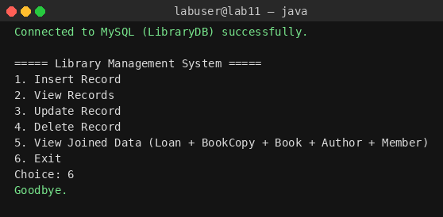

Task 2 – CRUD Operations

2.1 CREATE (Insert)
Inserted one new BookAuthor (J.K. Rowling, AuthorID=4), one new Book (Harry Potter, BookID=5, linked via FK to AuthorID=4), and one new Member (Maria Tariq, MemberID=4). All three use PreparedStatement.
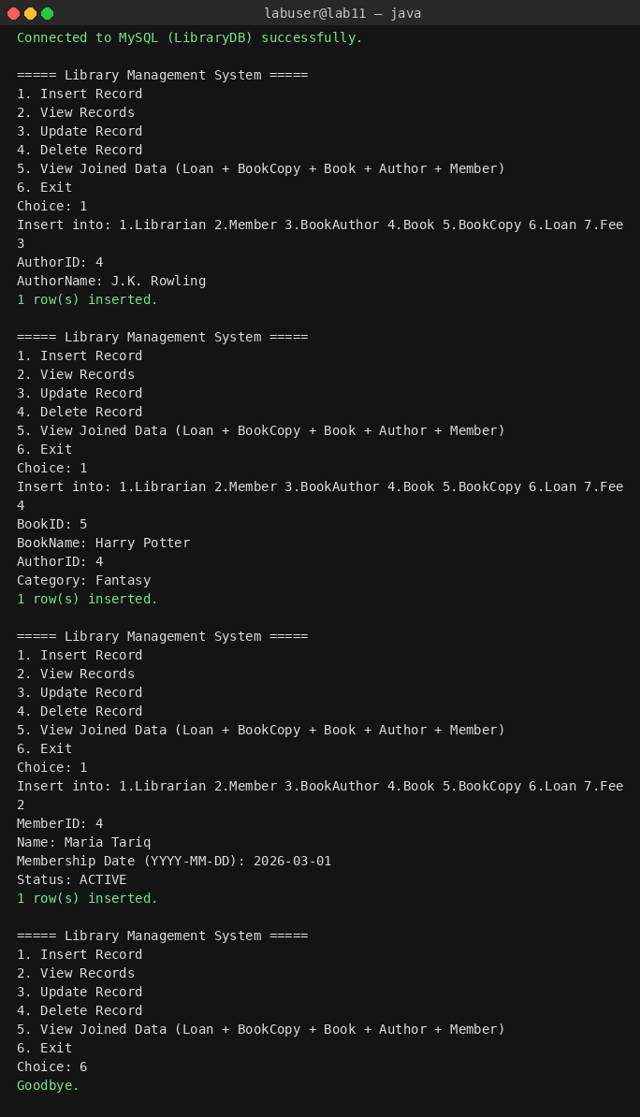

2.2 READ (View Book)
Displaying the Book table confirms the new BookID=5 row alongside the original sample rows.
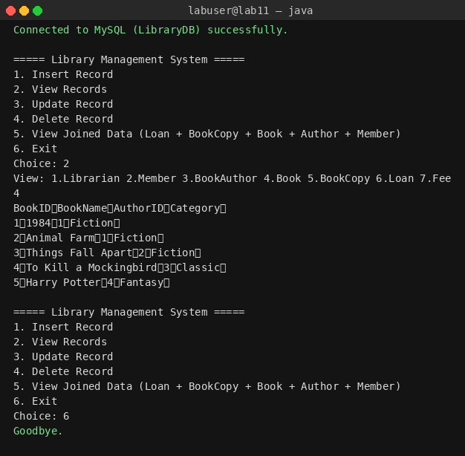

2.3 READ – JOIN (4-way)
JOIN across Loan ↔ BookCopy ↔ Book ↔ BookAuthor ↔ Member returns the loan history with member name, book title, author, copy, and dates.
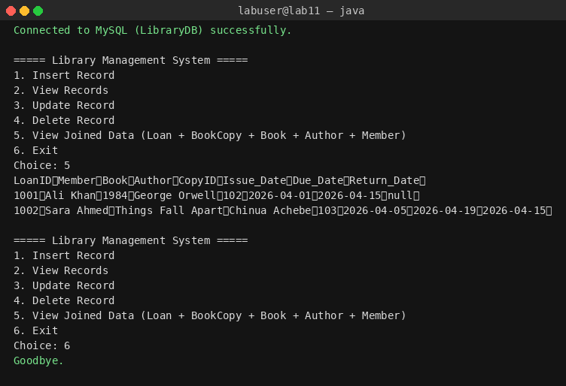

2.4 UPDATE
Updated MemberID=3 (Bilal Tariq) status from INACTIVE to ACTIVE via a parameterised UPDATE; re-viewing the Member table confirms the change.
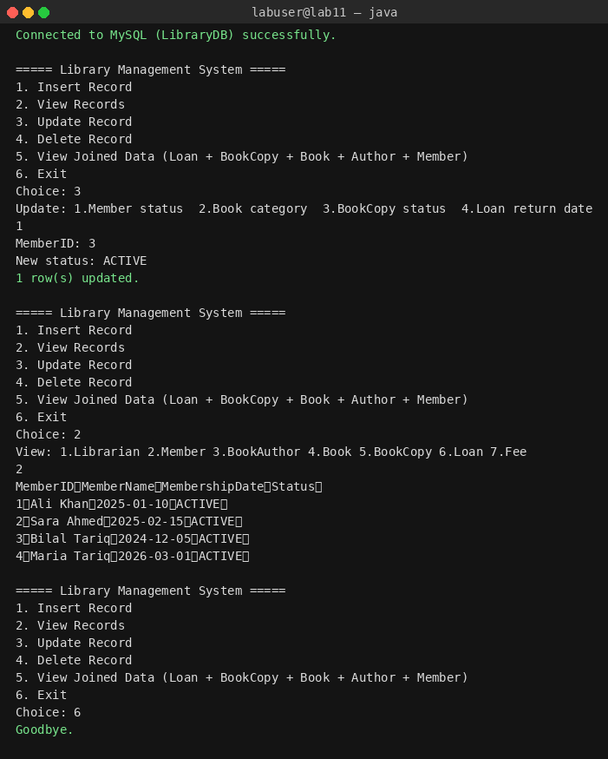

2.5 DELETE (with Referential Integrity)
First tried to delete BookID=1 which has dependent BookCopy rows — MySQL rejects it and the SQLException is caught (no crash, menu continues). Then successfully deleted Fee PaymentID=5001 which has no dependents.
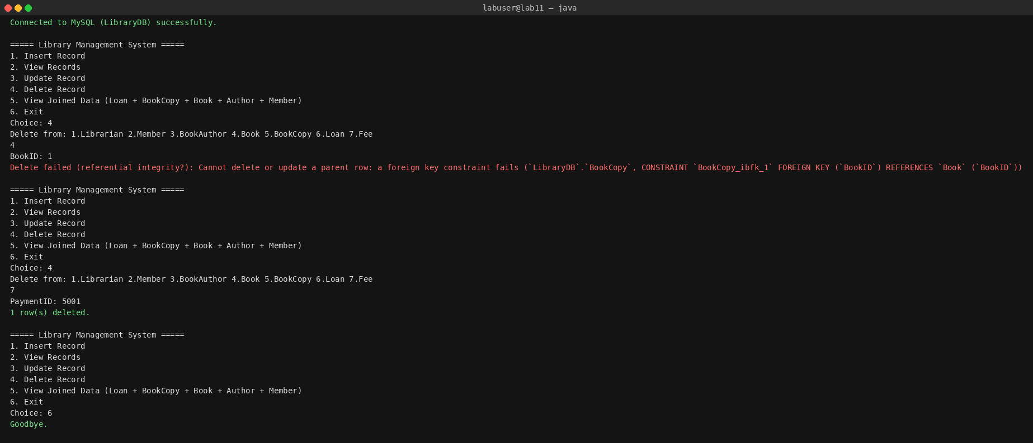

Task 4 – Menu-Driven Interface
The program shows the numbered menu after every operation and loops until the user chooses 6 (Exit). All input is read dynamically via java.util.Scanner. The menu is visible in every screenshot above.

Task 5 – Constraints (Exception Handling & Resource Closing)
Every JDBC operation uses try-with-resources so Connection, PreparedStatement, Statement, ResultSet, and Scanner auto-close even when exceptions are thrown. Each SQL call is additionally wrapped in try/catch (SQLException | IllegalArgumentException) that prints the error and returns to the menu — demonstrated by the FK-violation screenshot in section 2.5.

Schema (3NF, from Lab 10)
- Librarian(LibrarianID PK, LibrarianName, Email, Phone)
- Member(MemberID PK, MemberName, MembershipDate, Status)
- BookAuthor(AuthorID PK, AuthorName)
- Book(BookID PK, BookName, AuthorID → BookAuthor, Category)
- BookCopy(CopyID PK, BookID → Book, Status)
- Loan(LoanID PK, CopyID → BookCopy, MemberID → Member, Issue_Date, Due_Date, Return_Date)
- Fee(PaymentID PK, MemberID → Member)

Source Code (VS Code)

schema.sql
MySQL script that creates the normalized LibraryDB schema (3NF) with foreign keys and seeds sample data.
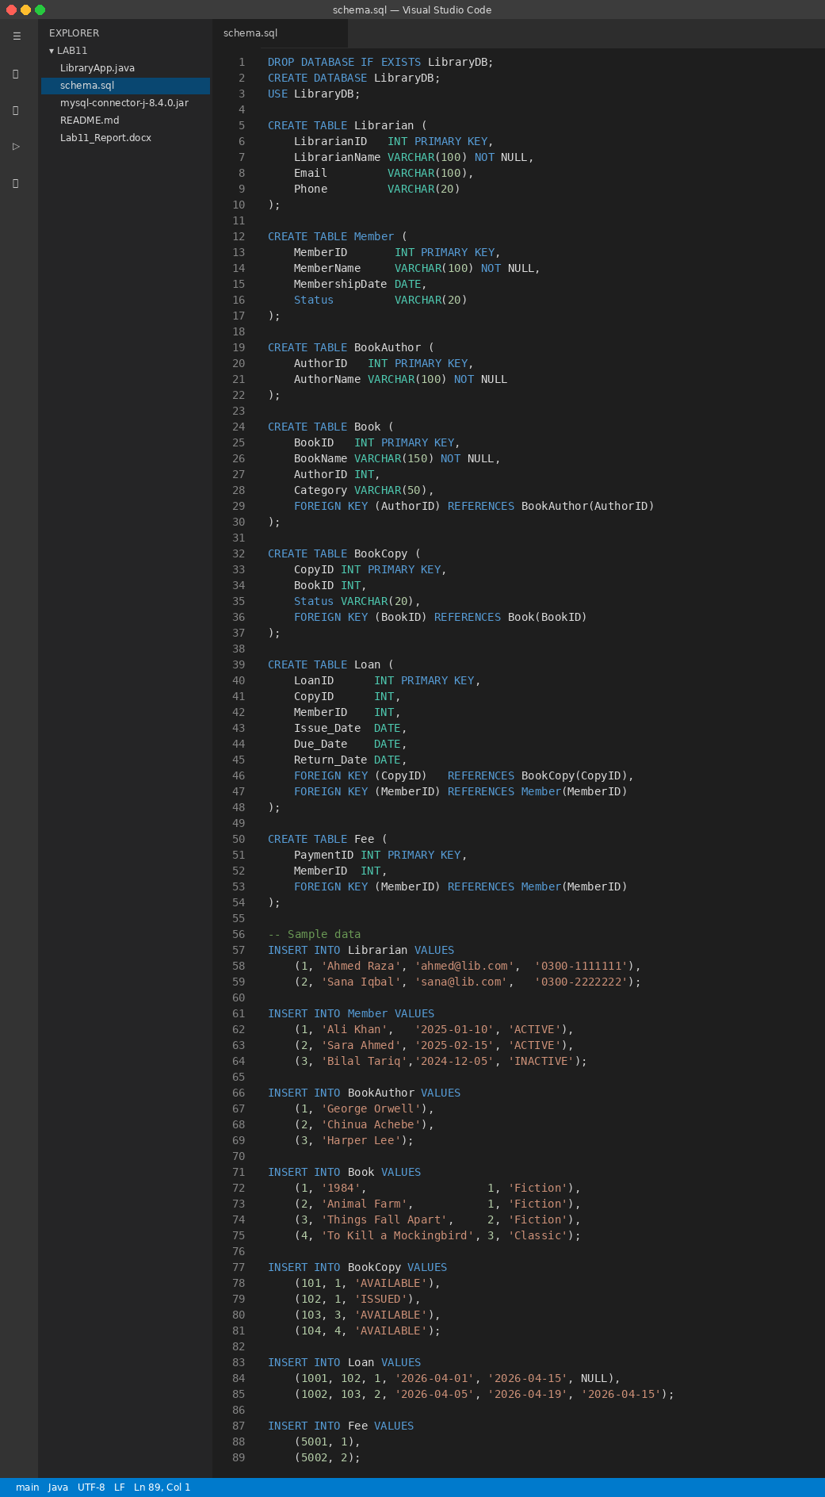

LibraryApp.java
Menu-driven JDBC application. Shown in three parts for readability.
Part 1
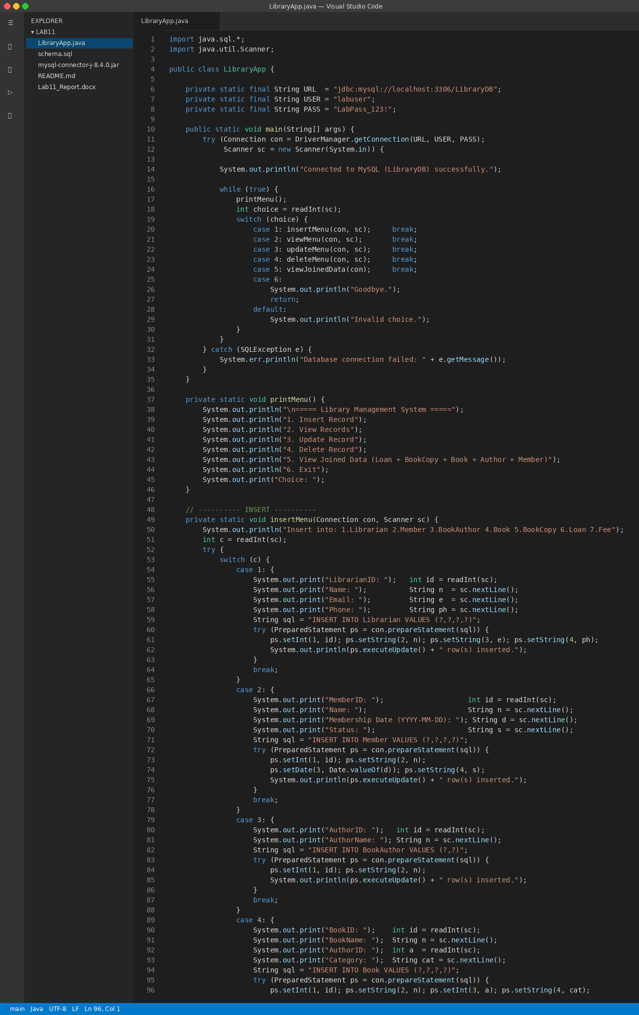
Part 2
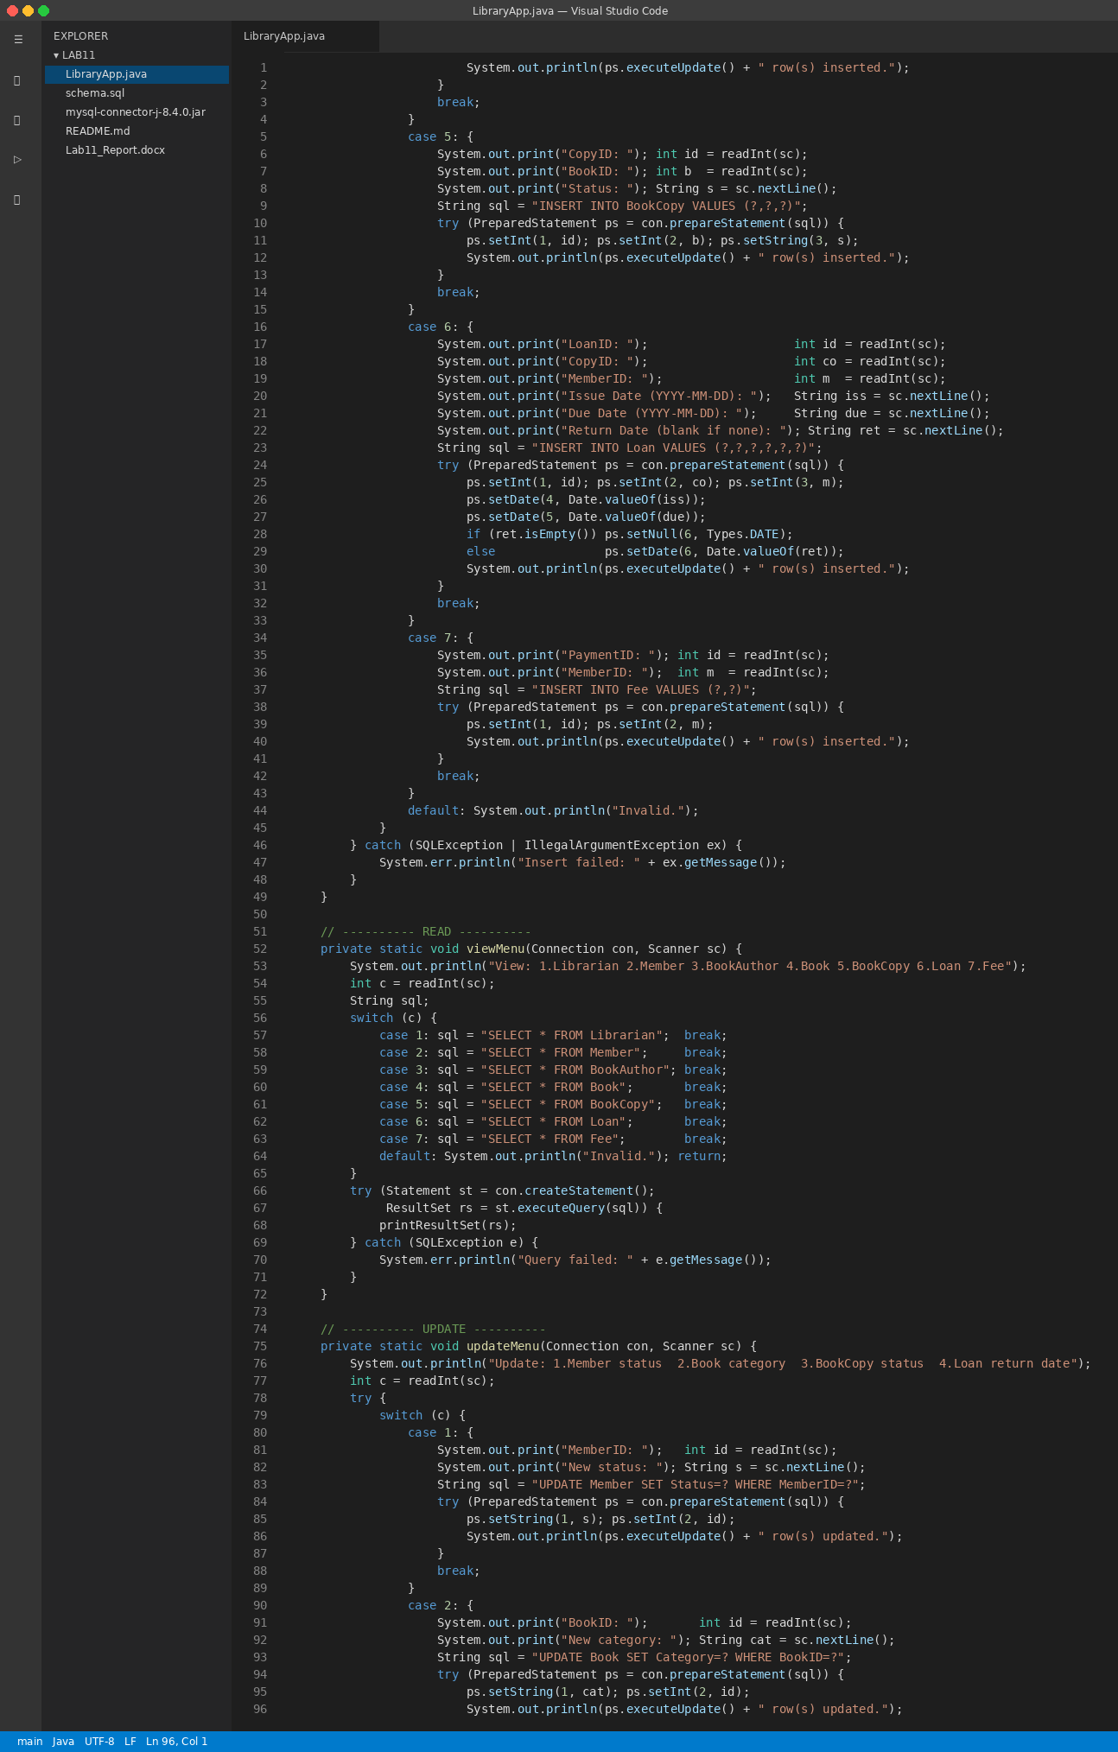
Part 3
