Information Security
Lab 2: Classical Symmetric Block Cipher - Playfair Cipher
Arqam Waheed 553514 BSDS 3A 18 September 2026
Task 1) Playfair Encryption
I wrote both tasks in Python. task1.py builds the 5x5 matrix from the key, strips the message, splits it into pairs and encrypts each pair. task2.py imports the matrix code from task1.py and does the reverse.
a) Key and matrix
Key: EXPLANATION
After removing the repeated letters (the second A, N and the second I) the key gives EXPLNTIO. The rest of the alphabet fills the remaining squares in order, with I and J sharing one square.
E | X | P | L | A
N | T | I/J | O | B
C | D | F | G | H
K | M | Q | R | S
U | V | W | Y | Z

b) Actual message and stripped message
Plain text: Information security is a "MUST" to learn.
Stripped message: INFORMATIONSECURITYISAMUSTTOLEARN
Spaces, quotes and the full stop are removed and everything is changed to uppercase. There is no J in the message so nothing had to be replaced.
c) Pairing and encrypted message
Pairs: IN FO RM AT IO NS EC UR IT YI SA MU ST TO LE AR NQ
Encrypted: OT GI SQ XB OB BK NK YK OI WO ZB KV MB IB AX LS IK
The message has 33 letters, so the last N gets a Q added to it. None of the pairs had the same letter twice (the TT in MUST TO falls across two pairs, ST and TO), so no Q had to be inserted in the middle.
Pair | Rule | Result
IN | Same row | OT
FO | Rectangle | GI
RM | Same row | SQ
AT | Rectangle | XB
IO | Same row | OB
NS | Rectangle | BK
EC | Same column | NK
UR | Rectangle | YK
IT | Same row | OI
YI | Rectangle | WO
SA | Same column | ZB
MU | Rectangle | KV
ST | Rectangle | MB
TO | Same row | IB
LE | Same row | AX
AR | Rectangle | LS
NQ | Rectangle | IK

d) Code and output
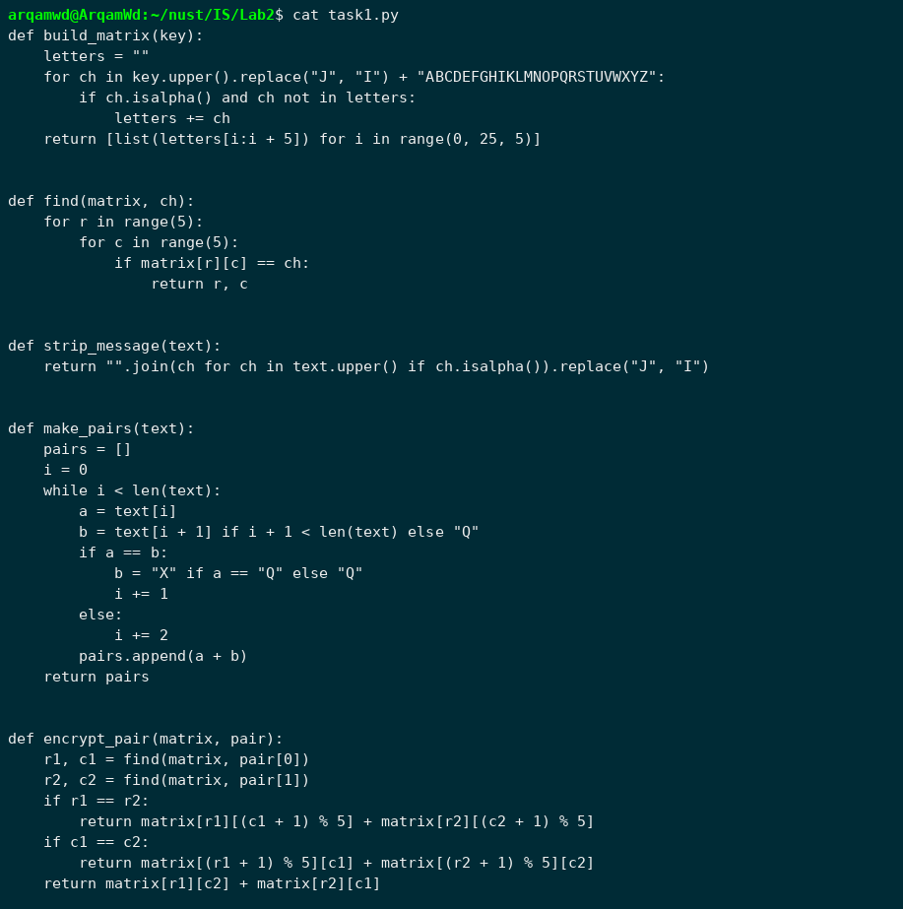
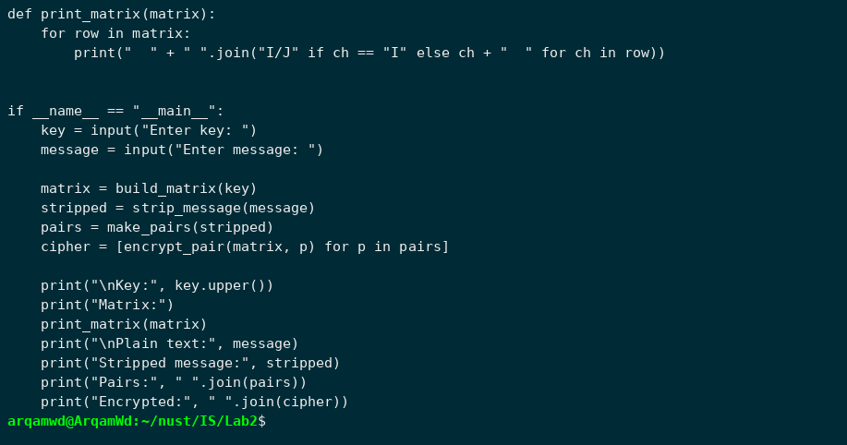
Output:
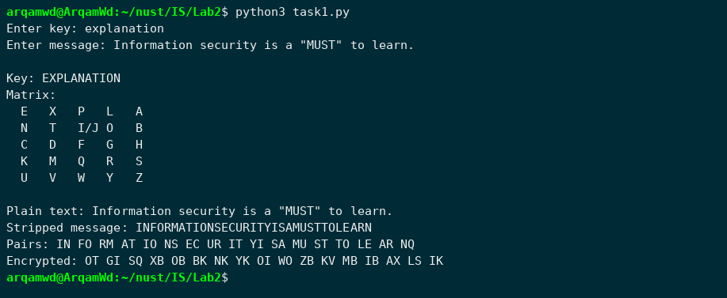
To check the program I also ran the two examples from the lab handout with the key KEYWORD. Both match the handout (WH comes out as YI, which the handout says is the same as YJ).
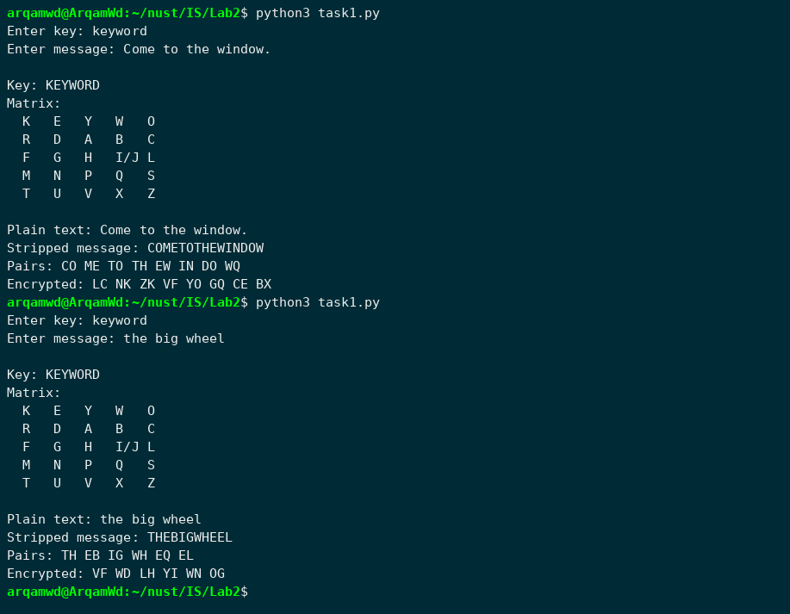
Task 2) Playfair Decryption
Decryption uses the same matrix. For a rectangle the rule is the same as encryption, for a row each letter is replaced by the one on its left, and for a column by the one above it. At the end the program removes the Q that was added at the end and any Q that sits between two identical letters.
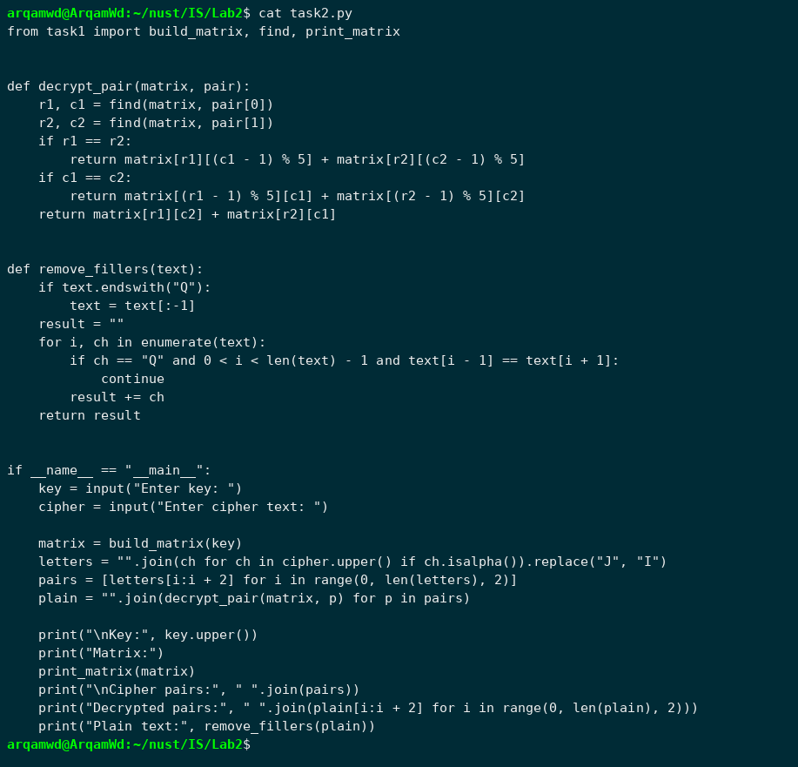
Output:
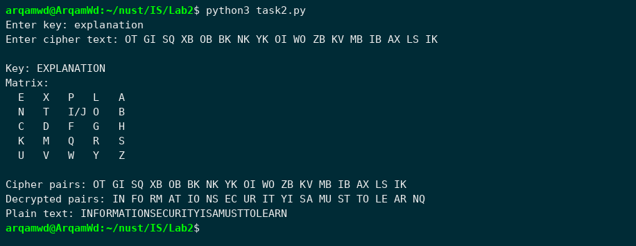
The cipher text from Task 1 decrypts back to the stripped message. The spaces, quotes and lowercase letters can't come back because they were removed before encryption. Running it on the handout examples also gives back THE BIG WHEEL (the inserted Q between EE is removed) and COME TO THE WINDOW.
