CS-250: Data Structure and Algorithms
Lab 9: Binary Search Tree
Arqam Waheed 553514 BSDS 3A 10 November 2026
GitHub: https://github.com/ArqamWaheed/nust/tree/testbranch/dsa/lab9
Task 1) Range Query and Successor/Predecessor Finder using BST
I insert the given sequence into a BST and print the inorder traversal to check it is sorted. For the predecessor and successor I walk down from the root: every time I go right the node is a predecessor candidate, every time I go left it is a successor candidate, and when the key is found I take the max of its left subtree and the min of its right subtree. The range query has a recursive version and an iterative version that uses an array stack. Both skip subtrees that cannot have keys in the range and count every key comparison. For the given tree both made 24 comparisons for [30, 70], because they visit the same nodes in the same order, only the iterative one does it without recursion.
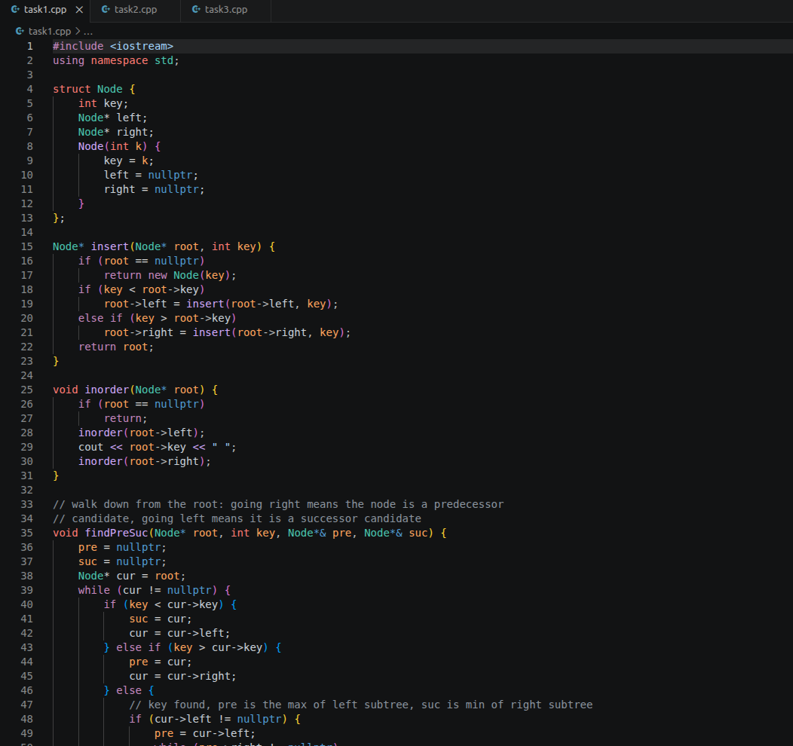
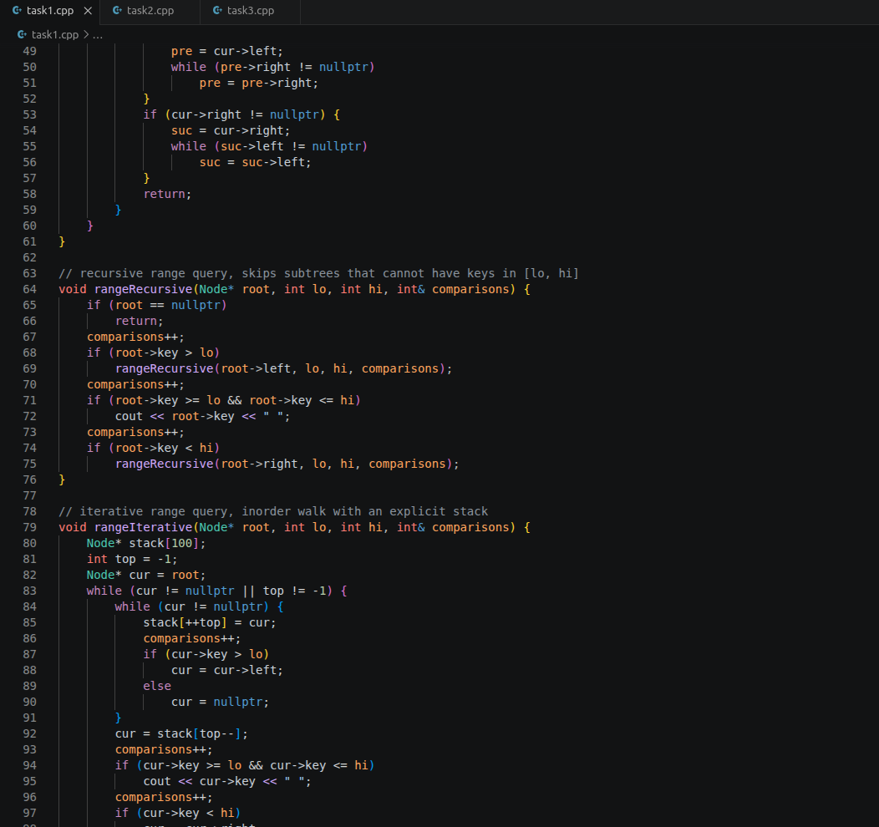
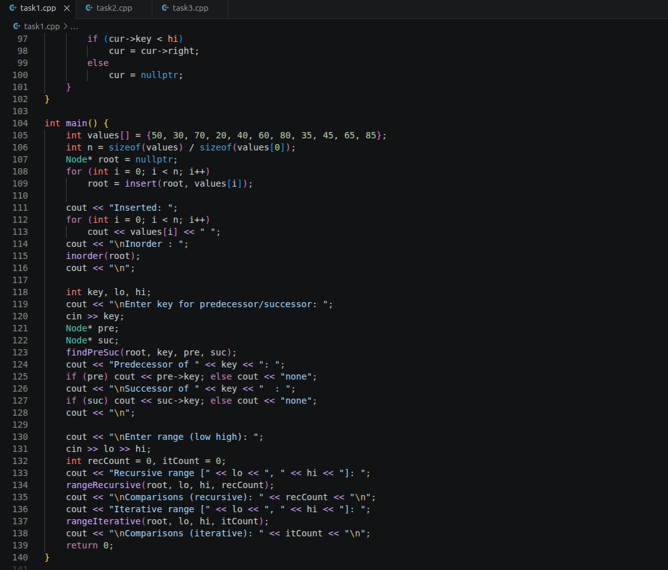
Output:
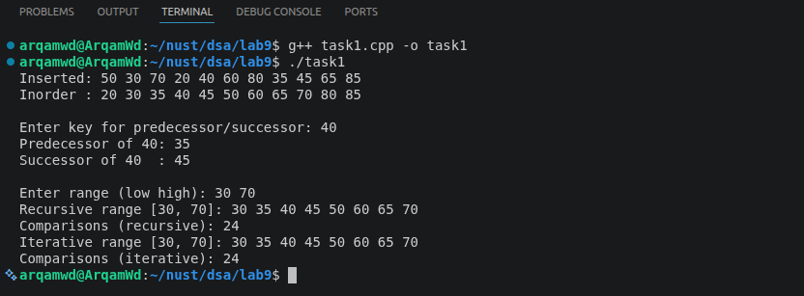
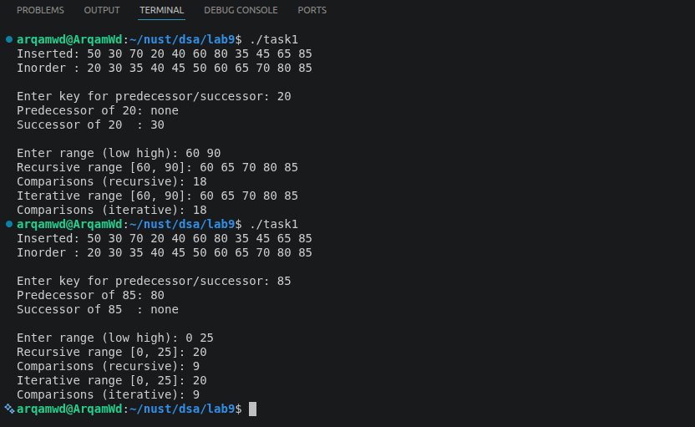
Task 2) Word Frequency Indexing using BST
Each node stores a word and its count. The paragraph is split on anything that is not a letter and every word is lowercased, so "The" and "the" go to the same node and the full stops are dropped. displayAlphabetical() is just an inorder traversal. displayByFrequency() copies the nodes into an array with an inorder walk and sorts them with insertion sort by count, which keeps equal counts in alphabetical order. findMostFrequentWord() finds the highest count and prints every word with that count. The paragraph has 15 words and 11 unique ones, and "the" is the most frequent with 3.
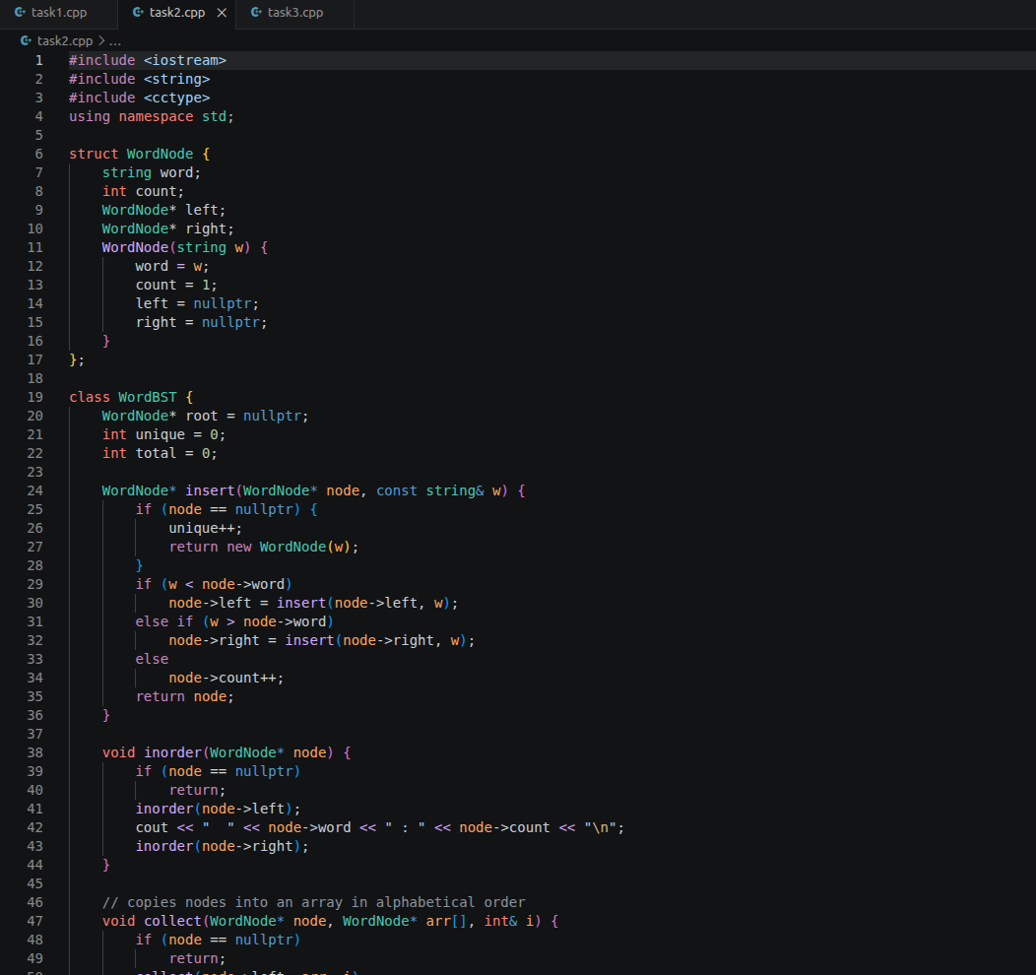
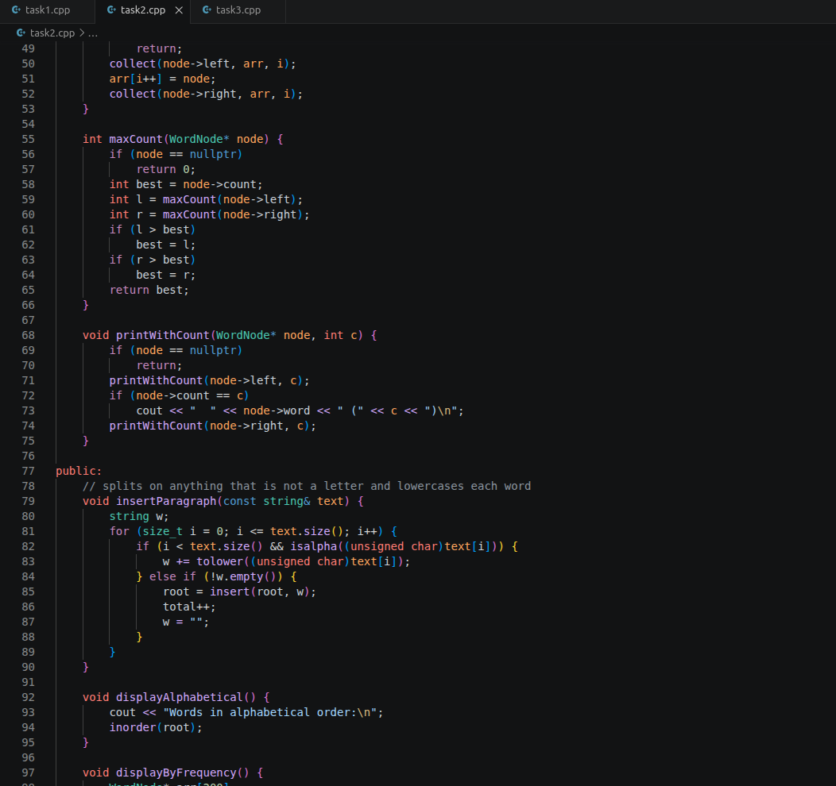
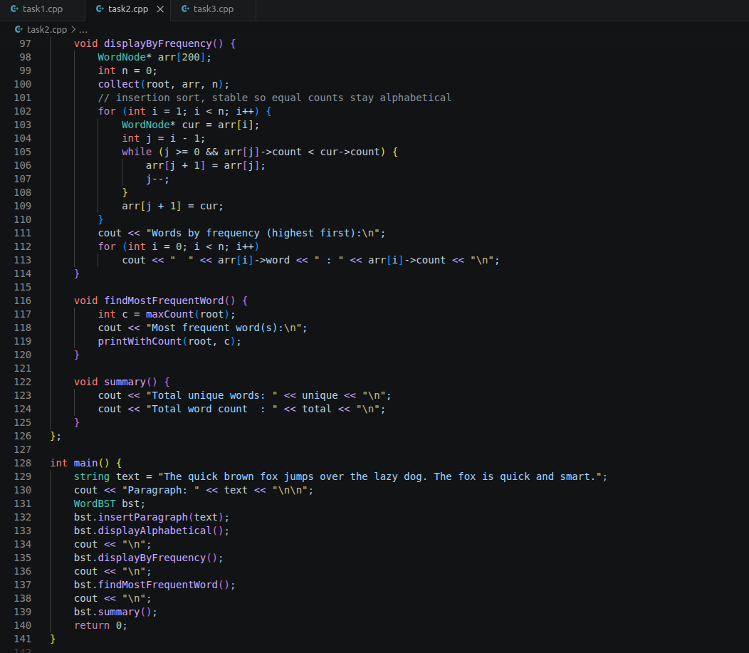
Output:
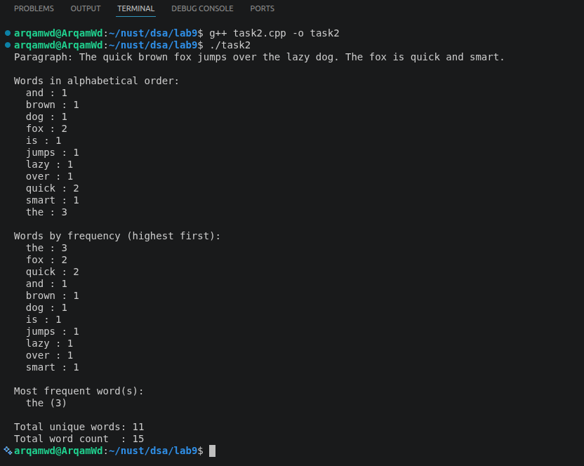
Task 3) Weighted M-ary Tree: Galaxy Representation Problem
StarSystem holds the id, name, planets, coordinates and habitable flag, plus an array of TravelRoute pointers to its children. TravelRoute stores the travel cost and the destination system. Galaxy has two constructors, one with only M and one with M and a root, and addRoute() refuses to give a system more than M routes. count_leaves() returns 1 for a system with no routes and otherwise adds up its children. is_balanced() works out the size of every child subtree (a missing child counts as size 0) and checks that the biggest and smallest differ by at most 1 at every node. The first galaxy is balanced with 3 leaves. After I add two more systems under Alpha Centauri its subtree has 4 nodes against 2 and 2, so the tree is no longer balanced.
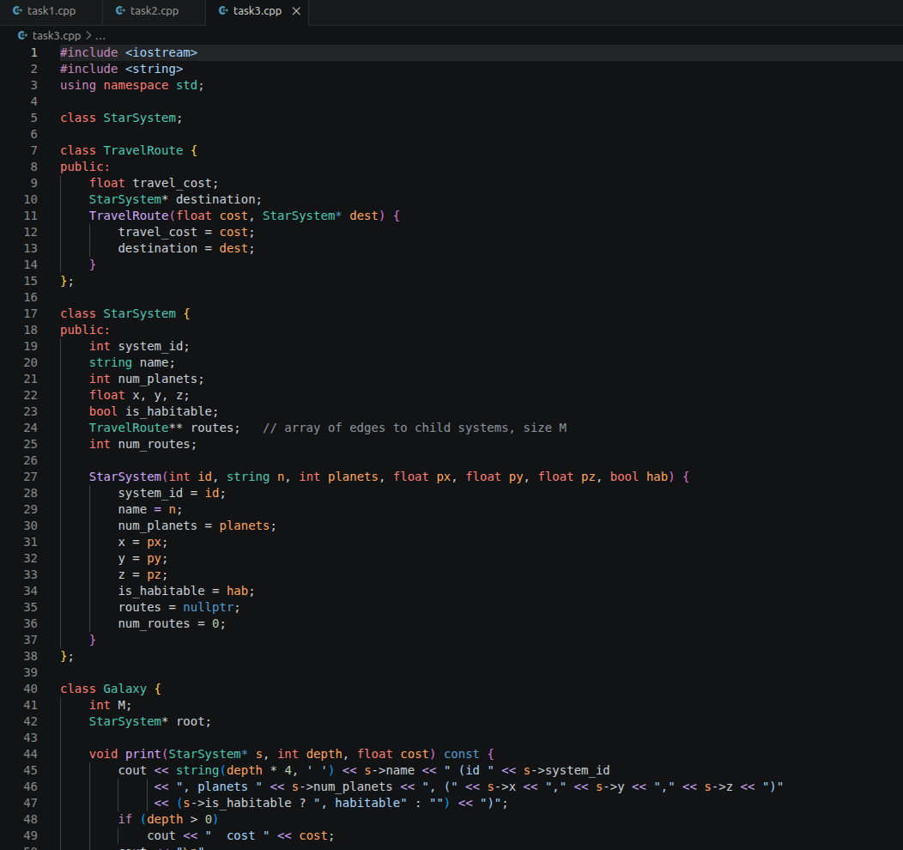
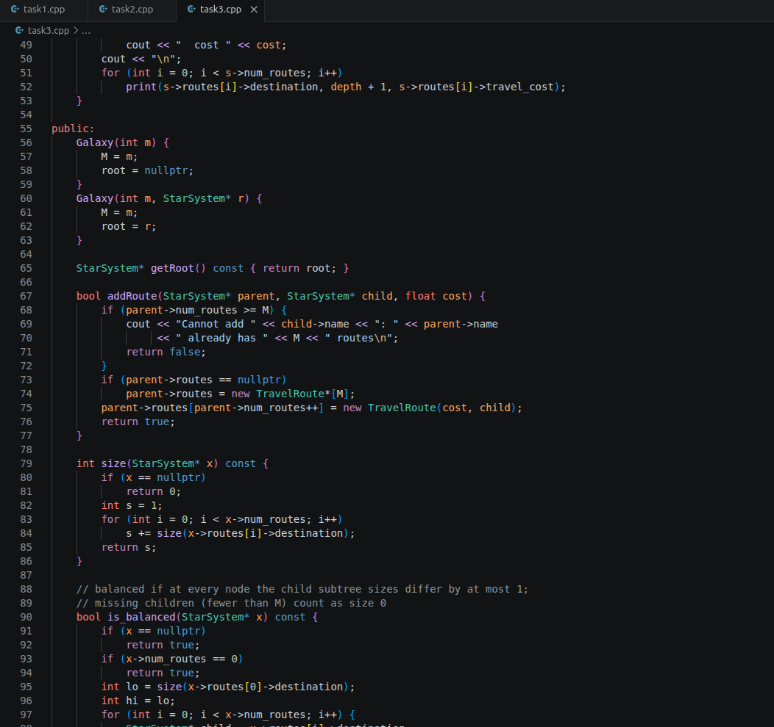
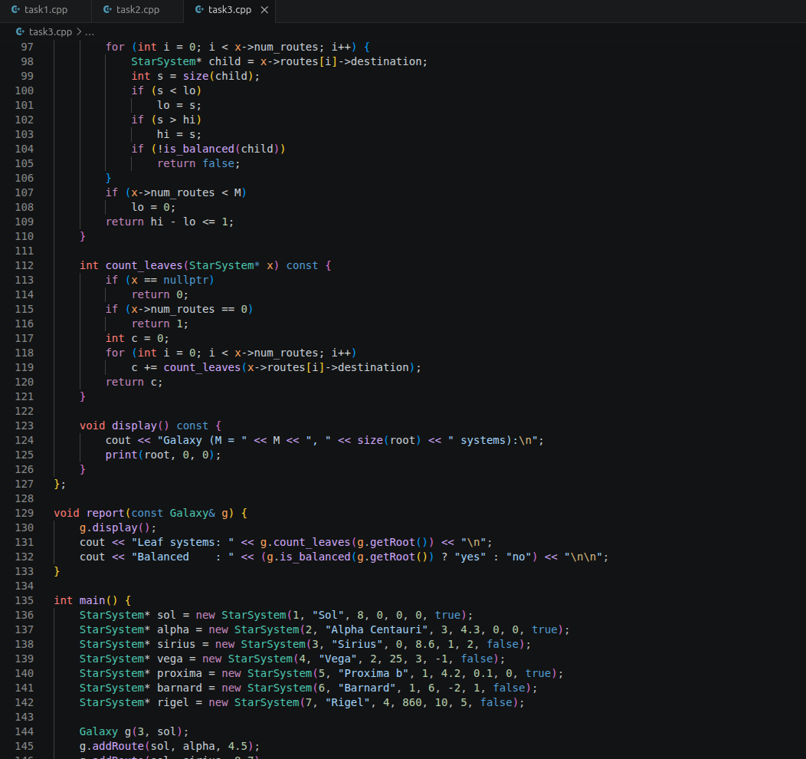
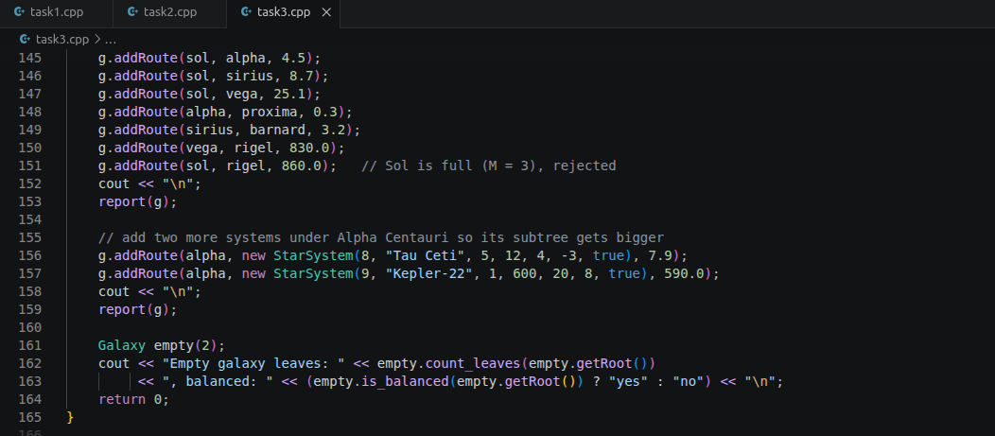
Output:


