Department of Computing

School of Electrical Engineering and Computer Science

CS-250: Data Structure and Algorithms
Class: BSDS 3A

Lab 8: Binary Tree

Date: 20th October 2026
Time: 10:00 am – 12:50 pm

Instructor: Dr. Fahad Ahmed Satti

Lab Engineer: Hassan Mohtashim

Submitted by: Arqam Waheed (553514)

Lab 8: Binary Tree

Introduction
This lab focuses on binary trees. A binary tree is given as a bracketed string. The string is validated, the tree is built with nodes and pointers, and it is traversed recursively and iteratively using a stack. The height of the tree and the depth of each node are also found.
Objectives
Understand and implement binary trees, construct and validate trees from string representations, implement preorder, inorder and postorder traversals using recursion and a stack, and calculate tree height and node depth.
Tools/Software Requirement
Visual Studio Code in Unix/Linux Environment.
Task 1: Binary Tree Representation and Operations
Given the string representation of a binary tree a(b(d,e),c(,f(g,))), perform the following tasks:
1. Generate a binary tree from the given string using nodes and pointers.
2. Generate the preorder form using a recursive function.
3. Generate the inorder form iteratively using a stack (linear ADT) instead of recursion.
4. Generate the postorder form iteratively using a stack.
5. Validate the tree string (balanced parentheses, correct child placement) without building the tree.
6. Calculate the height of the tree and the depth of each node recursively.
Solution
The tree is kept in a global root pointer, the same way the playlist in Lab 4 kept head and tail. parse() reads the string with an index: a letter makes a node, and if "(" follows, the left child is parsed up to "," and the right child up to ")". An empty slot before "," or ")" returns nullptr, so a missing child stays null. Preorder is a plain recursive function, and toTreeString() prints the tree back in bracket form to show it was built correctly. Inorder and postorder use a small array stack of node pointers. Inorder pushes nodes while going left, pops one, prints it and moves to its right child. Postorder uses one stack and a lastVisited pointer, so a node is printed only after its right subtree is done. Validation reads the string twice without creating nodes. The first pass counts brackets. The second pass checks that every node is a label, optionally followed by (left,right), with empty children allowed but not "(,)". Height is counted in edges (leaf = 0), and depth is passed down from the root starting at 0. The menu checks a new string before loading it, so an invalid string never replaces the tree. For the given tree: preorder a b d e c f g, inorder d b e a c g f, postorder d e b g f c a, height 3.
Code: task1.cpp
#include <iostream>
#include <string>
#include <cctype>
using namespace std;

struct Node {
char data;
Node* left;
Node* right;

Node(char c) {
data = c;
left = nullptr;
right = nullptr;
}
};

Node* root = nullptr;
string treeString = "a(b(d,e),c(,f(g,)))";

// array based stack of node pointers, used for inorder and postorder
struct Stack {
Node* items[100];
int top = -1;

bool isEmpty() {
return top == -1;
}

bool push(Node* n) {
if (top == 99)
return false;
items[++top] = n;
return true;
}

Node* pop() {
if (isEmpty())
return nullptr;
return items[top--];
}

Node* peek() {
if (isEmpty())
return nullptr;
return items[top];
}
};

// ---------- 1. build the tree from the string ----------

// i walks through the string, an empty slot before ',' or ')' gives a null child
Node* parse(const string &s, int &i) {
if (i >= (int)s.size() || s[i] == ',' || s[i] == ')')
return nullptr;

Node* fresh = new Node(s[i]);
i++;

if (i < (int)s.size() && s[i] == '(') {
i++; // skip '('
fresh->left = parse(s, i);
i++; // skip ','
fresh->right = parse(s, i);
i++; // skip ')'
}
return fresh;
}

Node* buildTree(const string &s) {
int i = 0;
return parse(s, i);
}

void destroyTree(Node* n) {
if (n == nullptr)
return;
destroyTree(n->left);
destroyTree(n->right);
delete n;
}

// walks the tree and writes it back in bracket form, used to check the build
string toTreeString(Node* n) {
if (n == nullptr)
return "";

string s(1, n->data);
if (n->left != nullptr || n->right != nullptr)
s += "(" + toTreeString(n->left) + "," + toTreeString(n->right) + ")";
return s;
}

// ---------- 2. preorder (recursive) ----------

void preorder(Node* n) {
if (n == nullptr)
return;
cout << n->data << " ";
preorder(n->left);
preorder(n->right);
}

// ---------- 3. inorder (iterative, stack) ----------

void inorderIterative() {
Stack st;
Node* cur = root;

while (cur != nullptr || !st.isEmpty()) {
// go as far left as possible
while (cur != nullptr) {
st.push(cur);
cur = cur->left;
}
cur = st.pop();
cout << cur->data << " ";
cur = cur->right;
}
}

// ---------- 4. postorder (iterative, one stack) ----------

// lastVisited stops a node from being printed before its right subtree
void postorderIterative() {
Stack st;
Node* cur = root;
Node* lastVisited = nullptr;

while (cur != nullptr || !st.isEmpty()) {
if (cur != nullptr) {
st.push(cur);
cur = cur->left;
}
else {
Node* top = st.peek();
if (top->right != nullptr && lastVisited != top->right) {
cur = top->right;
}
else {
cout << top->data << " ";
lastVisited = st.pop();
}
}
}
}

// ---------- 5. validation without building the tree ----------

// tree -> label | label '(' child ',' child ')'
// child -> tree | nothing ("(,)" is not allowed)
bool checkTree(const string &s, int &i, string &err);

bool checkChild(const string &s, int &i, string &err, bool &present) {
present = false;
if (i < (int)s.size() && (s[i] == ',' || s[i] == ')'))
return true;
present = true;
return checkTree(s, i, err);
}

bool checkTree(const string &s, int &i, string &err) {
if (i >= (int)s.size() || !isalnum(s[i])) {
err = "expected a node label at position " + to_string(i);
return false;
}
i++;

if (i >= (int)s.size() || s[i] != '(')
return true;
i++;

bool hasLeft, hasRight;
if (!checkChild(s, i, err, hasLeft))
return false;

if (i >= (int)s.size() || s[i] != ',') {
err = "expected ',' between children at position " + to_string(i);
return false;
}
i++;

if (!checkChild(s, i, err, hasRight))
return false;

if (i >= (int)s.size() || s[i] != ')') {
err = "expected ')' at position " + to_string(i);
return false;
}
if (!hasLeft && !hasRight) {
err = "empty brackets '(,)' at position " + to_string(i - 2);
return false;
}
i++;
return true;
}

bool isValidTreeString(const string &s, string &err) {
// first pass: brackets must balance
int depth = 0;
for (int k = 0; k < (int)s.size(); k++) {
if (s[k] == '(')
depth++;
else if (s[k] == ')')
depth--;

if (depth < 0) {
err = "unmatched ')' at position " + to_string(k);
return false;
}
}
if (depth != 0) {
err = "unbalanced parentheses";
return false;
}

// second pass: children in the right places
int i = 0;
if (!checkTree(s, i, err))
return false;
if (i != (int)s.size()) {
err = "extra characters after position " + to_string(i);
return false;
}
return true;
}

// ---------- 6. height and depth ----------

// height in edges: a leaf is 0, an empty tree is -1
int height(Node* n) {
if (n == nullptr)
return -1;
int l = height(n->left);
int r = height(n->right);
return 1 + (l > r ? l : r);
}

// depth is passed down, root starts at 0
void printDepths(Node* n, int depth) {
if (n == nullptr)
return;
cout << "Node " << n->data << ": depth " << depth << ", height " << height(n) << endl;
printDepths(n->left, depth + 1);
printDepths(n->right, depth + 1);
}

// ---------- menu ----------

void showTraversals() {
cout << "Tree : " << toTreeString(root) << endl;
cout << "Preorder : ";
preorder(root);
cout << endl;
cout << "Inorder : ";
inorderIterative();
cout << endl;
cout << "Postorder : ";
postorderIterative();
cout << endl;
}

string readTreeString() {
string s;
cout << "Enter tree string: ";
cin >> s;
return s;
}

void showMenu() {
cout << endl;
cout << "1.Load tree 2.Traversals 3.Height/Depth 4.Validate 5.Exit" << endl;
cout << "Enter choice: ";
}

int main() {
int choice;
string s, err;
bool running = true;

root = buildTree(treeString);
cout << "Tree loaded: " << treeString << endl;

while (running) {
showMenu();
if (!(cin >> choice)) {
if (cin.eof())
break;
cin.clear();
cin.ignore(1000, '\n');
cout << "Invalid choice" << endl;
continue;
}

switch (choice) {
case 1:
s = readTreeString();
if (!isValidTreeString(s, err)) {
cout << "Invalid tree string: " << err << endl;
break;
}
destroyTree(root);
treeString = s;
root = buildTree(treeString);
cout << "Tree loaded: " << treeString << endl;
showTraversals();
break;

case 2:
showTraversals();
break;

case 3:
cout << "Height of tree: " << height(root) << endl;
printDepths(root, 0);
break;

case 4:
s = readTreeString();
if (isValidTreeString(s, err))
cout << s << " is valid" << endl;
else
cout << s << " is invalid: " << err << endl;
break;

case 5:
running = false;
break;

default:
cout << "Invalid choice" << endl;
}
}

destroyTree(root);
cout << "Goodbye" << endl;
}
Output
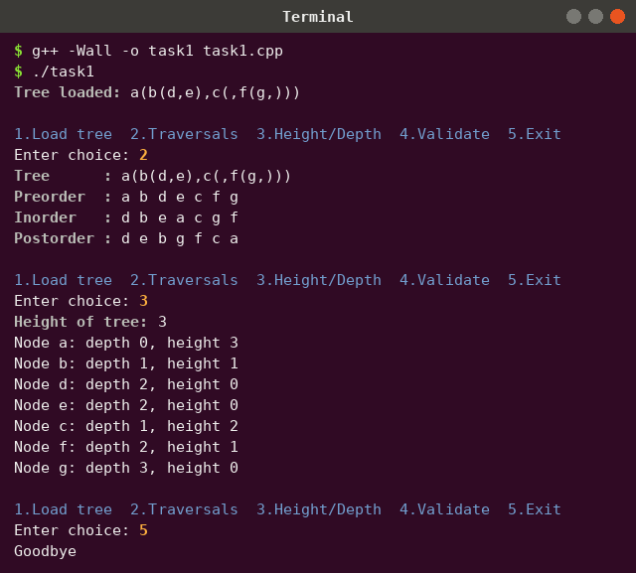
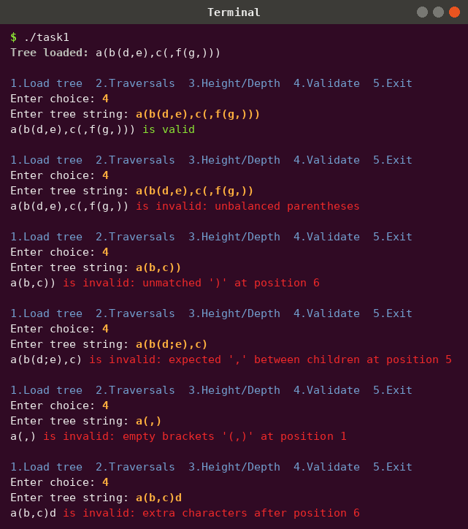
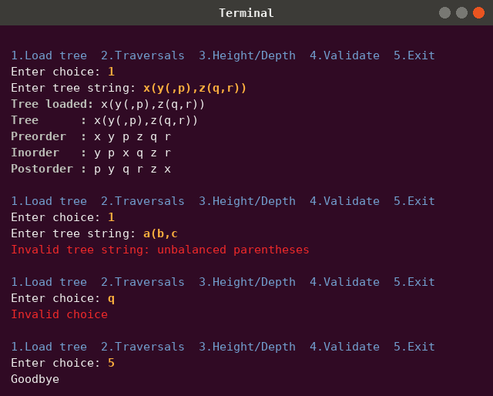

Grading Rubrics:
Assessment Criteria | CLO | Activity | Exceeds Expectations (5) | Satisfactory (4) | Meets Expectations (3) | Needs Improvement (2) | Unsatisfactory (1)
Binary Tree Representation and Operations | CLO 2 | Implementing tree construction, traversal, and validation from string-based representation | Correctly builds and validates binary tree; all traversals (preorder, inorder using stack, postorder iterative) and BST generation fully functional | All core operations implemented with minor logic or formatting issues | Basic construction and traversal work; limited validation accuracy | Partial functionality or incorrect traversal logic | No valid implementation or incorrect algorithm
 | CLO 3 | Applying recursive and iterative traversal logic using linear ADTs | Efficient and optimized use of recursion and stacks; demonstrates strong conceptual understanding | Traversal and validation logic correct with minor inefficiencies | Functional code but limited depth in recursive/iterative handling | Incorrect or inefficient traversal/stack usage | No correct traversal logic shown
 | CLO 4 | Code clarity, documentation, and ethical practices | Fully documented, modular, efficient, and plagiarism-free code | Well-structured code with adequate documentation and minor lapses | Acceptable readability and commenting | Poor documentation or inconsistent formatting | Unclear, disorganized, or unethical code

