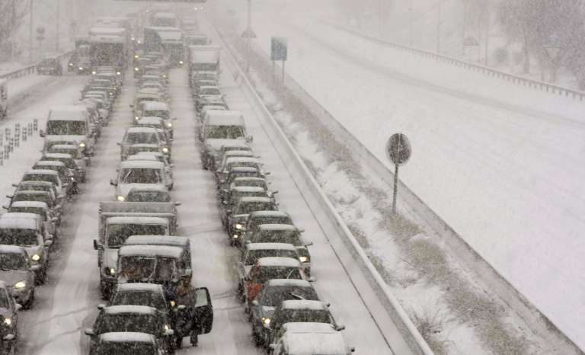

School of Computer Science Engineering

2018-03-05

Aquilino A. Juan Fuente

José Emilio Labra Gayo

Begoña Cristina Pelayo García-Bustelo

Jordán Pascual Espada

Vicente García Díaz

GestUsers: User Management System

**INCIDENT MANAGEMENT SYSTEM**

*Software Architecture for GestUsers. Description of the practice work (2018)*

Description of the first practice work to be made by the work teams of the course “Software Architecture” during the academic year 2017-18.

**Grado de Ingeniería Informática del Software**

|  |  |
| --- | --- |
|  |  |

**GestUsers: Incident Management System**

**Authors**:

**Alejandro González Hevia - UO251513**

**Carmen Luisa Sors González - UO252449**

**Eduardo Ulibarri Toledo - UO251436**

**Jaime Fernández Martínez - UO251119**

**Pablo González Balbuena - UO239394**

**Sergio Faya Fernández - UO251005**

**Álvaro Tejido Jardón - UO250821**

**Date**: 05/03/2018

**Version**: 2018.MAR.001

Table of Contents

1 Introduction and Goals 5

2 Requirements 6

2.1 Loader 6

2.2 Agents 6

2.3 Incidence Manager 7

2.4 Incidence Dashboard 7

3 Methodology 9

4 Stakeholders 10

4.1 Students that develop the assignment 10

4.2 System administrator 10

4.3 Agents 10

4.4 Operators 11

4.5 Administrator 11

4.6 Developers of the Incident System 11

4.7 Course teachers 11

5 Quality Attributes 12

5.1 List of Quality Attributes 13

5.2 Quality Attributes and stakeholders 14

6 Architecture Constraints 16

6.1 Technical constraints 16

6.2 Organizational Constraints 16

7 System scope and context 17

8 Quality Scenarios 21

9 Views 27

9.1 Context 27

9.1.1 Main overview 27

9.1.2 Elements Catalogue 28

9.1.3 Rationale 31

9.2 Loader 31

9.2.1 Main overview 31

9.2.2 Catalogue of Elements 32

9.2.3 Context Diagram 33

9.2.4 Rationale 33

9.3 Agents 34

9.3.1 Main overview 34

9.3.2 Catalogue of elements 34

9.3.3 Context Diagram 36

9.3.4 Rationale 36

9.4 Incidence Management 37

9.4.1 Main Overview 37

9.4.2 Catalogue of elements 37

9.4.3 Context diagram 39

9.4.4 Rationale 39

9.5 Incidence Dashboard 40

9.5.1 Main overview 40

9.5.2 Catalogue of elements 40

9.5.3 Context Diagram 42

9.5.4 Rationale 43

9.6 Package View 43

9.6.1 Main overview 43

9.6.2 Catalogue of elements 43

9.6.3 Context Diagram 43

9.6.4 Rationale 43

9.7 Deployment View 44

9.7.1 Main overview 44

9.7.2 Catalogue of elements 44

9.7.3 Context Diagram 44

9.7.4 Rationale 44

10 References 45

# Introduction and Goals

The goal of this document is to describe the structure of an architecture of User Management that will be reused. Although the system that we describe has its own functionality, the main goal is that it will be part of a general system of citizen participation.

This document describes the first deliverable of the laboratory assignment of the course "*Software Architecture*" which is taught by the authors. The course is part of the Degree in Software Engineering, School of Computer Science Engineering, University of Oviedo.

The system is divided in four parts:

* Loader, to load data from agents
* Agents, to obtain information about the agents that can participate in the system
* InciManagement, to process the incidents that are delivered by the different agents
* InciDashboard, to visualize and manage the incidents that appear in the system

The students have to implement the software described in this document in two teams of 3 or 4 students. One team will implement the Loader and Incident Dashboard modules of the system and document the architecture of Incident Manager. On the other hand, the other team will implement the Agents and Incident Manager modules and document the Incident Dashboard.

In the next deliverables, the students will create the architecture and implement a prototype of the rest of the Incidence Analysis System of which the current system will be part of.

# Requirements

The Incidence Management system will be divided in four parts:

* *Loader*: is in charge of loading data from agents that can submit incidences to the system.
* *Agents*: allows to query information about the agents that participate in the system.
* *Incidence Manager*: processes the incidents delivered by the agents.
* *Incidence Dashboard*: in charge of showing and managing the incidents.

## Loader

The System administrator must be able to introduce data from the agents list. That data can be obtained from different sources like people or automatic agents such as sensors or others.

The introduction of data will be made from Excel files that contain a list of rows. Each row (except the first with the headings) contains the following information:

* Name (first and last name in the case of a person)
* Location (geographical coordinates)
* Email (if an automatic agent, eg. sensors, may provide the email of its administrator)
* Identifier (an ID in the case of a person)
* Kind of agent

When importing the agents’ data, the system will create a user (whose login key will be its username) and a random password which will enable the user to enter the system to check if the data is correct as well as to later participate in the system. The system will also generate personal letters, but it is not part of it to send these letters to each user by email.

If a user appears in two different lists, this event will be recorded and informed in a log file. A user can only be created once. If the data is different from the current data available in the system, the current data will not be modified and an error will be recorded in the log.

[**Optional**] The system could be extended to emit the letters using other formats like Microsoft Word or PDF.

[**Optional**] If the input file contains errors, the system must detect them and report the errors found.

[**Optional**] The input data parser can be configured to accept data in different formats. Although it is mandatory to import data in Excel format, the system should be ready to be extended in the future to accept other formats easily.

(**Optional**) The service can be extended to handle security aspects

## Agents

Agents should be able to login into the system to check that they are in once the notification letter has been received. In order to implement that feature, a simple web service will be created that has two parameters passed as a POST message along the agent kind: username name and password and returns the data available about the agent if the information is correct or reports an error if it isn't. All call parameters and the return information will employ JSON format.

The web service can be extended to offer a simple HTML interface where a user can login and see his information in a human-friendly way.

Using HTTP content negotiation, the system could handle other formats as XML.

The service can be extended to enable the user to change his password.

The service can be extended to handle security aspects.

## Incidence Manager

The incidence manager must process the incidences provided by the different agents. It should be able to check if the agents are registered and allowed to submit said incidences.

The incidents must contain the following fields: user name and password, incident name, description, location (which will be automatically obtained if possible), tags (list of words separated by commas that will allow to categorize incidents), additional information (pictures, videos, etc). A list of fields may be added with the form "property/value", where the property field refers to a property name and the value field refers to the value of that property.

The incidence manager must be able to check if the username and password are correct and be able to report this type of errors.

The incidence manager must be able to handle periodical incidences by taking account of their schedules and periods. These incidences must be automatically sent in a specified schedule.

The incidence manager can get information about the incidences such as comments or expiration date.

Incidents must have a state and it may be changed in the process of handling. These states are open, in-process, closed and cancelled.

The incidence manager must only store incidents submitted by a person or entity and specific ones from sensors. These agents can have access to see the incidents he has submitted and follow their evolution.

[**Optional**] In the case of people or entities, the incident submission system will offer a conversational user interface using a chat-bot that will be asking information to the user about the incident.

[**Optional**] An alarm system will be developed to send some specific kinds of incidents to some operators, so they can assign them.

## Incidence Dashboard

The incidence management staff must be able to visualize and manage the incidents that appear in the system. The incidents received are the ones submitted by the Incidence Manager module through Apache Kafka.

The system should be aware that some agents, like sensors, will continually submit incidents with some property values. For those agents, the dashboard should know which incidents are allowed and how to classify them based on their property values.

A notification must appear in the dashboard if any of the incidents’ property values is dangerous, so the operators can take the appropriate actions.

The system will offer a continuous monitoring about the evolution of most representative property values, as well as the incidents that are being generated by some person or entity. It will also offer the possibility to visualize the geo-located incidents in a map, as well as the current values, their states, and the historical values of some of the incidents (for example, temperature).

The system has to offer information about incidents to the correct operators, that is, the ones that are assigned to them. Also, the operators must be allowed to control those incidents, changing their state or adding comments about them.

[**Optional**] An administration module that allows administrative people to configure the behaviour of the dashboard can be offered. One of the possible uses of this new module, could be assigning kinds of incidents to different kinds of operators or configure the operators’ permissions to assign or manage incidents.

[**Optional**] The system can be extended to offer statistics about incidents.

# Methodology

This document employs the ADD (Attribute-Driven Design) methodology (Bass, Clements, & Kazman, 2003) and the SEI ￼￼(ANSI/IEEE 1471, 2000).

The templates have also been inspired by the Arc42 templates (<http://arc42.org/>) where documentation architecture templates are defined in English, German and Spanish.

Another project that follows those templates for a biking domain is available at:

<http://biking.michael-simons.eu/docs/index.html>

# Stakeholders

The stakeholders identified are:

1. Students from Team 1 (Loader and InciDashboard).
2. Students from Team 2 (Agents and InciManagement).
3. System administrator.
4. Agents.
5. People responsible of the incident system.
6. Incident management operators.
7. Incident management administrators.
8. Course Teachers.

| Code | Stakeholder | Interests (Modules) |
| --- | --- | --- |
| ST-01 | Students from Team 1 | Loader and Incidence Dashboard |
| ST-02 | Students from Team 2 | Agents and Incidence Manager |
| ST-03 | System administrator | Load files |
| ST-04 | Agents | Check data |
| ST-05 | Developers of Incident System | Check data |
| ST-06 | Incident management operators | Incidence Dashboard |
| ST-07 | Incident management administrators | Incidence Dashboard |
| ST-08 | Course Teachers | All the modules |

Table 1. List of stakeholders/interests

## Students that develop the assignment

This group is formed by the two teams that will develop the system. Some of their goals are:

* Use of known technologies and methodologies minimizing the risks to learn new ones.
* Learn how to develop software collaboratively and in a professional way
* Use similar technologies to the group with whom they will work later to minimize incompatibilities.

## System administrator

This is the person who is in charge of loading the agents list.

Some of the goals are:

* Use of simple and well-known technologies for input files
* Files that can be read by humans.
* Be able to automate the loading process.
* Be able to debug the loading process in case of failures
* Be able to use different formats of input files

## Agents

These are the final users of the system. Some of their goals are:

* Get access to the system in a simple way.
* Being able to get information in a safe way.
* Being able to query their status in the system.
* Being able to update or change their information in the system, for example, their password.
* Be able to use the system in a user-friendly way with a simple HTML interface.
* Being able to submit incidents.

## Operators

These are the operators of the incident management system. Some of their goals are:

* Being able to see the incidents they have assigned in a simple way.
* Being able to modify those incidents that they have assigned.
* Be notified as soon as possible whenever a new dangerous incident occurs.
* Obtain graphic visualizations and statistics about the incidents [**Optional**].

## Administrator

These are the administrators of the incident management system. Some of their goals are:

* Configure the behaviour of the dashboard (e.g. change permissions of the operators or manage the incidents). [**Optional**]

## Developers of the Incident System

This is the team that will implement the incident system. Some of their goals are:

* Have a simple way to detect if an agent can participate in the system as soon as possible
* Use of simple technologies that can interoperate with other systems

## Course teachers

They are responsible for the results of this assignment. Some of their goals are:

* Use technologies that help students acquire skills related with Software Architecture by developing a practical assignment.
* Introduce the students in collaborative and professional software development through TDD (Test driven development) techniques.
* Show the students an example documentation of a software architecture

# Quality Attributes

We have identified the following quality attributes:

* **Availability**
  + The system must be able to process data 24x7.
* **Modifiability**
  + Easily change some parts of the application: Change the parser of input data
  + Easily change some parts of the application: Add an error reporting feature
  + Easily modify some parts of the application: Add other output files to generate the letters
  + Easily modify some parts of the application: Enable password change by users
  + Easily modify some parts of the application: Enable different formats to be used by the web service
  + Easily modify the kind of agents that are processed in the application.
* Flexibility
  + The incidence dashboard must allow the administrator to dynamically change the behaviour of the dashboard. [**Optional**]
* **Performance**
  + The performance of the data loading system is reasonable
  + Querying information about a user through the web service should be fast
* **Security** 
  + The system should warrant the confidentiality of the agents’ data
  + The incidence manager only allows agents to see their incidences.
* **Testability**
  + It must be testable that the agents’ data loading process is correct
  + It must be testable that the web service behaves as expected
  + It must be testable that the incidences (and their properties) displayed in the Incidence Dashboard are correct
* **Usability**
  + The data loading system must be easy to use by System administrator users which are familiar with Unix-like tools.
  + The dashboard must be easy to use by people which are not very familiar with computers.
  + The incidence dashboard must provide visualizations and statistics about the incidents received so results can be easily evaluated by the staff. [**Optional**]
* **Interoperability**
  + The agents’ web service must be used by an automated process that can query the status of a user.
* **Simplicity**
  + The two modules should be simple and easy to develop
  + The Incidence Manager must allow incidents to have expiration time to make the calculations easier.
* **Deployability**
  + The system should be easily deployable, especially in a cloud based server
* **Reliability**
  + The Incidence Dashboard must provide assurance of the delivery of data to the incident management staff.
* **Scalability**
  + The Incidence Dashboard must be able to handle increases in the number of incidents received at any moment in time.
* **Responsiveness**
  + The Incidence Dashboard must display new incidents received in as little time as possible.
* **Integrity**
  + If the combination "user name/password" is not right, incidents will not be procesed and an error will be reported

## List of Quality Attributes

The list of quality attribute is the following:

| **Code** | **Description** | **Type of Attribute** | **Module** |
| --- | --- | --- | --- |
| **AT001** | The system must be able to process data 24x7 | Availability | Agents and InciDashboard |
| **AT002** | Easily modify some parts of the application: Change the parser of input data | Modifiability | Loader |
| **AT003** | Easily modify some parts of the application: Add an error reporting feature | Modifiability | Loader |
| **AT004** | Easily modify some parts of the application: Add other output files to generate the letters | Modifiability | Loader |
| **AT005** | Easily modify some parts of the application: Enable password change by users | Modifiability | Agents |
| **AT006** | Easily modify some parts of the application: Enable different formats to be used by the web service | Modifiability | Agents |
| **AT007** | The incidence dashboard must allow the administrator to dynamically change the behaviour of the dashboard. | Flexibility | InciDashboard |
| **AT008** | The performance of the data loading system is reasonable (not too slow, but not critical) | Performance | Loader |
| **AT009** | Querying information about a user through the web service should be fast. | Performance | Agents |
| **AT010** | The system should warrant the confidentiality of the agents’ data | Security | Loader and Agents |
| **AT011** | It must be testable that the web service behaves as expected | Testability | Agents |
| **AT012** | It must be testable that the user loading process is correct | Testability | Loader |
| **AT013** | It must be testable that the incidences displayed in the Incidence Dashboard are correct | Testability | InciDashboard |
| **AT014** | The data loading system must be easy to use by system administrator users which are familiar with Unix-like tools. | Usability | Loader |
| **AT015** | The dashboard must be easy to use for people which are not very familiar with computers. | Usability | InciDashboard |
| **AT016** | The incidence dashboard must provide visualizations and statistics about the incidents received so results can be easily evaluated by the management staff. | Usability | InciDashboard |
| **AT017** | The querying web service must be used by automated processes that can query the status of the system. | Interoperability | Agents |
| **AT018** | The system must be simple and easy to develop | Simplicity | Loader and Agents |
| **AT019** | The system should be easily deployable | Deployability | Agents |
| **AT020** | The Incidence Dashboard must provide assurance of the delivery of data to the incidence management staff. | Reliability | InciDashboard |
| **AT021** | The Incidence Dashboard must be able to handle increases in the number of incidents received at any moment in time. | Scalability | InciDashboard |
| **AT022** | The Incidence Dashboard must display new incidents received in as little time as possible. | Responsiveness | InciDashboard |
| **AT023** | The Incidence Manager must allow incidents to have an expiration time. | Simplicity | InciManager |
| **AT024** | If the combination "user name/password" is not right, incidents will not be procesed and an error will be reported | Integrity | InciManager |
| **AT025** | Each agent can have access only to see the incidents that he or she has submitted | Security | InciManager |
| **AT026** | A dynamic service is provided for the agents to see the status of their opened incidents and follow their evolution | Usability | InciManager |
| **AT027** | The kind of agents is determined at the time of parsing the csv file | Modifiability | Loader |
|  |  |  |  |

Table 2. List of quality attributes and their types

## Quality Attributes and stakeholders

The following table shows which attribute qualities are interesting for which stakeholder:

| **Attributes**  **vs**  **Stakeholders** | **ST-01** | **ST-02** | **ST-03** | **ST-04** | **ST-05** | **ST-06** | **ST-07** | **ST-08** |
| --- | --- | --- | --- | --- | --- | --- | --- | --- |
| **AT001** | X | X |  | X | X | X | X | X |
| **AT002** | X |  | X |  |  |  |  | X |
| **AT003** | X |  | X |  |  |  |  | X |
| **AT004** | X |  | X |  |  |  |  | X |
| **AT005** |  | X |  | X |  |  |  | X |
| **AT006** |  | X |  | X | X |  |  | X |
| **AT007** | X |  |  |  |  |  | X | X |
| **AT008** | X |  | X |  |  |  |  | X |
| **AT009** |  | X |  |  |  |  |  | X |
| **AT010** | X | X | X |  |  |  |  | X |
| **AT011** |  | X |  | X |  |  |  | X |
| **AT012** | X |  | X |  |  |  |  | X |
| **AT013** | X |  |  |  |  |  |  | X |
| **AT014** | X |  | X |  |  |  |  | X |
| **AT015** | X |  |  |  |  | X | X | X |
| **AT016** | X |  |  |  |  | X | X | X |
| **AT017** |  | X |  |  | X |  |  | X |
| **AT018** | X | X |  |  | X |  |  | X |
| **AT019** |  | X | X |  |  |  |  | X |
| **AT020** | X |  |  |  |  | X |  | X |
| **AT021** | X |  |  |  |  | X |  | X |
| **AT022** | X |  |  |  |  | X |  | X |
| **AT023** |  | X |  |  |  | X |  | X |
| **AT024** |  | X |  | X |  | X |  | X |
| **AT025** |  | X |  | X |  | X |  | X |
| **AT026** |  | X |  | X |  | X |  | X |
| **AT027** | X |  | X |  |  |  |  | X |

Table 3. List of stakeholders: interests vs quality attributes

# Architecture Constraints

## Technical constraints

We have detected the following set of technical constraints in the project:

| **Code** | **Constraint** | **Background/Motivation** |
| --- | --- | --- |
|  |  |  |
| **TC001** | The data will be stored in a relational database. | The developer team (ST001) has knowledge of relational databases and there are a lot of libraries to work with relational databases from Java |
| **TC002** | The web service will be based on REST using JSON format | The REST style of web services using JSON is very popular and easy to implement nowadays. |
| **TC003** | The input data format to load data is .xls and .csv | Excel is a popular format for data exchange and there are several libraries to process Excel files |
| **TC004** | The output data of the loader module will be a set of text files | In order to facilitate the implementation, text files are the easier format to generate. However, the developer team can optionally implement other generators. |
| **TC005** | The processed incidents of the incidence manager module will be submitted to Apache Kafka | Kafka is a popular open source distributed streaming platform. Although the students are new to this technology, it is easily learnable. |
|  |  |  |

Table 4. Technical constraints

## Organizational Constraints

| **Code** | **Constraint** | **Background/Motivation** |
| --- | --- | --- |
| **OC001** | Each system will be implemented by a small team of student developers. | The size of the teams will be between 3 or 4 students. The goal is that students learn to work collaboratively by developing a simple project |
| **OC002** | The structure of the database will be shared by both teams. | Although the projects are designed to enable independent development by each team. The database acts as a glue between both systems so its structure must be shared by both teams |
| **OC003** | The source code will be available as a github repository | Github offers very powerful project management tool for this kind of projects. |

Table 5. Organizational constraints

# System scope and context

Context diagrams and text explanations will be used to describe the system.  
  
The system is decomposed in four modules in total, the first two being:

* Loader: This module will be responsible to convert data from Excel files and load it into the database. The system will be invoked by a system administrator.
* Agents: This module will allow to query the agents that participate in the system obtaining information from the database.

The main interfaces of each module are shown in the diagram below, the Database module being common to both groups:

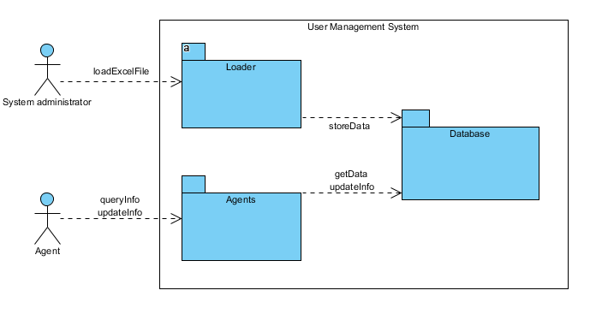

Figure 1. Business Context

The following figure contains a BPMN diagram showing the whole process of both sub-systems:

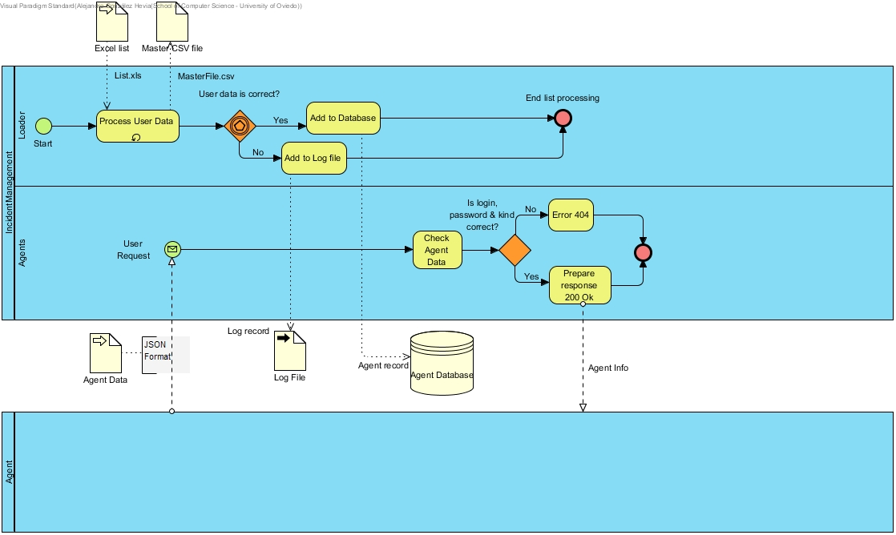

Figure 2. BPMN Diagram

Regarding the other two modules:

* Incidence Manager: Processes the incidents delivered by different agents. Processes incidents are submitted to the stream of Apache Kafka.
* Incidence Dashboard: Receives the stream from Apache Kafka and makes the incidents able to be visualized and managed.

The main interfaces of each module are shown in the diagram below. The Apache Kafka module is shared by both teams and it will be an Apache Kafka stream as stated in the constraints.

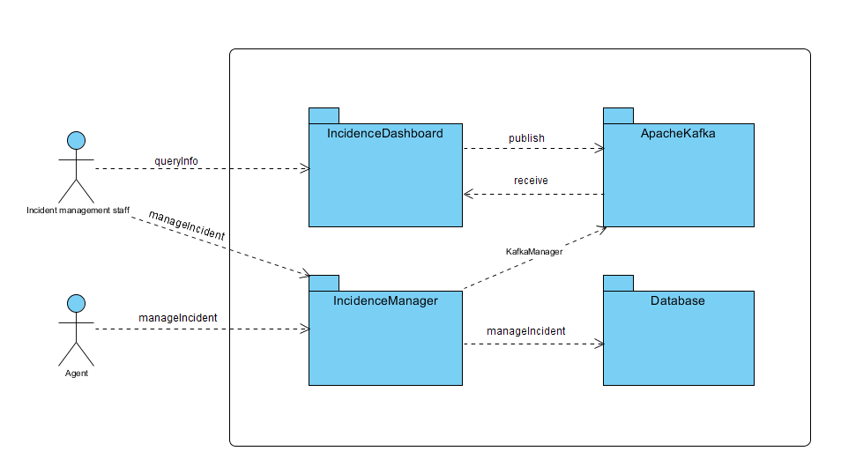

Figure 3. Business Context

Figure 4. BPMN Diagram

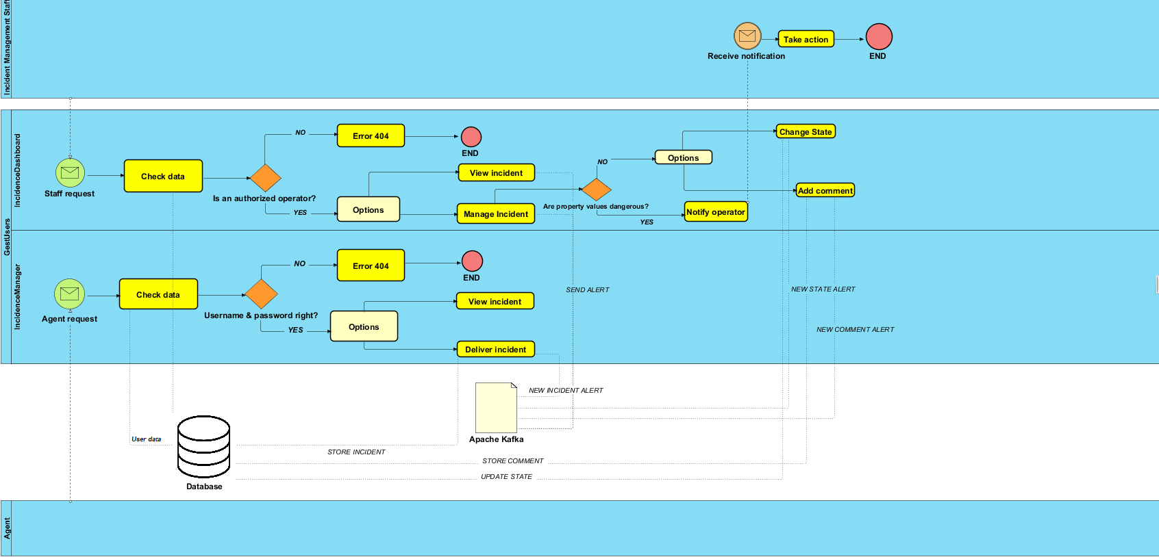

# Quality Scenarios

The table below contains the quality scenarios that have been identified:

| Scenario | Source Stimulus | Stimulus | Environment | Artifact | Response | Measure | Affected  Attribute Quality |
| --- | --- | --- | --- | --- | --- | --- | --- |
| 1 | Agency System | Ask information about an agent | Runtime | Agents | Agency System obtains the required information in less than 15seg at any time in the day | The required information is obtained in less than 15seg | **AT001** |
| 2 | Student developer | A new parser is introduced | Development | Parser | Change is successfully introduced | The system is compiled and passes all the tests without errors | **AT002** |
| 3 | Student developer | A new option is implemented for the report file | Development | ReportWriter, DBUpdate and Parser | The option is implemented with minimal changes that affect only the report writer module | Less than one day of work | **AT003** |
| 4 | Student developer | A new output format is added | Development | Agents and DBManagement | The new output format is included with minimal changes to existing code. | Less than one day of work | **AT004** |
| 5 | Student developer | The option to change user's password is introduced | Development | Agents and DBManagement | The password of a user is successfully changed | Less than one day of work | **AT005** |
| 6 | Student developer | A new format is added to the web service | Development | Agents | The new format is implemented | Less than 2 days of work | **AT006** |
| 7 | Administrator | The administrated wants to change the behaviour of the dashboard. | Runtime | InciDashboard | The behaviour of the dashboard changes dynamically at runtime (instantly). | The behaviour automatically changes without having to restart the module. | **AT007** |
| 8 | System administrator | Load an Excel file into the System (DB) | Runtime | Parser, DBUpdate and ReportWriter | Loading an excel file without errors is done in a reasonable time. | < 1 second for each 10 agents | **AT008** |
| 9 | Agents | Querying information about an agent. | Runtime | Agents | The information about the agent is obtained in a reasonable time. | < 1 second for each 10 agents | **AT009** |
| 10 | Student developer | Load an Excel file into the system (DB) | Development /  Runtime | Parser, DBUpdate and ReportWriter | Loading data should be done in a safe way | It is not possible to get access to the users’ personal data except by the system administrator who cannot get access to the password. | **AT010** |
| 11 | Agents | Get access to the application | Runtime | Agents | An agent can get access to his data but not to other one's data | Access to data is enabled only if the pair user name/password is correct | **AT011** |
| 12 | System administrator | Loads an excel file into the DB | Runtime | Parser, DBUpdate and ReportWriter | The loading process is made in a reliable way and it is possible to check that the data has been loaded | There are no errors in the database, no repeated record, and no loader has less information than expected | **AT012** |
| 13 | Management staff | Checks information in the dashboard. | Runtime | InciDashboard  And InciManagement | The information shown in the dashboard is valid and corresponds to the actual information sent from the incidence management system. | There are no errors in the information shown in the dashboard. | **AT013** |
| 14 | System administrator | Loads excel and csv file into the DB | Runtime | Parser, DBUpdate and ReportWriter | The loading process behaves in a usual way and the options available to run the system are easy to understand | The system shows help options if the user asks for them. The error messages and other information can be understood by technical people | **AT014** |
| 15 | Incidence management staff | Using the dashboard. | Runtime | Incidence Dashboard | An operator starts the dashboard. | The operator understands all the available options, and can start working. | **AT015** |
| 16 | Incidence management staff | Interpreting the dashboard. | Runtime | Incidence Dashboard | The dashboard provides visualizations and statistics, so the staff can easily interpret the information | The visualizations can be understood and interpreted by the incidence management staff. | **AT016** |
| 17 | Agents System | Access to the web service | Runtime | Agents | The agents System requests information about a user by passing a combination of user name and password and specifying the agent's kind. | A JSON response is sent with the correct format if the combination is OK or a failure information is returned | **AT017** |
| 18 | Student developer | Develops the system | Development | Agents and Loader | The student developers can implement the system | The system can be implemented and tested in 2/3 weeks by third year undergraduate students. | **AT018** |
| 19 | System administrator | Deploys the system | Deployment | Agents and Loader | The system is deployed in a production environment | The system can be deployed by a system administrator in less than an hour. | **AT019** |
| 20 | Management staff | Checks information in the dashboard. | Runtime | InciDashboard | The information is shown in a reliable way. | The information obtained from the incident management system is displayed in the dashboard, with neither a loss of information nor invalid data shown. | **AT020** |
| 21 | Management staff | Huge load of incidents coming to the system. (+1000 incidents per minute). | Runtime | InciDashboard | The system must continue to behave as expected. | Information about every incident must continue to be shown in the dashboard. | **AT021** |
|  |  |  |  |  |  |  |  |
| 22 | Management staff | New incidents arrive from the incident management system. | Runtime | InciDashboard | The system must display the new incidents in as little time as possible. | The new incidents will be displayed through the dashboard in less than 10 seconds since they were sent from the incident management system. | **AT022** |
| 23 | Management staff | Connection with kafka | Runtime | InciManagement | Each incident must be sent to kafka. | Each succesfully submited incident must be sent to apache kafka so the module dashboard will receive them | **AT023** |
|  |  |  |  |  |  |  |  |
| 24 | Agents | Check Agents' account information | Runtime | InciManagemen | Addition of the incident to Kafka or error notification | The system username and password must be consistent with the database, if it is correct the incident will be sent to kafka. If not an error will be notified. | **AT024** |
| 25 | Management System | Insert Incidence in DB | Runtime | Incidence Management | Insertion in the database of some incidents | The system must store all the incidents form people and entities and some specific values provided by sensors | **AT025** |
| 26 | ManagementDatabase | See Incidence Info | Development | Incidence Management | The agent gets the status of its incidence | A web service is provided for the agents to see the status of their opened incidents and follow their | **AT026** |
|  |  |  |  |  |  |  |  |

Table 6. List of quality scenarios

# Views

In the following paragraphs the identified the views that will be documented following the learning guide instructions.

|  |  |  |  |  |
| --- | --- | --- | --- | --- |
| View | Stakeholders | Quality Attributes | Architecture Constraints | Scenarios |
| Context | ST-01, ST-02, ST-03, ST-04, ST-05, ST-06 | AT011, AT013, AT14 | TC001, OC001, OC002, OC003 | 11, 13, 14 |
| Loader | ST-01, ST-03, ST-05, ST-06 | AT002, AT003, AT004, AT007, AT008 y AT010, AT011, AT013, AT014 | TC003, TC004 | 2, 3, 4, 7, 8, 10, 11, 13, 14 |
| Agents  Incidence Management  Incidence Dashboard | ST-02, ST-04, ST-05, ST-06  ST-02, ST-04, ST-05, ST-08  ST-01, ST-05,ST-06, ST-07, ST-08 | AT001, AT005, AT006, AT008, AT009, AT012, AT013, AT014  AT001, AT023, AT024, AT025, AT026  AT001, AT007, AT013, AT015, AT016, AT020, AT021, AT022 | TC002  TC005 | 1, 5, 6, 8, 9, 12, 13, 14  1, 13, 23, 24, 25, 26  1, 7, 13, 15, 16, 20, 21, 22 |

In the catalogues and views we have described both the mandatory and some optional elements.

## Context

The System view is divided in 4 main sub-systems interacting with each other.

### Main overview

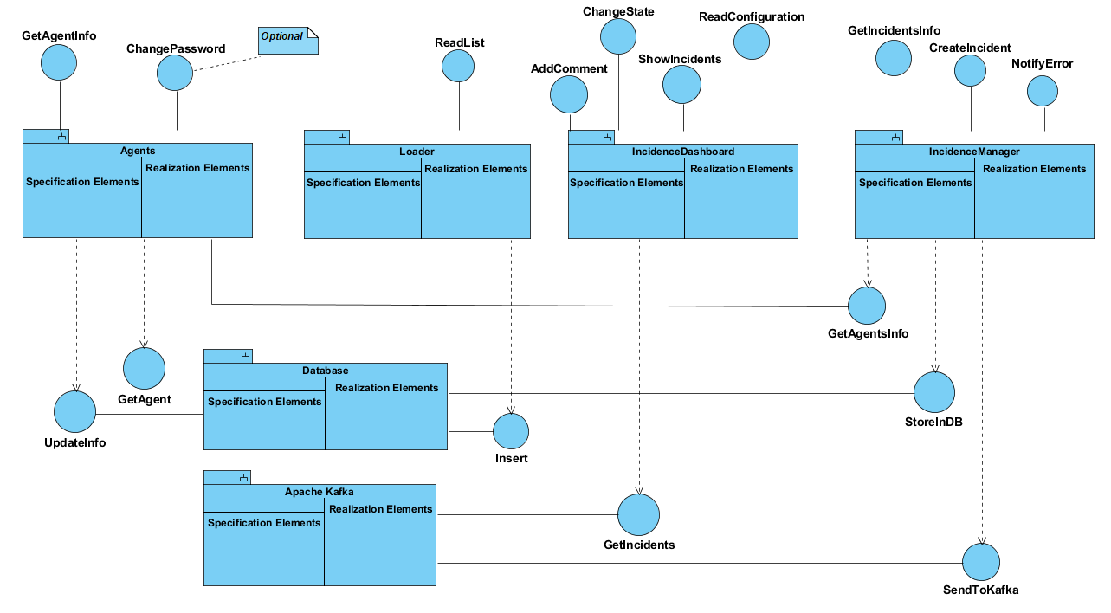

Figure 3. Context view

### Elements Catalogue

#### Elements

|  |  |
| --- | --- |
| Element | Properties |
| Loader | It introduces agents’ data in the system. It reads an Excel file with data, generates passwords, personal letters and reports any errors. |
| Agents  Incidence Manager  Incidence Dashboard | This is the module used by agents to check that their information is available in the system. They can optionally change some of their personal information and their password.  It’s the module in charge of creating new incidents and let agents visulize them. This is the module that the different agent users will employ.  It’s the module in charge of showing system incidents and reporting errors within them as well as managing the state of an incident or comment on it. It is used by the incident management staff.  . Es utilizado por el equipo de gobierno. |
| DataBase | This module encapsulates database access. |

#### Relationships

Agents’ data are introduced in the system through the interface *ReadList* from module *Loader*. For each agent, a password is generated as well as a personalized letter with information about the agent.

That interface sends the data to the database through the interface *UpdateDB* from the DataBase module.

The *Agents* module allows an external system to check the information about an agent through the web service *GetAgentInfo*. In order to check the information, *Agents* asks data to the *DataBase* module through the *GetAgent* interface.

Optionally, it is possible to implement the interface *ChangePassword* that will allow a user to change her password. In order to do that, the *Agents* module requests the *DataBase* to change the password through the *UpdatePasswd* interface.

After successfully loging in and being an agent, the module *IncidenceManager* allows agents to deliver new incidents through the interface *StoreInDB* and visualize their own incidents. It communicates with the database by means of the *StoreInDB* interface. Also, when a new incident is delivered by an agent, it is sent to the Apache Kafka stream through the *SendToKafka* interface.

The module *IncidenceDashboard* is accesses after login in and being a member of the incident management staff. It allows to check on incidents through the interface *ShowIncidents*, view charts related to them by means of the interface *VisualizeData*, comment on incidents with the interface *AddComment* and change the state of an incident using the interface *ChangeStatus*. It communicates with the Apache Kafka stream by means of the *GetIncidents* interface.

#### Interfaces / Ports

##### Loader

|  |  |  |  |
| --- | --- | --- | --- |
| Interface | Type | Technology | Properties |
| ReadList | Interface | Command line invocation | This interface will be invoked from the main application as a console program |

##### Agents

|  |  |  |  |  |  |
| --- | --- | --- | --- | --- | --- |
| Interface | Type | Technology | | Properties | |
| GetAgentInfo  ChangePassword | | Interface  Interface | Web Service  Web Service | | This interface will be invoked through an HTTP request  This interface will be invoked through an HTTP request |

##### IncidenceManager

|  |  |  |  |
| --- | --- | --- | --- |
| Interface | Type | Technology | Properties |
| GetIncidentsInfo | Interface | Method invocation | Allows to operate on incidents |

##### IncidenceDashboard

|  |  |  |  |
| --- | --- | --- | --- |
| Interface | Type | Technology | Properties |
| ShowIncidents | Interface | Web Service | Returns data from incidents. This interface will be invoked through an HTTP request |
| VisualizeDarta  AddComment  ChangeState | Interface  Interface  Interface | Web Service  Method Method invocation Method invocation | Visually shows data from incidents. This interface will be invoked through an HTTP request  Adds a comment regarding an incident  Changes the status of an incident in the system |

##### DataBase

|  |  |  |  |
| --- | --- | --- | --- |
| Interface | Type | Technology | Properties |
| GetAgent | Interface | Method invocation | Returns data from agents |
| Insert | Interface | Method invocation | Inserts into the database data about an agent included its password |
| UpdatePasswd  StoreInDB | Interface  Interface | Method invocation  Method invocation | Updates the password of an agent in the database  Inserts a new incident in the database |

##### Apache Kafka

|  |  |  |  |
| --- | --- | --- | --- |
| Interface | Type | Technology | Properties |
| GetIncidents | Interface | Method invocation | Apache Kafka retrieves incidents’ data from its stream |
| SendToKafka | Interface | Method invocation | Registers and sends the new incidents that have been delivered |

#### Behaviour

##### Loader

See 9.2.2.3.4.

It can also do the following options:

* (**Optional**) the subsystem that generates the letters could implement the Adapter pattern which would enable to generate the letters in different formants in the future (Word, ODT, PDF, RTF, etc.).
* (**Optional**) If the file contains errors, those errors should be detected, and a report should be generated for its later treatment
* (**Optional**) The parser of input data should be configurable using an adapter pattern to allow input data in different formats (Excel, TXT, etc.).

##### Agents

It allows users to get access into the system to check if they can participate, using the information that they received in the letter. The users may not get access directly by a web browser, but through an external incidence system that invokes the Agents module as a web service.

##### IncidenceManager

External incidence sytem that allows users to deliver an incident or visualize own old delivered incidents.

* (**Optional**) In the case of people or entities, the incident submission system will offer a conversational user interface using a chat-bot that will be asking information to the user about the incident.
* (**Optional**) An alarm system will be developed to send some specific kinds of incidents to some operators so they can assign them.

##### Incidence Dashboard

Will be used by the management staff to monitor the incidents that appear in the system. Receives incidents submitted to Apache Kafka. The dashboard will be configured to know which incident values are allowed and how to classify the property values. In case that some property values are dangerous the system will notify the operators so they can take the corresponding actions.

* (**Optional**) The system will offer an administration module that will enable administrative people to interactively configure the behaviour of the dashboard. For example, it can be used to define which kinds of incidents are assigned to which kind of operators, as well as configure permissions to the different operators to assign or manage incidents
* (**Optional**) The system can offer some graphical visualizations or statistics about incidents.

##### DataBase

All the operations done in this module will be integrated in a *Facade pattern* which will contain the operations that offer access to the database. It encapsulates all the operations that affect the database.

##### Apache Kafka

Encapsulates all the functionality dependan ton the Apache Kafka’s stream of data used to monitor incidents.

### Rationale

The main design decisions of this sub-system are:

|  |  |  |
| --- | --- | --- |
| Scenario | Quality attributes | Justification |
| 11 | AT014 | The *Loader* module is invoked from the main application as a console program, so its use will be familiar to people who use Unix-like tools. |
| 13 | AT018 | Both modules are simple enough to develop in 3 weeks given the number of students and their current knowledge of software engineering. |
| 14 | AT019 | For the *Loader* module, a batch application can be directly executed without any special needs for deployment. In case of the *Agents* module, the use of Spring Boot framework facilitates deployment. |

## Loader

### Main overview

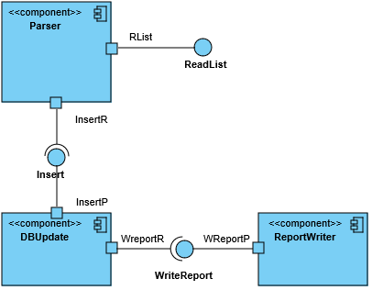

Figura 4. Loader view

### Catalogue of Elements

#### Elements

|  |  |
| --- | --- |
| Element | Properties |
| Parser | Reads data from the Excel file and transforms them into an in-memory object container that can be later iterated to insert the data in the database.  It will also generate the *password* of the agent as well as the personal letter.  During the design and implementation this component can be divided into the sub-components needed to separate these services following the quality attributes AT002, AT003, AT004 and AT007. |
| DBUpdate | Encapsulates all the database operations using interfaces to allow the database access to be separated from some specific database implementations. |
| ReportWriter | It receives the pieces of data that were not possible to insert into the database as well as the reasons and writes a report containing all that information in a human-readable way |

#### Relationships

The *Parser* component receives the input file in Excel format and reads and converts the information about the different agents. It generates a new password for each agent and adds the information to the database using the *DBUpdate* component.

(**Optional**) If there are any errors during the loading phase (duplicated DNIs, empty DNI fields, etc.) or if the database component returns an error, this information will be notified to the Reportwriter component through the *WriteReport* interface.

#### Interfaces/Ports

##### Parser

|  |  |  |  |
| --- | --- | --- | --- |
| Interface | Type | Technology | Properties |
| ReadList | Interface | Method invocation | Read the Excel file with the agents’ data. |
| Rlist | Port |  | Creates the needed subcomponents of the parser to process the input file. |
| Insert | Interface (Required) | Method invocation | It calls a method in the *DBUpdate* component to insert the information in the database. |
| InserR | Port |  | Verifies the data and creates the object to send to the *DBUpdate* component. |

##### DBUpdate

|  |  |  |  |
| --- | --- | --- | --- |
| Interface | Type | Technology | Properties |
| Insert | Interface | Method invocation | Receives and object with the information to insert in the database. |
| InsertP | Port |  | Verifies input data and generates and error if there is a lack of some mandatory attribute. |
| WriteReport | Interface (Required) | Method invocation | Calls a method from the *ReportWriter* component to write a new item in the report file. |
| WreportR | Port |  | Verifies the data to write |

##### ReportWriter

|  |  |  |  |
| --- | --- | --- | --- |
| Interface | Type | Technology | Properties |
| WriteReport | Interface | Method Invocation | Receives the data to write in the report file. |
| WreportP | Port |  | Adds data at the corresponding date and time. |

##### Parser

Introduces the agents’ data in the system obtained from Excel files that contain a row for each agent. Each row (except the first one that contains the headings) contains the following columns:

* Name (string - in the case of a person, first and last name)
* Location (geographical coordinates)
* Email (string – in the case of sensors or other kinds of automatic agents, it can contain the email of the admin person who manages it)
* Identifier: The agent’s ID (string - in the case of a person or an entity it can be the NIF)
* Kind (integer representing the agent’s kind)

The system will also employ a master file in CSV format which will contain all the agent’s kinds available. The file contains two fields separated by commas, where the first field is the numeric code and the second one is the name of the user kind. These numeric codes will be considered to resolve the corresponding agent’s kind.

Invocation will be done through a batch program executed in the command line by the system administrator. During the import process a password will be generated so the combination of username/password enable a user to enter the system.

This component will also generate personal emails communicating the user that he has been added to the system with a user name (his identifier) and a password.

##### DBUpdate

It updates the database. See 9.1.2.4.3.

##### ReportWriter

(**Optional**) It stores in a text file information about the errors that were produced by the conversion process. The basic information to store is:

* Date
* Time
* Original Excel file
* Error information (with all the needed information)

### Context Diagram

See 9.1.

### Rationale

The main design decisions of this sub-system are:

|  |  |  |
| --- | --- | --- |
| Scenario | Quality attributes | Justification |
| 2 | AT002 | Access to the parser using an Adapter pattern facilitates to change the implementation without affecting other parts of the application. |
| 3 | AT003 | Defining an interface and an object for error reporting allows to add this functionality later. |
| 5 | AT008 | Using a relational database will improve the performance of accessing information about users. |
| 6 | AT010 | Using a relational database that offer security aspects can improve the security of the system. Sending the login name and password by regular mail avoids that the information can be accessed electronically. |
| 8 | AT012 | Using a standard database which can be queried using SQL can allow the students to verify that the data has been correctly loaded. |
| 10 | AT014 | The use of a batch application that can be executed manually or configured for its automatic execution is a common practice for system administrators. |
| 14 | AT019 | A batch application can be directly executed without any special needs for deployment |

## Agents

### Main overview

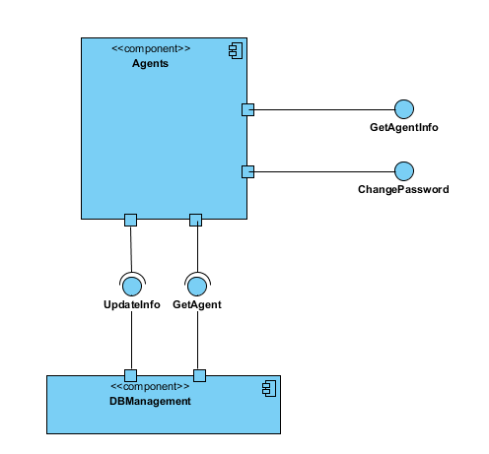

Figure 5. Agents View

### Catalogue of elements

#### Elements

|  |  |
| --- | --- |
| Element | Properties |
| Agents | It offers two web services: *GetAgentInfo*, which allows to obtain information about an agent (person, entity, sensor…) and *ChangePassword,* that allows to change the password of a user. |
| DBManagement | It offers two interfaces: GetAgent, that returns the data of an agent from the database and *UpdateInfo*, to update a password change in the database. |

#### Relationships

The ParticipantParticipation System invokes *Agents* using a web service call which is processed by *GetAgentInfo* (sending *user name/password*) and it gets access to the DBManagement system using the interface *GetAgent*. If the user name/password are correct the data is returned as a JSON response.

The user can invoke *Agents* through a web browser to change his password invoking *ChangePassword* and sending the parameters *user name/password/newPasswod*. It will invoke the interface *UpdateInfo* to modify the password using the *DBManagement* component.

#### Interfaces/Ports

##### Agents

|  |  |  |  |
| --- | --- | --- | --- |
| Interface | Type | Technology | Properties |
| GetAgentInfo | Interface | Web service | Allows to get access to an agent data through the user/password combination. |
| ChangePassword | Interface | Web service | Allows to change a password using the combination: *user/password/newPasswod*. |
| ChangeInfo | Port |  | Validates a user before asking to change his password. |
| UpdateInfo | Interface (Required) | Method invocation | Asks a password change for a user. |
| GetParticipant | Interface (Required) | Method invocation | Asks information for the user |

##### DBManagement

|  |  |  |  |
| --- | --- | --- | --- |
| Interface | Tipo | Tecnología | Propiedades |
| UndateInfo | Interface | Method invocation | Handles the password change of a user. |
| GetAgent | Interface | Method invocation | Handles the information request for the user. |

#### Behaviour

##### Agents

It implements a REST web service to handle requests of information about agents. The POST HTTP request will be done to the following address:

<WebServiceURI>/agent

where <WebServiceURI> represents the URI where the web service has been deployed. The POST request contains JSON data with the following structure:

{"login": user, "password": password, "kind": agent’s kind}

In case that the (user, password) combination are available in the database the response will be 200 OK with the a JSON body of the form:

{ "name": Name,

"location": Coordinates (optional),

"email": Email,

"id": identifier,

"kind": agent’s kind,

"kindCode": numeric code that represents the kind,

}

In case that the (username, password) is incorrect, the response will be 404 Not found.

There is available a HTML interface, so the web service can be used by humans through a web browser. Furthermore, the users are also allowed to change their password.

##### DBManagement

This component encapsulates all the database access, so it can be easy to change the underlying database system.

### Context Diagram

See 9.1.

### Rationale

The main design decisions have been:

| Scenario | Quality Attributes | Justification |
| --- | --- | --- |
| 1 | AT001 | Using a REST Web Service leverages on HTTP technology and makes it easier to deploy the system in some infrastructure with high availability. |
| 4 | AT005 | The encapsulation of model features that affect the database during development and the use of a MVC framework will facilitate the addition of functionalities like password change. |
| 6 | AT006 | Using a Web framework like Spring Boot will facilitate the development of common web features like content negotiation |
| 8 | AT010 | Accessing by *username/password* is considered secure enough for this process. Passwords should be stored encrypted. |
| 9 | AT011 | The development of a REST web service based on JSON formats will facilitate the development of tests. The Spring Boot framework contains several tools for unit and integration testing of web applications that can be used. |
| 12 | AT017 | The use of a REST web service enables the automatic access to the system through a software client |
| 13 | AT018 | The web service API defined is simple and contains the minimal functionality. Leveraging on Spring Boot web framework will facilitate the development by the students given that the framework has solutions for all the required functionality |
| 14 | AT019 | The use of Spring Boot framework facilitates deployment. There are several examples that show how to deploy Spring Boot based applications to production servers |

## Incidence Management

### Main Overview

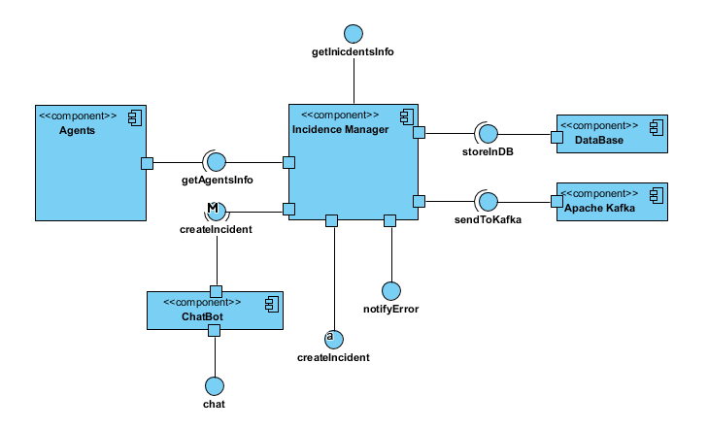

### Catalogue of elements

#### Elements

|  |  |
| --- | --- |
| Element | Properties |
| Apache Kafka | The stream platform where we will post any incidence detected in the module so that the Incidence Dashboard will be able to deal with them. |
| Agents | This module sends the incidents information of the agents to the incidence manager. |
| Incidence Manager | This component will process the incidents that are sent by the incidence creator, then the incidents will be sent to Apache Kafka and if required they will be stored in the database. |
| DataBase | This database stores the incidents sent by the Incidence Manager. |
| ChatBot | Receives and follows instructions provided by the agents in relation to creating incidents. |

#### Relationships

The incidence manager invokes agents (module 2), to check if the username password combination exists by calling getAgentsInfo, in case it does not, the manager will notify an error to the user via notifyError.

If the agent exists the user will be able to call createIncident and the created Incident will be sent to Apache Kafka (calling sendToKafka) and stored in the database depending on the type of incident via storeInDB.

The users can also get track of their open incidences calling getIncidentsInfo.

#### Interfaces

##### Agents

|  |  |  |  |
| --- | --- | --- | --- |
| Interface | Type | Technology | Properties |
| GetAgentsInfo | Interface | Method Invocation | Sends true if the requested agent exists, false otherwise. |

##### Incidence Manager

|  |  |  |  |
| --- | --- | --- | --- |
| Interface | Type | Technology | Properties |
|  |  |  |  |
| CreateIncident  NotifyError  SendIncident  GetIncidentsInfo  StoreInDB  SendToKafka | Interface  Interface  Interface  Web Service  Interface  Interface | Web Service  Web Service  Method Invocation  Web Service  Method Invocation  Method Invocation | Allows to create an Incident via web form. A period of time may be specified for an incident to be generated periodically.  Shows and error message if the agent does not exist.  Sends an incident to the incidence manager  Shows the information about a requested Incident.  Stores an incident into the database.  Synchronizes the incidents data with the Kafka stream |

##### Apache Kafka

|  |  |  |  |
| --- | --- | --- | --- |
| Interface | Type | Technology | Properties |
| SendToKafka | Interface | Method Invocation | Receives the data from the incidence manager |

##### ChatBot

|  |  |  |  |
| --- | --- | --- | --- |
| Interface | Type | Technology | Properties |
| Chat | Interface | WebService | Provides a chat where agents can add incidences by talking to a bot. |

#### Behaviour

##### Agents

Agents can submit incidences in two ways: periodically or non-periodically. Periodical incidences have a specified period or date in which they are automatically sent, and non-periodical incidences are just sent as soon as possible.

##### Incidents Manager

The data for the incidents will be sent to the manager as a JSON file.

The JSON data that will give the data of the incident has the following form:

{

"user": name,

"password": pass,

"incident name": incident's name,

"description": description,

"location": coordinates (automatically obtained if possible),

"tags": [{"tag"},{"tag"}...],

"extra info": pictures, videos...,

"property": value (list of fields)

}

The manager must take account of the timing or dates of periodic incidents and send them at the corresponding time.

Incidents will acquire different states (open, in-process, closed, cancelled) as well as other information generated by the system like assigned operator/entity that must handle the incident, comments about the incident, etc. Incidents can also have an expiration time.

The incidence manager also offers an alarm system to send some specific kinds of incidents to some operators so they can assign them. [**Optional**]

##### Database

The database will store all the people and entities

##### Apache Kafka

The alarm system provided by the incident manager sends the incident to the incident dashboard by means of Apache Kafka so that the operator will be able to operate with it. [**Optional**]

##### ChatBot

A chat where the agents can communicate the incidences, which will be automatically created and processed. [**Optional**]

### Context diagram

See 9.1

### Rationale

|  |  |  |
| --- | --- | --- |
| Scenario | Quality Attributes | Justification |
| 13 | **AT013** | The data sent to Apache Kafka is the data inserted in the manager system. Thus relying on Kafka the data received by the other team will be the same. |
| 23 | **AT023** | All successfully created incidences must are sent to Apache Kafka. |
| 24 | **AT024** | The system notifies an error if the agent username password combination is wrong via web. |
| 25 | **AT025** | The system stores all the incidents in the database but some sensor ones. |
| 26 | **AT026** | A web service is provided for the agents to see the status of their opened incidents and follow their evolution. |

## Incidence Dashboard

### Main overview

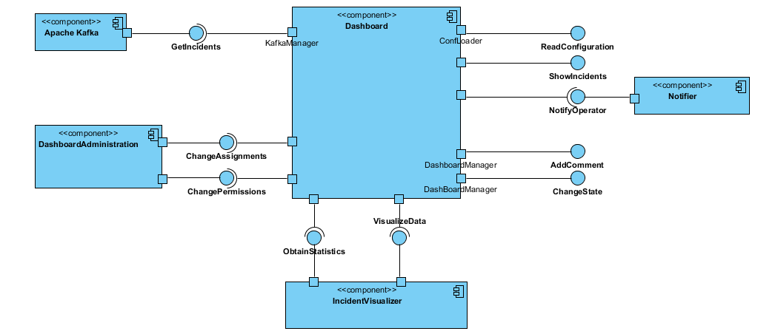

### Catalogue of elements

#### Elements

|  |  |
| --- | --- |
| Element | Properties |
| Apache Kafka | Is a stream that passes the information of the module 3 to the dashboard (module 4). |
| DashBoard | It receives the information provided by module 3(InciManagement) through Apache Kafka and prints it on a DashBoard. It knows which values are invalid by reading a configuration file. It also allows the modification of the state of the incidents, as well as adding comments to them. |
| Notifier | It allows the system to notify some operator when it receives dangerous values. |
| DashboardAdministration | It allows the administrator to modify the behaviour of the dashboard. [Optional] |
| IncidentVisualizer | Provides the ability to the dashboard to obtain summary statistics about the incidents, as well as obtaining some graphics to visualize the data. [Optional] |

#### Relationships

The system invokes DashBoard by receiving information about the incidents through Apache Kafka, with GetIncidents. This information can be seen by the user in the dashboard thanks to ShowIncidents. When an invalid or dangerous value is received the system will notify the operators through the NotifyOperator interface provided by the Notifier component.

The information received can be displayed graphically and with statistics, thanks to the component IncidentVisualizer. Operators can modify information about the incidents (adding comments, changing the state…) through the dashboard through AddComment and ChangeState.

#### Interfaces / Ports

DashBoard

|  |  |  |  |
| --- | --- | --- | --- |
| Interface | Type | Technology | Properties |
| GetIncidents | Interface | Method Invocation | Allows DashBoard to get access to an incident information. |
| EditInfo | Interface | Method Invocation | Allows to change the incidents status or add comments. |
| ShowIncidents | Interface | Method Invocation | Prints the dashboard. |
| KafkaManager | Port |  | Handles the communication with Apache Kafka. |
| ConfLoader | Port |  | Responsible of loading the configuration file and setting its location. |
| ReadConfiguration | Interface | Method Invocation | Reads the configuration file, allowing the system to know which values received through Kafka are invalid / dangerous. |
| NotifyOperator | Interface | Method Invocation | Asks for a notification to a given operator. |
| AddComment | Interface | Method Invocation | Adds a comment to a specific incident. |
| ChangeState | Interface | Method Invocation | Changes the state of an incident. |
| DashboardManager | Port |  | Responsible of managing the different incidents of the dashboard. |
| ChangeAssignments | Interface | Method Invocation | Asks for a change in the assignments of operators to kinds of incidents. [Optional] |
| ChangePermissions | Interface | Method Invocation | Asks for a change of permissions to an operator. [Optional] |
| ObtainStatistics | Interface | Method Invocation | Asks for a summary of statistics about a set of incidents. |
| VisualizeData | Interface | Method Invocation | Asks for some graphics about a set of incidents. |

Apache Kafka

|  |  |  |  |
| --- | --- | --- | --- |
| Interface | Type | Technology | Properties |
| GetIncidents | Interface | Method Invocation | Handles the incident information. |

Notifier

|  |  |  |  |
| --- | --- | --- | --- |
| Interface | Type | Technology | Properties |
| NotifyOperator | Interface | Method Invocation | Handles the notification of an operator. |

DashboardAdministration [**Optional**]

|  |  |  |  |
| --- | --- | --- | --- |
| Interface | Type | Technology | Properties |
| ChangeAssignments | Interface | Method Invocation | Handles the change in the assignments of operators to some kind of incidents. |
| ChangePermissions | Interface | Method Invocation | Handles the change of permissions to an operator. |

IncidentVisualizer [**Optional**]

|  |  |  |  |
| --- | --- | --- | --- |
| Interface | Type | Technology | Properties |
| ObtainStatistics | Interface | Method Invocation | Computes a set of statistics about the incidents given. |
| VisualizeData | Interface | Method Invocation | Obtains graphics about the incidents given. |

#### Behaviour

##### Dashboard

The dashboard will start reading the configuration file. After that, it will get the information about incidents of Apache Kafka, and look for an error in the incidents info. If there is an error, the system will notify the error to the operator. If not, the system will let the user see the information of the incidents. The user will be able to change the state of an incident or add comments to it through the user interface.

##### Notifier

Whenever an invalid or dangerous value is received through Kafka, the system will call the notifier, which is responsible of notifying the operator about the incident.

##### IncidentVisualizer

This component computes a set of summary statistics about the incidents of an operator, and provides some graphics that the staff can see through the user interface. [**Optional**]

##### DashboardAdministration

This component provides a set of operations for the administrators that allow them to change dynamically the behaviour of the dashboard (e.g. changing the permissions of an operator, or modifying the assignments of incidents to operators). [**Optional**]

### Context Diagram

See 9.1

### Rationale

| Scenario | Quality Attributes | Justification |
| --- | --- | --- |
| 7 | **AT007** | The DashboardAdministration component provides operations to dynamically change the behaviour of the dashboard. |
| 13 | **AT013** | When the information enters the dashboard, it checks that everything is correct (thanks to the information obtained from the configuration file), if there is an error, a notification will be sent through the Notification component. |
| 15 | **AT015** | The information is displayed in a graphical way with statistics through a user interface thanks to the use of the IncidentVisualizer component. |
| 19 | **AT020** | The use of Apache Kafka ensures the reliability of the data obtained. |
| 20 | **AT021** | The use of Apache Kafka lets the system continuing working properly with a big amount of data. |
| 21 | **AT022** | Apache Kafka is known to have great performance, so the module will be respond to new data sent to Kafka in very little time. |

## Package View

### Main overview

### Catalogue of elements

#### Elements

#### Relationships

#### Interfaces

#### Behaviour

### Context Diagram

See …

### Rationale

The main design decisions have been:

| Scenario | Quality Attributes | Justification |
| --- | --- | --- |
|  |  |  |
|  |  |  |
|  |  |  |
|  |  |  |
|  |  |  |

## Deployment View

### Main overview

### Catalogue of elements

#### Elements

#### Relationships

#### Interfacessss

#### Behaviour

### Context Diagram

See …

### Rationale

The main design decisions have been:

| Scenario | Quality Attributes | Justification |
| --- | --- | --- |
|  |  |  |
|  |  |  |
|  |  |  |
|  |  |  |
|  |  |  |

# References

ANSI/IEEE 1471. (2000). *Recommended Practice for Architectural Description of Software-Intensive Systems.* ANSI/IEEE.

Bass, L., Clements, P., & Kazman, R. (2003). *Software Architecture in Practice, Second Edition.* Boston: Addison Wesley.