**University of Oviedo**

**Documentation Second Derivable**

**Software Architecture**

**Ana Areces**

**Raquel Arrojo**

**David Casado**

**María González**

**Álvaro Palanco**

**Iván Sánchez**

Contents

User manual 3

Initial window 3

About 3

Create a new user 4

Play 4

Statistics 4

System Manual 5

# User manual

This application is very simple and intuitive to use, since it is based on the original Trivial game; so, everybody will be able to learn how to use it in almost no time.

The most important thing the user must know before starting to use or application is that it is composed by 5 different windows:

## Initial window

The first window that appears when the application is ran. In this window, you can enter your user name or create a new one, in case you are not logged in as a user.

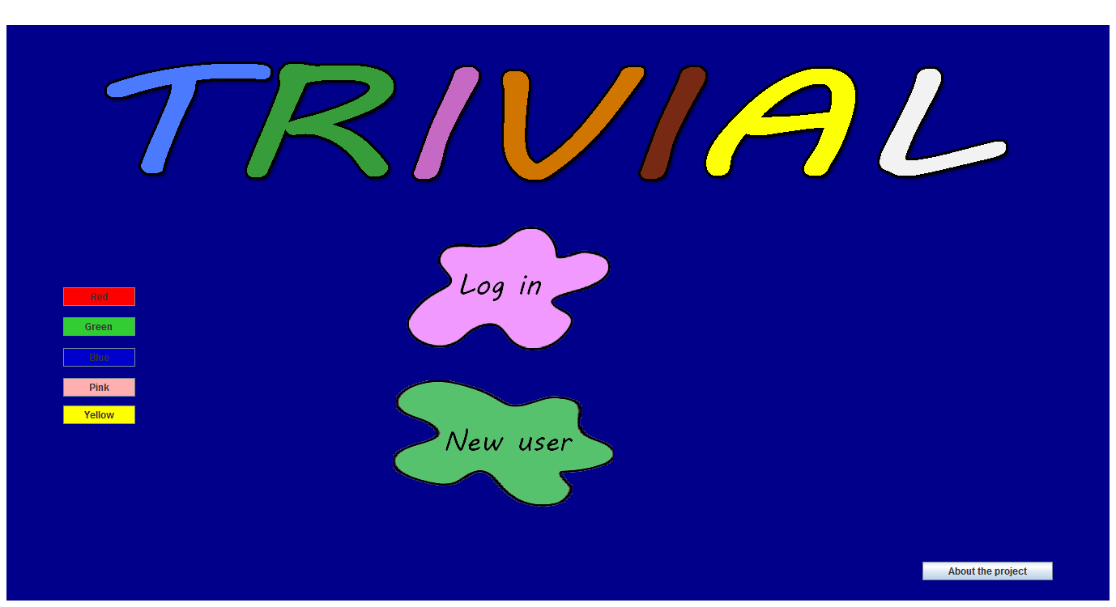

In this window the user will be able to change the background of the application by clicking on the buttons on the left hand side of the screen,

## About

In this window you can take a look at the information about the development team

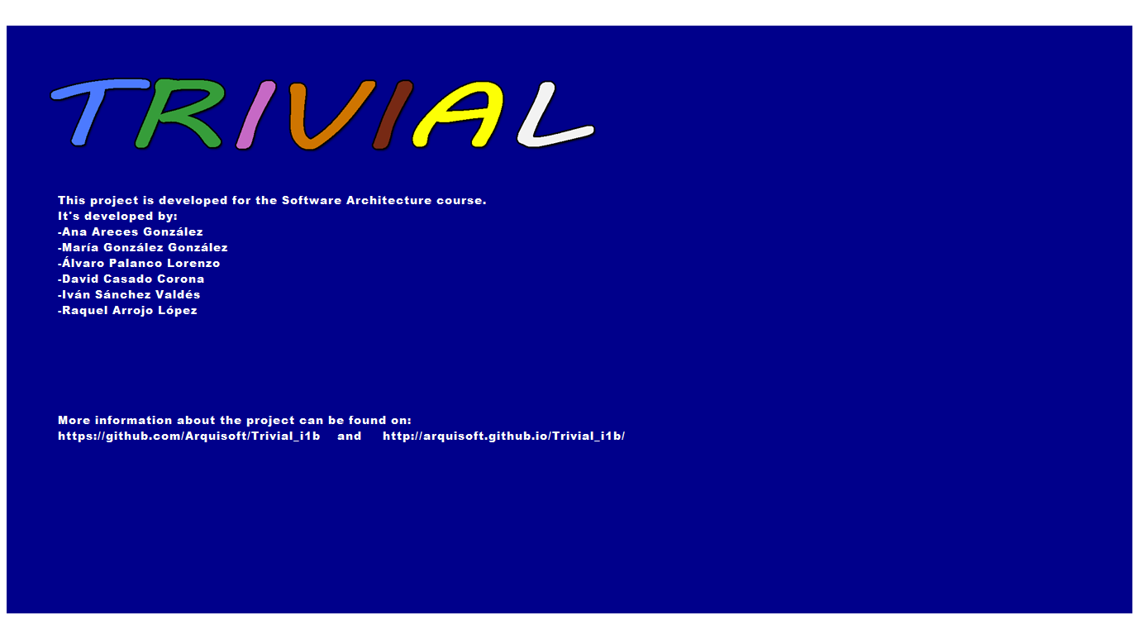

## Create a new user

If you want to create a new user, you must provide some personal data like your name, your email and a password. All this information is required to create the user.

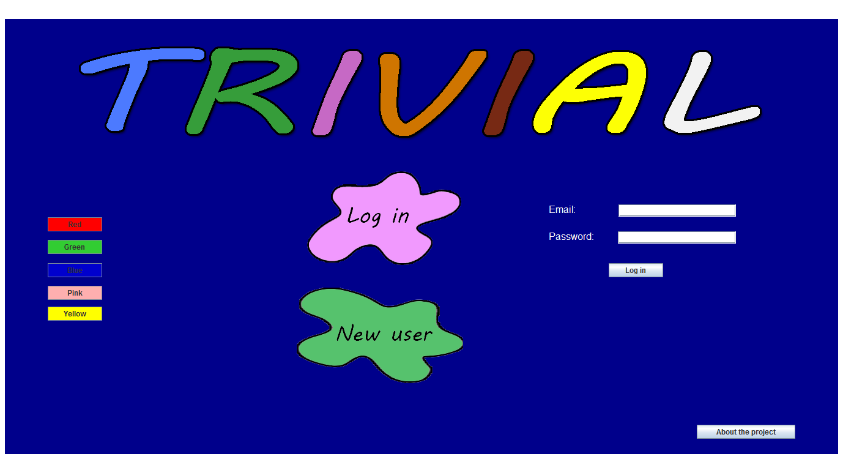

## Play

This is the main window of the application. Here is the board to show the player the different cells that can be selected. To start the game, the dice has to be pressed and the player has to decide which category he/she prefers. Depending on the category selected, one question or another will be retrieved from the database and asked to the player. The player has also the possibility of changing the background colour of the window, selecting it with some buttons. The colours are those corresponding to the 6 different categories of the questions.

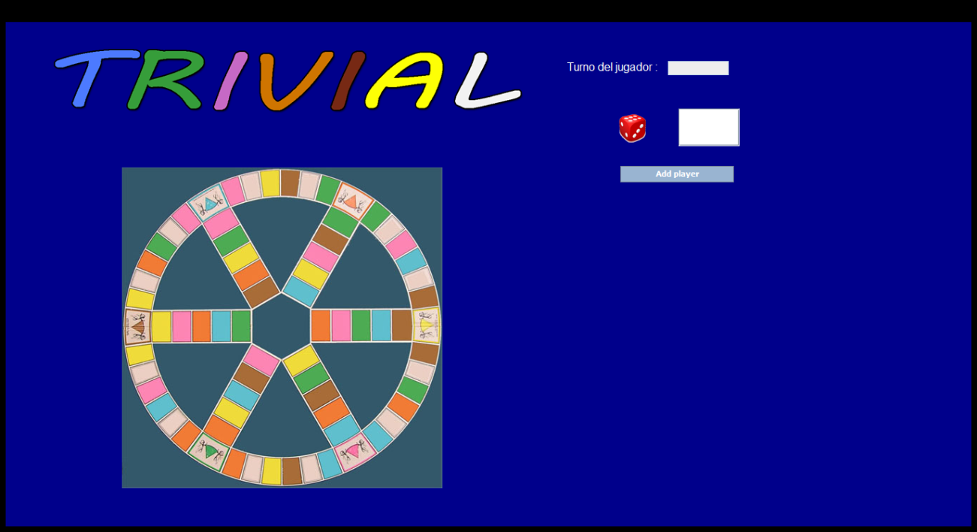

## Statistics

In this window the user will be able to see a small piece of information as a table. In this page the information shown is the number of games played, number of answers and and number of correct ones for the player in session.

# System Manual