**University of Oviedo**

**Documentation Second Derivable**

**Software Architecture**

**Ana Areces**

**Raquel Arrojo**

**David Casado**

**María González**

**Álvaro Palanco**

**Iván Sánchez**

Contents

Project information 2

Architecture diagrams 3

Package view 3

Component views 4

Extract 4

Game 5

Deployment view 6

User manual 7

Initial window 7

About 8

Create a new user 8

Play 9

List Users 9

Statistics 10

System Manual 11

System requirements 11

Project information 11

Logic 11

GUI 12

# Project information

All the documentation files can be found inside the documentation folder in our Github repository.

<https://github.com/Arquisoft/Trivial_i1b>

This is a direct access to the Readme that contains the general information of the group.

<https://github.com/Arquisoft/Trivial_i1b/blob/master/README.md>

This folder contains the Documentation information like manuals and all the diagrams, also the Visual Paradigm project.

<https://github.com/Arquisoft/Trivial_i1b/tree/master/Documentation>

This one is the Eclipse project, where you could find the src folder with all the implementation.

<https://github.com/Arquisoft/Trivial_i1b/tree/master/Game>

The cucumber tests can be found following this link.

<https://github.com/Arquisoft/Trivial_i1b/tree/master/Game/src/test/java>

The generated documentation.

<https://github.com/Arquisoft/Trivial_i1b/blob/master/Documentation/GeneratedVPDocumentation.pdf>

# Architecture diagrams

## Package view

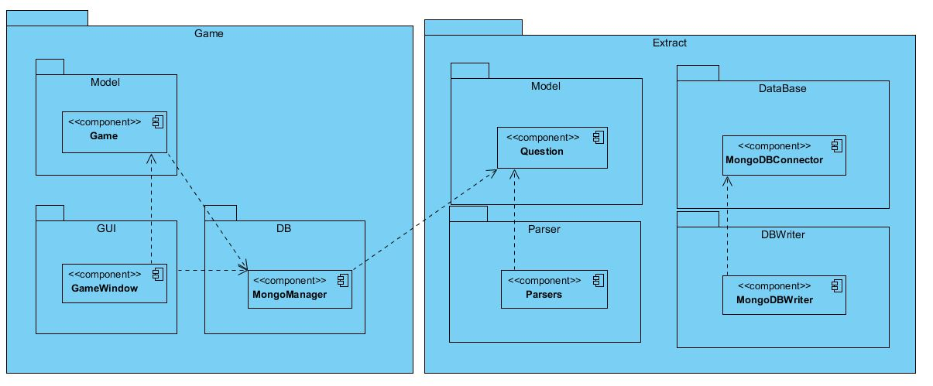

## Component views

### Extract

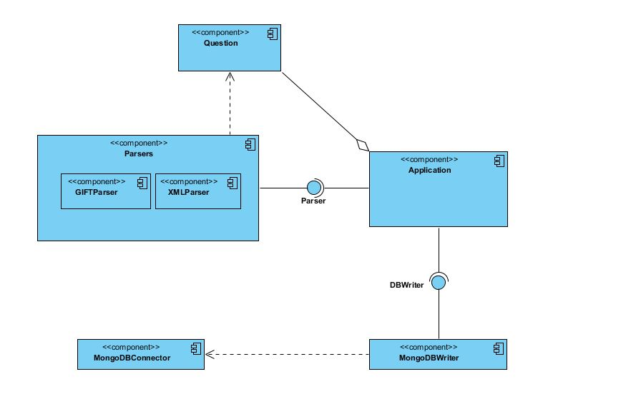

### Game

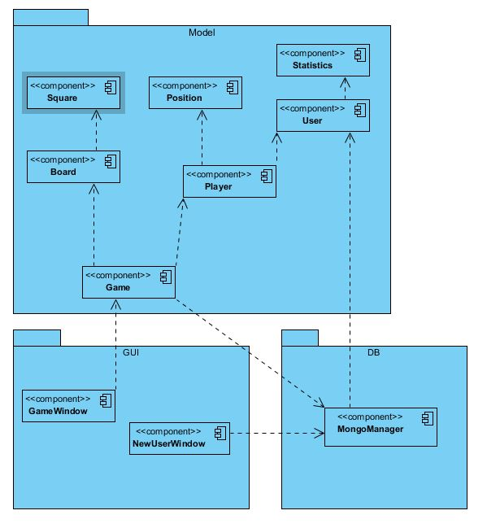

### Deployment view

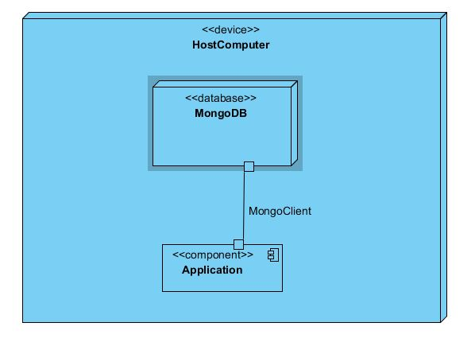

# User manual

This application is very simple and intuitive to use, since it is based on the original Trivial game; so, everybody will be able to learn how to use it in almost no time.

It is important for the correct working of the application that the user has a local MongoDB database.

The most important thing the user must know before starting to use or application is that it is composed by 5 different windows:

## Initial window

The first window that appears when the application is ran. In this window, you can enter your user name or create a new one, in case you are not logged in as a user.

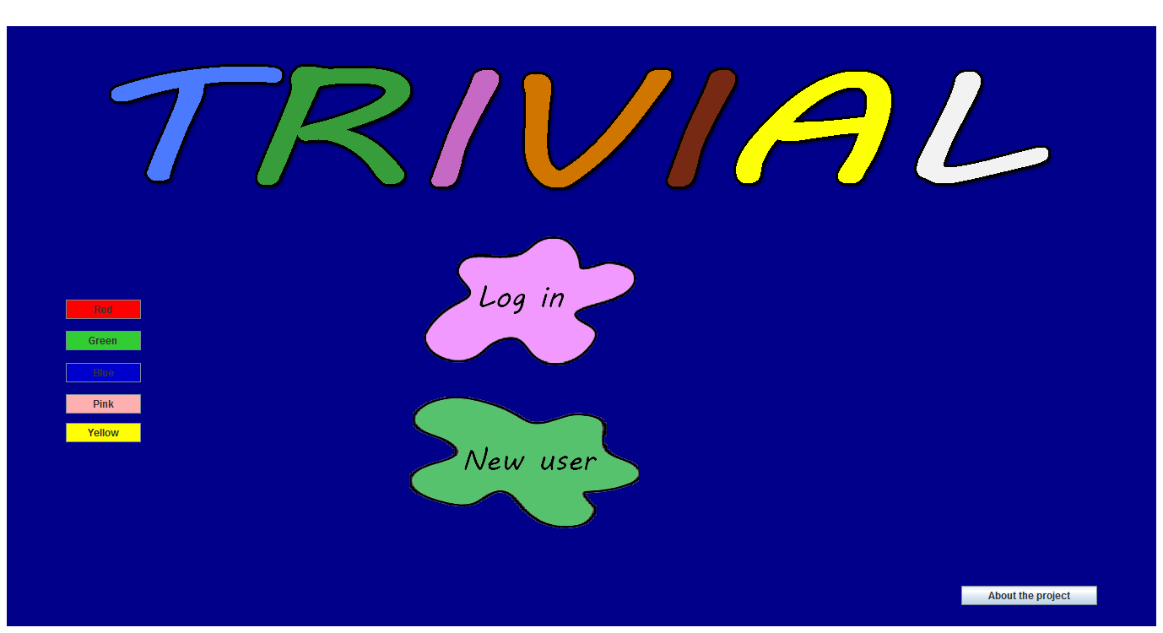

In this window the user will be able to change the background of the application by clicking on the buttons on the left hand side of the screen,

## About

In this window you can take a look at the information about the development team

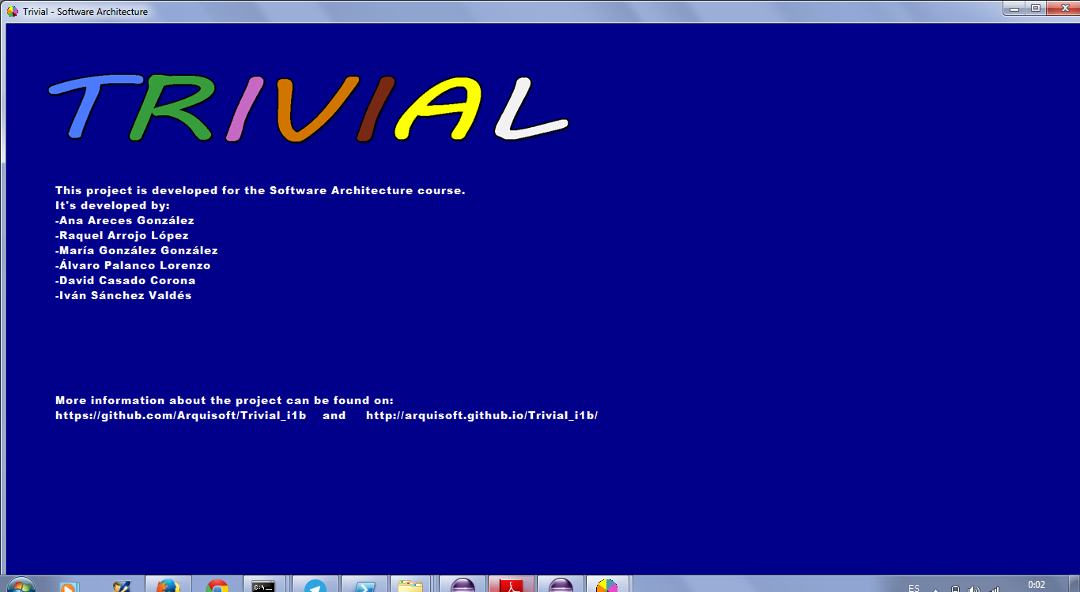

## Create a new user

If you want to create a new user, you must provide some personal data like your name, your email and a password. All this information is required to create the user.

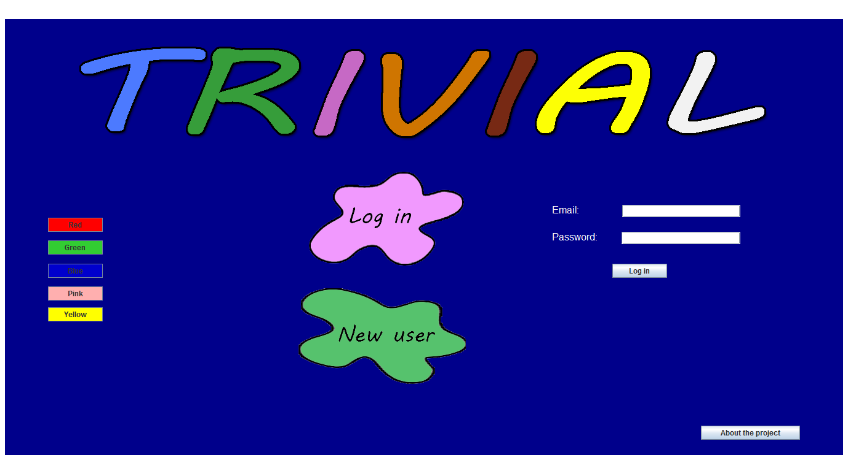

## Play

This is the main window of the application. Here is the board to show the player the different cells that can be selected. To start the game, the dice has to be pressed and the player has to decide which category he/she prefers. Depending on the category selected, one question or another will be retrieved from the database and asked to the player. The player has also the possibility of changing the background colour of the window, selecting it with some buttons. The colours are those corresponding to the 6 different categories of the questions.

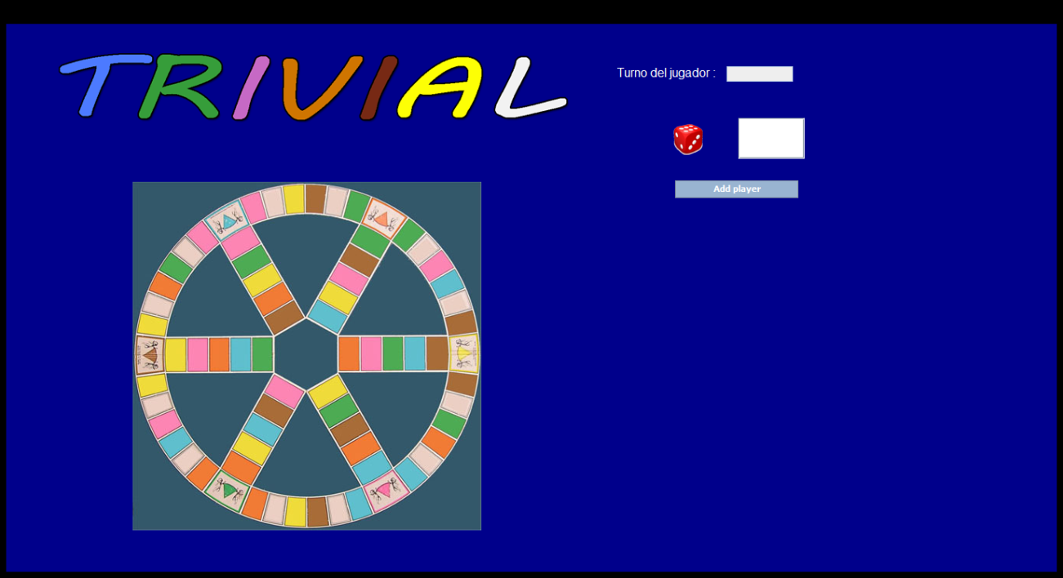

## List Users

If the active user is the admin, the list users is shown and it shows the list of all the registered users in the game. In this window, the admin can select a user and see the statistics, shown in the Statistics window.

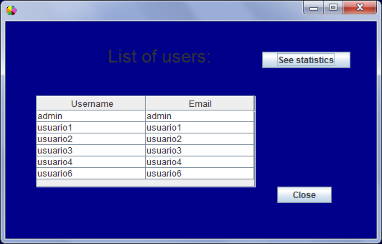

## Statistics

In this window the user will be able to see a small piece of information as a table. In this page the information shown is the number of games played, number of answers and and number of correct ones for the player in session.

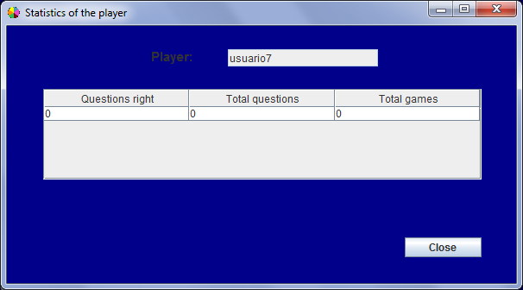

# System Manual

## System requirements

In order to work properly with this project the main requirement is use a Java version greater than or equal to Java 1.7, otherwise some compliance errors may appear in the project.

## Project information

The project is composed by two different packages, one for the logic of the game and another one for the user interface.

In the following sections we’ll explain the main classes contained in those packages.

### Logic

***MongoQuestionManager***

The one which controls the questions in the database. It has two constants, one containing the name of the database and another one with the collection. In the constructor the connection to the database is created. This class has to methods. One of them is private and it is used in order to translate a Document object to a Question one. The other one is public and returns all the questions in the database.

***MongoStatisticsManager***

It has a public method that, given a user saves its statistics in the database. There are other two methods, one of them in order to retrieve the statistics of a certain user passed as parameter; and the other is used when it is necessary to update the statistics. In this last case, the user is needed in order to update the correct one.

***MongoUserManager***

This class it is important because it manages all related to users in the database. There is a method in order to retrieve a certain user by its name but we also have implemented another method in order to get all the users in the database.

It has also a method in order to update the information of a certain user.

***Board***

This class represents the board and initializes it. It allows the movement through it depending on the result obtaining when dropping the die.

***Die***

It simulates dropping the die. Its unique method return a number from 1 to 6.

***Player***

The function of this class is create players to associate them to the database each time a user is logged in.

***Position***

This class provides the information about in which cell the player is. The method walk returns the array in which the player is placed, in case the returned value is 0 its position is in one of the cell in the external circle, otherwise is in one of the paths arriving to the center.

***Statistics***

This class retrieves the statistics for each user in the database. All the methods in this class are getters and setters.

***User***

Simulates the users in the database, the identification of each user is the login that is unique.

***Game***

This class is the factory to be called from the interface. From it you can access all the methods needed in order to play, such as creating the players, move them …

***SimpleSquare***

It represents the cell in the external part of the board. In order to create them a position and a category is needed.

***CompositeSquare***

In this case, the cells to be represented are the internal paths. It contains a list with more squares representing the cells contained in each path.

### GUI

We will not explain the complete implementation of the class in this package. Since they are classes representing the user interface it seems to be enough to explain the main purpose of each one of them.

***About Trivial***

This class is used in order to give the user the information about the development team.

***Game Window***

As it name says, is the one in charge of providing the space for playing the game.

***Initial Window***

The one the user see the firs when starting the application. From this one you can access to the others.

***List players***

This class will be used in order to show the administrator the users that have played the game. From this window he will be able to select one of them and see the statistics for the selected one.

***New User Window***

In order to play the game is it compulsory to have the required player saved in the database. In case it is not, the application provides this window in order to allow the user to add a new player to the database.

***Statistics Window***

The last window of the user interface shows the statistics of the player selected in the List Players window.