

Quality Report Generator

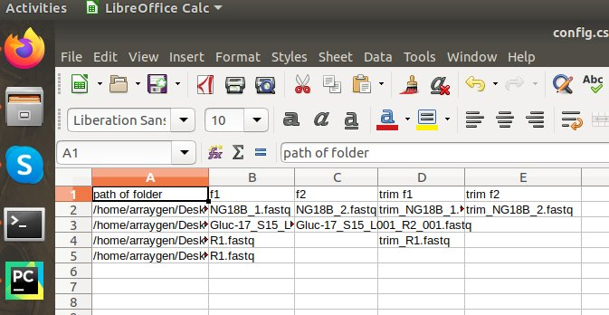**Step 1** : Edit config file

In above you will see some columns ,

path of folder : We needs to pass folder path where fastq files present

f1 : First file name for pair end data / single end

f2 : [optional] : Second file name for pair end data

trim f1 : [optional] : First trimmed file name for pair end data / single end

trim f2 : [optional] : Second trimmed file name for pair end data

**Step 2** : Install python3.6 and modules required for python

pip3 install zip bs4 xlsxwriter

**Step 3** : Execute Multiple_Fastqc_Report_Maker.cpython-36.pyc file using below command:

python3 Multiple_Fastqc_Report_Maker.cpython-36.pyc

Check your output in respective input folders