1. Pop Up 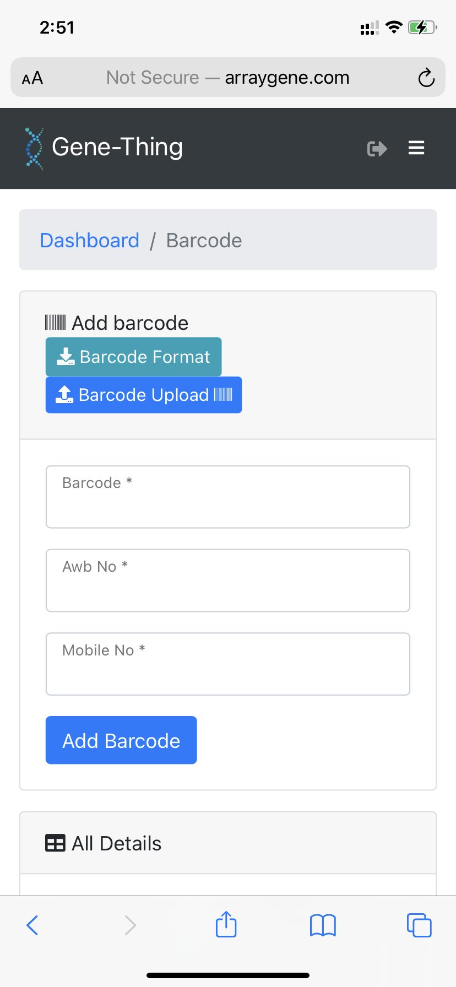After registartion done

2. Forget password near login

3. Here need to add one more colum of order no. Barcode awb no and order no

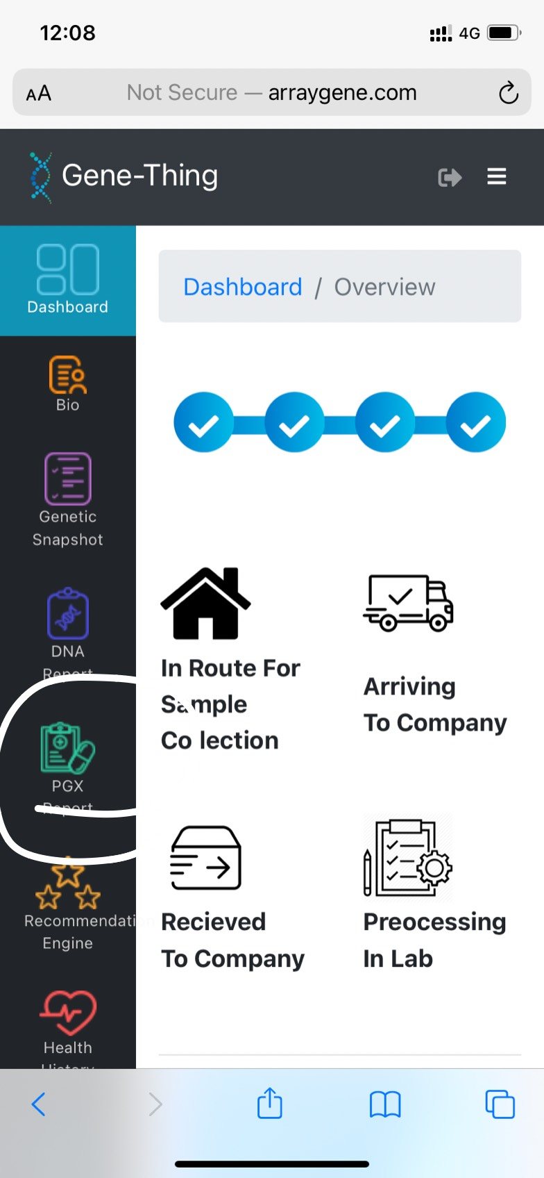

4. Pharmaco need to be removed

5.Good score should go to favourable response

Typical should go to average response

Poor should go to unfavourable response

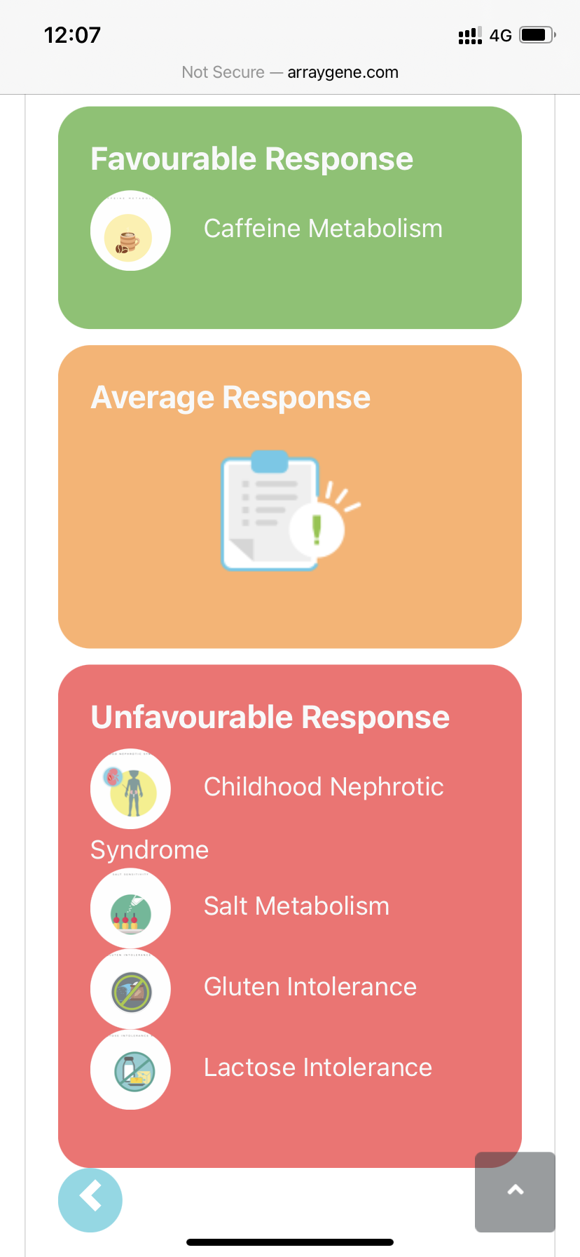

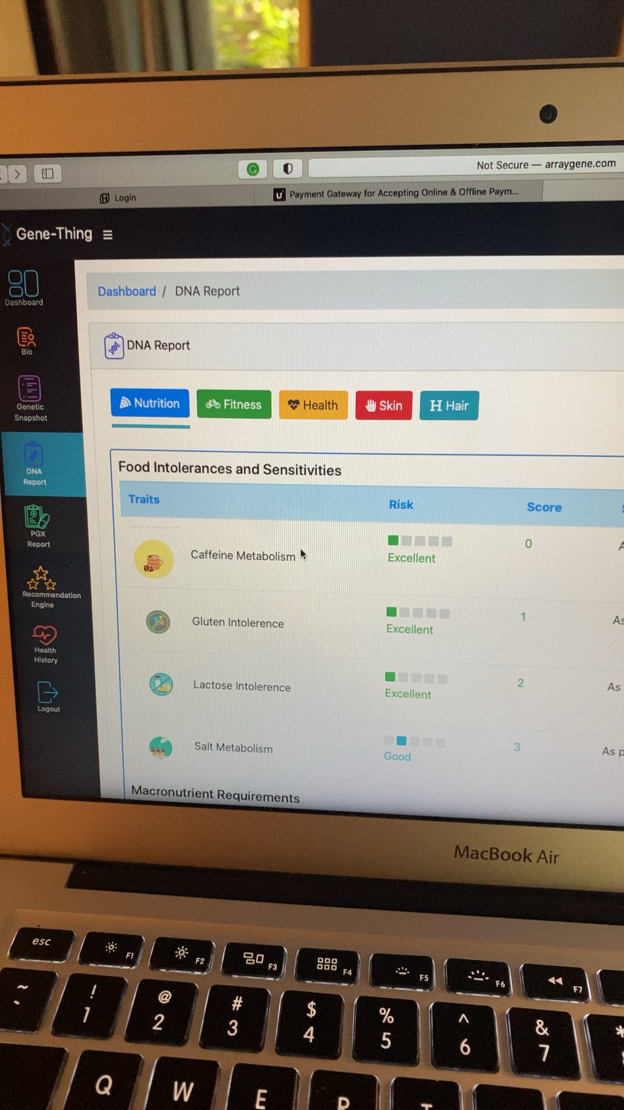6. This should be added as separate panel

Nutrition

Food Intolerances and sensitives

Fitness

Health

Skin & Hair

7. at all places make changes in icon of score

8. add change password in user too

9. Create employee login too