PRELIMINARY PROJECT PROPOSAL
Google Workspace Reporting and KPI Platform
A cloud-based internal platform for automated property reporting, historical KPI trends, document control and missing-report follow-up.
Prepared for Valoris Capital Partners
Draft 1 | July 24, 2026
Proposed initial portfolio: La Jolla, August at Friendswood, Oasis and Dalecrest

Executive summary
Valoris Capital Partners can build a private, cloud-based reporting platform entirely within the Google ecosystem. The platform would receive recurring property reports through Gmail, archive original documents in Google Drive, store structured operating data in Google Sheets, run scheduled workflows in Google Apps Script and present results through an internal web application.
The proposed system is not an AI application in production. Artificial intelligence would support design, coding, testing and future enhancements. Once deployed, the tool would operate through deterministic code and business rules without ChatGPT, Codex, token consumption or a local computer.
The recommended first release focuses on four properties and a controlled set of reports and KPIs. It should first prove that Valoris can receive, classify, archive, validate, visualize and monitor its existing reporting flow reliably. The initial KPI set should include occupancy and leads, with additional metrics added after the source reports and definitions have been reviewed.
Recommended decision: Proceed with a Google Workspace MVP, subject to a source-report review and agreement on standard KPI definitions, delivery deadlines and stable report formats.

Project parameters
Parameter | Initial position
Business purpose | Centralize property reporting and expose historical KPI trends.
Initial properties | La Jolla, August at Friendswood, Oasis and Dalecrest.
Technology boundary | Google Workspace first: Gmail, Drive, Sheets and Apps Script.
User experience | Private browser-based application accessible with corporate Google accounts.
AI dependency | Development support only; no AI required for routine operation.
Primary constraint | Source reports must be structured and sufficiently consistent.

1. Project objective
The objective is to create one internal reporting platform for recurring daily, weekly and monthly property reports. The platform should reduce manual collection work, preserve the original evidence, make trends visible and create a reliable control over missing, late, duplicate or invalid reports.
The finished product will be available through a private URL. Authorized users will open the application from a browser and view current and historical information without downloading local files or running a desktop program.

Target outcomes
- Create a complete register of expected and received reports by property and reporting period.
- Preserve each source email and attachment in a controlled Google Drive structure.
- Convert recurring operational data into comparable historical KPI records.
- Show weekly and monthly trends instead of isolated point-in-time values.
- Automate reminders when a required report has not arrived by its agreed deadline.
- Maintain traceability from every displayed value back to its original report.

2. Daily operating model
The workflow begins when a property manager sends a report by email. A scheduled Apps Script process reviews the reporting mailbox, classifies the message, saves the source file, extracts the approved data points and updates the central data store. The dashboard then reflects the new information without manual refresh work.
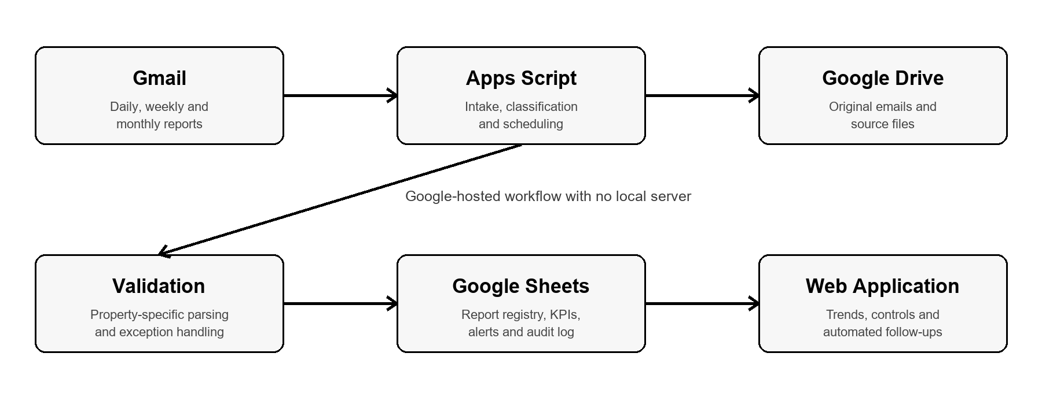
Figure 1. Proposed Google-hosted operating model

Illustrative processing sequence
- A property manager submits the required report through Gmail.
- Apps Script identifies the sender, property, report type and reporting period.
- The source email and attachment are saved in the correct Google Drive folder.
- A property-specific parser extracts the approved KPI values.
- Validation rules check format, period, duplication and acceptable values.
- Valid data is written to Google Sheets and becomes available to the web application.
- Exceptions are logged for review instead of being published as reliable data.
- A separate scheduled control compares received reports with the reporting calendar and sends approved follow-ups for missing items.

3. System components

Gmail
Receives the reports and provides the message metadata used to identify the sender, property, report type and period. A dedicated reporting mailbox or corporate automation account is preferable to an employee's personal inbox.

Google Drive
Stores the original emails and attachments as the documentary record. The recommended folder structure separates each property by daily, weekly, monthly and exception files.

Google Sheets
Acts as the initial structured data store for the MVP. Separate tables should hold property configuration, reporting schedules, the received-report register, KPI history, alerts, errors and processing logs.

Google Apps Script
Runs the intake, classification, file handling, parsing, validation, scheduling and email workflows. Google hosts and executes this code, so no Valoris computer or local server must remain online.

Property-specific parsers
Read known report layouts and map source values to approved KPI fields. Each supported format requires a controlled parser and validation rules. Unrecognized formats go to an exception queue.

Internal web application
Provides the portfolio, property, reporting-control and administrative views. It can be deployed as an Apps Script web application and, if useful, surfaced through an internal Google Site.

Core data structure
Data set | Purpose | Representative fields
Property master | Defines the properties in scope. | Property name, code, status and responsible team.
Reporting calendar | Defines what should arrive and when. | Frequency, due day, deadline and owner.
Report register | Tracks each expected and received report. | Property, type, period, status, email ID and Drive link.
KPI history | Stores comparable trend data. | Property, period, KPI, value, unit and source.
Alert log | Tracks reminders and escalations. | Recipient, reason, sent date and current status.
Error log | Captures processing exceptions. | File, issue, timestamp and resolution.

4. Access, security and ownership
The application should remain private to Valoris. Users will authenticate through their corporate Google Workspace accounts, and access should be limited to the company domain or to a specifically approved user list.

Recommended roles
Role | Recommended access
Administrator | Configuration, users, properties, schedules, KPIs and exception management.
Asset Management | Portfolio-wide dashboards, reports, alerts and source documents.
Leadership | Executive portfolio and property views with trend analysis.
Property Manager | Access limited to the relevant property and approved submissions.
Read-only user | Dashboard access without configuration or processing rights.

Control requirements
- Use a dedicated corporate automation account so the platform does not depend on one employee.
- Store source documents in a Shared Drive or controlled corporate folder structure.
- Protect configuration and historical-data tabs from accidental manual edits.
- Log every processing event, exception, reminder and configuration change.
- Back up the central data set on a defined schedule.
- Review Google Workspace permissions before production deployment.

5. Role of artificial intelligence
Artificial intelligence will be used to accelerate development, not to operate the production workflow. It can help design the architecture, write and review Apps Script code, build the interface, create test cases, document the solution and adapt future report formats.
After deployment, standard code and business rules will execute the reporting process. The platform will not require an active ChatGPT or Codex session, and it will not incur routine AI token usage.

Operating boundary
AI-assisted activity | Production activity without AI
Architecture and code generation | Scheduled Apps Script execution
Parser development and testing | Rule-based extraction from approved formats
Interface design | Browser-based web application
Troubleshooting and enhancements | Gmail, Drive and Sheets workflows
Documentation | Automated alerts and audit logging

Design implication: To remain AI-independent in production, the reporting formats must be structured and reasonably stable. Highly variable narrative documents require standardization, manual review or a future AI service.

6. Recommended MVP scope
The first release should remain narrow enough to validate reliability before expanding. The proposed MVP covers the four current properties, known recurring report types and a limited set of confirmed KPIs.

Included in Draft 1
- La Jolla, August at Friendswood, Oasis and Dalecrest.
- Daily, weekly and monthly reports with identifiable source formats.
- Automated Gmail intake and Google Drive filing.
- Expected-versus-received report register.
- Duplicate, late and missing-report controls.
- Initial extraction of occupancy and leads.
- Portfolio and property trend views.
- Links from the dashboard to original source documents.
- Approved email reminders and exception notifications.
- Google Workspace authentication and internal access controls.
- Historical backfill sufficient to establish meaningful trends.

Outside the initial MVP
- Automatic interpretation of any PDF regardless of structure.
- AI-generated forecasts or narrative commentary.
- External client or investor access.
- Integrations outside the approved Google environment.
- Unlimited properties and uncontrolled report formats.
- Replacement of the property management source systems.

Primary user views
View | Purpose | Initial content
Portfolio | Executive visibility across properties. | Occupancy, leads, trends, missing reports and last update.
Property | Detailed operating history. | KPI trends, period comparisons, report status and source links.
Reporting control | Monitor delivery compliance. | Expected, received, late, duplicate, missing and exception items.
Administration | Maintain business rules. | Properties, schedules, owners, senders, KPIs and thresholds.

7. Build and deployment plan
The platform should be built in controlled stages. Deployment should occur only after source-data review, historical testing and business-owner acceptance.
Phase | Core work | Acceptance output
1. Source review and requirements | Collect representative reports; confirm delivery schedules, senders, formats, periods and KPI locations. | Approved source inventory and reporting calendar.
2. Data model and Google foundation | Create the Shared Drive structure, central Sheets data model and corporate automation account. | Controlled storage, configuration and ownership.
3. Intake and parsers | Build Gmail searches, Drive filing, duplicate controls and property-specific extraction modules. | Reliable processing for approved formats.
4. Dashboard and controls | Build portfolio, property, reporting-control and administration views; add alerts and exception handling. | Usable internal application with audit trail.
5. Historical backfill and testing | Process prior reports, reconcile values to source documents and test failures, duplicates and late reports. | Validated historical trends and documented exceptions.
6. Production deployment | Publish the Apps Script web application, restrict access, activate scheduled triggers and confirm monitoring. | Google-hosted production release.
7. Handover and controlled expansion | Document administration, support and change procedures; add KPIs or properties only through tested releases. | Maintainable operating model.

Deployment configuration
- Publish the interface as a Google Apps Script web application.
- Restrict access to authorized Valoris Google Workspace accounts.
- Execute scheduled processes under the corporate automation account.
- Connect the application to the controlled Gmail, Drive and Sheets resources.
- Activate time-based triggers for email intake, missing-report control and backups.
- Confirm error notifications, processing logs and operational ownership.
- Optionally place the application inside an internal Google Site for easier navigation.
Deployment result: Google hosts the application and scheduled code. Users access it through a browser, and Valoris does not maintain a local server or keep a workstation running.

8. Risks, controls and success criteria

Principal project risk
The principal risk is source-report inconsistency. If a property changes worksheet names, cell locations, labels or document structure without notice, a deterministic parser may fail or read the wrong value. The system must reject uncertain processing and route the document to an exception queue rather than publish questionable data.

Risk and control summary
Risk | Control
Changing report formats | Approve templates and maintain one tested parser per supported format.
Duplicate submissions | Use email ID, file identity, property, report type and period as duplicate checks.
Incorrect period assignment | Validate the report date against subject, file content and reporting calendar.
Unrecognized sender or file | Route to an exception queue and notify the administrator.
Manual edits to data | Protect system tabs and log approved configuration changes.
Apps Script limits or failures | Use batching, scheduled monitoring and error notifications.
Employee account dependency | Run production under a dedicated corporate automation account.
Unsupported PDF structures | Standardize the source, require manual review or defer to a future phase.

MVP success criteria
- The system correctly identifies each supported property, report type and reporting period.
- Every processed report is stored in the appropriate Drive location.
- Duplicate files do not create duplicate KPI records.
- Occupancy and leads reconcile to the approved source reports.
- Every displayed KPI retains a link to its source evidence.
- Missing reports are identified only after the configured deadline.
- Approved follow-ups are sent and logged correctly.
- Authorized users can access the platform simultaneously through their Google accounts.
- The platform operates without an AI session or local computer.

Recommended next action
Hold a working session to review representative daily, weekly and monthly reports from each property. The session should produce the initial KPI dictionary, report-delivery calendar, source-format inventory and list of responsible senders. Those items will determine the final technical scope and implementation sequence.
Conclusion: The proposed platform is feasible within Google Workspace. Gmail receives the reports, Drive preserves the documents, Sheets stores structured data, Apps Script runs the automation and a private web application presents the results. AI helps build and improve the solution but is not required for routine operation.

