## Copy Tomcat

Copy C:\Program Files\Apache Software Foundation to C:\Program Files\Archive2008

Edit C:\Program Files\Archive2008\Tomcat 5.5\conf\server.xml

Set Server port to unused portA

Connector port to unused portB

## Configure Tomcat service

### Install Tomcat service

* Open the command-line prompt (Start » Run... cmd.exe)
* C:\ Program Files\Archive2008\tomcat5\bin> **service.bat install Archive2008** *(go to control panel -> Administrative Tools -> Services and a new service “Apache Tomcat Archive2008” should appear)*
* To remove/uninstall the Tomcat Service : C:\www\tomcat5\bin> **service.bat remove Archive2008**

### Start /Stop Tomcat service

* To start the Tomcat Service: ...> **NET START Archive2008**
* To shutdown the Tomcat Service: ...> **NET STOP Archive2008**

## Configure ISAPI redirector

Edit C:\Program Files\Archive2008\IsapiRedirector\conf\workers.properties.minimal

Set worker.ajp13w.port=portB

Create isapi_redirect.properties in C:\Program Files\Archive2008\IsapiRedirector\bin as following:

# Configuration file for the Jakarta ISAPI Redirector

# The path to the ISAPI Redirector Extension, relative to the website

# This must be in a virtual directory with execute privileges

extension_uri=/jakarta/isapi_redirect.dll

# Full path to the log file for the ISAPI Redirector

log_file=C:\Program Files\Archive2008\IsapiRedirector\logs\isapi_redirect.log

# Log level (debug, info, warn, error or trace)

log_level=info

# Full path to the workers.properties file

worker_file=C:\Program Files\Archive2008\IsapiRedirector\conf\workers.properties.minimal

# Full path to the uriworkermap.properties file

worker_mount_file=C:\Program Files\Archive2008\IsapiRedirector\conf\uriworkermap.properties

## Create DNS name for the new archive server

archive2008.servicetrax.org

## Configure IIS

Create web site home directory using file browser, C:\web2008.

Launch Internet Information Services (IIS) Manager.

Create new virtual host:

Right click on Web Sites -> New -> Web Site...

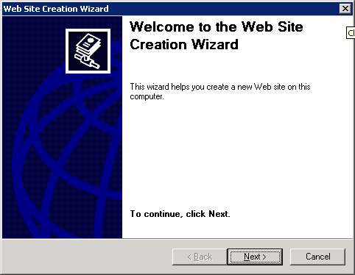

Click Next.

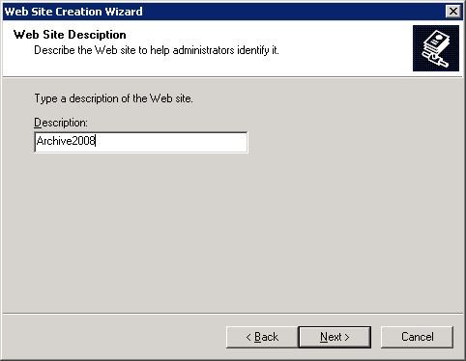

Set description = Archive2008. Click Next.

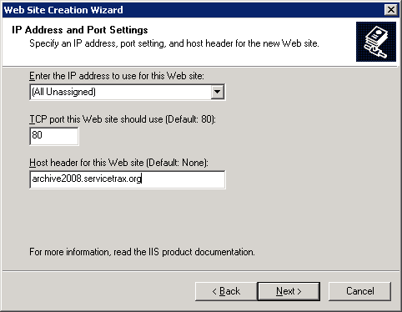

Set host header for this web site to match the DNS name created for the archive site, e.g. archive2008.servicetrax.org.

Click Next.

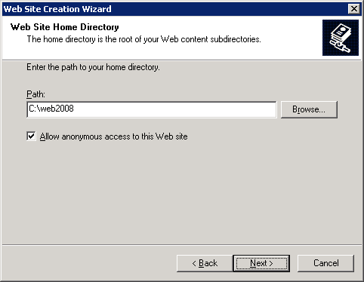

Set Path as web2008 (the newly created web home folder). Click Next.

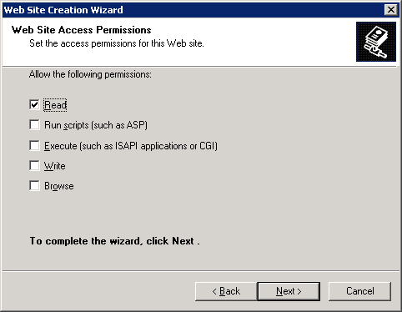

Click Next.

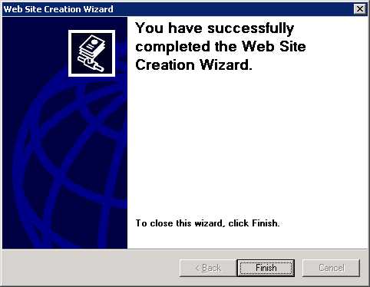

Click Finish.

Right click on archive2008 -> Properties -> ISAPI Filters -> Add,

Set Filter name = Tomcat Connector

Set Executable = C:\Program Files\Apache Software Foundation2\IsapiRedirector\bin\isapi_redirect.dll

Right click on archive2008 -> Properties -> Home Directory. Check Script source access. Set Execute Permissions = Script and Executables.

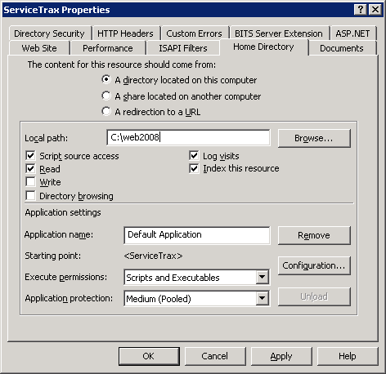

Click Apply/OK.

In IIS Manager, click Web Service Extensions - > Jakarta -> Properties -> Required Files -> Add and browser to C:\Program Files\Archive2008\IsapiRedirector\bin\isapi_redirect.dll, and click open and then click OK. Click OK.

In IIS Manager, right click on archive2008 -> New -> Virtual Directory... -> Next -> Set Alias = Jakarta

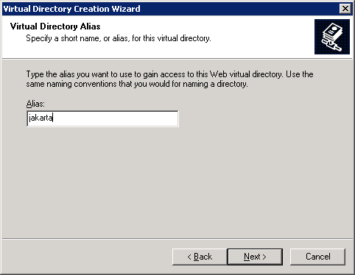

Click Next and browse to C:\Program Files\Archive2008\IsapiRedirector\bin. Click Next.

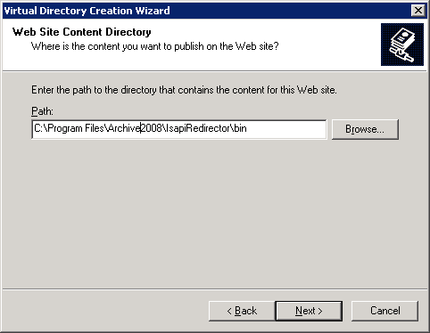

Check Execute (such as ISAPI applications or CGI.

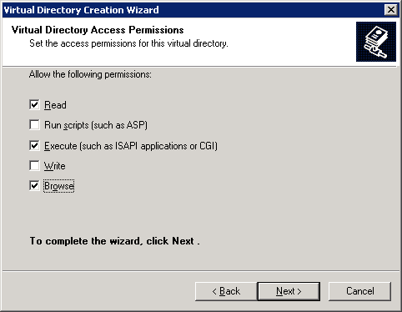

Click Next. Click Finish.

In IIS Manager, right click on Jakarta underneath archive2008 -> Properties -> Virtual directory and check Script source access.

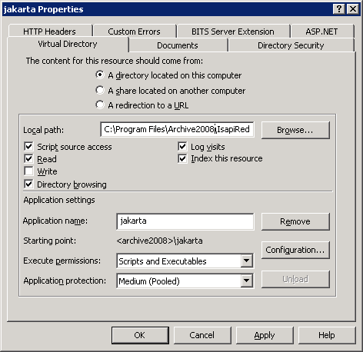

Click OK.

Make sure archive2008 is running. If not right click on archive2008 -> select Start.

From command line run: …>  **iisreset**

## Create Archive Database

Create ims_2008 by restoring from a proper ims_new backup.

## Build and Deploy ServiceTrax to Archive Site

### Create configuration file for Archive Build

* Create a copy of ims-prod.xml and name it as ims-archive.xml.
* Modify projectDir to archive location. For example from "E:\Program Files\Apache Software Foundation\Tomcat 5.5\webapps\ims\" to "E:\Program Files\Archive2008\Tomcat 5.5\webapps\ims\".
* Modify htmlDir to archive location.
* Modify appGLobalDatum loginTo from “seriveTrax” to “serviceTrax archive 2008” (optional).
* Deactivate all daemons by commenting out them.
* Modify resource SQLServer in ResourceManager section to point to the archive database.

### Other New/Modified Configuration Files

build.xml

ims/ant/build.xml

ims/src/main/filters/archive-filter.properties

ims/src/main/webapp/WEB-INF/ims-archive.xml

ims/src/main/webapp/WEB-INF/web-archive.xml

stc/src/main/filters/archive-filter.properties

### Deployments

* Deploy production build as usual
* Deploy archive build to archive site

## Delete Archived Data from Production Database

Execute delete script, ims_archive_delete_2008.sql. It is recommended that the script is executed after normal business hours.

## Recording Archive history

### Create archive_logs table if it has not been created

CREATE TABLE archive_logs (

archive_log_id INT IDENTITY NOT NULL,

db_name VARCHAR(50) NOT NULL,

start_date DATETIME NOT NULL,

end_date DATETIME NOT NULL,

app_svn_revision INT NOT NULL,

app_url VARCHAR(100) NOT NULL,

tomcat_home VARCHAR(100) NOT NULL,

tomcat_port int NOT NULL,

created_by NUMERIC(18,0) NOT NULL,

date_created DATETIME NOT NULL CONSTRAINT [df_db_archives_date_created] DEFAULT (getdate()),

modified_by NUMERIC(18, 0) NULL,

date_modified DATETIME NULL,

CONSTRAINT pk_archive_logs PRIMARY KEY CLUSTERED (archive_log_id ASC)

)

GO

### Add new record for current archive

Example:

INSERT INTO archive_logs (db_name, start_date, end_date, app_svn_revision, app_url, tomcat_home, tomcat_port, created_by, date_created)

VALUES ('ims_2008', '1/1/2003', '1/1/2006', '1345', 'archive2008.servicetrax.org', 'E:\Program Files\Archive2008\Tomcat 5.5', '8883', 1, getDate())