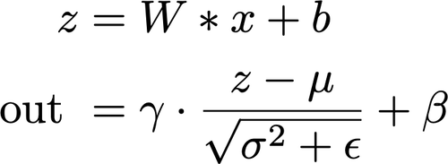
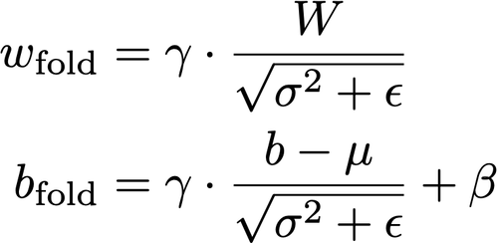
CNN Accelerator PCAP Malware Detection Research

Source 1: https://towardsdatascience.com/building-an-intrusion-detection-system-using-deep-learning-b9488332b321
Source 2: https://www.opensourceforu.com/2016/09/deep-learning-network-packet-forensics-using-tensorflow/
Source 3: https://www.studytonight.com/network-programming-in-python/building-a-port-scanner

Normalization layers:
https://www.tensorflow.org/addons/tutorials/layers_normalizations

BatchNormalization
https://medium.com/@krishna_84429/understanding-batch-normalization-1eaca8f2f63e#:~:text=Batch%20Normalization%20during%20inference,variance%20on%20a%20single%20sample.

Normalization of any data is about finding the mean and variance of the data and normalizing the data so that the the data has 0 mean and unit variance.

Consider we have d number of hidden units in a hidden layer of any Deep neural network. We can represent the activation values of this layer as x=[x1,x2,………xd]. Now we can normalize the kth hidden unit activation using the formula bellow.

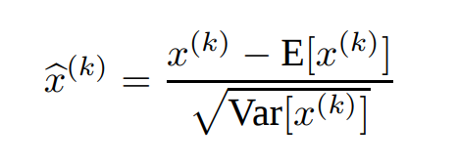

Speedup Inference with BatchNormalization Folding
https://towardsdatascience.com/speed-up-inference-with-batch-normalization-folding-8a45a83a89d8
Batch Normalization is a technique which takes care of normalizing the input of each layer to make the training process faster and more stable. In practice, it is an extra layer that we generally add after the computation layer and before the non-linearity.

It consists of 2 steps:
- Normalize the batch by first subtracting its mean μ, then dividing it by its standard deviation σ.
- Further scale by a factor γ and shift by a factor β. Those are the parameters of the batch normalization layer, required in case of the network not needing the data to have a mean of 0 and a standard deviation of 1.

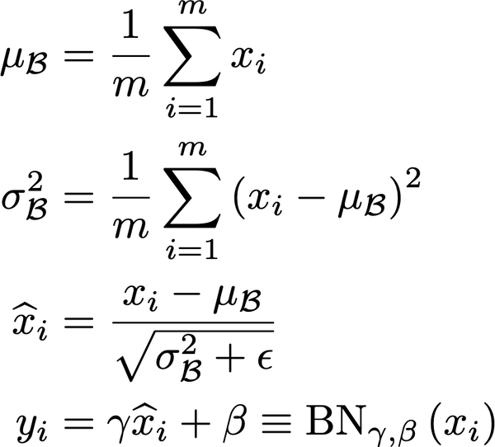

Once the training has ended, each batch normalization layer possesses a specific set of γ and β, but also μ and σ, the latter being computed using an exponentially weighted average during training. It means that during inference, the batch normalization acts as a simple linear transformation of what comes out of the previous layer, often a convolution.

How to do that in practice?
With a little bit of math, we can easily rearrange the terms of the convolution to take the batch normalization into account.
As a little reminder, the convolution operation followed by the batch normalization operation can be expressed, for an input x, as:

So, if we re-arrange the W and b of the convolution to take the parameters of the batch normalization into account, as such:
We can remove the batch normalization layer and still have the same results!
Note: Usually, you don’t have a bias in a layer preceding a batch normalization layer. It is useless and a waste of parameters as any constant will be canceled out by the batch normalization.

