Test Runs
Setup:
(train_images, train_labels), (test_images, test_labels) = datasets.cifar10.load_data() #datasets.mnist.load_data() #datasets.cifar10.load_data()

# Normalize pixel values to be between 0 and 1
train_images, test_images = train_images / 255.0, test_images / 255.0

class_names = ['airplane', 'automobile', 'bird', 'cat', 'deer',
'dog', 'frog', 'horse', 'ship', 'truck']

Training:
model.compile(optimizer='adam',
loss=tf.keras.losses.SparseCategoricalCrossentropy(from_logits=True),
metrics=['accuracy'])

history = model.fit(train_images, train_labels, epochs=10,
validation_data=(test_images, test_labels))

Test 1:
model = models.Sequential()
model.add(layers.Conv2D(32, (3, 3), activation='relu', input_shape=(32, 32, 3)))
model.add(layers.MaxPooling2D((2, 2)))
model.add(layers.Conv2D(64, (3, 3), activation='relu'))
model.add(layers.MaxPooling2D((2, 2)))
model.add(layers.Conv2D(64, (3, 3), activation='relu'))

model.add(layers.Flatten())
model.add(layers.Dense(64, activation='relu'))
model.add(layers.Dense(10))

and as Functional:
model_input = Input(shape=(32, 32, 3), name="frame")
x = layers.Conv2D(32, (3,3), padding='VALID', activation="relu")(model_input)
x = layers.MaxPooling2D((2,2))(x)
x = layers.Conv2D(64, (3,3), padding='VALID', activation="relu")(x)
x = layers.MaxPooling2D((2,2))(x)
x = layers.Conv2D(64, (3,3), padding='VALID', activation="relu")(x)
x = layers.Flatten()(x)
x = layers.Dense(64, activation="relu")(x)
x = layers.Dense(10)(x)

Layer (type) Output Shape Param #
=================================================================
frame (InputLayer) [(None, 32, 32, 3)] 0
_________________________________________________________________
conv2d (Conv2D) (None, 30, 30, 32) 896
_________________________________________________________________
max_pooling2d (MaxPooling2D) (None, 15, 15, 32) 0
_________________________________________________________________
conv2d_1 (Conv2D) (None, 13, 13, 64) 18496
_________________________________________________________________
max_pooling2d_1 (MaxPooling2 (None, 6, 6, 64) 0
_________________________________________________________________
conv2d_2 (Conv2D) (None, 4, 4, 64) 36928
_________________________________________________________________
flatten (Flatten) (None, 1024) 0
_________________________________________________________________
dense (Dense) (None, 64) 65600
_________________________________________________________________
dense_1 (Dense) (None, 10) 650
=================================================================
Total params: 122,570
Trainable params: 122,570
Non-trainable params: 0

313/313 - 1s - loss: 0.8365 - accuracy: 0.7155
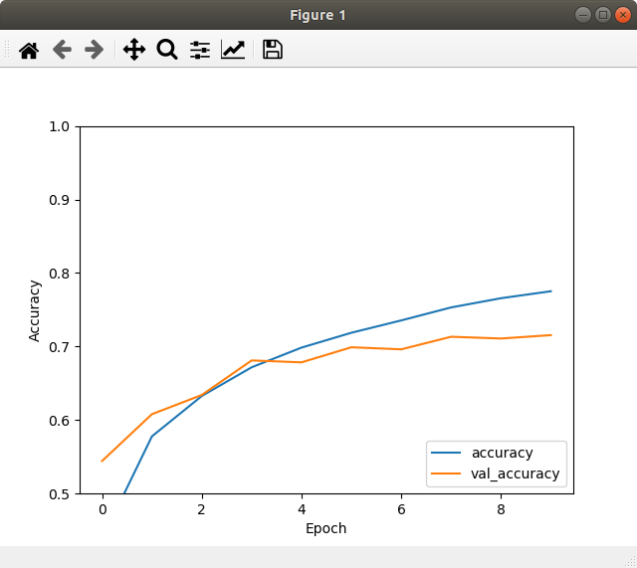
0.715499997138977

313/313 - 0s - loss: 0.8678 - accuracy: 0.7212
0.7211999893188477

2nd:
313/313 - 0s - loss: 0.8958 - accuracy: 0.7085
0.7085000276565552

Test 2:
model = models.Sequential()
model.add(layers.Conv2D(8, (3, 3), activation='relu', input_shape=(32, 32, 3)))
model.add(layers.Conv2D(8, (3, 3), activation='relu'))
model.add(layers.MaxPooling2D((2, 2)))

model.add(layers.Flatten())
model.add(layers.Dense(128, activation='relu'))
model.add(layers.Dense(10))

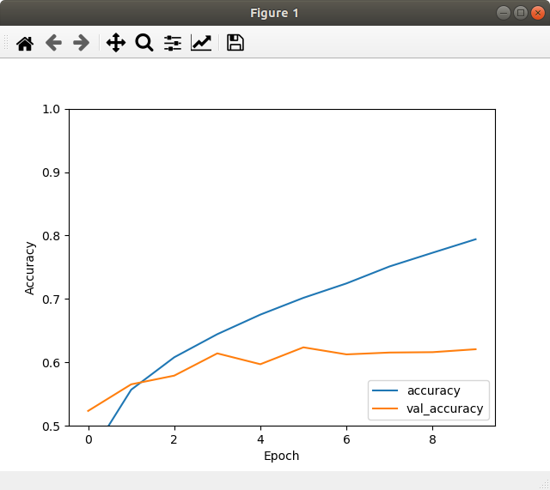
313/313 - 0s - loss: 1.2346 - accuracy: 0.6207
0.6207000017166138

Test 3:
model = models.Sequential()
model.add(layers.Conv2D(8, (3, 3), activation='relu', input_shape=(32, 32, 3)))
model.add(layers.Conv2D(8, (3, 3), activation='relu'))
model.add(layers.Conv2D(8, (3, 3), activation='relu'))
model.add(layers.Conv2D(8, (3, 3), activation='relu'))
model.add(layers.MaxPooling2D((2, 2)))

model.add(layers.Flatten())
model.add(layers.Dense(64, activation='relu'))
model.add(layers.Dense(10))

ayer (type) Output Shape Param #
=================================================================
frame (InputLayer) [(None, 32, 32, 3)] 0
_________________________________________________________________
conv2d (Conv2D) (None, 30, 30, 8) 224
_________________________________________________________________
conv2d_1 (Conv2D) (None, 28, 28, 8) 584
_________________________________________________________________
conv2d_2 (Conv2D) (None, 26, 26, 8) 584
_________________________________________________________________
conv2d_3 (Conv2D) (None, 24, 24, 8) 584
_________________________________________________________________
max_pooling2d (MaxPooling2D) (None, 12, 12, 8) 0
_________________________________________________________________
flatten (Flatten) (None, 1152) 0
_________________________________________________________________
dense (Dense) (None, 64) 73792
_________________________________________________________________
dense_1 (Dense) (None, 10) 650
=================================================================
Total params: 76,418
Trainable params: 76,418
Non-trainable params: 0
313/313 - 0s - loss: 1.1648 - accuracy: 0.6143
0.614300012588501
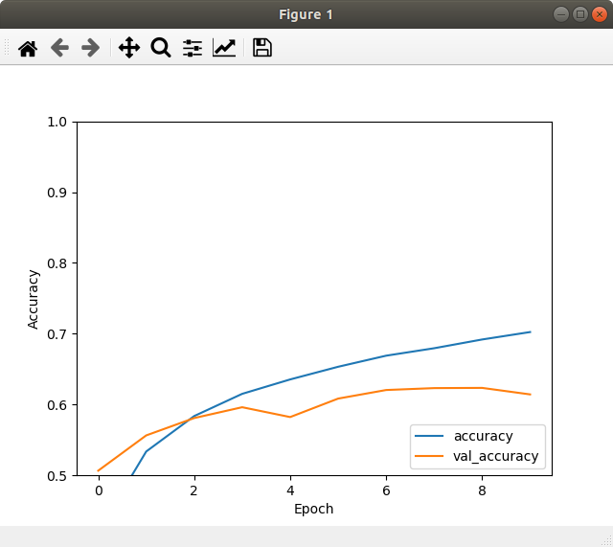

Test 3+:
model_input = Input(shape=(32, 32, 3), name="frame")
x = layers.Conv2D(8, (3,3), padding='VALID', activation="relu")(model_input)
x = layers.Conv2D(8, (3,3), padding='VALID', activation="relu")(x)
x = layers.Conv2D(8, (3,3), padding='VALID', activation="relu")(x)
x = layers.Conv2D(8, (3,3), padding='VALID', activation="relu")(x)
x = layers.MaxPooling2D((2,2))(x)
x = layers.Flatten()(x)
x = layers.Dense(128, activation="relu")(x)
x = layers.Dense(10)(x)

_________________________________________________________________
Layer (type) Output Shape Param #
=================================================================
frame (InputLayer) [(None, 32, 32, 3)] 0
_________________________________________________________________
conv2d (Conv2D) (None, 30, 30, 8) 224
_________________________________________________________________
conv2d_1 (Conv2D) (None, 28, 28, 8) 584
_________________________________________________________________
conv2d_2 (Conv2D) (None, 26, 26, 8) 584
_________________________________________________________________
conv2d_3 (Conv2D) (None, 24, 24, 8) 584
_________________________________________________________________
max_pooling2d (MaxPooling2D) (None, 12, 12, 8) 0
_________________________________________________________________
flatten (Flatten) (None, 1152) 0
_________________________________________________________________
dense (Dense) (None, 128) 147584
_________________________________________________________________
dense_1 (Dense) (None, 10) 1290
=================================================================
Total params: 150,850
Trainable params: 150,850
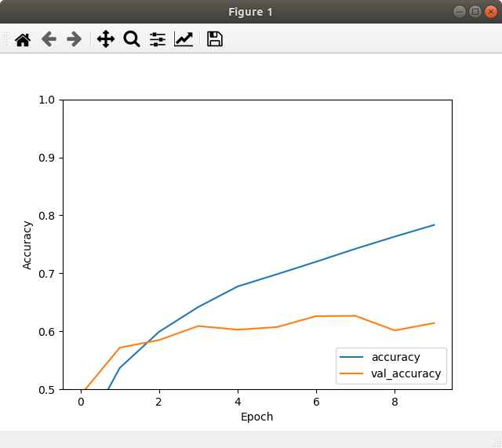
Non-trainable params: 0

313/313 - 0s - loss: 1.2422 - accuracy: 0.6142
0.6141999959945679

Test 3++:
model_input = Input(shape=(32, 32, 3), name="frame")
x = layers.Conv2D(8, (3,3), padding='VALID', activation="relu")(model_input)
x = layers.Conv2D(16, (3,3), padding='VALID', activation="relu")(x)
x = layers.MaxPooling2D((2,2))(x)
x = layers.Flatten()(x)
x = layers.Dense(128, activation="relu")(x)
x = layers.Dense(10)(x)

Layer (type) Output Shape Param #
=================================================================
frame (InputLayer) [(None, 32, 32, 3)] 0
_________________________________________________________________
conv2d (Conv2D) (None, 30, 30, 8) 224
_________________________________________________________________
conv2d_1 (Conv2D) (None, 28, 28, 16) 1168
_________________________________________________________________
max_pooling2d (MaxPooling2D) (None, 14, 14, 16) 0
_________________________________________________________________
flatten (Flatten) (None, 3136) 0
_________________________________________________________________
dense (Dense) (None, 128) 401536
_________________________________________________________________
dense_1 (Dense) (None, 10) 1290
=================================================================
Total params: 404,218
Trainable params: 404,218
Non-trainable params: 0

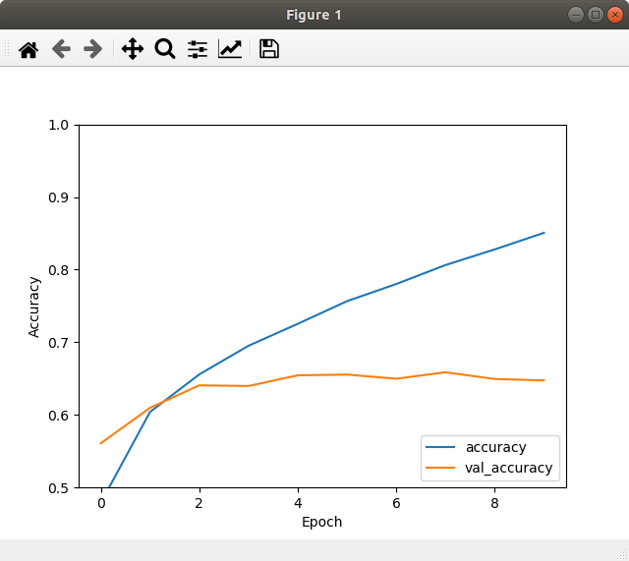
313/313 - 0s - loss: 1.2604 - accuracy: 0.6475
0.6474999785423279

Test 3+++:
model_input = Input(shape=(32, 32, 3), name="frame")
x = layers.Conv2D(16, (3,3), padding='VALID', activation="relu")(model_input)
x = layers.Conv2D(8, (3,3), padding='VALID', activation="relu")(x)
x = layers.MaxPooling2D((2,2))(x)
x = layers.Flatten()(x)
x = layers.Dense(128, activation="relu")(x)
x = layers.Dense(10)(x)

Layer (type) Output Shape Param #
=================================================================
frame (InputLayer) [(None, 32, 32, 3)] 0
_________________________________________________________________
conv2d (Conv2D) (None, 30, 30, 16) 448
_________________________________________________________________
conv2d_1 (Conv2D) (None, 28, 28, 8) 1160
_________________________________________________________________
max_pooling2d (MaxPooling2D) (None, 14, 14, 8) 0
_________________________________________________________________
flatten (Flatten) (None, 1568) 0
_________________________________________________________________
dense (Dense) (None, 128) 200832
_________________________________________________________________
dense_1 (Dense) (None, 10) 1290
=================================================================
Total params: 203,730
Trainable params: 203,730
Non-trainable params: 0

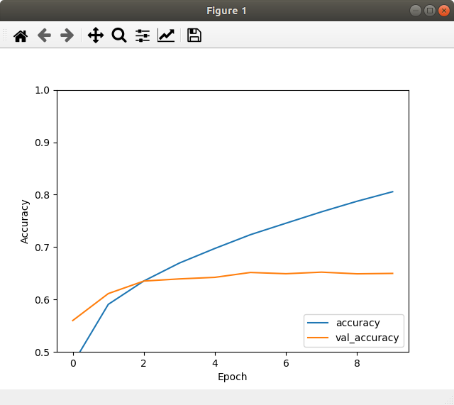
313/313 - 0s - loss: 1.1473 - accuracy: 0.6498
0.6498000025749207

2nd:
313/313 - 0s - loss: 1.1945 - accuracy: 0.6266
0.6266000270843506

3rd:
313/313 - 0s - loss: 1.2270 - accuracy: 0.6414
0.6413999795913696

Test 3 4x+:
model_input = Input(shape=(32, 32, 3), name="frame")
x = layers.Conv2D(32, (3,3), padding='VALID', activation="relu")(model_input)
x = layers.Conv2D(8, (3,3), padding='VALID', activation="relu")(x)
x = layers.MaxPooling2D((2,2))(x)
x = layers.Flatten()(x)
x = layers.Dense(128, activation="relu")(x)
x = layers.Dense(10)(x)

Layer (type) Output Shape Param #
=================================================================
frame (InputLayer) [(None, 32, 32, 3)] 0
_________________________________________________________________
conv2d (Conv2D) (None, 30, 30, 32) 896
_________________________________________________________________
conv2d_1 (Conv2D) (None, 28, 28, 8) 2312
_________________________________________________________________
max_pooling2d (MaxPooling2D) (None, 14, 14, 8) 0
_________________________________________________________________
flatten (Flatten) (None, 1568) 0
_________________________________________________________________
dense (Dense) (None, 128) 200832
_________________________________________________________________
dense_1 (Dense) (None, 10) 1290
=================================================================
Total params: 205,330
Trainable params: 205,330
Non-trainable params: 0
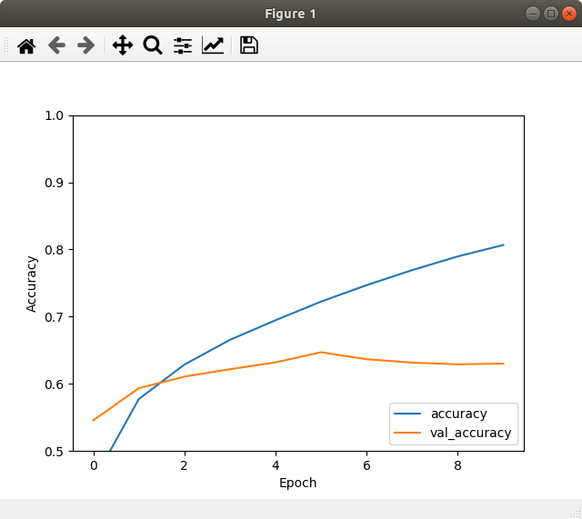
313/313 - 0s - loss: 1.2520 - accuracy: 0.6301
0.6301000118255615

2nd:
313/313 - 0s - loss: 1.3621 - accuracy: 0.6266
0.6266000270843506

3rd:
313/313 - 0s - loss: 1.4188 - accuracy: 0.6265
0.6265000104904175

Test 3 5x+:
model_input = Input(shape=(32, 32, 3), name="frame")
x = layers.Conv2D(32, (3,3), padding='VALID', activation="relu")(model_input)
x = layers.Conv2D(16, (3,3), padding='VALID', activation="relu")(x)
x = layers.Conv2D(8, (3,3), padding='VALID', activation="relu")(x)
x = layers.MaxPooling2D((2,2))(x)
x = layers.Flatten()(x)
x = layers.Dense(128, activation="relu")(x)
x = layers.Dense(10)(x)

Layer (type) Output Shape Param #
=================================================================
frame (InputLayer) [(None, 32, 32, 3)] 0
_________________________________________________________________
conv2d (Conv2D) (None, 30, 30, 32) 896
_________________________________________________________________
conv2d_1 (Conv2D) (None, 28, 28, 16) 4624
_________________________________________________________________
conv2d_2 (Conv2D) (None, 26, 26, 8) 1160
_________________________________________________________________
max_pooling2d (MaxPooling2D) (None, 13, 13, 8) 0
_________________________________________________________________
flatten (Flatten) (None, 1352) 0
_________________________________________________________________
dense (Dense) (None, 128) 173184
_________________________________________________________________
dense_1 (Dense) (None, 10) 1290
=================================================================
Total params: 181,154
Trainable params: 181,154
Non-trainable params: 0
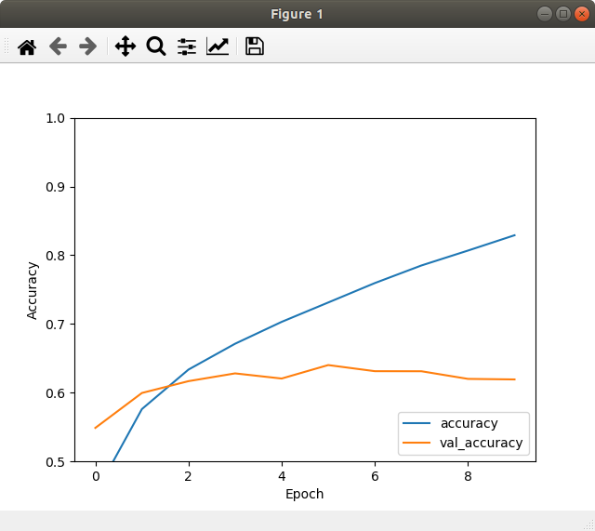

313/313 - 0s - loss: 1.3482 - accuracy: 0.6193
0.6193000078201294

2nd:
313/313 - 0s - loss: 1.1339 - accuracy: 0.6530
0.652999997138977

3rd:
313/313 - 0s - loss: 1.5474 - accuracy: 0.6298
0.629800021648407

Test 3 6x:
model_input = Input(shape=(32, 32, 3), name="frame")
x = layers.Conv2D(16, (3,3), padding='VALID', activation="relu")(model_input)
x = layers.Conv2D(8, (3,3), padding='VALID', activation="relu")(x)
x = layers.Conv2D(8, (3,3), padding='VALID', activation="relu")(x)
x = layers.MaxPooling2D((2,2))(x)
x = layers.Flatten()(x)
x = layers.Dense(128, activation="relu")(x)
x = layers.Dense(10)(x)

_________________________________________________________________
Layer (type) Output Shape Param #
=================================================================
frame (InputLayer) [(None, 32, 32, 3)] 0
_________________________________________________________________
conv2d (Conv2D) (None, 30, 30, 16) 448
_________________________________________________________________
conv2d_1 (Conv2D) (None, 28, 28, 8) 1160
_________________________________________________________________
conv2d_2 (Conv2D) (None, 26, 26, 8) 584
_________________________________________________________________
max_pooling2d (MaxPooling2D) (None, 13, 13, 8) 0
_________________________________________________________________
flatten (Flatten) (None, 1352) 0
_________________________________________________________________
dense (Dense) (None, 128) 173184
_________________________________________________________________
dense_1 (Dense) (None, 10) 1290
=================================================================
Total params: 176,666
Trainable params: 176,666
Non-trainable params: 0

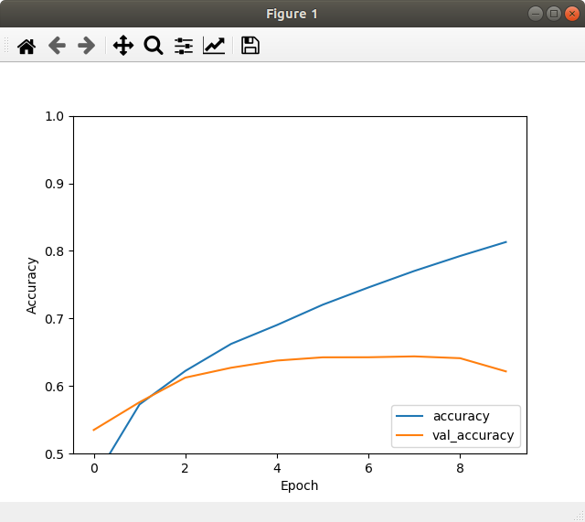
313/313 - 0s - loss: 1.2930 - accuracy: 0.6217
0.6216999888420105

2nd:
313/313 - 0s - loss: 1.2963 - accuracy: 0.5967
0.5967000126838684

3rd:
313/313 - 0s - loss: 1.2158 - accuracy: 0.6139
0.6139000058174133

Test 3 7x+:

Layer (type) Output Shape Param #
=================================================================
frame (InputLayer) [(None, 32, 32, 3)] 0
_________________________________________________________________
conv2d (Conv2D) (None, 30, 30, 16) 448
_________________________________________________________________
conv2d_1 (Conv2D) (None, 28, 28, 8) 1160
_________________________________________________________________
conv2d_2 (Conv2D) (None, 26, 26, 8) 584
_________________________________________________________________
conv2d_3 (Conv2D) (None, 24, 24, 8) 584
_________________________________________________________________
max_pooling2d (MaxPooling2D) (None, 12, 12, 8) 0
_________________________________________________________________
flatten (Flatten) (None, 1152) 0
_________________________________________________________________
dense (Dense) (None, 128) 147584
_________________________________________________________________
dense_1 (Dense) (None, 10) 1290
=================================================================
Total params: 151,650
Trainable params: 151,650
Non-trainable params: 0

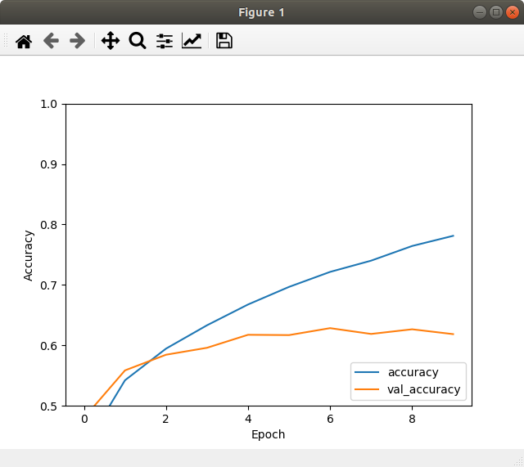
313/313 - 0s - loss: 1.1982 - accuracy: 0.6186
0.6186000108718872

2nd:
313/313 - 0s - loss: 1.1988 - accuracy: 0.6317
0.6316999793052673

Test 3 8+:
model_input = Input(shape=(32, 32, 3), name="frame")
x = layers.Conv2D(16, (5,5), padding='VALID', activation="relu")(model_input)
x = layers.Conv2D(8, (3,3), padding='VALID', activation="relu")(x)
x = layers.MaxPooling2D((2,2))(x)
x = layers.Flatten()(x)
x = layers.Dense(128, activation="relu")(x)
x = layers.Dense(10)(x)

________________________________________________________________
Layer (type) Output Shape Param #
=================================================================
frame (InputLayer) [(None, 32, 32, 3)] 0
_________________________________________________________________
conv2d (Conv2D) (None, 28, 28, 16) 1216
_________________________________________________________________
conv2d_1 (Conv2D) (None, 26, 26, 8) 1160
_________________________________________________________________
max_pooling2d (MaxPooling2D) (None, 13, 13, 8) 0
_________________________________________________________________
flatten (Flatten) (None, 1352) 0
_________________________________________________________________
dense (Dense) (None, 128) 173184
_________________________________________________________________
dense_1 (Dense) (None, 10) 1290
=================================================================
Total params: 176,850
Trainable params: 176,850
Non-trainable params: 0

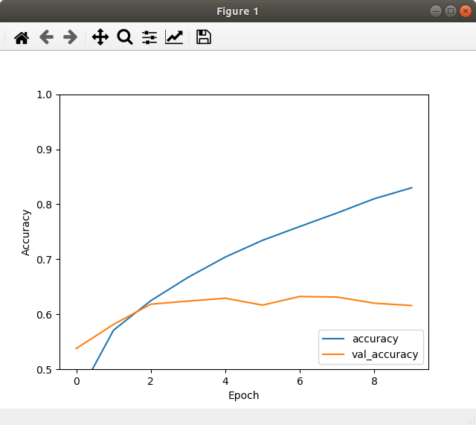

313/313 - 0s - loss: 1.3865 - accuracy: 0.6160
0.6159999966621399

2nd:
313/313 - 0s - loss: 1.1924 - accuracy: 0.6078
0.6078000068664551

3 9:
model_input = Input(shape=(32, 32, 3), name="frame")
x = layers.Conv2D(8, (3,3), padding='VALID', activation="relu")(model_input)
x = layers.MaxPooling2D((2,2))(x)
x = layers.Conv2D(16, (3,3), padding='VALID', activation="relu")(x)
x = layers.MaxPooling2D((2,2))(x)
x = layers.Conv2D(16, (3,3), padding='VALID', activation="relu")(x)
x = layers.Flatten()(x)
x = layers.Dense(64, activation="relu")(x)
x = layers.Dense(10)(x)

_________________________________________________________________
Layer (type) Output Shape Param #
=================================================================
frame (InputLayer) [(None, 32, 32, 3)] 0
_________________________________________________________________
conv2d (Conv2D) (None, 30, 30, 8) 224
_________________________________________________________________
max_pooling2d (MaxPooling2D) (None, 15, 15, 8) 0
_________________________________________________________________
conv2d_1 (Conv2D) (None, 13, 13, 16) 1168
_________________________________________________________________
max_pooling2d_1 (MaxPooling2 (None, 6, 6, 16) 0
_________________________________________________________________
conv2d_2 (Conv2D) (None, 4, 4, 16) 2320
_________________________________________________________________
flatten (Flatten) (None, 256) 0
_________________________________________________________________
dense (Dense) (None, 64) 16448
_________________________________________________________________
dense_1 (Dense) (None, 10) 650
=================================================================
Total params: 20,810
Trainable params: 20,810
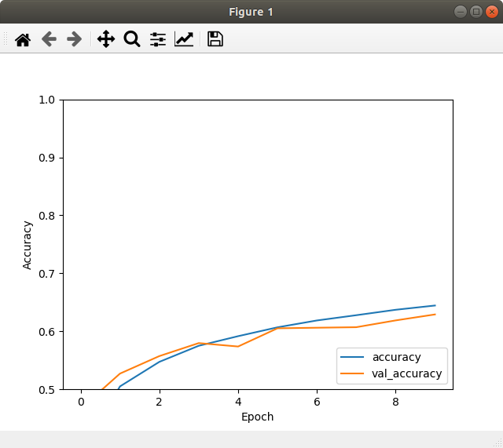
Non-trainable params: 0

313/313 - 0s - loss: 1.0523 - accuracy: 0.6291
0.6291000247001648

Test 3 10:
model_input = Input(shape=(32, 32, 3), name="frame")
x = layers.Conv2D(64, (3,3), padding='VALID', activation="relu")(model_input)
x = layers.MaxPooling2D((2,2))(x)
x = layers.Conv2D(128, (3,3), padding='VALID', activation="relu")(x)
x = layers.MaxPooling2D((2,2))(x)
x = layers.Conv2D(128, (3,3), padding='VALID', activation="relu")(x)
x = layers.Flatten()(x)
x = layers.Dense(64, activation="relu")(x)
x = layers.Dense(10)(x)

Layer (type) Output Shape Param #
=================================================================
frame (InputLayer) [(None, 32, 32, 3)] 0
_________________________________________________________________
conv2d (Conv2D) (None, 30, 30, 64) 1792
_________________________________________________________________
max_pooling2d (MaxPooling2D) (None, 15, 15, 64) 0
_________________________________________________________________
conv2d_1 (Conv2D) (None, 13, 13, 128) 73856
_________________________________________________________________
max_pooling2d_1 (MaxPooling2 (None, 6, 6, 128) 0
_________________________________________________________________
conv2d_2 (Conv2D) (None, 4, 4, 128) 147584
_________________________________________________________________
flatten (Flatten) (None, 2048) 0
_________________________________________________________________
dense (Dense) (None, 64) 131136
_________________________________________________________________
dense_1 (Dense) (None, 10) 650
=================================================================
Total params: 355,018
Trainable params: 355,018
Non-trainable params: 0
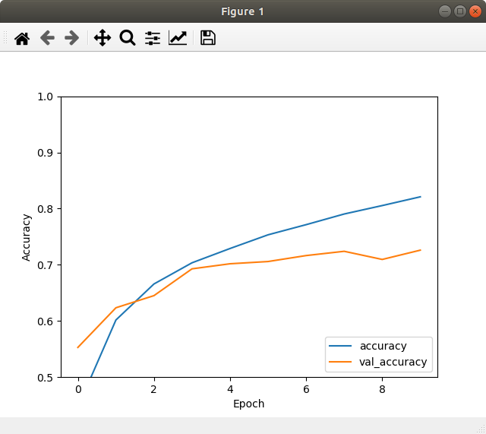

313/313 - 1s - loss: 0.8653 - accuracy: 0.7260
0.7260000109672546

Test 4:
model = models.Sequential()
model.add(layers.Conv2D(8, (3, 3), activation='relu', input_shape=(32, 32, 3)))
model.add(layers.Conv2D(8, (3, 3), activation='relu'))
model.add(layers.MaxPooling2D((2, 2)))

model.add(layers.Flatten())
model.add(layers.Dense(128, activation='relu'))
model.add(layers.Dense(64, activation='relu'))
model.add(layers.Dense(10))

_________________________________________________________________
Layer (type) Output Shape Param #
=================================================================
conv2d (Conv2D) (None, 30, 30, 8) 224
_________________________________________________________________
conv2d_1 (Conv2D) (None, 28, 28, 8) 584
_________________________________________________________________
max_pooling2d (MaxPooling2D) (None, 14, 14, 8) 0
_________________________________________________________________
flatten (Flatten) (None, 1568) 0
_________________________________________________________________
dense (Dense) (None, 128) 200832
_________________________________________________________________
dense_1 (Dense) (None, 64) 8256
_________________________________________________________________
dense_2 (Dense) (None, 10) 650
=================================================================
Total params: 210,546
Trainable params: 210,546
Non-trainable params: 0
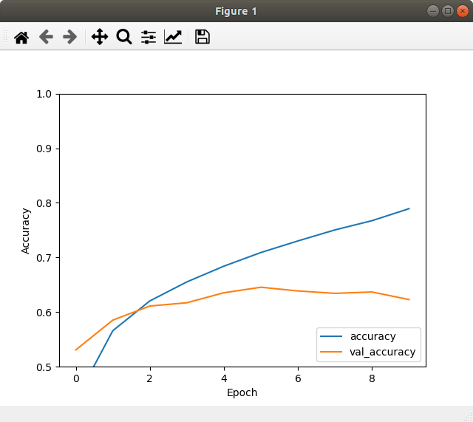
313/313 - 0s - loss: 1.2261 - accuracy: 0.6229
0.6229000091552734

Test 5:
model = models.Sequential()
model.add(layers.Conv2D(8, (3, 3), activation='relu', input_shape=(32, 32, 3)))
model.add(layers.Conv2D(8, (3, 3), activation='relu'))
model.add(layers.Conv2D(8, (3, 3), activation='relu'))
model.add(layers.Conv2D(8, (3, 3), activation='relu'))
model.add(layers.MaxPooling2D((2, 2)))

model.add(layers.Flatten())
model.add(layers.Dense(128, activation='relu'))
model.add(layers.Dense(64, activation='relu'))
model.add(layers.Dense(10))

Layer (type) Output Shape Param #
=================================================================
conv2d (Conv2D) (None, 30, 30, 8) 224
_________________________________________________________________
conv2d_1 (Conv2D) (None, 28, 28, 8) 584
_________________________________________________________________
conv2d_2 (Conv2D) (None, 26, 26, 8) 584
_________________________________________________________________
conv2d_3 (Conv2D) (None, 24, 24, 8) 584
_________________________________________________________________
max_pooling2d (MaxPooling2D) (None, 12, 12, 8) 0
_________________________________________________________________
flatten (Flatten) (None, 1152) 0
_________________________________________________________________
dense (Dense) (None, 128) 147584
_________________________________________________________________
dense_1 (Dense) (None, 64) 8256
_________________________________________________________________
dense_2 (Dense) (None, 10) 650
=================================================================
Total params: 158,466
Trainable params: 158,466
Non-trainable params: 0
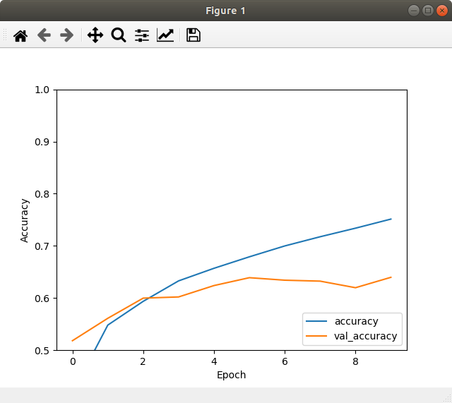
313/313 - 0s - loss: 1.0864 - accuracy: 0.6397
0.6396999955177307

Test 6:
# Functional API
model_input = Input(shape=(32, 32, 3), name="frame")
l1 = layers.Conv2D(16, (3,3), activation="relu")(model_input)
l2 = layers.Conv2D(32, (3,3), activation="relu")(l1)
l3 = layers.MaxPooling2D((3,3))(l2)
l4 = layers.Conv2D(32, (3,3), activation="relu")(l3)
l5 = layers.Conv2D(16, (3,3), activation="relu")(l4)
l6 = layers.MaxPooling2D((3,3))(l5)
l7 = layers.Flatten()(l6)
l8 = layers.Dense(128, activation="relu")(l7)
l9 = layers.Dense(10)(l8)

# Create the model
model = Model(inputs=model_input, outputs=l9)

Layer (type) Output Shape Param #
=================================================================
frame (InputLayer) [(None, 32, 32, 3)] 0
_________________________________________________________________
conv2d (Conv2D) (None, 30, 30, 16) 448
_________________________________________________________________
conv2d_1 (Conv2D) (None, 28, 28, 32) 4640
_________________________________________________________________
max_pooling2d (MaxPooling2D) (None, 9, 9, 32) 0
_________________________________________________________________
conv2d_2 (Conv2D) (None, 7, 7, 32) 9248
_________________________________________________________________
conv2d_3 (Conv2D) (None, 5, 5, 16) 4624
_________________________________________________________________
max_pooling2d_1 (MaxPooling2 (None, 1, 1, 16) 0
_________________________________________________________________
flatten (Flatten) (None, 16) 0
_________________________________________________________________
dense (Dense) (None, 128) 2176
_________________________________________________________________
dense_1 (Dense) (None, 10) 1290
=================================================================
Total params: 22,426
Trainable params: 22,426
Non-trainable params: 0

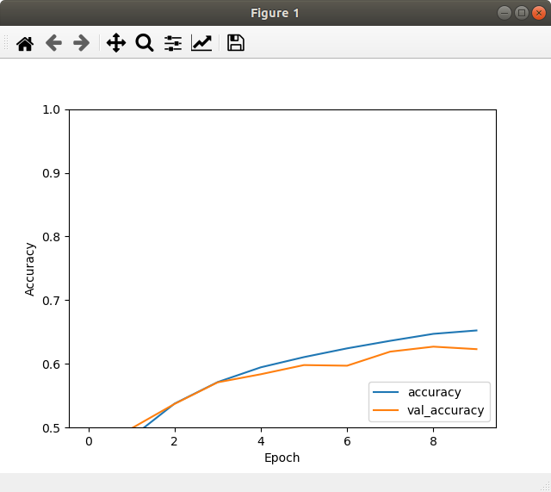
313/313 - 0s - loss: 1.0750 - accuracy: 0.6231
0.6230999827384949

Test 7:
# Functional API
model_input = Input(shape=(32, 32, 3), name="frame")
l1 = layers.Conv2D(16, (3,3), padding='VALID', activation="relu")(model_input)
l2 = layers.Conv2D(32, (3,3), padding='VALID', activation="relu")(l1)
l3 = layers.MaxPooling2D((3,3))(l2)
l4 = layers.Conv2D(32, (3,3), padding='VALID', activation="relu")(l3)
l5 = layers.Conv2D(16, (3,3), padding='VALID', activation="relu")(l4)
l6 = layers.MaxPooling2D((3,3))(l5)
l7 = layers.Flatten()(l6)
l8 = layers.Dense(128, activation="relu")(l7)
l9 = layers.Dense(10)(l8)

# Create the model
model = Model(inputs=model_input, outputs=l9)

Layer (type) Output Shape Param #
=================================================================
frame (InputLayer) [(None, 32, 32, 3)] 0
_________________________________________________________________
conv2d (Conv2D) (None, 30, 30, 16) 448
_________________________________________________________________
conv2d_1 (Conv2D) (None, 28, 28, 32) 4640
_________________________________________________________________
max_pooling2d (MaxPooling2D) (None, 9, 9, 32) 0
_________________________________________________________________
conv2d_2 (Conv2D) (None, 7, 7, 32) 9248
_________________________________________________________________
conv2d_3 (Conv2D) (None, 5, 5, 16) 4624
_________________________________________________________________
max_pooling2d_1 (MaxPooling2 (None, 1, 1, 16) 0
_________________________________________________________________
flatten (Flatten) (None, 16) 0
_________________________________________________________________
dense (Dense) (None, 128) 2176
_________________________________________________________________
dense_1 (Dense) (None, 10) 1290
=================================================================
Total params: 22,426
Trainable params: 22,426
Non-trainable params: 0
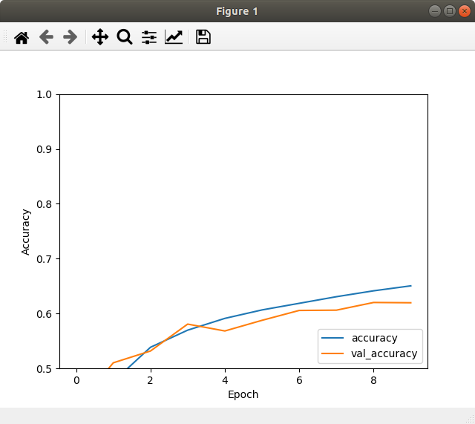

Test 8:
model_input = Input(shape=(32, 32, 3), name="frame")
x = layers.Conv2D(8, (3,3), padding='VALID', activation="relu")(model_input)
x = layers.Conv2D(8, (3,3), padding='VALID', activation="relu")(x)
x = layers.Conv2D(8, (3,3), padding='VALID', activation="relu")(x)
x = layers.Conv2D(8, (3,3), padding='VALID', activation="relu")(x)
x = layers.MaxPooling2D((2,2))(x)
x = layers.Flatten()(x)
x = layers.Dense(128, activation="relu")(x)
x = layers.Dense(10)(x)

Layer (type) Output Shape Param #
=================================================================
frame (InputLayer) [(None, 32, 32, 3)] 0
_________________________________________________________________
conv2d (Conv2D) (None, 30, 30, 8) 224
_________________________________________________________________
conv2d_1 (Conv2D) (None, 28, 28, 8) 584
_________________________________________________________________
conv2d_2 (Conv2D) (None, 26, 26, 8) 584
_________________________________________________________________
conv2d_3 (Conv2D) (None, 24, 24, 8) 584
_________________________________________________________________
max_pooling2d (MaxPooling2D) (None, 12, 12, 8) 0
_________________________________________________________________
flatten (Flatten) (None, 1152) 0
_________________________________________________________________
dense (Dense) (None, 128) 147584
_________________________________________________________________
dense_1 (Dense) (None, 10) 1290
=================================================================
Total params: 150,850
Trainable params: 150,850
Non-trainable params: 0

