13 12 11 10 9 8 7 6 5 4 3 2 1

25 24 23 22 21 20 19 18 17 16 15 14

看的方向为：

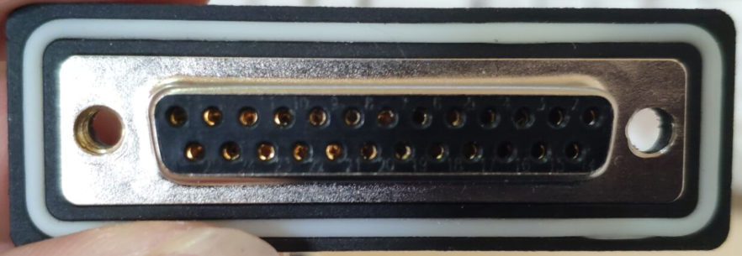

**13 ----------------------------------------------------------> 模拟输出1 输出**

**12 ----------------------------------------------------------> 模拟输入1 电流**

**11 ----------------------------------------------------------> 模拟输入1 电压**

**10 ----------------------------------------------------------> 模拟输入1 24V**

**9 ----------------------------------------------------------> 485 1 A**

**8 ----------------------------------------------------------> 485 1 B**

**7 ----------------------------------------------------------> GND（未标识的GND全部共地到此处）**

**6 ----------------------------------------------------------> 数字输入1 24V**

**5 ----------------------------------------------------------> 数字输入1 输入**

**4 ----------------------------------------------------------> 数字输出1 输出**

**3 ----------------------------------------------------------> 继电器1 24V**

**2 ----------------------------------------------------------> 继电器1 GND**

**1 ----------------------------------------------------------> DC座24V**

**25 ----------------------------------------------------------> 模拟输出2 输出**

**24 ----------------------------------------------------------> 模拟输入2 电流**

**23 ----------------------------------------------------------> 模拟输入2 电压**

**22 ----------------------------------------------------------> 模拟输入2 24V**

**21 ----------------------------------------------------------> 485 2 A**

**20 ----------------------------------------------------------> 485 2 B**

**19 ----------------------------------------------------------> GND（未标识的GND全部共地到此处）**

**18 ----------------------------------------------------------> 数字输入2 24V**

**17 ----------------------------------------------------------> 数字输入2 输入**

**16 ----------------------------------------------------------> 数字输出2 输出**

**15 ----------------------------------------------------------> 继电器2 24V**

**14 ----------------------------------------------------------> 继电器2 GND**