

**G and I Series**

**Digital Thermal Based MFC**

## Technology Manual

*Part 1046210-001*

*Rev. B*

**WARRANTY**

G and I Series Mass Flow Controllers

MKS Instruments, Inc. (MKS) warrants that for one (1) year from the date of shipment the equipment which is described above and manufactured by MKS, shall be free from defects in materials and workmanship.

For the period commencing with the date of shipment of this equipment and ending one (1) year later, MKS will, at its option, either repair or replace any part which is defective in materials or workmanship without charge to the purchaser. The foregoing shall constitute the exclusive and sole remedy of the purchaser for any breach of MKS of this warranty.

The purchaser, before returning any equipment covered by this warranty, which is asserted to be defective by the purchaser, shall make specific written arrangements with respect to the responsibility for shipping the equipment and handling any other incidental charges with the MKS Sales Representative or distributor from which the equipment was purchased or, in the case of a direct purchase from MKS, with the MKS home office in Andover, Massachusetts, USA.

This warranty does not apply to any equipment which has not been installed and used in accordance with the specifications recommended by MKS for the proper and normal use of the equipment. MKS shall not be liable under any circumstances for indirect, special, consequential, or incidental damages in connection with, or arising out of, the sale, performance, or use of the equipment covered by this warranty.

MKS recommends that all MKS pressure and flow products be calibrated periodically (typically) every 6 to 12 months) to ensure accurate readings. When a product is returned to MKS for this periodic re- calibration it is considered normal preventative maintenance not covered by any warranty.

THIS WARRANTY IS IN LIEU OF ALL OTHER RELEVANT WARRANTIES, EXPRESSED OR IMPLIED, INCLUDING THE IMPLIED WARRANTY OF MERCHANTABILITY AND THE IMPLIED WARRANTY OF FITNESS FOR A PARTICULAR PURPOSE, AND ANY WARRANTY AGAINST INFRINGEMENT OF ANY PATENT.

Copyright © 2017 by MKS Instruments, Inc.

All rights reserved. No part of this work may be reproduced or transmitted in any form or by any means, electronic or mechanical, including photocopying and recording, or by any information storage or retrieval system, except as may be expressly permitted in writing by MKS Instruments, Inc.

Printed in the United States of America.

mksinst™ is a trademark of MKS Instruments, Inc.

Baratron® is a registered trademark of MKS Instruments, Inc., Andover, MA

Swagelok®, VCO®, and VCR® are registered trademarks of Swagelok Company, Solon, OH Inconel® is a registered trademark of Inco Alloys, Inc. Huntington, WV

Elgiloy is a registered trademark of Elgiloy Specialty Metals, Elgin, IL

Teflon is a registered trademark of E.I. du Pont de Nemours and Company, Wilmington, DE

All other product names herein are used for identification purposes only and are recognized as properties (including trademarks, registered trademarks, and referenced copyrighted materials) of their respective companies.



MKS Instruments, Inc. 2 Tech Drive, Suite 201

Andover, MA 01810 USA

Phone: 978-645-5500, Fax: 978-557-5100

Email: [mks@mksinst.com](mailto:mks@mksinst.com) [www.mksinst.com](http://www.mksinst.com/)

**Table of Contents**

1. OVERVIEW 1

Product Support Documents 2

Manual References 2

Product Description Guide 3

General MFC Overview and Features 4

Performance 4

Multi Gas and Multi-Range Functions 4

User Interface and MFC Diagnostics 4

MFC Reliability 5

MFC Cleanliness 5

Specifications 6

Mechanical Dimensions 8

1. SAFETY INFORMATION 1

Mass Flow Controller Safety Information 1

Symbols Used in This Instruction Manual 1

Symbols Found on the Unit 1

Safety Procedures and Precautions 2

Sicherheitshinweise für das Massenflussgerät 3

In dieser Betriebsanleitung vorkommende Symbole 3

Erklärung der am Gerät angebrachten Symbole 4

Sicherheitsvorschriften und Vorsichtsmaßnahmen 4

Informations de sécurité pour appareils de mesure/contrôle de débit massique 6

Symboles utilisés dans ce manuel d'utilisation 6

Symboles figurant sur l'unité 6

Mesures de sécurité et précautions 7

Medidas de seguridad del dispositivo de flujo de masa 8

Símbolos usados en este manual de instrucciones 8

Símbolos hallados en la unidad 8

Procedimientos y precauciones de seguridad 9

マスフロー機器の安全に関する情報 10

本取扱説明書のマーク 10

本機器のマーク 10

安全対策について 11

질량 유량 장치 안전 정보 12

본 지침 매뉴얼에 사용되는 기호들 12

장치에 표시된 기호들 13

안전 절차 및 예방조치 13

1. MFC OPERATION 15

Typical Flow Control System Configuration 15

Flow Path 15

Flow Control Range 15

Measurement Technique 16

Control Circuitry 16

Control Valve 16

Operation of the MFC with Gases Other Than Nitrogen 16

1. INSTALLATION AND MFC SETUP 17

Considering the MFC Installation Environment 17

MFC Installation Environment 17

Pre-Installation Safety Considerations 18

Unpacking the MFC in a Clean Environment 18

Mounting Hardware for Installing the MFC 19

Checking the Leak Tight Seal for the MFC 21

Applying Power and Signal Cables to the MFC 21

Analog Power and Control I/O Definitions 23

Digital I/O Connections 24

Leak Checking the MFC Installation 29

Setting Up and Configuring the MFC 29

Zeroing the MFC 30

Check Temperature Stabilization 30

Establish a Proper “No Flow” Condition Across the MFC Control Valve 30

1. MFC PRODUCT CODE DEFINITION AND DESIGN CONFIGURATIONS 33

G and I Series Elastomer Models 33

Elastomer Sealed G and I Series Product Code Structure 33

MFC Configuration Code – CCCCC 33

Gas Code – GGG 33

Flow Full Scale Range Designation – FFF 34

MFC Fittings – Y 34

MFC Power and Control I/O Connector – W 35

Elastomer Seal Materials – Z 35

Valve Type – V 36

Firmware Revision – AA 36

G and I Series Metal Sealed Models 36

Metal Sealed G and I Series Product Code Structure 36

MFC Configuration 36

Gas Code – GGG 36

Full Scale Range – FFF 37

Fittings – Y 37

Power and Control I/O Connectors – W 38

Valve Type – V 39

Firmware – AA 39

1. TROUBLESHOOTING AND MAINTENANCE 41

MFC Setup and Function Troubleshooting 41

MFC Performance Troubleshooting 46

Digital Communications I/O Troubleshooting 47

DeviceNet47

RS485 Serial Communication 48

Profibus Communication 49

Ethercat Communication 49

Profinet Communication 50

* 1. SEMI GAS CODES AND MFC FLOW RANGE SUMMARY 51

G and I Series MFC Relationship with SEMI Gas Code Numbers 51

* 1. MFC WEB BROWSER 59

Communicating with the MFC via Ethernet 59

Opening the Web Browser – Monitor Mode 62

Going to the Setup Mode 63

Utilizing the Plot Page and Saving Data 65

ToolWeb Folder 65

Downloading Java from java.com 66

Placing the java.policy in the C:drive Java Folder 66

Creating a Java Security “Trusted” Site 68

* 1. ELECTRICAL CABLES AND ACCESSORIES 73
  2. IP RATING FOR THE I SERIES MFC AND WHAT IT MEANS 75
  3. MODBUS OPERATION 77

Enabling Modbus TCP/IP Control 77

Modbus Labview Library 77

MKS Example VI 78

* 1. ANALOG OPTIONAL INPUT 81

Setup Mode: Optional Input Tab 81

Basic Wiring Diagram for Optional Input (Downstream Control Example) 81

Optional Input Configuration via the Web Browser 82

Optional Input Plot Page 83

* 1. PRODUCT WARRANTY II

List of Figures

Figure 1-1. MKS G and I Series MFC 1

Figure 1-2. MFC Mechanical Dimensions 8

Figure 4-1. Mounting Screw Holes Locations for In-Line Axial Gas Flow Compression Fittings 20

Figure 4-2. Mounting Bolt Holes Location for Non-axial Gas Flow Compression Fittings 21

Figure 4-3. Analog I/O − 15 pin 23

Figure 4-4. Analog I/O − 9 pin 23

Figure 4-5. Analog I/O − 4-20 mA 23

Figure 4-6. RS485 Communication Protocol 24

Figure 4-7. DeviceNet Communication Protocol 25

Figure 4-8. DeviceNet 4-Position Rotary Switch 26

Figure 4-9. DeviceNet Pair of Rotary Switches 26

Figure 4-10. Profibus I/O Communications Protocol 27

Figure 4-11. EtherCat I/O Communications Protocol 28

Figure 4-12. Profinet I/O Communications Protocol 29

Figure 5-1. Elastomer Sealed G and I Series Product Code Structure 33

Figure 5-2. Metal Sealed G and I Series Product Code Structure 36

Figure B-1. Basic Network Information 59

Figure B-2. Local Area Connection Status 60

Figure B-3. Internet Protocol Version 4 60

Figure B-4. Properties 61

Figure B-5. IP Settings 61

Figure B-6. Device Page in Monitor Mode 62

Figure B-7. Enter Password to Change Settings 63

Figure B-8. Additional Tabs 64

Figure B-9. Tool Web Folder 65

Figure B-10. Java Web Site 66

Figure B-11. Java Web Site 66

Figure B-12. Security Folder 67

Figure B-13. Java Policy Security Document in the Security Folder 67

Figure B-14. Java Policy Security Document 68

Figure B-15. Java Folder 68

Figure B-16. Security Tab 69

Figure B-17. Exception Site List 69

Figure B-18. Security Warning 70

Figure B-19. Security Window 70

Figure E-1. Configuration Page 77

Figure E-2. Configuration Page 78

Figure E-3. MKS Modbus MFC Example 79

Figure F-1. Basic Wiring Diagram for Optional Input (Downstream Control Example) 82

Figure F-2. Optional Input Page 82

Figure F-3. Optional Input Plot Page 83

Figure F-4. Optional Input Plot Page Example 84

**List of Tables**

Table 1-1. G Series MFC 3

Table 1-2. I Series MFC 3

Table 1-3. General Performance and Design Specification 6

Table 1-4. Electrical Specification 7

Table 1-5. Mechanical and Material Specification 7

Table 1-6. Fitting Design and MFC Length 8

Table 1-7. Elastomer Sealed MFC Model Height Dimensions 9

Table 2-1. Symbols Found on the Unit 2

Tabelle 2-2. Bedeutung der am Gerät angebrachten Symbole 4

Tableau 2-3. Définition des symboles sur l'unité 6

Tabla 2-4. Definición de los símbolos hallados en la unidad 8

表 2-5. 本機器に使用されているマークについて 11

표 2-6. 장치에 표시된 기호들의 정의 13

Table 4-1. Mounting Pattern Hardware: Fitting Types by Model 19

Table 5-1. MFC Configuration Code – CCCCC 33

Table 5-2. Flow Full Scale Range Designation – FFF 34

Table 5-3. MFC Fittings – Y 34

Table 5-4. Analog Control I/O 35

Table 5-5. Digital I/O Protocols 35

Table 5-6. Elastomer Seal Materials – Z 35

Table 5-7. Valve Type – V 36

Table 5-8. MFC Configuration 36

Table 5-9. Full Scale Range – FFF 37

Table 5-10. Fittings – Y 37

Table 5-11. Analog I/O 38

Table 5-12. Digital I/O 38

Table 5-13. Valve Type – V 39

Table 6-1. MFC Setup and Function Troubleshooting 41

Table 6-2. MFC Performance Troubleshooting 46

Table 6-3. DeviceNet Status LED 47

Table 6-4. Module (MOD) LED 47

Table 6-5. DeviceNet Connectivity 48

Table 6-6. RS485 LED Status 48

Table 6-7. RS485 Connectivity 48

Table 6-8. Profibus LED Status 49

Table 6-9. Profibus Connectivity 49

Table 6-10. Ethercat LED Status 49

Table 6-11. Ethercat Connectivity 50

Table 6-12. Profinet LED Status 50

Table 6-13. Profinet Connectivity 50

Table A-1. SEMI Process Gas Definition 52

Table A-2. Standard SEMI Gas Mixtures 54

Table A-3. Non Standard Gas Mixtures 56

Table B-1. Basic Features in the Setup Mode 64

Table C-1. Analog Power and Signal I/O Cables 73

# Overview



**1**

The MKS G and I Series family of thermal based mass flow controller (MFC) technologies represents state of the art MFC technology in a cost effective, reliable, and versatile design platform that allows for easy integration into new applications. Advances in the three major design components of the traditional thermal based MFC (flow sensor, by-pass, and control valve) combined with an enhanced feedback control algorithm have yielded improvements in performance and accuracy for the multi-gas/multi-range G and I Series MFCs. Features that are common to the G and I product lines are:

* + - Fast flow control settling times for set point startup and during process step changes.
    - External communications port that allows users to access the embedded software to verify MFC functionality or change MFC flow conditions without removing from its installation location.
    - Multi-gas, multi-range availability in the embedded software that allows immediate reconfiguration of the MFC for changing process requirements, minimizing inventory for a variety of process conditions.

Enhanced I series environmental design features include:

* + - IP66 design for severe moisture and dust protection in severe process environments.

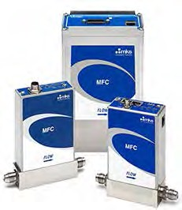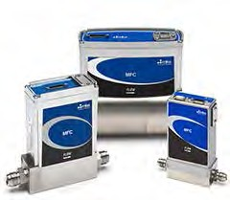

**G Series MFCs I Series MFCs**

**Figure 1-1. MKS G and I Series MFC**

### Product Support Documents

Product support documents and additional detailed information about various I/O specifications can be found on the MKS web site for the G and I series MFC products. These documents include:

* + - MFC data sheets
    - Quick start guides to establish communication to the device over TCP/IP for MFC configuration
    - Step files
    - DeviceNet specification (1046412-001)
    - Profibus specification (1046413-001)
    - RS 485 communication specification (1046411-001)
    - Ethercat specification
    - Profinet specification

### Manual References

The documents listed below are referenced throughout this manual.

1. “DeviceNet Specification, Volume I: DeviceNet Communication Model and Protocol”,

Open DeviceNet Vendors Association, Inc. Release 2.0. ERRATA 4.0

1. “DeviceNet Specification, Volume II: DeviceNet Profiles and Object Library”, Open DeviceNet Vendors Association, Inc. Release 2.0. ERRATA 4.0
2. “Sensor/Actuator Network Common Device Model”, SEMI Standards Document E54.1- 0097.
3. “Sensor/Actuator Network Communications Standard for DeviceNet”, SEMI Standards Draft Document E54.4-0097.
4. “Sensor/Actuator Network Specific Device Model for Mass Flow Devices”, SEMI Standards Draft Document #2253C.
5. “Sensor/Actuator Network Standard”, SEMI Standards Document E54-0097.
6. SEMI E17-00-0060 Guideline for Mass Flow Controller Transient Characteristics Tests
7. SEMI E18-00-0091. Guideline for Temperature Specifications of the Mass Flow Controller
8. SEMI E27-00-0092. Standard for Mass Flow Controller and Mass Flow Meter Linearity
9. SEMI E28-00-0092. Guideline for Pressure Specifications of the Mass Flow Controller
10. SEMI E56-00-1296. Test Method for Determining Accuracy, Linearity, Repeatability, Short Term Reproducibility, Hysteresis, and Dead Band of Thermal Mass Flow Controllers
11. SEMI Standards Document E52-95.
12. SEMI E80-00-0299. Test Method Determining Attitude Sensitivity of Mass Flow Controllers
13. SEMI Standards Document E52-95. Practice for Referencing Gases and Gas Mixtures Used in Digital Mass Flow Controllers
14. Instruction Manual, G / I-Series MFC, RS845 Supplement
15. Instruction Manual, G / I-Series MFC, DeviceNet Supplement
16. Instruction Manual, G / 1 -Series MFC, Profibus Supplement
17. Modbus Communications Supplement
18. Ethercat Supplement

### Product Description Guide

**Table 1-1. G Series MFC**

|  |  |  |  |  |  |
| --- | --- | --- | --- | --- | --- |
| **G Series Model** | **MFC Seal** | **Flow Range (sccm)** | **Multi-Gas/Multi- Range** | **Design Features** | **Applications** |
| G**E**50A | **E**lastomer Sealed | 10-50000 | Model based gas table. Able to re- range the MFC 40 to 60% depending on bin size. | Standard 1.5” form factor. Wetted surfaced 316 SS with 16 Ra surface finish. One elastomer O- ring. Wide range of analog and digital I/Os. | Designed for use with inert, non- toxic/non- corrosive gases. |
| G**M**50A | **M**etal Sealed | 10-50000 | Model based gas table. Able to re- range the MFC 40 to 60% depending on bin size. | Standard 1.5” form factor. Wetted surfaced 316 SS with 10 Ra surface finish. Wide range of analog and digital I/Os. | Designed to be compatible with all gases. |
| G**V**50A | Elastomer Sealed  / Designed with an integral positive Shut-off **V**alve | 10-50000 | Model based gas table. Able to re- range the MFC 40 to 60% depending on bin size. | Standard 1.5” form factor. Wetted surfaced 316 SS with 16 Ra surface finish. One elastomer O- ring. Wide range of analog and digital I/Os. | Designed for use with inert, non- toxic/non- corrosive gases. |
| G**M**51A | **M**etal Sealed | 10-50000 | Model based gas table. Able to re- range the MFC 40 to 60% depending on bin size. | Standard 1.125” form factor, compatible with tight gas panel designs. Wetted surfaced 316 SS with 10 Ra surface finish. Wide range of analog and digital I/Os. | Designed to be compatible with all gases. |
| G**M**100A | **M**etal Sealed | 1000000 | Model based gas table. Able to re- range the MFC 50%. | Standard 1.5” form factor, compatible with tight gas panel designs. Wetted surfaced 316 SS with 10 Ra surface finish. Wide range of analog and digital I/Os. | Designed to be compatible with all gases. |

**Table 1-2. I Series MFC**

|  |  |  |  |  |  |
| --- | --- | --- | --- | --- | --- |
| **I Series Model** | **MFC Seal** | **Flow Range (sccm)** | **Multi-Gas/Multi- Range** | **Design Features** | **Applications** |
| I**E**50A | **E**lastomer Sealed | 10-50000 | Model based gas table. Able to re- range the MFC 40 to 60% depending on bin size. | Standard 1.5” form factor. Wetted surfaced 316 SS with 16 Ra surface finish. One elastomer O- ring. Wide range of analog and digital I/Os. IP 66 rating for severe environmental conditions. | General industrial applications.  Designed for use with inert, non- toxic/non- corrosive gases. |
| I**M**50A | **M**etal Sealed | 10-50000 | Model based gas table. Able to re- range the MFC 40 to 60% depending on bin size. | Standard 1.5” form factor. Wetted surfaced 316 SS with 10 Ra surface finish. Wide range of analog and digital I/Os. IP 66 rating for severe environmental conditions. | Industrial applications where external environmental factors influence performance.  Designed to be compatible with all gases. |

### General MFC Overview and Features

#### Performance

G and I series mass flow controller technology has brought together a combination of patented flow sensor technology and high speed single processor digital architecture to provide control feedback to a fast response solenoid valve design. The result of this design effort is to provide an MFC with a typical flow control response time less than 750 milliseconds over a wide dynamic control range from 5 to 100% Full Scale (FS) of the device. For time critical flow transitions the flow control response of the G and I series MFC can be tailored exactly to the required process steps with easily configured ramp and set point delay functions available in the embedded MFC Browser Interface.

#### Multi Gas and Multi-Range Functions

The latest generation two-element sensing circuit provides accurate, repeatable performance even in low flow ranges (< 10 sccm). Understanding the physics of the active flow path (sensor and bypass) has resulted in the development of a model based multi-gas algorithm that is more accurate for both linear and non-linear process gases as compared to the application of the traditional linear Gas Correction Factor (GCF). New gas tables can be immediately created on board the MFC from a list with new calibration tables for the selected gas being derived from a single accurate N2 manufacturing calibration gas table created using NIST traceable primary standards. Once selected from the Browser Interface, the new gas table can be re-scaled based upon the automatically defined N2 equivalent minimum and maximum flow values without affecting:

* + - New gas table accuracy
    - Control range of the MFC (2% to 100% FS)
    - Closed conductance leak integrity of the control valve (.2% FS for the selected gas table)

#### User Interface and MFC Diagnostics

All of the G and I Series models have an external LAN port on the side of the MFC body. Connecting the host computer or a remote laptop to this port using a standard Ethernet cable gives the user the ability to open and use the embedded browser to:

* + - Configure the device for users application
      * Change and create gases from the extensive gas table list
      * Set the full scale flow and flow units
      * Execute a flow zero function to re-zero the sensor
      * Set ramp rates or delay times for the set point to optimize process steps
    - Upgrade in the field as new features are added to MFC
      * Upload updated firmware and new gas tables directly to the MFC
    - Diagnose and troubleshoot MFC issues before removing the MFC from service
      * Utilize the plot page to graph key MFC variables at data rates up to 100 Hz

### MFC Reliability

G and I Series MFC designs utilize a low mechanical and electronic components count in an effort to ensure the reliability of the device.

Mechanical and electrical “stress” tests have been used by the engineering design team including:

* + - STRIFE, including temperature cycling and vibration (sine and random tests)
    - EMC Directive 2004/108/EC for CE Mark compliance (with a metal braided, shielded cable, properly grounded at both ends)

DeviceNet hardware and software compliance testing includes:

* + - ODVA Compliance Certification

|  |  |
| --- | --- |
| **Note**  ? | All MFC Models are RoHS compliant designs. |

#### MFC Cleanliness

The mechanical design of the G and I Series MFC has been engineered to minimize internal wetted surface area and virtual leaks allowing rapid dry-down during purge process steps. All MFC wetted surfaces go through an MKS proprietary cleaning process making them compatible for O2 service.

Elastomer sealed MFC models have a machined 16 Ra surface finish, while the metal sealed MFC models are manufactured with a precision machined 10 Ra max surface finish and electro-polished wetted surfaces to enhance the cleanliness of the GM and IM models.

A variety of internal valve plug materials are available for the elastomer sealed GE and IE models. Selection of plug material is dependent on the type of gas to which the MFC will be exposed during operation. The internal valve control plug of the metal sealed GM and IM MFCs is Teflon due to its chemical stability and other materials properties such as low outgassing and particle generation from the precision polished plug.

### Specifications

**Table 1-3. General Performance and Design Specification**

|  |  |  |  |
| --- | --- | --- | --- |
| **Model and Specification** | **GE50A, GV50A, IE50A –**  **Elastomer Sealed** | **GM50A, IM50A, GM51A –**  **Metal Sealed** | **GM100A – Metal Sealed** |
| **Performance** | | | |
| Full Scale Flow (N2 equivalent) | 10-50000 sccm | 10-50000 sccm | 100000 sccm |
| Accuracy | ± 1% of setpoint for > 20 to 100% F.S. | ± 1% of setpoint for > 20 to 100% F.S. | ± 1% of setpoint for > 20 to 100% F.S. |
| ± 0.2% of FS for 2 to 20% F.S. | ± 0.2% of FS for 2 to 20% F.S. | ± 0.2% of FS for 2 to 20% F.S. |
| Control Range | 2% to 100% of F.S. | 2% to 100% of F.S. | 2% to 100% of F.S. |
| Typical Controller Settling Time (per SEMI Guideline E17-0600) | ~ 750 milliseconds (typical above 5% F.S.) | ~ 750 milliseconds (typical above 5% F.S.) | ~ 750 milliseconds (typical above 10% F.S.) |
| Repeatability | ± 0.3% of Reading | ± 0.3% of Reading | ± 0.3% of Reading |
| Resolution | 0.1% of Full Scale | 0.1% of Full Scale | 0.1% of Full Scale |
| **Operation Ratings** | | | |
| Normal Operating Pressure Differential (with atmospheric pressure at the MFC outlet) | 10 to 5000 sccm: 10 to 40 psid | 10 to 5000 sccm: 10 to 40 psid | 50000 - 100000 sccm:  40 to 80 psid |
| 10000 to 20000 sccm:  15 to 40 psid | 10000 to 20000 sccm:  15 to 40 psid |
| 30000 to 50000 sccm:  25 to 40 psid | 30000 to 50000 sccm:  25 to 40 psid |
| Proof Pressure | 1000 psig | 1000 psig | 1000 psig |
| Burst Pressure | 1500 psig | 1500 psig | 1500 psig |
| Temperature Coefficients Zero  Span | <0.05% F.S./°C | <0.05% F.S./°C | <0.05% F.S./°C |
| <0.08% Reading/°C | <0.08% Reading/°C | <0.08% Reading/°C |
| Inlet Pressure Coefficient | < 0.02% of Reading./psi | < 0.02% of Reading./psi | < 0.02% of Reading./psi |
| Warm-Up Time | < 30 min | < 30 min | < 30 min |
| Normal Operating Temperature Range | 10°C to 50°C | 10°C to 50°C | 10°C to 50°C |
| Storage Humidity | 0 to 95% Relative Humidity, non-condensing | 0 to 95% Relative Humidity, non-condensing | 0 to 95% Relative Humidity, non-condensing |
| Storage Temperature | -20°C to 65°C (-4°F to 149°F) | -20°C to 65°C (-4°F to 149°F) | -20°C to 65°C (-4°F to 149°F) |
| ROHS Compliant | Yes | Yes | Yes |
| Electromagnetic Compatibility | CE Compliant 2004/108/EC | CE Compliant 2004/108/EC | CE Compliant 2004/108/EC |

**Table 1-4. Electrical Specification**

|  |  |  |  |
| --- | --- | --- | --- |
| **I/O Type** | **Electrical Connection** | **MFC Connector Design** | **Power Supply and Consumption** |
| Analog | 9 pin / 15 pin Male D sub | Power and Device Control | +15- 24V, < 4 Watts |
| RS 485 | 9 pin Male D sub | Power and Digital Communication | +15- 24V, < 4 Watts |
| DeviceNet | 5 pin Male Trunkline Connector | Power and Digital Communication | +11- 24V, < 4 Watts |
| Profibus | 1 9 pin Female D sub (communication)  1 9 pin Male D sub (power) | Power and Digital Communication | +15- 24V, < 4 Watts |
| Ethercat | 5 pin M8 Connector | Power only | +24 V (+/-10%), < 5 Watts |
| Profinet | 5 pin M8 Connector | Power only | +24 V (+/-10%), < 5 Watts |

**Table 1-5. Mechanical and Material Specification**

|  |  |  |  |  |
| --- | --- | --- | --- | --- |
|  | **GE50A, GV50A.**  **IE50A – Elastomer Sealed** | **GM50A, IM50A –**  **Metal Sealed** | **GM100A - Metal Sealed** | **GM51A - Metal Sealed** |
| **Valve Type** | Normally Closed / Normally open / No valve (Meter only) | | | |
| **Leak Integrity** | | | | |
| External (scc/sec He) | < 1 x 10-9 | < 1 x 10-10 | < 1 x 10-10 | < 1 x 10-10 |
| Through closed valve | < 10K Valve - < 0.1%  of F.S. at 40 psig inlet to atm > 10K Valve -  < 1% FS @ 40 psig inlet to atm | < 1% of F.S. at 40 psig inlet to atm | < 1% of F.S. at 40 psig inlet to atm | < 1% of F.S. at 40 psig inlet to atm |
| Through shut-off valve | <4x 10-09 atm-cc/sec He (GV50A model only) | Not Applicable | Not Applicable | Not Applicable |
| **Wetted Materials** | | | | |
| Standard | 316L S.S. VAR  (equivalent to 316 S.S. SCQ for semiconductor quality), 316 S.S., Elgiloy, Nickel | 316L S.S. VAR  (equivalent to 316 S.S. SCQ for semiconductor quality), 316 S.S., Elgiloy, KM-45 | 316L S.S. VAR  (equivalent to 316 S.S. SCQ for semiconductor quality), 316 S.S., Elgiloy, KM-45 | 316L S.S. VAR  (equivalent to 316 S.S. SCQ for semiconductor quality), 316 S.S., Elgiloy, KM-45 |
| Seals and Valve Seat | Viton, Buna, Neoprene, EPDM, Kalrez | SS / PTFE | SS / Viton, Buna, Neoprene, EPDM, Kalrez | SS / PTFE |
| **Surface Finish** | 16 in Ra | 10 in Ra, Electropolished | 10 in Ra, Electropolished | 10 in Ra, Electropolished |
| **Weight** | ≤ 3 lbs (1.4 kg) | ≤ 3 lbs (1.4 kg) | ≤ 3 lbs (1.4 kg) | ≤ 3 lbs (1.4 kg) |

|  |  |  |
| --- | --- | --- |
| **Fitting Design** | **MFC Length (inches / mm)** | |
| Swaglok 4 VCR Male | 4.88 | 124 |
| Swaglok 8 VCR Male | 5.28 | 134.1 |
| 1/8" Swaglok | 4.44 | 112.8 |
| 1/4" Swaglok | 4.44 | 112.8 |
| 3/8" Swaglok | 4.72 | 120 |
| 1/2" Swaglok | 4.72 | 120 |
| 6 mm | 4.44 | 112.8 |
| 8 mm | 4.72 | 120 |
| 10 mm | 4.72 | 120 |
| 12 mm | 4.72 | 120 |
| C Seal Surface Mount | 4.14 | 105.2 |
| W Seal Surface Mount | 4.14 | 105.2 |
| 4 VCO Male | 4.56 | 115.8 |
| 8 VCO Male | 4.9 | 124.5 |
| KF 16 | 4.88 | 124 |

### ?Mechanical Dimensions

**Figure 1-2. MFC Mechanical Dimensions** **Table 1-6. Fitting Design and MFC Length**

**Table 1-7. Elastomer Sealed MFC Model Height Dimensions**

|  |  |  |  |  |  |
| --- | --- | --- | --- | --- | --- |
| **G and I Series Height Dimensions for Elastomer Sealed MFC Models** | | | | | |
| **MFC Model** | **I/O** | **MFC Height - Group A (inches / mm)** | | **MFC Height Group B (inches / mm)** | |
| GE50A GM50A | 15 pin D sub | 5.49 | 139.4 | 6.12 | 155.4 |
| 9 pin D sub | 5.49 | 139.4 | 6.12 | 155.4 |
| 15 pin 4-20mA | 5.49 | 139.4 | 6.12 | 155.4 |
| RS 485 | 5.49 | 139.4 | 6.12 | 155.4 |
| DeviceNet | 5.65 | 143.6 | 6.26 | 159 |
| Profibus | 5.49 | 139.4 | 6.12 | 155.4 |
| Ethercat | 5.69 | 144.5 | 6.32 | 160.6 |
| Profinet | 5.69 | 144.5 | 6.32 | 160.6 |
| IE50A IM50A | 15 pin D sub | 5.64 | 143.2 | 6.26 | 159 |
| 9 pin D sub | N/A | N/A | N/A | N/A |
| 15 pin 4-20mA | 5.64 | 143.2 | 6.26 | 159 |
| RS485 | N/A | N/A | N/A | N/A |
| DeviceNet | N/A | N/A | N/A | N/A |
| Profibus | 5.64 | 143.2 | 6.26 | 159 |
| Ethercat | N/A | N/A | N/A | N/A |
| Profinet | N/A | N/A | N/A | N/A |
| GV50A | 15 pin D sub | 5.61 | 142.5 | N/A | N/A |
| 9 pin D sub | 5.61 | 142.5 | N/A | N/A |
| 15 pin 4-20mA | 5.61 | 142.5 | N/A | N/A |
| RS 485 | 5.61 | 142.5 | N/A | N/A |
| DeviceNet | 5.78 | 146.8 | N/A | N/A |
| Profibus | 5.63 | 143 | N/A | N/A |
| Ethercat | 5.82 | 147.7 | N/A | N/A |
| Profinet | 5.82 | 147.7 | N/A | N/A |
| GM51A | 15 pin D sub | 5.48 | 139.2 | N/A | N/A |
| 9 pin D sub | 5.48 | 139.2 | N/A | N/A |
| DeviceNet | 5.66 | 143.8 | N/A | N/A |
| RS485 | 5.49 | 139.4 | N/A | N/A |
| Ethercat | 5.68 | 144.2 | N/A | N/A |
| Profinet | 5.68 | 144.2 | N/A | N/A |
| GM100A | 15 pin D sub | 5.58 | 141.8 | N/A | N/A |
| 9 pin D sub | 5.58 | 141.8 | N/A | N/A |
| 15 pin 4-20mA | 5.58 | 141.8 | N/A | N/A |
| RS-485 | 5.58 | 141.8 | N/A | N/A |
| DeviceNet | 5.79 | 147 | N/A | N/A |
| Profibus | 5.58 | 141.8 | N/A | N/A |
| Ethercat | 5.77 | 146.6 | N/A | N/A |
| Profinet | 5.77 | 146.6 | N/A | N/A |

**Notes**

**Safety Information**



**2**

###### The following general safety precautions must be observed during all phases of operation of this instrument. Failure to comply with these precautions or with specific warnings elsewhere in this manual violates safety standards of intended use of the instrument and may impair the protection provided by the equipment. MKS Instruments, Inc. assumes no liability for the customer’s failure to comply with these requirements.

DO NOT SUBSTITUTE PARTS OR MODIFY INSTRUMENT

Do not install substitute parts or perform any unauthorized modification to the instrument. Return the instrument to an MKS Calibration and Service Center for service and repair to ensure that all safety features are maintained.

SERVICE BY QUALIFIED PERSONNEL ONLY

Operating personnel must not remove instrument covers. Component replacement and internal adjustments must be made by qualified service personnel only.

### Mass Flow Controller Safety Information

#### Symbols Used in This Instruction Manual

The following are definitions of WARNING, CAUTION, and NOTE messages used throughout the manual.

|  |  |
| --- | --- |
| **Warning**  ? | **The WARNING sign denotes a hazard. It calls attention to a procedure, practice, condition, or the like, which, if not correctly performed or adhered to, could result in injury to personnel.** |
|  |  |

|  |  |
| --- | --- |
| **Caution**  ? | **The CAUTION sign denotes a hazard. It calls attention to an operating procedure, practice, or the like, which, if not correctly performed or adhered to, could result in damage to or destruction of all or part of the product.** |
|  |  |

|  |  |
| --- | --- |
| **Note**  ? | The NOTE sign denotes important information. It calls attention to a procedure, practice, condition, or the like, which is essential to highlight. |

#### Symbols Found on the Unit

The following table describes symbols that may be found on the unit.

**Table 2-1. Symbols Found on the Unit**

|  |  |  |  |  |  |
| --- | --- | --- | --- | --- | --- |
| | | Off (Supply) IEC 417, No. 5008 | | Earth (ground) IEC 417, No. 5017 | | Protective Earth (ground)  IEC 417, No. 5019 |
| On (Supply) IEC 417, No. 5007 |
| Frame or Chassis IEC 417, No. 5020 | Equipotentiality IEC 417, No. 5021 | | Direct Current IEC 417, No. 5031 | | Alternating Current IEC 417, No. 5032 |
| Both Direct and Alternating Current  IEC 417, No. 5033-a | | Class II Equipment IEC 417, No. 5172-a | | Three Phase Alternating Current IEC 617-2, No. 020206 | |
| Caution (refer to accompanying documents)  ISO 3864, No. B.3.1 | | Caution, Risk of Electric Shock ISO 3864, No. B.3.6 | | Caution, Hot Surface IEC 417, No. 5041 | |

#### Safety Procedures and Precautions

###### Observe the following general safety precautions during all phase of operation of this instrument. Failure to comply with these precautions or with specific warnings elsewhere in this manual violates safety standards of intended use of the instrument and may impair the protection provided by the equipment. MKS Instruments, Inc. assumes no liability for the customer’s failure to comply with these requirements.

**DO NOT SUBSTITUTE PARTS OR MODIFY INSTRUMENT**

Do not install substitute parts or perform any unauthorized modification to the instrument. Return the instrument to an MKS Calibration and Service Center for service and repair to ensure that all safety features are maintained.

**SERVICE BY QUALIFIED PERSONNEL ONLY**

Operating personnel must not remove instrument covers. Component replacement and internal adjustments must be made by qualified service personnel only.

**KEEP AWAY FROM LIVE CIRCUITS**

Do not replace components with power cable connected. Under certain conditions, dangerous voltages may exist even with the power cable removed. To avoid injuries, always disconnect power and discharge circuits before touching them.

**USE CAUTION WHEN OPERATING WITH HAZARDOUS MATERIALS**

If hazardous materials are used, users must take responsibility to observe the proper safety precautions, completely purge the instrument when necessary, and ensure that the material used is compatible with sealing materials.

**PURGE THE INSTRUMENT**

After installing the unit, or before its removal from a system, be sure to purge the unit completely with a clean dry gas to eliminate all traces of the previously used flow material.

**USE PROPER PROCEDURES WHEN PURGING**

This instrument must be purged under a ventilation hood, and gloves must be worn to protect personnel. To purge this instrument properly, it must be purged in both the horizontal base down and horizontal base up configurations as defined in SEM spec. Device has trapped volume in pressure sensor where gas which is higher than air but still hazardous can accumulate.

**DO NOT OPERATE IN AN EXPLOSIVE ENVIRONMENT**

To avoid explosion, do not operate this product in an explosive environment unless it has been specifically certified for such operation.

**USE PROPER FITTINGS AND TIGHTENING PROCEDURES**

All instrument fittings must be consistent with instrument specifications, and compatible with the intended use of the instrument. Assemble and tighten fittings according to manufacturer's directions.

**CHECK FOR LEAK-TIGHT FITTINGS**

Before proceeding to instrument setup, carefully check all plumbing connections to the instrument to ensure leak-tight installation.

**OPERATE AT SAFE INLET PRESSURES**

This unit should never be operated at pressures higher than the rated maximum pressure (refer to the product specifications for the maximum allowable pressure).

**INSTALL A SUITABLE BURST DISC**

When operating from a pressurized gas source, a suitable burst disc should be installed in the vacuum system to prevent system explosion should the system pressure rise.

**KEEP THE UNIT FREE OF CONTAMINANTS**

Do not allow contaminants of any kind to enter the unit before or during use. Contamination such as dust, dirt, lint, glass chips, and metal chips may permanently damage the unit.

**ALLOW PROPER WARM UP TIME FOR TEMPERATURE-CONTROLLED UNITS**

Temperature-controlled unit will only meet specifications when sufficient time is allowed for the unit to meet, and stabilize at, the designed operating temperature. Do not zero or calibrate the unit until the warm up is complete.

### Sicherheitshinweise für das Massenflussgerät

#### In dieser Betriebsanleitung vorkommende Symbole

Bedeutung der mit WARNUNG!, VORSICHT! und HINWEIS gekennzeichneten Absätze in dieser Betriebsanleitung.

|  |  |
| --- | --- |
| **Warnung!**  ? | **Das Symbol WARNUNG! weist auf eine Gefahr für das Bedienpersonal hin. Es macht auf einen Arbeitsablauf, eine Arbeitsweise, einen Zustand oder eine sonstige Gegebenheit aufmerksam, deren unsachgemäße Ausführung bzw. ungenügende Berücksichtigung zu Verletzungen führen kann.** |
|  |  |

|  |  |
| --- | --- |
| **Vorsicht!**  ? | **Das Symbol VORSICHT! weist auf eine Gefahr für das Gerät hin. Es macht auf einen Bedienungsablauf, eine Arbeitsweise oder eine sonstige Gegebenheit aufmerksam, deren unsachgemäße Ausführung bzw. ungenügende Berücksichtigung zu einer Beschädigung oder Zerstörung des Gerätes oder von Teilen des Gerätes führen kann.** |

|  |  |
| --- | --- |
| **Hinweis**  ? | Das Symbol HINWEIS macht auf wichtige Informationen bezüglich eines Arbeitsablaufs, einer Arbeitsweise, eines Zustands oder einer sonstige Gegebenheit aufmerksam. |

#### Erklärung der am Gerät angebrachten Symbole

Nachstehender Tabelle sind die Bedeutungen der Symbole zu entnehmen, die am Gerät angebracht sein können.

**Tabelle 2-2. Bedeutung der am Gerät angebrachten Symbole**

|  |  |  |  |  |  |
| --- | --- | --- | --- | --- | --- |
| | | Aus (Energie) IEC 417, No.5008 | | Erdanschluss IEC 417, No.5017 | | Schutzleiteranschluss IEC 417, No.5019 |
| Ein (Energie) IEC 417, No.5007 |
| Masseanschluss IEC 417, No.5020 | Aquipotentialanschluss IEC 417, No.5021 | | Gleichstrom IEC 417, No.5031 | | Wechselstrom IEC 417, No.5032 |
| Gleich- oder Wechselstrom IEC 417, No.5033-a | | Durchgängige doppelte oder verstärkte Isolierung IEC 417, No.5172-a | | Dreileiter-Wechselstrom (Drehstrom)  IEC 617-2, No.020206 | |
| Warnung vor einer Gefahrenstelle (Achtung, Dokumentation beachten) ISO 3864, No.B.3.1 | | Warnung vor gefährlicher elektrischer Spannung ISO 3864, No.B.3.6 | | Höhere Temperatur an leicht zugänglichen Teilen IEC 417, No.5041 | |

#### Sicherheitsvorschriften und Vorsichtsmaßnahmen

###### Folgende allgemeine Sicherheitsvorschriften sind während allen Betriebsphasen dieses Gerätes zu befolgen. Eine Missachtung der Sicherheitsvorschriften und sonstiger Warnhinweise in dieser Betriebsanleitung verletzt die für dieses Gerät und seine Bedienung geltenden Sicherheitsstandards, und kann die Schutzvorrichtungen an diesem Gerät wirkungslos machen. MKS Instruments, Inc. haftet nicht für Missachtung dieser Sicherheitsvorschriften seitens des Kunden.

**Niemals Teile austauschen oder Änderungen am Gerät vornehmen!**

Ersetzen Sie keine Teile mit baugleichen oder ähnlichen Teilen, und nehmen Sie keine eigenmächtigen Änderungen am Gerät vor. Schicken Sie das Gerät zwecks Wartung und Reparatur an den MKS- Kalibrierungs- und -Kundendienst ein. Nur so wird sichergestellt, dass alle Schutzvorrichtungen voll funktionsfähig bleiben.

**Wartung nur durch qualifizierte Fachleute!**

Das Auswechseln von Komponenten und das Vornehmen von internen Einstellungen darf nur von qualifizierten Fachleuten durchgeführt werden, niemals vom Bedienpersonal.

**Vorsicht vor stromführenden Leitungen!**

Ersetzen Sie keine Komponente von Geräten, die an Netzstrom angeschlossen sind. Unter Umständen kann gefährliche Spannung auch dann bestehen, wenn das Netzanschlusskabel von der Strmversorgung entfernt wurde. Um Verletzungen vorzubeugen sollten zuerst alle Geräte von der Stromversorgung getrennt und alle Stromkreusläufe entladen werden.

**Vorsicht beim Arbeiten mit gefährlichen Stoffen!**

Wenn gefährliche Stoffe verwendet werden, muss der Bediener die entsprechenden Sicherheitsvorschriften genauestens einhalten, das Gerät, falls erforderlich, vollständig spülen, sowie sicherstellen, dass der Gefahrstoff die am Gerät verwendeten Materialien, insbesondere Dichtungen, nicht angreift.

**Spülen des Gerätes mit Gas!**

Nach dem Installieren oder vor dem Ausbau aus einem System muss das Gerät unter Einsatz eines reinen Trockengases vollständig gespült werden, um alle Rückstände des Vorgängermediums zu entfernen.

**Anweisungen zum Spülen des Gerätes**

Das Gerät darf nur unter einer Ablufthaube gespült werden. Schutzhandschuhe sind zu tragen.

**Gerät nicht zusammen mit explosiven Stoffen, Gasen oder Dämpfen benutzen!**

Um der Gefahr einer Explosion vorzubeugen, darf dieses Gerät niemals zusammen mit (oder in der Nähe von) explosiven Stoffen aller Art eingesetzt werden, sofern es nicht ausdrücklich für diesen Zweck zugelassen ist.

**Anweisungen zum Installieren der Armaturen!**

Alle Anschlussstücke und Armaturenteile müssen mit der Gerätespezifikation übereinstimmen, und mit dem geplanten Einsatz des Gerätes kompatibel sein. Der Einbau, insbesondere das Anziehen und Abdichten, muss gemäß den Anweisungen des Herstellers vorgenommen werden.

**Verbindungen auf Undichtigkeiten prüfen!**

Überprüfen Sie sorgfältig alle Verbindungen der Vakuumkomponenten auf undichte Stellen.

**Gerät nur unter zulässigen Anschlussdrücken betreiben!**

Betreiben Sie das Gerät niemals unter Drücken, die den maximal zulässigen Druck (siehe Produktspezifikationen) übersteigen.

**Geeignete Berstscheibe installieren!**

Wenn mit einer unter Druck stehenden Gasquelle gearbeitet wird, sollte eine geeignete Berstscheibe in das Vakuumsystem installiert werden, um eine Explosionsgefahr aufgrund von steigendem Systemdruck zu vermeiden.

**Verunreinigungen im Gerät vermeiden!**

Stellen Sie sicher, dass Verunreinigungen jeglicher Art weder vor dem Einsatz noch während des Betriebs in das Instrumenteninnere gelangen können. Staub- und Schmutzpartikel, Glassplitter oder Metallspäne können das Gerät dauerhaft beschädigen oder Prozess- und Messwerte verfälschen.

**Bei Geräten mit Temperaturkontrolle korrekte Anwärmzeit einhalten!**

Temperaturkontrollierte Geräte arbeiten nur dann gemäß ihrer Spezifikation, wenn genügend Zeit zum Erreichen und Stabilisieren der Betriebstemperatur eingeräumt wird. Kalibrierungen und Nulleinstellungen sollten daher nur nach Abschluss des Anwärmvorgangs durchgeführt werden.

### Informations de sécurité pour appareils de mesure/contrôle de débit massique

#### Symboles utilisés dans ce manuel d'utilisation

Définitions des indications AVERTISSEMENT, ATTENTION, et REMARQUE utilisées dans ce manuel.

|  |  |
| --- | --- |
| **Avertissement**  ? | **L'indication AVERTISSEMENT signale un danger pour le personnel. Elle attire l'attention sur une procédure, une pratique, une condition, ou toute autre situation présentant un risque d'accident pour le personnel, en cas d'exécution incorrecte ou de non-respect des consignes.** |
|  |  |

|  |  |
| --- | --- |
| **Attention**  ? | **L'indication ATTENTION signale un danger pour l'appareil. Elle attire l'attention sur une procédure d'exploitation, une pratique, ou toute autre situation, présentant un risque de dégât ou de destruction partielle ou totale du produit, en cas d'exécution incorrecte ou de non-respect des consignes.** |
|  |  |

|  |  |
| --- | --- |
| **Remarque**  ? | L'indication REMARQUE signale une information importante. Elle attire l'attention sur une procédure, une pratique, une condition, ou toute autre situation, présentant un intérêt  particulier. |

#### Symboles figurant sur l'unité

Le tableau suivant décrit les symboles pouvant apparaître sur l'unité.

**Tableau 2-3. Définition des symboles sur l'unité**

|  |  |  |  |  |  |
| --- | --- | --- | --- | --- | --- |
| | | Arrêt (hors tension) IEC 417, No.5008 | | Terre (masse) IEC 417, No.5017 | | Terre de protection (masse)  IEC 417, No.5019 |
| Marche (sous tension) IEC 417, No.5007 |
| Masse  IEC 417, No.5020 | Equipotentialité IEC 417, No.5021 | | Courant continu IEC 417, No.5031 | | Alternating Current IEC 417, No. 5032 |
| Courant continu et alternatif IEC 417, No.5033-a | | Matériel de classe II IEC 417, No.5172-a | | Courant alternatif IEC 417, No.5032 | |
| Attention : se reporter à la documentation ISO 3864, No.B.3.1 | | Attention : risque de choc électrique  ISO 3864, No.B.3.6 | | Attention : surface brûlante IEC 417, No.5041 | |

#### Mesures de sécurité et précautions

###### Observer les précautions générales de sécurité suivantes pendant toutes les phases d'exploitation de cet appareil. Le non-respect des ces précautions ou des avertissements du manuel constitue une violation des normes de sécurité relatives à l'utilisation de l'appareil et peut compromettre la protection assurée par l'appareil. MKS Instruments, Inc. rejette toute responsabilité en cas de non-respect des consignes par les clients.

**PAS DE REMPLACEMENT DE PIÈCES OU DE MODIFICATION DE L'APPAREIL**

Ne pas installer de pièces de remplacement ni effectuer des modifications non autorisées sur l'appareil. Renvoyer l'appareil à un centre de service et de calibrage MKS pour tout dépannage ou réparation afin de garantir le l'intégrité des dispositifs de sécurité.

**DÉPANNAGE UNIQUEMENT PAR DU PERSONNEL QUALIFIÉ**

Le personnel d'exploitation ne doit pas essayer de sortir les composants du boîtier ou faire des réglages internes. Le dépannage est réservé au personnel qualifié.

**ÉLOIGNEMENT DES CIRCUITS SOUS-TENSION**

Ne pas remplacer de composants lorsqu’un câble d’alimentation est branché. Dans certaines conditions, des tensions dangereuses peuvent être présentes même après le retrait du câble d’alimentation. Pour éliminer tout risque de blessure, procéder toujours à la déconnexion et décharger les circuits avant tout contact physique.

**PRÉCAUTION EN CAS D'UTILISATION AVEC DES PRODUITS DANGEREUX**

Si des produits dangereux sont utilisés, l'utilisateur est responsable du respect des mesures de sécurité appropriées, de la purge complète de l'appareil quand elle s’avère nécessaire, et doit s’assurer que les produits utilisés sont compatibles avec les matériaux d'étanchéité.

**PURGE DE L'APPAREIL**

Après l'installation de l'unité, ou avant son retrait d'un système, purger l'unité complètement avec un gaz propre et sec afin d'éliminer toute trace du produit de flux utilisé précédemment.

**UTILISATION DES PROCÉDURES APPROPRIÉES POUR LA PURGE**

Cet appareil doit être purgé sous une hotte de ventilation. Le personnel doit porter des gants de protection.

**PAS D'EXPLOITATION DANS UN ENVIRONNEMENT EXPLOSIF**

Pour éviter toute explosion, ne pas utiliser cet appareil dans un environnement explosif, sauf en cas d'homologation spécifique pour une telle exploitation.

**UTILISATION D'ÉQUIPEMENTS ET PROCÉDURES DE SERRAGE APPROPRIÉS**

Tous les équipements de l'appareil doivent être conformes à ses spécifications, et compatibles avec l'utilisation prévue de l'appareil. Assembler et serrer les équipements conformément aux directives du fabricant.

**VÉRIFICATION DE L'ÉTANCHÉITÉ DES CONNEXIONS**

Vérifier attentivement toutes les connexions des composants pour le vide afin de garantir l'étanchéité de l'installation.

**EXPLOITATION AVEC DES PRESSIONS D'ENTRÉE NON DANGEREUSES**

Ne jamais utiliser des pressions supérieures à la pression nominale maximum (se reporter aux spécifications de l'unité pour la pression maximum admissible).

**INSTALLATION D'UN DISQUE D'ÉCHAPPEMENT ADAPTÉ**

En cas d'exploitation avec une source de gaz pressurisé, installer un disque d'échappement adapté dans le système à vide, afin d'éviter une explosion du système en cas d'augmentation de la pression.

**MAINTIEN DE L'UNITÉ À L'ABRI DES CONTAMINATIONS**

Ne pas laisser des produits contaminants pénétrer dans l'unité avant ou pendant l'utilisation. Des produits contaminants tels que des poussières et des fragments de tissu, de verre et de métal peuvent endommager l'unité de manière permanente.

**RESPECT DU TEMPS D'ÉCHAUFFEMENT APPROPRIÉ POUR LES UNITÉS Á RÉGULATION DE TEMPÉRATURE**

Les unités à régulation de température sont conformes à leurs spécifications uniquement quand on leur laisse un temps suffisant pour atteindre d'une manière stable la température d'exploitation. Ne pas remettre à zéro ou calibrer l'unité tant que l'échauffement n'est pas terminé.

### Medidas de seguridad del dispositivo de flujo de masa

#### Símbolos usados en este manual de instrucciones

Definiciones de los mensajes de advertencia, precaución y de las notas usados en el manual.

|  |  |
| --- | --- |
| **Advertencia**  ? | **El símbolo de advertencia indica la posibilidad de que se produzcan daños personales. Pone de relieve un procedimiento, práctica, estado, etc. que en caso de no realizarse o cumplirse correctamente puede causar daños personales.** |
|  |  |

|  |  |
| --- | --- |
| **Precaución**  ? | **El símbolo de precaución indica la posibilidad de producir daños al equipo. Pone de relieve un procedimiento operativo, práctica, etc. que en caso de no realizarse o cumplirse correctamente puede causar daños o la destrucción total o parcial del equipo.** |
|  |  |

|  |  |
| --- | --- |
| **Nota**  ? | El símbolo de notas indica información de importancia. Este símbolo pone de relieve un procedimiento, práctica o condición cuyo conocimiento es esencial destacar. |

#### Símbolos hallados en la unidad

La tabla siguiente contiene los símbolos que puede hallar en la unidad.

**Tabla 2-4. Definición de los símbolos hallados en la unidad**

|  |  |  |  |  |  |
| --- | --- | --- | --- | --- | --- |
| | | Apagado (alimentación eléctrica)  IEC 417, N° 5008 | | Puesta a tierra IEC 417, N° 5017 | | Protección a tierra IEC 417, N° 5019 |
| Encendido (alimentación eléctrica) IEC 417, N° 5007 |
| Caja o chasis IEC 417, N° 5020 | Equipotencialidad IEC 417, N° 5021 | | Corriente continua IEC 417, N° 5031 | | Corriente alterna IEC 417, N° 5032 |
| Corriente continua y alterna IEC 417, N° 5033-a | | Equipo de clase II IEC 417, N° 5172-a | | Corriente alterna trifásica IEC 617-2, N° 020206 | |

|  |  |  |
| --- | --- | --- |
| Precaución. Consulte los documentos adjuntos ISO 3864, N° B.3.1 | Precaución.  Riesgo de descarga eléctrica ISO 3864, N° B.3.6 | Precaución. Superficie caliente IEC 417, N° 5041 |

#### Procedimientos y precauciones de seguridad

###### Las medidas generales de seguridad descritas a continuación deben observarse durante todas las etapas de funcionamiento del instrumento. La falta de cumplimiento de dichas medidas de seguridad o de las advertencias específicas a las que se hace referencia en otras partes de este manual, constituye una violación de las normas de seguridad establecidas para el uso previsto del instrumento y podría anular la protección proporcionada por el equipo. Si el cliente no cumple dichas precauciones y advertencias, MKS Instruments, Inc. no asume responsabilidad legal alguna.

**NO UTILICE PIEZAS NO ORIGINALES O MODIFIQUE EL INSTRUMENTO**

No instale piezas que no sean originales ni modifique el instrumento sin autorización. Para asegurar el correcto funcionamiento de todos los dispositivos de seguridad, envíe el instrumento al Centro de servicio y calibración de MKS toda vez que sea necesario repararlo o efectuar tareas de mantenimiento.

**LAS REPARACIONES DEBEN SER EFECTUADAS ÚNICAMENTE POR TÉCNICOS AUTORIZADOS**

Los operarios no deben retirar las tapas del instrumento. El reemplazo de los componentes y las tareas de ajuste deben ser realizadas únicamente por personal autorizado.

**MANTÉNGASE ALEJADO DE LOS CIRCUITOS ACTIVOS**

No reemplace componentes con el cable de alimentación eléctrica conectado. En algunos casos, puede haber presente alto voltaje aun con el cable de alimentación eléctrica desconectado. Para evitar lesiones personales, desconecte siempre el cable y descargue los circuitos antes de entrar en contacto con los mismos.

**TENGA CUIDADO CUANDO TRABAJE CON MATERIALES TÓXICOS**

Cuando se utilicen materiales tóxicos, es responsabilidad de los operarios tomar las medidas de seguridad correspondientes, purgar totalmente el instrumento cuando sea necesario y comprobar que el material utilizado sea compatible con los materiales de sellado.

**PURGUE EL INSTRUMENTO**

Una vez instalada la unidad o antes de retirarla del sistema, purgue completamente la unidad con gas limpio y seco para eliminar todo resto de la sustancia líquida empleada anteriormente.

**USE PROCEDIMIENTOS ADECUADOS PARA REALIZAR LA PURGA**

El instrumento debe purgarse debajo de una campana de ventilación y deben utilizarse guantes protectores.

**NO HAGA FUNCIONAR EL INSTRUMENTO EN AMBIENTES CON RIESGO DE EXPLOSIÓN**

Para evitar que se produzcan explosiones, no haga funcionar este instrumento en un ambiente con riesgo de explosiones, excepto cuando el mismo haya sido certificado específicamente para tal uso.

**USE ACCESORIOS ADECUADOS Y REALICE CORRECTAMENTE LOS PROCEDIMIENTOS DE AJUSTE**

Todos los accesorios del instrumento deben cumplir las especificaciones del mismo y ser compatibles con el uso que se debe dar al instrumento. Arme y ajuste los accesorios de acuerdo con las instrucciones del fabricante.

**COMPRUEBE QUE LOS ACCESORIOS SEAN A PRUEBA DE FUGAS**

Antes de proceder con la instalación del instrumento, inspeccione cuidadosamente todas las conexiones de las tuberías para comprobar que hayan sido instaladas a prueba de fugas.

**HAGA FUNCIONAR EL INSTRUMENTO CON PRESIONES DE ENTRADA SEGURAS**

No haga funcionar nunca el instrumento con presiones superiores a la máxima presión nominal (en las especificaciones del instrumento hallará la presión máxima permitida).

**INSTALE UNA CÁPSULA DE SEGURIDAD ADECUADA**

Cuando el instrumento funcione con una fuente de gas presurizado, instale una cápsula de seguridad adecuada en el sistema de vacío para evitar que se produzcan explosiones cuando suba la presión del sistema.

**MANTENGA LA UNIDAD LIBRE DE CONTAMINANTES**

No permita el ingreso de contaminantes en la unidad antes o durante su uso. Los productos contaminantes tales como polvo, suciedad, pelusa, lascas de vidrio o virutas de metal pueden dañar irreparablemente la unidad.

**CALIENTE ADECUADAMENTE LAS UNIDADES CONTROLADAS POR MEDIO DE TEMPERATURA**

Las unidades controladas por medio de temperatura funcionarán de acuerdo con las especificaciones sólo cuando se las caliente durante el tiempo suficiente para permitir que lleguen y se estabilicen a la temperatura de operación indicada. No calibre la unidad y no la ponga en cero hasta que finalice el procedimiento de calentamiento.

### マスフロー機器の安全に関する情報

#### 本取扱説明書のマーク

本マニュアルでは警告、注意、ポイントのマークを用いて重要な事項を記載しています。

|  |  |
| --- | --- |
| **警告**  ? | **この表示を無視して誤った取り扱い (手順や使用方法、条件など) をすると、人が重傷を負う可能性が想定される内容を示しています。必ずお読みください。** |
|  |  |

|  |  |
| --- | --- |
| **注意**  ? | **この表示を無視して誤った取り扱い (手順や使用方法など) をすると、 製品が損傷する**  **可能性が想定される内容を示しています。必ずお読みください。** |
|  |  |

|  |  |
| --- | --- |
| **ポイント**  ? | この表示は手順や使用方法、条件などに関する重要な情報が記載されていることを示  しています。必ずお読みください。 |

#### 本機器のマーク

以下の表では、本機器に使用されているマークについて説明いたします。

**表 2-5. 本機器に使用されているマークについて**

|  |  |  |  |  |  |
| --- | --- | --- | --- | --- | --- |
| | | オ フ ( 電 源 ) IEC 417, No. 5008 | | 接地 (アース) IEC 417, No. 5017 | | 保護接地 (アース) IEC 417, No. 5019 |
| オ ン ( 電 源 ) IEC 417, No. 5007 |
| フレームまたはシャーシ  IEC 417, No. 5020 | 等電位  IEC 417, No. 5021 | | 直流  IEC 417, No. 5031 | | 交流  IEC 417, No. 5032 |
| 直流と交流  IEC 417, No. 5033-a | | クラス 2 機器  IEC 417, No. 5172-a | | 三相交流  IEC 617-2, No. 020206 | |
| 注意 (付属書を参照) ISO 3864, No. B.3.1 | | 注意 (感電の危険あり) ISO 3864, No. B.3.6 | | 注意 (表面が熱くなっています) IEC 417, No. 5041 | |

#### 安全対策について

**本機器を使用する際は、必ず以下の安全対策を守ってください。これらの安全対策や本マニュアルの警告を無視すると、機器本来の用途の安全基準を侵害することになり、機器が提供する保護機能が損なわれる可能性があります。MKS Instruments, Inc. は、顧客側の安全対策の不履行に対しては一切責任を負いかねます。**

**勝⼿に部品を変えたり、本体を改造しないこと**

本機器に代⽤部品を使⽤したり、不正な改造を加えないでください。すべての安全システムを正しく機能させるための修理やメンテナンスが必要な場合は、本機器を MKS Calibration and Service Center

まで戻してください。

**修理は必ず専⼿の修理サービスを利⼿すること**

オペレータは絶対に本機器を分解しないでください。部品の交換や内部の調整は必ず専⾨の修理サービスを利⽤してください。

**電流が通じている回路から切断すること**

電源ケーブルを接続したままで部品を交換しないでください。特定の状況では、電源ケーブルを取り外した状態でも危険な電圧が残っている場合があります。感電などの事故を防ぐため、回路に触れる前に必ず電源から切断し、放電してください。

**危険な材料を使⼿する場合は慎重に機器を使⼿すること**

危険な材料を使⽤する場合は、使⽤者は各⾃の責任の元で適切な安全対策を講じてください。必要に応じて本機器を浄化してください。また、使⽤する材料に対するシーリング材の耐久性を確認してください。

**機器を浄化すること**

本機器を取り付けた後やシステムから取り外す前に、きれいな乾燥ガスで本機器を浄化し、使⽤した材料を完全に取り除いてください。

**浄化する場合は適切な⼿順で⼿うこと**

本機器の浄化は換気フードの下で⾏う必要があります。また、浄化作業を⾏う⼈は必ず⼿袋を着⽤してください。

**爆発の危険性のある環境で機器を使⼿しないこと**

爆発が起きるのを防ぐため、本機器を爆発の危険性のある環境で使⽤しないでください。ただし、そのような環境での使⽤が特別に保証されている場合は除きます。

**適切な⼿具類を使⼿し、⼿順に従って⼿具の締めを⼿うこと**

⾦具類は本機器の仕様と⼀致し、機器本来の⽤途に適合したものである必要があります。⾦具類の取り付けや締めは、製造業者の指⽰に従ってください。

**液体の漏れがないよう接続箇所を確認すること**

本機器を設定する前に、すべての配管の接続を慎重に確認し、液体が漏れないようにしてください。マスフロー機器の安全に関する情報

**安全なインレット圧⼿で使⼿すること**

定格の最⼤圧⼒を超える圧⼒の下で本機器を絶対に使⽤しないでください

(最⼤許容圧⼒については仕様書を参照)。

**適切なバーストディスクを取り付けること**

圧⼒のかかったガスを使⽤する場合は、万⼀システムが爆発した場合にシステムの圧⼒が上昇するのを防ぐため、真空システムに適切なバーストディスクを取り付けてください。

**本機器に異物やゴミが混⼿しないようにすること**

本機器の使⽤前または使⽤中に、ほこりやゴミ、繊維、ガラスの破⽚、⾦属⽚などの異物やゴミが混⼊しないようにしてください。本機器が損傷する可能性があります。

**温度調整された機器を⼿分に温めてから使⼿すること**

温度調整された機器が適切な作動温度にならないうちに使⽤すると、仕様通りの動作をしないことがあります。本機器が⼗分に温まるまでは⽬盛りをゼロに合わせたり、較正しないでください。

### 질량 유량 장치 안전 정보

#### 본 지침 매뉴얼에 사용되는 기호들

매뉴얼 전체에 사용되는 경고, 주의 및 참고 메시지의 정의.

|  |  |
| --- | --- |
| **경고**  ? | **경고 표시는 위험을 나타냅니다. 이 표시는 올바르게 수행되거나 지켜지지 않을 경우, 사람에게 상해를 입힐 수 있는 절차, 수행지침, 상태 또는 이와 유사한 상황들에 대한 주의를 환기시킵니다.** |
|  |  |

|  |  |
| --- | --- |
| **주의**  ? | **주의 표시는 위험을 나타냅니다. 이 표시는 올바르게 수행되거나 지켜지지 않을**  **경우, 제품의 일부나 전체에 손상이나 파손을 일으킬 수 있는 절차, 수행지침 또는 이와 유사한 상황들에 대한 주의를 환기시킵니다.** |
|  |  |

|  |  |
| --- | --- |
| **참고**  ? | 참고 표시는 중요한 정보를 나타냅니다. 이 표시는 강조할 만한 주요 절차,  수행지침, 상태 또는 이와 유사한 상황들에 대한 주의를 환기시킵니다. |

#### 장치에 표시된 기호들

다음 표는 장치에서 볼 수 있는 기호들을 설명합니다.

**표 2-6. 장치에 표시된 기호들의 정의**

|  |  |  |  |  |  |
| --- | --- | --- | --- | --- | --- |
| | | 끔 (전원)  IEC 417, No. 5008 | | 접지(지면) IEC 417, No. 5017 | | 보호 접지(지면) IEC 417, No. 5019 |
| 켬 (전원)  IEC 417, No. 5007 |
| 프레임 또는 섀시  IEC 417, No. 5020 | 등전위성  IEC 417, No. 5021 | | 직류  IEC 417, No. 5031 | | 교류  IEC 417, No. 5032 |
| 직류와 교류 모두  IEC 417, No. 5033-a | | 클래스 II 장비  IEC 417, No. 5172-a | | 3상 교류  IEC 617-2, No. 020206 | |
| 주의 (동봉 문서 참조) ISO 3864, No. B.3.1 | | 주의, 감전 위험  ISO 3864, No. B.3.6 | | 주의, 표면이 뜨거움  IEC 417, No. 5041 | |

#### 안전 절차 및 예방조치

###### 본 기계의 모든 작동 시에 다음의 일반 안전 예방조치를 준수하십시오. 아래 예방조치를 준수하지 않거나 본 매뉴얼의 다른 부분에 있는 특정 경고를 준수하지 않을 경우, 기계 사용 목적의 안전 기준을 위반하는 것이 되며, 장비가 제공하는 보호기능을 손상시킬 수 있습니다. MKS Instruments, Inc.는 고객이 본 요건을 준수하지 않는 경우에 대해서는 어떠한 책임도 지지 않습니다.

**부품을 교체하거나 기계를 개조하지 마십시오**

교체 부품을 설치하거나 기계에 허가되지 않은 어떠한 수정도 가하지 마십시오. 서비스와 수리가 필요한 경우에는 모든 안전 특성이 유지되도록 기계를 MKS 보정 서비스 센터(MKS Calibration and Service Center)로 보내주십시오.

**자격이 있는 사람에게만 서비스를 받으십시오**

작동하는 사람은 기계 겉면을 제거해서는 안됩니다. 부품 교체 및 내부 조정은 자격이 있는 서비스 기사에게만 받으실 수 있습니다.

**전류가 통하는 회로에서 분리해 보관하십시오**

전원 케이블을 연결한 채로 부품을 교체하지 마십시오. 일부 환경에서는 전원 케이블을 제거한 상태라도 위험 전압이 존재할 수 있습니다. 부상을 방지하려면, 전원을 항상 분리하고 회로를 만지기 전에 회로를 방전시키십시오.

**위험한 물질과 함께 작동할 때는 주의를 기울이십시오**

위험한 물질이 사용되는 경우, 사용자는 필요시 기계를 완전히 청소하여, 적절한 안전 예방조치를준수할 책임을 지키고, 사용된 물질이 봉인 물질과 함께 사용해도 무방하다고 보증할 수 있어야합니다.

**기계를 청소하십시오**

장치를 설치한 후나 시스템에서 장치를 제거하기 전에는 반드시 깨끗한 건조성 기체로 장치를완전히 청소하여 이전에 사용된 유량 물질의 모든 흔적을 제거하십시오.

**청소 시에는 적절한 절차를 사용하십시오**

본 기계는 환기 후드 아래에서 청소되어야 하며, 인체 보호를 위해 장갑을 착용해야 합니다.

**폭발성 환경에서 작동하지 마십시오**

폭발을 방지하려면, 폭발성 환경에서 작동하도록 특별히 승인받지 않은 경우 본 제품을 폭발성 환경에서 작동하지 마십시오.

**적절한 조립부품과 조임 절차를 사용하십시오**

모든 기계 조립부품은 제품 사양과 일치해야 하고, 기계의 사용 목적에 부합해야 합니다. 제조업체의 지시에 따라 조립부품을 조립하고 조이십시오.

**누출방지 조립부품을 점검하십시오**

기계 설치를 진행하기 전에 기계의 모든 연관 연결부를 점검해 누출방지 설치가 되었는지 확인하십시오.

**안전한 흡입 압력에서 작동하십시오**

이 장치는 절대 정격 최대 압력보다 높은 압력에서 작동해서는 안됩니다(최대 허용 압력에 대해서는 제품 사양을 참조하십시오).

**적합한 안전 파열판을 설치하십시오**

가압 가스 공급원에서 작동시, 시스템 폭발이 시스템 압력 상승을 일으키는 것을 방지하기 위해적합한 안전 파열판이 진공 시스템에 설치되어야 합니다.

**장치를 오염이 없는 곳에 보관하십시오**

장치를 사용하기 전이나 사용 중에는 어떠한 종류의 오염 물질도 허용해서는 안됩니다. 먼지, 때, 보풀, 유리 조각, 금속 조각과 같은 오염 물질은 영구적으로 장치를 손상시킬 수 있습니다.

**온도 제어 장치의 경우 알맞은 시동 시간을 두십시오**

온도 제어 장치는 장치가 설계 작동 온도와 일치하고 이 온도에서 안정화될 수 있도록 충분한 시간을 허용해야만 사양에 맞게 작동합니다. 시동이 완료될 때까지 장치를 영점 설정하거나 보정하지 마십시오.

## Notes

**MFC Operation**



**3**

The MFC is used in a wide variety of control systems, most of which share several characteristics.

### Typical Flow Control System Configuration

The control system consists of four basic parts:

* + - Mass flow transducer
    - Control electronics
    - Control valve
    - Flow system (whose flow is being controlled by the MFC)

The MFC provides the first three components. The mass flow transducer is a patented MKS thermal sensor design that is used to meter the mass flow of the gas during the flow control operation. Control electronics effectively coordinate the close looped interaction between the mass flow transducer and a proportional control valve to provide fast and accurate response from the host controller to control the process flow system.

### Flow Path

Upon entering the MFC, the gas stream passes first through the metering section of the instrument for its mass flow to be measured. The gas moves on through the control valve, which regulates the flow rate according to the given set point and in response to the device’s control system, and then exits the instrument at the established rate of flow.

The metering section consists of one of the following:

* + - A sensor tube for Full Scale ranges < 10 sccm (N2 equivalent)
    - A sensor tube and parallel bypass for ranges > 10 sccm (N2 equivalent)

The geometry of the sensor tube, in conjunction with the specified full scale flow rate, ensures fully developed laminar flow in the sensing region. The bypass elements are specifically matched to the characteristics of the sensor tube to achieve a flow splitting ratio which remains constant throughout each range.

#### Flow Control Range

The MFC can control flow over a range of 2 to 100% of full scale flow.

*Example: 1000 sccm N2*

Control range = 20 to 1000 sccm

*Example: 100 sccm N2*

Control range = 2 to 100 sccm

**G and I Series Digital Thermal Based MFC, 3: MFC Operation**

#### Measurement Technique

The flow measurement is based on differential heat transfer between temperature sensing heater elements, which are attached to the exterior of the sensor tube. This senses the thermal mass movement which is converted to mass flow via the specific heat, Cp, of the gas.

### Control Circuitry

The controller employs the above measurement technique and utilizes a control circuit that provides drive current for the proportioning control valve. The flow controller accepts a set point signal, compares it to its own metered flow signal, and generates an error voltage. This error signal is then conditioned so that it can reposition the control valve, thus reducing the control error to zero.

In the normally closed control valve, the MFC instrument lifts the armature and plug assembly from the seat to regulate the gas flow rate.

### Control Valve

The control valve is a specially constructed solenoid valve in which the armature (moving valve mechanism) is suspended. The arrangement ensures that no friction is present and makes precise control possible.

### Operation of the MFC with Gases Other Than Nitrogen

The G-Series MFCs are unique in MKS flow control technology in that it they have pre- stored gas parameters that allow the user to easily configure the device for gases other than Nitrogen simply using a computer with a standard web browser without the need for special software. The current MKS library of gases and functions is in excess of 200 gases in common utilized in a variety of industries. Consult MKS Applications Engineering for a list of the currently stored gases.

When the user selects a gas other than the calibration gas, the MFC automatically pulls up the correct functions, which are based on thermodynamic principals and multicomponent analysis, to accurately calculate the linear or non-linear gas flow of that gas with respect to the original N2 calibration.

## Notes

**Installation and MFC Setup**



**4**

This chapter describes techniques and details on how to properly handle a newly acquired G or I Series MFC in an effort to prepare the gas system and the MFC for a safe and clean installation. Installation process steps described are:

* + - Considering the MFC Installation Environment, below
    - Unpacking the MFC in a Clean Environment, page 18
    - Mounting Hardware for Installing the MFC, page 19
    - Checking the Leak Tight Seal for the MFC, page 21
    - Applying Power and Signal Cables to the MFC, page 21
    - Leak Checking the MFC Installation, page 29
    - Setting Up and Configuring the MFC, page 29
    - Zeroing the MFC, page 30

|  |  |
| --- | --- |
| **Note**  ? | All documented procedures for installation and safety checks for installation of a new MFC by the end user supersede any procedural recommendations by MKS Instruments in this manual. |

### Considering the MFC Installation Environment

#### MFC Installation Environment

The area around where the MFC is installed should have adequate ventilation and control of the ambient humidity and temperature to meet the suggested manufacturing specification for proper operating temperatures between 10°C and 50°C.

Careful consideration should be given to the design of the installation to minimize any shock and vibration during actual operation while still allowing the user:

* + - Easy access to control switches and communication ports available on the top and sides of the MFC
    - Ability to purge and remove the device should the device require servicing

Installation of an upstream particle filter is recommended to help protect the flow sensor and valve area from potential foreign material entering the MFC during operation and adversely affecting the performance of the instrument.

Note that the control valve of the MFC is not designed to be a shut off valve and the MFC has an acceptable closed conductance leak specification across the valve when the MFC is idle. It is highly recommended that positive pneumatic shut off valves be installed on the inlet and outlet of the MFC to properly isolate the MFC when it is idle. These types of valves also

provide the means to execute a recommended proper zero routine when required by the process.

#### Pre-Installation Safety Considerations

Safety is the paramount consideration while installing the MFC so it is necessary to make sure all gas lines have been purged with high purity, dry Nitrogen or other high purity dry inert gas to ensure that the lines are free of potentially harmful gases (toxic, flammable), organic contaminants, moisture, and oxygen.

|  |  |
| --- | --- |
| **Warning**  ? | **PERSONAL SAFETY HAZARDS!**  **Gas systems can contain toxic, explosive, combustible, corrosive or other gases that can present life-threatening hazards.**  **ALWAYS use appropriate personal protection equipment.**  **NEVER open a gas line unless the system has been properly purged of harmful gases. Certain gas system components may contain hazardous residuals if not properly prepared. Consult with your facility safety engineers prior to working on any gas delivery system and notify all personnel in adjacent areas to take appropriate personal safety precautions BEFORE working on the equipment.** |

### Unpacking the MFC in a Clean Environment

Each device is built and leak tested with helium in a cleanroom environment. The instrument is double-packaged using vacuum to ensure maintenance of its particle-free condition during shipment.

To maintain the integrity of the manufacturing MFC packaging procedures, follow clean room protocols while removing the device from the second vacuum sealed bag. Inside the second sealed bag is the Calibration Certificate for your records and traceability. This official document summarizes the MFC accuracy of the N2 manufacturing calibration utilizing NIST traceable primary standards.

Once the MFC is out of the cleanroom sealed bag, carefully inspect the MFC for any sign of mechanical damage to the enclosure, gas connector fittings, electrical connectors, etc. If damage is noted on the MFC, notify your carrier and MKS Service immediately. If the MFC needs to be returned to MKS for repair, two forms must be completed:

* + - RMA Request Form to properly document the reason for return. This form is available on the MKS web site at: <http://www.mksinst.com/service/serviceeraform.aspx>
    - Health and Safety Form to ensure the safety of handling the MFC once it is in a MKS Service Center. This form is available on the MKS web site at:<http://www.mksinst.com/service/HealthAndSafetyForms.aspx>

Once MKS Service receives the completed forms, we will provide an RMA number and contact details for shipping the device back to MKS.

### Mounting Hardware for Installing the MFC

The G and I MFC stainless steel bodies are designed with in-line fittings or with a down mount designed C and W seals (model dependent) that are used to secure the MFC in a gas panel location.

A summary of the fitting types by model, mounting pattern hardware are shown in Table 4-1 and dimensional drawings (Figure 4-1 and Figure 4-2 on the following pages).

**Table 4-1. Mounting Pattern Hardware: Fitting Types by Model**

|  |  |  |
| --- | --- | --- |
| **MFC Model** | **Fitting Design** | **Mounting Pattern Hardware** |
| GM50A / IM50A | In-Line VCR / Compression | 2 - # 8/32 UNC2B, 2-M4 |
| Down Mount C / W Seal | 4 - M5 - .8 x 30 mm long |
| GE50A / IE50A | In-Line VCR / Compression | 2 - # 8/32 UNC2B, 2-M4 |
| GM51A | In-Line VCR / Compression | 4 - # 8/32 UNC2B, 2-M4 |
| Down Mount C / W Seal | 4 - M4 - .7 x 30 mm long |
| GM100A | In-Line VCR / Compression | 2 - # 8/32 UNC2B, 2-M4 |
| Down Mount C / W Seal | 4 - M5 - .8 x 30 mm lo |
| GV50A | In-Line VCR / Compression | Pre-mounts base plate with slots |

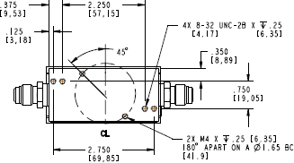 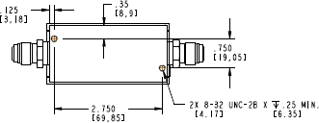

**GM50A / IM50A GE50A / IE50A**

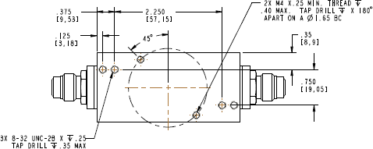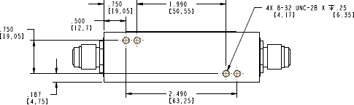

**GM100A GM51A**

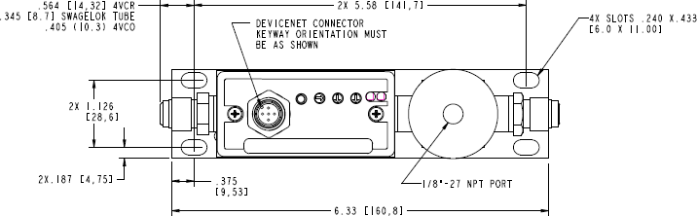

**GV50A – Mounting Plate Slot Location**

**Figure 4-1. Mounting Screw Holes Locations for In-Line Axial Gas Flow Compression Fittings**

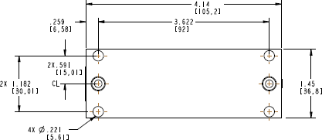

**G and I 50A Series MFC C-Seal / W-Seal**

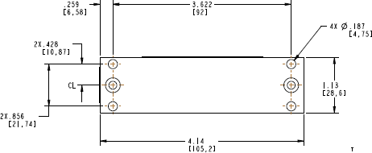

**GM51A C-Seal / W-Seal**

**Figure 4-2. Mounting Bolt Holes Location for Non-axial Gas Flow Compression Fittings**

### Checking the Leak Tight Seal for the MFC

With the MFC body mounted in its gas panel location, connect the external gas line fittings using the appropriate gasket type and material for the MFC process application.

Install and tighten the gasket material according to the fitting manufacturer’s instructions and specifications.

### Applying Power and Signal Cables to the MFC

Connect the appropriately designed power and signal cables to the MFC interface. Secure the cable to posts on each side of the MFC connector.

|  |  |
| --- | --- |
| **Note**  ? | One important aspect of determining the appropriate cable design for 15 and 9 pin analog I/O is to review and understand how the MFC signal commons and power common are going to be tied together for the system installation. It is extremely important that these electrical commons are tied at one location between the power source and the MFC in order to avoid potential ground loops which can result in analog flow signal offsets and even increased noise in the flow signal. |

|  |  |
| --- | --- |
| **Caution**  ? | **Before connecting any cable to the MFC, verify that the power supply being used for this application meets the MFC manufacturer’s recommendation for voltage and current ratings. DO NOT submit the MFC to an over voltage condition in order to avoid damaging the MFC during power up.** |
|  |  |

|  |  |
| --- | --- |
| **Note**  ? | Before connecting any cable to the MFC, verify that all pinouts for power and signals match those for the I/O type being used. Pertinent information is provided in *Analog Power and**Control I/O Definitions*, below, and *Digital I/O Connections*, page 24). |
|  |  |

|  |  |
| --- | --- |
| **Note**  ? | Cables and other accessories manufactured by MKS for the G and I Series MFCs are listed in Appendix C. |

If you choose to manufacture your own cables, use the following guidelines for cable construction:

1. The cable must have an overall metal braided shield, covering all wires. Neither aluminum foil nor spiral shielding will be as effective; using either may nullify regulatory compliance.
2. The connectors must have a metal case with direct contact to the cable shield on the whole circumference of the cable. The inductance of a flying lead or wire from the shield to the connector will seriously degrade the shields effectiveness. Ground the shield to the connector before its internal wires exit.
3. With very few exceptions, the connector(s) must make good contact to the device’s case (ground). Good contact is about 0.01 ohms and the ground should surround all wires. Contact to ground at just one point may not suffice.
4. For shielded cables with flying leads at one or both ends; it is important to ground the shield at each such end before the wires exit. Make this ground with absolute minimum length. (A ¼ inch piece of #22 wire may be undesirably long since it has approximately 5 nH of inductance, equivalent to 31 ohms at 1000 MHz). After picking up the braid ground, keep wires and braid flat against the case. With very few exceptions, grounded metal covers are not required over terminal strips. If one is required, it will be stated in the Declaration of Conformity.

|  |  |
| --- | --- |
| **Note**  ? | Special considerations must be given to the design of the connector for the I series MFC in order to ensure a water and dust proof seal is generated at the connector interface for the IP66 rated I series MFC. See Appendix D for additional details. |

#### Analog Power and Control I/O Definitions

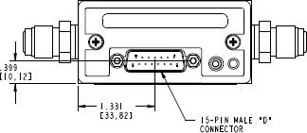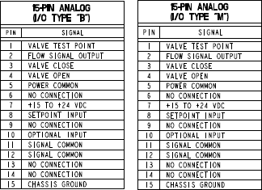

**Figure 4-3. Analog I/O − 15 pin**

|  |  |
| --- | --- |
| **Note**  ? | I/O Type M has pins 11 and 12 signal commons tied to pin 5 power common internally in the MFCails. |

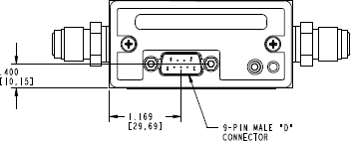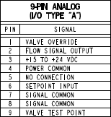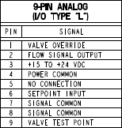

**Figure 4-4. Analog I/O − 9 pin**

|  |  |
| --- | --- |
| **Note**  ? | I/O Type L has pins 7 and 8 signal commons tied to pin 4 power common internally in the MFC. |

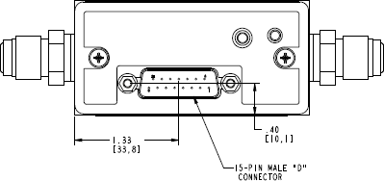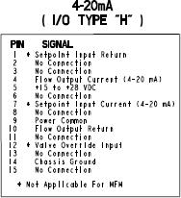

**Figure 4-5. Analog I/O − 4-20 mA**

##### *Important G and I Series Design Features for the Analog MFC*

**Status LED** — Located on the top of the MFC cover, the status light confirms that power has been applied correctly and the MFC has successfully completed an initialization routine by turning solid green several seconds after power is connected to the device. If the indicator light remains a solid red after power up, contact MKS service.

**Zero Button** — Just to the left of the LED status indicator is a zero button. To execute a MFC zero from this location, depress and hold the button down for 3 seconds. Refer to *Zeroing the MFC*, page 30, for the basic procedures to follow to execute a proper zero for the flow sensor.

|  |  |
| --- | --- |
| **Note**  ? | Due to the dust and moisture requirements for the IP 66 rating, these features are not visible or accessible on the I Series MFC. |

**Valve Override** — All analog connectors have pin locations that allow the execution of a valve override close or valve override open. The wiring requirements for the connector pin(s) to drive a valve closed or open are dependent on whether the MFC I/O is a 9 or 15 pin D-dub design.

* + - 9 pin — The voltage between pin 1 (valve override) and pin 4 (power common) floats at 2.5V when the device is powered up. To execute a valve close, pull pin 1 to ground. To execute a valve open, pull pin 1 to 5V.
    - 15 pin — To execute a valve close, pull pin 3 to ground. To execute a valve open, pull pin 4 to ground. *15-Pin 4-20mA acts like 9-Pin (pin 12 valve override) and pin 9 (common).*

**Optional Input (15 pin only)** — This feature has been used extensively as a means to take an external pressure signal, feed it back into the instrument on pin 10 to modulate the valve, and effectively turn the MFC into a pressure controller. Additional details on how to set up the MFC for optional input pressure control are available in Appendix F.

#### Digital I/O Connections

##### *RS485 Communication Description*

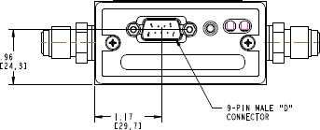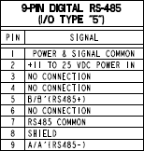

**Figure 4-6. RS485 Communication Protocol**

* + - G and I Series MFC serial communication uses drivers to send digital messages based on a variable length ASCII format that sends a message to a specific address and then waits for the MFC’s response before trying to communicate with the next device.
    - This format has been used in MKS legacy MFC RS485 devices such as the 1179 and 1479, and makes the integration of the G and I series into existing 1179/ 1479 applications easier for the end user.
    - RS485 communication supports multi-device bus drop designs.
    - *MKS Document MKS G-Series MFC, RS485 Supplement* (1046411-001) provides additional information on RS485 command structure and MFC features supported by the Type 5 RS485 specification.

##### *G Series RS485 MFC Features*

**LED Status Indicators** — There are two LED lights for error and communication. When you apply power to the digital MFD, a series of steps occur as the unit is initializes. As each step occurs, the COMM LED on the top of the unit illuminates. During MFC initialization, the two device LEDs will blink 3 times after which the COMM LED will stay solid amber. The COMM LED sequence, which takes about 10 seconds, must be completed before any communication commands are issued. Refer to *DeviceNet*, page 47, for additional information about LED status definitions.

**Zero Button** — Just to the right of the connector is a zero button. To execute an MFC zero from this location, depress and hold the button down for 3 seconds. Refer to *Zeroing the**MFC*, page 30, for the basic procedures to follow to execute a proper zero for the flow sensor.

**Selectable Serial Baud Rate** — G series RS485 supports baud rates of 9600, 19200, and 38400. The factory default is 9600 and can be changed using setup commands over RS485 (see *G-Series MFC, RS485 Supplement* (1046411-001) for additional command details).

Baud rates also can be selected using the “Setup Mode” of the MFC embedded web browser.

**Selectable RS485 Address** — Each MFC connected serially in a RS485 network must have a unique address. The G Series default address is 254 and can be changed using setup commands over RS485 (see *G-Series MFC, RS485 Supplement* (1046411-001) for command details). The RS485 address may be changed using the “Setup Mode” of the MFC embedded web browser. Refer to the Appendix B tutorial for the establishing Ethernet communications to the G Series MFC web browser and to enter the “Setup Mode” for access to MFC variables.

##### *G Series DeviceNet Communication Description*

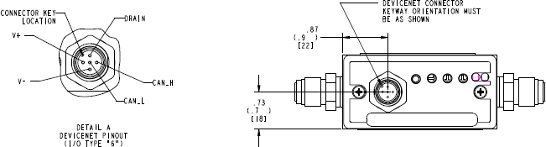

**Figure 4-7. DeviceNet Communication Protocol**

* + - DeviceNet communication is a master/slave (MFC) relationship comprised of a physical layer that makes up the trunk-line topology connecting devices and the data-link layer that is automatically capable of arbitrating message traffic between the master and the MFC slave.
    - The G and I Series MFC DeviceNet Mass Flow Device complies with the ODVA DeviceNet Specification Volume I and Volume II [1, 2], and the SEMI Standards

Common and Specific Device Models [3, 4]. Refer to those documents for a complete functional description of the MFC Mass Flow Device along with the *MKS G-Series MFC DeviceNet Supplement* (1046412-001).

##### *G DeviceNet MFC Features*

**LED Status Indicators** — Two bi-color LED status indicators are located on the top of the MFC enclosure for network (NET) and module (MOD) status. During MFC initialization, the NET and MOD will toggle green and red for 2 seconds, and the MOD light will remain solid green. Once a DeviceNet network has been detected by the MFC, the NET LED will begin blinking green. Once connected to the DeviceNet network, the NET LED will be solid green. Refer to *DeviceNet*, page 47, for additional information about LED status definitions.

**Zero Button** — Just to the right of the connector is a zero button. To execute a MFC zero from this location, depress and hold the button down for 3 seconds. The MFC can also be zeroed using commands over primary I/O messaging or via the Ethernet web browser. Refer to *Zeroing the MFC*, page 30, for the basic procedures to follow to execute a proper zero for the flow sensor.

**Baud Rate Selection** — Default factory baud rate is 500 kps. Baud rate selection can be physically selected by using the 4-position rotary switch on the top of the MFC enclosure to select one of the three allowable choices (125, 250, 500 kps) or by placing the switch to PGM and using DeviceNet programming commands (the value is read from the non-volatile memory).

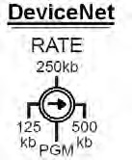

**Figure 4-8. DeviceNet 4-Position Rotary Switch**

**DeviceNet MAC ID (Node Address) Switches** — A pair of rotary switches located on the top of the MFC enclosure are used to set a unique node address for every device on the network. The factory default is 55. Valid switch positions for a DeviceNet network are from 00 to 63. The MSD (most significant digit (MSD switch represents an increment of 10 (0, 10, 20, etc…60), while the LSD (least significant digit) switch represents an increment of 1 (0-9).

It is also possible to use the PGM position on the MSD switch and set the node address using DeviceNet commands. The master will read the node address from non-volatile memory.

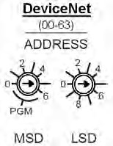

**Figure 4-9. DeviceNet Pair of Rotary Switches**

|  |  |
| --- | --- |
| **Note**  ? | Due to the dust and moisture requirements for the IP 66 rating, these features are not visible or accessible on the I Series MFC. All set up of these parameters must be accomplished using DeviceNet commands or over Ethernet communications using the web browser. |

##### *G and I Series Profibus Communication*

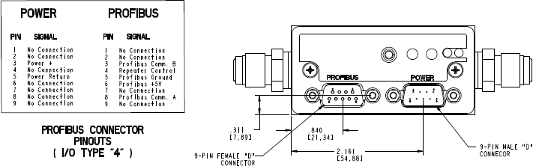

**Figure 4-10. Profibus I/O Communications Protocol**

* + - Master/slave (MFC) field bus communication protocol uses a serial approach to control bit transmission between the master and slave. With one master to control the network, the master sends an output message to a slave device that must provide input information immediately back to the master before the master will query another network device.
    - Refer to the complete functional description of the MFC Mass Flow device along with the

*MKS G-Series MFC, Profibus Supplement* (1046413-001).

|  |  |
| --- | --- |
| **Note**  ? | Profibus model code has firmware revisions 3 and 4 available for G series MFC. See Model Code Configuration for additional details to determine the proper revision for the application. |

##### *G and I Series Profibus MFC Features*

The two 9-pin D-sub connector design has a male connector for Profibus communication and female connector for MFC power.

**LED Status Indicators** — The MFC is designed with two standard bi-color (amber/red) Profibus status LEDs for network (NET) and module (MOD) status located on the top of the MFC enclosure. When power is supplied to the 9 pin male power connector on the MFC, the LED will toggle green and red during initialization for a few seconds before the MOD LED turns solid green. When the 9-pin female Profibus communication connector is connected to and recognized by the master, the NET LED will begin to blink green. Refer to *DeviceNet*, page 47, for additional information about LED status definitions.

**Zero Button** — Just to the right of the connector is a zero button. To execute a MFC zero from this location, depress and hold the button down for 3 seconds. The MFC can also be zeroed using commands over primary I/O messaging or via the Ethernet web browser. Refer to *Zeroing the MFC*, page 30, for the basic procedures to follow to execute a proper zero for the flow sensor.

##### *G Series Ethercat Communication*

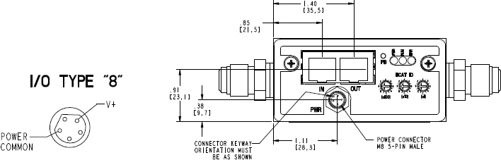

**Figure 4-11. EtherCat I/O Communications Protocol**

* + - Ethercat is a high performance Ethernet based fieldbus network protocol that takes advantage of the efficient way messages between the master and slave devices propagate through the network. Messages or instructions from the master are “passed through” each slave device (node), and corresponding data from the slave device is added to the output message that is going to the next node in the network. This process continues throughout the network and, when the message arrives back at the master, every slave has received new input data from the master and returned new output data to the master.
    - Ethercat requires an ESI file that provides the master with an appropriate configuration file specific to a G Series MFC.
    - A detailed device specific profile for the G Series MFC has been created for Ethercat communication in document *ETG.5003.2020 S (R) V1.0.0*.

##### *G Series Ethercat MFC Features*

Two Ethernet ports marked <IN> and <OUT> are used to propagate messages from the master (IN), adding any data to the string and then allowing message to pass to the next slave or node (OUT).

Push button (PB) can be used to zero the MFC flow. To execute a MFC zero from this location, depress and hold the button down for 3 seconds.

There are three LEDs for Power (PWR), Network communication (RUN), and network issues (ERR).

LED status indicators function as follows:

* + - When power has been established, the PWR LED will turn solid green.
    - The RUN LED will remain dark until a network connection between the master and slave has been established and the device has been put in an operational mode by the master. At this time, the slave device will respond to messages from the master and the LED is solid green.
    - The ERR LED stays dark as long as there are no issues between the master and the slave. If an issue is detected, the LED will flash red.

ECAT ID consists of three rotary switches that provide an option of manually setting the node address (function is normally automatic from the master). A maximum of 4095 distinct

addresses can be set by these rotary switches and it is important to note that these switches are in HEX (max setting FFF = 4095 decimal).

##### *G Series Profinet Communications*

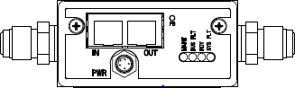

**Figure 4-12. Profinet I/O Communications Protocol**

* + - Profinet is a master (I/O controller) / slave (I/O device) communication protocol designed to provide a high level of automation over an industrial Ethernet network with data exchange rates on the order of a few milliseconds. Cyclic data exchange is point to point between the I/O controller and I/O device.
    - Profinet requires that the MFC device characteristics be defined in a GSDML file and provides the I/O supervisor software with configuration information about the G Series MFC.

##### *G Series MFC Features*

Two Ethernet ports marked <IN> and <OUT> are used to propagate cyclic messages back and forth from the I/O controller and the I/O device.

Push button (PB), which is located next to the <OUT> Ethernet port, can be used to zero the MFC flow. To execute a MFC zero from this location, depress and hold the button down for 3 seconds.

There are four LEDs to verify successful communication between the I/O controller and I/O device:

* + - MAINT (Maintenance) — Not used by MKS (dark).
    - BUS FLT (Bus Fault) — Red on power up and dark when a TPS-1 (I/O controller) link is established.
    - RDY (Ready) — Solid Green on power up and when a TPS-1 link is established.
    - SYS FLT (System Fault) — Dark on power up and red if an issue is detected.

### Leak Checking the MFC Installation

Perform leak checks on gas lines and MFC connections to verify the integrity of the gas seals before introducing any process gas to the MFC using appropriate He leak detection equipment or other methodology specified by the gas panel designer.

### Setting Up and Configuring the MFC

Connect the G/I Series MFC to a desktop computer or laptop using a standard Ethernet cable in order to utilize the embedded web browser interface to verify that the as-received configuration from the manufacturer matches the MFC gas and full scale flow rate designated on the MFC label attached to its enclosure.

Details on how to set up the computer in order to establish communication to the MFC and the functionality of the web browser are described in Appendix B.

Changes to the configuration of the MFC can also be initiated and completed over the web browser interface including:

* + - Re-ranging the full scale of the current nameplate gas
    - Creating a new gas type
    - Changing the factory IP address of the device if you have multiple devices on a multiport hub or switch
    - Setting ramps rates and set point delay times for process requirements

### Zeroing the MFC

Proper zeroing of the MFC is one of the most critical steps to ensure that the MFC performs correctly in any application.

The two most important considerations when zeroing an MFC are making sure:

* + - The MFC has reached a stable internal temperature in the orientation (attitude) that is being used for the application, and
    - No differential pressure exists across the MFC control valve (“no flow”) when a zero is initiated.

To ensure that these conditions are met, refer to the following recommended guidelines and procedures.

#### Check Temperature Stabilization

The MFC should be powered up in its final installation orientation for at least 30 minutes before initiating an MFC zero. MKS recommends additional steps to verify that MFC has reached a stable temperature by using the plot page available on the web browser to monitor the MFC temperature in real time prior to zeroing the MFC.

#### Establish a Proper “No Flow” Condition Across the MFC Control Valve

The definition of a “no flow” condition is that the pressure on the inlet side of the MFC is equal to the pressure on the outlet side of the MFC control valve. Whether the MFC is at atmospheric pressure, vacuum pressure, or process pressure, the zero should not be initiated until the pressure differential across the MFC is zero.

|  |  |
| --- | --- |
| **Note**  ? | MKS recommends that an MFC be zeroed at its operating inlet gas pressure. To successfully complete the recommended procedures, a positive shut off valve should be installed in the gas line to properly isolate the MFC at operating pressures. |

1. Pressurize the gas line to the inlet of the MFC (open upstream positive shut off valve if required).
2. Open the downstream shut off valve and give the MFC a full scale set point.
3. Let the MFC operate at full scale flow for 15 seconds and then close the downstream shut off valve while leaving the set point on the MFC.
4. Allow the reported flow to fall to a stable zero value.

|  |  |
| --- | --- |
| **Note**  ? | The set point and flow signals can be monitored in real time on the plot page to confirm that the MFC has reached a stable zero condition. |

1. If a positive shut off valve is installed upstream, close the valve and then give a zero set point to the MFC to close the control valve.
2. Issue a zero function to the MFC by holding down the button on the top of the enclosure for 3 seconds.

|  |  |
| --- | --- |
| **Note**  ? | The zero function can be also executed from the Configuration page of the web browser (see Appendix B).  Digital protocols such as DeviceNet, Profibus, RS485, Ethercat, and Modbus also support zero commands that can be sent over the primary I/O (see I/O supplemental documentation for details). |

## Notes

**MFC Product Code Definition and Design Configurations**



**5**

### G and I Series Elastomer Models

#### Elastomer Sealed G and I Series Product Code Structure

**Gas Code**

**Flow Range Full Scale**

**Fittings**

**Connector Type**

**Seal Material**

**Valve Type**

**Firmware Version**

**Configuration Code**

**AA**

**V**

**Z**

**W**

**Y**

**FFF**

**GGG**

**CCCCC**

**Figure 5-1. Elastomer Sealed G and I Series Product Code Structure**

#### MFC Configuration Code – CCCCC

**Table 5-1. MFC Configuration Code – CCCCC**

|  |
| --- |
| CCCCC |
| GE50A |
| IE50A |
| GV50A |

#### Gas Code – GGG

MKS gas code designations are in accordance to *SEMI Guideline E52, Practice for Referencing Gases and Gas Mixtures Used in Digital Mass Flow Controllers*.

|  |  |
| --- | --- |
| **Note**  ? | Information for SEMI gas codes is provided in Appendix A. |

#### Flow Full Scale Range Designation – FFF

The full scale flow for the MFC is defined by a 3-digit code as shown in the table below.

**Table 5-2. Flow Full Scale Range Designation – FFF**

|  |  |  |  |  |
| --- | --- | --- | --- | --- |
| **Mass Flow Rate** | **Full Scale Flow** | **MFC Model** | | |
| **Ordering Code Designation** | **GE50A** | **IE50A** | **GV50A** |
| 10 sccm | 101 | ? | ? | ? |
| 20 sccm | 201 | ? | ? | ? |
| 50 sccm | 501 | ? | ? | ? |
| 100 sccm | 102 | ? | ? | ? |
| 200 sccm | 202 | ? | ? | ? |
| 500 sccm | 502 | ? | ? | ? |
| 1000 sccm | 103 | ? | ? | ? |
| 2000 sccm | 203 | ? | ? | ? |
| 5000 sccm | 503 | ? | ? | ? |
| 10000 sccm | 104 | ? | ? | ? |
| 20000 sccm | 204 | ? | ? | ? |
| 30000 sccm | 304 | ? | ? | ? |
| 50000 sccm | 504 | ? | ? | ? |

#### MFC Fittings – Y

**Table 5-3. MFC Fittings – Y**

|  |  |  |  |  |  |
| --- | --- | --- | --- | --- | --- |
| **MFC Model and Fitting Combinations** | | | | | |
| **Fittings Type / Description** | **Product Code** | **Fitting Utilization** | **GE50A** | **IE50A** | **GV50A** |
| Swagelok 2 VCR Male | B | < 1000 sccm N2 Equivalent | ? | ? | ? |
| Swagelok 4 VCR Male | R | All MFC Full Scale Flow Ranges | ? | ? | ? |
| Swagelok 8 VCR Male | T | All MFC Full Scale Flow Ranges | ? | ? | ? |
| 1/8" Swagelok | A | < 1000 sccm N2 Equivalent | ? | ? | ? |
| 1/4" Swagelok | S | All MFC Full Scale Flow Ranges | ? | ? | ? |
| 3/8" Swagelok | J | All MFC Full Scale Flow Ranges | ? | ? | ? |
| 1/2" Swagelok | K | All MFC Full Scale Flow Ranges | ? | ? | ? |
| 6 mm | M | All MFC Full Scale Flow Ranges | ? | ? | ? |
| 8 mm | E | All MFC Full Scale Flow Ranges | ? | ? | ? |
| 10 mm | P | All MFC Full Scale Flow Ranges | ? | ? | ? |
| 12mm | F | All MFC Full Scale Flow Ranges | ? | ? | ? |
| C Seal Surface Mount | C | All MFC Full Scale Flow Ranges | ? | ? | ? |
| 4 VCO Male | G | All MFC Full Scale Flow Ranges | ? | ? | ? |

|  |  |  |  |  |  |
| --- | --- | --- | --- | --- | --- |
| **MFC Model and Fitting Combinations** | | | | | |
| **Fittings Type / Description** | **Product Code** | **Fitting Utilization** | **GE50A** | **IE50A** | **GV50A** |
| 8 VCO Male | D | All MFC Full Scale Flow Ranges | ? | ? | ? |
| KF16 | U | All MFC Full Scale Flow Ranges | ? | ? | ? |

#### MFC Power and Control I/O Connector – W

##### *Analog Control I/O*

**Table 5-4. Analog Control I/O**

|  |  |  |  |  |
| --- | --- | --- | --- | --- |
| **Analog I/O** | **Product Code** | **GE50A** | **IE50A** | **GV50A** |
| 15 pin D sub | B1, M (Grounds Tied2) | ? |  | ? |
| 15 pin D sub | B |  | ? |  |
| 9 pin D sub | A1, L (Grounds Tied2) | ? |  | ? |
| 9 pin D sub | A |  |  |  |
| 15 pin 4-20mA | H | ? | ? | ? |
| 15 pin D sub | K3 | ? |  | ? |

1 15-24V, signal and power common are not tied internally in MFC.

2 15-24V, signal and power common tied together internally, compatible with MKS legacy MFC designs.

3 Special 24V connector designed to be compatible with 1179B.

##### *Digital I/O Protocols*

**Table 5-5. Digital I/O Protocols**

|  |  |  |  |  |
| --- | --- | --- | --- | --- |
| **Digital I/O** | **Product Code** | **GE50A** | **IE50A** | **GV50A** |
| RS 485 | 5 | ? |  | ? |
| DeviceNet | 6 | ? |  | ? |
| Profibus | 31, 42 | ? | ? | ? |
| Ethercat | 8 | ? |  | ? |
| Profinet | 9 | ? |  | ? |

1 Model Code 3 – Profibus Full setup, compatible with 1179B.

2 Model Code 4 – Profibus Small setup, compatible with 1480 and 1179B.

#### Elastomer Seal Materials – Z

**Table 5-6. Elastomer Seal Materials – Z**

|  |  |  |  |  |
| --- | --- | --- | --- | --- |
| **Seal Materials** | **Product Code** | **GE50A** | **IE50A** | **GV50A** |
| Viton | V | ? | ? | ? |
| Buna -N | B | ? | ? | ? |
| Neoprene | N | ? | ? | ? |
| Kalrez | K | ? | ? | ? |
| EPDM | E | ? | ? | ? |

#### Valve Type – V

**Table 5-7. Valve Type – V**

|  |  |  |  |  |
| --- | --- | --- | --- | --- |
| **MKS Valve Designations** | **Product Code** | **GE50A** | **IE50A** | **GV50A** |
| Valve Type – Normally Closed | O | ? | ? | ? |
| Valve Type – Normally Open | P | ? | ? |  |

#### Firmware Revision – AA

The latest version of firmware for the MFC model is installed in the device unless something different is specified by the customer or the model code is a 5-digit sequential that has specific instructions for device configuration.

### G and I Series Metal Sealed Models

#### Metal Sealed G and I Series Product Code Structure

**Gas Code**

**Flow Range Full Scale**

**Fittings**

**Connector Type**

**Device Type / Valve and Seal Material Firmware Version**

**Configuration Code**

**AA**

**V**

**W**

**Y**

**FFF**

**GGG**

**CCCCC**

**Figure 5-2. Metal Sealed G and I Series Product Code Structure**

#### MFC Configuration

**Table 5-8. MFC Configuration**

|  |
| --- |
| CCCCC |
| GM50A |
| IM50A |
| GM51A |
| GM100A |

#### Gas Code – GGG

MKS gas code designations follow *SEMI Guideline E52, Practice for Referencing Gases and Gas Mixtures Used in Digital Mass Flow Controllers*.

|  |  |
| --- | --- |
| **Note**  ? | Information for SEMI gas codes is provided in Appendix A. |

#### Full Scale Range – FFF

**Table 5-9. Full Scale Range – FFF**

|  |  |  |  |  |  |
| --- | --- | --- | --- | --- | --- |
| **Mass Flow Rate** | **Full Scale Flow** | **MFC Model** | | | |
| **Ordering Code Designation** | **GM50A** | **IM50A** | **GM51A** | **GM100A** |
| 10 sccm | 101 | ? | ? | ? |  |
| 20 sccm | 201 | ? | ? | ? |  |
| 50 sccm | 501 | ? | ? | ? |  |
| 100 sccm | 102 | ? | ? | ? |  |
| 200 sccm | 202 | ? | ? | ? |  |
| 500 sccm | 502 | ? | ? | ? |  |
| 1000 sccm | 103 | ? | ? | ? |  |
| 2000 sccm | 203 | ? | ? | ? |  |
| 5000 sccm | 503 | ? | ? | ? |  |
| 10000 sccm | 104 | ? | ? | ? |  |
| 20000 sccm | 204 | ? | ? | ? |  |
| 30000 sccm | 304 | ? | ? | ? |  |
| 50000 sccm | 504 | ? | ? | ? |  |
| 100000 sccm | 105 |  |  |  | ? |

#### Fittings – Y

**Table 5-10. Fittings – Y**

|  |  |  |  |  |  |  |
| --- | --- | --- | --- | --- | --- | --- |
| **MFC Model and Fitting Combinations** | | | | | | |
| **Fittings Type / Description** | **Product Code** | **Fitting Utilization** | **GM50A** | **IM50A** | **GM51A** | **GM100A** |
| Swagelok 2 VCR Male | B | < 1000 sccm N2 Equivalent | ? | ? |  |  |
| Swagelok 4 VCR Male | R | All MFC Full Scale Flow Ranges | ? | ? | ? | ? |
| Swagelok 8 VCR Male | T | All MFC Full Scale Flow Ranges | ? | ? |  | ? |
| 1/8" Swagelok | A | < 1000 sccm N2 Equivalent | ? | ? |  |  |
| 1/4" Swagelok | S | All MFC Full Scale Flow Ranges | ? | ? |  |  |
| 3/8" Swagelok | J | All MFC Full Scale Flow Ranges | ? | ? |  | ? |
| 1/2" Swagelok | K | All MFC Full Scale Flow Ranges | ? | ? |  | ? |
| 6 mm | M | All MFC Full Scale Flow Ranges | ? | ? |  |  |
| 8 mm | E | All MFC Full Scale Flow Ranges | ? | ? |  |  |

|  |  |  |  |  |  |  |
| --- | --- | --- | --- | --- | --- | --- |
| **MFC Model and Fitting Combinations** | | | | | | |
| **Fittings Type / Description** | **Product Code** | **Fitting Utilization** | **GM50A** | **IM50A** | **GM51A** | **GM100A** |
| 10 mm | P | All MFC Full Scale Flow Ranges | ? | ? |  | ? |
| 12 mm | F | All MFC Full Scale Flow Ranges | ? | ? |  | ? |
| C Seal Surface Mount | C | All MFC Full Scale Flow Ranges | ? | ? | ? |  |
| W Seal Surface Mount | H | All MFC Full Scale Flow Ranges | ? |  | ? |  |
| 4 VCO Male | G | All MFC Full Scale Flow Ranges |  |  |  |  |
| 8 VCO Male | D | All MFC Full Scale Flow Ranges |  |  |  | ? |
| KF16 | U | All MFC Full Scale Flow Ranges | ? | ? |  |  |

#### Power and Control I/O Connectors – W

##### *Analog I/O*

**Table 5-11. Analog I/O**

|  |  |  |  |  |  |
| --- | --- | --- | --- | --- | --- |
| **Analog I/O** | **Product Code** | **GM50A** | **IM50A** | **GM51A** | **GM100A** |
| 15 pin D sub | B1, M (Grounds Tied2) | ? |  |  | ? |
| 15 pin D sub | B |  | ? | ? |  |
| 9 pin D sub | A1, L (Grounds Tied2) | ? |  |  | ? |
| 9 pin D sub | A |  |  | ? |  |
| 15 pin 4-20mA | H | ? | ? | ? | ? |
| 15 pin D sub | K3 | ? |  |  | ? |

1 15-24V, signal and power common are not tied internally in MFC.

2 15-24V, signal and power common tied together internally, compatible with MKS legacy MFC designs.

3 Special 24V connector designed to be compatible with 1179B.

##### *Digital I/O*

**Table 5-12. Digital I/O**

|  |  |  |  |  |  |
| --- | --- | --- | --- | --- | --- |
| **Digital I/O** | **Product Code** | **GM50A** | **IM50A** | **GM51A** | **GM100A** |
| RS 485 | 5 | ? |  | ? | ? |
| DeviceNet | 6 | ? |  | ? | ? |
| Profibus | 31, 42 | ? | ? |  | ? |
| Ethercat | 8 | ? |  | ? | ? |
| Profinet | 9 | ? |  | ? | ? |

1 Model Code 3 – Profibus Full setup, compatible with 1179B.

2 Model Code 4 – Profibus Small setup, compatible with 1480 and 1179B.

#### Valve Type – V

**Table 5-13. Valve Type – V**

|  |  |  |  |  |  |
| --- | --- | --- | --- | --- | --- |
| **MKS Device Type / Valve Designations** | **Product Code** | **GM50A** | **IM50A** | **GM51A** | **GM100A** |
| Mass Flow Controller / Normally Closed  / Teflon Seal | M0 | ? | ? | ? |  |
| Mass Flow Controller / Normally Closed  / Viton Seal | MV |  |  |  | ? |
| Mass Flow Controller / Normally Closed  / Buna Seal | MB |  |  |  | ? |
| Mass Flow Controller / Normally Closed  / Neoprene Seal | MN |  |  |  | ? |
| Mass Flow Controller / Normally Closed  / EPDM Seal | ME |  |  |  | ? |
| Mass Flow Controller / Normally Open / Teflon Seal | PT | ? | ? |  |  |
| Mass Flow Meter | 30 | ? | ? | ? | ? |

#### Firmware – AA

The latest version of firmware for the MFC model is installed in the device unless something different is specified by the customer or the model code is a 5-digit sequential that has specific instructions for device configuration.

## Notes

**Troubleshooting and Maintenance**



**6**

### MFC Setup and Function Troubleshooting

**Table 6-1. MFC Setup and Function Troubleshooting**

|  |  |  |  |  |  |
| --- | --- | --- | --- | --- | --- |
|  | **Analog I/O** | |  | **Digital I/O** | |
| MFC Status  / Module Light Dark | No power | Check power source. |  | No power | Check power source. |
| Low power | Check supply voltage. | Low power | Check supply voltage. |
| Cable Design | Verify I/O pinout. | Cable Design | Verify I/O pinout. |
| Bad cable connection | Check pin(s) continuity. | Bad cable connection | Check pin(s) continuity. DNET - Verify that there is no path from the DNET electrical connector pins and chassis ground. |
| MFC does not respond to any setpoint | Verify Analog Status Led is solid green | If LED is **DARK** check power source.  If LED is **RED**, contact MKS Service. |  | Verify Module LED or Power LED (Ethercat) is solid green | If LED is **DARK** check power source.  If LED is **RED**, contact MKS Service. |
| Control circuit failure | Follow Appendix B and use the Ethernet Web Browser to observe and diagnose set point and flow response. If unresponsive contact MKS Service. | Verify the MFC is communicating with the I/O Network | DNET I/O - NET LED  Blinking no connection. Profibus I/O - Solid NET LED no  connection.  RS485 - Solid NET  LED no connection. Ethercat - Dark NET LED no connection. |
| Contamination/Clogged  - blocked MFC device or gas line | Check inlet pressure @ MFC. Check outlet pressure at MFC using pressure gauge. Check outlet pressure downstream of positive shut off (pneumatic) valve downstream of MFC. Check air line to pneumatic valve. Check for any restriction such as filter or check valve downstream of MFC. | Control circuit failure | Follow Appendix B and use the Ethernet Web Browser to observe and diagnose set point and flow response. If unresponsive contact MKS Service. |
| Wrong cable | Verify cable and MFC pinouts are correct for MFC. | Wrong cable | Check cable pin out design and verify digital communication lines are correct for Profibus and RS485. |

|  |  |  |  |  |  |
| --- | --- | --- | --- | --- | --- |
|  | **Analog I/O** | |  | **Digital I/O** | |
|  | Bad cable connection | Check pin(s) continuity. |  | Contamination/Clogged  - blocked MFC device or gas line | Check inlet pressure @ MFC. Check outlet pressure at MFC using pressure gauge. Check outlet pressure downstream of positive shut off (pneumatic) valve downstream of MFC. Check air line to pneumatic valve. Check for any restriction such as filter or check valve downstream of MFC. |
| Bad cable connection | Check pin(s) continuity. |
| MFC shows 0 flow when given setpoint | Closed upstream and/or downstream pneumatic valves | Open valves, check inlet pressure. |  | Closed upstream and/or downstream pneumatic valves | Open valves, check inlet pressure. |
| No gas supply | Turn on gas supply. | No gas supply | Turn on gas supply. |
| Upstream clogged filter/component | Check flow through of components by measuring pressure from gas supply to MFC inlet. | Upstream clogged filter/component | Check flow through of components by measuring pressure from gas supply to MFC inlet. |
| MFC clogged orifice | Verify MFC inlet pressure, check valve current for open valve condition. Check for gas flow downstream of MFC. If flow does not exist, possible clogged orifice. | MFC clogged orifice | Verify MFC inlet pressure, check valve current for open valve condition. Check for gas flow downstream of MFC. If flow does not exist, possible clogged orifice. |
| MFC clogged sensor | Run MFC diagnostics. Verify MFC inlet pressure, check valve current for open valve condition and check for gas flow downstream of MFC. If flow present, possible clogged sensor. | MFC clogged sensor | Run MFC diagnostics. Verify MFC inlet pressure, check valve current for open valve condition and check for gas flow downstream of MFC. If flow present, possible clogged sensor. |
| MFC control circuit failure | Follow Appendix B and use the Ethernet Web Browser to observe valve current after giving set point. If unresponsive contact MKS Service. | MFC control circuit failure | Follow Appendix B and use the Ethernet Web Browser to observe valve current after giving set point. If unresponsive contact MKS Service. |
| MFC Flow output signal does not match setpoint | Inlet pressure too low | Increase inlet pressure. |  | Inlet pressure too low | Increase inlet pressure. |
| Outlet pressure too high | Decrease outlet pressure. | Outlet pressure too high | Decrease outlet pressure. |
| Flow signal is not properly grounded. | Verify MFC signal commons and power common are tied together. Check electrical connections for ground loops. | Contamination | Check for partial block orifice or sensor using valve override command over primary I/O. Max flow with valve wide open should be > 110% FS. |

|  |  |  |  |  |  |
| --- | --- | --- | --- | --- | --- |
|  | **Analog I/O** | |  | **Digital I/O** | |
|  | Contamination | Check for partial block orifice or sensor using Analog pins for valve open override condition. Max flow with valve wide open should be > 110% FS. |  | Control electronics failure, sensor failure | Follow Appendix B and use the Ethernet Web Browser to observe set point, flow output, valve current, and temperature. |
| Control electronics failure, sensor failure | Follow Appendix B and use the Ethernet Web Browser to observe set point, flow output, valve current, and temperature. |  |  |
| Electronics failure - Analog to Digital signal calibration | Follow Appendix B and use the Ethernet Web Browser to observe set point, flow output, valve current. If the valve controls at set points between 10 - 100% FS but the flow output is off by a constant amount, contact MKS Service, |  |  |
| MFC cannot achieve FS flow | Inlet pressure low | Increase inlet pressure. |  | Inlet pressure low | Increase inlet pressure |
| Outlet pressure high | Decrease outlet pressure. | Outlet pressure high | Decrease outlet pressure |
| Valve / flow sensor contamination | Check valve current for maximum position. | Valve / flow sensor contamination | Check valve current for maximum position |
| Valve set up - not enough valve stroke | Use Analog pin for valve open override condition. Max flow with valve wide open should be > 110% FS. | Valve set up - not enough valve stroke | Use appropriate digital command over primary I/O for valve open override condition. Max flow with valve wide open should be > 110% FS. |
| Gas line blockage/contamination | Measure pressure drop across from gas supply regulator to MFC inlet. If pressure drop greater than expected check filters, check valves, and other in line components for signs of blockage. | Gas line blockage/contamination | Measure pressure drop across from gas supply regulator to MFC inlet. If pressure drop greater than expected check filters, check valves, and other in line components for signs of blockage. |
|  |  | MFC setpoint in counts  < than 100% FS of 24567 counts. | Verify the DNET Master is sending correct HEX value (0x6000) for FS set point over primary I/O. |
| MFC shows output flow  > FS  (overrange) | MFC valve full open | Check valve current for maximum condition. |  | MFC valve full open | Check valve current for maximum condition. |
| Pressure drop across MFC is greater than specification | Measure upstream pressure & downstream pressure. Compare to specification. | Pressure drop across MFC is greater than specification | Measure upstream pressure & downstream pressure. Compare to specification. |

|  |  |  |  |  |  |
| --- | --- | --- | --- | --- | --- |
|  | **Analog I/O** | |  | **Digital I/O** | |
|  | Faulty valve control circuit/ valve setup | Follow Appendix B and use the Ethernet Web Browser to observe set point, flow output, valve current. Send set points 10 -100% and observe valve current values. |  | Faulty valve control circuit/ valve setup | Follow Appendix B and use the Ethernet Web Browser to observe set point, flow output, valve current. Send set points 10 -100% and observe valve current values. |
| Possible contamination in valve assembly | Follow Appendix B and use the Ethernet Web Browser to observe set point, flow output, valve current. Send 0 set point to the MFC and observe flow output. Close downstream isolation valve for additional confirmation of through valve closed conductance leak. | Possible contamination in valve assembly | Follow Appendix B and use the Ethernet Web Browser to observe set point, flow output, valve current. Send 0 set point to the MFC and observe flow output. Close downstream isolation valve for additional confirmation of through valve closed conductance leak. |
|  |  | Set Point values over from Primary I/O master incorrect | Validate set point values from the Master to the MFC slave are correct for MFC configuration. |
| Output signal matches setpoint @ higher flows, but will not go to 0 | Analog I/O | |  | Digital I/O | |
| MFC valve partial contamination | Cycle-purge device, check valve current. | MFC valve partial contamination | Cycle-purge device, check valve current |
| MFC control valve issue | Follow Appendix B and use the Ethernet Web Browser to observe set point, flow output, valve current. Send 0 set point to the MFC and observe flow output. Close downstream isolation valve for additional confirmation of through valve closed conductance leak. | MFC control valve issue | Follow Appendix B and use the Ethernet Web Browser to observe set point, flow output, valve current. Send 0 set point to the MFC and observe flow output. Close downstream isolation valve for additional confirmation of through valve closed conductance leak. |
| Pressure differential across valve outside specification | Measure inlet and outlet pressure. Confirm differential pressure meets published MFC specification. Adjust pressure as required. | Pressure differential across valve outside specification | Measure inlet and outlet pressure. Confirm differential pressure meets published MFC specification. Adjust pressure as required. |
| Device zero offset | re-zero device with known zero flow conditions. | Device zero offset | re-zero device with known zero flow conditions. |
| MFC output shows large overshoot | Analog I/O | |  | Digital I/O | |
| Inlet pressure too high | Decrease inlet pressure. | Inlet pressure too high | Decrease inlet pressure |
| MFC inlet pressure to high for default  <Operating Pressure> parameter | Follow Appendix B and use the Ethernet Web Browser to observe  <Operating Pressure Parameter (default value is 40). Increase value between 40-90 for control gains to be less aggressive. | MFC inlet pressure to high for default  <Operating Pressure> parameter | Follow Appendix B and use the Ethernet Web Browser to observe  <Operating Pressure Parameter (default value is 40). Increase value between 40-90 for control gains to be less aggressive. |

|  |  |  |  |  |  |
| --- | --- | --- | --- | --- | --- |
|  | **Analog I/O** | |  | **Digital I/O** | |
|  | MFC not programmed for correct gas - actual gas used different | Check MFC active gas using digital interface or Ethernet GUI. |  | MFC not programmed for correct gas - actual gas used different | Check MFC active gas using digital interface or Ethernet GUI. |
| MFC control parameters set incorrectly | Contact MKS service center. | MFC control parameters set incorrectly | Contact MKS service center. |
| MFC output slow to respond to setpoint | Inlet pressure too low | Increase inlet pressure. |  | Inlet pressure too low | Increase inlet pressure. |
| MFC inlet pressure to low for default  <Operating Pressure> parameter | Follow Appendix B and use the Ethernet Web Browser to observe  <Operating Pressure Parameter (default value is 40). Decrease value between 20-40 for control gains to be more aggressive. | MFC inlet pressure to low for default  <Operating Pressure> parameter | Follow Appendix B and use the Ethernet Web Browser to observe  <Operating Pressure Parameter (default value is 40). Decrease value between 20-40 for control gains to be more aggressive. |
| MFC not programmed for correct gas - actual gas used different | Check MFC active gas using digital interface or Ethernet GUI. | MFC not programmed for correct gas - actual gas used different | Check MFC active gas using digital interface or Ethernet GUI. |
| MFC control parameters set incorrectly | Contact MKS service center. | MFC control parameters set incorrectly | Contact MKS service center. |
| MFC output signal oscillates | Inlet pressure oscillates | Check for faulty regulator. |  | Inlet pressure oscillates | Check for faulty regulator |
| Inlet pressure too high | Lower inlet pressure. | Inlet pressure too high | Lower inlet pressure |
| MFC inlet pressure to high for default  <Operating Pressure> parameter | Follow Appendix B and use the Ethernet Web Browser to observe  <Operating Pressure Parameter (default value is 40). Increase value between 40-90 for control gains to be less aggressive. | MFC inlet pressure to high for default  <Operating Pressure> parameter | Follow Appendix B and use the Ethernet Web Browser to observe  <Operating Pressure Parameter (default value is 40). Increase value between 40-90 for control gains to be less aggressive. |
| MFC nameplate gas not same as actual gas | Check that MFC active gas is the same as the namplate gas using Ethernet Web Browser. | MFC nameplate gas not same as actual gas | Check that MFC active gas is the same as the namplate gas using Ethernet Web Browser. |
| MFC valve and control parameter setup | Contact MKS Service Center. | MFC valve and control parameter setup | Contact MKS Service Center. |

### MFC Performance Troubleshooting

**Table 6-2. MFC Performance Troubleshooting**

|  |  |  |  |  |  |
| --- | --- | --- | --- | --- | --- |
|  | **Analog I/O** | |  | **Digital I/O** | |
| MFC output shows large overshoot | Inlet pressure too high | Decrease inlet pressure |  | Inlet pressure too high | Decrease inlet pressure |
| MFC inlet pressure to high for default  <Operating Pressure> parameter | Follow Appendix B and use the Ethernet Web Browser to observe  <Operating Pressure Parameter (default value is 40). Increase value between 40-90 for control gains to be less aggressive. | MFC inlet pressure to high for default  <Operating Pressure> parameter | Follow Appendix B and use the Ethernet Web Browser to observe  <Operating Pressure Parameter (default value is 40). Increase value between 40-90 for control gains to be less aggressive. |
| MFC not programmed for correct gas - actual gas used different | Check MFC active gas using digital interface or Ethernet GUI. | MFC not programmed for correct gas - actual gas used different | Check MFC active gas using digital interface or Ethernet GUI. |
| MFC control parameters set incorrectly | Contact MKS service center. | MFC control parameters set incorrectly | Contact MKS service center. |
| MFC output slow to respond to setpoint | Inlet pressure too low | Increase inlet pressure. |  | Inlet pressure too low | Increase inlet pressure. |
| MFC inlet pressure to low for default  <Operating Pressure> parameter | Follow Appendix B and use the Ethernet Web Browser to observe  <Operating Pressure Parameter (default value is 40). Decrease value between 20-40 for control gains to be more aggressive. | MFC inlet pressure to low for default  <Operating Pressure> parameter | Follow Appendix B and use the Ethernet Web Browser to observe  <Operating Pressure Parameter (default value is 40). Decrease value between 20-40 for control gains to be more aggressive. |
| MFC not programmed for correct gas - actual gas used different | Check MFC active gas using digital interface or Ethernet GUI. | MFC not programmed for correct gas - actual gas used different | Check MFC active gas using digital interface or Ethernet GUI. |
| MFC control parameters set incorrectly | Contact MKS service center. | MFC control parameters set incorrectly | Contact MKS service center. |
| MFC output signal oscillates | Inlet pressure oscillates | Check for faulty regulator. |  | Inlet pressure oscillates | Check for faulty regulator. |
| Inlet pressure too high | Lower inlet pressure. | Inlet pressure too high | Lower inlet pressure. |
| MFC inlet pressure to high for default  <Operating Pressure> parameter | Follow Appendix B and use the Ethernet Web Browser to observe  <Operating Pressure Parameter (default value is 40). Increase value between 40-90 for control gains to be less aggressive. | MFC inlet pressure to high for default  <Operating Pressure> parameter | Follow Appendix B and use the Ethernet Web Browser to observe  <Operating Pressure Parameter (default value is 40). Increase value between 40-90 for control gains to be less aggressive. |
| MFC nameplate gas not same as actual gas | Check that MFC active gas is the same as the namplate gas using Ethernet Web Browser. | MFC nameplate gas not same as actual gas | Check that MFC active gas is the same as the namplate gas using Ethernet Web Browser. |
| MFC valve and control parameter setup | Contact MKS Service Center. | MFC valve and control parameter setup | Contact MKS Service Center. |

### Digital Communications I/O Troubleshooting

#### DeviceNet

**Table 6-3. DeviceNet Status LED**

|  |  |  |
| --- | --- | --- |
| **Network Status LED** | | **Network LED Description** |
| Solid Green | Link OK, On-line, Connected | The device in on-line and has connection in the established state. |
| * For a Group 2 only device it means that this device is not allocated to a master. |
| Flashing Green | On-line, Not Connected | Device is on-line but has no connection in the established state. |
| * The device has passed The Dup_MAC_ID test, is on- line, but has no established connections to other nodes. |
| * For a Group 2 only device it means that this device is not allocated to a master. |
| Red | Critical Link Failure | Failed communication device. The device has detected an error that has rendered it incapable of communicating on the network (Duplicate MAC ID, or Bus-off). |
| Flashing Red | Connection Time-Out | One or more I/O Connections are in the Timed-Out state. |
| Flashing Red & Green | Communication Faulted and Received an Identify Comm Fault Request - Long Protocol | A specific Communication Faulted device. The device has detected a Network Access error and is in the Communication Faulted state. The device has subsequently received and accepted an Identify Communication Faulted Request - Long Protocol message. |
| Off | Not Powered/Not On-Line | Device is not on-line. |

**Table 6-4. Module (MOD) LED**

|  |  |  |
| --- | --- | --- |
| **DeviceNet Module Status Indicator** | | **MOD LED Description** |
| Green | Device operational | The device is operating in a normal condition. |
| Flashing Green | Device in Standby (The Device Needs Commissioning) | The device needs commisioning due to configuration missing, incomplete or incorrect. |
| Red | Unrecoverable Fault | The device has an unrecoverable fault; may need replacing. |
| Flashing Red | Minor Fault | Recoverable Fault. |
| Flashing Red & Green | Device Self Testing | The Device is in Self Test. Reference the Identity Object in Volume II for Device states. |
| Off | No power | There is no power applied to the device. |

**Table 6-5. DeviceNet Connectivity**

|  |  |
| --- | --- |
| **Device Not Establishing Network Connector** | |
| Device has green MOD LED and Flashing Green NET LED | Polled Assembly Mismatch between Master and Slave MFC |
| Baud Rate Mismatch |
| EDS File for MFC Required and installed in Master Library |
| Host Software not recognizing Identity Object Attributes (MFC model/ Firmware revision/ Vendor code). Use independent DNET Communications Tool to validate connectivity to MFC. If MFC fails to connect using local independent DeviceNet Diagnostic tool contact MKS Service. |
| Bad Electronics. Use independent DNET Communications Tool to validate connectivity to Network. If unit fails to connect using independent DeviceNet diagnostic tool contact MKS Service. |
| Bad DNET Cable |
| Device has green MOD LED and Solid Red NET LED | Duplicate MAC Node Address |

#### RS485 Serial Communication

**Table 6-6. RS485 LED Status**

|  |  |
| --- | --- |
| **COMM LED Status** | **COMM LED Description** |
| Dark | No power, check cable wiring to MFC. |
| Solid Amber | MFC Initialization successfully completed |
| Blinking Amber | Successful serial connection opened between host and MFC. MFC has replied to request from the Host. Note that the COMM LED is solid Amber if the host is not querying the MFC. |
| Error LED Status | Error LED Description |
| Dark | MFC initialization complete, no error detected |
| Solid Red | Critical Unrecoverable Fault. Contact MKS Service |

**Table 6-7. RS485 Connectivity**

|  |  |
| --- | --- |
| **Device Not Establishing Serial Connection to HOST** | |
| Device has solid Amber COMM LED | Compare set up of HOST with MFC serial communication parameters: Parameter Value  Start Bit 1  Data Bits 8  Parity no parity  Stop Bit 1  Baud Rate* 9,600 (initial); 19,200; 38,400 End-of-Line Delimiter semicolon (;) |
| COMM Port is properly identified for the serial driver program. |
| Verify the host is sending message to correct MAC Address. |
| Verify the wiring of the serial to RS485 converter is half duplex (2 wire). |
| Electronics failure related to damaged or blown digital signal transceivers. |

#### Profibus Communication

**Table 6-8. Profibus LED Status**

|  |  |
| --- | --- |
| **Module (MOD) LED Status** | **MOD LED Description** |
| Dark | No power, check cable wiring to MFC. |
| Solid Green | MFC initialized properly. |
| Solid Red | Unrecoverable Fault. Contact MKS Service. |
| Blinking Green | Wink On |
| Network LED Status | Network LED Description |
| Dark | No connection to Profibus Master and Network. |
| Blinking Green | Network connection is established between MFC and Profibus Master. |

**Table 6-9. Profibus Connectivity**

|  |  |
| --- | --- |
| **Device Not Establishing serial connection to HOST/ Master** | |
| Device has Dark NET LED | Master / Host not recognizing attributes of the MFC. Check that the correct GDS file was used when configuring the network. |
| Verify pinout of communication signal lines for transmit and receive between Master and Slave MFC. |
| Electronics Failure. Contact MKS Service. |

#### Ethercat Communication

**Table 6-10. Ethercat LED Status**

|  |  |  |
| --- | --- | --- |
| **LED Identification** | **LED Status** | **LED Description** |
| PWR (Power) | Dark | No power to the Device. |
| Solid Green | Power properly wired on connector pins. |
| RUN  (Operation Status) | Dark | No communication has been established between Master and Slave. |
|  | Master is communicating but the device is in an INIT mode. |
| Blinking Green - 2 HZ | Device currently in PREOP mode. |
| Blinking Green - Fast | Device in Bootstrap mode. |
| Blinking Green - 1 Hz | Device in Safe OP mode. Device set to default safe mode (valve closed). Device will not respond to active commands. |
| Solid Green | Device in OP mode and is fully functional. |
| Err (Error LED) | Dark | No communication issues detected. |
| Blinking RED | Process data timeout. |
| Process data configuration Error (Wrong ESI File being used). |

**Table 6-11. Ethercat Connectivity**

|  |  |
| --- | --- |
| **Device Not Establishing Serial Connection to HOST/ Master** | |
| Device has Dark RUN LED | Master / Host not recognizing attributes of the MFC. Check that the correct ESI file was used when configuring the network. |
| Verify Ethernet In/ Out connections at the device are correct to promote process data exchange from Master to Device. |
| If using Hubs and Switches in the network, verify operation at each point. |
| Network card from computer not configured or defined by the MASTER. |
| Verify Power LED is solid Green. |
| Electronics Failure. Contact MKS Service. |

#### Profinet Communication

**Table 6-12. Profinet LED Status**

|  |  |  |
| --- | --- | --- |
| **LED Identification** | **LED Status** | **LED Description** |
| Maintenance | Dark | Not used by MKS. |
| Bus Fault | Solid Red | Power on but no communication link between I/O controller and MFC. |
| Blinking Red | MFC acknowledges I/O controller connection, but active communication link not established. |
| Dark | Communication link has been established. |
| Ready | Dark | No power. |
| Solid Green | Device Powered up or in combination with the bus fault is dark, I/O controller has establish communication. |
| System Fault | Dark | No communication or network issues. |
| Red | Non recoverable MFC fault, contact MKS Service. |

**Table 6-13. Profinet Connectivity**

|  |  |
| --- | --- |
| **Device Not Establishing Connection to I/O controller** | |
| Device has solid Green Ready LED and Solid Red Bus Fault LED | Duplicate MAC ID. |
| Verify Ethernet In/ Out connections at the device are correct to promote process data exchange from I/O controller to Device. |
| If using Hubs and Switches in the network, verify operation at each point. |
| GSDML file not linked to Master to properly configure MFC. |
| Electronics Failure. Contact MKS Service. |

# SEMI Gas Codes and MFC Flow Range Summary



**A**

### G and I Series MFC Relationship with SEMI Gas Code Numbers

Gas codes, which are used to identify the model configuration, are in accordance with *SEMI Guideline E52, Practice for Referencing Gases and Gas Mixtures Used in Digital Mass Flow Controllers* for the G and I Series MFC.

MKS has designed a total of 13 flow body combinations for the G and I Series MFC products to cover the operating flow ranges between 5 to 50000 sccm full scale N2. Nitrogen is always used as the MFC manufacturing calibration gas.

The nameplate gas based on the SEMI guideline is described by a 3-digit code number assigned to each gas or gas mixture. The full scale flow range for a SEMI process gas is determined by the physical and thermodynamic properties of that specific gas with respect to nitrogen. This relationship provides a Full Scale Calculation Factor (FSCF), which acts as a guideline when determining the MFC model required for a particular application.

Here are a few examples of how the information in the following tables can be used as a guideline for determining if the G or I Series can be used in a given process design scenario:

* + - A process requires 80000 sccm of Ar. Can the G or I Series MFC be configured for this application?

|  |  |  |  |  |
| --- | --- | --- | --- | --- |
| Ar | 004 | 1.39 | 13.9 | 69500 |

Based on the information in the table, the maximum full scale for Ar = 69500 sccm. To meet this flow requirement, a different MKS MFC designed for high flow applications would have to be used instead of a G or I Series MFC.

* + - A process requires the ability to control and flow 1 sccm of Ar.

|  |  |  |  |  |
| --- | --- | --- | --- | --- |
| Ar | 004 | 1.39 | 13.9 | 69500 |

The lowest full scale range for Ar is 13.9. A 1 sccm set point is approximately 7% of the allowable full scale. The control range for the G and I Series MFC is 2-100% FS as defined in Table 1-3, page 6. Based on this information, a G or I Series MFC could be configured to meet this process flow requirement.

|  |  |
| --- | --- |
| **Note**  ? | If the gas or gas mixture is not included in the following summary table, contact MKS Applications Engineering for additional information. |

**Table A-1. SEMI Process Gas Definition**

|  |  |  |  |  |
| --- | --- | --- | --- | --- |
| **Symbol** | **SEMI Gas Code #** | **Full Scale Calculation Factor** | **Full Scale Flow Range for SEMI Gas (sccm)** | |
| He | 001 | 1.4 | 14 | 70000 |
| Ne | 002 | 1.38 | 13.8 | 69000 |
| Ar | 004 | 1.39 | 13.9 | 69500 |
| Kr | 005 | 1.4 | 14 | 70000 |
| Xe | 006 | 0.6 | 6 | 30000 |
| H2 | 007 | 1 | 10 | 50000 |
| Air | 008 | 1 | 10 | 50000 |
| CO | 009 | 1 | 10 | 50000 |
| HBr | 010 | 1 | 10 | 50000 |
| HCl | 011 | 1 | 10 | 50000 |
| HF | 012 | 1 | 10 | 50000 |
| N2 | 013 | 1 | 10 | 50000 |
| D2 | 014 | 1 | 10 | 50000 |
| O2 | 015 | 1 | 10 | 50000 |
| NO | 016 | 1 | 10 | 50000 |
| HI | 017 | 1 | 10 | 50000 |
| F2 | 018 | 0.91 | 9.1 | 45500 |
| Cl2 | 019 | 0.84 | 8.4 | 42000 |
| H2S | 022 | 0.86 | 8.6 | 43000 |
| H2Se | 023 | 0.82 | 8.2 | 41000 |
| CO2 | 025 | 0.76 | 7.6 | 38000 |
| NO2 | 026 | 0.75 | 7.5 | 37500 |
| N2O | 027 | 0.73 | 7.3 | 36500 |
| CH4 | 028 | 0.72 | 7.2 | 36000 |
| NH3 | 029 | 0.73 | 7.3 | 36500 |
| PH3 | 031 | 0.72 | 7.2 | 36000 |
| SO2 | 032 | 0.7 | 7 | 35000 |
| CH3F | 033 | 0.74 | 7.4 | 37000 |
| COS | 034 | 0.67 | 6.7 | 33500 |
| AsH3 | 035 | 0.69 | 6.9 | 34500 |
| CH3Cl | 036 | 0.65 | 6.5 | 32500 |
| C2H4 | 038 | 0.62 | 6.2 | 31000 |
| SiH4 | 039 | 0.6 | 6 | 30000 |
| CS2 | 040 | 0.61 | 6.1 | 30500 |
| OF2 | 041 | 0.64 | 6.4 | 32000 |
| C2H2 | 042 | 0.62 | 6.2 | 31000 |
| GeH4 | 043 | 0.56 | 5.6 | 28000 |
| CH3Br | 044 | 0.63 | 6.3 | 31500 |
| BF3 | 048 | 0.55 | 5.5 | 27500 |
| CHF3 | 049 | 0.5 | 5 | 25000 |
| CH5N | 052 | 0.52 | 5.2 | 26000 |
| NF3 | 053 | 0.5 | 5 | 25000 |
| C2H6 | 054 | 0.47 | 4.7 | 23500 |

|  |  |  |  |  |
| --- | --- | --- | --- | --- |
| **Symbol** | **SEMI Gas Code #** | **Full Scale Calculation Factor** | **Full Scale Flow Range for SEMI Gas (sccm)** | |
| C2H3Cl | 055 | 0.49 | 4.9 | 24500 |
| B2H6 | 058 | 0.41 | 4.1 | 20500 |
| C3H6 | 061 | 0.44 | 4.4 | 22000 |
| PF3 | 062 | 0.47 | 4.7 | 23500 |
| CF4 | 063 | 0.42 | 4.2 | 21000 |
| C2H2F2 | 064 | 0.45 | 4.5 | 22500 |
| C3H4 | 066 | 0.45 | 4.5 | 22500 |
| SiH2Cl2 | 067 | 0.4 | 4 | 20000 |
| C3H6 | 069 | 0.41 | 4.1 | 20500 |
| BCl3 | 070 | 0.41 | 4.1 | 20500 |
| C2H6O | 073 | 0.4 | 4 | 20000 |
| ClF3 | 077 | 0.43 | 4.3 | 21500 |
| C2H7N | 085 | 0.38 | 3.8 | 19000 |
| SF4 | 086 | 0.36 | 3.6 | 18000 |
| SiF4 | 088 | 0.35 | 3.5 | 17500 |
| C3H8 | 089 | 0.35 | 3.5 | 17500 |
| Si2H6 | 097 | 0.34 | 3.4 | 17000 |
| GeF4 | 099 | 0.32 | 3.2 | 16000 |
| C4H6 | 100 | 0.32 | 3.2 | 16000 |
| C2H3ClF2 | 103 | 0.32 | 3.2 | 16000 |
| C4H8 | 106 | 0.28 | 2.8 | 14000 |
| SiCl4 | 108 | 0.31 | 3.1 | 15500 |
| SF6 | 110 | 0.26 | 2.6 | 13000 |
| C4H10(i) | 111 | 0.26 | 2.6 | 13000 |
| C4H10(n) | 117 | 0.26 | 2.6 | 13000 |
| C2F6 | 118 | 0.24 | 2.4 | 12000 |
| WF6 | 121 | 0.25 | 2.5 | 12500 |
| MoF6 | 124 | 0.23 | 2.3 | 11500 |
| C6H14 | 127 | 0.18 | 1.8 | 9000 |
| C3F8 | 128 | 0.19 | 1.9 | 9500 |
| C4F8 | 129 | 0.17 | 1.7 | 8500 |
| C3H9BO3 | 131 | 0.2 | 2 | 10000 |
| C3F6 | 138 | 0.22 | 2.2 | 11000 |
| NOCl | 141 | 0.64 | 6.4 | 32000 |
| SiHCl3 | 147 | 0.37 | 3.7 | 18500 |
| C2HF5 | 155 | 0.28 | 2.8 | 14000 |
| C2H2F4 | 156 | 0.3 | 3 | 15000 |
| T2 | 159 | 1 | 10 | 50000 |
| HNO3 | 167 | 0.5 | 5 | 25000 |
| C2H3N | 173 | 0.51 | 5.1 | 25500 |
| CH4O | 176 | 0.6 | 6 | 30000 |
| C8H10 | 179 | 0.16 | 1.6 | 8000 |
| C7H8 | 181 | 0.23 | 2.3 | 11500 |
| CH3Cl3Si | 183 | 0.27 | 2.7 | 13500 |
| C3H6O | 184 | 0.35 | 3.5 | 17500 |

|  |  |  |  |  |
| --- | --- | --- | --- | --- |
| **Symbol** | **SEMI Gas Code #** | **Full Scale Calculation Factor** | **Full Scale Flow Range for SEMI Gas (sccm)** | |
| CH6Si | 185 | 0.4 | 4 | 20000 |
| C6H6 | 197 | 0.29 | 2.9 | 14500 |
| CBr4 | 200 | 0.25 | 2.5 | 12500 |
| SiH3Cl | 205 | 0.52 | 5.2 | 26000 |
| C6H18Si2O | 228 | 0.1 | 1 | 5000 |
| C5H12 | 231 | 0.21 | 2.1 | 10500 |
| C4F8 | 236 | 0.27 | 2.7 | 13500 |
| C4F10 | 241 | 0.14 | 1.4 | 7000 |
| C4H12Si | 251 | 0.17 | 1.7 | 8500 |
| C5F8 | 266 | 0.19 | 1.9 | 9500 |
| C3H2F6 | 267 | 0.21 | 2.1 | 10500 |
| CH2O | 322 | 0.78 | 7.8 | 39000 |
| CH3I | 323 | 0.6 | 6 | 30000 |
| NG | 357 | 0.73 | 7.3 | 36500 |

**Table A-2. Standard SEMI Gas Mixtures**

|  |  |  |  |  |
| --- | --- | --- | --- | --- |
| **Symbol / Gas Mixture** | **SEMI Gas**  **Code #** | **Full Scale Calculation Factor** | **Full Scale Flow Range for SEMI Gas (sccm)** | |
| 15% PH3/ N2 | 500 | 1 | 10 | 50000 |
| 5% PH3/ N2 | 501 | 1 | 10 | 50000 |
| 10% H2Se/ H2 | 511 | 1 | 10 | 50000 |
| 20% O2/ CF4 | 513 | 0.49 | 4.9 | 24500 |
| 1% PH3/ N2 | 514 | 1 | 10 | 50000 |
| 1% (CH3O)3B/ H2 | 526 | 0.93 | 9.3 | 46500 |
| 20% SiH4/ He | 529 | 1.09 | 10.9 | 54500 |
| 1% PH3/ SiH4 | 531 | 0.62 | 6.2 | 31000 |
| 10% H2/ N2 | 532 | 1 | 10 | 50000 |
| 1.5% PH3/ SiH4 | 533 | 0.62 | 6.2 | 31000 |
| 3% PH3/ Ar | 534 | 1.36 | 13.6 | 68000 |
| 20% O2/ He | 536 | 1.26 | 12.6 | 63000 |
| 10% PH3/ Ar | 538 | 1.29 | 12.9 | 64500 |
| 5% H2/ N2 | 542 | 1 | 10 | 50000 |
| 0.01% B2H6/ H2 | 547 | 1 | 10 | 50000 |
| 0.8% PH3 / N2 | 552 | 1 | 10 | 50000 |
| 1% B2H6/ N2 | 558 | 1 | 10 | 50000 |
| 1%H2/ N2 | 561 | 1 | 10 | 50000 |
| 1% O2/ N2 | 562 | 1 | 10 | 50000 |
| 1% PH3/ H2 | 563 | 1 | 10 | 50000 |
| 10% SiH4/ Ar | 565 | 1.25 | 12.5 | 62500 |
| 10% O3/ O2 | 571 | 0.94 | 9.4 | 47000 |
| 10% SiH4/ He | 573 | 1.21 | 12.1 | 60500 |
| 15% PH3/ SiH4 | 584 | 0.62 | 6.2 | 31000 |
| 2% H2/ N2 | 588 | 1 | 10 | 50000 |

|  |  |  |  |  |
| --- | --- | --- | --- | --- |
| **Symbol / Gas Mixture** | **SEMI Gas**  **Code #** | **Full Scale Calculation Factor** | **Full Scale Flow Range for SEMI Gas (sccm)** | |
| 2% SiH4/ He | 589 | 1.32 | 13.2 | 66000 |
| 20% PH3/ H2 | 593 | 0.92 | 9.2 | 46000 |
| 21% O2/ N2 | 594 | 1 | 10 | 50000 |
| 30% He/ O2 | 603 | 1 | 10 | 50000 |
| 30% O2/ He | 604 | 1.21 | 12.1 | 60500 |
| 4% H2/ N2 | 607 | 1 | 10 | 50000 |
| 5% H2/ Ar | 619 | 1.37 | 13.7 | 68500 |
| 5% O2/ Ar | 623 | 1.37 | 13.7 | 68500 |
| 5% SiH4/ Ar | 629 | 1.32 | 13.2 | 66000 |
| 50% N2/ O2 | 631 | 1 | 10 | 50000 |
| 15% O3/ O2 | 641 | 0.92 | 9.2 | 46000 |
| 10% O2/ He | 649 | 1.3 | 13 | 65000 |
| 15% NO/ N2 | 652 | 1 | 10 | 50000 |
| 2% SiH4/ N2 | 653 | 1 | 10 | 50000 |
| 5% B2H6/ N2 | 654 | 0.93 | 9.3 | 46500 |
| 0.8% B2H6/N2 | 662 | 1 | 10 | 50000 |
| 5% PH3/ He | 693 | 1.3 | 13 | 65000 |
| 10% GeH4/ Ar | 698 | 1.22 | 12.2 | 61000 |
| 5% CH4/ He | 699 | 1.3 | 13 | 65000 |
| 5% PH3 /H2 | 709 | 1 | 10 | 50000 |
| 10% CH4/ Ar | 710 | 1.29 | 12.9 | 64500 |
| 5% B2H6/ H2 | 722 | 0.91 | 9.1 | 45500 |
| 8% H2/ N2 | 727 | 1 | 10 | 50000 |
| 20% O2/ N2 | 736 | 1 | 10 | 50000 |
| 5% B2H6/ He | 766 | 1.21 | 12.1 | 60500 |
| 5% SiH4/ N2 | 773 | 1 | 10 | 50000 |
| 5% SiH4/ He | 780 | 1.27 | 12.7 | 63500 |
| 1% SO2/ N2 | 782 | 1 | 10 | 50000 |
| 0.1% PH3/ N2 | 789 | 1 | 10 | 50000 |
| 0.1% PH3/ H2 | 793 | 1 | 10 | 50000 |
| 10% CO2/ Ar | 813 | 1.29 | 12.9 | 64500 |
| 15% SiH4/ Ar | 821 | 1.16 | 11.6 | 58000 |
| 2% NO/ N2 | 822 | 1 | 10 | 50000 |
| 2% SiH4/ Ar | 823 | 1.28 | 12.8 | 64000 |
| 3% NH3/ N2 | 831 | 1 | 10 | 50000 |
| 3% H2/ Ar | 833 | 1.39 | 13.9 | 69500 |
| 5% NH3/ N2 | 843 | 1 | 10 | 50000 |
| 5% CO/ N2 | 862 | 1 | 10 | 50000 |
| 2% O2/ Ar | 863 | 1.39 | 13.9 | 69500 |
| 3% SiH4/ H2 | 870 | 1 | 10 | 50000 |
| 20% O2/ Ar | 875 | 1.29 | 12.9 | 64500 |
| 10% B2H6/ Ar | 881 | 1.12 | 11.2 | 56000 |
| 10% AsH3/ N2 | 907 | 1 | 10 | 50000 |
| 2% PH3/ H2 | 916 | 1 | 10 | 50000 |

|  |  |  |  |  |
| --- | --- | --- | --- | --- |
| **Symbol / Gas Mixture** | **SEMI Gas**  **Code #** | **Full Scale Calculation Factor** | **Full Scale Flow Range for SEMI Gas (sccm)** | |
| 10% NO/ N2 | 924 | 1 | 10 | 50000 |
| 2% GeH4/ H2 | 938 | 1 | 10 | 50000 |
| 10% H2S/ H2 | 942 | 1 | 10 | 50000 |
| 40% H2/ N2 | 943 | 1 | 10 | 50000 |
| 1%NO/ N2 | 945 | 1 | 10 | 50000 |
| 10% H2/ He | 950 | 1.3 | 13 | 65000 |
| 10% H2/ Ar | 955 | 1.35 | 13.5 | 67500 |
| 5% O2/ N2 | 960 | 1 | 10 | 50000 |
| 20% F2/ N2 | 963 | 1 | 10 | 50000 |
| 2% (CH3O)3B/ H2 | 966 | 0.9 | 9 | 45000 |
| 5% NO2/ N2 | 972 | 1 | 10 | 50000 |
| 2% H2/ Ar | 973 | 1.39 | 13.9 | 69500 |
| 20% GeH4/ H2 | 978 | 0.86 | 8.6 | 43000 |
| 1% HCl/ N2 | 990 | 1 | 10 | 50000 |
| 5% C3H6/ N2 | 995 | 1 | 10 | 50000 |

**Table A-3. Non Standard Gas Mixtures**

|  |  |  |  |  |
| --- | --- | --- | --- | --- |
| **Symbol / Gas Mixture** | **Gas Code #** | **Full Scale Calculation Factor** | **Full Scale Flow Range for SEMI Gas (sccm)** | |
| 40% SiCl4/ O2 | 9037 | 0.53 | 5.3 | 26500 |
| 15% O2/ Ar | 9045 | 1.32 | 13.2 | 66000 |
| 10% CO/ N2 | 9047 | 1 | 10 | 50000 |
| 10% Ar/ He | 9049 | 1.36 | 13.6 | 68000 |
| 2% B2H6/ H2 | 9050 | 0.94 | 9.4 | 47000 |
| 50% He/ C2H6 | 9051 | 0.73 | 7.3 | 36500 |
| 10% C2H2/ Ar | 9052 | 1.25 | 12.5 | 62500 |
| 8% CO2/ Ar | 9053 | 1.31 | 13.1 | 65500 |
| 35% CO2/ CH4 | 9054 | 0.75 | 7.5 | 37500 |
| 25% N2/ H2 | 9055 | 1 | 10 | 50000 |
| 6% PH3/ H2 | 9057 | 0.95 | 9.5 | 47500 |
| 10% Cl2/ N2 | 9058 | 1 | 10 | 50000 |
| 3% NO/ N2 | 9059 | 1 | 10 | 50000 |
| 3% NO2/ N2 | 9060 | 1 | 10 | 50000 |
| 5% O2/ CO2 | 9061 | 0.75 | 7.5 | 37500 |
| 10% SO2/ Air | 9062 | 1 | 10 | 50000 |
| 0.1% SO2/ Air | 9063 | 1 | 10 | 50000 |
| Custom9064 | 9064 | 0.72 | 7.2 | 36000 |
| Custom9065 | 9065 | 0.71 | 7.1 | 35500 |
| 35 PH3/ H2 | 9067 | 1 | 10 | 50000 |
| 35 (CH3O)3B/ H2 | 9068 | 0.87 | 8.7 | 43500 |
| 1% CO/ N2 | 9069 | 1 | 10 | 50000 |
| 1% NH3/ N2 | 9070 | 1 | 10 | 50000 |

|  |  |  |  |  |
| --- | --- | --- | --- | --- |
| **Symbol / Gas Mixture** | **Gas Code #** | **Full Scale Calculation Factor** | **Full Scale Flow Range for SEMI Gas (sccm)** | |
| 1% C3H8/ N2 | 9071 | 1 | 10 | 50000 |
| 50% C4H10/ N2 | 9072 | 0.41 | 4.1 | 20500 |
| 13.3% O3/ O2 | 9073 | 0.93 | 9.3 | 46500 |
| 1% C3H8/ 2% C3H6/ N2 | 9074 | 1 | 10 | 50000 |
| 30% HCl/ N2 | 9075 | 1 | 10 | 50000 |
| 25% B2H6/ H2 | 9076 | 0.73 | 7.3 | 36500 |
| 8.5% CF4/ O2 | 9077 | 0.89 | 8.9 | 44500 |
| 9.35 O3/ O2 | 9078 | 0.95 | 9.5 | 47500 |
| (CH2)5 | 9079 | 0.29 | 2.9 | 14500 |
| 25% C3H9Ga/ H2 | 9080 | 0.56 | 5.6 | 28000 |
| 0.25 % C3H9In/ H2 | 9081 | 1 | 10 | 50000 |
| 1% BCl3/ He | 9082 | 1.33 | 13.3 | 66500 |
| 10% SiCl4/ N2 | 9083 | 0.82 | 8.2 | 41000 |
| 5% C2H6/ N2 | 9084 | 0.95 | 9.5 | 47500 |
| 5% C3H8/ N2 | 9085 | 0.91 | 9.1 | 45500 |
| 5% iso-C5H12/ N2 | 9086 | 0.84 | 8.4 | 42000 |
| 5% C5H12/ N2 | 9087 | 0.84 | 8.4 | 42000 |
| 5%_neo-C5H12/ N2 | 9088 | 0.84 | 8.4 | 42000 |
| 1% C6H14/ N2 | 9089 | 1 | 10 | 50000 |
| 205 C4H8/ N2 | 9090 | 0.68 | 6.8 | 34000 |
| 20% trans-2-C4H8/N2 | 9091 | 0.68 | 6.8 | 34000 |
| 20%_cis-2-C4H8/N2 | 9092 | 0.7 | 7 | 35000 |
| 20%_iso-C4H8/N2 | 9093 | 0.67 | 6.7 | 33500 |
| 5.1% H2S/ N2 | 9094 | 1 | 10 | 50000 |
| 1% C6H12/ N2 | 9095 | 1 | 10 | 50000 |
| 5.93% C2H2/ N2 | 9096 | 1 | 10 | 50000 |
| 5% NO/ He | 9097 | 1.33 | 13.3 | 66500 |
| 30% H2/ N2 | 9099 | 1 | 10 | 50000 |
| 10% NH3/ He | 9100 | 1.26 | 12.6 | 63000 |
| 10% Cl2/ He | 9101 | 1.28 | 12.8 | 64000 |
| 1% Cl2/ He | 9102 | 1.35 | 13.5 | 67500 |
| 2% B2H6/ He | 9103 | 1.29 | 12.9 | 64500 |
| 25% SiH4/ H2 | 9104 | 0.85 | 8.5 | 42500 |
| Custom9105 | 9105 | 0.72 | 7.2 | 36000 |
| Custom9106 | 9106 | 0.7 | 7 | 35000 |
| Custom9107 | 9107 | 0.63 | 6.3 | 31500 |
| Custom9108 | 9108 | 0.33 | 3.3 | 16500 |
| C3H2ClF3 | 9109 | 0.26 | 2.6 | 13000 |
| 0.5% B2H6/H2 | 9110 | 1 | 10 | 50000 |
| 5% NO/ N2 | 9111 | 1 | 10 | 50000 |
| 1% AsH3/ He | 9112 | 1.34 | 13.4 | 67000 |
| Custom9113 | 9113 | 0.43 | 4.3 | 21500 |
| Custom9114 | 9114 | 0.6 | 6 | 30000 |
| Custom9115 | 9115 | 0.75 | 7.5 | 37500 |

|  |  |  |  |  |
| --- | --- | --- | --- | --- |
| **Symbol / Gas Mixture** | **Gas Code #** | **Full Scale Calculation Factor** | **Full Scale Flow Range for SEMI Gas (sccm)** | |
| Custom9116 | 9116 | 0.46 | 4.6 | 23000 |
| Custom9117 | 9117 | 0.63 | 6.3 | 31500 |
| Custom9118 | 9118 | 0.77 | 7.7 | 38500 |
| 25_He/N2 | 9119 | 1 | 10 | 50000 |
| 8% SO2/ 13% O2/ N2 | 9120 | 1 | 10 | 50000 |
| 0.6% C3H8/ 2.4% C3H6/ N2 | 9122 | 1 | 10 | 50000 |
| C3H7NH2 | 9123 | 0.26 | 2.6 | 13000 |
| 3.5% Ar/ Ne | 9124 | 1.37 | 13.7 | 68500 |
| 0.05% Xe/ 3.5% Ar/ Ne | 9125 | 1.37 | 13.7 | 68500 |
| 3% CH4/ N2 | 9126 | 1 | 10 | 50000 |
| 25% H2/ CO | 9127 | 1 | 10 | 50000 |
| 10% Ar/ O2 | 9128 | 1 | 10 | 50000 |
| 4% H2S/ N2 | 9129 | 1 | 10 | 50000 |
| 5% C3H9N/ N2 | 9131 | 0.88 | 8.8 | 44000 |
| 5% C2H4O/ N2 | 9132 | 1 | 10 | 50000 |
| Custom9133 | 9133 | 1 | 10 | 50000 |
| 2.25% He/ B2H6 | 9135 | 0.42 | 4.2 | 21000 |
| 2.25% He/ PH3 | 9136 | 0.75 | 7.5 | 37500 |
| 0.5% He/ O2 | 9137 | 1 | 10 | 50000 |

# MFC Web Browser



**B**

The Web browser that is accessible via the Ethernet port on the side of the MFC provides the user with in-situ ability to setup, change configurations, and troubleshoot device functionality. The purpose of this sppendix is to provide basic instructions on:

* + - Establishing communications between a computer and the MFC
    - Monitor Mode versus Setup Mode
    - Basic MFC functionality associated with the Setup Mode
    - Setting up the <Plot> page for plotting and saving data

|  |  |
| --- | --- |
| **Note**  ? | Additional detailed information is available in a browser tutorial document created by MKS Engineering. Contact MKS Applications Engineering for a copy of this document. |

### Communicating with the MFC via Ethernet

1. Connect an Ethernet cable between the MFC and the computer or laptop that is going to be used to communicate to the device.
2. Open the **Control Panel** on the Startup menu.
3. Select Network and Sharing Center.
4. View the active networks on the laptop.

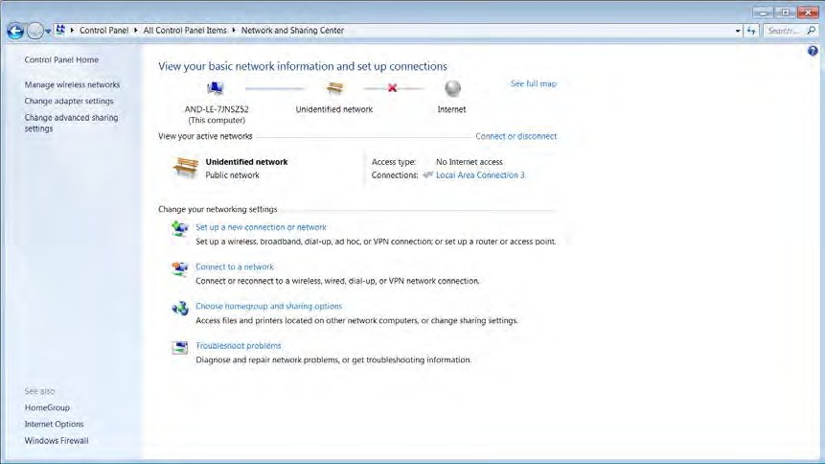

**Figure B-1. Basic Network Information**

1. Double-click on the local area connection to open.

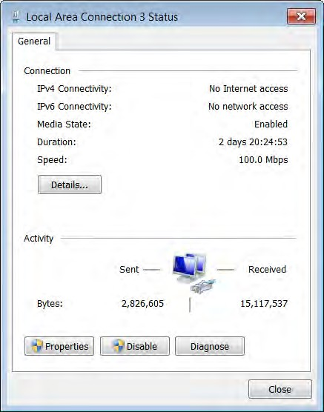

**Figure B-2. Local Area Connection Status**

1. Select **Properties**. Scroll down to find and highlight **Internet Protocol Version 4**.

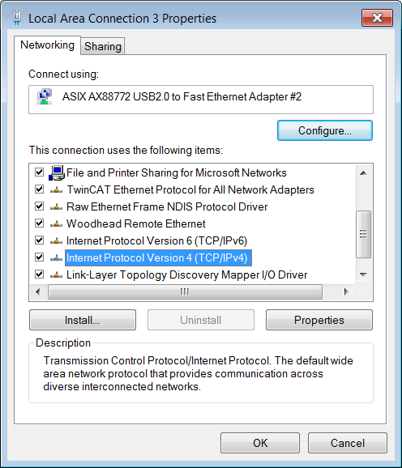

**Figure B-3. Internet Protocol Version 4**

1. Select Properties.

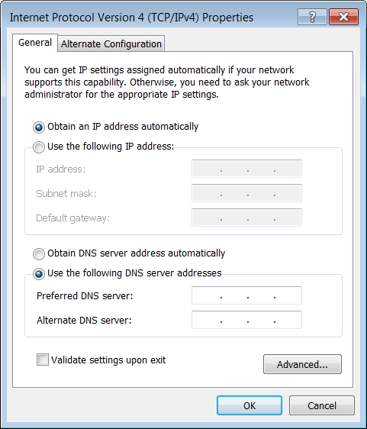

**Figure B-4. Properties**

1. Select **Use the following IP Address**. Enter a unique IP address for the computer in the format shown below. Press the Tab key on the computer to populate the Subnet mask.

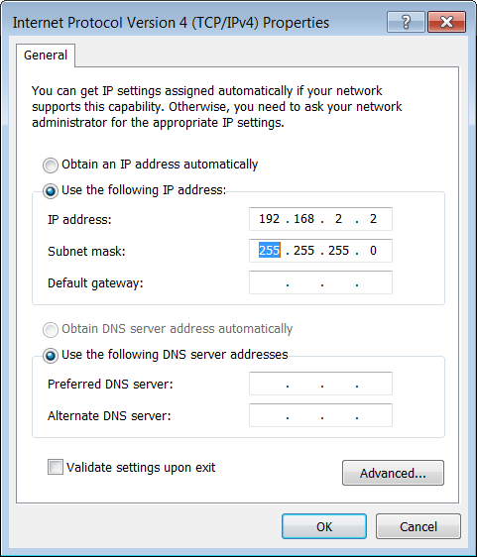

**Figure B-5. IP Settings**

1. Click **OK** to select and close the window.
2. Once the address has been updated, close the remaining network connection windows.

The laptop is ready for Ethernet communication with MKS MFC devices.

### Opening the Web Browser – Monitor Mode

1. Open Internet Explorer window.

|  |  |
| --- | --- |
| **Note**  ? | MKS recommends using Internet Explorer Version 11 to open the Web Browser. |

1. Enter the IP address of the device.

192.168.2.155 is the factory default address for the G and I Series MFC.

When the Web browser opens, it shows the Device page and it is in the Monitor Mode.

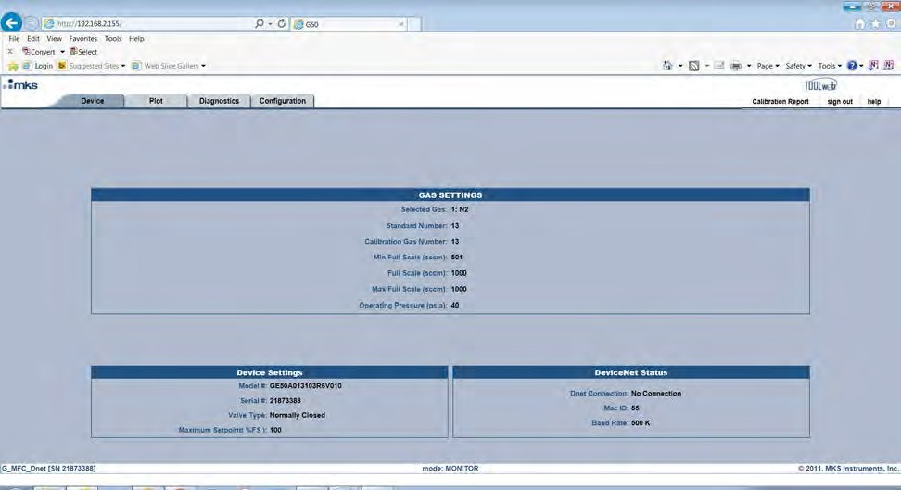

**Figure B-6. Device Page in Monitor Mode**

The Monitor Mode Device tab displays the current setup of the device:

* + - Gas Setting – Selected Gas, Min and Max Full Scale
    - Device Settings – Model Code and Serial Number

### Going to the Setup Mode

The Setup Mode allows for the user to access and make changes to a variety of Device features by opening the tabs located at the top of the page. The Setup Mode is accessed from the Configuration tab by entering a password in the Enter Password to Change Settings field.

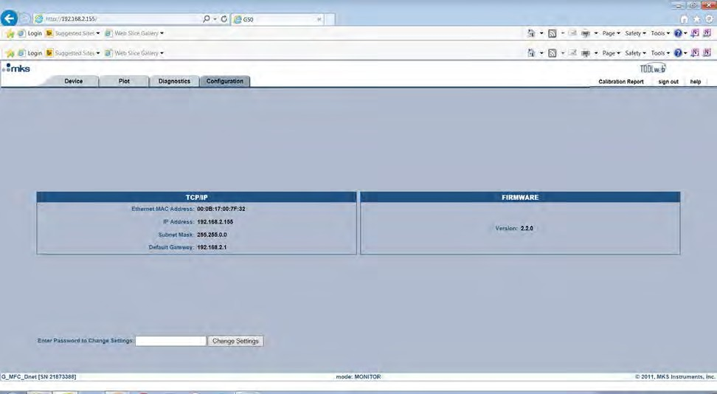

**Figure B-7. Enter Password to Change Settings**

|  |  |
| --- | --- |
| **Note**  ? | The password to change from a Monitor to the Setup mode is config. |

Once the password has been entered additional page tabs and active fields within the various Web browser pages allow the user to configure the MFC to a specific application.

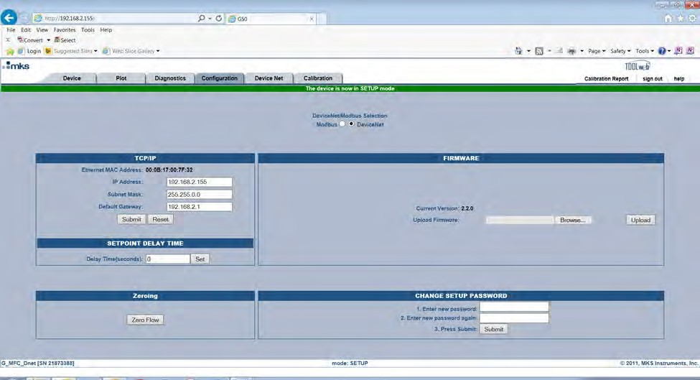

**Figure B-8. Additional Tabs**

The table below describes basic features that can be configured via the Web browser for all G and I Series MFCs in the Setup Mode.

**Table B-1. Basic Features in the Setup Mode**

|  |  |  |
| --- | --- | --- |
| **MFC Function** | **Browser Tab** | **MFC I/O Type** |
| Create a new gas | Device | All MFC Models |
| Re-range Full Scale | Device | All MFC Models |
| Select an existing gas table | Device | All MFC Models |
| Change MFC IP address | Configuration | All MFC Models |
| Change the firmware version | Configuration | All MFC Models |
| Set a set point delay time | Configuration | All MFC Models |
| Zero the MFC | Configuration | All MFC Models |
| Change the setup password | Configuration | All MFC Models |
| Modbus Mode | Configuration | All MFC Models |
| Change unit type | Device | 9 pin / 15 pin / 4 to 20 mA |
| Set ramp rate | Configuration | 9 pin / 15 pin / 4 to 20 mA |
| Set point offset (% FS) | Configuration | 9 pin / 15 pin |
| Optional input control | Optional Input | 15 pin |
| Select baud rate | RS485 | RS485 |
| Select MAC address | RS485 | RS485 |

### Utilizing the Plot Page and Saving Data

As described in the following sections, four steps must be completed to be able to actively plot selected MFC parameters:

1. Create a special folder called ToolWeb in the computers local C drive.
2. Download the latest version of Java from java.com Web site.
3. Before being able to successfully save data to the ToolWeb folder, place a special Java policy document into a Java security folder located on the C drive.
4. Configure the IP Address of the MFC as a “Trusted” site in order to be able to run the Java applet for the plot page.

#### ToolWeb Folder

1. Open the C drive on the computer.
2. Right-click and open a new folder.
3. Rename the new folder as ToolWeb. This is the folder where all data collected will be saved.

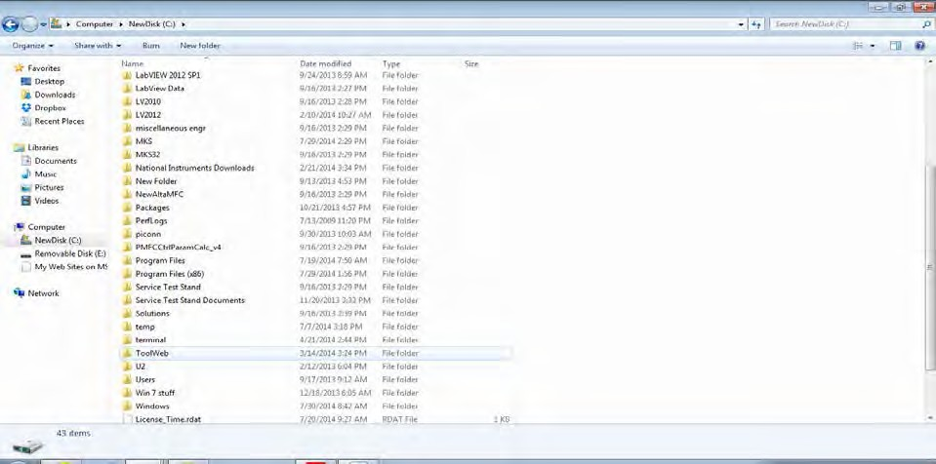

**Figure B-9. Tool Web Folder**

#### Downloading Java from java.com

Go online to java.com and download the latest version available on the Java Web site.



**Figure B-10. Java Web Site**

#### Placing the java.policy in the C:drive Java Folder

A special version of the security document java.policy has been modified to allow permission to “write” to the ToolWeb folder. This document must be placed in the security folder of the Java folder located on the C drive of the computer.

1. Locate the Java folder that was just downloaded to the computer.

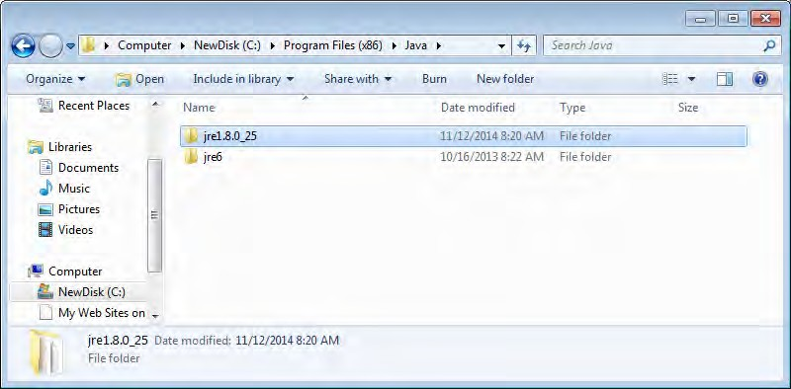

**Figure B-11. Java Web Site**

1. Open the folder and follow the path to the security folder.

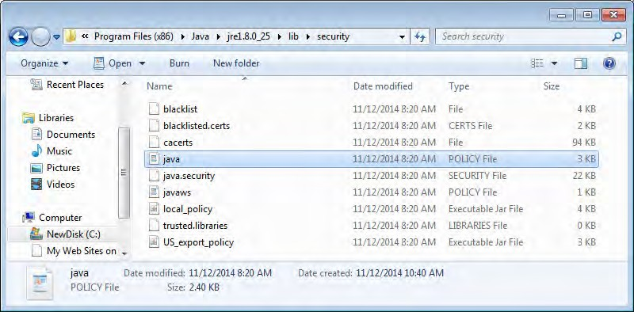

**Figure B-12. Security Folder**

1. Locate the new Java policy security document (supplied by MKS) and drop it into the Java security folder.

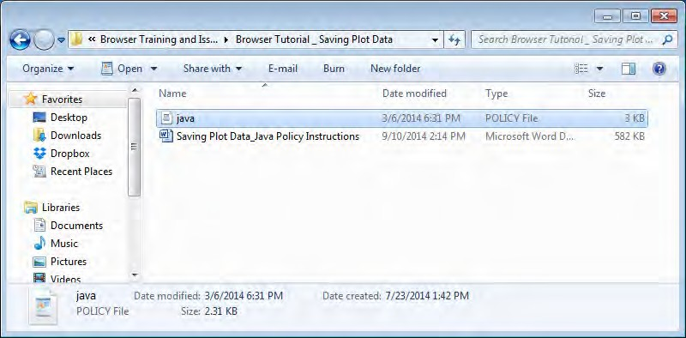

**Figure B-13. Java Policy Security Document in the Security Folder**

|  |  |
| --- | --- |
| **Note**  ? | If you do not want to overwrite the original java.policy file, change the name of the original file to java_old (as shown in the example below) to keep both files. |

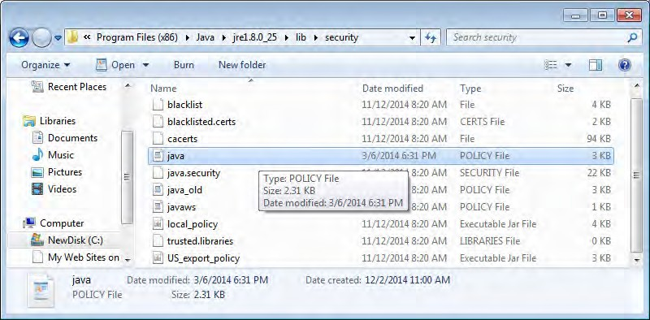

**Figure B-14. Java Policy Security Document**

#### Creating a Java Security “Trusted” Site

1. Locate the Java folder in the Programs listing.

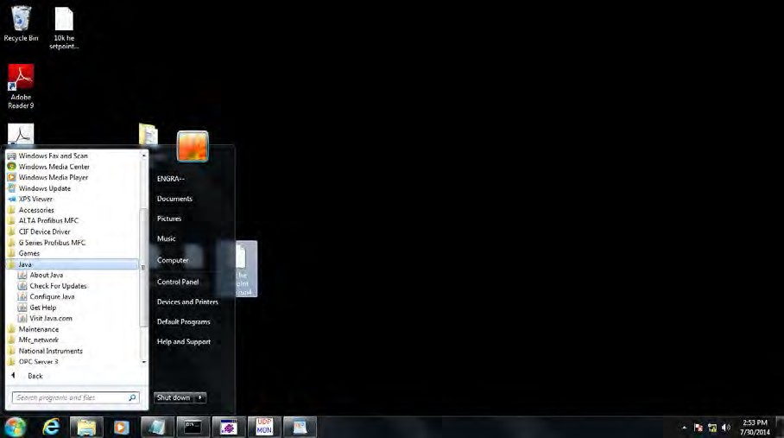

**Figure B-15. Java Folder**

1. Select **Configure Java**.
2. Go to the Security tab.

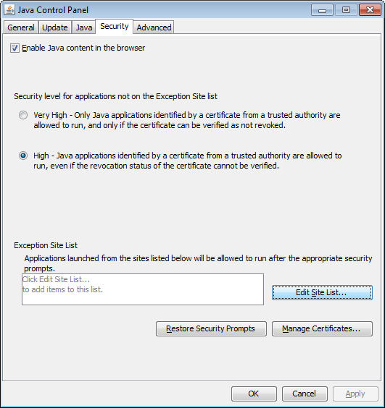

**Figure B-16. Security Tab**

1. Click the **Edit Sites List** button.
2. Click **Add** and enter the IP address of the MFC. Click **OK** to save it to the Exception Site List.

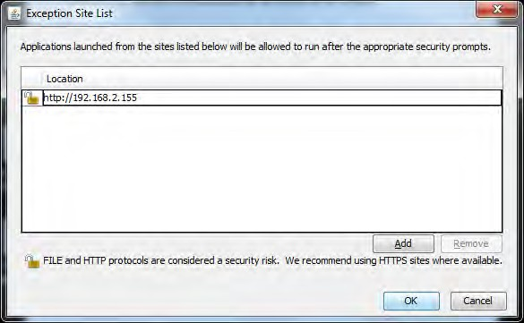

**Figure B-17. Exception Site List**

1. When you see a Security Warning, click **Continue** and then **OK** to close the Edit List window.

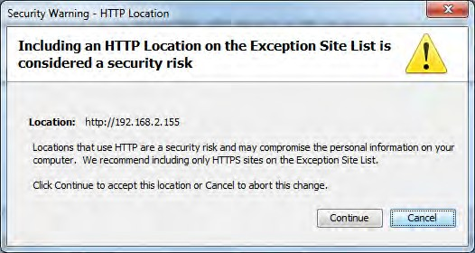

**Figure B-18. Security Warning**

1. Click OK to close the Security window.

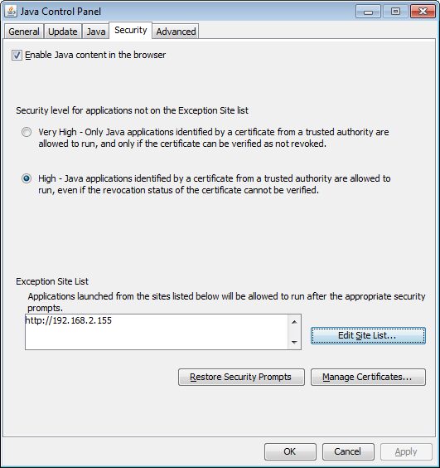

**Figure B-19. Security Window**

|  |  |
| --- | --- |
| **Note**  ? | After completing all steps in this section, close the Web browser and re-launch Internet Explorer. Re-open the Web browser, select the Plot tab, and provide permission to run the Java applet for the Plot function.  If a security pop-up message denying access persists, close all applications and re-boot the computer before trying to open the Plot page of the Web browser. |

**Notes**

**Electrical Cables and Accessories**



**C**

An analog G and I Series MFC should have both signal commons and the power common grounded together in order to minimize noise on the flow output signal and avoid potential analog signal offsets between set point and flow output. Tying these signal commons together can be done at:

* + - Power supply / I/O signal source
    - Inside the cable, as noted in the table below
    - Inside the MFC by selecting product code M (15-pin) or L (9-pin) when configuring the MFC

|  |  |
| --- | --- |
| **Note**  ? | MKS recommends a close examination of any existing electrical connections between the power supply / I/O signal source, cabling, and MFC prior to configuring a MKS MFC product as a replacement for existing process technology. Contact MKS Applications Engineering for additional assistance. |

**Table C-1. Analog Power and Signal I/O Cables**

|  |  |  |  |  |
| --- | --- | --- | --- | --- |
| **Cable Number** | **MFC Connector** | **Other Connector** | **Similar to** | **Notes, Description** |
| RCBDMFC-1 | 15 pin D subFemale | 15 pin D male | CB259-5 | Commons are tied at non- MFC end. No connections to valve open or close. |
| RCBDMFC-2 | 15 pin D sub Female | Flying leads | CB259-6 | Commons are tied at MFC end. No wires allocated for valve open or close. |
| RCBDMFC-3 | 9 pin D sub Female | 15 pin D male | CB147-12 | Commons are tied at non- MFC end. No connections to valve open or close. |
| RCBDMFC-4 | 15 pin D sub Female | 15 pin D male | CB147-1 | Commons are tied at non- MFC end. Connections to valve open and close. |
| RCBDMFC-5 | 15 pin D sub Female | Flying leads | (none) | 4-20 mA connections. All grounds are separate. |

**G and I Series Digital Thermal Based MFC, C: Electrical Cables and Accessories**

## Notes

**IP Rating for the I Series MFC and What It Means**



**D**

The I-series MFC has passed independent IP66 testing, so the question is:

What level of protection would that provide for the MFC in a harsh or demanding process environment?

The IP Code (or International Protection Rating, sometimes also interpreted as Ingress Protection Rating) consists of the letters IP followed by two digits and an optional letter. As defined in international standard IEC 60529, it classifies the degrees of protection provided against the intrusion of solid objects (such as dust) and water into a sealed enclosure. The standard aims to provide users more detailed information rather than vague marketing terms, such as waterproof.

The first digit indicates the level of protection that the enclosure provides against the ingress of solid foreign objects.

6 Dust Tight No ingress of dust; complete protection against contact.

To pass IP6X Dust Test Category 1, a vacuum was pulled on the interior of the MFC enclosure. The MFC was exposed to 2 kg/m3 of circulating talc for 3 minutes.

The second digit indicates the level of protection inside the enclosure against harmful ingress of water.

6 Powerful water jets Water projected in powerful jets (12.5mm nozzle) against the

enclosure from any direction shall have no harmful effects.

To pass IPX6 Spray Test, the MFC was subjected to a high force water jet impinging on all sides of the MFC at a rate of 100 l/min for 3 minutes.

**G and I Series Digital Thermal Based MFC, D: IP Rating for the I Series MFC and What It Means**

## Notes

**Modbus Operation**



**E**

### Enabling Modbus TCP/IP Control

G and I Series MFCs have the option of being controlled digitally over Modbus TCP/IP. Before an MFC can be operated using the Modbus LabView library, the secondary Modbus control system must be enabled from the Configuration page of the Web browser.

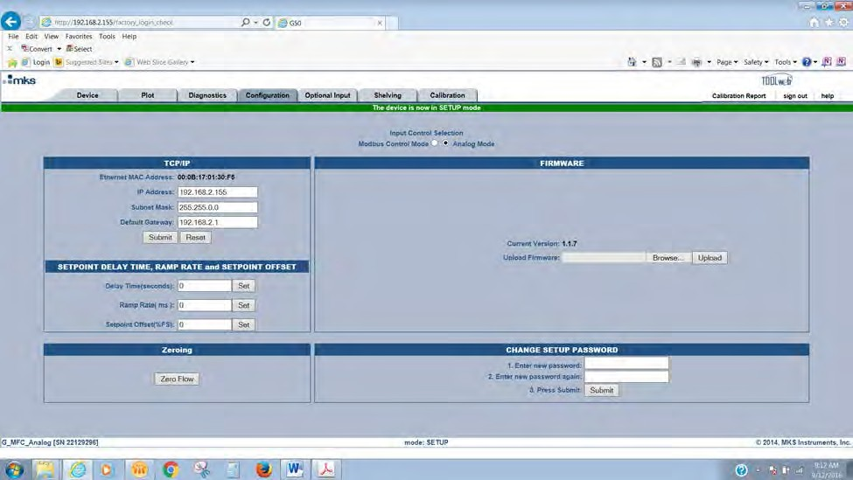

**Figure E-1. Configuration Page**

### Modbus Labview Library

MKS has created a Modbus LabView library that consists of a series of individual LabView virtual instruments (VIs) that can be used to connect to, communicate with, and control an MKS MFC of any interface type. In addition, as part of this Modbus Library, MKS has built a basic Modbus VI that provides an example of how the sub-VI’s can be designed for MFC Modbus operation.

|  |  |
| --- | --- |
| **Note**  ? | To get full benefit of the Modbus LabView library, a National Instruments LabView application development system is required. Without a National Instruments LabView application development system, only the executable example VI is accessible for control of the MFC. Contact MKS Applications Engineering to obtain the Modbus LabView Library file information. |

|  |  |
| --- | --- |
| **Note**  ? | MKS created these files for customers who are knowledgeable with regards to Modbus and are experienced programmers in LabView. MKS does not provide any additional technical LabView programming support for this application. |

### MKS Example VI

The example Modbus VI is a basic LabView program that provides communication and control of basic G and I Series functionality, including:

* + - Exhibit MFC identity parameters
    - Ability to send set point and read back flow
    - Ability to graph set point and flow
    - Valve override open and close
    - Zero flow

To access and launch the VI, the laptop or computer must have installed either a National Instruments 2011 Runtime Engine (can be downloaded from the National Instruments Web Site) or a version of the LabView development system from 2011 or later.

1. Enable Modbus from the Configuration page.

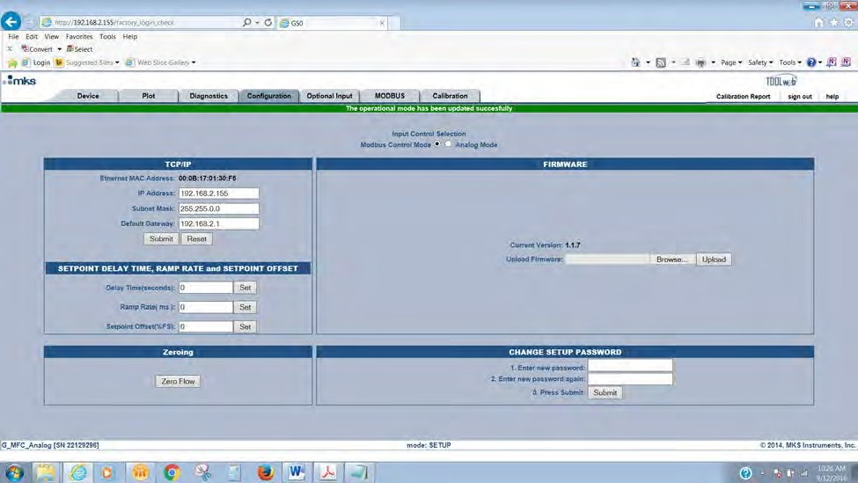

**Figure E-2. Configuration Page**

1. Launch the VI. The VI assumes that the IP address is the default address 192.168.2.155.
2. Select **Initialize**.

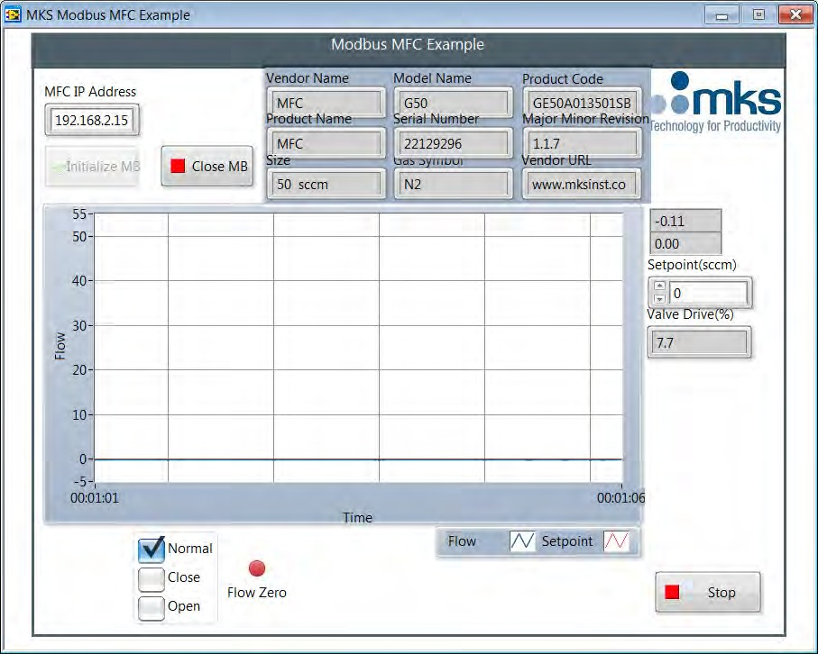

**Figure E-3. MKS Modbus MFC Example**

|  |  |
| --- | --- |
| **Note**  ? | Before leaving the VI, verify the MFC is in Normal Mode as shown above. Enable the Close button before clicking the Stop button and exiting the program. |
|  |  |

|  |  |
| --- | --- |
| **Note**  ? | Once Modbus is selected on the Web Browser Configuration page, the MFC will not respond to **any** primary I/O commands. To return to primary I/O control, the radio button must be returned to its original position using the Web browser. |
|  |  |

|  |  |
| --- | --- |
| **Note**  ? | Ethercat MFC does not have the option to be converted to Modbus TCP/IP. |

## Notes

**Analog Optional Input**



**F**

### Setup Mode: Optional Input Tab

1. Optional input provides the user with the ability to take an external control signal from a pressure transducer and feed that signal back into the MFC through pin 10. Response to a set point then uses that output signal from the transducer to drive the MFC valve, and modulate gas flow such that the pressure in the volume is controlled to the application pressure.
2. Using this mode relegates the MFC to control the pressure output as determined by the set point. Flow under these control conditions is independent of the set point being delivered to the device.
3. This control feature of the MFC is available only with analog 15-pin D devices.
4. The MFC allows the user to select an upstream or downstream pressure control scheme depending on the application.

#### Basic Wiring Diagram for Optional Input (Downstream Control Example)

**Baratron to MFC**: Two wires

1. Transducer pressure output Pin 1 ------------ MFC Optional Input Pin 10
2. Transducer pressure return Pin 8 ------------ MFC Signal Common Pin 11 or 12 Refer to the example on the next page.

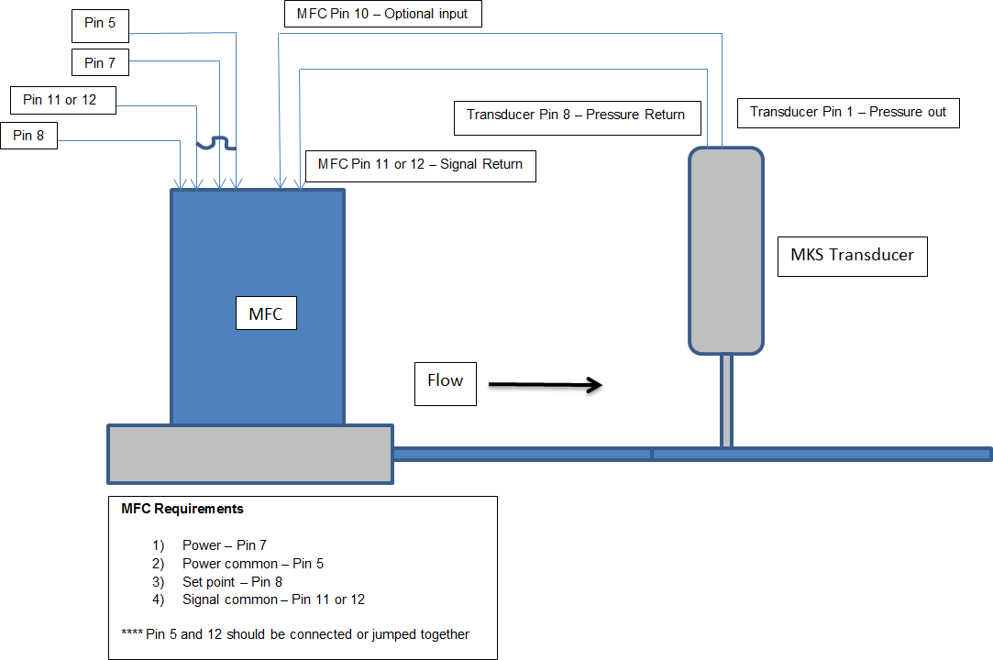

**Figure F-1. Basic Wiring Diagram for Optional Input (Downstream Control Example)**

#### Optional Input Configuration via the Web Browser

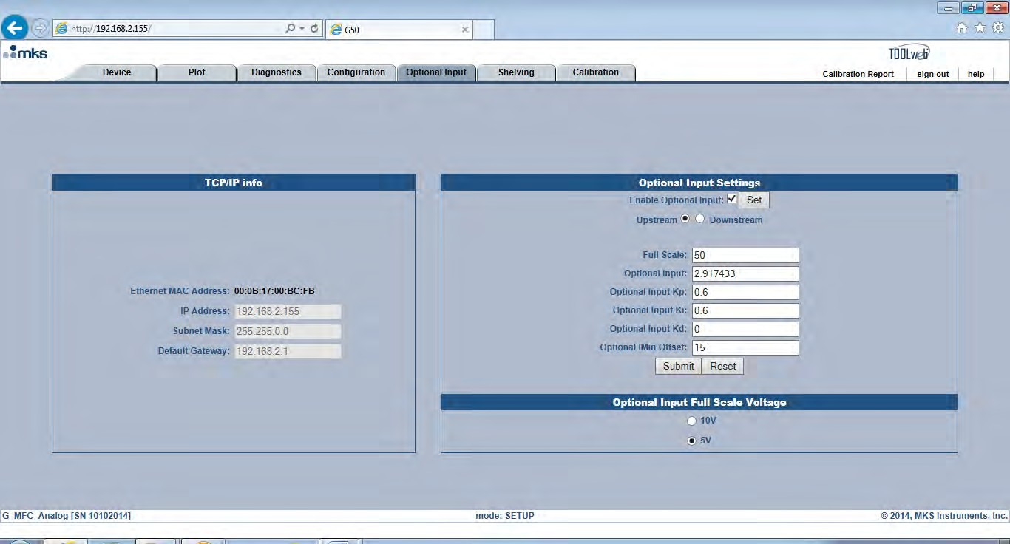The Web browser is used to enable the Optional Input function.

**Figure F-2. Optional Input Page**

Setting up the MFC requires that **Optional Input** is enabled by checking the enable box and clicking **Set**.

Optional Input may be set for upstream or downstream control, as determined by the application.

Full scale and full scale voltage of the transducer must be defined.

Response to set point can be adjusted using **Optional Input Kp** and **Ki**. These values can also be adjusted on the Plot page as shown below.

To save changes made to define the Optional Input setup, click **Submit**.

|  |  |
| --- | --- |
| **Note**  ? | The full scale voltage for the transducer has to be determined and selected on the Web page as 5 or 10V full scale. The set point that drives the MFC to respond to the optional input transducer signal also scales according to the full scale voltage selected.  Full scale transducer = 5 V / Set point input 0-5 V Full scale transducer = 10 V / Set point input 0-10 V |

#### ?Optional Input Plot Page

**Figure F-3. Optional Input Plot Page**

The key parameters for tuning an optional input pressure response is Opt_kp and ki.

Opt_imin_offset is a factor that is applied to the valve command minimum (valve current starting point) to effectively lower the command min by the value of the offset. For example, an Opt_imin_offset of 15, the default, would shift the valve command minimum down by 15 mA.

In some pressure control circumstance normally associated with trying to control to very low at optional input set points (trying to control at very low pressures), the following condition can occur:

MFC command min (valve starting point in flash memory) > valve_cmd at set point (valve mA at steady state for a given set point)

If this condition is true, the MFC is going to essentially start at a higher current than necessary to actually achieve set point and the response is going to overshoot when the set point is initiated. This parameter can be used to correct overshoot in this very special circumstance.

The default value, 15, should be adequate for the majority of optional input control scenarios and does not need to be changed for the application.

##### *Optional Input Plot Page Example*

Pressure control data collected, saved from the Plot page, and transferred into an Excel spreadsheet is presented in the graph below:

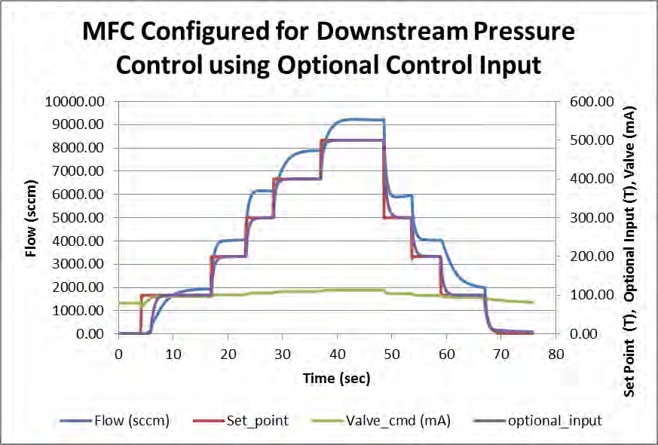

**Figure F-4. Optional Input Plot Page Example**