**1046210-001, Rev A**

**January, 2013**

**MKS G-Series**

**Digital**

**Mass Flow Controllers Instruction Manual**

**WARRANTY**

* 1. eries Mass Flow Controllers

MKS Instruments, Inc. (MKS) warrants that for one (1) year from the date of shipment the equipment described above (the “equipment”) manufactured by MKS shall be free from defects in materials and workmanship.

For the period commencing with the date of shipment of this equipment and ending one (1) year later, MKS will, at its option, either repair or replace any part which is defective in materials or workmanship without charge to the purchaser. The foregoing shall constitute the exclusive and sole remedy of the purchaser for any breach of MKS of this warranty.

The purchaser, before returning any equipment covered by this warranty, which is asserted to be defective by the purchaser, shall make specific written arrangements with respect to the responsibility for shipping the equipment and handling any other incidental charges with the MKS Sales Representative or distributor from which the equipment was purchased or, in the case of a direct purchase from MKS, with the MKS home office in Andover, Massachusetts, USA.

This warranty does not apply to any equipment which has not been installed and used in accordance with the specifications recommended by MKS for the proper and normal use of the equipment. MKS shall not be liable under any circumstances for indirect, special, consequential, or incidental damages in connection with, or arising out of, the sale, performance, or use of the equipment covered by this warranty.

MKS recommends that all MKS pressure and flow products be calibrated periodically (typically) every 6 to 12 months) to ensure accurate readings. When a product is returned to MKS for this periodic re-calibration it is considered normal preventative maintenance not covered by any warranty.

THIS WARRANTY IS IN LIEU OF ALL OTHER RELEVANT WARRANTIES, EXPRESSED OR IMPLIED, INCLUDING THE IMPLIED WARRANTY OF MERCHANTABILITY AND THE IMPLIED WARRANTY OF FITNESS FOR A PARTICULAR PURPOSE, AND ANY WARRANTY AGAINST INFRINGEMENT OF ANY PATENT.

*Copyright © 2013 by MKS Instruments, Inc.*

*All rights reserved. No part of this work may be reproduced or transmitted in any form or by any means, electronic or mechanical, including photocopying and recording, or by any information storage or retrieval system, except as may be expressly permitted in writing by MKS Instruments, Inc.*

*Printed in the United States of America*

Baratron and Mass-Flo are registered trademarks of MKS Instruments, Inc., Andover, MA DeviceNet™ is a trademark of Open DeviceNet Vendor Association, Inc., Coral Springs, FL Elgiloy is a registered trademark of Elgiloy Specialty Metals, Elgin, IL

Teflon is a registered trademark of E.I. du Pont de Nemours and Company, Wilmington, DE Swagelok and VCR are registered trademarks of Swagelok Marketing Company, Solon, OH Protected by U. S. Patents 5314164 and 5461913 and other Patents and Patents Pending

# Table of Contents

List of References v

Mass Flow Device Safety Information 1

Symbols Used in This Instruction Manual 1

Symbols Found on the Unit 1

Safety Procedures and Precautions 1

Sicherheitshinweise für das Massenflussgerät 3

In dieser Betriebsanleitung vorkommende Symbole 3

Erklärung der am Gerät angebrachten Symbole 3

Sicherheitsvorschriften und Vorsichtsmaßnahmen 3

Informations de sécurité pour appareils de mesure/contrôle de débit massique 5

Symboles utilisés dans ce manuel d'utilisation 5

Symboles figurant sur l'unité 5

Mesures de sécurité et précautions 5

Medidas de seguridad del dispositivo de flujo de masa 7

Símbolos usados en este manual de instrucciones 7

Símbolos hallados en la unidad 7

Procedimientos y precauciones de seguridad 7

マスフロー機器の安全に関する情報 9

本取扱説明書のマーク 9

本機器のマーク 9

安全対策について 10

질량 유량 장치 안전 정보 13

본 지침 매뉴얼에 사용되는 기호들 13

장치에 표시된 기호들 13

안전 절차 및 예방조치 14

Chapter One: General Information 17

Introduction 17

How This Manual is Organized 18

Customer Support 19

Chapter Two: Overview 21

General Information 21

How the MFC Works 22

Operation of the MFC with Gases other than Nitrogen 22

Chapter Three: Installation and Configuration 24

Unpacking 24

Product Location and Requirements 25

Product Dimensions 25

GE50A and GM50A – See Appendix C 25

GV50A – See Appendix D 25

Mounting Hardware 26

Installation Procedure 26

Chapter Four: Analog and Digital Interfaces 29

Analog I/O Interface Cables 29

Analog Interface Input and Output Options 30

Digital Interface Input and Output Options 33

Chapter Five: Ethernet Interface Setup and Configuration 44

Step 1: Install the Java™ Plug-in (for single IP address) 44

Step 2: Setup Network for Communication through Ethernet 45

Chapter Six: Embedded Web-Based GUI and Diagnostics 54

Logging On to Your MFC 54

Monitor Mode 54

Setup Mode 59

Chapter Seven: Maintenance 68

General Information 68

Recalibration 68

Flow Zero Adjustment 68

Chapter Eight: Troubleshooting 73

Troubleshooting Chart 73

Appendix A: Product Specifications 79

Performance Specifications – GE50A/GV50A/GM50A 79

Specifications are subject to change without notice.Mechanical Specifications - GE50A/GV50A/GM50A 79

Electrical Specifications for GE50A, GM50A and GV50A 80

Appendix B : Model Code Explanation for GE50A & GV50A 84

Model Code Description – Elastomer Sealed Products 84

Appendix C: Model Code Explanation for GM50A 90

Model Code Description – GM50A – Metal Sealed Products 90

Appendix D : Outline Drawings 96

GE50A MFC and GM50A MFC/MFM 96

GV50A MFC w/ Integral Shut-off Valve 99

Appendix D: Health and Safety Form 102

#### ......................................................................................................................................................................... 102

**List of Figures**

Figure 1: Serial Number Label (sample) 26

Figure 2: DeviceNet Connector Pin Diagram 33

Figure 3: Devicenet Top View 34

Figure 4: Devicenet Baud Rate Switch 35

Figure 5: Devicenet MAC ID Switches 35

Figure 6: Profibus Top View 38

Figure 7: Profibus Station Address Switches 39

Figure 8: RS485 Top View 41

Figure 9: Embedded GUI, MFC Device Page in Monitor Mode 55

Figure 10: Embedded GUI, Plot Page in Monitor Mode 56

Figure 11: Embedded GUI, Configuration Page in Monitor Mode 57

Figure 12: Embedded GUI, RS485 Comm Page in Monitor Mode 58

Figure 13: Setup Mode (Configuration Page) 59

Figure 14: Embedded GUI, Device Page in Setup Mode 60

Figure 15: Embedded GUI, Creating A New Gas Instance 61

Figure 16: Changing the Full Scale Flow Range 61

Figure 17: Embedded GUI, Plot Page in Setup Mode 62

Figure 18: Embedded GUI, Configuration Page in Setup Mode 63

Figure 19: Embedded GUI, RS485 Comm Page in Setup Mode 65

Figure 20: Embedded GUI, Diagnostics Page in Setup Mode 66

# List of Tables

Table 1: Definition of Symbols Found on the Unit 1

Tabelle 2: Bedeutung der am Gerät angebrachten Symbole 3

Tableau 3: Définition des symboles sur l'unité 5

Tabla 4: Definición de los símbolos hallados en la unidad 7

表 5: 本機器に使⽤されているマークについて 9

표 6: 장치에 표시된 기호들의 정의 13

Table 7: MKS Interface Cables 29

Table 8: Analog Interface Voltage I/O (0 to 5 VDC) – 9 Pin D Male Pinouts – Model Code A 30

Table 9: Analog Interface Voltage I/O (0 to 5 VDC) – 15 Pin D Male Pinouts – Model Code B 31

Table 10: Digital Interface - DeviceNet Connector Pinout – Model Code 6 33

Table 11: Network (NET) Status LED Indicators 34

Table 12A: Profibus 9 Pin D Male Power Connector– Model Code 4 37

Table 12B: Profibus 9 Pin D Female Communications Connector – Model Code 4 38

Table 13: Digital Interface – RS485 Using 9 Pin D – Model Code 5 40

Table 14: RS485 Module Status LED Indicators 40

Table 15: Troubleshooting Chart 73

# List of References

The documents listed below are referenced throughout this manual.

* + 1. “DeviceNet Specification, Volume I: DeviceNet Communication Model and Protocol”, Open DeviceNet Vendors Association, Inc. Release 2.0. ERRATA 4.0
    2. “DeviceNet Specification, Volume II: DeviceNet Profiles and Object Library”, Open DeviceNet Vendors Association, Inc. Release 2.0. ERRATA 4.0
    3. “Sensor/Actuator Network Common Device Model”, SEMI Standards Document E54.1-0097.
    4. “Sensor/Actuator Network Communications Standard for DeviceNet”, SEMI Standards Draft Document E54.4-0097.
    5. “Sensor/Actuator Network Specific Device Model for Mass Flow Devices”, SEMI Standards Draft Document #2253C.
    6. “Sensor/Actuator Network Standard”, SEMI Standards Document E54-0097.
    7. SEMI E17-00-0060 Guideline for Mass Flow Controller Transient Characteristics Tests
    8. SEMI E18-00-0091. Guideline for Temperature Specifications of the Mass Flow Controller
    9. SEMI E27-00-0092. Standard for Mass Flow Controller and Mass Flow Meter Linearity
    10. SEMI E28-00-0092. Guideline for Pressure Specifications of the Mass Flow Controller
    11. SEMI E56-00-1296. Test Method for Determining Accuracy, Linearity, Repeatability, Short Term Reproducibility, Hysteresis, and Dead Band of Thermal Mass Flow Controllers
    12. SEMI Standards Document E52-95.
    13. SEMI E80-00-0299. Test Method Determining Attitude Sensitivity of Mass Flow Controllers
    14. SEMI Standards Document E52-95. Practice for Referencing Gases and Gas Mixtures Used in Digital Mass Flow Controllers
    15. Instruction Manual, G-Series MFC, RS845 Supplement
    16. Instruction Manual, G-Series MFC, DeviceNet Supplement
    17. Instruction Manual, G-Series MFC, Profibus Supplement

This page intentionally left blank.

# Mass Flow Device Safety Information

## Symbols Used in This Instruction Manual

Definitions of WARNING, CAUTION, and NOTE messages used throughout the manual.

**Warning The WARNING sign denotes a hazard. It calls attention to a procedure, practice, condition, or the like, which, if not correctly performed or adhered to, could result in injury to personnel.**

#### Caution The CAUTION sign denotes a hazard. It calls attention to an operating procedure, practice, or the like, which, if not correctly performed or adhered to, could result in damage to or destruction of all or part of the product.

**Note** The NOTE sign denotes important information. It calls attention to a procedure, practice, condition, or the like, which is essential to highlight.

## Symbols Found on the Unit

The following table describes symbols that may be found on the unit.

**Table 1: Definition of Symbols Found on the Unit**

|  |  |  |  |  |  |
| --- | --- | --- | --- | --- | --- |
| |  On (Supply) IEC 417, No. 5007 | Off (Supply) IEC 417, No. 5008 | | Earth (ground) IEC 417, No. 5017 | | Protective Earth (ground) IEC 417, No. 5019 |
| Frame or Chassis IEC 417, No. 5020 | Equipotentiality IEC 417, No. 5021 | | Direct Current IEC 417, No. 5031 | | Alternating Current IEC 417, No. 5032 |
| Both Direct and Alternating Current IEC 417, No. 5033-a | | Class II Equipment IEC 417, No. 5172-a | | Three Phase Alternating Current IEC 617-2, No. 020206 | |
| Caution (refer to accompanying documents)  ISO 3864, No. B.3.1 | | Caution, Risk of Electric Shock ISO 3864, No. B.3.6 | | Caution, Hot Surface IEC 417, No. 5041 | |

## Safety Procedures and Precautions

#### Observe the following general safety precautions during all phases of operation of this instrument. Failure to comply with these precautions or with specific warnings elsewhere in this manual violates safety standards of intended use of the instrument and may impair the protection provided by the equipment. MKS Instruments, Inc. assumes no liability for the customer’s failure to comply with these requirements.

**DO NOT SUBSTITUTE PARTS OR MODIFY INSTRUMENT**

Do not install substitute parts or perform any unauthorized modification to the instrument. Return the instrument to an MKS Calibration and Service Center for service and repair to ensure that all safety features are maintained.

**SERVICE BY QUALIFIED PERSONNEL ONLY**

Operating personnel must not remove instrument covers. Component replacement and internal adjustments must be made by qualified service personnel only.

**KEEP AWAY FROM LIVE CIRCUITS**

Do not replace components with power cable connected. Under certain conditions, dangerous voltages may exist even with the power cable removed. To avoid injuries, always disconnect power and discharge circuits before touching them.

**USE CAUTION WHEN OPERATING WITH HAZARDOUS MATERIALS**

If hazardous materials are used, users must take responsibility to observe the proper safety precautions, completely purge the instrument when necessary, and ensure that the material used is compatible with sealing materials.

**PURGE THE INSTRUMENT**

After installing the unit, or before its removal from a system, be sure to purge the unit completely with a clean dry gas to eliminate all traces of the previously used flow material.

**USE PROPER PROCEDURES WHEN PURGING**

This instrument must be purged under a ventilation hood, and gloves must be worn to protect personnel. To purge this instrument properly, it must be purged in both the horizontal base down and horizontal base up configurations as defined in SEM spec. Device has trapped volume in pressure sensor where gas which is higher than air but still hazardous can accumulate.

**DO NOT OPERATE IN AN EXPLOSIVE ENVIRONMENT**

To avoid explosion, do not operate this product in an explosive environment unless it has been specifically certified for such operation.

**USE PROPER FITTINGS AND TIGHTENING PROCEDURES**

All instrument fittings must be consistent with instrument specifications, and compatible with the intended use of the instrument. Assemble and tighten fittings according to manufacturer's directions.

**CHECK FOR LEAK-TIGHT FITTINGS**

Before proceeding to instrument setup, carefully check all plumbing connections to the instrument to ensure leak-tight installation.

**OPERATE AT SAFE INLET PRESSURES**

This unit should never be operated at pressures higher than the rated maximum pressure (refer to the product specifications for the maximum allowable pressure).

**INSTALL A SUITABLE BURST DISC**

When operating from a pressurized gas source, a suitable burst disc should be installed in the vacuum system to prevent system explosion should the system pressure rise.

**KEEP THE UNIT FREE OF CONTAMINANTS**

Do not allow contaminants of any kind to enter the unit before or during use. Contamination such as dust, dirt, lint, glass chips, and metal chips may permanently damage the unit.

**ALLOW PROPER WARM UP TIME FOR TEMPERATURE-CONTROLLED UNITS**

Temperature-controlled unit will only meet specifications when sufficient time is allowed for the unit to meet, and stabilize at, the designed operating temperature. Do not zero or calibrate the unit until the warm up is complete.

# Sicherheitshinweise für das Massenflussgerät

## In dieser Betriebsanleitung vorkommende Symbole

Bedeutung der mit WARNUNG!, VORSICHT! und HINWEIS gekennzeichneten Absätze in dieser Betriebsanleitung.

**Warnung! Das Symbol WARNUNG! weist auf eine Gefahr für das Bedienpersonal hin. Es macht auf einen Arbeitsablauf, eine Arbeitsweise, einen Zustand oder eine sonstige Gegebenheit aufmerksam, deren unsachgemäße Ausführung bzw. ungenügende Berücksichtigung zu Verletzungen führen kann.**

#### Vorsicht! Das Symbol VORSICHT! weist auf eine Gefahr für das Gerät hin. Es macht auf einen Bedienungsablauf, eine Arbeitsweise oder eine sonstige Gegebenheit aufmerksam, deren unsachgemäße Ausführung bzw. ungenügende Berücksichtigung zu einer Beschädigung oder Zerstörung des Gerätes oder von Teilen des Gerätes führen kann.

**Hinweis** Das Symbol HINWEIS macht auf wichtige Informationen bezüglich eines Arbeitsablaufs, einer Arbeitsweise, eines Zustands oder einer sonstige Gegebenheit aufmerksam.

## Erklärung der am Gerät angebrachten Symbole

Nachstehender Tabelle sind die Bedeutungen der Symbole zu entnehmen, die am Gerät angebracht sein können.

**Tabelle 2: Bedeutung der am Gerät angebrachten Symbole**

|  |  |  |  |  |  |
| --- | --- | --- | --- | --- | --- |
| |  Ein (Energie) IEC 417, No.5007 | Aus (Energie) IEC 417, No.5008 | | Erdanschluss IEC 417, No.5017 | | Schutzleiteranschluss IEC 417, No.5019 |
| Masseanschluss IEC 417, No.5020 | Aquipotentialanschluss IEC 417, No.5021 | | Gleichstrom IEC 417, No.5031 | | Wechselstrom IEC 417, No.5032 |
| Gleich- oder Wechselstrom IEC 417, No.5033-a | | Durchgängige doppelte oder verstärkte Isolierung IEC 417, No.5172-a | | Dreileiter-Wechselstrom (Drehstrom) IEC 617-2, No.020206 | |
| Warnung vor einer Gefahrenstelle (Achtung, Dokumentation beachten) ISO 3864, No.B.3.1 | | Warnung vor gefährlicher elektrischer Spannung ISO 3864, No.B.3.6 | | Höhere Temperatur an leicht zugänglichen Teilen IEC 417, No.5041 | |

## Sicherheitsvorschriften und Vorsichtsmaßnahmen

#### Folgende allgemeine Sicherheitsvorschriften sind während allen Betriebsphasen dieses Gerätes zu befolgen. Eine Missachtung der Sicherheitsvorschriften und sonstiger Warnhinweise in dieser Betriebsanleitung verletzt die für dieses Gerät und seine Bedienung geltenden Sicherheitsstandards,

**und kann die Schutzvorrichtungen an diesem Gerät wirkungslos machen. MKS Instruments, Inc. haftet nicht für Missachtung dieser Sicherheitsvorschriften seitens des Kunden.**

**Niemals Teile austauschen oder Änderungen am Gerät vornehmen!**

Ersetzen Sie keine Teile mit baugleichen oder ähnlichen Teilen, und nehmen Sie keine eigenmächtigen Änderungen am Gerät vor. Schicken Sie das Gerät zwecks Wartung und Reparatur an den MKS-Kalibrierungs- und -Kundendienst ein. Nur so wird sichergestellt, dass alle Schutzvorrichtungen voll funktionsfähig bleiben.

**Wartung nur durch qualifizierte Fachleute!**

Das Auswechseln von Komponenten und das Vornehmen von internen Einstellungen darf nur von qualifizierten Fachleuten durchgeführt werden, niemals vom Bedienpersonal.

**Vorsicht vor stromführenden Leitungen!**

Ersetzen Sie keine Komponente von Geräten, die an Netzstrom angeschlossen sind. Unter Umständen kann gefährliche Spannung auch dann bestehen, wenn das Netzanschlusskabel von der Strmversorgung entfernt wurde. Um Verletzungen vorzubeugen sollten zuerst alle Geräte von der Stromversorgung getrennt und alle Stromkreusläufe entladen werden.

**Vorsicht beim Arbeiten mit gefährlichen Stoffen!**

Wenn gefährliche Stoffe verwendet werden, muss der Bediener die entsprechenden Sicherheitsvorschriften genauestens einhalten, das Gerät, falls erforderlich, vollständig spülen, sowie sicherstellen, dass der Gefahrstoff die am Gerät verwendeten Materialien, insbesondere Dichtungen, nicht angreift.

**Spülen des Gerätes mit Gas!**

Nach dem Installieren oder vor dem Ausbau aus einem System muss das Gerät unter Einsatz eines reinen Trockengases vollständig gespült werden, um alle Rückstände des Vorgängermediums zu entfernen.

**Anweisungen zum Spülen des Gerätes**

Das Gerät darf nur unter einer Ablufthaube gespült werden. Schutzhandschuhe sind zu tragen.

**Gerät nicht zusammen mit explosiven Stoffen, Gasen oder Dämpfen benutzen!**

Um der Gefahr einer Explosion vorzubeugen, darf dieses Gerät niemals zusammen mit (oder in der Nähe von) explosiven Stoffen aller Art eingesetzt werden, sofern es nicht ausdrücklich für diesen Zweck zugelassen ist.

**Anweisungen zum Installieren der Armaturen!**

Alle Anschlussstücke und Armaturenteile müssen mit der Gerätespezifikation übereinstimmen, und mit dem geplanten Einsatz des Gerätes kompatibel sein. Der Einbau, insbesondere das Anziehen und Abdichten, muss gemäß den Anweisungen des Herstellers vorgenommen werden.

**Verbindungen auf Undichtigkeiten prüfen!**

Überprüfen Sie sorgfältig alle Verbindungen der Vakuumkomponenten auf undichte Stellen.

**Gerät nur unter zulässigen Anschlussdrücken betreiben!**

Betreiben Sie das Gerät niemals unter Drücken, die den maximal zulässigen Druck (siehe Produktspezifikationen) übersteigen.

**Geeignete Berstscheibe installieren!**

Wenn mit einer unter Druck stehenden Gasquelle gearbeitet wird, sollte eine geeignete Berstscheibe in das Vakuumsystem installiert werden, um eine Explosionsgefahr aufgrund von steigendem Systemdruck zu vermeiden.

**Verunreinigungen im Gerät vermeiden!**

Stellen Sie sicher, dass Verunreinigungen jeglicher Art weder vor dem Einsatz noch während des Betriebs in das Instrumenteninnere gelangen können. Staub- und Schmutzpartikel, Glassplitter oder Metallspäne können das Gerät dauerhaft beschädigen oder Prozess- und Messwerte verfälschen.

**Bei Geräten mit Temperaturkontrolle korrekte Anwärmzeit einhalten!**

Temperaturkontrollierte Geräte arbeiten nur dann gemäß ihrer Spezifikation, wenn genügend Zeit zum Erreichen und Stabilisieren der Betriebstemperatur eingeräumt wird. Kalibrierungen und Nulleinstellungen sollten daher nur nach Abschluss des Anwärmvorgangs durchgeführt werden.

# Informations de sécurité pour appareils de mesure/contrôle de débit massique

## Symboles utilisés dans ce manuel d'utilisation

Définitions des indications AVERTISSEMENT, ATTENTION, et REMARQUE utilisées dans ce manuel.

**Avertissement L'indication AVERTISSEMENT signale un danger pour le personnel. Elle attire l'attention sur une procédure, une pratique, une condition, ou toute autre situation présentant un risque d'accident pour le personnel, en cas d'exécution incorrecte ou de non-respect des consignes.**

#### Attention L'indication ATTENTION signale un danger pour l'appareil. Elle attire l'attention sur une procédure d'exploitation, une pratique, ou toute autre situation, présentant un risque de dégât ou de destruction partielle ou totale du produit, en cas d'exécution incorrecte ou de non-respect des consignes.

**Remarque** L'indication REMARQUE signale une information importante. Elle attire l'attention sur une procédure, une pratique, une condition, ou toute autre situation, présentant un intérêt particulier.

## Symboles figurant sur l'unité

Le tableau suivant décrit les symboles pouvant apparaître sur l'unité.

**Tableau 3: Définition des symboles sur l'unité**

|  |  |  |  |  |  |
| --- | --- | --- | --- | --- | --- |
| |  Marche (sous tension) IEC 417, No.5007 | Arrêt (hors tension) IEC 417, No.5008 | | Terre (masse) IEC 417, No.5017 | | Terre de protection (masse) IEC 417, No.5019 |
| Masse  IEC 417, No.5020 | Equipotentialité IEC 417, No.5021 | | Courant continu IEC 417, No.5031 | | Courant alternatif IEC 417, No.5032 |
| Courant continu et alternatif IEC 417, No.5033-a | | Matériel de classe II IEC 417, No.5172-a | | Courant alternatif triphasé IEC 617-2, No.020206 | |
| Attention : se reporter à la documentation ISO 3864, No.B.3.1 | | Attention : risque de choc électrique  ISO 3864, No.B.3.6 | | Attention : surface brûlante IEC 417, No.5041 | |

## Mesures de sécurité et précautions

#### Observer les précautions générales de sécurité suivantes pendant toutes les phases d'exploitation de cet appareil. Le non-respect des ces précautions ou des avertissements du manuel constitue une violation des normes de sécurité relatives à l'utilisation de l'appareil et peut compromettre la protection assurée

**par l'appareil. MKS Instruments, Inc. rejette toute responsabilité en cas de non-respect des consignes par les clients.**

**PAS DE REMPLACEMENT DE PIÈCES OU DE MODIFICATION DE L'APPAREIL**

Ne pas installer de pièces de remplacement ni effectuer des modifications non autorisées sur l'appareil. Renvoyer l'appareil à un centre de service et de calibrage MKS pour tout dépannage ou réparation afin de garantir le l'intégrité des dispositifs de sécurité.

**DÉPANNAGE UNIQUEMENT PAR DU PERSONNEL QUALIFIÉ**

Le personnel d'exploitation ne doit pas essayer de sortir les composants du boîtier ou faire des réglages internes. Le dépannage est réservé au personnel qualifié.

**ÉLOIGNEMENT DES CIRCUITS SOUS-TENSION**

Ne pas remplacer de composants lorsqu’un câble d’alimentation est branché. Dans certaines conditions, des tensions dangereuses peuvent être présentes même après le retrait du câble d’alimentation. Pour éliminer tout risque de blessure, procéder toujours à la déconnexion et décharger les circuits avant tout contact physique.

**PRÉCAUTION EN CAS D'UTILISATION AVEC DES PRODUITS DANGEREUX**

Si des produits dangereux sont utilisés, l'utilisateur est responsable du respect des mesures de sécurité appropriées, de la purge complète de l'appareil quand elle s’avère nécessaire, et doit s’assurer que les produits utilisés sont compatibles avec les matériaux d'étanchéité.

**PURGE DE L'APPAREIL**

Après l'installation de l'unité, ou avant son retrait d'un système, purger l'unité complètement avec un gaz propre et sec afin d'éliminer toute trace du produit de flux utilisé précédemment.

**UTILISATION DES PROCÉDURES APPROPRIÉES POUR LA PURGE**

Cet appareil doit être purgé sous une hotte de ventilation. Le personnel doit porter des gants de protection.

**PAS D'EXPLOITATION DANS UN ENVIRONNEMENT EXPLOSIF**

Pour éviter toute explosion, ne pas utiliser cet appareil dans un environnement explosif, sauf en cas d'homologation spécifique pour une telle exploitation.

**UTILISATION D'ÉQUIPEMENTS ET PROCÉDURES DE SERRAGE APPROPRIÉS**

Tous les équipements de l'appareil doivent être conformes à ses spécifications, et compatibles avec l'utilisation prévue de l'appareil. Assembler et serrer les équipements conformément aux directives du fabricant.

**VÉRIFICATION DE L'ÉTANCHÉITÉ DES CONNEXIONS**

Vérifier attentivement toutes les connexions des composants pour le vide afin de garantir l'étanchéité de l'installation.

**EXPLOITATION AVEC DES PRESSIONS D'ENTRÉE NON DANGEREUSES**

Ne jamais utiliser des pressions supérieures à la pression nominale maximum (se reporter aux spécifications de l'unité pour la pression maximum admissible).

**INSTALLATION D'UN DISQUE D'ÉCHAPPEMENT ADAPTÉ**

En cas d'exploitation avec une source de gaz pressurisé, installer un disque d'échappement adapté dans le système à vide, afin d'éviter une explosion du système en cas d'augmentation de la pression.

**MAINTIEN DE L'UNITÉ À L'ABRI DES CONTAMINATIONS**

Ne pas laisser des produits contaminants pénétrer dans l'unité avant ou pendant l'utilisation. Des produits contaminants tels que des poussières et des fragments de tissu, de verre et de métal peuvent endommager l'unité de manière permanente.

**RESPECT DU TEMPS D'ÉCHAUFFEMENT APPROPRIÉ POUR LES UNITÉS Á RÉGULATION DE TEMPÉRATURE**

Les unités à régulation de température sont conformes à leurs spécifications uniquement quand on leur laisse un temps suffisant pour atteindre d'une manière stable la température d'exploitation. Ne pas remettre à zéro ou calibrer l'unité tant que l'échauffement n'est pas terminé.

# Medidas de seguridad del dispositivo de flujo de masa

## Símbolos usados en este manual de instrucciones

Definiciones de los mensajes de advertencia, precaución y de las notas usados en el manual.

**Advertencia El símbolo de advertencia indica la posibilidad de que se produzcan daños personales. Pone de relieve un procedimiento, práctica, estado, etc. que en caso de no realizarse o cumplirse correctamente puede causar daños personales.**

#### Precaución El símbolo de precaución indica la posibilidad de producir daños al equipo. Pone de relieve un procedimiento operativo, práctica, etc. que en caso de no realizarse o cumplirse correctamente puede causar daños o la destrucción total o parcial del equipo.

**Nota** El símbolo de notas indica información de importancia. Este símbolo pone de relieve un procedimiento, práctica o condición cuyo conocimiento es esencial destacar.

## Símbolos hallados en la unidad

La tabla siguiente contiene los símbolos que puede hallar en la unidad.

**Tabla 4: Definición de los símbolos hallados en la unidad**

|  |  |  |  |  |  |
| --- | --- | --- | --- | --- | --- |
| |  Encendido (alimentación eléctrica) IEC 417, N° 5007 | Apagado (alimentación eléctrica)  IEC 417, N° 5008 | | Puesta a tierra IEC 417, N° 5017 | | Protección a tierra IEC 417, N° 5019 |
| Caja o chasis IEC 417, N° 5020 | Equipotencialidad IEC 417, N° 5021 | | Corriente continua IEC 417, N° 5031 | | Corriente alterna IEC 417, N° 5032 |
| Corriente continua y alterna IEC 417, N° 5033-a | | Equipo de clase II IEC 417, N° 5172-a | | Corriente alterna trifásica IEC 617-2, N° 020206 | |
| Precaución. Consulte los documentos adjuntos  ISO 3864, N° B.3.1 | | Precaución.  Riesgo de descarga eléctrica ISO 3864, N° B.3.6 | | Precaución. Superficie caliente IEC 417, N° 5041 | |

## Procedimientos y precauciones de seguridad

#### Las medidas generales de seguridad descritas a continuación deben observarse durante todas las etapas de funcionamiento del instrumento. La fMFC de cumplimiento de dichas medidas de seguridad o de las advertencias específicas a las que se hace referencia en otras partes de este manual, constituye una violación de las normas de seguridad establecidas para el uso previsto del instrumento y podría anular la protección proporcionada por el equipo. Si el cliente no cumple dichas precauciones y advertencias, MKS Instruments, Inc. no asume responsabilidad legal alguna.

**NO UTILICE PIEZAS NO ORIGINALES O MODIFIQUE EL INSTRUMENTO**

No instale piezas que no sean originales ni modifique el instrumento sin autorización. Para asegurar el correcto funcionamiento de todos los dispositivos de seguridad, envíe el instrumento al Centro de servicio y calibración de MKS toda vez que sea necesario repararlo o efectuar tareas de mantenimiento.

**LAS REPARACIONES DEBEN SER EFECTUADAS ÚNICAMENTE POR TÉCNICOS AUTORIZADOS**

Los operarios no deben retirar las tapas del instrumento. El reemplazo de los componentes y las tareas de ajuste deben ser realizadas únicamente por personal autorizado.

**MANTÉNGASE ALEJADO DE LOS CIRCUITOS ACTIVOS**

No reemplace componentes con el cable de alimentación eléctrica conectado. En algunos casos, puede haber presente alto voltaje aun con el cable de alimentación eléctrica desconectado. Para evitar lesiones personales, desconecte siempre el cable y descargue los circuitos antes de entrar en contacto con los mismos.

**TENGA CUIDADO CUANDO TRABAJE CON MATERIALES TÓXICOS**

Cuando se utilicen materiales tóxicos, es responsabilidad de los operarios tomar las medidas de seguridad correspondientes, purgar totalmente el instrumento cuando sea necesario y comprobar que el material utilizado sea compatible con los materiales de sellado.

**PURGUE EL INSTRUMENTO**

Una vez instalada la unidad o antes de retirarla del sistema, purgue completamente la unidad con gas limpio y seco para eliminar todo resto de la sustancia líquida empleada anteriormente.

**USE PROCEDIMIENTOS ADECUADOS PARA REALIZAR LA PURGA**

El instrumento debe purgarse debajo de una campana de ventilación y deben utilizarse guantes protectores.

**NO HAGA FUNCIONAR EL INSTRUMENTO EN AMBIENTES CON RIESGO DE EXPLOSIÓN**

Para evitar que se produzcan explosiones, no haga funcionar este instrumento en un ambiente con riesgo de explosiones, excepto cuando el mismo haya sido certificado específicamente para tal uso.

**USE ACCESORIOS ADECUADOS Y REALICE CORRECTAMENTE LOS PROCEDIMIENTOS DE AJUSTE**

Todos los accesorios del instrumento deben cumplir las especificaciones del mismo y ser compatibles con el uso que se debe dar al instrumento. Arme y ajuste los accesorios de acuerdo con las instrucciones del fabricante.

**COMPRUEBE QUE LOS ACCESORIOS SEAN A PRUEBA DE FUGAS**

Antes de proceder con la instalación del instrumento, inspeccione cuidadosamente todas las conexiones de las tuberías para comprobar que hayan sido instaladas a prueba de fugas.

**HAGA FUNCIONAR EL INSTRUMENTO CON PRESIONES DE ENTRADA SEGURAS**

No haga funcionar nunca el instrumento con presiones superiores a la máxima presión nominal (en las especificaciones del instrumento hallará la presión máxima permitida).

**INSTALE UNA CÁPSULA DE SEGURIDAD ADECUADA**

Cuando el instrumento funcione con una fuente de gas presurizado, instale una cápsula de seguridad adecuada en el sistema de vacío para evitar que se produzcan explosiones cuando suba la presión del sistema.

**MANTENGA LA UNIDAD LIBRE DE CONTAMINANTES**

No permita el ingreso de contaminantes en la unidad antes o durante su uso. Los productos contaminantes tales como polvo, suciedad, pelusa, lascas de vidrio o virutas de metal pueden dañar irreparablemente la unidad.

**CALIENTE ADECUADAMENTE LAS UNIDADES CONTROLADAS POR MEDIO DE TEMPERATURA**

Las unidades controladas por medio de temperatura funcionarán de acuerdo con las especificaciones sólo cuando se las caliente durante el tiempo suficiente para permitir que lleguen y se estabilicen a la temperatura de operación indicada. No calibre la unidad y no la ponga en cero hasta que finalice el procedimiento de calentamiento.

# マスフロー機器の安全に関する情報

## 本取扱説明書のマーク

本マニュアルでは警告、注意、ポイントのマークを⽤いて重要な事項を記載しています。

**警告 この表⽰を無視して誤った取り扱い(⼿順や使⽤⽅法、条件など) をすると、⼈が重傷を負う可能性が想定される内容を⽰しています。必ずお読みください。**

 **注意 この表⽰を無視して誤った取り扱い(⼿順や使⽤⽅法など) をすると、 製品が損傷する可能性が想定される内容を⽰しています。必ずお読みください。**

 **ポイント** この表⽰は⼿順や使⽤⽅法、条件などに関する重要な情報が記載されていることを⽰しています。必ずお読みください。

## 本機器のマーク

以下の表では、本機器に使⽤されているマークについて説明いたします。

**表 5: 本機器に使⽤されているマークについて**

|  |  |  |  |  |  |
| --- | --- | --- | --- | --- | --- |
| |  オン (電源) IEC 417, No. 5007 | オフ (電源) IEC 417, No. 5008 | | 接地 (アース) IEC 417, No. 5017 | | 保護接地 (アース) IEC 417, No. 5019 |
| フレームまたはシャーシ  IEC 417, No. 5020 | 等電位  IEC 417, No. 5021 | | 直流  IEC 417, No. 5031 | | 交流  IEC 417, No. 5032 |
| 直流と交流  IEC 417, No. 5033-a | | クラス 2 機器  IEC 417, No. 5172-a | | 三相交流  IEC 617-2, No. 020206 | |
| 注意 (付属書を参照) ISO 3864, No. B.3.1 | | 注意 (感電の危険あり) ISO 3864, No. B.3.6 | | 注意 (表⾯が熱くなっています) IEC 417, No. 5041 | |

## 安全対策について

**本機器を使⽤する際は、必ず以下の安全対策を守ってください。これらの安全対策や本マニュアルの警告を無視すると、機器本来の⽤途の安全基準を侵害することになり、機器が提供する保護機能が 損なわれる可能性があります。MKS Instruments, Inc. は、顧客側の安全対策の不履⾏に対して**

**は⼀切責任を負いかねます。**

**勝⼿に部品を変えたり、本体を改造しないこと**

本機器に代⽤部品を使⽤したり、不正な改造を加えないでください。すべての安全システムを正しく機能させるた めの修理やメンテナンスが必要な場合は、本機器を MKS Calibration and Service Center まで戻してください。

**修理は必ず専⾨の修理サービスを利⽤すること**

オペレータは絶対に本機器を分解しないでください。部品の交換や内部の調整は必ず専⾨の修理サービスを利

⽤してください。

**電流が通じている回路から切断すること**

電源ケーブルを接続したままで部品を交換しないでください。特定の状況では、電源ケーブルを取り外した状態 でも危険な電圧が残っている場合があります。感電などの事故を防ぐため、回路に触れる前に必ず電源から切 断し、放電してください。

**危険な材料を使⽤する場合は慎重に機器を使⽤すること**

危険な材料を使⽤する場合は、使⽤者は各⾃の責任の元で適切な安全対策を講じてください。必要に応じて 本機器を浄化してください。また、使⽤する材料に対するシーリング材の耐久性を確認してください。

**機器を浄化すること**

本機器を取り付けた後やシステムから取り外す前に、きれいな乾燥ガスで本機器を浄化し、使⽤した材料を完全に取り除いてください。

**浄化する場合は適切な⼿順で⾏うこと**

本機器の浄化は換気フードの下で⾏う必要があります。また、浄化作業を⾏う⼈は必ず⼿袋を着⽤してください。

**爆発の危険性のある環境で機器を使⽤しないこと**

爆発が起きるのを防ぐため、本機器を爆発の危険性のある環境で使⽤しないでください。ただし、そのような環境 での使⽤が特別に保証されている場合は除きます。

**適切な⾦具類を使⽤し、⼿順に従って⾦具の締めを⾏うこと**

⾦具類は本機器の仕様と⼀致し、機器本来の⽤途に適合したものである必要があります。⾦具類の取り付け や締めは、製造業者の指⽰に従ってください。

**液体の漏れがないよう接続箇所を確認すること**

本機器を設定する前に、すべての配管の接続を慎重に確認し、液体が漏れないようにしてください。

**安全なインレット圧⼒で使⽤すること**

定格の最⼤圧⼒を超える圧⼒の下で本機器を絶対に使⽤しないでください (最⼤許容圧⼒については仕様書を参照)。

**適切なバーストディスクを取り付けること**

圧⼒のかかったガスを使⽤する場合は、万⼀システムが爆発した場合にシステムの圧⼒が上昇するのを防ぐため、 真空システムに適切なバーストディスクを取り付けてください。

**本機器に異物やゴミが混⼊しないようにすること**

本機器の使⽤前または使⽤中に、ほこりやゴミ、繊維、ガラスの破⽚、⾦属⽚などの異物やゴミが混⼊しないよ うにしてください。本機器が損傷する可能性があります。

**温度調整された機器を⼗分に温めてから使⽤すること**

温度調整された機器が適切な作動温度にならないうちに使⽤すると、仕様通りの動作をしないことがあります。 本機器が⼗分に温まるまでは⽬盛りをゼロに合わせたり、較正しないでください。

# 질량 유량 장치 안전 정보

**본 지침 매뉴얼에 사용되는 기호들**

매뉴얼 전체에 사용되는 경고, 주의 및 참고 메시지의 정의.

**경고 경고 표시는 위험을 나타냅니다. 이 표시는 올바르게 수행되거나 지켜지지 않을 경우, 사람에게 상해를 입힐 수 있는 절차, 수행지침, 상태 또는 이와 유사한 상황들에 대한 주의를 환기시킵니다.**

 **주의 주의 표시는 위험을 나타냅니다. 이 표시는 올바르게 수행되거나 지켜지지 않을 경우, 제품의 일부나 전체에 손상이나 파손을 일으킬 수 있는 절차, 수행지침 또는**

**이와 유사한 상황들에 대한 주의를 환기시킵니다.**

 **참고** 참고 표시는 중요한 정보를 나타냅니다. 이 표시는 강조할 만한 주요 절차, 수행지침, 상태 또는 이와 유사한 상황들에 대한 주의를 환기시킵니다.

## 장치에 표시된 기호들

다음 표는 장치에서 볼 수 있는 기호들을 설명합니다.

**표 6: 장치에 표시된 기호들의 정의**

|  |  |  |  |  |  |
| --- | --- | --- | --- | --- | --- |
| |  켬 (전원)  IEC 417, No. 5007 | 끔 (전원)  IEC 417, No. 5008 | | 접지(지면) IEC 417, No. 5017 | | 보호 접지(지면) IEC 417, No. 5019 |
| 프레임 또는 섀시  IEC 417, No. 5020 | 등전위성  IEC 417, No. 5021 | | 직류  IEC 417, No. 5031 | | 교류  IEC 417, No. 5032 |
| 직류와 교류 모두  IEC 417, No. 5033-a | | 클래스 II 장비  IEC 417, No. 5172-a | | 3상 교류  IEC 617-2, No. 020206 | |
| 주의 (동봉 문서 참조) ISO 3864, No. B.3.1 | | 주의, 감전 위험  ISO 3864, No. B.3.6 | | 주의, 표면이 뜨거움  IEC 417, No. 5041 | |

## 안전 절차 및 예방조치

#### 본 기계의 모든 작동 시에 다음의 일반 안전 예방조치를 준수하십시오. 아래 예방조치를 준수하지 않거나 본 매뉴얼의 다른 부분에 있는 특정 경고를 준수하지 않을 경우, 기계 사용 목적의 안전 기준을 위반하는 것이 되며, 장비가 제공하는 보호기능을 손상시킬 수 있습니다. MKS Instruments, Inc.는 고객이 본 요건을 준수하지 않는 경우에 대해서는 어떠한 책임도 지지 않습니다.

**부품을 교체하거나 기계를 개조하지 마십시오**

교체 부품을 설치하거나 기계에 허가되지 않은 어떠한 수정도 가하지 마십시오. 서비스와 수리가 필요한 경우에는 모든 안전 특성이 유지되도록 기계를 MKS 보정 서비스 센터(MKS Calibration and Service Center)로 보내주십시오.

**자격이 있는 사람에게만 서비스를 받으십시오**

작동하는 사람은 기계 겉면을 제거해서는 안됩니다. 부품 교체 및 내부 조정은 자격이 있는 서비스 기사에게만 받으실 수 있습니다.

**전류가 통하는 회로에서 분리해 보관하십시오**

전원 케이블을 연결한 채로 부품을 교체하지 마십시오. 일부 환경에서는 전원 케이블을 제거한 상태라도 위험 전압이 존재할 수 있습니다. 부상을 방지하려면, 전원을 항상 분리하고 회로를 만지기 전에 회로를 방전시키십시오.

**위험한 물질과 함께 작동할 때는 주의를 기울이십시오**

위험한 물질이 사용되는 경우, 사용자는 필요시 기계를 완전히 청소하여, 적절한 안전 예방조치를 준수할 책임을 지키고, 사용된 물질이 봉인 물질과 함께 사용해도 무방하다고 보증할 수 있어야 합니다.

**기계를 청소하십시오**

장치를 설치한 후나 시스템에서 장치를 제거하기 전에는 반드시 깨끗한 건조성 기체로 장치를 완전히 청소하여 이전에 사용된 유량 물질의 모든 흔적을 제거하십시오.

**청소 시에는 적절한 절차를 사용하십시오**

본 기계는 환기 후드 아래에서 청소되어야 하며, 인체 보호를 위해 장갑을 착용해야 합니다.

**폭발성 환경에서 작동하지 마십시오**

폭발을 방지하려면, 폭발성 환경에서 작동하도록 특별히 승인받지 않은 경우 본 제품을 폭발성 환경에서 작동하지 마십시오.

**적절한 조립부품과 조임 절차를 사용하십시오**

모든 기계 조립부품은 제품 사양과 일치해야 하고, 기계의 사용 목적에 부합해야 합니다. 제조업체의 지시에 따라 조립부품을 조립하고 조이십시오.

**누출방지 조립부품을 점검하십시오**

기계 설치를 진행하기 전에 기계의 모든 연관 연결부를 점검해 누출방지 설치가 되었는지 확인하십시오.

**안전한 흡입 압력에서 작동하십시오**

이 장치는 절대 정격 최대 압력보다 높은 압력에서 작동해서는 안됩니다(최대 허용 압력에 대해서는 제품 사양을 참조하십시오).

**적합한 안전 파열판을 설치하십시오**

가압 가스 공급원에서 작동시, 시스템 폭발이 시스템 압력 상승을 일으키는 것을 방지하기 위해 적합한 안전 파열판이 진공 시스템에 설치되어야 합니다.

**장치를 오염이 없는 곳에 보관하십시오**

장치를 사용하기 전이나 사용 중에는 어떠한 종류의 오염 물질도 허용해서는 안됩니다. 먼지, 때, 보풀, 유리 조각, 금속 조각과 같은 오염 물질은 영구적으로 장치를 손상시킬 수 있습니다.

**온도 제어 장치의 경우 알맞은 시동 시간을 두십시오**

온도 제어 장치는 장치가 설계 작동 온도와 일치하고 이 온도에서 안정화될 수 있도록 충분한 시간을 허용해야만 사양에 맞게 작동합니다. 시동이 완료될 때까지 장치를 영점 설정하거나 보정하지 마십시오.

# Chapter One: General Information

## Introduction

MKS Instruments G-Series MFCs represent state-of-the-art technology meeting the advanced process requirements of next generation toolsets. These devices integrate thermal sensor technology together with a MKS real-time feedback control system providing typical flow control response times of 600 to 800 milliseconds with a normally closed valve. There are three device types in the G-Series MFC product line.

* + - * GE50A – elastomer sealed MFC
      * GM50A – metal sealed MFC
      * GV50A – elastomer sealed MFC with integral downstream shut-off valve

The G-SERIES MFC are available with full scale flow ranges of 10 sccm to 50 slm (N2 equivalent) in a standard 1.5” wide form factor with a variety of fitting types. Digital I/O options for Devicenet, Profibus and RS485 are available. All devices include an embedded, web-based user interface.

#### Design Features

**Increases Throughput and Performance**

* 1% of setpoint accuracy for the calibration gas.
* Enables better chamber matching through tight MFC accuracy.
* Includes embedded diagnostics software that allows users to check MFC functionality without removing the MFC.
* Increases tool uptime through reduction of “No Problem Found” MFC replacements.

#### Reduce Overall Costs

* Over 90 selectable gases stored on the MFC.
* Reduces MFC inventory through multi-gas, multi-range availability.
* Minimizes overall footprint of gas delivery module.

#### Easy to Integrate and Operate

* Straightforward configuration and diagnostics through Ethernet user interface which uses a standard web browser (e.g. IE8 or Firefox) – no special software required.

The design of these MFCs incorporates an advanced flow sensor, a control valve, and an optimized bypass. The latest generation two-element sensing circuit provides accurate, repeatable performance even in low flow ranges (< 10 sccm). A low temperature effect from ambient temperature change and minimal attitude sensitivity effect are also ensured. The optimized sensor/bypass arrangement minimizes the flow splitting error for gases with different properties, which dramatically improves measurement accuracy when gases other than the calibration gas are used.

#### Control (I/O) Interfaces

These G-Series MFCs are available with either a digital or analog (future) interface I/O which is specified by the user at time of ordering.

The digital control I/O may be via RS485, DeviceNet or Profibus protocol. An overview of each along with connector, power supply and switch information is included in Chapter 4 of this manual. Protocol specifics (profile) are included in separate documentation available from MKS.

Analog I/O is available via either a 9-pin D or 15-pin D. The 9-pin D option provides for setpoint I/O along with a valve override function. The 15-pin D option provides for setpoint I/O, valve override and the ability to control to an optional input. Analog I/O is covered in detail in Chapter 4 of this manual.

#### Reliability

To provide excellent reliability, the design utilizes a low mechanical and electronic components count and has successfully passed the following tests:

* STRIFE, including temperature cycling and vibration (sine and random tests)
* EMC Directive 2004/108/EC for CE Mark compliance (with a metal braided, shielded cable, properly grounded at both ends)
* ODVA Compliance (DeviceNet version)

#### Cleanliness Features

The G-SERIES are available with either elastomer (GE50A & GV50A) or metal seals (GM50A). The MFC’s mechanical design incorporates minimal wetted surface area and virtual leaks, assuring rapid dry- down. All instruments are assembled and double-packaged in a Class 100 clean room environment.

The GM50A’s metal seals eliminate gas permeation and ensure extremely low external leakage under pressure or vacuum conditions relative to atmosphere. The internal valve control plug of the GM50A is Teflon which is chemically stable and not prone to out-gassing or particle generation*.* To further enhance its cleanliness, internal surfaces are precision machined to a 10Ra surface finish that is electropolished.

## How This Manual is Organized

#### Before installing the device in a system and/or operating it, carefully read and familiarize yourself with all precautionary notes in the *Mass Flow Device Safety Information* section at the front of this manual. In addition, observe and obey all WARNING and CAUTION notes provided throughout the manual.

*Chapter One: General Information* introduces the product and describes the organization of the manual.

*Chapter Two: Overview* provides an overview on the use of Mass Flow Control

*Chapter Three: Installation and Configuration* provides outline drawings and information on the product installation.

*Chapter Four: Analog and Digital Interfaces*

*Chapter Five: Ethernet Interface Setup and Configuration Chapter Six: Embedded Web-Based GUI and Diagnostics Chapter Seven: Maintenance*

*Chapter Eight: Troubleshooting*

*Appendix A: Product Specifications* lists the specifications of the instrument.

*Appendix B: Model Code Explanation for GE50A & GV50A Appendix C: Model Code Explanation for GM50A Appendix D: Outline Drawings*

## Customer Support

Standard maintenance and repair services are available through all of the regional MKS Calibration and Service Centers.

If any difficulties arise in the use of your device, or to obtain information about companion products MKS offers, contact any authorized MKS Calibration and Service Center. If it is necessary to return the instrument to MKS, then two actions must be completed before shipping: (1) a RMA (Return Material Authorization) number must be obtained and (2) a Health and Safety Form must be completed and included with the instrument.

**Warning All returns to MKS Instruments must be free of harmful, corrosive, radioactive, or toxic materials.**

#### Obtaining a Return Material Authorization (RMA) Number

RMA (Return Material Authorization) numbers expedite handling and ensure proper servicing of your instrument.

RMA numbers can be obtained by contacting the MKS Calibration and Service Center or through the MKS website at: [http://www.mksinst.com/service/servicehowtoorder.aspx.](http://www.mksinst.com/service/servicehowtoorder.aspx)

**Note** Returned instruments will not be accepted without a valid RMA number displayed on the shipping container.

#### Health and Safety Form

A returned instrument will not be examined without a signed Health and Safety form indicating that the unit is free of harmful materials.

The Health and Safety form can be obtained on the last page of this manual or through the MKS website at: [http://www.mksinst.com/service/servicehowtoorder.aspx.](http://www.mksinst.com/service/servicehowtoorder.aspx)

**Note** Returned instruments will not be examined without a signed certificate indicating the instruments are free of harmful materials.

**Warning All returns to MKS Instruments must be free of harmful, corrosive, radioactive, or toxic materials and is the responsibility of the user to ensure.**

# Chapter Two: Overview

## General Information

#### Typical Flow Control System Configuration

The MFC is used in a wide variety of control systems, most of which share several characteristics. The control system consists of four basic parts:

* + Mass flow transducer
  + Control electronics
  + Control valve
  + Flow system (whose flow is being controlled by the MFC.)

The MFC provides the first three components. The mass flow transducer is a patented MKS thermal sensor design. The MFC instrument contains the electronics necessary for flow control and communications to the flow system host controller. The control valve included in the device is a proportional control valve. The flow system can be any process whose flow you need to control. In addition, the MFC is capable of metering the mass flow of the gas during the flow control operation.

#### Flow Measurement Overview

The MFC measures the mass flow rate of a gas and controls the flow rate according to a given setpoint. The accuracy from 20% to 100% of Full Scale (F.S.) is ± 1% of Setpoint relative to the calibration gas. For setpoints between 2% and 20%, MFC Mass Flow Devices have an accuracy of ±0.2% FS.

#### Flow Path

Upon entering the MFC, the gas stream passes first through the metering section of the instrument for its mass flow to be measured. The gas moves on through the control valve, which regulates the flow rate according to the given setpoint and in response to the device’s control system, and then exits the instrument at the established rate of flow.

The metering section consists of one of the following:

* + A sensor tube for Full Scale ranges < 10 sccm (N2 equivalent)
  + A sensor tube and parallel bypass for ranges > 10 sccm (N2 equivalent)

The geometry of the sensor tube, in conjunction with the specified full scale flow rate, ensures fully developed laminar flow in the sensing region. The bypass elements are specifically matched to the characteristics of the sensor tube to achieve a flow splitting ratio which remains constant throughout each range.

#### Flow Control Range

The MFC can control flow over a range of 2 to 100% of full scale flow. This means that a MFC with a 1000 sccm Full Scale configuration can control flow from 20 to 1000 sccm, whereas an MFC with a 100 sccm Full Scale configuration can control flow from 2 to 100 sccm.

#### Measurement Technique

The flow measurement is based on differential heat transfer between temperature sensing heater elements which are attached to the exterior of the sensor tube. This senses the thermal mass movement which is converted to mass flow via the specific heat, Cp, of the gas.

#### Control Circuitry

The controller employs the above measurement technique and utilizes a control circuit that provides drive current for the proportioning control valve. The flow controller accepts a setpoint signal, compares it to its own metered flow signal, and generates an error voltage. This error signal is then conditioned so that it can reposition the control valve, thus reducing the control error to zero.

In the normally closed control valve, the MFC instrument lifts the armature and plug assembly from the seat to regulate the gas flow rate.

#### Control Valve

The control valve is a specially constructed solenoid valve in which the armature (moving valve mechanism) is suspended. The arrangement ensures that no friction is present and makes precise control possible.

## How the MFC Works

The MKS MFC includes technology improvements in functionality and performance to help users increase tool throughput and reduce overall system costs. Real-time accurate flow control is provided through advanced digital algorithms. Enabling real-time control of process gas flow, accuracy and repeatability are significantly improved over conventional PID based digital MFC’s. For optimum control performance, the user can (should) specify the inlet pressure to the device through the Ethernet User Interface.

The MFC compares the flow reading to the setpoint, and positions the valve to maintain, or achieve, the setpoint rate. The controller functions as a model based, pressure insensitive flow controller.

#### Example

Assume that your MFC is positioned upstream of the process chamber. The MFC is positioned *before* the chamber so it will regulate the flow rate of the gas entering the process chamber.

When the actual flow rate reading is *less than* the setpoint value, the MFC opens the valve to increase the amount of gas entering the system. As the valve opens, assuming adequate differential pressure across the flow controller, gas enters the process chamber, so the flow rate rises to meet the setpoint value.

When the actual flow rate reading is *more than* the setpoint value, the MFC closes the valve to decrease the amount of gas entering the system. As the valve closes, there is a reduced flow of gas entering the process chamber, so the flow rate decreases to meet the setpoint value.

**Note** The MFC must have sufficient differential pressure from inlet to outlet to achieve the setpoint. If the device does not reach setpoint for lack of differential pressure, either increasing the inlet pressure or decreasing the outlet pressure may be necessary.

**Note** For optimal control performance, the user should specify the inlet pressure provided to the MFC through the Ethernet user interface.

## Operation of the MFC with Gases other than Nitrogen

The G-Series MFCs are unique in MKS flow control technology in that it they have pre-stored gas parameters that allow the user to easily configure the device for gases other than Nitrogen simply using a computer with a standard web-browser without the need for special software. The current MKS library of gases and functions is in excess of 90 in number and includes most gases in common usage. Consult MKS Applications Engineering for a list of the currently stored gases.

When a gas other than the calibration gas is selected by the user, the MFC automatically pulls up the correct gas correction factor (GCF) to determine the flow of that gas with respect to the original N2 calibration. For light gases such as helium and hydrogen, additional parameters are utilized to correct for the inherent nonlinear response between Nitrogen and these gases.

# Chapter Three: Installation and Configuration

## Unpacking

MKS has carefully packed your device so that it will reach you in perfect operating order. Upon receiving the unit, however, you should check for defects, cracks, broken connectors, etc., to be certain that damage has not occurred during shipment.

**Note** Do *not* discard any packing materials until you have completed your inspection and are sure the unit arrived safely.

If you find any damage, notify your carrier and MKS immediately. If it is necessary to return the unit to MKS, obtain an RMA Number (Return Material Authorization Number) from the MKS Calibration and Service Center before shipping. Please refer to the inside of the back cover of this manual for a list of MKS Calibration and Service Centers.

#### Opening the Package

Each device is assembled, leak tested with helium, and calibrated with Nitrogen in a cleanroom environment. The instrument is double-packaged in this environment to ensure maintenance of its particle free condition during shipment. It is very important to remove the packaging according to good clean room practices. To maintain at least a minimal level of clean room standards, follow the instructions below:

1. Remove all cardboard and packaging materials. Set aside before entering the garmenting room. Do not discard until the device has been inspected for damage and determined to be in working order.
2. Remove the outer plastic shipping container in an ante room (garmenting room) or transfer box. Do not allow this container to enter the clean room.
3. Remove the inner bag in the clean room.
4. Inspect for any damage.
5. Pass the original calibration sheet to the appropriate personnel at your company.

**Caution Only qualified individuals should perform the installation and adjustments of the MFC. Individuals must comply with all necessary ESD handling precautions while installing and adjusting the instrument. Proper handling is essential when working with all highly sensitive precision electronic instruments.**

#### Unpacking Checklist

Standard Equipment:

* + MFC
  + Flow calibration sheet

## Product Location and Requirements

Ventilation requirements include sufficient air circulation

Ambient operating temperature range: 10° to 50° C (50° to 122° F)

Power requirement (Devicenet): 11-25 VDC [320 mA maximum current @ 11 VDC; 146 mA @ 24 VDC nominal)]

**Note** Voltage and current requirements are specific to the device I/O type. See Appendix A for voltage and current requirements by device I/O type.

Storage temperature range: -20° to 65° C (-4° and 149° F)

Mount the MFC in an upright position if possible for easy viewing of the display (G-SERIES only), although any mounting orientation is satisfactory.

Install a separate positive shutoff valve if your system cannot tolerate any leakage through the MFC. The internal flow control valve is not a positive shutoff valve so some leakage across the valve may occur.

**Warning Your corporate policy on handling toxic or hazardous gases supersedes the instructions in this manual. Comply with your corporate policy. MKS assumes no liability for the safe handling of such materials.**

Install the MFC in a “flowing” system where gas is continually added and evacuated. Do ***not*** use the controller in a “dead-ended” system (a system which cannot remove excess mass). The MFC cannot vent excess mass to the atmosphere.

Warm up time: 30 minutes minimum (1 hour suggested to equilibrate with ambient environment) Use high purity gas filters in line upstream of the device.

Observe the pressure limits for the flow device.

Controller:

Maximum gas inlet pressure is 150 psig with a properly configured valve (consult factory for cases where inlet pressure is expected to exceed 40 psig).

Operationing differential pressure with atmosphere for standard valve configurations at the outlet is:

* + - 10 to 5000 sccm, 10 to 40 psid
    - 10000 to 20000 sccm 15 to 40 psid
    - 30000 to 50000 sccm 25 to 40 psid

Valve configurations for low pressure drop applications are available. Please consult MKS for these situations.

For additional information, refer to Appendix A, *Product Specifications*, page 79

## Product Dimensions

GE50A and GM50A – See Appendix C GV50A – See Appendix D

#### Serial Label

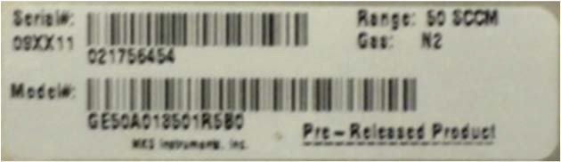Each MFC has one serial number label. Each label shows the serial number, the model code, the full scale flow range, and the calibration gas. The label is located on the MFC’s body below the pinout label on the device’s enclosure.

## Mounting Hardware

**Figure 1: Serial Number Label (sample)**

GE50A and GM50A MFCs with in-line fittings (VCR) have four threaded mounting holes located on the bottom or base of the unit: two #8-32 and two M4. Depending on the hole pattern chosen, use #8-32 UNC-2B or M4 hardware to mount the instrument. The outline drawings in Appendix C show the location and dimensions of the mounting holes for standard axial fittings.

The GM50A MFC’s C-Seal and W-Seal downmount fittings are designed for device mounting using four M5-0.8 x 30 mm long, socket head cap screws. In addition, C-Seal units may be mounted using 10-32 UNF x 1.25” long socket head cap screws if your mounting substrate requires.

GV50A MFCs are mounted on a baseplate which is attached to the base of the MFC body and the base of the integral shut-off valve body. The four slots, one in each corner of the baseplate are to be used to mount and secure the MFC. The outline drawings in Appendix D show the location and dimensions of the mounting holes in the baseplate.

#### Control Valve – Not a Shut-off Valve

The control valve is *not* a positive shutoff valve. Some leakage across the valve may occur. Refer to Appendix A, *Product Specifications,* page 79, for the leak integrity specifications. If necessary, install a separate positive shutoff valve in your system.

**Note** Connect the MFC to your system so that the gas flows in the direction of the flow arrow on the front of the unit.

## Installation Procedure

#### Install the MFC

**Note** DO NOT make any electrical connections to the MFC until directed to do so.

**Note** Information on electrical connections (pinouts and settings) is found in the following chapter.

1. The MFC is prepared for cleanroom installation.

Follow standard cleanroom practices to ensure a clean installation:

* + discard outer material outside of the cleanroom
  + remove the outer packaging in the gray area
  + carry the MFC into the clean area then remove the inner bag and any protective fitting covers just prior to installation.
  + Do not discard calibration sheet

Prepare the system according to your facility’s gas handling procedures, including purging of the gas lines with appropriate purge gas, and notification to equipment personnel and haz/mat teams.

**PERSONAL Gas systems can contain toxic, explosive, combustible, corrosive or other gases**

#### SAFETY HAZARDS!

**which can present life- threatening hazards. ALWAYS use appropriate personal protection equipment. NEVER open a gas line unless the system has been properly purged of harmful gases. Certain gas system components may contain hazardous residuals if not properly prepared. Consult with your facility safety engineers prior to working on any gas delivery system and notify all personnel in adjacent areas to take appropriate personal safety precautions BEFORE working on the equipment.**

1. Prepare the connections fittings:

* Flow clean, dry purge gas across the fittings to minimize particle contamination prior to and during installation. Use only purge gases that are approved for your process.
* Use appropriate size and material gaskets (VCR or w-seal) or c-seals for the application. These are not included with the MFC.
* Install the MFC and secure according to the fitting manufacturer’s instructions. DO NOT overtighten connections.

**Note** Before installing a Devicenet or a Profibus MFC be sure to set the Baud Rate and MACID for the device.

1. Perform appropriate helium leak checking of your gas lines and MFC connections to verify the integrity of the gas seals prior to supplying power to the MFC.

**Note** Before connecting the cable leading to the MFC, verify all pinouts for power and signals match those for the I/O type being used. Information on each I/O type’s pinouts are found in the following chapter.

### Connect cable and power up the MFC.

1. Set the device gas type and Full Scale using the Ethernet User Interface if it is to be different that that displayed on the product lable. The device IP address may also be changed at this time. If changes are made be sure to record the IP address, Gas Type and Maximum Flow Rate (Full Scale Flow Rate) on the calibration sheet.

**Note** When using Ethernet interface for setup, a crossover cable (similar to null modem) is required when the MFC is connected directly to a PC. When the MFC is on a network with a hub interface, a standard Ethernet cable should be used.

See Chapters 5 and 6 for details on setting up and using the Ethernet user interface.

### After an appropriate warmup period of at least thirty (30) minutes, zero the device.

# Chapter Four: Analog and Digital Interfaces

## Analog I/O Interface Cables

*As of January 1, 1996, all products shipped to the European Community must comply with the EMC Directive 89/336/EEC, which covers radio frequency emissions and immunity tests. MKS products that meet these requirements are identified by application of the CE Mark.*

This MKS product meets CE Mark requirements, per EMC Directive 2004/336/EEC. To ensure compliance when installed, an overall metal braided shielded cable, properly grounded at both ends, is required during use. MKS offers a variety of interface cables, listed in Table 12, page 27.

**Table 7: MKS Interface Cables**

|  |  |  |
| --- | --- | --- |
|  | **Power Supply End** | |
| **MFC End** | **15-Pin Type “D”** | **Flying Leads** |
| 15-pin Type D analog | CB147-1 CB259-5 | CB259-6 |
| 9-pin Type D analog | CB147-12 | Not Available |

**Note** An overall metal braided, shielded cable, properly grounded at both ends, is required to meet CE Mark specifications.

**Note** To order an overall metal, braided, shielded cable, add an “S”. after the cable type designation. For example, to order a standard connection cable to connect the MFC to a power supply with a 15-pin Type .D. connector, use part number CB259-5; for an overall metal braided, shielded cable use part number CB259S-5.

#### Generic Shielded Cable Description

MKS offers a full line of cables for most MKS equipment. Should you choose to manufacture your own cables, follow the guidelines listed below:

1. The cable must have an overall metal *braided* shield, covering all wires. Neither aluminum foil nor spiral shielding will be as effective; using either may nullify regulatory compliance.
2. The connectors must have a metal case with direct contact to the cable shield on the whole circumference of the cable. The inductance of a flying lead or wire from the shield to the connector will seriously degrade the shields effectiveness. Ground the shield to the connector before its internal wires exit.
3. With very few exceptions, the connector(s) must make good contact to the device’s case (ground). Good contact is about 0.01 ohms and the ground should surround all wires. Contact to ground at just one point may not suffice.
4. For shielded cables with flying leads at one or both ends; it is important to ground the shield at each such end *before* the wires exit. Make this ground with absolute minimum length. (A ¼ inch piece of #22 wire may be undesirably long since it has approximately 5 nH of inductance, equivalent to 31 ohms at 1000 MHz). After picking up the braid ground, keep wires and braid flat against the case. With very few exceptions, grounded metal covers are not required over terminal strips. If one is required, it will be stated in the Declaration of Conformity.
5. In selecting the appropriate type and wire size for cables, consider:
   * Voltage ratings.
   * Cumulative I2R heating of all the conductors (keep them safely cool).
   * IR drop of the conductors, so that adequate power or signal voltage gets to the device.
   * Capacitance and inductance of cables that handle fast signals (such as data lines or stepper motor drive cables).
   * Some cables may need internal shielding from specific wires to others.

## Analog Interface Input and Output Options

### These analog I/O types are included for future reference. They were not available at the time this manual was written.

The G-SERIES analog I/O MFC is available with either a 9 pin D male connector or a 15 pin D male connector for providing power and signal I/O.

**Table 8: Analog Interface Voltage I/O (0 to 5 VDC) – 9 Pin D Male Pinouts – Model Code A**

|  |  |
| --- | --- |
| Pin 1 | Valve Open/Close: Apply +5 to+15 VDC to Open; Pull to ground or apply -5 to -15 VDC to Close. |
| Pin 2 | Flow Output Signal, 0 to5 VDC (into high impedance load, minimum 10K-ohm) |
| Pin 3 | +15 to +25 VDC :Power |
| Pin 4 | Power Common |
| Pin 5 | No Connection |
| Pin 6 | Setpoint Input, 0-5 VDC |
| Pin 7 | Signal Common |
| Pin 8 | Signal Common |
| Pin 9 | Valve Test Point |

**Notes** 1. Chassis ground is not available on a separate pin. Instead, it is carried out through the cable shielding. Be sure that the connector on the other end of the cable is properly grounded to its chassis ground.

* 1. The 0 to 5 VDC flow signal output comes from pin 2 and is referenced to pin 7 (signal common).
  2. Use any appropriate 0 to 5 VDC input signal of less than 1K ohm source impedance referenced to pin 7 as the setpoint signal to pin 6.
  3. A signal common line MUST be connected to the power common line at either at the tool end or at the MFC 15 pin D connector end of the cable to avoid setpoint/readback offsets. DO NOT connect a signal common line and the power common line at both ends of the cable as this will result in ground loops.

**Table 9: Analog Interface Voltage I/O (0 to 5 VDC) – 15 Pin D Male Pinouts – Model Code B**

|  |  |
| --- | --- |
| Pin 1 | Valve Test Point |
| Pin 2 | Flow Signal Output, 0 to 5 VDC (into high impedance load, minimum 10K-ohm) |
| Pin 3 | Valve Close (Pull to Ground or Pull Low – 5 to -15 VDC) |
| Pin 4 | Valve Open (Pull High +5 to +15 VDC) |
| Pin 5 | Power Supply Common Digital Ground (see Note 4 below) |
| Pin 6 | No Connection |
| Pin 7 | +15 to +25 VDC (see Note 4 below) |
| Pin 8 | Setpoint Input (0 to +5 VDC) |
| Pin 9 | Zero Function |
| Pin 10 | Optional Input |
| Pin 11 | Signal Common |
| Pin 12 | Signal Common |
| Pin 13 | No Connection |
| Pin 14 | No Connection |
| Pin 15 | Chassis Ground |

**Note** 1. The “No Connection” pin assignment refers to a pin with no internal connection.

* + 1. The 0 to 5 VDC flow signal output comes from pin 2 and is referenced to pin 12 (signal

common).

* + 1. Any appropriate 0 to 5 VDC input signal of less than 1K ohm source impedance referenced to pin 12 can be used to supply a setpoint signal to pin 8.
    2. A signal common line MUST be connected to the power common line at either at the tool end or at the MFC 15 pin D connector end of the cable to avoid setpoint/readback offsets. DO NOT connect a signal common line and the power common line at both ends of the cable as this will result in ground loops.

##### *The Optional Input (15 Pin D Analog Controllers Only)*

The standard 15-pin MFC can control flow based on a 0 to 5 Volt signal from an external sensing device using the optional input feature (for a 0 to 10 Volt input range, contact the MKS Applications Department). A common application of this feature is for pressure control using input from a pressure transducer.

To use the optional input feature, route the 0-5 Volt (or 0 to 10 VDC) output from the desired external device to the optional input pin 10.

**Note** The optional input feature is only available on the 15-pin Type D connector with standard MKS pinout assignments. The 9-pin Type D connector does not support this feature. Voltage applied

to the optional input pin overrides the signal generated by the flow sensor internal to the MFC. The control electronics drives the valve so that the optional input signal matches the setpoint. Use the same pin for the setpoint signal, regardless of whether you are using the optional input or the standard flow control signal. Although controlling to the external optional input signal, the

metered flow output signal is still provided on the standard output pin 2.

**Start-Up Procedure for the Analog MFC**

1. Leak test the fittings on the unit using standard helium leak check procedures. Do not proceed to the next step until you are certain that there is no gas leakage.
2. Before connecting the cable leading to the MFC, verify all pinouts for power and signals match those for the connector being used.
3. Plug the power supply/readout cable (MKS or customer-supplied) into the connector (either a 9-pin or 15-pin D type) located at the inlet end of the device.
4. Plug the other end of the cable into an MKS or MKS-compatible power supply/readout unit.
5. Apply power to the device. Once the device is sufficiently warmed-up, you can proceed to zero it. See instructions in Section 7.

##### *Warm Up Time*

After installation and power connection, allow the MKS MFC to warm up for a minimum of 30 minutes. This is to account for both warm-up of the device electronics as well as for the device to reach ambient temperature conditions.

##### *Zeroing the Device*

Although MKS flow devices are zeroed at the factory prior to shipment, it is normal to check the zero and re- zero them, if needed, when they are first installed on the tool.

A mass flow meter or mass flow device will provide a zero output signal under no flow gas conditions. Zero offset from improper zeroing procedures can contribute to flow measurement inaccuracy. This is more apparent at the lower end of the device flow range.

In order to complete a true zeroing of the device, ensure the following conditions are satisfied prior to beginning the procedure.

* Device is installed in the orientation intended for final use (i.e. horizontal base down, vertical flow up, etc.).
* Device is powered at operating temperature, preferably for 30 or more minutes.
* Devices subject to ambient temperatures other than room temperature (23º C) should be zeroed under those conditions.
* Pressure drop and flow across the device is reduced to zero. Depending on the gas panel configuration, this may be done by one of the referenced procedures. See Chapter 7 Maintenance for zeroing procedures.

#### How To Override the Valve (Controllers Only)

The valve override feature enables the control valve to be fully opened (purged) or closed independent of the setpoint command signal.

If the MFC is equipped with a 9-pin Type D connector:

*To Open* the valve, apply +5 to +15 VDC to Pin 1.

*To Close* the valve, apply -5 to -15 VDC Low to Pin 1 or connect Pin 1 to Signal Ground.

Normal Setpoint operation occurs when Pin 1 is allowed to float. If the MFC is equipped with a 15-pin Type D connector:

* + *To Open* the valve by applying a +5 to +15 VDC to pin 4.
  + *To Close* the valve by applying a -5 to -15 VDC low to pin 3 *or* connect pin 3 to the power ground pin.

##### *Priority of the Valve Commands*

The MFC executes commands based on a hierarchical command structure. The highest priority command is Valve Open, followed by Valve Close, and Setpoint Control. Therefore, if the flow controller is operating under Setpoint Control, you can send a Valve Open command to force the valve to the full open position.

**Note** When both the Valve Close and Valve Open pins are pulled down, the Valve Open command takes precedence and the valve is moved to the open position.

## Digital Interface Input and Output Options

The G-SERIES digital I/O MFC is available with either the DeviceNet, Profibus or RS485 communications protocol. The specific protocol is specified at the time of order.

#### DeviceNet Digital Interface Using 5 Pin Microconnector

The MFC has one 5-pin, male DeviceNet connector that provides the communications interface with the DeviceNet network, electrical power from the network bus, and shielding for the instrument signals.

**Table 10: Digital Interface - DeviceNet Connector Pinout – Model Code 6**

|  |  |
| --- | --- |
| **Pin Number** | **Signal Name** |
| 1 | Drain |
| 2 | V+ |
| 3 | V- |
| 4 | CAN_H |
| 5 | CAN_L |

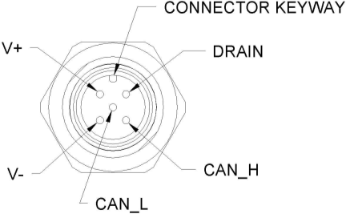

**Figure 2: DeviceNet Connector Pin Diagram**

##### *Overview of MFC DeviceNet Digital Operation*

The G-SERIES (G-SERIES) MFC DeviceNet Mass Flow Device complies with the ODVA DeviceNet Specification Volume I and Volume II [1, 2], and the SEMI Standards Common and Specific Device Models [3, 4]. Refer to those documents for a complete functional description of the MFC Mass Flow device along with the MKS G-Series MFC DeviceNet Supplement, 1046412-001. Please contact MKS for this document.

##### *Power Requirements*

The MFC requires an input voltage of 11 to 25 VDC with 500 mA max @ 11 VDC (230 mA @ 24 VDC, nominal). The input voltage, provided by the DeviceNet network, is introduced to the mass flow controller through the 5-pin micro-style connector located on the top of the instrument.

##### *DeviceNet Controls and Indicators*

The top panel of the MFC contains several DeviceNet controls and indicators.

The mass flow device has two standard bi-color (green/red) DeviceNet status LEDs, (Module Status LED and Network Status LED) located on top of the instrument. The power-up sequence of these LEDs conforms to the requirements in the ODVA DeviceNet Specification, Volume 1 [1].DeviceNet Network Status LED (MOD & NET)

The Network Status LED indicates the status of the communications link. If no problems are detected, the Network Status LED illuminates a solid green. A red, dark, or flashing green Network Status LED indicates a fault condition on the network.

**Table 11: Network (NET) Status LED Indicators**

|  |  |
| --- | --- |
| **LED Status** | **Meaning** |
| Solid Green | Communications link is OK.  The device is online and connections are established. |
| Flashing Green | The device is online but no connections are established.  The device has passed the Dup MAC_ID test and is online, but has no established connections to other nodes. |
| Solid Red | Critical link failure.  The device has detected an error that prevents network communication (Duplicate MAC_ID or bus-off.). |
| Dark | Not powered / Not online.  The device has not completed the Dup_MAC_ID test, or the device is not powered; check the module status LED. |

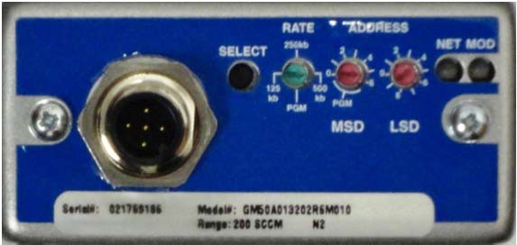

**Figure 3: Devicenet Top View**

#### DeviceNet Baud Rate and MAC ID Switches

The baud rate and MAC ID (node address) for your device can be set through software commands using standard DeviceNet protocol over the network, or manually using the rotary switches located on the top panel of the device. The baud rate and MAC ID switches allow you to easily configure units without an operational network, or to network multiple units quickly.

The baud rate and MAC ID rotary switches support an assigned *network* position, labeled on the device as “PGM” to indicate software operation.

If the rotary switch is in the network (PGM) position at power-up, the baud rate or address is read from the non-volatile memory. Any changes to the values must be made over the network; any changes in the rotary switch positions after power-up are ignored.

If the rotary switch is *not* in the network (PGM) position at power-up, the baud rate or address is read directly from the switches.

**Note** The DeviceNet General Error Codes are listed in the ODVA DeviceNet Specification, Volume 1 [1].

#### DeviceNet Baud Rate Switch

The 4-position rotary switch is used to select the DeviceNet baud rate. The choices are: PGM (the baud rate is read from the non-volatile memory), 125, 250, and 500 Kb. *(Factory Default is 500 Kb.)*

The switch positions are numbered in a clockwise direction, to correspond to the increasing address values.

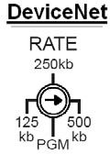

**Figure 4: Devicenet Baud Rate Switch**

#### DeviceNet MAC ID (Node Address) Switches

Two 10-position rotary switches, shown below, are used to set the MAC ID (node address).

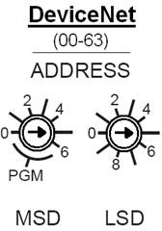The MAC ID is an integer identification value assigned to each node on the DeviceNet network.

**Figure 5: Devicenet MAC ID Switches**

The valid MAC ID switch positions are 0 to 63. Use the switch on the left to set the most significant digit (MSD), that is, the factor of ten (10, 20, 30...60). Use the switch on the right to set the least significant digit (LSD), that is, the increments of one (1, 2, 3...9). The switch positions are numbered in a clockwise direction, to correspond to the increasing address values. *(Factory Default is 55.)*

**Note** Setting the switches to a value that is greater than 63 is the same as setting the rotary switch to the “PGM” position (the baud rate is read from the non-volatile memory).

**Note** The MAC ID switch on the top of the device must be set to the network (PGM) position before power up in order for changes to be made over the network. Any changes in the rotary switch positions after power up are ignored.

##### *Unrecoverable Fault Condition*

A hardware problem with the EEPROM, or a memory problem with the RAM are major unrecoverable faults. This fault condition sets its exception status bit, and the Module Status LED illuminates solid red, complying with Volume I of the DeviceNet Specification.

**Note** A major unrecoverable fault prevents operation because the device cannot communicate on the network. Contact MKS Instruments, Inc. for assistance.

##### *Power Up*

At power-up, flow device performs checks on its communications link and internal diagnostic checks of the EEPROM and RAM. The results of these checks are indicated by the color (green or red) and condition (solid or flashing) of the status LEDs on top of the instrument. The following LED sequence occurs when the MFC is powered up (times are approximate):

1. The Module Status LED flashes first GREEN for ¼ second, then RED for ¼ second, then turns OFF.
2. The Network Status LED flashes first GREEN for ¼ second, then RED for ¼ second, then turns OFF.
3. The Module Status LED flashes from GREEN to RED for five seconds while the device is initializing. The Network Status LED remains OFF.
4. The Module Status LED illuminates solid GREEN when initialization is completed.
5. When the device establishes communication with other devices on the network, the Network Status LED illuminates GREEN.

**Note** If the power up LED sequence does not function properly, contact MKS for assistance.

See Table 7: Network Status LED Indicators for more information on the operation of the Network Status LED and the Module Status LED.

#### Warm-Up and Zero the MFC

After installation and power up, allow the MFC to warm up for a minimum of 30 minutes, then refer to the installation section to Zero the MFC.

##### *Warm Up Time*

After installation and power connection, allow the MKS MFC to warm up for a minimum of 30 minutes. This is to account for both warm-up of the device electronics as well as for the device to reach ambient temperature conditions.

##### *Zeroing the Device*

Although MKS flow devices are zeroed at the factory prior to shipment, it is normal to check the zero and re- zero them, if needed, when they are first installed on the tool.

A mass flow meter or mass flow device will provide a zero output signal under no flow gas conditions. Zero offset from improper zeroing procedures can contribute to flow measurement inaccuracy. This is more apparent at the lower end of the device flow range.

In order to complete a true zeroing of the device, ensure the following conditions are satisfied prior to beginning the procedure.

* + Device is installed in the orientation intended for final use (i.e. horizontal base down, vertical flow up, etc.).
  + Device is powered at operating temperature, preferably for 30 or more minutes.
  + Devices subject to ambient temperatures other than room temperature (23º C) should be zeroed under those conditions.
  + Pressure drop and flow across the device is reduced to zero. Depending on the gas panel configuration, this may be done by one of the referenced procedures. See Chapter 7 Maintenance for zeroing procedures.

#### Profibus Digital Interface Using Two 9 Pin D Connectors

The Profibus MFC has two 9 pin D connectors. A 9 pin D males (Table 12 A) that provides power to the device and a 9 pin D female (Table 12 B) which provides the communications interface with the Profibus master slave network, electrical power from the network bus.

The G-SERIES (G-SERIES) MFC Profibus Mass Flow Device connector, switches and initial power up are described in this section. For a complete functional description of the MFC Mass Flow device along with the MKS G-Series MFC, Profibus Supplement, 1046413-001. Please contact MKS for this document.

**Table 12A: Profibus 9 Pin D Male Power Connector– Model Code 4**

Power Connector – 9 pin D male

|  |  |
| --- | --- |
| Pin 1 | Valve Open/Close: Apply +5 to+15 VDC to Open; Pull to ground or apply -5 to -15 VDC  to Close. |
| Pin 2 | No Connection |
| Pin 3 | 11 to 25 VDC Supply |
| Pin 4 | No Connection |
| Pin 5 | Power Common |
| Pin 6 | No Connection |
| Pin 7 | No Connection |
| Pin 8 | No Connection |
| Pin 9 | No Connection |

**Table 12B: Profibus 9 Pin D Female Communications Connector – Model Code 4**

### Communications Connector – 9 pin D female

|  |  |
| --- | --- |
| Pin 1 | No Connection |
| Pin 2 | No Connection |
| Pin 3 | B Line (RXD/TXD-P) Bus Positive |
| Pin 4 | ISO_RTS (CNTR – P (Control for Repeater) |
| Pin 5 | ISO_GND (Digital Ground) |
| Pin 6 | ISO_VCC (Power Supply (5 V) |
| Pin 7 | No Connection |
| Pin 8 | A Line (RXD/TXP – N) Bus Negative |
| Pin 9 | No Connection |

#### Profibus Controls and Indicators

The MKS G-Series Profibus mass flow device contains several Profibus controls and indicators located on the top of the device enclosure. There are two switches which are used to set the Station Address and two standard bi-color (green/red) Profibus status LEDs, (Module Status LED and Network Status LED). The LEDS provide an indication of the device status. At power-up, the device performs checks on its communications link and internal diagnostic checks of the EEPROM and RAM. The results of these checks are indicated by the color (green or red) and illumination condition of the status LEDs on top of the instrument. The Module and Network Status LED’s illuminate solid GREEN when initialization is complete. The Network Status LED illuminates flashing GREEN when the device establishes communication with other devices on the network.

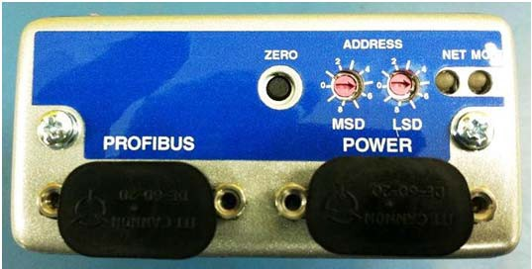

**Figure 6: Profibus Top View**

#### Station Address

The address (station address) for the device is set using the rotary switches (MSD and LSD) located on the top panel of the device. The address switches allow you to easily configure units without an operational network, or to network multiple units quickly.

The address is read from the non-volatile memory. Any changes to the values must be made over the network; any changes in the rotary switch positions after power-up are ignored.

#### Station Address Switches

Two 10-position rotary switches, shown in Figure 15, are used to set the station address.

The station address is an integer identification value assigned to each node on the Profibus network.

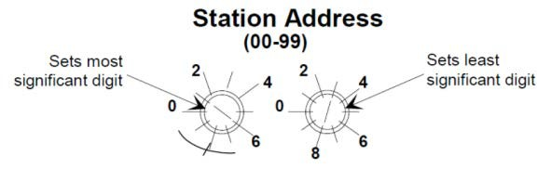

**Figure 7: Profibus Station Address Switches**

The valid STATION ADDRESS switch positions are 0 to 99. Use the switch on the left to set the most significant digit (MSD), that is, the factor of ten (10, 20, 30...90). Use the switch on the right to set the least significant digit (LSD), that is, the increments of one (1, 2, 3...9). The switch positions are numbered in a clockwise direction, to correspond to the increasing address values.

#### Power Up

This is the power-up sequence of the LEDs.

1. MOD LED is set to solid RED if SYSTEM_ERROR in the Small Receive Data is set, otherwise it is set to solid GREEN.
2. NET LED is set to solid GREEN if the module is in idle state. It is set to about 2 Hz blinking GREEN if the module is in executing state (check Device Status in Slot 30, Index 9).
3. NET LED is set to about 5 Hz blinking red if the WINK_STATUS is set to 1 and stops blinking RED if WINK_STATUS is set to 0.

#### Warm-Up and Zero the MFC

After installation and power up, allow the MFC to warm up for a minimum of 30 minutes, then refer to the installation section to Zero the MFC.

##### *Warm Up Time*

After installation and power connection, allow the MKS MFC to warm up for a minimum of 30 minutes. This is to account for both warm-up of the device electronics as well as for the device to reach ambient temperature conditions.

##### *Zeroing the Device*

Although MKS flow devices are zeroed at the factory prior to shipment, it is normal to check the zero and re- zero them, if needed, when they are first installed on the tool.

A mass flow meter or mass flow device will provide a zero output signal under no flow gas conditions. Zero offset from improper zeroing procedures can contribute to flow measurement inaccuracy. This is more apparent at the lower end of the device flow range.

In order to complete a true zeroing of the device, ensure the following conditions are satisfied prior to beginning the procedure.

* + Device is installed in the orientation intended for final use (i.e. horizontal base down, vertical flow up, etc.).
* Device is powered at operating temperature, preferably for 30 or more minutes.
* Devices subject to ambient temperatures other than room temperature (23º C) should be zeroed under those conditions.
* Pressure drop and flow across the device is reduced to zero. Depending on the gas panel configuration, this may be done by one of the referenced procedures. See Chapter 7 Maintenance for zeroing procedures.

#### RS485 Digital Interface Using 9 Pin D Male Connector

The RS485 MFC has one 9 pin D male connector that provides the communications interface with the RS485 master slave network, electrical power from the network bus, and shielding for the instrument signals. There are no analog I/O signals on this device.

**Table 13: Digital Interface – RS485 Using 9 Pin D – Model Code 5**

|  |  |
| --- | --- |
| Pin Number | Assignment |
| Pin 1 | Power & Signal Common |
| Pin 2 | + 11 to 25 VDC Power In |
| Pin 3 | No connection |
| Pin 4 | No connection |
| Pin 5 | B/B’ (RS485+) |
| Pin 6 | No connection |
| Pin 7 | RS485 Common |
| Pin 8 | Shield |
| Pin 9 | A/A’ (RS485-) |

##### *RS485 Communications Protocol*

The MFC controller acts as a slave device on an RS485 multi-drop bus. It continually listens for transaction requests from the host controller, processes requests addressed to it, and sends replies as needed. For a complete description of this multi-drop protocol see the MKS Document MKS G-Series MFC, RS485 Supplement, 1046411-001. Please contact MKS for this document.

##### *RS485 Controls and Indicators*

The top panel of the MFC contains a zero button and two LED indicators, Error and Comm.

**Table 14: RS485 Module Status LED Indicators**

|  |  |
| --- | --- |
| **LED Status** | **Meaning** |
| Flashing Red | The device is online and functioning properly.  The Module Status LED flashes red when receiving commands from Host. |
| Solid Red | Critical link failure.  The device has detected an error that prevents network communication (Duplicate MAC_ID or bus-off.) |
| Dark | Not powered / Not online.  The device is offline or the device is not powered; check the network status LED. |

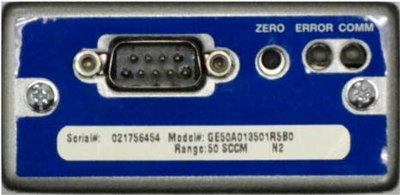

**Figure 8: RS485 Top View**

##### *Setting the RS485 Device MACID and Baud Rate*

For RS485 the baud rate and MAC ID must be set up prior to installation into a network. The baud rate and MAC ID may be setup up individually from the host computer or via a PC using the Ethernet UI. These are the *only* ways to configure an RS485 MFC. There are no Baud Rate or MAC ID switches on the device. See the RS485 supplement for information to set the device up over the host or Chapter 6 of this manual.

##### *Unrecoverable Fault Condition*

A hardware problem with the EEPROM, or a memory problem with the RAM are major unrecoverable faults. This fault condition sets its exception status bit, and the LED illuminates solid red

**Note** A major unrecoverable fault prevents operation because the device cannot communicate on the network. Contact MKS Instruments, Inc. for assistance.

#### Warm-Up and Zero the MFC

After installation and power up, allow the MFC to warm up for a minimum of 30 minutes, then refer to the installation section to Zero the MFC.

##### *Warm Up Time*

After installation and power connection, allow the MKS MFC to warm up for a minimum of 30 minutes. This is to account for both warm-up of the device electronics as well as for the device to reach ambient temperature conditions.

##### *Zeroing the Device*

Although MKS flow devices are zeroed at the factory prior to shipment, it is normal to check the zero and re- zero them, if needed, when they are first installed on the tool.

A mass flow meter or mass flow device will provide a zero output signal under no flow gas conditions. Zero offset from improper zeroing procedures can contribute to flow measurement inaccuracy. This is more apparent at the lower end of the device flow range.

In order to complete a true zeroing of the device, ensure the following conditions are satisfied prior to

beginning the procedure.

* Device is installed in the orientation intended for final use (i.e. horizontal base down, vertical flow up, etc.).
* Device is powered at operating temperature, preferably for 30 or more minutes.
* Devices subject to ambient temperatures other than room temperature (23º C) should be zeroed under those conditions.
* Pressure drop and flow across the device is reduced to zero. Depending on the gas panel configuration, this may be done by one of the referenced procedures. See Chapter 7 Maintenance for zeroing procedures.

Chapter Five: Ethernet Interface Setup and Configuration

Step 1: Install the Java™ Plug-in

(for single IP address)

# Chapter Five: Ethernet Interface Setup and Configuration

The Ethernet interface is a supplemental interface that can be used for MFC setup, configuration, and diagnostics purposes. It is not used to control the MFC during normal operation. To access the diagnostic features of the MFC via the Ethernet port, follow Steps 1 and 2.

## Step 1: Install the Java™ Plug-in (for single IP address)

The MFC interface software uses a web-based Internet Explorer interface that requires a Java Technology plug-in to display real-time data plots.

If you are installing the MFC on a network that has web access AND you are setting up multiple IP addresses, then go to “*Option 3: For Multiple IP Address Setup*” on page 49 and skip the steps below. The “Multiple IP Address Setup” procedure enables you to access the web for download at completion.

OTHERWISE perform the following steps:

1. Download the (2) files listed below from the MKS website [(www.](http://www.mksinst.com/MDsw.html))m[ksinst.com/MDsw.html)](http://www.mksinst.com/MDsw.html)) by clicking on the link “MFC java plugin file for web access.” The MKS download includes an installation script to properly load the plug-in.
   * Java installer: jinstaller.exe
   * Installation script: InstallPlot.bat
2. Copy the installer and script file to your hard drive, then double-click on the InstallPlot.bat file. This file connects to the Sun Microsystems download site according to the following command:
   * jinstall.exe <http://java.sun.com/update/1.4.2/1.4.2-b28.xm>
3. Follow the onscreen prompts to install the Java application.

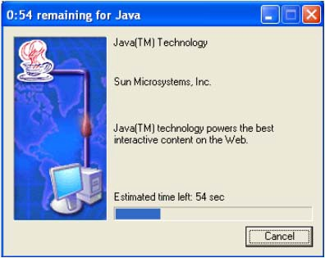

1. Read the license agreement, select “I accept...”, click “Next” to continue installation.

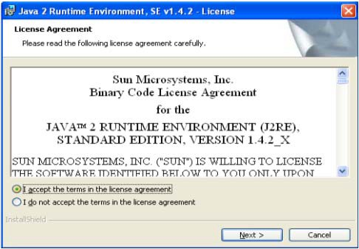

1. Select the “Typical” installation option and follow the prompts to install the Java plug-in.

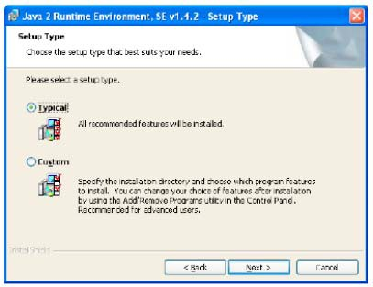

1. Java plug-in is now complete.

## Step 2: Setup Network for Communication through Ethernet

There are three possible ways to setup your network for communication through Ethernet. Choose the correct option based on the following criteria:

Option 1 (see below) [single port/single device]

* The Java applet discussed in Step 1 on page 44 has already been installed on your computer.
* You have no need to connect to the Internet.
* You only have one IP address, i.e. 192.168.2.X, to connect with.
* If your computer has more than one network card, this option may not work. Use option 2. Option 2 (see page 47) [single port/multiple devices]
* The Java applet discussed in Step 1 on page 44 has already been installed on your computer.
* You have no need to connect to the Internet.
* You have one or Multiple IP addresses you want to connect with, i.e. 192.168.2.X, 10.X.X.X, etc. Option 3 (see page 49) [multiple ports/multiple devices]
* The Java applet discussed in Step 1 on page 44 has or has not installed on your computer.
* You need to be able connect to the Internet while connecting to one or multiple units.
* You have Multiple IP addresses to connect with, i.e. 192.168.2.X, 10.X.X.X, etc.

#### Option 1: Network Automatic Setup

A software script allows you to rapidly create a network connection to the MFC. Once connected a series of web-browser type windows allow you to easily monitor and configure the MFC.

1. Logon to the MKS website [(www.](http://www.mksinst.com/MDsw.html))m[ksinst.com/MDsw.html)](http://www.mksinst.com/MDsw.html)) and download a copy of the IP setup script, HostIP.cmd by clicking on the HostIP.cmd link.
2. Copy the setup script HostIP.cmd to your root directory (Typically **C:\**).
3. Connect a **crossover** network cable to the MFC and your laptop computer. A crossover cable is required when the MFC is connected directly to a computer. When the MFC is connected to a network using a hub interface, a standard Ethernet cable can be used.
4. From your computer’s “Start” menu, select “Run...” then enter the word “command” and click OK.

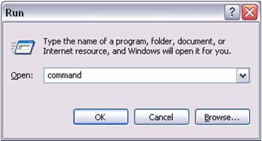

1. At the command prompt, if it’s not already in the root directory “C:\>”, then you can use the following commands to change the directory: “CD\” will bring you to the root of whatever drive that is currently set. If this is not the root directory, enter the command “C:”. Use the “CD\” command again if necessary. This will bring you to the C:\> prompt. See the example below:

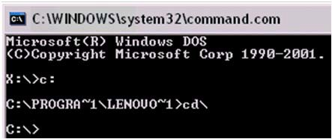

1. Enter the command “HostIP x y z” where (x) stands for the IP address of your Host computer, (y) stands for the subnet mask and (z) stands for the gateway. The system will setup a new host IP address and display it as shown in the example below:

**Note** The HostIP.cmd script looks for a network connection with the name “Local Area Connection”.

If the network connection you’re using does not have this name and can be renamed, this is easiest. If not, then you’ll need to use one of the other manual options.

**Note** The HostIP.cmd script does not need the subnet mask (y) or gateway (z) to work. If only the Host IP address (x) is sent with the command, the script assigns its own subnet mask (255.0.0.0) and gateway (10.0.0.0).

**Note** The MKS IP Address format is 192.168.2.X, so the Host IP Address must be of the same format. A recommended Host IP address is 192.168.1.Y with a Subnet Mask of 255.255.252.0, where Y is some number between 5 and 254. The combination of a Subnet Mask with the value of “252” in the third segment along with a 192.168.1.Y IP allows for a connection to any IP address in the 192.168.1.X, 192.168.2.X & 192.168.3.X range. By setting the Host IP to 192.168.1.X, there is assurance that there will never be a conflict between the Host and the MKS MFC.

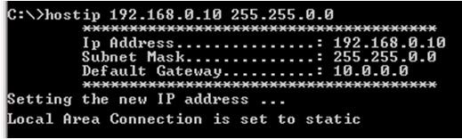

To restore to a dynamic IP address, run the HostIP script with an argument of “auto” as shown below:

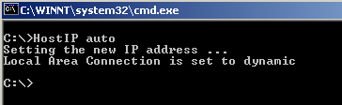

These commands may also be entered directly in the “Run…” window. Instead of typing “command” simply type “c:/HostIP x y z” (without “ ”) or “c:/HostIP auto” (without “ ”).

1. After running the HostIP command, launch Internet Explorer, enter [“http://xx.xx.xx.xx”](http://xx.xx.xx.xx/) in the address field, where xx.xx.xx.xx stands for the IP address of the MFC you wish to connect to, and click “Go.” Internet Explorer will open and display the device Monitor screen which displays the device’s gas settings, model code, valve type and the Digital I/O connection status (if applicable). The Serial Number can always be found in the bottom left-hand corner of the browser window.

##### *For more information on the web-based program, go to Chapter 6 on page 54.*

**Option 2: Manual Setup**

If you have not setup automatic network script in Option 1, a manual setup is required to access the MFC Ethernet interface.

1. Connect a crossover network cable to the MFC and your laptop computer.

A crossover cable is required when the MFC is connected directly to a computer. When the MFC is connected to a network using a hub interface, a standard Ethernet cable can be used.

1. Open the Local Area Connection by doing one of the following options:

##### *Option 2.1:*

Select **My Network Places** (On Desktop typically). Right-Click on the icon, then select **Properties**.

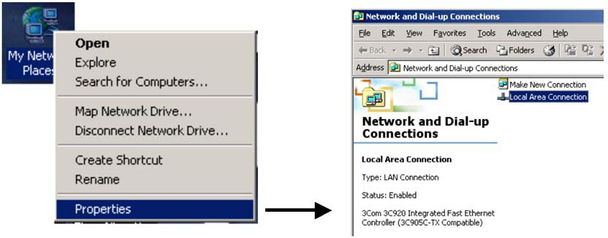

In the “Network and Dial-Up Connections” window, Double-click on “Local Area Connection.” Not all Local Area Connections have the same name, yours may have a different name.

##### *Option 2.2:*

From your computer’s “Start” menu, select “Settings” →Network and Dialup Connections → Local Area Connections

1. Select **Properties**.

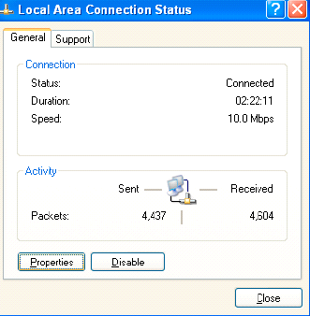

1. Select **Internet Protocol (TCP/IP)**, then select **Properties**.

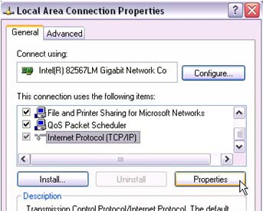

1. Select **Use the following IP address**.

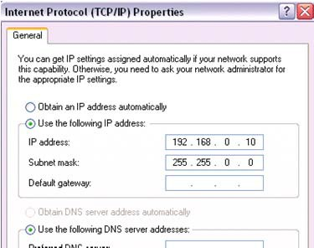

1. Enter the IP address **192.168.0.10**. Now click in the Subnet mask field and the Subnet mask 255.255.255.0 should appear. Change the 3rd 255 to “0” as shown in the figure above. So the final subnet mask will be (**255.255.0.0**). Also make sure that the “**Use the following DNS server Addresses**” is also selected. Leave this blank.

##### *Additional IP Addresses*

In the case that you need to be able to connect to more than one IP Address, simply click on the “Advanced” button at the bottom of the current window. Once the “Advanced TCP/IP Settings” window pops up, verify that you’re on the “IP Settings” tab and then click “Add” in the “IP Addresses” section. If you have a different IP Address on your network, e.g., 10.X.X.X, you will need to add the IP Address 10.X.X.X, where “X” is a number from 0 to 254 that is unique from any other IP address on your network. Now click in the Subnet mask field and enter the Subnet mask (255.0.0.0).

1. Close out all dialog boxes by selecting **O.K**., **Close**, etc. as required.
2. Launch Internet Explorer (or a similar program) and enter [“http://xx.xx.xx.xx”](http://xx.xx.xx.xx/) in the address field, where xx.xx.xx.xx stands for the IP address of the MFC you wish to connect to, and click “Go.” Internet Explorer will open and display the device Monitor screen which displays the device’s gas settings, model code, valve type and Digital I/O connection status (if applicable). The Serial Number can always be found in the bottom left-hand corner of the browser window.

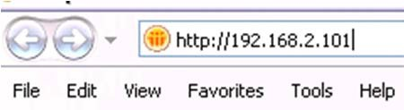

##### *For more information on the web-based program, go to Chapter 6 on page 54.*

**Option 3: For Multiple IP Address Setup**

1. From your computer’s “Start” menu, select “Run...” then enter the word “command” and click OK.

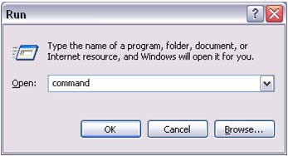

1. At the command prompt, if it’s not already in the root directory “C:\>”, then you can use the following commands to change the directory: “CD\” will bring you to the root of whatever drive that is currently set. If this is not the root directory, enter the command “C:”. Use the “CD\” command again if necessary. This will bring you to the C:\> prompt. See the example below:

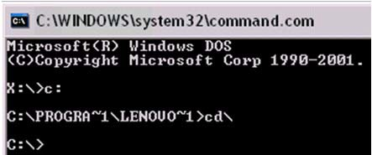

1. Now, before going any further, it is important that you have an active network connection that allows you to connect to the Internet. If you do not have an active connection, please set that up and then continue.
2. At the command prompt, enter the command “ipconfig /all” (as shown below) then press Enter.

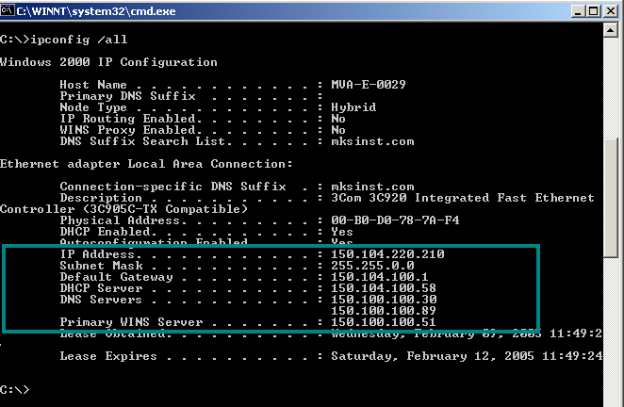

The data inside the highlighted area (lower section, between IP Address and Primary WINS Server) are what is needed for the steps below.

1. Open the Local Area Connection by doing one of the following options:

##### *Option 5.1:*

Select **My Network Places** (On Desktop typically). Right-Click on the icon, then select **Properties**.

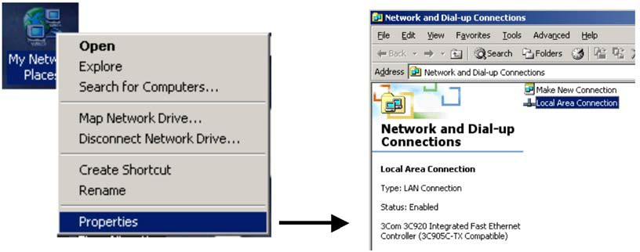

In the “Network and Dial-Up Connections” window, Double-click on “Local Area Connection.” Not all Local Area Connections have the same name, yours may have a different name.

##### *Option 5.2:*

From your computer’s “Start” menu, select “Settings” →Network and Dialup Connections → Local Area Connections

1. Select **Properties**. In the Properties window select **Internet Protocol (TCP/IP)**, then select **Properties**

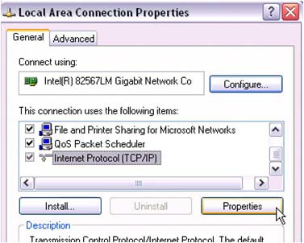

1. Select **Use the following IP address**. Now do the following to configure your computer so that it can still connect to the Internet:
   * Type in the “IP address”, the “Subnet mask” and the “Default gateway” fields with values returned from the “ipconfig /all” query in the DOS command window.
   * Select “Use the following DNS server addresses:”
   * Type in the Preferred DNS server and the Alternate DNS server fields with values returned from the “ipconfig /all” query in the DOS command window. An example is shown below:

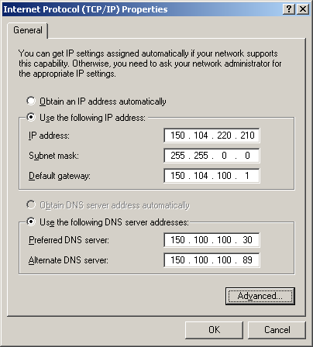

1. Click the “Advanced…” button at the bottom of the window. The following window will be displayed:

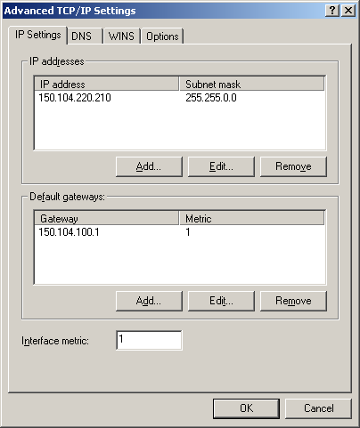

1. Verify you’re on the “IP Settings” tab and then do the following to configure your computer to talk to the MFC and any other devices with an IP address:

o Click “Add…” in the “IP address” section and enter the IP address **192.168.0.10**. Now click in the Subnet mask field and the Subnet mask 255.255.255.0 should appear. Change this value to 255.255.0.0. Then click “OK.”

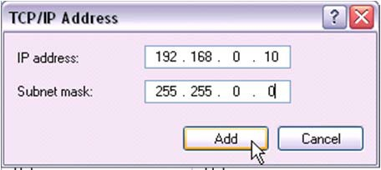

1. Now click “Add…” in the “Default gateways” group. Enter the Gateway value you will use to connect to the MFC. Typically a gateway value will be the IP address with a (1) on the end. The Metric value will always be (1). Then click “Add.”

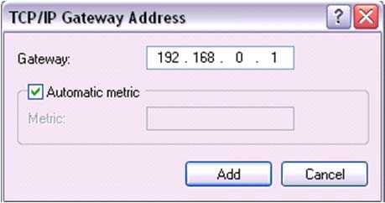 ** You can use Automatic Metric or enter (1)

1. In the case that you need to be able to connect to more than one IP Address, i.e. not all devices on your network use a 10.X.X.X address; more addresses can be added by repeating steps 10 and 11 above. If you have another MFC, you may also need to add the IP Address 10.0.0.X, where “X” is a number from 0 to 254 that is unique from any other IP address on your network. The Subnet mask for this IP address is 255.0.0.0, and the typical Default Gateway is 10.0.0.1.
2. 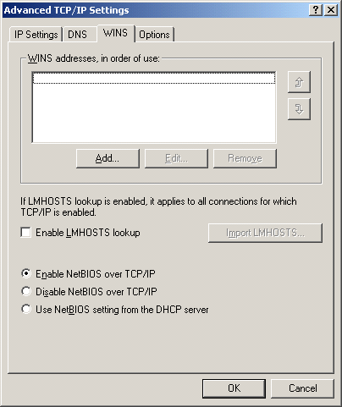Click the “WINS” tab.
3. In the “WINS addresses, in order of use” section, click “Add…” Enter in the Primary WINS server address that was returned from the “ipconfig /all” query in the DOS command window, and click “Add.” If there were any alternate WINS servers listed in the DOS window, now enter them. If not, go ahead to the next step.

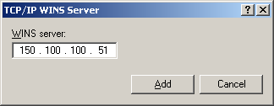

Example is shown below:

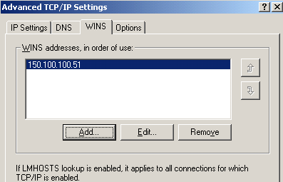

1. Close out all dialog boxes by selecting **O.K**., **Close**, etc. as required.
2. You are ready to connect to multiple IP addresses from your computer. You can connect both to the Internet and to your MFC local network.
3. Launch Internet Explorer (or a similar program) and enter [“http://xx.xx.xx.xx”](http://xx.xx.xx.xx/) in the address field, where xx.xx.xx.xx stands for the IP address of the MFC you wish to connect to, and click “Go.” Internet Explorer will open and display the device Monitor screen which displays the device’s gas settings, model code, valve type and Digital I/O connection status (if applicable). The Serial Number can always be found in the bottom left-hand corner of the browser window.

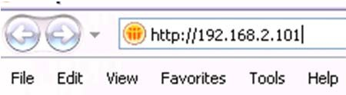

For the plot web page to work in the MFC, a java plug-in has to be installed on your computer.

With the multiple IP addresses setup, if the Java plug-in has NOT already been installed, the IE browser will automatically connect to the correct web site for the downloading the first time someone connects to a MFC and clicks on the “Plot” page. If, for some reason, this does not work please follow the Step 1 instructions (see page 44).

##### *For more information on the web-based program, go to Chapter 6 on page 54.*

# Chapter Six: Embedded Web-Based GUI and Diagnostics

## Logging On to Your MFC

Before trying to logon to your MFC you must have your network setup correctly. To do this, complete the steps listed in Chapter Three, *Ethernet Interface Setup and Configuration*, starting on page 44.

Once you complete the steps in Chapter Six, launch Internet Explorer (or a similar program) and enter [“http://xx.xx.xx.xx”](http://xx.xx.xx.xx/) in the address field, where xx.xx.xx.xx stands for the IP address of the MFC you wish to connect to, then click “Go”. Internet Explorer will open and display the Device page in Monitor Mode.

The modes are described in detail below.

## Monitor Mode

Holding true to its name, “Monitor Mode” allows the user to only *Monitor* the MFC performance. In order to configure the MFC, i.e. zero the device, set the gas inlet pressure (used by device control algorithm), change the IP Address, etc., you must enter “Setup” mode. See *Setup Mode*, page 59.

Each of the pages, i.e. tabs, in Monitor Mode are listed and described below in detail.

#### Device Page – Monitor Mode

This page, which contains the general information for the MFC, is where you are initially directed once you logon to the MFC.

##### *What’s Displayed*

The Device Page displays the device’s selected (operating) gas, Semi gas number, calibration gas, minimum and maximum full scales allowed for the device, the device’s current full scale for the selected gas and the current operating pressure setting. In addition, you can see the device information and the Digital I/O connection status (if applicable).

**Note** The MFC’s **serial number** can always be found in the bottom left-hand corner of the browser window.

Figure 9, next page, shows a screen capture of the Device Page for the MFC.

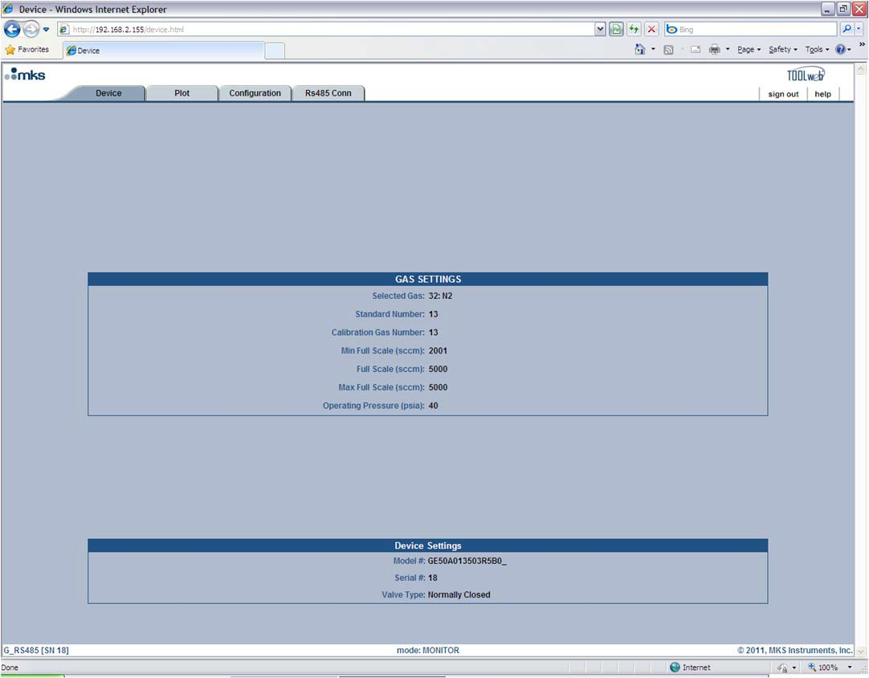

**Figure 9: Embedded GUI, MFC Device Page in Monitor Mode**

#### Plot Page – Monitor Mode

This page, shown in Figure 10, enables you to plot and see real-time performance of the device. In Monitor Mode you are able to select variables to plot, the rate at which to display them, and save the data that has been plotted.

**Note** The Plot Page requires a java applet to use the plot program. This applet, which must be installed on the computer trying to view the page, can be downloaded by following the instructions listed on page 44.Step 1: Install the Java™ Plug-In

##### *Selecting Variables To Plot*

On the right-hand side of the Plot page you should see the Variables section. Here you have the ability to select one or more variables to plot.

* *To plot one variable:* click on the variable you wish to plot.
* *To plot two or more variables:* either select the variables one-by-one while holding your keyboard’s control “Ctrl” key down or select all the variables by selecting the first variable in the list and then selecting the last variable listed while holding your keyboard’s “Shift” key down.

##### *Selecting Rate*

Directly below the list of variables is the Rate selection drop down menu. Here you are able to select the sampling rate at which you’d like to plot the variables. Available rates are 1, 2, 5, 10, 50 and 100 Hz.

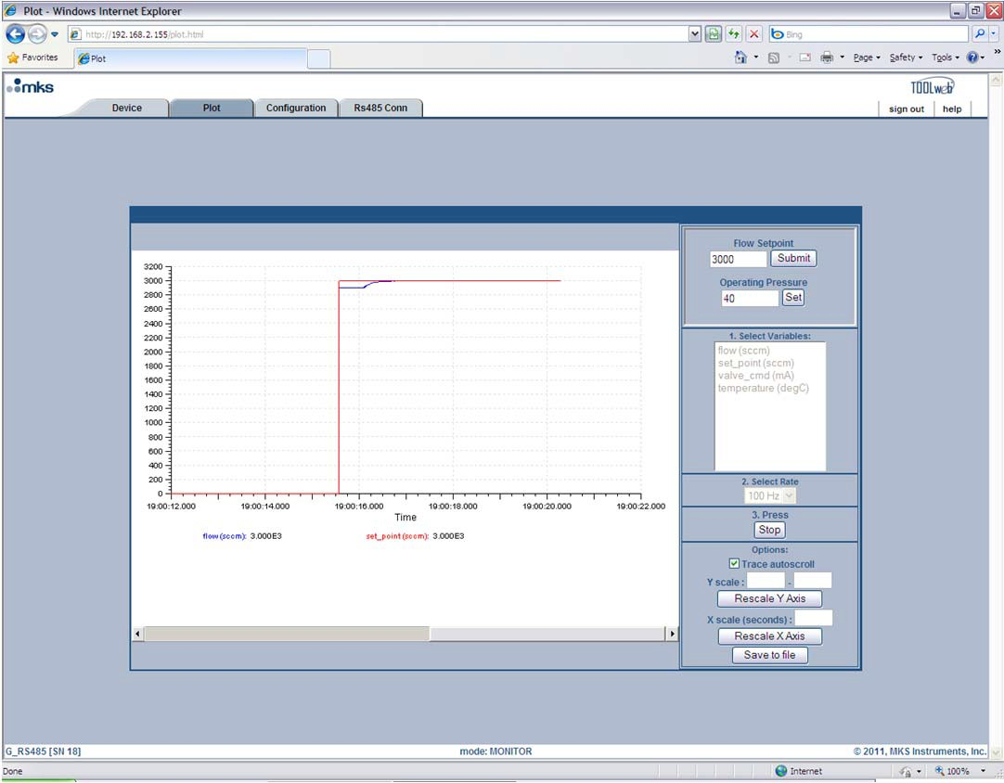

**Figure 10: Embedded GUI, Plot Page in Monitor Mode**

##### *Starting and Stopping the Plot program*

Below the Rate selection is the Start/Stop button for the plot program. You must click on this button to start the plot program and click on it a second time to stop the program.

##### *Options (Trace Autoscroll, Rescaling Y Axis, Rescaling X Axis, Save to File)*

Below the Start/Stop button, you should see the Options section. Here you are able to start/stop the autoscrolling feature, rescale the Y-Axis, rescale the X-Axis or save the plot data to a file. These options are described in detail below:

*Trace Autoscroll* → unchecking this checkbox will stop the plot program from scrolling in the X-direction. This option only has an effect while the program is running. Rechecking this checkbox will enable the plot program to resume scrolling. The X-Axis scroll bar may be used for manual scrolling.

*Rescaling Y-Axis* → next to where it says “Y scale:” enter in the scale (Min) to (Max), and then click on the “Rescale Y-Axis” button. This option only has an effect if the “Trace Autoscroll” checkbox is unchecked or the plot program is stopped. Otherwise the Y-Axis will automatically scale itself to fit all variables being plotted.

*Rescaling X-Axis* → entering a value next to where it says “X scale (seconds):” adjusts the number of seconds spanned across the X-Axis, e.g. entering a value of ten seconds sets the X-Axis so that it will show ten second segments at a time. To use this feature, enter the value and then click on the “Rescale X-Axis” button. This option can be used at anytime.

*Save to File* → the “Save to file” option can be used at anytime once you’ve started the plot program. The data stored consists of the data collected from the time the Start button was pressed to the time the “Save to file” button is pressed. The file will be saved in a (.csv) format which can be later imported into a spreadsheet for further analysis.

#### Configuration Page – Monitor Mode

This page displays the TCP/IP settings and the current Firmware version for the MFC. In “Monitor Mode” you are only able to view this information. At the bottom of this page you are able to enter the password to change into “Setup Mode.” The Factory-shipped password is “config” (without the ““). Figure11, below, shows a screen capture of the Configuration Page in “Monitor Mode.”

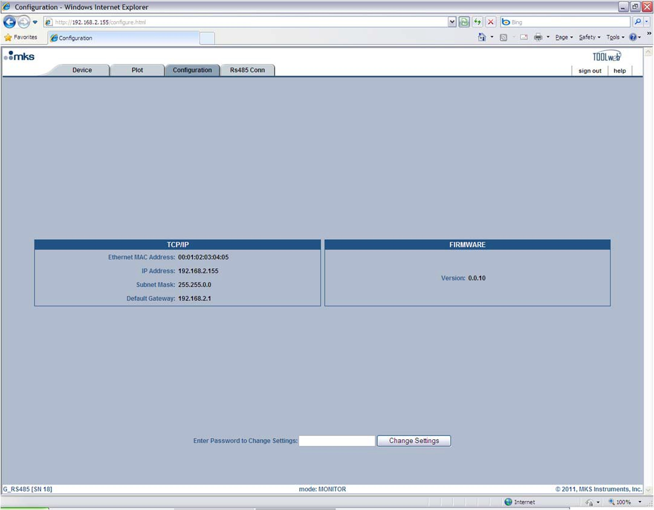

**Figure 11: Embedded GUI, Configuration Page in Monitor Mode**

#### RS485 Comm Page – Monitor Mode

This page displays the Baud Rate and MacID settings for the RS485 MFC. In “Monitor Mode” you are able to view this information as well as change it. Figure 12, below, shows a screen capture of the Configuration Page in “Monitor Mode.” Similar pages exist for the DeviceNet and Profibus G-Series Products.

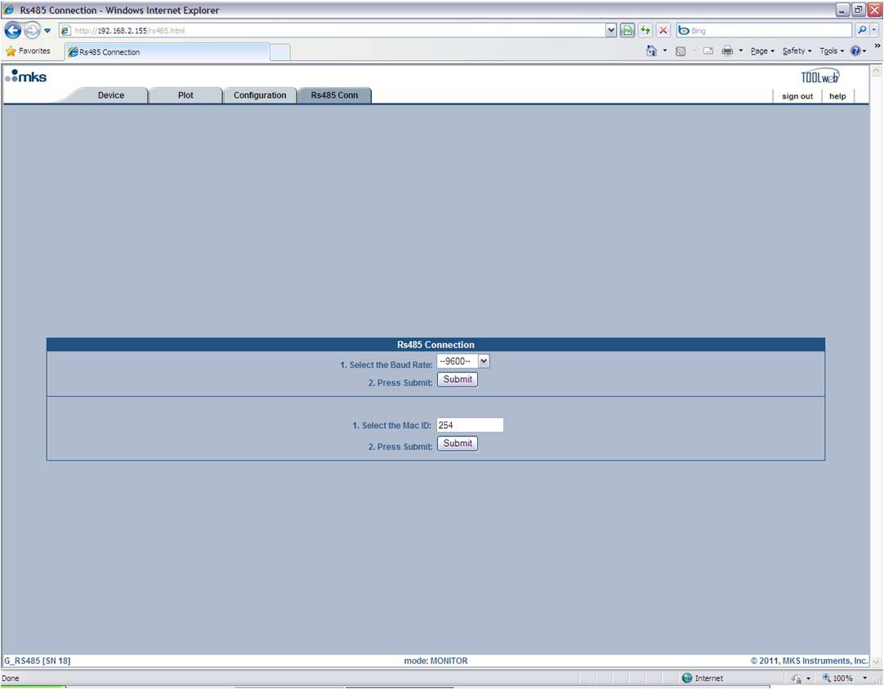

**Figure 12: Embedded GUI, RS485 Comm Page in Monitor Mode**

## Setup Mode

In “Setup Mode” the user is able to configure the MFC, i.e. zero the device, change the IP address, configure the operating pressure, etc. To enter this mode, while in “Monitor Mode”, go to the “Configuration Page” and enter the Factory-shipped password “config” (without “”). Once you press the “Change Settings” button you will be directed to the “Configuration Page” in “Setup Mode.” You should now a see a green banner that lines the top of the page that says, “The device is now in SETUP mode.” (See Figure 13)

Each of the pages, i.e. tabs, in “Setup Mode” are listed and described below in detail starting with the Device Page. Please note that this section will only describe in detail the features that are different from those in “Monitor Mode.” For a complete understanding of each page, also read the *Monitor Mode* section starting on page 54.

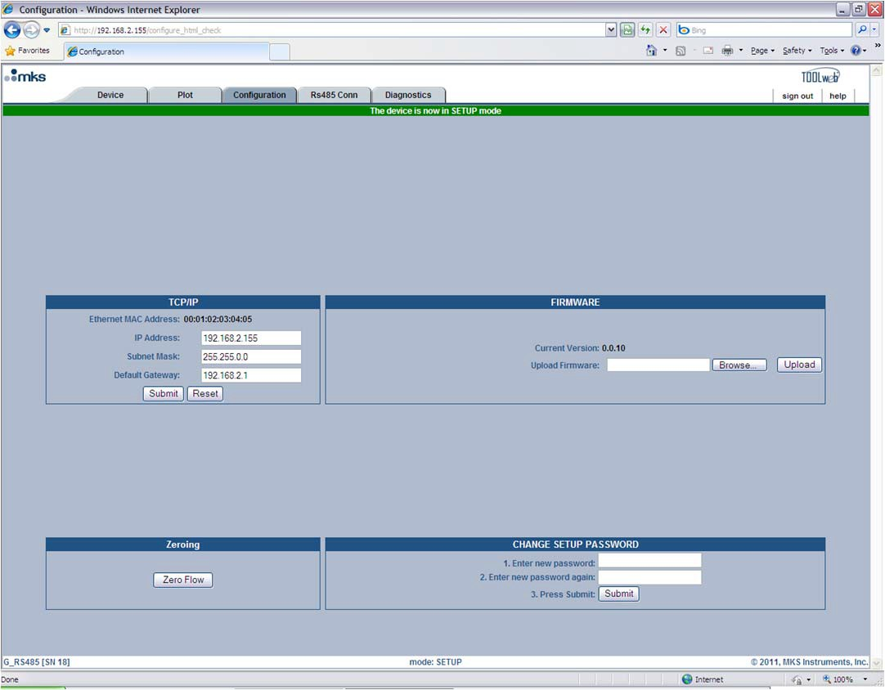

**Figure 13: Setup Mode (Configuration Page)**

#### Device Page – Setup Mode

In “Setup Mode” this page gives you the ability to modify the gas settings.

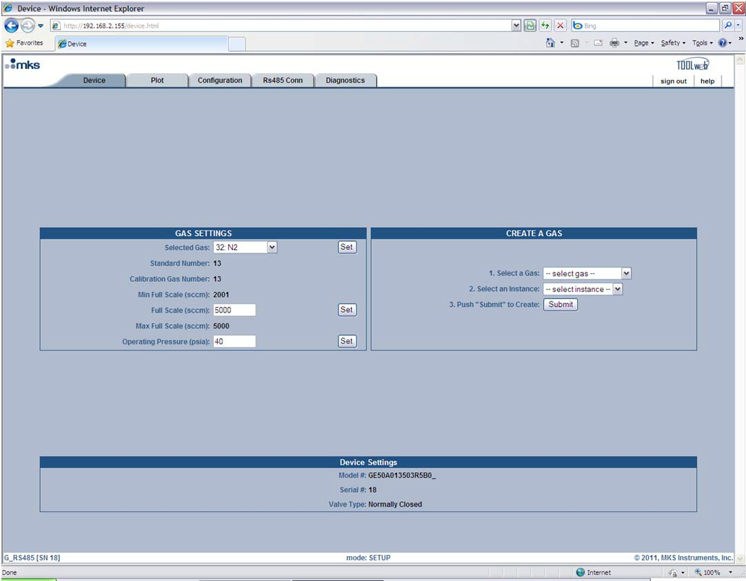

**Figure 14: Embedded GUI, Device Page in Setup Mode**

Gas Settings: The Device Page enables the user to change the MFC’s gas settings. To change the gas settings review the following possible operations and go to the appropriate page.

* To create a new gas instance, see page 60.
* To change the full scale range of the current gas instance, see page 61.
* To set the MFC to a different gas instance, see page 61.

##### *Creating A New Gas Instance*

*(Refer to Figure 15, Embedded GUI, Creating a New Gas Instance during the following steps.)*

In the “Create A Gas” section of the Device Page:

1. Click on the “select gas” drop-down menu arrow and find the gas you’d like to create.
2. Click on the “select instance” drop-down menu arrow and find an instance that says “No Gas.” *Please note that you can write or re-write to any instance except instance 32, which is the Factory calibration.*
3. Press the “Submit” button.
4. This process typically takes under two minutes to complete. When the process is completed, the browser will display a green banner across the top of the Device Page that says, “Gas Selection Update SUCCEEDED.”
5. You should now see the newly created gas and its attributes now listed in the “Gas Settings” section of the Device Page. At this point, if you want to change the full scale, then go ahead to the next section on page 61. **Otherwise you need to cycle the power to the MFC. Once you cycle the power, click on the refresh button of the browser. Once the MFC powers up, the browser will reload and start on the Device Page in Monitor Mode.**

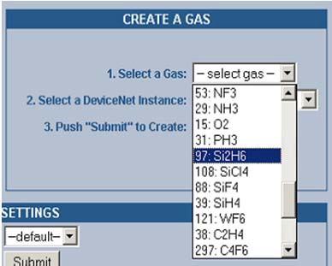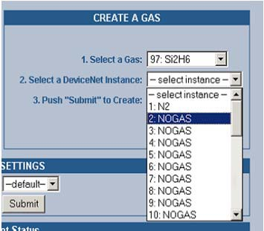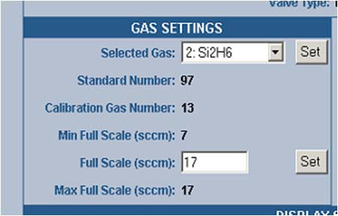

**Figure 15: Embedded GUI, Creating A New Gas Instance**

##### *Changing the Full Scale Flow Range*

In the “Gas Settings” section of the Device Page the user is able to change the full scale gas flow range to any number between the “Min Full Scale (sccm)” and the “Max Full Scale (sccm)” values.

To do this, enter in the desired full scale range in the “Full Scale (sccm):” field and then press the “Set” button. This operation typically takes less than one minute. **Once completed, cycle the power to the MFC. Once you cycle the power, click on the refresh button of the browser. Once the MFC powers up, the browser will reload and start on the Device Page in Monitor Mode.**

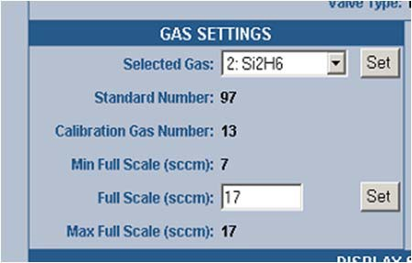

**Figure 16: Changing the Full Scale Flow Range**

##### *Changing the Active Gas Instance*

In the “Gas Settings” section of the Device Page the user is able to change the active gas instance.

To change the “Selected Gas”, click on the drop-down menu’s arrow and select one of the gases that have been created. *Please note that you are able to select the Factory calibration gas instance (32) but you cannot change anything. Instance (1) is an exact replica of that instance* if it has not been overwritten by the user on previous modifications to the gas tables.

Once you’ve selected the instance you want press the “Set” button. The gas will change within (10) seconds. You’ll notice that the “Standard Number” and the minimum and maximum full-scale ranges will change also.

#### Plot Page – Setup Mode

In “Setup Mode” this page enables the user to adjust the Operating Pressure setting to optimize control performance and plot and collect data. To learn more about how to tune the MFC to your system see page XX in the xxx section. This section only deals with setting the values.

Figure 17, Embedded GUI Plot Page in Setup Mode is a screen capture of the Plot Page in “Setup Mode.” The Flow Setpoint and Operating pressure are located above the “Select Variables” section in the top right-hand corner of the page. This page enables you to send a setpoint to the MFC through Ethernet (see notes below), watch the MFC’s performance on the plot, and adjust the Operating Pressure parameter accordingly to optimize the performance of the MFC.

**Note** For Analog units, sending a setpoint through Ethernet will not work unless the Analog checkbox is selected. This checkbox tells the device to bypass the analog setpoint on the analog/power interface. To begin sending setpoints through the analog interface again, either uncheck the Analog checkbox or close the browser.

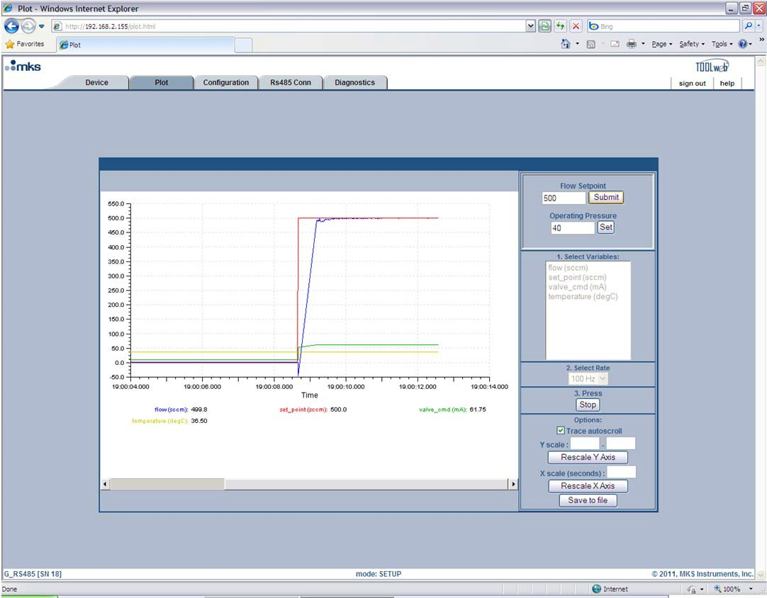

**Figure 17: Embedded GUI, Plot Page in Setup Mode**

Before a MFC leaves the factory the performance is checked with Nitrogen in a typical application. During this test the control parameters are set so that the device’s performance is optimized.

#### Configuration Page – Setup Mode

As was noted earlier, the Configuration Page is where you are initially directed once you’ve entered “Setup Mode.” Here the MFC can be zeroed, the “Setup Mode” password can be changed, changes can be made to the Ethernet settings and firmware can be updated.

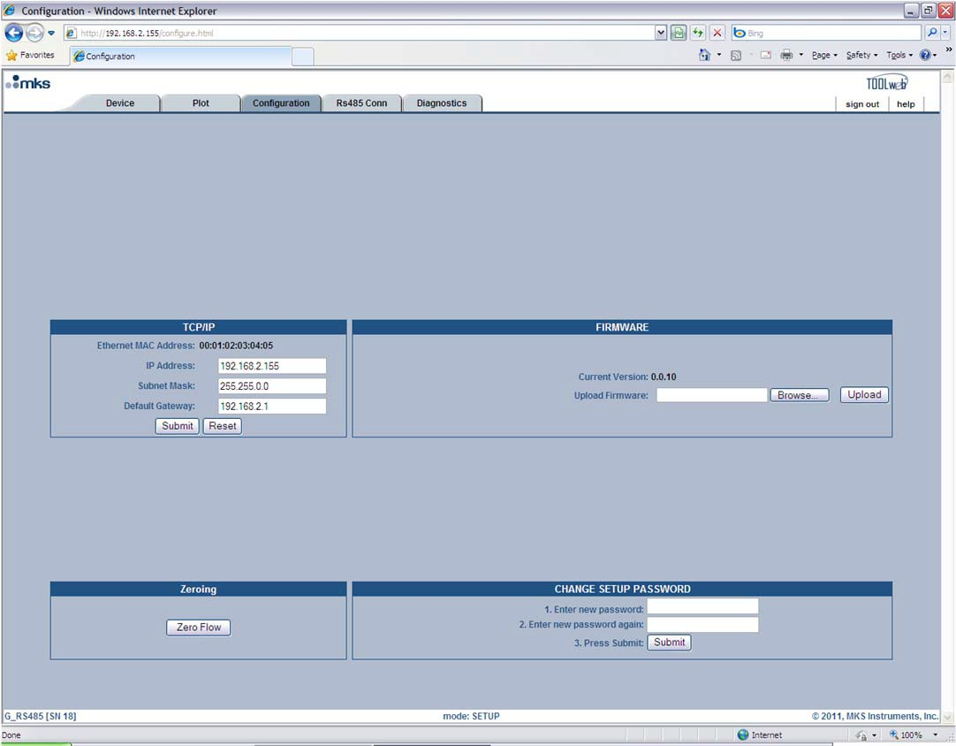

**Figure 18: Embedded GUI, Configuration Page in Setup Mode**

##### *Changing the Ethernet (TCP/IP) Settings*

The TCP/IP section allows you to change the IP Address, Subnet Mask, and Default Gateway for the MFC.

#### Caution If you are unfamiliar with setting TCP/IP settings for the MFC, please contact your company’s IT personnel or local MKS representative for help. If settings are done incorrectly, you may no longer be able to connect to the MFC over Ethernet.

To set a new IP Address, enter in the IP address and press the “Submit” button. Pressing the “Reset” button will reset the entry fields to what was in them prior to you making any changes. For the new IP address to take effect the power to the MFC must be cycled. To use the Embedded GUI, you must now change the URL to reflect the new IP address, e.g. [http://xx.xx.xx.xx,](http://xx.xx.xx.xx/) where xx.xx.xx.xx is the new IP address for the MFC.

##### *Updating Firmware*

Updating firmware is the responsibility of your local MKS representative. If any updates are “necessary”, then your local representative will be in contact to set up a time to complete the upgrade. Please note that a “necessary” update is one that is deemed “Critical” by the factory.

##### *Zeroing the MFC*

For the MFC there will be a “Zero Flow” option. Before zeroing the value make sure the “Zero Adjustment” procedure in Chapter 7 has been followed correctly. To zero the flow, press the “Zero Flow” button. A green banner across the top of the page will tell you if the device received the command and is processing. Zeroing typically will take (10) seconds. The MFC will be unresponsive during this time.

**Caution Zeroing the flow incorrectly can cause system failure. Make sure that the “Zero Adjustment” procedure on page** Error! Bookmark not defined. **is followed properly.**

##### *Changing the Setup Mode Password*

To change the “Setup Mode” password from the default password “config,” follow the steps in the “Change Setup Password” section.

#### RS485 Comm Page – Monitor Mode

This page displays the Baud Rate and MacID settings for the RS485 MFC. In “Monitor Mode” you are able to view this information as well as change it. Figure 19, below, shows a screen capture of the Configuration Page in “Setup Mode.” Similar pages exist for the DeviceNet and Profibus G-Series Products.

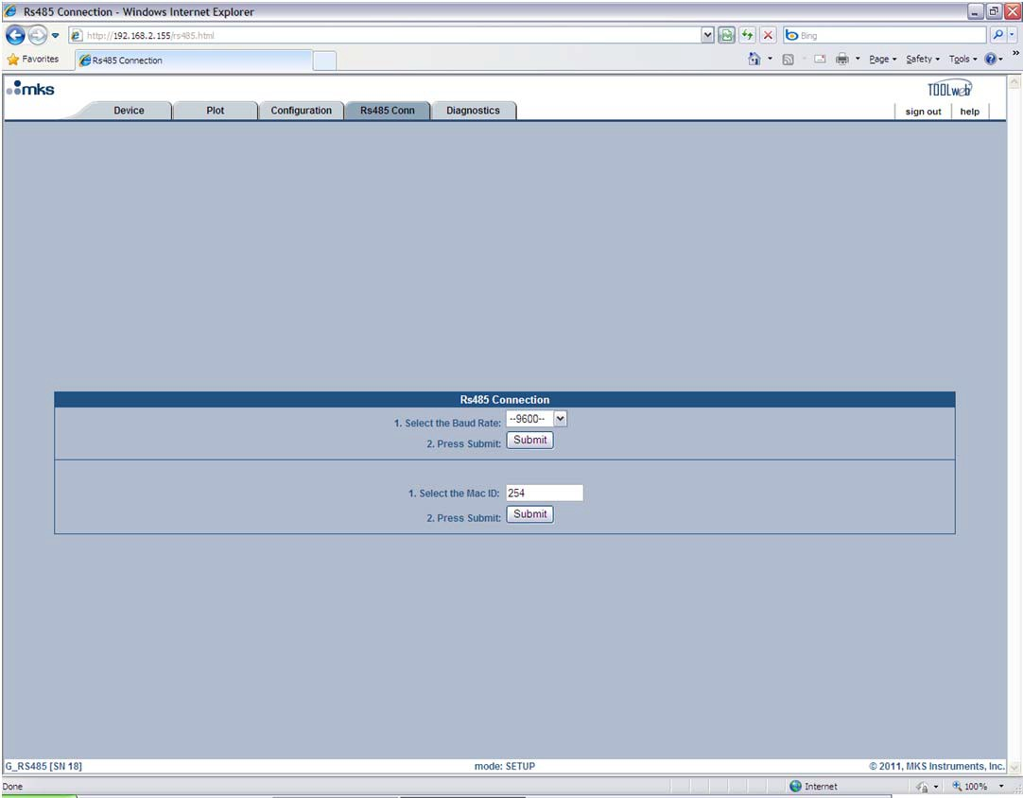

**Figure 19: Embedded GUI, RS485 Comm Page in Setup Mode**

#### Diagnostics Page – Setup Mode

The Diagnostics Page consists of a few basic diagnostic tests. In this section the user is given the ability to run basic diagnostic tests on the flow and temperature. These tests can be run individually or all at once. These tests are explained in more detail below.

##### *Device Diagnostics*

The tests listed in this section are designed to insure that there are no major electrical problems and that the sensors are working properly. These tests are described in detail below:

*Raw Flow* → this basic test is a simple diagnostic check for the flow circuit to verify that the sensor and the electronics are working properly. To run this test, select the checkbox next to where it says “Raw Flow:” and then press the “Run the test” button. When the test finishes you will either see the word “Pass” or “Fail” next to the checkbox. If the test passes, then the flow circuit is good. If it fails, then there may be a problem.

*Temperature* → this basic test is a simple diagnostic check for the temperature circuit to verify that the sensor and the electronics are working properly. To run this test, select the checkbox next to where it says “Temperature:” and then press the “Run the test” button. When the test finishes you will either see the word “Pass” or “Fail” next to the checkbox. If the test passes, then the temperature circuit is good. If it fails, then there may be a problem.

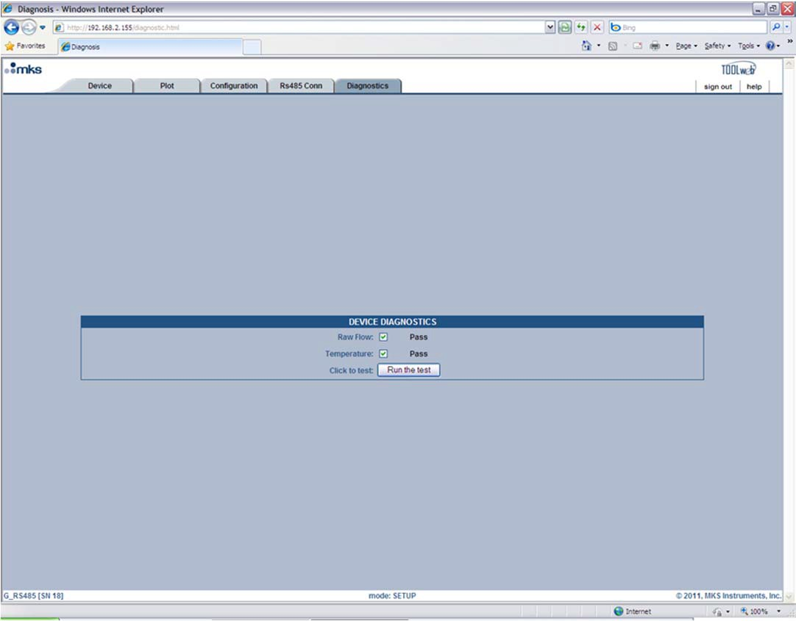

**Figure 20: Embedded GUI, Diagnostics Page in Setup Mode**

# Chapter Seven: Maintenance

## General Information

In general, no maintenance is required other than proper installation and operation. Periodically check for wear on the cables and inspect the enclosure for visible signs of damage. If a mass flow device fails to operate properly on receipt, check for shipping damage, and check the device’s cable for proper power supply. Any damage should be reported to the freight carrier and MKS Instruments immediately. If there is no obvious damage, and the unit fails to operate properly, obtain an RMA Number (Return Materials Authorization Number) before returning the unit to MKS Instruments for service to expedite handling and ensure proper servicing of your instrument.

## Recalibration

It is recommended that the instrument be recalibrated annually (once per year) if no other time interval has been specifically established. Refer to the inside of the back cover of this instruction manual for a complete list of MKS Calibration and Service Centers.

## Flow Zero Adjustment

#### Recommended Interval

For the best accuracy and repeatability performance of the MFC, the zero output output of the device should be periodically checked and reset, if necessary. All MFCs should be zeroed under actual installation conditions prior to use. Very slight offsets in the zero condition can contribute to flow measurement inaccuracy. This may be especially noticeable at the lower end of the device range. At minimum, it is recommended that the MFC be checked and zeroed, if necessary:

* At the time of initial installation (or reinstallation).
* Any time the ambient temperature at the MFC changes more than 10 degrees Centigrade.
* Monthly, as part of a normal preventative maintenance procedure.

#### Methods to Adjust the MFC Flow Zero

There are multiple methods to adjust the Flow Zero of the G-Series MFCs. The methods available depend on the I/O type, either analog or digital.

##### *Analog I/O Devices*

* Manually - Depress and hold the zero (“Select”) button on the top of the device enclosure for three (3) seconds.
* Via the Ethernet UI – Connect to the device using the Ethernet UI and enter the Setup Mode. Go to the Configure Tab and zero using the “Zero Flow” button on the screen. See Figure 18.
* Electronically (15 Pin D analog only) – Pull Pin 9 to ground for three (3) seconds.

##### *Digital I/O Devices*

* Manually - Depress and hold the zero (“Select”) button on the top of the device enclosure for three (3) seconds.
* Via the Ethernet UI – Connect to the device using the Ethernet UI and enter the Setup Mode. Go to the Configure Tab and zero using the “Zero Flow” button on the screen. See Figure 18.
  + Via the protocol Zero Service.
    - For DeviceNet – Refer to “MKS G-Series MFC, Devicenet Supplement” 1046412-001.
    - For Profibus – Refer to “MKS G-Series MFC Profibus Supplement”, 1046413-001
    - For RS485 – Refer to “MKS G-Series MFC, RS485 Supplement”, 1046411-001.

#### Flow Zero Adjustment Procedure

1. Assure that the MFC is setup in the exact process conditions:
   1. Verify that the MFC is installed in the final equipment and orientation (base up, base down, vertical flow up, etc.)
   2. Verify that the MFC is powered at operating temperature for at least 30 minutes.
   3. If the MFC will be subjected to elevated ambient temperature conditions, verify that these temperatures have been achieved and stable for at least 30 minutes before continuing.
2. Verify that the pressure drop across the MFC is reduced to zero and zero the device. Depending on the gas panel configuration, this may be done by one of the following procedures.

#### System has upstream and downstream positive shut off valves

* + 1. Close the upstream valve.
    2. Close the downstream valve.
    3. Open the MFC’s control valve.
    4. Allow pressure across MFC to equilibrate as flow output approaches zero and stabilizes.
    5. Close the MFC’s control valve.
    6. Wait one minute and adjust the zero using one of the methods specified for the device I/O type.
  1. **For systems with downstream valve only** - Zero the MFC at typical operating inlet pressure.
     1. Close the downstream valve.
     2. Open the MFC’s control valve.
     3. Allow pressure to equilibrate across the MFC as flow output approaches zero and stabilizes.
     4. Close the MFC’s control valve.
     5. Wait one minute and adjust zero using one of the methods specified for the device I/O type.
  2. **For systems with upstream valve only -** MFC may be re-zeroed with downstream line under vacuum or atmosphere.
     1. Close the upstream valve.
     2. Open the MFC’s control valve.
     3. The MFC may be evacuated to vacuum or exposed to atmosphere on downstream side. For either case, the downstream pressure must be kept constant to insure there is no pressure drop across MFC.
     4. Allow pressure to equilibrate across MFC as flow output approaches zero and stabilizes.
     5. Close the MFC’s control valve.
     6. Wait one minute and adjust zero using one of the methods specified for the device I/O type.

#### DeviceNet Zeroing Commands

The MFC must be in the executing state then send the zero service with a target value of zero. The following assumes explicit messaging only using the DeviceNet communication protocol.

Place the device in the Executing State through the S-Device Supervisor Object: Note the response Status: Success

The following DeviceNet Command places the device in executing.

##### *Service 0x06, Class 0x30, Instance 1*

1. Verify you are in executing through the S-Device Supervisor Object: Note the response Data (hex): 04 means we are in executing. Attribute 0x0B The following DeviceNet Command is used to verify you are

in executing.

##### *Service 0xE, Class 0x30, Instance 1, Service Data (attribute) 0x0B*

You should get response data of 0x04

1. Send the Zero Adjust Service using S-Analog Sensor Object Instance 1 ( Flow ) The following DeviceNet Command Starts the Pressure zero.

##### *Service 0x4B, Class 0x31, Instance 1, Service Data (Target Value) can be Empty Data or Data Type based* value, i.e. 2 byte for integer or 4 byte real value, if a value is used, it must be a target value equal to zero.

1. The Flow zeroing procedure usually takes several seconds to perform. Recheck your flow to verify zero has occurred. You can also perform an explicit GET(Service 0x0E) on Class 0x31, Instance 1, Attribute 0x1C, which is the Autozero Status. This attribute’s service data will equal “1” while zeroing is in progress and equal “0” when the zeroing has completed. It is most important that the device is at a zero flow, if a high flow is detected by the MFC, then zeroing will not occur.

#### Profibus Zeroing Commands

In cyclic data exchange communication, set the AUTOZERO field in the Send Data structure to 1. In DP-V1 Extension message, set the Auto Zero Value (Index 16) to zero in slot 0x31 in the Analog Sensor Object .

#### RS485 Zeroing Commands

The MFC must be in the Calibrate Mode to zero the device. In the calibrate mode, send the command “AZ” to zero the device. The message structure appears as shown below:

#### @@@254AZ!;FF

In this example, “254” is the address and “FF” is the Checksum. Substitute the correct address and checksum applicable to your device.

This page intentionally left blank.

# Chapter Eight: Troubleshooting

## Troubleshooting Chart

**Table 15: Troubleshooting Chart**

**Possible Cause**

**Check/Corrective Action**

**Symptom**

|  |  |  |
| --- | --- | --- |
| MFC LED does not light | No power | Check power source |
|  | Low power | Check supply voltage |
| Wrong cable | Check cable |
| Bad cable connection | Check pin(s) continuity |

|  |  |  |
| --- | --- | --- |
| MFC does not respond to any setpoint | Bad DNet connection | Verify correct DNet I/O instance |
|  | Control circuit failure | Provide setpoint, gas & pressure to device, run diagnostic using Ethernet interface. |
| Low or no power | Check power source, measure voltage |
| Contamination/Clogged - blocked MFC device or gas line | Check inlet pressure @ MFC. Check outlet pressure MFC using pressure gauge. Check outlet pressure downstream of positive shut off (pneumatic) valve downstream of MFC. Check air line to pneumatic valve. Check for any restriction such as filter or check valve downstream of MFC. |
| MFC shows 0 flow when given setpoint | Closed upstream and/or downstream pneumatic valves | Open valves, check inlet pressure |
|  | No gas supply | Turn on gas supply |
| Upstream clogged filter/component | Check flow through of components by measuring pressure drop across device |
| MFC clogged orifice | Verify MFC inlet pressure, check valve current for open valve condition. Check for gas flow downstream of MFC - If flow does not exist, possible clogged orifice |

|  |  |
| --- | --- |
| MFC clogged sensor | Run MFC diagnostics. Verify MFC inlet pressure, check valve current for open valve condition and check for gas flow downstream of MFC. If flow present, possible clogged sensor |
| MFC control circuit failure | Run MFC diagnostics. If error results, contact MKS service center. |

|  |  |  |
| --- | --- | --- |
| MFC shows output flow > FS (overrange) | MFC valve full open | Check valve current for maximum condition |
|  | Pressure drop across MFC is greater than specification | Measure upstream pressure & downstream pressure. Compare to specification. |
| Faulty valve control circuit/calibration | Run MFC diagnostics using Ethernet GUI |
| Possible contamination in valve assembly | Cycle-purge MFC to clear suspected contamination |
| MFC output signal does not match setpoint | Contamination | Check for partial block orifice or sensor. Cycle purge MFC to clear contaminant |
|  | Inlet pressure too low | Increase inlet pressure |
| Outlet pressure too high | Decrease outlet pressure |
| Flow signal is not properly grounded. | Check for ground loops. |
| Control electronics failure, sensor failure | Run MFC diagnostics test |
| MFC output signal oscillates | Inlet pressure oscillates | Check for faulty regulator |
|  | Inlet pressure too high | Lower inlet pressure  Adjust programmed inlet pressure through Ethernet GUI. |
| Inlet pressure too high |
| MFC nameplate gas not same as actual gas | Check for programmed gas using Ethernet GUI or digital interface. Reprogram as necessary |
| Faulty control circuit | Run MFC diagnostic test. |

|  |  |  |
| --- | --- | --- |
| MFC output signal matches setpoint, but actual gas flow less (as determined by transfer standard) | Contaminated bypass | Check process chamber pressure. Compare to normal or reference. |
|  | MFC programmed for different gas | Compare gas programmed in MFC to actual gas used. Verify using DNet or Ethernet interface. |
| MFC cannot achieve FS flow | Inlet pressure low | Increase inlet pressure |
|  | Outlet pressure high | Decrease outlet pressure |
| Valve contamination | Check valve current for maximum position |
| Gas line blockage/contamination | Measure pressure drop across component suspected of contamination such as filter or check valve |
| MFC setpoint in counts > than 100% FS of 24567 counts | Program attributed 6 to 100% =  24567 counts (0x6000) |
| Output signal matches setpoint @ higher flows, but will not go to 0 | MFC valve partial contamination | Cycle-purge device, check valve current |
|  | Faulty control valve, adjustment or electronics | Run MFC diagnostics, call MKS service center |
| Inlet pressure too high | Decrease inlet pressure |
| Device zero offset | re-zero device with known zero flow conditions |
| Display powers up, but MFC does not respond | Bad DNet/RS485 connection | Check status DNet polled connection/RS485 connection. check network LED |
|  | Incorrect MAC ID Address | Check MAC ID on device |
| Incorrect baud rate setting | Check baud rate on device |
| Incorrect DNet I/O Instance Setting | Check I/O setting using DNet commissioning tool/software |
|  | Check tool host |
| Low power, power supply | Measure current & voltage from power source |
| MFC output shows large overshoot | Inlet pressure too high | Decrease inlet pressure |
|  | Actual inlet pressure higher than pressure programmed to | Adjust programmed inlet pressure through Ethernet GUI. |

MFC output slow to respond to setpoint

|  |  |
| --- | --- |
| device. |  |
| MFC not programmed for correct gas - actual gas used different | Check MFC active gas using digital interface or Ethernet GUI |
| MFC control parameters set incorrectly | Contact MKS service center |
| Inlet pressure too low | Increase inlet pressure |
| Actual inlet pressure lower than pressure programmed to device. | Adjust programmed inlet pressure through Ethernet GUI. |
| MFC not programmed for correct gas - actual gas used different | Check MFC active gas using digital interface or Ethernet GUI |

MFC control parameters set incorrectly

Contact MKS service center

|  |  |  |
| --- | --- | --- |
| Output signal > zero with confirmed zero flow condition | MFC device zero offset | Re-zero device per instruction manual |
|  | Fault in valve adjustment, gap between plug & orifice | Contact MKS service center |

|  |  |  |
| --- | --- | --- |
| **DeviceNet LED indicator (color)** | **State** | **Indication** |
| **- Network status LED** |  |  |
| Green | Link OK, On-line, Connected | The device in on-line and has connection in the established state.  - For a Group 2 only device it means that this device is not allocated to a master. |
|  | |
|  | | |
| Flashing Green | On-line, Not Connected | Device is on-line but has no connection in the established state.   * The device has passed The Dup_MAC_ID test, is on-line, but has no established connections to other nodes. * For a Group 2 only device it means that this device is not allocated to a master. |
|  | |

|  |  |  |
| --- | --- | --- |
|  | |  |
| Red | Critical Link Failure | Failed communication device. The device has detected an error that has rendered it incapable of communicating on the network (Duplicate MAC ID, or Bus-off) |
| Flashing Red | Connection Time-Out | One or more I/O Connections are in the Timed-Out state. |
| Flashing Red & Green | Communication Faulted and Received an Identify Comm Fault Request - Long Protocol | A specific Communication Faulted device. The device has detected a Network Access error and is in the Communication Faulted state. The device has subsequently received and accepted an Identify Communication Faulted Request - Long Protocol message. |
| Off | Not Powered/Not On-Line | Device is not on-line |
|  | | - The device has not completed The Dup_MAC-ID test yet |
| - The device may not be powered, look at Module Status LED. |
| **- DeviceNet Module Status Indicator** |  |  |
| Green | Device operational | The device is operating in a normal condition |
| Flashing Green | Device in Standby (The Device Needs Commissioning) | The device needs commisioning due to configuration missing, incomplete or incorrect. |
| Red | Unrecoverable Fault | The device has an unrecoverable fault; may need replacing. |
| Flashing Red | Minor Fault | Recoverable Fault |
| Flashing Red & Green | Device Self Testing | The Device is in Self Test. Reference the Identity Object in Volume II for Device states. |
| Off | No power | There is no power applied to the device |

This page intentionally left blank.

# Appendix A: Product Specifications

## Performance Specifications – GE50A/GV50A/GM50A

|  |  |  |
| --- | --- | --- |
|  | **GE50A, GV50A – Elastomer Sealed** | **GM50A – Metal Sealed** |
| Full Scale Flow (N2 equivalent) | 10-50000 sccm | 10-50000 sccm |
| Maximum Inlet Pressure | 150 psig, limited to maximum differential pressure across MFC. | 150 psig, limited to maximum differential pressure across MFC. |
| Normal Operating Pressure Differential (with atmospheric pressure at the MFC outlet) | 10 to 5000 sccm, 10 to 40 psid  10000 to 20000 sccm 15 to 40 psid  30000 to 50000 sccm 25 to 40 psid | 10 to 5000 sccm, 10 to 40 psid  10000 to 20000 sccm 15 to 40 psid  30000 to 50000 sccm 25 to 40 psid |
| Proof Pressure | 1000 psig | 1000 psig |
| Burst Pressure | 1500 psig | 1500 psig |
| Control Range | 2% to 100% of F.S. | 2% to 100% of F.S. |
| Accuracy |  1% of setpoint for > 20 to 100% F.S.   0.2% of FS for 2 to 20% F.S. |  1% of setpoint for > 20 to 100% F.S.   0.2% of FS for 2 to 20% F.S. |
| Repeatability |  0.3% of Reading |  0.3% of Reading |
| Resolution | 0.1% of Full Scale | 0.1% of Full Scale |
| Temperature Coefficients Zero  Span | <0.05% F.S./C  <0.08% Reading/C | <0.05% F.S./C  <0.08% Reading/C |
| Inlet Pressure Coefficient | < 0.02% of Reading./psi | < 0.02% of Reading./psi |
| Typical Controller Settling Time (per SEMI Guideline E17-0600) | < 750 milliseconds (typical above 5% F.S.) | < 750 milliseconds (typical above 5% F.S.) |
| Warm-Up Time  (to within 0.2% of F.S. of steady state performance) | < 30 min. | < 30 min. |
| Normal Operating Temperature Range | 10C to 50C | 10C to 50C |
| Storage Humidity | 0 to 95% Relative Humidity, non- condensing | 0 to 95% Relative Humidity, non- condensing |
| Storage Temperature | -20C to 65C (-4F to 149F) | -20C to 65C (-4F to 149F) |
| ROHS Compliant | Yes | Yes |
| Electromagnetic Compatibility | CE Compliant 2004/108/EC | CE Compliant 2004/108/EC |

**Specifications are subject to change without notice.**

Specifications are subject to change without notice. Mechanical Specifications - GE50A/GV50A/GM50A

Appendix A: Product Specifications

## Mechanical Specifications - GE50A/GV50A/GM50A

|  |  |  |
| --- | --- | --- |
|  | **GE50A, GV50A – Elastomer Sealed** | **GM50A – Metal Sealed** |
| Fittings (compatible with) | ¼” Swagelok, 4 VCR, 4 VCO | ¼” Swagelok, 4 VCR, 1-1/2” surface mount (C-seal, W-seal) |
| Leak Integrity |  |  |
| External (scc/sec He) | < 1 x 10-9 | < 1 x 10-10 |
| Through closed valve | < 0.1% for F.S. at 40 psig inlet to atmos. | < 1% for F.S. at 40 psig inlet to atmos. |
| Through shut-off valve | <4x 10-09 atm-cc/sec He | Not Applicable |
| Wetted Materials |  |  |
| Standard | 316L S.S. VAR (equivalent to 316 S.S. SCQ for semiconductor quality), 316 S.S. , Elgiloy, Nickel, 430FR | 316L S.S. VAR (equivalent to 316 S.S. SCQ for semiconductor quality), 316 S.S. , Elgiloy, KM-45, PTFE |
| Seals (select option) | Viton, Buna, or Neoprene | Stainless Steel |
| Surface Finish | 16 inches, average Ra | 10 inches, average Ra, Electropolished |
| Weight | ≤ 3 lbs (1.4 kg) | ≤ 3 lbs (1.4 kg) |

## Electrical Specifications for GE50A, GM50A and GV50A

|  |  |
| --- | --- |
| **Analog I/O** |  |
| Input Voltage Required  Max current at start-up (first 5 sec.) Typical current at steady state | +15 to +25 VDC  15VDC (±5 %) @ TBD mA  15VDC (±5 %) @ TBD mA |
| Set Point Command Signal | 0 to 5 VDC |
| Flow Output Signal | 0 to 5 VDC (into high impedance load, minimum 10K-ohm) |
| Output Impedance | < 1 Ω |
| Connectors | 15-pin Type “D”, 9-pin Type “D” |
| **Digital I/O (DeviceNet)** |  |
| Input Voltage  Max current at start-up (first 5 sec.) Typical current at steady state | +11 to +25 VDC  15VDC (±5 %) @ 350 mA  15VDC (±5 %) @ 280 mA |
| Data Rate/Network Length | Date Rate (User selectable) 125 Kbps, 500 m (1,640 ft)  250 Kbps, 250m (820 ft)  500 Kbps, 100m (328 ft) |
| Level of Filtering | User software adjustable |
| Digital Functions (flow) | Select units: counts, slm, sccm % of F.S. Remote Zero |

|  |  |
| --- | --- |
|  | Set/read flow rate  Flow totalizer and run hours Valve soft start  Monitor MFC status – valve drive level and trip points (alarm for high flow, alarm for low flow, warning for high flow, warning for low flow)  Reset factory defaults Report run time hours  Change user tags and device address  Device Identification Storage includes manufacturer information, model and serial number, original factory calibration, software and hardware revision numbers. |
| Digital Functions (temperature) | Set units  Read temperature  Alarm enable, Warning enable  Alarm settling time, Warning settling time Alarm trip point high, Warning trip point high Alarm trip point low, Warning trip point low  Zero adjust |
| Data Rate Switch | 4 positions: 125, 250, 500K, PGM (programmable over the network) |
| MAC ID Switches | 2 switches, 10 positions; 0,0 to 6,3 are hardware ID numbers: 7,0 to 9,9 are software ID numbers; (6,4 to 6,9 are unused and, if selected will default to hardware ID number 6,3) |
| Input Power | 11 to 25 VDC per DeviceNet specifications ( @ <3.5 watts) |
| Network Size | Up to 64 nodes |
| Network Topology | Linear (trunkline/dropline) power and signal on same network cable |
| Visual Communication Indicators | LED network status (green/red) LED module status (green/red) |
| **Digital I/O (RS485)** |  |
| Input Voltage  Max current at start-up (first 5 sec.) Typical current at steady state | +15 to +25 VDC  15VDC (±5 %) @ 350 mA  15VDC (±5 %) @ 280 mA |
| Date Rate/Network Length | Date Rate (User selectable) 9.6 KBaud/1200 m (4000 ft.)  19.2 KBaud/1200 m (4000 ft.)  38.4 KBaud /1200 m (4000 ft.) |
| Digital Functions (flow) | Query for MAC – Host controller will use this message to query the existence of a MFC controller.  Freeze Follow – Host controller will use this message to configure a MFC controller to act upon a new set point when received.  Set Point – Host controller will use this message to send a new set point to a MFC controller.  Filtered Set Point – Host controller will use this message to get the current set point from a MFC controller.  Indicated Flow - Host controller will use this message to get the current flow |

Electrical Specifications for GE50A, GM50A and GV50A

Appendix A: Product Specifications

|  |  |
| --- | --- |
|  | reading from a MFC controller.  Valve Drive Current - Host controller will use this message to get the valve drive current.  Calibration Instance (Process Gas) Selection - Host controller will use this message to select which calibration instance is to be used for flow metering.  Query for Calibration Instance (Process Gas) Selected - Host controller will use this message to query the selected calibration instance, which is currently being used for flow metering.  Requested Zero Enable - Host controller will use this message to enable requested function.  Query for Requested Zero Status – Host controller will use this message to query if the requested zero function has been completed.  Query for Zero Offset - Host controller will use this message to query the present sensor zero offset.  Set Ramp Time – Used to set the tamp time in ms. The set point will ramp in from the present to the new setpoint in this period of time..  Query All - This is used to obtain 3 measurements, Flow, valve and temperature in 1 command.  Set Actuator Mode - This is used to set valve to open, closed or normal control |
| Data Rate Switch | 3 positions: 9.6, 19.2, 38.4 KBaud (programmable over the network) |
| MAC ID Switches | 2 switches, 10 positions each; 15 available MACIDs (33-99) |
| Input Power | 11 to 25 VDC per DeviceNet specifications ( @ <3.5 watts) |
| Network Size | Up to 256 nodes (15 available MFC MACIDs) |
| Network Topology | Master/slave |
| Visual Communication Indicators | LED Comm status (green/red) LED Error status (green/red) |

**Specifications are subject to change without notice.**

# Appendix B : Model Code Explanation for GE50A & GV50A

## Model Code Description – Elastomer Sealed Products

The model code of the MFC defines features of the unit such as device type, flow range, fittings, valve configuration, connector type, seal material and firmware revision.

#### CCCCC GGG FFF Y W Z S VV

Configuration Code Gas Code

Flow Range Full Scale

Fittings

Connector Type

Seal Type

Reserved For MKS Future Use Firmware Version

**Configuration Code (CCCCC)**

Type GE50A Elastomer Sealed Mass Flow Controller: CCCCC = GE50A

Type GV50A Elastomer Sealed Mass Flow Controller with Integral Shut-off Valve: CCCCC = GV50A

#### Gas Code (GGG)

Gas codes are in accordance with SEMI Guideline E52, Practice for Referencing Gases and Gas Mixtures Used in Digital Mass Flow Controllers. If the gas or gas mixture sought is not found in the list below, conult MKS Applications Engineering for assistance.

|  |  |  |
| --- | --- | --- |
| **Gas** | **Code** | **Symbol** |
| Acetone | 184 | C3H6O |
| Acetylene | 042 | C2H2 |
| Air | 008 | Air |
| Allene | 066 | C3H4 |
| Ammonia | 029 | NH3 |
| Argon | 004 | Ar |
| Arsine | 035 | AsH3 |
| Boron Trichloride | 070 | BCl3 |
| Boron Trifluoride | 048 | BF3 |
| Bromine | 021 | Br2 |
| Bromine Pentafluoride | 116 | BrF5 |
| Bromine Trifluoride | 076 | BrF3 |
| Bromotrifluoromethane (R-13b1) | 080 | CBrF3 |
| Butane | 117 | C4H10 |

|  |  |  |
| --- | --- | --- |
| Carbon Dioxide | 025 | CO2 |
| Carbon Disulfide | 040 | CS2 |
| Carbon Monoxide | 009 | CO |
| Carbon Tetrachloride | 101 | CCl4 |
| Carbon Tetrafluoride (R-14) | 063 | CF4 |
| Carbonyl Sulfide | 034 | COS |
| Chlorine | 019 | Cl2 |
| Chlorine Trifluoride | 077 | ClF3 |
| Chlorodifluoromethane (R-22) | 057 | CHClF2 |
| Chloroform (Trichloromethane) | 071 | CHCl3 |
| Chloropentafluoroethane (R-115) | 119 | C2ClF5 |
| Chlorotrifluoromethane (R-13) | 074 | CClF3 |
| Cyanogen | 059 | C2N2 |
| Cyanogen Chloride | 037 | ClCN |
| Cyclopropane | 061 | C3H6 |
| Deuterium | 014 | D2 |
| Diborane | 058 | B2H6 |
| Dichlorodifluoromethane (R-12) | 084 | CCl2F2 |
| Dichlorofluoromethane (R-21) | 065 | CHCl2F |
| Dichlorosilane | 067 | SiH2Cl2 |
| 1,2-Dichlorotetrafluoroethane (R-114) | 125 | C2Cl2F4 |
| Difluoroethylene (R-1132a) | 064 | C2H2F2 |
| Difluoromethane | 160 | CH2F2 |
| Dimethylamine | 085 | C2H7N |
| Dimethylpropane | 122 | C5H12 |
| Disilane | 097 | Si2H6 |
| Ethane | 054 | C2H6 |
| Ethanol | 136 | C2H6O |
| Ethyl Acetylene | 093 | C4H6 |
| Ethyl Chloride | 075 | C2H5Cl |
| Ethylene | 038 | C2H4 |
| Ethylene Oxide | 045 | C2H4O |
| Fluorine | 018 | F2 |
| Germane | 043 | GeH4 |
| Germanium Tetrachloride | 113 | GeCl4 |
| Helium | 001 | He |
| Hexafluoro Butadiene-1,3 | 297 | C4F6 |
| Hexafluoroethane (R-116) | 118 | C2F6 |
| Hexafluoropropylene | 138 | C3F6 |
| Hexane | 127 | C6H14 |
| Hydrogen | 007 | H2 |
| Hydrogen Bromide | 010 | HBr |

|  |  |  |
| --- | --- | --- |
| Hydrogen Chloride | 011 | HCl |
| Hydrogen Cyanide | 024 | HCN |
| Hydrogen Fluoride | 012 | HF |
| Hydrogen Iodide | 017 | HI |
| Hydrogen Selenide | 023 | H2Se |
| Hydrogen Sulfide | 022 | H2S |
| Iodine Pentafluoride | 115 | IF5 |
| Isobutane | 111 | C4H10 |
| Isobutylene | 106 | C4H8 |
| Krypton | 005 | Kr |
| Methane | 028 | CH4 |
| Methanol | 176 | CH4O |
| Methyl Acetylene | 068 | C3H4 |
| Methyl Bromide | 044 | CH3Br |
| Methyl Chloride | 036 | CH3Cl |
| Methyl Fluoride | 033 | CH3F |
| Methyl Mercaptan | 047 | CH4S |
| Methylamine | 052 | CH5N |
| Methyltrichlorosilane | 183 | CH3Cl3Si |
| Molybdenum Hexafluoride | 124 | MoF6 |
| Neon | 002 | Ne |
| Nitric Oxide | 016 | NO |
| Nitrogen | 013 | N2 |
| Nitrogen Dioxide | 026 | NO2 |
| Nitrogen Trifluoride | 053 | NF3 |
| Nitrosyl Chloride | 141 | NOCl |
| Nitrous Oxide | 027 | N2O |
| Octafluorocyclobutane (R-c318) | 129 | C4F8 |
| Oxygen | 015 | O2 |
| Oxygen Difluoride | 041 | OF2 |
| Ozone | 030 | O3 |
| Pentaborane | 142 | B5H9 |
| Pentafluorethane | 155 | C2HF5 |
| Perchloryl Fluoride | 072 | ClO3F |
| Perfluoropropane | 128 | C3F8 |
| Phosgene | 060 | CCl2O |
| Phosphine | 031 | PH3 |
| Phosphorous Oxychloride | 102 | POCl3 |
| Phosphorous Pentafluoride | 143 | PF5 |
| Propane | 089 | C3H8 |
| Propylene | 069 | C3H6 |
| Radon | 003 | Rn |
| Silane | 039 | SiH4 |

|  |  |  |
| --- | --- | --- |
| Silicon Tetrachloride | 108 | SiCl4 |
| Silicon Tetrafluoride | 088 | SiF4 |
| Sulfur Dioxide | 032 | SO2 |
| Sulfur Hexafluoride | 110 | SF6 |
| Sulfur Tetrafluoride | 086 | SF4 |
| Sulfuryl Fluoride | 087 | SO2F2 |
| Tetrafluoroethane (R-134a) | 156 | C2H2F4 |
| Titanium Tetrachloride | 114 | TiCl4 |
| Toluene | 181 | C7H8 |
| Trans-Butene | 098 | C4H8 |
| Trichloroethane | 112 | C2H3Cl3 |
| Trichlorofluoromethane (R-11) | 091 | CCl3F |
| Trichlorosilane | 147 | SiHCl3 |
| Trichlorotrifluoroethane (R-113) | 126 | C2Cl3F3 |
| Trifluoromethane (Fluoroform R-23) | 049 | CHF3 |
| Trimethoxyborine | 131 | C3H9BO3 |
| Trimethylamine | 109 | C3H9N |
| Tungsten Hexafluoride | 121 | WF6 |
| Uranium Hexafluoride | 123 | UF6 |
| Vinyl Bromide | 056 | C2H3Br |
| Vinyl Chloride | 055 | C2H3Cl |
| Xenon | 006 | Xe |

#### Flow Range Full Range (FFF)

The MFC’s mass flow full scale range is indicated by a three digit code.

|  |  |
| --- | --- |
| **Mass Flow Rate** | **G-SERIES**  **Ordering Code(FFF)** |
| 10 sccm | 101 |
| 20 sccm | 201 |
| 50 sccm | 501 |
| 100 sccm | 102 |
| 200 sccm | 202 |
| 500 sccm | 502 |
| 1000 sccm | 103 |
| 2000 sccm | 203 |
| 5000 sccm | 503 |
| 10000 sccm | 104 |
| 20000 sccm | 204 |
| 30000 sccm | 304 |
| 50000 sccm | 504 |

#### FittingType (Y)

The fitting options are designated by a letter code.

|  |  |
| --- | --- |
| **Fitting Style** |  |
|  | **GE50A & GV50A** |
| Swagelok 4 VCR male | R |
| Swagelok 4 VCO male | G |
| Swagelok ¼” compression seal | S |
| Downport C-Seal per SEMI 2787.1 | - |
| Downport W-Seal per SEMI 2787.3F | - |

#### Connector – Control I/O (W)

The MFC’s connector is designated by a single number code.

|  |  |
| --- | --- |
| **Connector Type** | **Ordering Code** |
| Profibus | 4 |
| Digital RS485 | 5 |
| DeviceNet | 6 |
| 9 Pin D(Analog I/O) | A |
| 15 Pin D(Analog I/O) | B |

#### Seal Type (Z)

The seal material option is designated by a letter code. The MFCs are normally closed valve with the following seal type.

|  |  |
| --- | --- |
| **Valve Type** | **Ordering Code** |
| Viton | V |
| Buna-N | B |
| Neoprene | N |

#### Reserved For MKS Future Use (S) Standard = 0

**Firmware Version (VV)**

The firmware version options are designated by a two digit number code for all product I/O types. The versions specified below are the released firmware versions at the time of this manuals release.

***Example:*** The release of firmware version 10.

|  |  |
| --- | --- |
| **Firmware Version** | **Ordering Code** |
| Profibus (4), RS485 (5) and Devicenet (6) I/O Devices | 10 |
| 9 Pin D (A) and 15 Pin D Analog I/O Devices | 10 |

# Appendix C: Model Code Explanation for GM50A

## Model Code Description – GM50A – Metal Sealed Products

The model code of the MFC defines features of the unit such as device type, flow range, fittings, valve configuration, connector type, seal material and firmware revision.

#### CCCCC GGG FFF Y W Z S VV

Configuration Code Gas Code

Flow Range Full Scale

Fittings

Connector Type

Valve Type (Closed “M” for MFC; None “3” for MFM)

Reserved For MKS Future Use Firmware Version

**Configuration Code (CCCCC)**

Type GM50A Metal Sealed Mass Flow Controller and Mass Flow Meter: CCCCC = GM50A

#### Gas Code (GGG)

Gas codes are in accordance with SEMI Guideline E52, Practice for Referencing Gases and Gas Mixtures Used in Digital Mass Flow Controllers. If the gas or gas mixture sought is not found in the list below, conult MKS Applications Engineering for assistance.

|  |  |  |
| --- | --- | --- |
| **Gas** | **Code** | **Symbol** |
| Acetone | 184 | C3H6O |
| Acetylene | 042 | C2H2 |
| Air | 008 | Air |
| Allene | 066 | C3H4 |
| Ammonia | 029 | NH3 |
| Argon | 004 | Ar |
| Arsine | 035 | AsH3 |
| Boron Trichloride | 070 | BCl3 |
| Boron Trifluoride | 048 | BF3 |
| Bromine | 021 | Br2 |
| Bromine Pentafluoride | 116 | BrF5 |
| Bromine Trifluoride | 076 | BrF3 |
| Bromotrifluoromethane (R-13b1) | 080 | CBrF3 |
| Butane | 117 | C4H10 |

|  |  |  |
| --- | --- | --- |
| Carbon Dioxide | 025 | CO2 |
| Carbon Disulfide | 040 | CS2 |
| Carbon Monoxide | 009 | CO |
| Carbon Tetrachloride | 101 | CCl4 |
| Carbon Tetrafluoride (R-14) | 063 | CF4 |
| Carbonyl Sulfide | 034 | COS |
| Chlorine | 019 | Cl2 |
| Chlorine Trifluoride | 077 | ClF3 |
| Chlorodifluoromethane (R-22) | 057 | CHClF2 |
| Chloroform (Trichloromethane) | 071 | CHCl3 |
| Chloropentafluoroethane (R-115) | 119 | C2ClF5 |
| Chlorotrifluoromethane (R-13) | 074 | CClF3 |
| Cyanogen | 059 | C2N2 |
| Cyanogen Chloride | 037 | ClCN |
| Cyclopropane | 061 | C3H6 |
| Deuterium | 014 | D2 |
| Diborane | 058 | B2H6 |
| Dichlorodifluoromethane (R-12) | 084 | CCl2F2 |
| Dichlorofluoromethane (R-21) | 065 | CHCl2F |
| Dichlorosilane | 067 | SiH2Cl2 |
| 1,2-Dichlorotetrafluoroethane (R-114) | 125 | C2Cl2F4 |
| Difluoroethylene (R-1132a) | 064 | C2H2F2 |
| Difluoromethane | 160 | CH2F2 |
| Dimethylamine | 085 | C2H7N |
| Dimethylpropane | 122 | C5H12 |
| Disilane | 097 | Si2H6 |
| Ethane | 054 | C2H6 |
| Ethanol | 136 | C2H6O |
| Ethyl Acetylene | 093 | C4H6 |
| Ethyl Chloride | 075 | C2H5Cl |
| Ethylene | 038 | C2H4 |
| Ethylene Oxide | 045 | C2H4O |
| Fluorine | 018 | F2 |
| Germane | 043 | GeH4 |
| Germanium Tetrachloride | 113 | GeCl4 |
| Helium | 001 | He |
| Hexafluoro Butadiene-1,3 | 297 | C4F6 |
| Hexafluoroethane (R-116) | 118 | C2F6 |
| Hexafluoropropylene | 138 | C3F6 |
| Hexane | 127 | C6H14 |
| Hydrogen | 007 | H2 |
| Hydrogen Bromide | 010 | HBr |
| Hydrogen Chloride | 011 | HCl |

|  |  |  |
| --- | --- | --- |
| Hydrogen Cyanide | 024 | HCN |
| Hydrogen Fluoride | 012 | HF |
| Hydrogen Iodide | 017 | HI |
| Hydrogen Selenide | 023 | H2Se |
| Hydrogen Sulfide | 022 | H2S |
| Iodine Pentafluoride | 115 | IF5 |
| Isobutane | 111 | C4H10 |
| Isobutylene | 106 | C4H8 |
| Krypton | 005 | Kr |
| Methane | 028 | CH4 |
| Methanol | 176 | CH4O |
| Methyl Acetylene | 068 | C3H4 |
| Methyl Bromide | 044 | CH3Br |
| Methyl Chloride | 036 | CH3Cl |
| Methyl Fluoride | 033 | CH3F |
| Methyl Mercaptan | 047 | CH4S |
| Methylamine | 052 | CH5N |
| Methyltrichlorosilane | 183 | CH3Cl3Si |
| Molybdenum Hexafluoride | 124 | MoF6 |
| Neon | 002 | Ne |
| Nitric Oxide | 016 | NO |
| Nitrogen | 013 | N2 |
| Nitrogen Dioxide | 026 | NO2 |
| Nitrogen Trifluoride | 053 | NF3 |
| Nitrosyl Chloride | 141 | NOCl |
| Nitrous Oxide | 027 | N2O |
| Octafluorocyclobutane (R-c318) | 129 | C4F8 |
| Oxygen | 015 | O2 |
| Oxygen Difluoride | 041 | OF2 |
| Ozone | 030 | O3 |
| Pentaborane | 142 | B5H9 |
| Pentafluorethane | 155 | C2HF5 |
| Perchloryl Fluoride | 072 | ClO3F |
| Perfluoropropane | 128 | C3F8 |
| Phosgene | 060 | CCl2O |
| Phosphine | 031 | PH3 |
| Phosphorous Oxychloride | 102 | POCl3 |
| Phosphorous Pentafluoride | 143 | PF5 |
| Propane | 089 | C3H8 |
| Propylene | 069 | C3H6 |
| Radon | 003 | Rn |
| Silane | 039 | SiH4 |

|  |  |  |
| --- | --- | --- |
| Silicon Tetrachloride | 108 | SiCl4 |
| Silicon Tetrafluoride | 088 | SiF4 |
| Sulfur Dioxide | 032 | SO2 |
| Sulfur Hexafluoride | 110 | SF6 |
| Sulfur Tetrafluoride | 086 | SF4 |
| Sulfuryl Fluoride | 087 | SO2F2 |
| Tetrafluoroethane (R-134a) | 156 | C2H2F4 |
| Titanium Tetrachloride | 114 | TiCl4 |
| Toluene | 181 | C7H8 |
| Trans-Butene | 098 | C4H8 |
| Trichloroethane | 112 | C2H3Cl3 |
| Trichlorofluoromethane (R-11) | 091 | CCl3F |
| Trichlorosilane | 147 | SiHCl3 |
| Trichlorotrifluoroethane (R-113) | 126 | C2Cl3F3 |
| Trifluoromethane (Fluoroform R-23) | 049 | CHF3 |
| Trimethoxyborine | 131 | C3H9BO3 |
| Trimethylamine | 109 | C3H9N |
| Tungsten Hexafluoride | 121 | WF6 |
| Uranium Hexafluoride | 123 | UF6 |
| Vinyl Bromide | 056 | C2H3Br |
| Vinyl Chloride | 055 | C2H3Cl |
| Xenon | 006 | Xe |

#### Flow Range Full Range (FFF)

The MFC’s mass flow full scale range is indicated by a three digit code.

|  |  |
| --- | --- |
| **Mass Flow Rate** | **G-SERIES**  **Ordering Code(FFF)** |
| 10 sccm | 101 |
| 20 sccm | 201 |
| 50 sccm | 501 |
| 100 sccm | 102 |
| 200 sccm | 202 |
| 500 sccm | 502 |
| 1000 sccm | 103 |
| 2000 sccm | 203 |
| 5000 sccm | 503 |
| 10000 sccm | 104 |
| 20000 sccm | 204 |
| 30000 sccm | 304 |
| 50000 sccm | 504 |

#### FittingType (Y)

The fitting options are designated by a letter code.

|  |  |
| --- | --- |
| **Fitting Style** |  |
|  | **GM50A** |
| Swagelok 4 VCR male | R |
| Swagelok 4 VCO male | - |
| Swagelok ¼” compression seal | S |
| Downport C-Seal per SEMI 2787.1 | C |
| Downport W-Seal per SEMI 2787.3F | H |

#### Connector – Control I/O (W)

The MFC’s connector is designated by a single number code.

|  |  |
| --- | --- |
| **Connector Type** | **Ordering Code** |
| Profibus | 4 |
| Digital RS485 | 5 |
| DeviceNet | 6 |
| 9 Pin D(Analog I/O) | A |
| 15 Pin D(Analog I/O) | B |

#### Valve Type (Z)

The valve type option is designated by a letter or numeric code. The MFCs are normally closed valve with the following seal type.

|  |  |
| --- | --- |
| **Valve Type** | **Ordering Code** |
| Normally closed valve - MFC | M |
| No valve - MFM | 3 |

#### Reserved For MKS Future Use (S) Standard = 0

**Firmware Version (VV)**

The firmware version options are designated by a two digit number code for all product I/O types. The versions specified below are the released firmware versions at the time of this manuals release.

***Example:*** The release of firmware version 10.

|  |  |
| --- | --- |
| **Firmware Version** | **Ordering Code** |
| Profibus (4), RS485 (5) and Devicenet (6) I/O Devices | 10 |
| 9 Pin D (A) and 15 Pin D Analog I/O Devices | 10 |

# Appendix D : Outline Drawings

## GE50A MFC and GM50A MFC/MFM

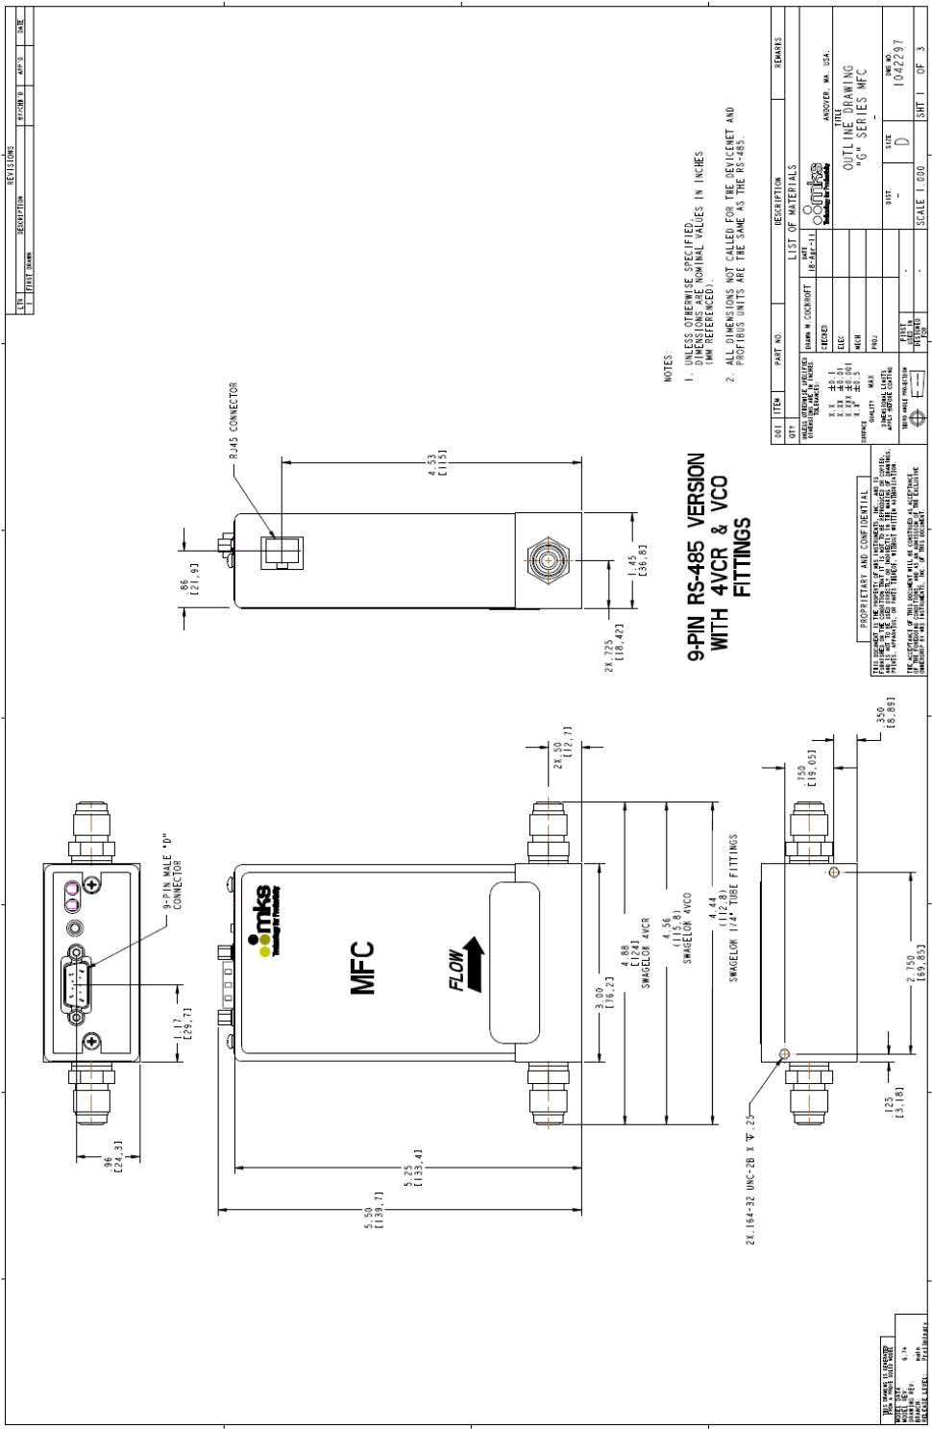

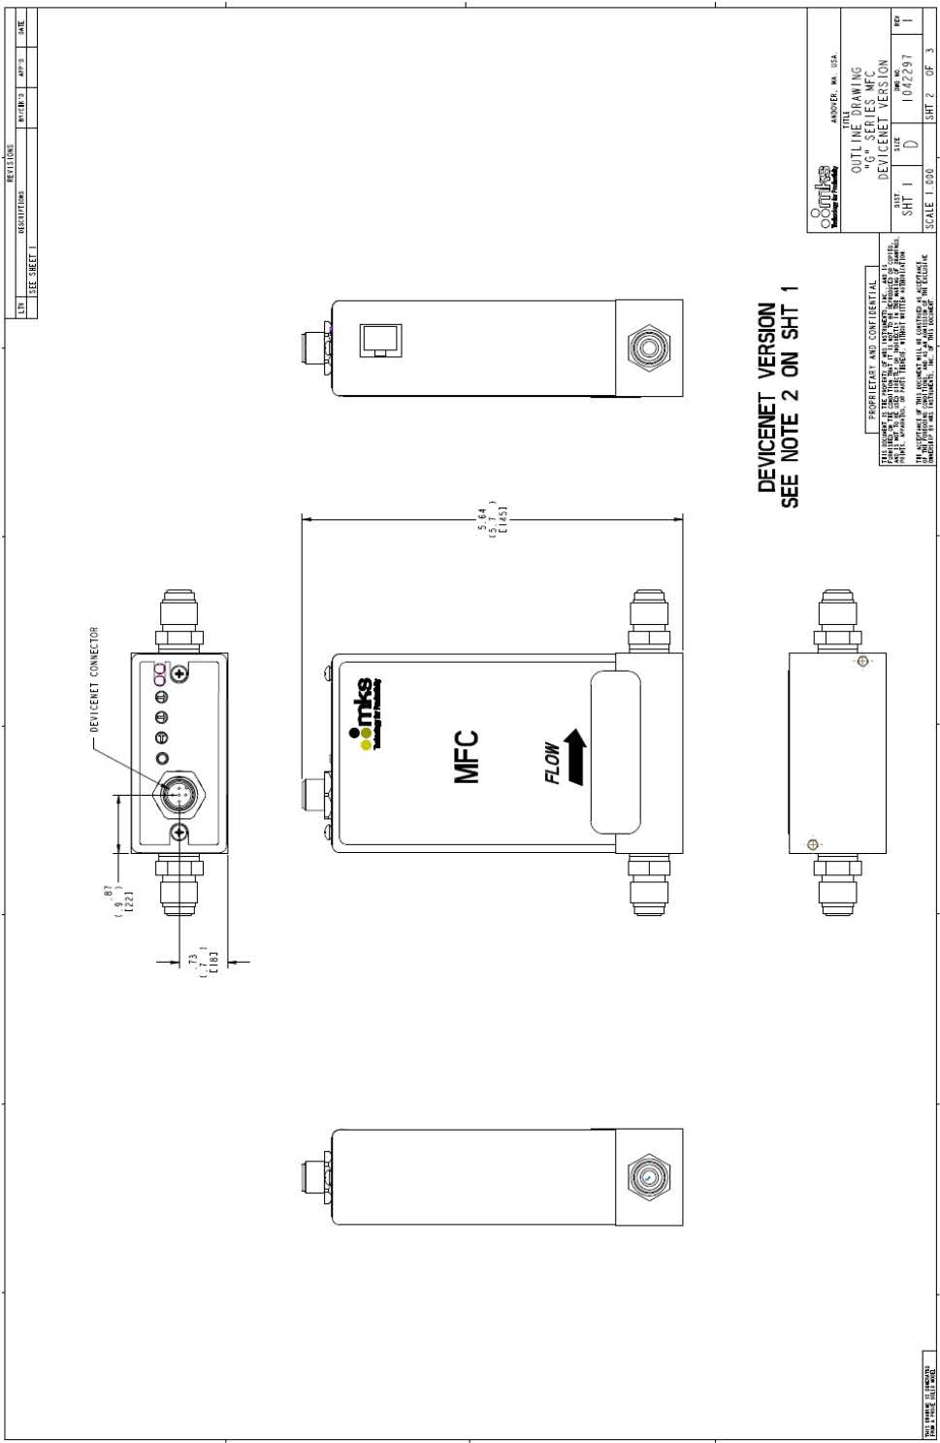

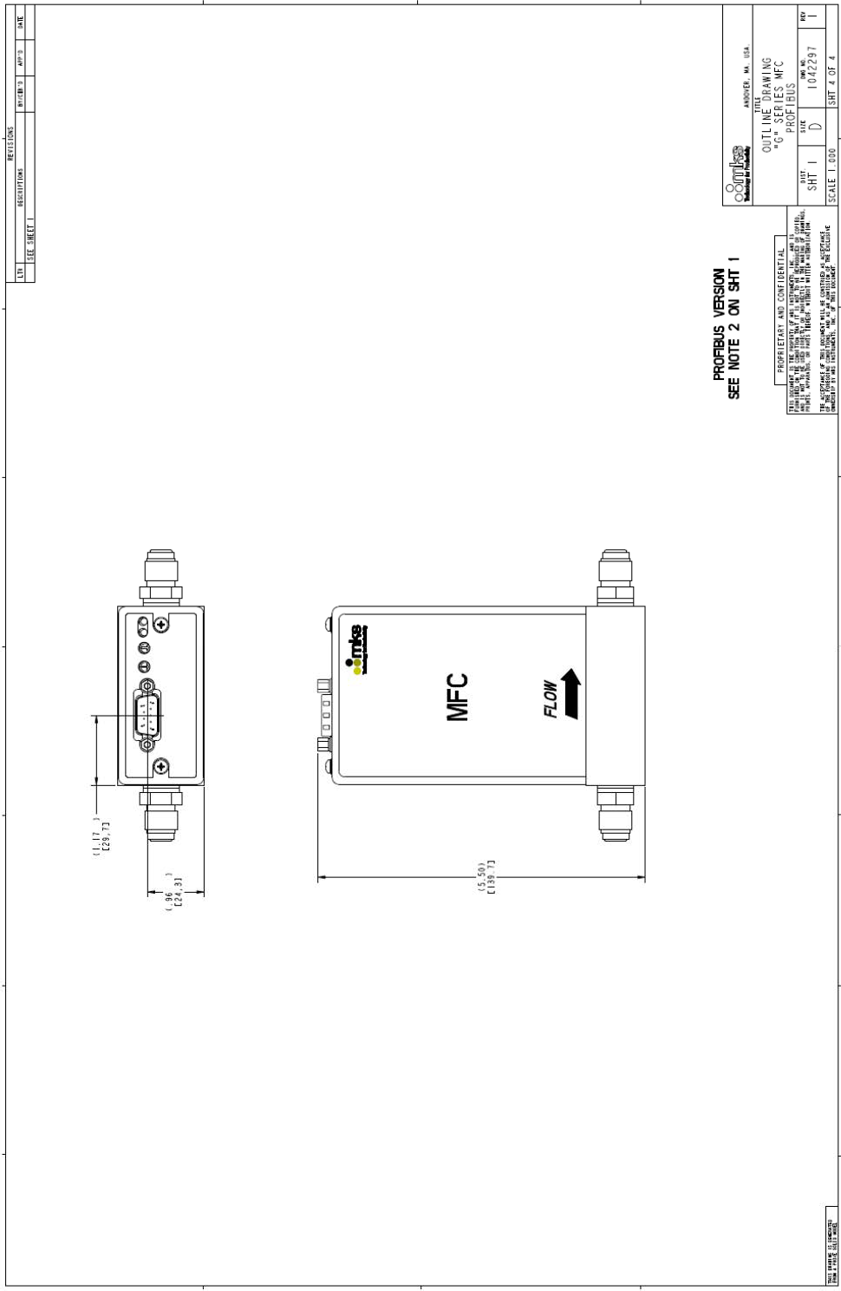

## GV50A MFC w/ Integral Shut-off Valve

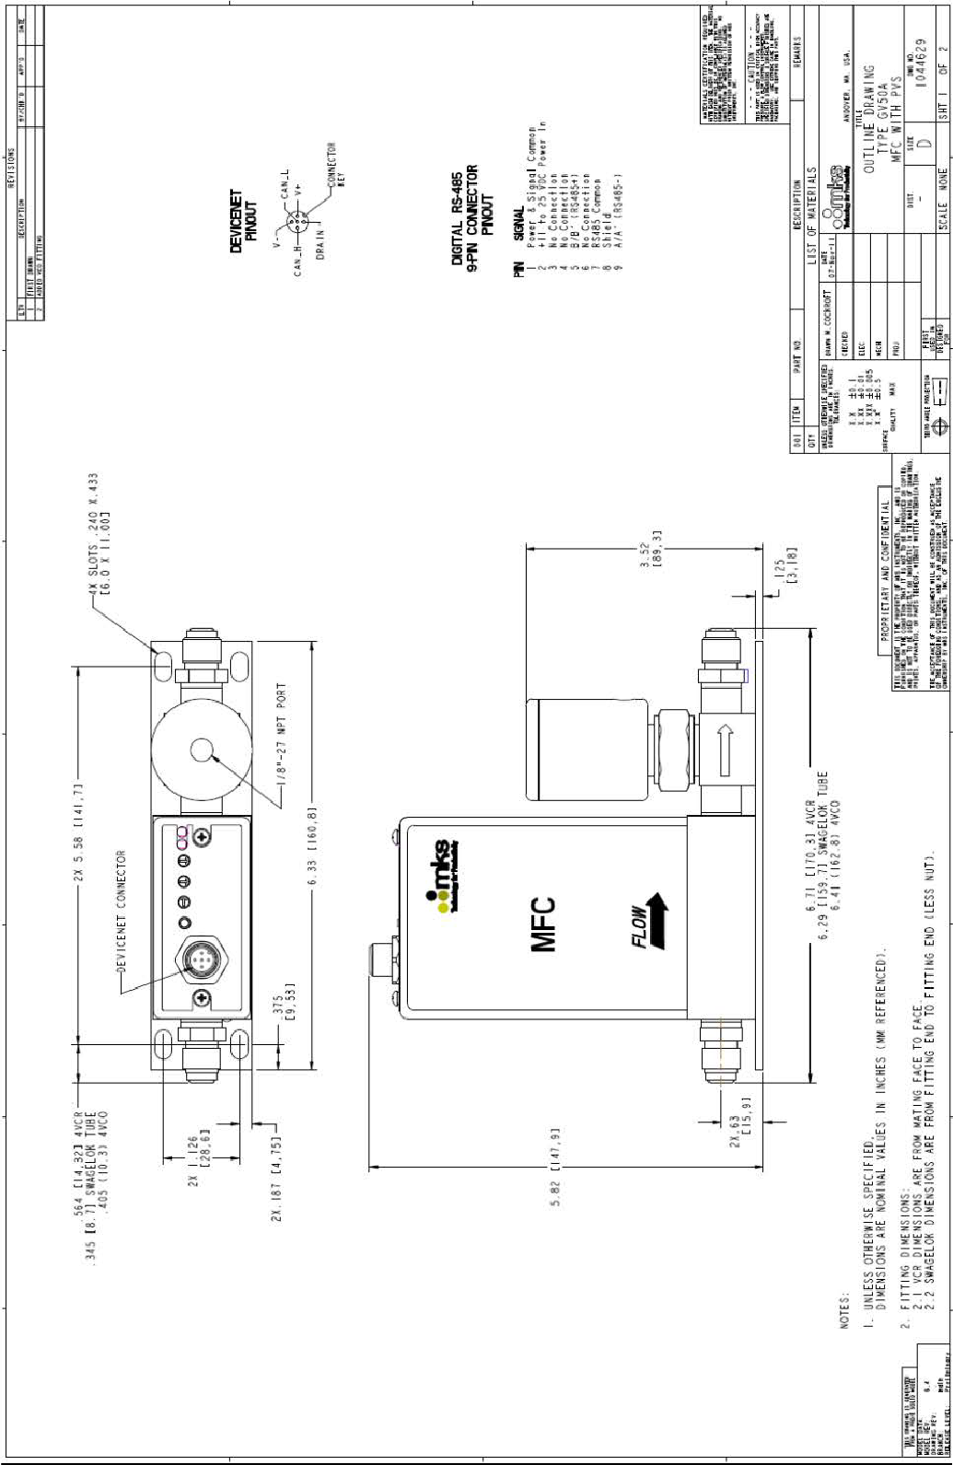

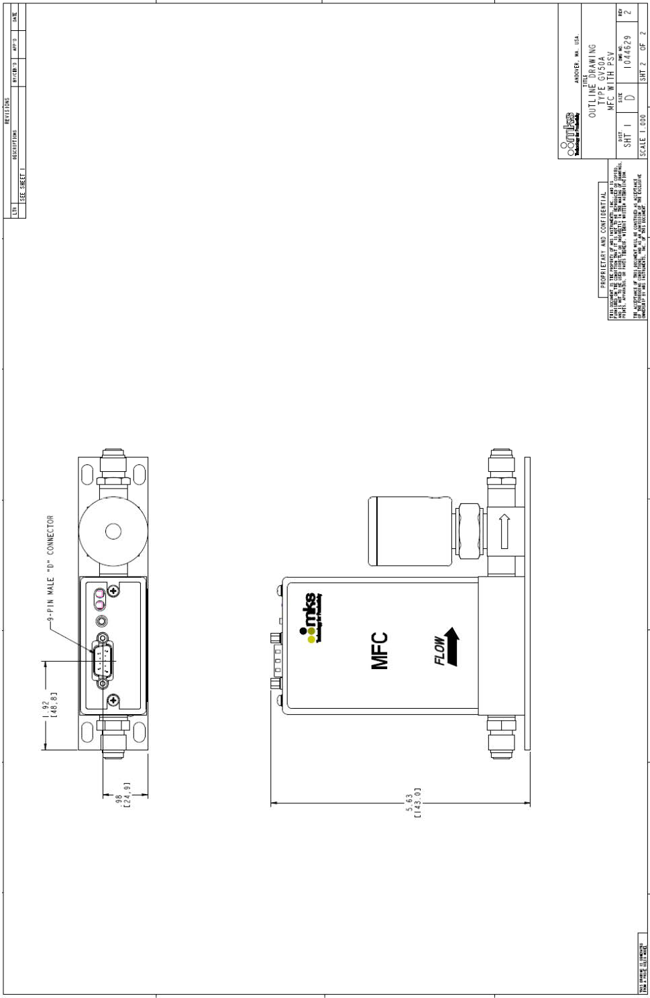

# Appendix D: Health and Safety Form

