Craig Hempcrete Demo Site — Website Requirements Specification
For AI-assisted site generation. This document describes the brand, content, page sections, image direction, and AI Assistant behavior. All images are AI generated except the founder photos supplied by the client. All copy may be written or refined by AI based on the brand context below.

1st person conversation requirements told by client
The client sells Hempcrete (hemp-lime) building materials directly to homeowners and DIY builders (B2C) and is preparing an online launch. Product packaging and SKUs are not finalized yet, so the site must not depend on fixed products or prices. They need two things: a demo site, and a company showcase website with a built-in AI assistant. The AI assistant should behave like a consultative sales advisor — helping visitors scope their project, estimate material volume, and answer the recurring questions prospects always ask (legality, building codes, cost vs. traditional materials, drying time). The client has provided real founder photos and wants a founder introduction section on the site.

1. Project Summary
- Build a single-page (or short multi-page) demo website for a B2C Hempcrete building-materials seller, integrated with an AI Assistant chat widget. The purpose is a sales demo: visual polish and completeness matter more than functional depth. No real e-commerce checkout, no payment, no admin backend. Preview environment only.
- Language: English only, for both the website and the AI Assistant.
- Images: AI generated, EXCEPT the founder photos, which are real photos supplied by the client (see Section 3.7). Do not generate AI faces for the founder.
- AI Assistant: preset with the 5 consultative workflows in Section 4.

2. Brand Context (for text and image generation)
Use this as the factual and tonal foundation. AI-generated copy should stay consistent with it.
- Product: Hempcrete — industrial hemp hurds + lime binder + water, curing over time into a breathable, stone-like mineral composition. Key properties: carbon-negative, zero-VOC, mold-resistant, pest-resistant, fire-resistant, strong thermal mass (insulating).
- Positioning: a healthy, natural building material for homes — “breathable walls, healthier living.” Target market: U.S. homeowners, DIY builders, and small builders.
- Audience model: three customer stages the site is organized around — (1) weekend DIY / interior retrofits, (2) homeowners and small builders using pre-cast blocks, (3) full custom cast-in-situ builds. Visitors should be able to self-identify their stage.
- Business status: SKUs, packaging, and pricing are NOT finalized. All product cards use placeholder prices; all AI Assistant math stays in universal physical volume (cubic meters / square feet), never tied to specific packaging, so the logic survives future SKU decisions.
- Tone of voice: warm, educational, trust-building, community-minded (“you’re joining a community of natural builders”). Avoid cold, corporate stock-photo language and imagery.
- Myth-busting requirement: copy must clearly state the material is 100% legal, 0% THC, fire-resistant, and entirely unrelated to recreational marijuana. Cite the 2024 International Residential Code (IRC) Appendix AU where relevant.
- Important compliance/image note: do NOT generate cannabis-leaf or marijuana-culture imagery anywhere on the site. All visuals stay clearly in the construction / healthy-home domain.

3. Site Sections

3.1 Hero
- Full-width hero with AI-generated background: a finished, textured Hempcrete wall or a sun-drenched living room with natural finishes; warm, high-resolution, static imagery.
- Headline direction: “Breathable Walls. Healthier Living.” Subheadline direction: carbon-negative, zero-VOC, mold-resistant, insulating building material for your home.
- Primary CTA: Explore DIY Projects (anchor to Section 3.4). Secondary CTA: Calculate My Energy Savings (anchor to Section 3.6).

3.2 What is Hempcrete? (material science infographic)
- A clean 3-part formula infographic (no video): Industrial Hemp Hurds + Lime Binder + Water = a breathable, stone-like mineral composition.
- Myth-busting micro-copy: how calcination turns the mixture into rock over time; 100% legal, 0% THC, fire-resistant, unrelated to recreational marijuana.

3.3 Core Health & Lifestyle Benefits (4 cards)
Four clean icons with one-line benefit copy each:
- Natural mold & pest defense — high-pH lime binder eliminates condensation and mold.
- Superior thermal mass — warm in winter, cool in summer; 30–40% lower heating/cooling bills.
- Fire-resistant & safe — flame-retardant, no toxic smoke.
- DIY & skin-friendly — zero formaldehyde, non-toxic, family-safe to handle.

3.4 The 3-Stage Application (“Where does your project fit?”)
Horizontal cards or tabs acting as a self-identification guide. Each stage: best-for line, 1–2 use cases, and approach summary.
- Stage 1 (green) — Weekend projects & interior retrofitting. Beginners; damp basement walls, small backyard studio; pre-mixed starter bundles, hand-tamping between studs.
- Stage 2 (yellow) — Fast & clean pre-cast blocks. Homeowners/small builders; workshops, garage conversions/ADUs, mid-size cabins; factory-cured blocks laid like bricks with thin lime mortar.
- Stage 3 (red) — Full homestead cast-in-situ. Eco-conscious custom builders; multi-room/multi-story eco-homes; bulk materials mixed on-site, tamped into slipforms.

3.5 Shop by Your Stage (demo e-commerce)
- Product cards mapped to the 3 stages: starter DIY kits, pre-cast block pallets, loose-mix bulk bundles. All prices are PLACEHOLDER values (SKUs not finalized); Add to Cart may be non-functional or lead to a mock cart.
- Interactive estimator: a simple input (wall area + thickness) that outputs an approximate number of bags/pallets. A scripted or simplified calculation is acceptable for the demo.

3.6 Interactive Carbon & Energy Calculator
- Inputs: project floor area (sq. ft. or m²) and climate zone. Outputs: CO₂ permanently locked away (with a planted-trees equivalent) and estimated annual HVAC savings.
- A simplified demo formula is acceptable; values only need to be plausible, not engineering-grade.

3.7 Meet the Maker & Brand Story (founder section)
- Split layout using the two REAL founder photos supplied by the client (embedded below for reference): (a) founder mixing Hempcrete at a drum mixer on-site, (b) founder standing in front of a finished tamped Hempcrete wall. Use these photos as-is; do not AI-generate the founder’s face. Strictly avoid corporate stock-photo styling.
- Copy direction (AI may draft): the “why” (homes as healthy sanctuaries, not chemical boxes), the founder’s personal journey discovering Hempcrete, and the promise (buyers join a supportive community of natural builders, guided from first mix to final wall).
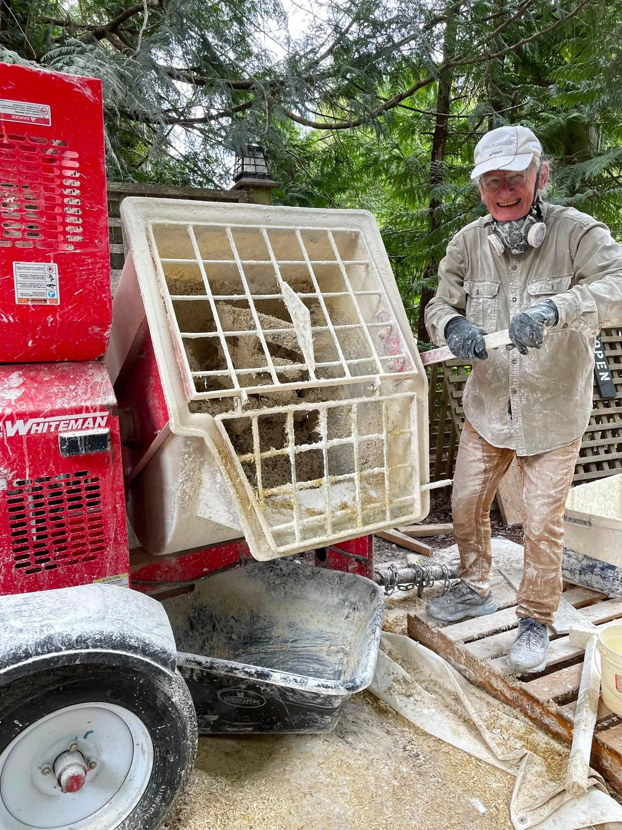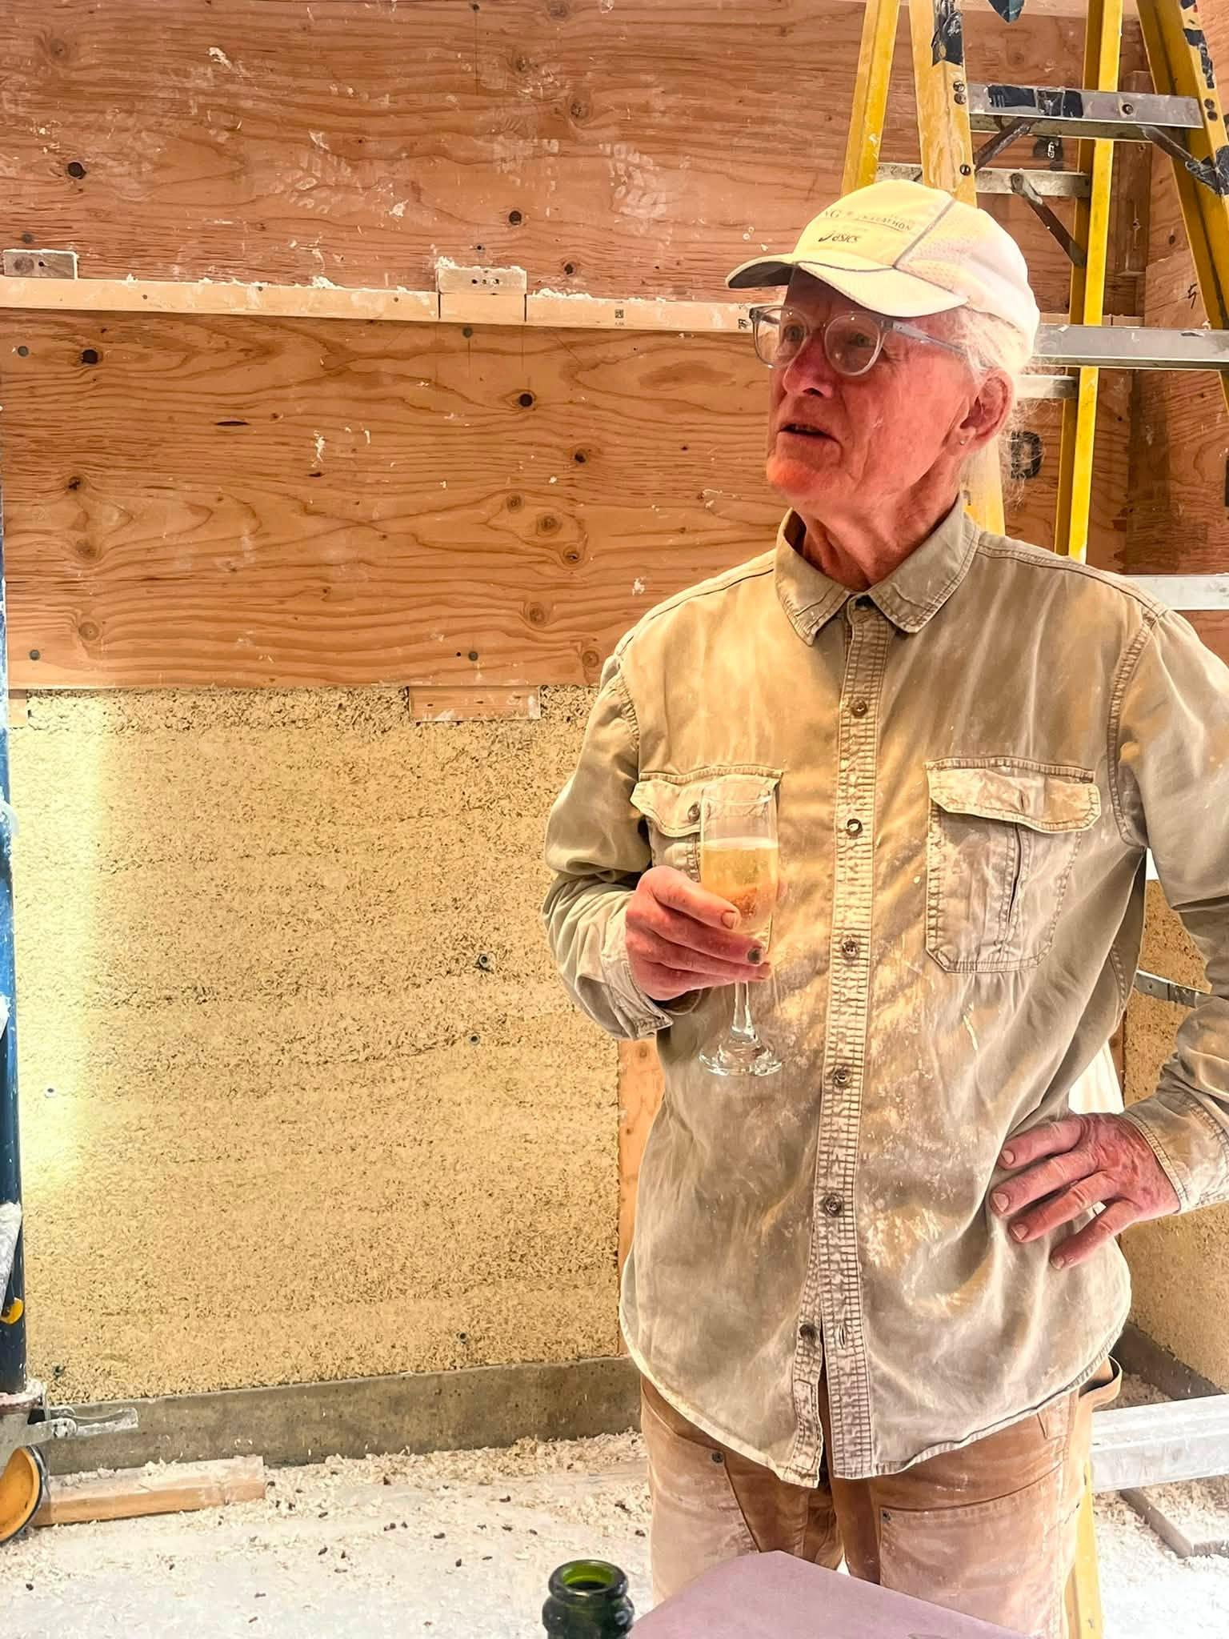

3.8 Step-by-Step Visual Guides & Workshops
- A 4-step illustrated diagram (no video): 1. Timber Framing → 2. Slip-Forming → 3. Mixing & Tamping → 4. Lime Plaster Finish.
- Lead-generation CTA: “Download the free DIY Homeowner’s Installation & Tool Guide (PDF)” — a mock email-capture form is acceptable for the demo.
- Workshop teaser: registration block for an upcoming in-person natural-building workshop (placeholder date/location).

3.9 FAQ & Homeowner Case Studies (social proof)
- 2–3 before/after transformation stories (e.g., a damp, freezing basement turned into a warm, mold-free home theater). AI-generated imagery; no photorealistic identifiable faces.
- Defensive FAQ: pests (high-pH lime deters them), fire resistance (reference to flame-resistance test reports as static imagery), and owner-builder permitting under the 2024 IRC Appendix AU.

4. AI Assistant (chat widget)
Widget floats bottom-right and opens with a short greeting in brand tone. Preset the 5 consultative workflows below. Design rules: every answer works in universal physical volume (m³ / sq. ft.), never in SKUs or package counts; every answer ends with one follow-up question that keeps the conversation going; tone is encouraging and consultative, not a static FAQ.
# | User question | Answer direction
1 | “I want to build a small backyard office (about 180 sq. ft.). How much Hempcrete do I need, and what’s the best way to do it?” | Estimate net exterior wall area (~400–450 sq. ft.), recommend 10–12 inch wall thickness, give a total volume estimate of roughly 10–12 m³, and recommend Stage 2 (pre-cast blocks) for a clean, fast backyard build. End with a follow-up question: 12-inch wall for insulation vs. thinner 8-inch wall for floor space.
2 | “I just want to renovate one cold, damp bedroom (about 300 sq. ft. of wall area) to stop mold. Can I use this inside, and will it eat up my room space?” | Reassure that interior retrofitting is a core use case (breathable, moisture-regulating layer). Recommend a thin 2.5–3 inch application, estimate roughly 2.5–3 m³, and recommend Stage 1 (furring strips + lightweight hand-tamping; non-toxic, no VOC fumes). End with a follow-up question about the existing wall type (drywall / brick / concrete) to guide surface prep.
3 | “Can Hempcrete support the weight of my roof? And is it actually legal to build a house with this under U.S. building codes?” | Two clear facts: (1) Hempcrete is non-load-bearing infill — a standard 2x4/2x6 timber frame carries the load; (2) it is fully legal and standardized under the 2024 IRC Appendix AU, which makes permitting straightforward for owner-builders. End with a follow-up question about where they are in the planning phase.
4 | “How does the cost compare to traditional drywall and fiberglass insulation? How can I estimate my project budget?” | Honest framing: upfront materials run ~15–20% higher, but total cost of ownership wins — 4-in-1 material efficiency (insulation, vapor barrier, drywall backing, acoustics), 30–40% annual HVAC savings with a 3–5 year payback, and zero lifetime maintenance (no rot, mold, or pests). End by offering a volume estimate if the user shares wall dimensions or square footage.
5 | “How long does it take from mixing/building to being fully dry and ready to live in? What are my options?” | Two pathways: Option A pre-cast blocks (arrive cured; mortar dries in 2–3 days, then plaster and move in) vs. Option B cast-in-situ hand-tamping (formwork off next day, but 3–6 weeks natural curing before final plaster). End with a follow-up question: hard deadline vs. hands-on DIY experience.

Note: full reference answers for all 5 workflows exist in the client’s blueprint and can be pasted in as-is; the engineer may lightly compress them for widget length but must keep the volume math, the recommendations, and the closing follow-up questions.

5. Out of Scope
- Real e-commerce: checkout, payment, inventory, order management.
- Final SKU packaging and real pricing (post-launch decision).
- Production domain and hosting; CRM/email backend behind the lead-capture form (mock capture acceptable).
- Real workshop scheduling/registration system.
- Import of the client’s real product data (post-sale task).

6. Pricing and Timeline
- Build fee and activation fee: TBD, to be confirmed with the client before kickoff.
- Priority and estimated build duration: TBD; assume a similar 3–5 business-day window from kickoff to client-ready preview unless otherwise agreed.

7. Open Items
- Measurement units: imperial primary with metric secondary, or imperial only — confirm.
- Estimator and carbon/energy calculator: scripted demo values vs. simple live formulas — confirm.
- Lead-capture PDF guide: real placeholder PDF vs. dead link — confirm.
- Workshop block: placeholder date/location acceptable for demo — confirm.
- AI image style lock: photorealistic warm-natural is the default recommendation; confirm before batch generation.

