Page Header:

**Twitter Text Analysis – Positive or Negative?**

Navigation bar for interactive section asking to enter text and we will analyze if it as positive or negative

Article: Purpose of this page:

All the text explaining the effects of positive or negative Tweets.

Main Image+ Graph

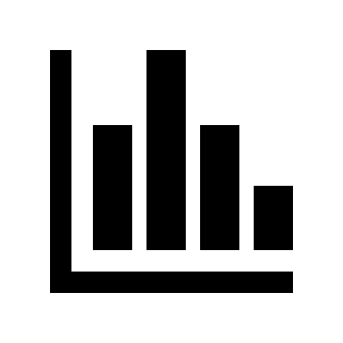





Table/Image to support above text analysis.

Conclusion and prepared by:

Credits and resources used- links if needed