GenAI Powered .NET Application Development

Use Case 1 Enterprise IT Service Desk Copilot
Standalone professional capstone assignment for associates with six months of experience
Training assignment specification
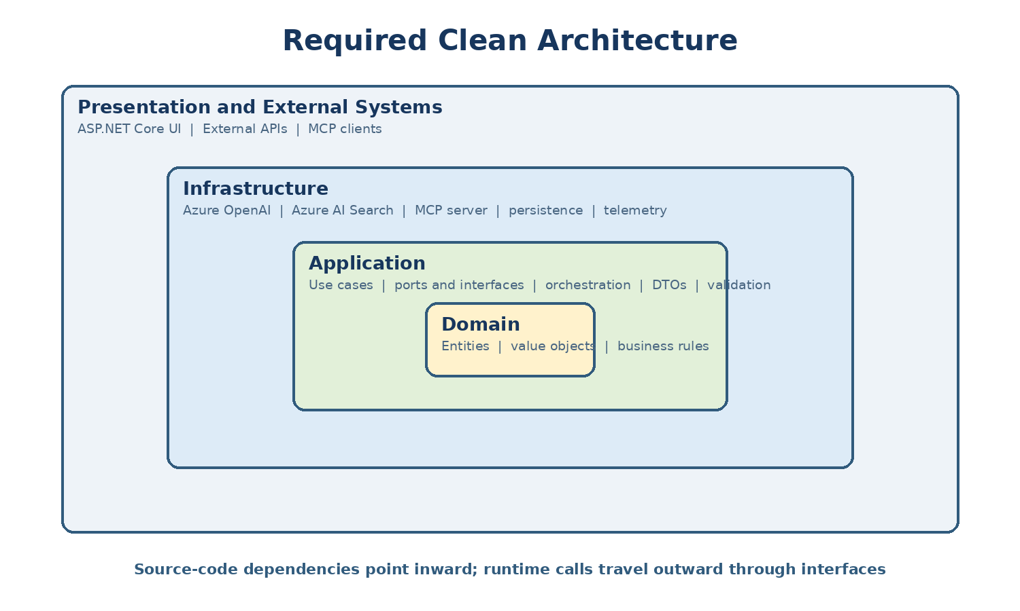
Prepared from the supplied NET GenAI Training Curriculum

Purpose and expected outcome
This assignment defines one complete GenAI-enabled .NET capstone solution: Enterprise IT Service Desk Copilot. The team will implement the project through progressive increments covering prompt engineering, Azure OpenAI, RAG, function calling, Semantic Kernel or equivalent orchestration, bounded agents, MCP, security, evaluation, monitoring and deployment.
The difficulty is calibrated for developers with approximately six months of experience. Deterministic business rules are explicit, integrations may begin with stubs, architecture boundaries are prescribed, and stretch goals are separated from the mandatory path.

How to use this pack
1. Trainer assigns this use case to a team of three or four associates.
2. The team creates a backlog from the requirements and completes the three-day sprint plan.
3. Team uses GitHub Copilot as an assistant but reviews, tests and documents every accepted change.
4. Team demonstrates both success and failure paths, including prompt injection, tool failure and denied write actions.
5. Trainer scores the submission using the common rubric at the end of this document.

Common Clean Architecture requirements
Figure 1 Required dependency direction
- Domain contains business meaning and deterministic rules only. It must not reference Azure SDKs, Semantic Kernel, ASP.NET Core, databases or logging frameworks.
- Application coordinates use cases and owns interfaces for model, retrieval, tools, persistence, approval and telemetry.
- Infrastructure implements those interfaces and contains Azure OpenAI, Azure AI Search, MCP, external API and database adapters.
- Web maps authenticated requests to Application commands and queries, streams results and displays safe errors; it contains no business rule.
- All external calls support cancellation, timeouts and correlation. Write actions require authorization, validation and human approval.
- Prompts are versioned assets. Their output is treated as untrusted until schema and business validation succeed.

Required technical baseline
Area | Minimum expectation
Platform | .NET 8 or the organization-approved current LTS; ASP.NET Core web API or web app
AI | Approved Azure OpenAI chat deployment plus embedding deployment
Retrieval | Azure AI Search index with source, version and citation metadata
Orchestration | Semantic Kernel plugins/function calling plus an agent framework or AutoGen-style workflow
Interoperability | One MCP server exposing typed, scoped enterprise tools
Quality | NUnit tests, integration tests and a repeatable prompt-evaluation dataset
Operations | Structured logging, OpenTelemetry/Application Insights, token and latency measurement
Security | Managed identity or safe local credential chain, role-based authorization and secret-free repository
Delivery | Cloud deployment with configuration separated from code and a documented rollback/fallback

Use Case 1 Enterprise IT Service Desk Copilot
  - A grounded support assistant that answers policy questions, diagnoses common incidents and creates approved tickets.
Attribute | Definition
Business domain | Internal IT operations and employee support
Target user | Employees, service-desk analysts and support managers
Delivery mode | Three-day team sprint with an end-to-end demonstration
Recommended team | 3-4 associates with approximately six months of .NET experience
Complexity | Foundation-to-intermediate; core path is mandatory and stretch work is optional

Business context and problem
Employees search multiple knowledge articles before reporting a problem, while analysts repeatedly ask for missing diagnostic details. The proposed assistant must provide evidence-backed guidance, collect structured facts, call approved support tools and hand unresolved work to a human without inventing status or policy.

Business objective
- Reduce time spent locating approved troubleshooting steps.
- Improve completeness and consistency of incident tickets.
- Demonstrate a safe read-to-write agent workflow with human approval.
- Produce measurable evidence for groundedness, latency, token consumption and escalation quality.

What the team will build
Build an ASP.NET Core support portal with streaming chat. The assistant searches IT policy and troubleshooting documents, checks system status, proposes diagnostic steps, and prepares an incident. A reviewer agent checks grounding and safety before the user confirms ticket creation.
Increment | Capability added | What it demonstrates
1 | Prompt and chat completion | Model connectivity and prompt constraints
2 | RAG with citations | Grounded enterprise answers
3 | Status and user-profile tools | Function calling and data retrieval
4 | Incident draft plus approval | Controlled business write action
5 | Planner, specialist and reviewer | Multi-agent orchestration and evaluation
6 | Cloud deployment and telemetry | Enterprise operations

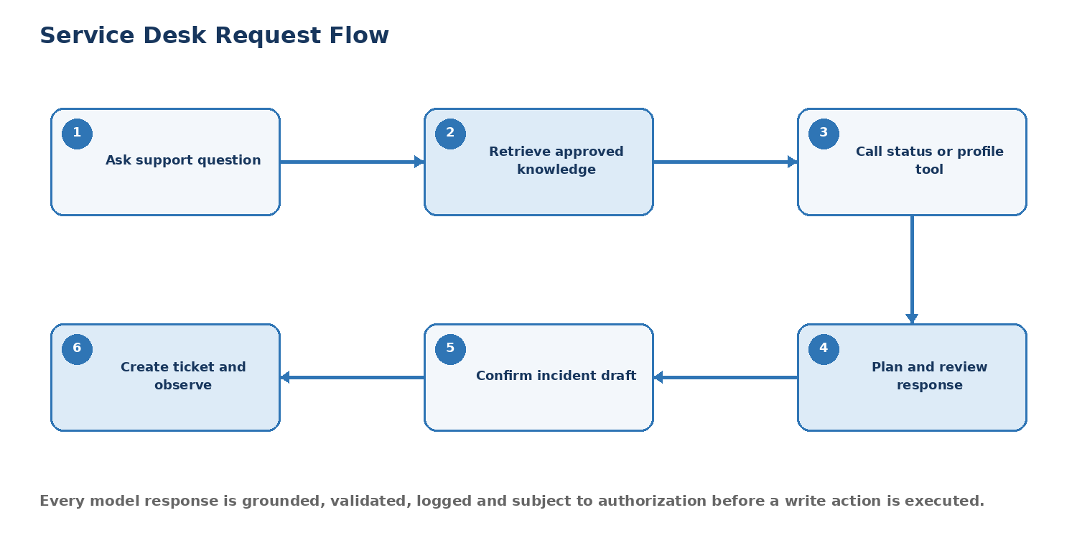
Figure 2 Enterprise IT Service Desk Copilot end-to-end flow

Scope
In scope | Out of scope
IT policy and knowledge search; status lookup; guided diagnosis; incident draft and approval; session history; citations; evaluation and telemetry | remote device control; password reset execution; production identity administration; free-form database access; fully autonomous ticket submission

Personas and responsibilities
Persona | Need | Permitted actions
Employee | Fast, trustworthy help | Search knowledge; run read-only status checks; approve own ticket draft
Analyst | Complete diagnostic context | Review and update assigned drafts; add resolution feedback
Manager | Quality and usage visibility | View aggregated evaluation, latency and cost metrics
Administrator | Safe configuration | Manage indexes, prompts and tool allow-lists; cannot alter audit history

Functional requirements
ID | Requirement | Priority
FR-01 | Accept a support question and stream a response with a correlation ID. | Must
FR-02 | Classify the request as policy, how-to, outage, incident or unsupported. | Must
FR-03 | Retrieve relevant approved articles using hybrid or semantic search and cite sources. | Must
FR-04 | Ask only for missing diagnostic information and preserve session context. | Must
FR-05 | Call a read-only system-status function when current status is required. | Must
FR-06 | Create a structured incident draft with summary, impact, urgency, category and evidence. | Must
FR-07 | Require explicit user confirmation before the ticket API is called. | Must
FR-08 | Use Planner, Support Specialist and Reviewer roles for a complex request. | Should
FR-09 | Expose knowledge search and incident draft operations through an MCP server. | Should
FR-10 | Capture feedback and evaluate groundedness, relevance and safe refusal. | Must

Business rules
Rule | Enforcement
BR-01 | Only approved and active knowledge sources may be retrieved.
BR-02 | An outage claim requires status-tool evidence; otherwise label it unconfirmed.
BR-03 | Priority is computed by deterministic impact and urgency rules, never solely by the model.
BR-04 | A ticket cannot be submitted until the authenticated user confirms the final draft.
BR-05 | Credentials, passwords, access tokens and secret values must be rejected and never logged.
BR-06 | Unsupported or low-confidence cases are routed to an analyst with the conversation summary.

Detailed scenarios

Scenario 1 Grounded policy answer
Field | Specification
Primary actor | Employee
Precondition | User is authenticated; approved policy documents are indexed.
Expected result | Answer is accurate, cites an approved source and contains no unsupported policy statement.

Main flow
1. User asks whether a personally owned device may connect to the corporate network.
2. The application validates the request and retrieves the most relevant policy chunks.
3. The AI composes a concise answer using only retrieved evidence.
4. The UI streams the response and displays source title and section.
Alternate and failure flow
- If retrieval confidence is below threshold, the assistant says it cannot verify the policy and offers escalation.
- If the prompt contains instructions copied from a document, those instructions are ignored as untrusted content.

Scenario 2 Diagnose a common issue
Field | Specification
Primary actor | Employee
Precondition | Troubleshooting articles and system-status tool are available.
Expected result | The guidance is grounded, sequenced, safe and records the resolution outcome.

Main flow
1. User reports that VPN login fails.
2. Assistant asks for error code, device type and whether the issue affects other services.
3. The status tool checks current VPN health.
4. RAG supplies approved steps; the assistant presents them one at a time.
5. User confirms whether the issue is resolved.
Alternate and failure flow
- A tool timeout produces a clearly marked status-unavailable message.
- Unsafe steps such as disabling security controls are refused.

Scenario 3 Create an approved incident
Field | Specification
Primary actor | Employee
Precondition | Diagnosis did not resolve the problem; ticket service is available.
Expected result | Exactly one ticket is created after approval and the audit log links it to the correlation ID.

Main flow
1. Assistant generates a schema-valid incident draft.
2. Application calculates priority from deterministic rules.
3. Reviewer agent checks for unsupported claims and sensitive data.
4. User edits or confirms the draft.
5. Ticket adapter submits the approved request and returns the real ticket number.
Alternate and failure flow
- Rejection returns to draft state without calling the ticket service.
- A failed ticket call returns a retryable error and never invents an ID.

Scenario 4 Complex issue agent collaboration
Field | Specification
Primary actor | Analyst
Precondition | Multi-agent workflow is enabled.
Expected result | Agent output includes evidence and finishes within configured step and token limits.

Main flow
1. Planner decomposes the issue into knowledge search, live status and ticket-history tasks.
2. Specialist executes only allow-listed read tools.
3. Reviewer verifies evidence and identifies missing facts.
4. Application returns a consolidated recommendation and proposed next action.
Alternate and failure flow
- Loop count and token budget stop excessive agent iteration.
- Any proposed write action pauses for human approval.

Clean Architecture solution design
The solution must keep domain and application policy independent of ASP.NET Core, Azure SDKs, search technology, databases and agent frameworks. Infrastructure components implement interfaces owned by the Application layer and are registered only in the composition root.
Layer | Required contents | Dependency rule
Domain | Entities, value objects, domain services, policies and domain exceptions | References no other project
Application | Commands, queries, use-case handlers, DTOs, validators and interface ports | Depends only on Domain
Infrastructure | Azure OpenAI, AI Search, database, MCP, identity and telemetry adapters | Implements Application interfaces
Web | ASP.NET Core endpoints, streaming UI, authentication and request mapping | Calls Application; no business rules
Workers | Indexing, long-running work and agent workflow hosts | Calls Application through defined ports
Tests | Domain, application, contract, integration, prompt evaluation and end-to-end tests | Mirrors production boundaries

Suggested solution structure
Repository layout
ServiceDeskCopilot.sln
src/
ServiceDesk.Domain/
Incidents/ Policies/ Common/
ServiceDesk.Application/
Chat/ Knowledge/ Incidents/ Abstractions/ Validation/
ServiceDesk.Infrastructure/
AzureOpenAI/ Search/ Ticketing/ Mcp/ Persistence/ Telemetry/
ServiceDesk.Web/
Endpoints/ Streaming/ Auth/ Composition/
ServiceDesk.Worker/
Indexing/ AgentWorkflows/
tests/
Domain.Tests/ Application.Tests/ Integration.Tests/ PromptEval.Tests/

Core application interfaces
Interface | Purpose | Example implementation
IChatModel | Complete and stream model responses | Azure OpenAI adapter
IKnowledgeRetriever | Return ranked chunks and citations | Azure AI Search adapter
ISystemStatusReader | Read live service health | Status API or MCP tool
IIncidentGateway | Create an approved ticket | Service-management API
IAgentWorkflow | Coordinate plan, execute and review | SK or agent-framework adapter
IAiTelemetry | Record safe AI measurements | OpenTelemetry/Application Insights

Data and integration design
Source or component | Sample content | Access pattern
Knowledge index | VPN, email, device and security articles with source metadata | Hybrid/semantic retrieval
Status API | Service name, state, started time and message | Read-only function call
Ticket API | Draft and confirmed incident payloads | Write after approval
Session store | Messages, cited sources and state, with retention limit | Repository interface
MCP server | search_knowledge, get_status, create_incident_draft | Typed allow-listed tools

Prompt engineering requirements
- Create a reusable system prompt containing role, permitted scope, grounding rule, citation rule, refusal behavior and output schema.
- Demonstrate zero-shot and few-shot versions for one task, compare the outputs and record why the selected version is more reliable.
- Use the Ask-Review-Improve and Explain-Generate-Refine patterns during development; maintain prompts as versioned application assets.
- Decompose complex work into explicit steps but request only a concise rationale or evidence, not hidden chain-of-thought.
- State assumptions, constrain formats, validate JSON outputs and reject an answer when required evidence is absent.
Minimum prompt contract
ROLE: Internal IT support assistant.
CONTEXT: Use only SOURCES and TOOL_RESULTS supplied by the application.
RULES: Cite factual guidance. Never request or repeat secrets. Never claim a ticket exists unless the create tool returned an ID.
TASK: Classify the request, ask for missing facts, then answer or propose escalation.
OUTPUT: Valid JSON matching SupportReply { category, answer, citations[], proposedAction, confidence }.
FALLBACK: If evidence is insufficient, say what is missing and route to a human.

Agent and tool design
Component | Responsibility | Safety boundary
Planner | Selects knowledge, status and history tasks | No direct external access
Support Specialist | Uses retrieval and read-only tools | Tool allow-list and argument validation
Reviewer | Checks grounding, privacy and completeness | Cannot execute tools
Application handler | Applies authorization, rules and approval state | Only component that permits write adapter

Implementation note: Semantic Kernel may be used for plugin registration and function calling. An agent framework or AutoGen-style orchestration may coordinate Planner, Specialist and Reviewer roles. MCP exposes only approved read or write tools; the domain rules remain inside the application, not inside prompts.

Security, responsible AI and operations
Area | Mandatory control | Evidence
Identity | Use managed identity or environment-based developer credentials; never commit secrets | Configuration scan and successful role-based access
Authorization | Enforce role checks in application handlers and again at write adapters | Denied-action test
Prompt injection | Treat retrieved content as data, delimit it, block instruction override and allow-list tools | Adversarial test set
Privacy | Redact or mask sensitive fields before model calls and logs | Redaction test and log sample
Validation | Validate input length, structured output, citations and tool arguments | Automated validation tests
Observability | Record correlation ID, latency, token usage, retrieval hits, tool calls and failures | Dashboard or structured log evidence
Resilience | Timeout, retry with backoff for transient faults, circuit breaker and user-safe fallback | Simulated 429 and dependency outage
Human review | Require approval for consequential write actions | Approval and rejection audit entries

Sprint implementation plan
Day | Focus | Expected checkpoint
1 | Plan the use case; create solution; model the domain; connect Azure OpenAI; build one chat endpoint; use Copilot for scaffolding and document all accepted changes | Compiling vertical slice with tests and safe configuration
2 | Add document ingestion, embeddings, Azure AI Search, grounded RAG, citations, Semantic Kernel plugins or equivalent tool calls, and MCP integration | Search and tool calls work through Application interfaces
3 | Add agents, approval flow, streaming, security tests, evaluation set, telemetry, deployment configuration and demo documentation | Deployed end-to-end solution with quality report

Testing and evaluation
Test category | Minimum cases | Pass condition
Domain unit | At least 8 business-rule and boundary tests | All deterministic rules pass without external services
Application unit | At least 6 handler tests with mocked ports | Success, denial, validation and fallback paths pass
Integration | Chat, embeddings/search, tool adapter and MCP contract | Approved test environment returns schema-valid data
Prompt evaluation | At least 15 golden questions plus 5 adversarial prompts | Meets thresholds for groundedness, relevance and refusal
API | Authentication, validation, streaming, cancellation and error contract | No internal exception or secret is exposed
Performance | Five concurrent users and one long-running request | Target latency recorded; no unhandled failures

Definition of done
- Solution builds from a clean checkout and automated tests pass.
- No API key, connection string, personal data or prompt transcript is committed to source control.
- Every answer based on enterprise documents shows source title and section or page metadata.
- The application declines unsupported questions and never invents a successful write action.
- One read tool and one controlled write tool work through interfaces; the write requires authorization and approval.
- Streaming, cancellation, loading and safe error states are visible in the web experience.
- Logs demonstrate correlation, latency, tokens, retrieval, agent steps and tool outcomes without sensitive content.
- README includes architecture, setup, model/search configuration, test commands, deployment and known limitations.

Required demonstration script
1. Ask a policy question and open its citation.
2. Ask about a known service outage and show the status function call.
3. Submit a prompt-injection attempt embedded in retrieved text and show safe handling.
4. Diagnose a VPN failure and create an incident draft.
5. Reject the draft, then approve a corrected version and display the real ticket ID.
6. Open telemetry and the evaluation summary for the same correlation ID.

Starter data and assumptions
- Provide 8-12 short IT knowledge documents in PDF, JSON or text format.
- Use a fake status API with at least three services and deterministic states.
- Use an in-memory or stub ticket adapter before connecting a real sandbox API.
- Supply 20 evaluation prompts: 10 answerable, 5 insufficient-evidence and 5 adversarial.

Stretch goals
- Add conversation summarization for long sessions.
- Use managed identity for model, search and storage access.
- Add analyst feedback to an offline prompt-evaluation pipeline.
- Deploy a background indexing worker and blue-green prompt versioning.

Common assessment rubric
Criterion | Marks | Full-credit evidence
Business fit and completeness | 10 | Mandatory scenarios work end to end; scope and user roles are clear.
Clean Architecture | 15 | Dependencies point inward; domain rules are deterministic; adapters are replaceable and tested.
Prompt engineering | 10 | Prompts are clear, constrained, reusable, versioned and evaluated; outputs are validated.
RAG and grounding | 15 | Search uses metadata filters; answers cite approved sources; insufficient evidence is handled safely.
Tools, MCP and agents | 15 | Typed tools work; agents are bounded; write actions require authorization and approval.
Security and responsible AI | 10 | Secrets, privacy, injection, authorization and safe-failure controls are demonstrated.
Testing and evaluation | 10 | Unit, integration, API, prompt and adversarial tests are repeatable and meaningful.
Operations and deployment | 10 | Deployed solution includes telemetry, token/cost tracking, resilience and health evidence.
Code quality and demonstration | 5 | Readable code, useful documentation, clear walkthrough and honest limitations.

Submission checklist
- Source repository with clean commit history and no secrets.
- Architecture diagram and short architecture-decision record.
- Running application plus deployment URL or recorded local demonstration if cloud access is restricted.
- Sample data, index schema and reproducible ingestion instructions.
- Prompt assets, evaluation dataset and result summary.
- Automated test report and screenshots or traces for critical failure paths.
- README with prerequisites, configuration, run, test, deploy and troubleshooting instructions.
- Five-minute presentation explaining business value, clean architecture, safety controls and known limitations.

Trainer acceptance gate
A submission cannot receive a passing score if it commits a secret, fabricates a tool result, performs a consequential write without approval, exposes data across users, or cannot show the source of a grounded enterprise answer. These are release blockers even when the application otherwise appears functional.

