

**MCU firmware build setup**

**Growhouse**

|  |  |
| --- | --- |
| **Version**  **Status**  **Date** | 0.2  Draft  19-Dec-2019 |

**Confidentiality Notice**

Copyright (c) 2020 eInfochips. - All rights reserved

This document is authored by eInfochips and is eInfochips intellectual property, including the copyrights in all countries in the world. This document is provided under a license to use only with all other rights, including ownership rights, being retained by eInfochips. This file may not be distributed, copied, or reproduced in any manner, electronic or otherwise, without the express written consent of eInfochips.

Contents

1 Introduction 4

2 PreRequisite 5

2.1 Hardware prerequisite 5

2.2 Software Prerequisite 5

3 Steps To Install Simplicity Studio 6

3.1 Create an Account in Si-lab forum 6

3.2 Download simplicity studio 6

4 Steps TO Install IAR Workbench 11

4.1 Download IAR Workbench 11

4.2 Install IAR Workbench 11

5 Import Growhouse sdk in simplicity studio 12

6 Import project in simplicity studio 15

6.1 Project path to generate bootloader binary and Firmware binary of Soil Node 22

6.1.1 Bootloader binary of Soil Node. 22

6.1.2 Firmware binary of Soil Node. 22

6.2 Project path to generate bootloader binary and Firmware binary of LED Node ZigBee Module 23

6.2.1 Bootloader binary of LED Node ZigBee Module. 23

6.2.2 Firmware binary of LED Node ZigBee Module. 23

6.3 Project path to generate bootloader binary and Firmware binary of LED Node BLE Module 24

6.3.1 Bootloader binary of LED Node BLE Module. 24

6.3.2 Firmware binary of LED Node BLE Module. 24

6.4 Project path to generate bootloader binary and Firmware binary of Mezzanine Board 25

6.4.1 Bootloader binary of Mezzanine board. 25

6.4.2 Firmware binary of Mezzanine board. 25

7 Flash MCU on board 26

7.1 Bootloader path and Firmware Binary path for Soil Node. 26

7.2 Bootloader path and Firmware Binary path for LED Node ZigBee Module. 26

7.3 Bootloader path and Firmware Binary path for LED Node BLE Module. 26

7.4 Bootloader path and Firmware Binary path for Mezzanine card. 27

**FIGURES**

Figure 1 :Creat Silicon Lab Account 6

Figure 2 : Login window on Simplicity studio 7

Figure 3 : installation progress bar 8

Figure 4 : Package Install option 8

Figure 5 : Install by product group 9

Figure 6 : Installation window 10

Figure 7 : Restart simplicity studio after installation complete 10

Figure 8 : Import Growhouse specific SDK reference 12

Figure 9 : Add Gecko SDK suite for zigbee 13

Figure 10 : Add Bluetooth Mesh SDK 14

Figure 11 : Import MCU project 15

Figure 12 : Browse the MCU project 16

Figure 13 : Configuration window for imported project 17

Figure 14 : Location and Name for imported project 18

Figure 15 : MCU project imported in IDE 19

Figure 16 : Build imported project 20

Figure 17 : Binary files after build completed 21

# Introduction

The purpose of this document is to guide how to set up Growhouse MCU firmware build environment. Simplicity studio is used IDE used for development, building and Debugging.

# PreRequisite

## Hardware prerequisite

CPU: 1 GHz or better

Memory: 8 GB recommended for Wireless Protocol development

Disk space: 600 MB disk space for minimum package installation

## Software Prerequisite

Linux or Window HOST machine

* Windows

Windows 10 (x86 and x64)

Windows 8 (x86 and x64)

Windows 7 (x86 and x84)

* Linux

X64 Kernel 3.13 and above

Tested on all LTS Ubuntu releases from 14.04 LTS to 18.04 LTS

* Simplicity Studio

Follow the Section 3 to install the Simplicity studio. Simplicity Studio is required to compile the source code for LED Node, Soil Node, and bootloader firmware.

* IAR Work bench

Follow the Section 4 to install the IAR Workbench studio. IAR Workbench is required to compile the source code of Mezzanine Card i.e. ZigBee-Coordinator code.

# Steps To Install Simplicity Studio

## Create an Account in Si-lab forum

* Follow below link to create account:

[**https://siliconlabs.force.com/apex/SL_CommunitiesSelfReg?form=short**](https://siliconlabs.force.com/apex/SL_CommunitiesSelfReg?form=short%20%20)

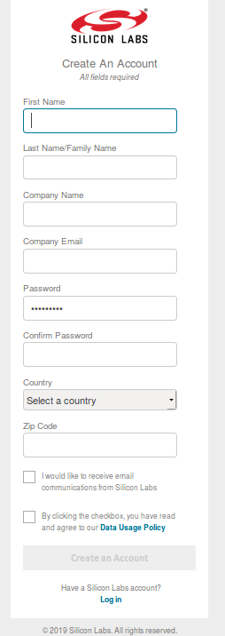

Figure 1 :Creat Silicon Lab Account

## Download simplicity studio

* Follow below link to download simplicity studio.

[**http://www.silabs.com/simplicity-studio**](http://www.silabs.com/simplicity-studio)

* By sign in your account you can download the simplicity studio tar file of required operating system.
* Extract downloaded file.
* Run Below commands:

***sudo apt-get update***

***sudo apt-get upgrade***

***cd SimplicityStudio_v4***

***sudo ./setup.sh***

* Open Studio using below command.

***sudo ./run_studio.sh***

* The first time you start Simplicity Studio, you will be prompted with a sign in screen. If you have a Silicon Labs user account, you can log in here. Some components provided by Simplicity Studio are only available to users who have applied for access. For these users, signing in to Simplicity Studio enables those components to be installed in subsequent steps. If you do not have an account, or if you have forgotten your password, the links below the user credentials will redirect you the Silicon Labs website. You can alternatively choose to continue without signing in, and the subsequent steps will present you with Simplicity Studio components available to all users.

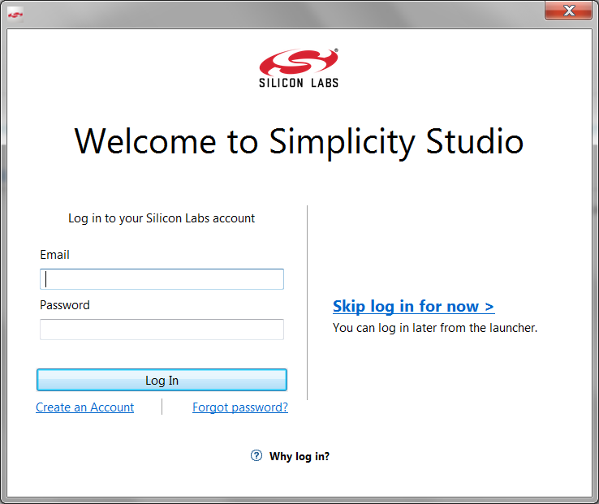

Figure 2 : Login window on Simplicity studio

* After signing in or continuing without signing in, the Simplicity Studio installer will query the remote server to construct installation options.

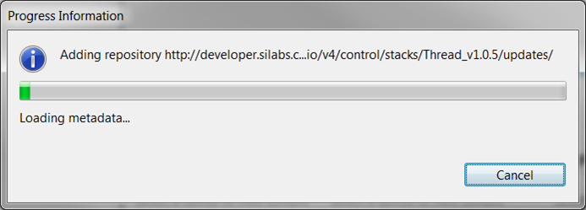

Figure 3 : installation progress bar

**Installation Method:**

Simplicity Studio allows you to install as much or as little as you need for your development needs.

The installation options include:

**Install by Device** – Use this option to install the minimum components necessary for development with a specified device

Install by Product Group – Use this option to install all components for an entire product group or select specific targets

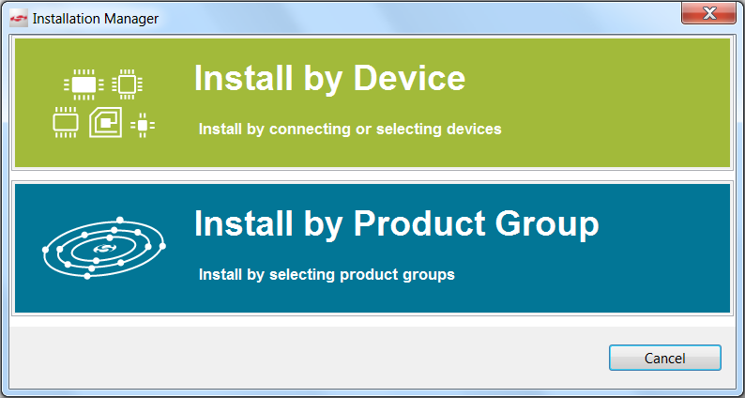

Figure 4 : Package Install option

* Select Install by Product group.

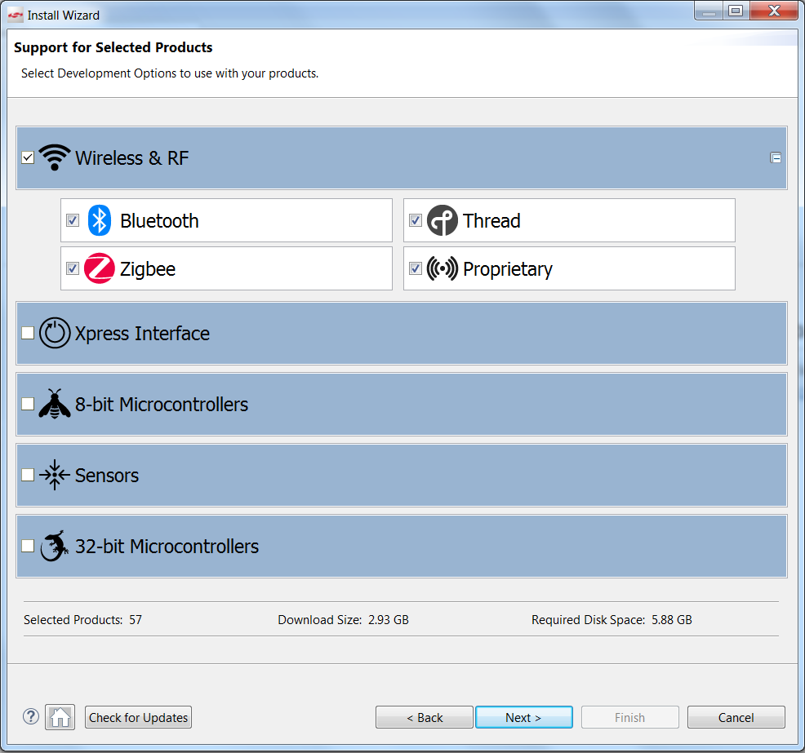

Figure 5 : Install by product group

* Select Bluetooth and ZigBee in Wireless & RF group.

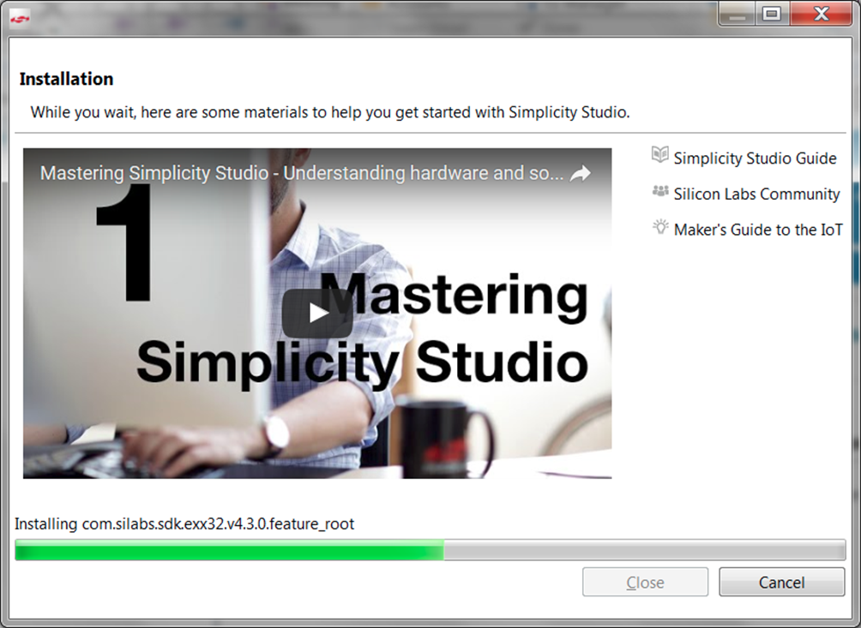

Figure 6 : Installation window

* The Simplicity Studio installer will now access remote servers to install components based upon your selections. Feel free to watch training videos during this installation step. Upon completion, you will be presented with the option to restart Simplicity Studio. Please select yes to ensure all functionality is ready for use.

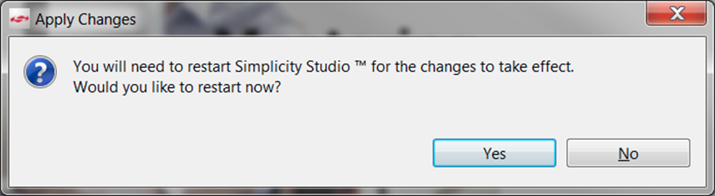

Figure 7 : Restart simplicity studio after installation complete

# Steps TO Install IAR Workbench

Note: Windows HOST OS is must to install IAR Workbench,

IAR Workbench will be required to compile source code of Mezzanine card firmware.

## Download IAR Workbench

* Follow below link to download IAR Workbench in Windows HOST Machine.

<https://www.iar.com/iar-embedded-workbench/#!?device=MGM13P02F512GA&architecture=Arm>

## Install IAR Workbench

* Double click on downloaded exe file. That will install the IAR Workbench and install necessary toolchain.

Note: IAR License would be required to use IAR toolchain. For license related query follow below link: <https://www.iar.com/rfq/>

# Import Growhouse sdk in simplicity studio

* Download the growhouse project zip file from “[Arrow electronics sharepoint](https://arrowelectronics.sharepoint.com/:u:/r/sites/GlobalMktgSales/Shared%20Documents/Growhouse/Development/Beta/Firmware/source/end-devices/growhouse_ED_v4.7.zip?csf=1&e=n3Q8uJ)” the Simplicity Studio path at

“***<Studio-Install-Directory>/SimplicityStudio_v4/developer/sdks/***”.

* After downloading the growhouse project zip file, extract the zip file. The directory named “growhouse” will be available in the directory.

**OR**

* Copy the ***growhouse*** directory available at ***Growhouse{GitHub repository}/growhouse*** at “***<Studio-Install-Directory>/SimplicityStudio_v4/developer/sdks/***” path.
* Once the project source downloaded or growouse directory copied, user needs to change the Simplicity default SDK preference to the one available in cloned source.
* We require two SDKs for growhouse end-device MCU firmware:

1. Gecko SDK Suits – EmberZnet: Zigbee wireless SDK from Silab.
2. Bluetooth Mesh : BLE mesh wireless SDK from Silab

* To change the SDs references, open Simplicity studio.
* Close all the project in Simplicity IDE from project Explorer bar If open.
* In top bar click in Window->Preferences->Simplicity Studio->Device Manager-> SDKs

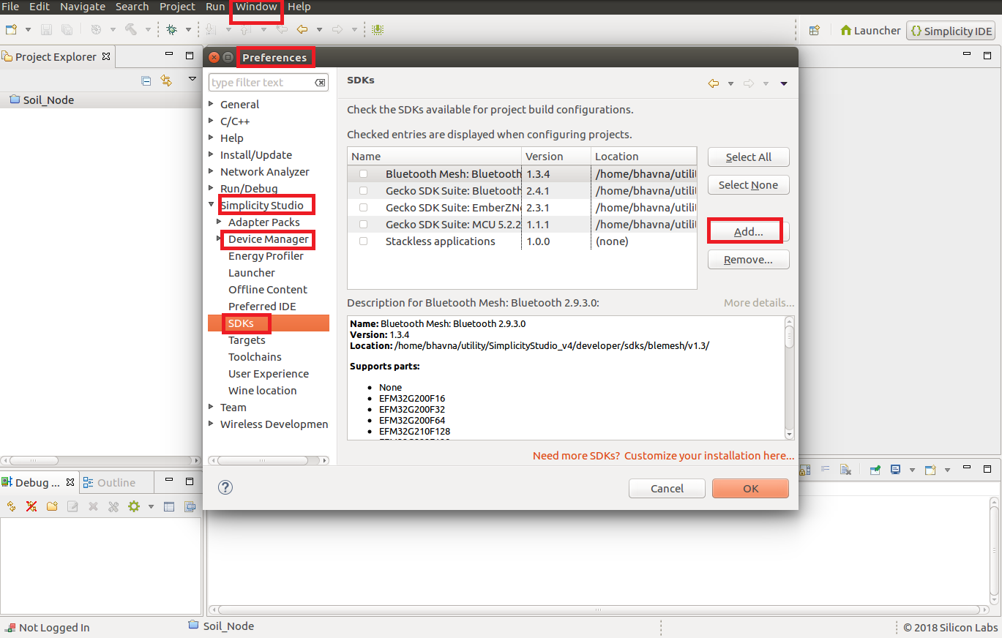

Figure 8 : Import Growhouse specific SDK reference

* Deselect all checked entries in SDKs and click Ok.
* Again go to same menu options In top bar click in Window->Preferences->Simplicity Studio->Device Manager-> SDKs

Click on Add, Browse the “***<Studio-Install-Directory>/SimplicityStudio_v4/developer/sdks/growhouse/end-devices/gecko_sdk_suite/v2.3”***

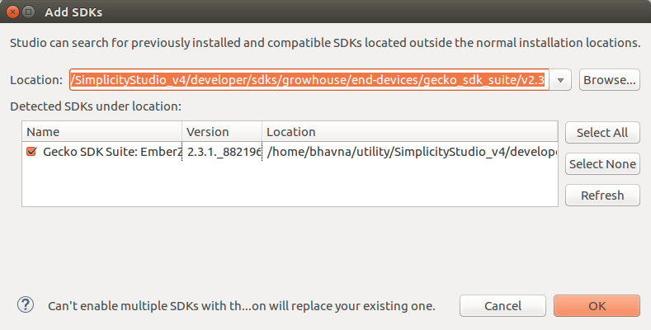

Figure 9 : Add Gecko SDK suite for zigbee

* Gecko SDK suite should be detected in window and press “OK” button. If not there might be some issue in cloning the project source.
* Your selected SDK will appear in List of SDKs, Next click on ok and you are done for “gecko sdk suite” for zigbee firmware.
* Similarly, add the Bluetooth mesh SDK reference, Window->Preferences->Simplicity Studio->Device Manager-> SDKs and Click on Add, Browse the ***“<Studio-Install-Directory>/SimplicityStudio_v4/developer/sdks/growhouse/blemesh/v1.3”***

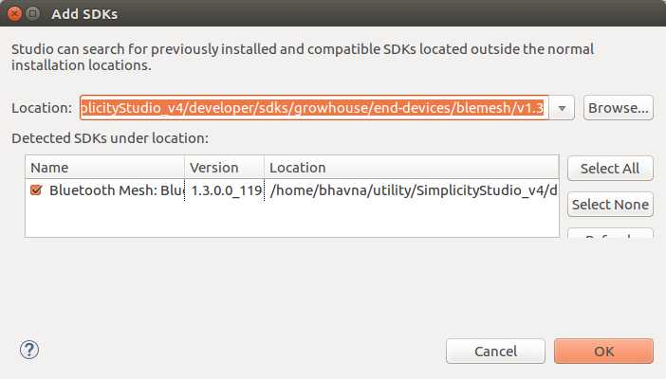

Figure 10 : Add Bluetooth Mesh SDK

* Bluetooth mesh SDK suite should be detected in window and press “OK” button. If not there might be some issue in cloning the project source.

# Import project in simplicity studio

* Once SDK references are imported in Simplicity Studio IDE, We can start importing the MCU firmware for LED Node, Soil Node or for Gateway Mezzanine card. To import the project follow below mentioned steps. We have taken the Soil Node MCU project for explaining the flow. Similarly any MCU firmware for end-device can be import.
* In Simplicity studio, click on [File] > [Import]

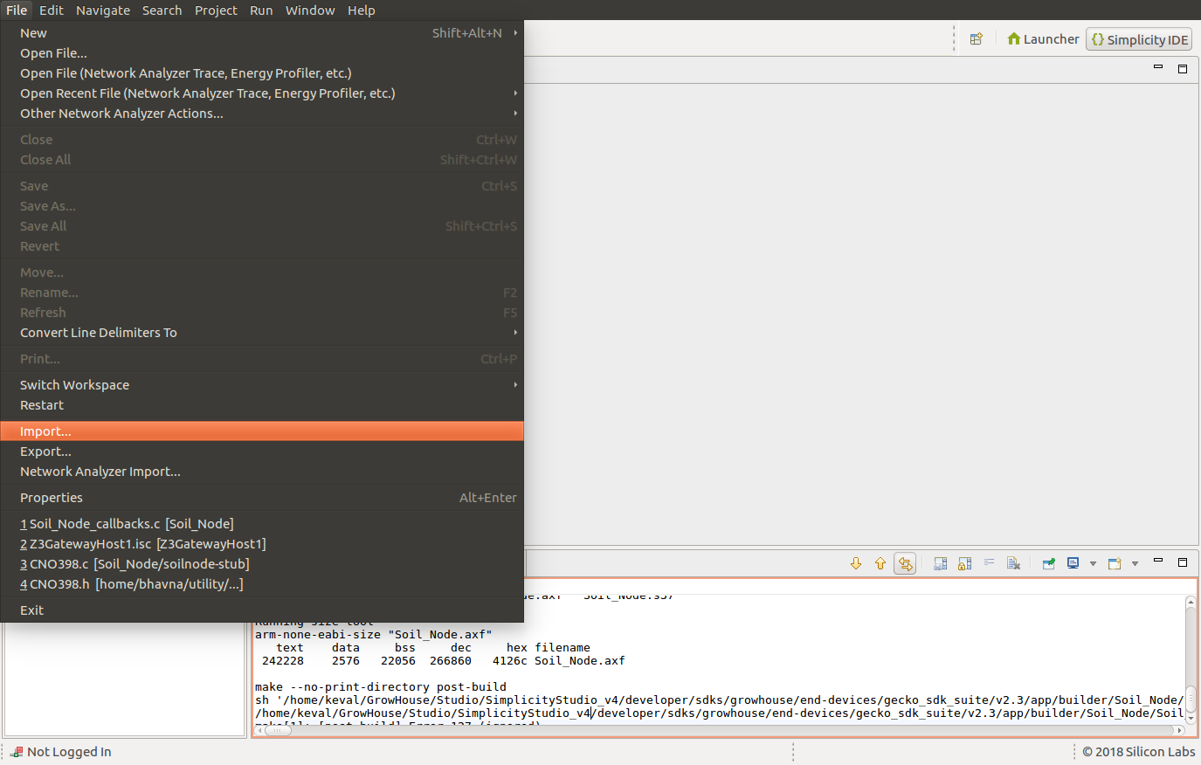

Figure 11 : Import MCU project

* Click on browse for selecting the location of Soil Node project in the pop-up window.
* Location for Firmware of Soil Node or LED Node or Gateway board is as below:

**<Install-Directory-of-Simplicity-studio>/*SimplicityStudio_v4/developer/sdks/*growhouse/end-devices/gecko_sdk_suite/v2.3/app/builder/**

* Once the directory selected properly, there will be two project import options as mentioned in below Figure 9. Select the sls project and click [Next>]

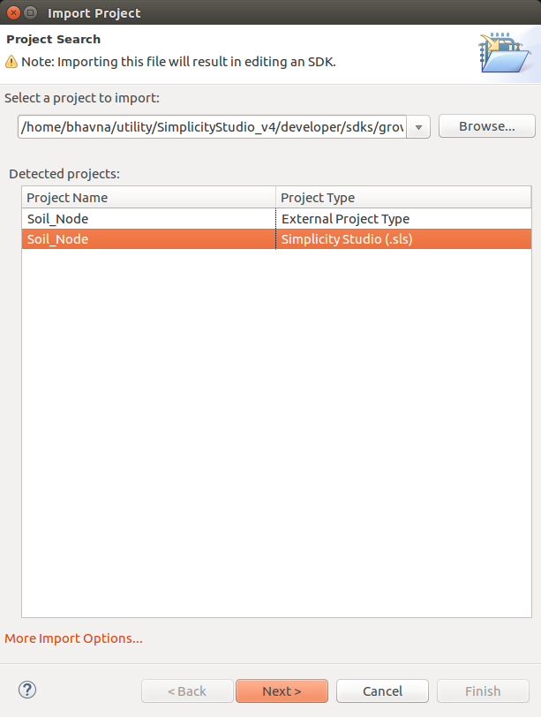

Figure 12 : Browse the MCU project

* Check the build configuration details and click [Next>]

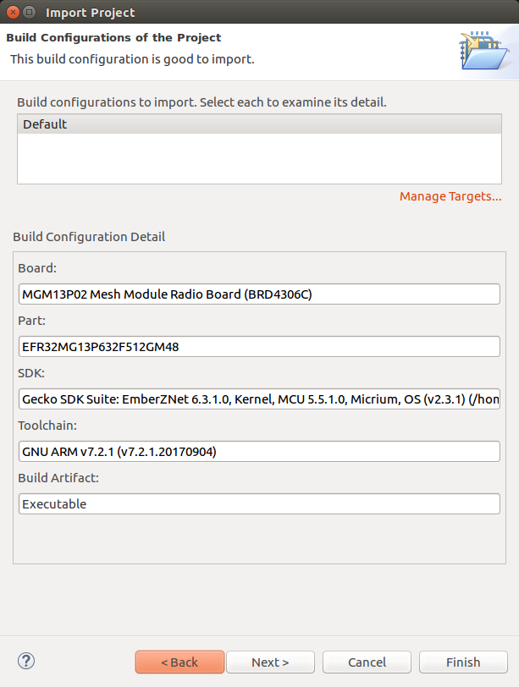

Figure 13 : Configuration window for imported project

* Now, the project name/location will be displayed, Uncheck (Use default location) check box and verify the path in “Location” box. The Location should be same as the one we browse the project source from. Now click [Finish] button.

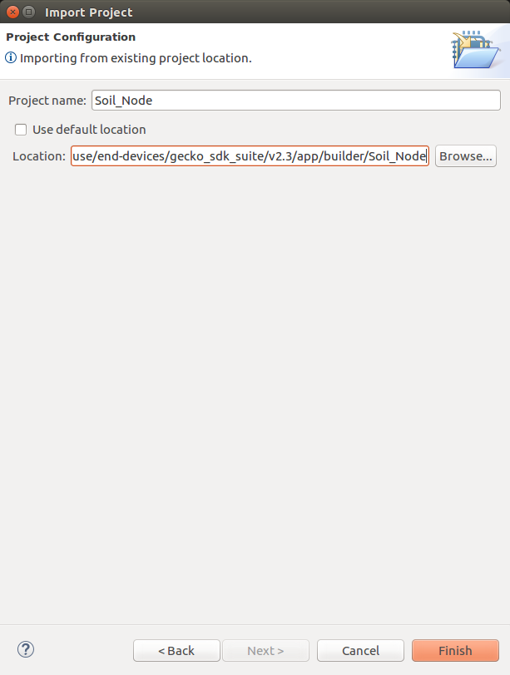

Figure 14 : Location and Name for imported project

* Your project should be displayed in Project Explorer in Simplicity IDE.

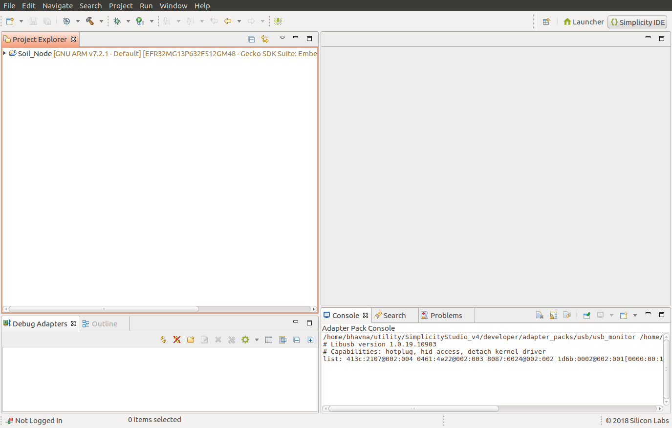

Figure 15 : MCU project imported in IDE

* Select the project by clicking on it.
* Now build the project, by clicking on hammer icon.

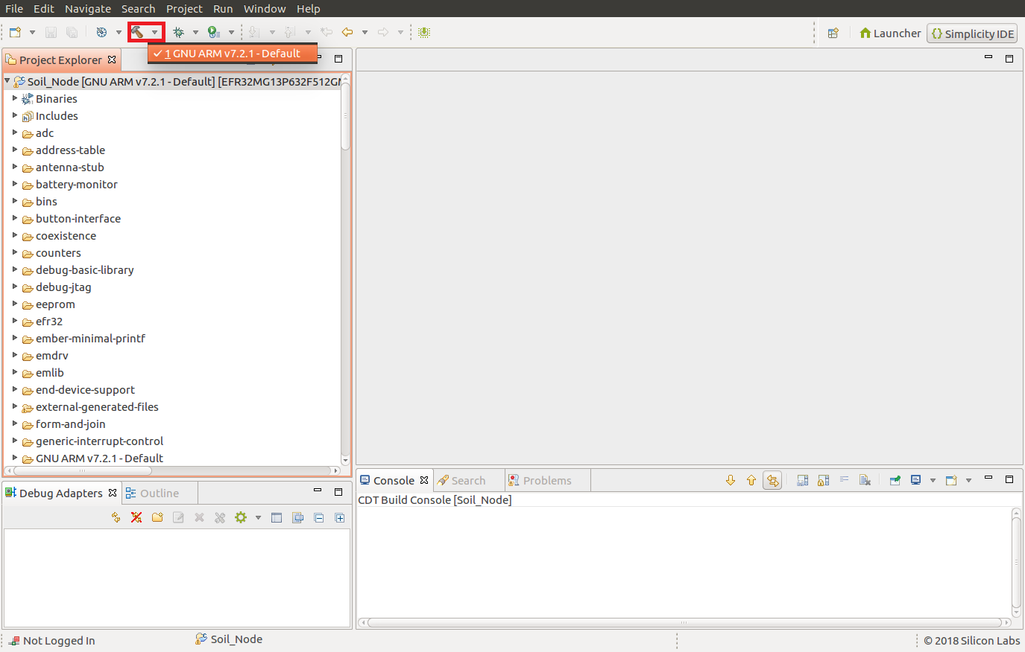

Figure 16 : Build imported project

* Once build finished, binary images for project will be generated.

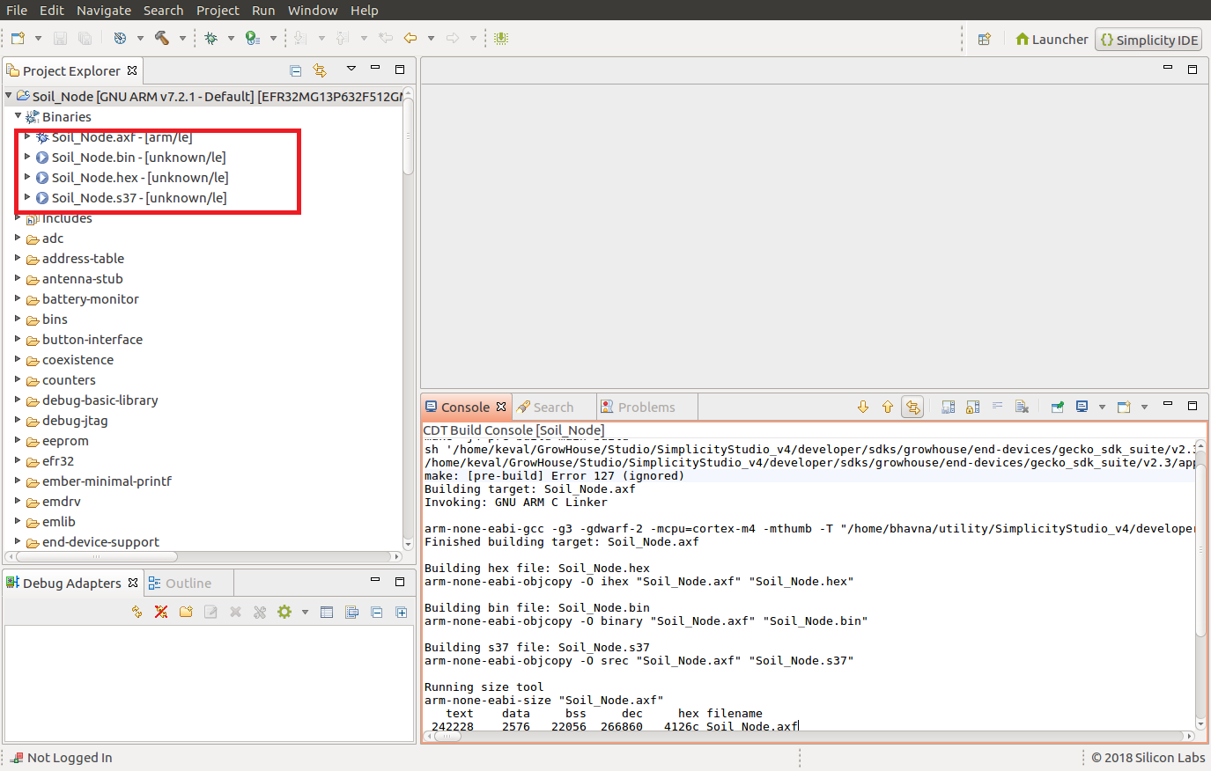

Figure 17 : Binary files after build completed

## Project path to generate bootloader binary and Firmware binary of Soil Node

### Bootloader binary of Soil Node.

* Before flashing firmware binary it is required to generate and flash bootloader binary.
* Below is the project path for bootloader source code for Soil Node.

Path:

**<Install-Directory-of-Simplicity-Studio>/*SimplicityStudio_v4/developer/sdks/*growhouse/end-devices/gecko_sdk_suite/v2.3/app/builder/EndDevice_Bootloader/**

* Import Soil Node bootloader project as mentioned in section 6 and build the code. **EndDevice_Bootloader.s37** binary will be generated at below mentioned path.

**<Install-Directory-of-Simplicity-Studio>/*SimplicityStudio_v4/developer/sdks/*growhouse/end-devices/gecko_sdk_suite/v2.3/app/builder/EndDevice_Bootloader/*GNU ARM v7.2.1 - Default/***

### Firmware binary of Soil Node.

* Make sure that you have generated bootloader binary for soil node as mentioned in section 6.1.1.
* Below is the project path for firmware source code for Soil Node.

Path:

**<Install-Directory-of-Simplicity-Studio>/*SimplicityStudio_v4/developer/sdks/*growhouse/end-devices/gecko_sdk_suite/v2.3/app/builder/Soil_Node/**

* Import Soil node firmware project as mentioned in section 6 and build the code. **Soil_Node.hex** binary will be generated at below mentioned path.

**<Install-Directory-of-Simplicity-Studio>/*SimplicityStudio_v4/developer/sdks/*growhouse/end-devices/gecko_sdk_suite/v2.3/app/builder/Soil_Node/*GNU ARM v7.2.1 - Default/***

## Project path to generate bootloader binary and Firmware binary of LED Node ZigBee Module

### Bootloader binary of LED Node ZigBee Module.

* Before flashing firmware binary it is required to generate and flash bootloader binary.
* Below is the project path for bootloader source code for LED Node.

Path:

**<Install-Directory-of-Simplicity-Studio>/*SimplicityStudio_v4/developer/sdks/*growhouse/end-devices/gecko_sdk_suite/v2.3/app/builder/EndDevice_Bootloader/**

* Import LED Node bootloader project as mentioned in section 6 and build the code. **EndDevice_Bootloader.s37** binary will be generated at below mentioned path.

**<Install-Directory-of-Simplicity-Studio>/*SimplicityStudio_v4/developer/sdks/*growhouse/end-devices/gecko_sdk_suite/v2.3/app/builder/EndDevice_Bootloader/*GNU ARM v7.2.1 - Default/***

### Firmware binary of LED Node ZigBee Module.

* Make sure that you have generated bootloader binary for LED node as mentioned in section 6.2.1.
* Below is the project path for firmware source code for LED Node.

Path:

**<Install-Directory-of-Simplicity-Studio>/*SimplicityStudio_v4/developer/sdks/*growhouse/end-devices/gecko_sdk_suite/v2.3/app/builder/LED_Node/**

* Import LED node firmware project as mentioned in section 6 and build the code. **LED_Node.hex** binary will be generated at below mentioned path.

**<Install-Directory-of-Simplicity-Studio>/*SimplicityStudio_v4/developer/sdks/*growhouse/end-devices/gecko_sdk_suite/v2.3/app/builder/LED_Node/*GNU ARM v7.2.1 - Default/***

## Project path to generate bootloader binary and Firmware binary of LED Node BLE Module

### Bootloader binary of LED Node BLE Module.

* Before flashing firmware binary it is required to generate and flash bootloader binary.
* Below is the project path for bootloader source code for LED Node.

Path:

**<Install-Directory-of-Simplicity-Studio>/** ***SimplicityStudio_v4/developer/sdks/growhouse/end-devices/blemesh/v1.3/app/bluetooth/appbuilder/BLE_Device_Bootloader***

* Import LED Node bootloader project as mentioned in section 6 and build the code. ***BLE_Device_Bootloader.*s37** binary will be generated at below mentioned path.

**<Install-Directory-of-Simplicity-Studio>/** ***SimplicityStudio_v4/developer/sdks/growhouse/end-devices/blemesh/v1.3/app/bluetooth/appbuilder/BLE_Device_Bootloader***

**/*GNU ARM v7.2.1 - Default/***

### Firmware binary of LED Node BLE Module.

* Make sure that you have generated bootloader binary for LED node as mentioned in section 6.3.1.
* Below is the project path for firmware source code for LED Node.

Path:

**<Install-Directory-of-Simplicity-Studio>/** ***SimplicityStudio_v4/developer/sdks/growhouse/end-devices/blemesh/v1.3/app/bluetooth/appbuilder/LED_Node_BLE***

* Import LED node firmware project as mentioned in section 6 and build the code. ***LED_Node_BLE.hex*** binary will be generated at below mentioned path.

**<Install-Directory-of-Simplicity-Studio>/** ***SimplicityStudio_v4/developer/sdks/growhouse/end-devices/blemesh/v1.3/app/bluetooth/appbuilder/LED_Node_BLE/GNU ARM v7.2.1 - Default/***

## Project path to generate bootloader binary and Firmware binary of Mezzanine Board

### Bootloader binary of Mezzanine board.

* Before flashing firmware binary it is required to generate and flash bootloader binary.
* Below is the project path for bootloader source code for Mezzanine board.

Path:

**<Install-Directory-of-Simplicity-Studio>/*SimplicityStudio_v4/developer/sdks/*growhouse/end-devices/gecko_sdk_suite/v2.3/app/builder/NCP_ZC_NodeBootloader**

* Import Mezzanine board bootloader project as mentioned in section 6 and build the code. **NCP_ZC_NodeBootloader*.*s37** binary will be generated at below mentioned path.

**<Install-Directory-of-Simplicity-Studio>/*SimplicityStudio_v4/developer/sdks/*growhouse/end-devices/gecko_sdk_suite/v2.3/app/builder/NCP_ZC_NodeBootloader**

***/GNU ARM v7.2.1 - Default/***

### Firmware binary of Mezzanine board.

**Note**: It is must require to use Simplicity Studio with IAR Workbench toolchain to compile firmware binary for mezzanine card. So use Windows Host machine (For dependency of IAR Workbench) to compile firmware binary for mezzanine board.

* Make sure that you have generated bootloader binary for Mezzanine board as mentioned in section 6.4.1.
* Below is the project path for firmware source code for Mezzanine board.

Path:

**<Install-Directory-of-Simplicity-Studio>/*SimplicityStudio_v4/developer/sdks/*growhouse/end-devices/gecko_sdk_suite/v2.3/app/builder/Zigbee_Coordinator/**

* Import Mezzanine board firmware project as mentioned in section 6 and build the code. ***Zigbee_Coordinator.hex*** binary will be generated at below mentioned path.

**<Install-Directory-of-Simplicity-Studio>/*SimplicityStudio_v4/developer/sdks/*growhouse/end-devices/gecko_sdk_suite/v2.3/app/builder/Zigbee_Coordinator/IAR ARM - Default - EFR32MG13P632F512GM48**

# Flash MCU on board

Follow the steps mentioned in MCU flashing document [“MGM13P_MCU_Flashing_User_Guide”](https://arrowelectronics.sharepoint.com/:w:/r/sites/GlobalMktgSales/Shared%20Documents/Growhouse/Development/Beta/Firmware/source/end-devices/MGM13P_MCU_Flashing_Guide.docx?d=wff2f5f13a58743c0bbbca70cdf809b7c&csf=1&e=MA8Mqg).

After the firmware build, Bootloaders binaries and firmware binaries will be generated on appropriate path. Select the appropriate Bootloaders and firmware binary file, while flashing the board,

by following the document [“MGM13P_MCU_Flashing_User_Guide”](https://arrowelectronics.sharepoint.com/:w:/r/sites/GlobalMktgSales/Shared%20Documents/Growhouse/Development/Beta/Firmware/source/end-devices/MGM13P_MCU_Flashing_Guide.docx?d=wff2f5f13a58743c0bbbca70cdf809b7c&csf=1&e=MA8Mqg).

Below is the path for bootloaders and Firmware file for Soil Node, LED Node and Mezzanine Board.

## Bootloader path and Firmware Binary path for Soil Node.

Bootloader path**:**

**<Install-Directory-of-Simplicity-Studio>/*SimplicityStudio_v4/developer/sdks/*growhouse/end-devices/gecko_sdk_suite/v2.3/app/builder/EndDevice_Bootloader/ EndDevice_Bootloader.s37**

Firmware Binary path:

**<Install-Directory-of-Simplicity-Studio>/*SimplicityStudio_v4/developer/sdks/*growhouse/end-devices/gecko_sdk_suite/v2.3/app/builder/Soil_Node/*GNU ARM v7.2.1 - Default/Soil_Node.hex***

## Bootloader path and Firmware Binary path for LED Node ZigBee Module.

Bootloader path**:**

**<Install-Directory-of-Simplicity-Studio>/*SimplicityStudio_v4/developer/sdks/*growhouse/end-devices/gecko_sdk_suite/v2.3/app/builder/EndDevice_Bootloader/ EndDevice_Bootloader.s37**

Firmware Binary path:

**<Install-Directory-of-Simplicity-Studio>/*SimplicityStudio_v4/developer/sdks/*growhouse/end-devices/gecko_sdk_suite/v2.3/app/builder/LED_Node/*GNU ARM v7.2.1 - Default/LED_Node.hex***

## Bootloader path and Firmware Binary path for LED Node BLE Module.

Bootloader path**:**

**<Install-Directory-of-Simplicity-Studio>/** ***SimplicityStudio_v4/developer/sdks/growhouse/end-devices/blemesh/v1.3/app/bluetooth/appbuilder/BLE_Device_Bootloader***

**/*GNU ARM v7.2.1 - Default/BLE_Device_Bootloader.*s37**

Firmware Binary path:

**<Install-Directory-of-Simplicity-Studio>/** ***SimplicityStudio_v4/developer/sdks/growhouse/end-devices/blemesh/v1.3/app/bluetooth/appbuilder/LED_Node_BLE/GNU ARM v7.2.1 - Default/LED_Node_BLE.hex***

## Bootloader path and Firmware Binary path for Mezzanine card.

Bootloader path**:**

**<Install-Directory-of-Simplicity-Studio>/*SimplicityStudio_v4/developer/sdks/*growhouse/end-devices/gecko_sdk_suite/v2.3/app/builder/NCP_ZC_NodeBootloader/ NCP_ZC_NodeBootloader*.*s37**

Firmware Binary path:

**<Install-Directory-of-Simplicity-Studio>/*SimplicityStudio_v4/developer/sdks/*growhouse/end-devices/gecko_sdk_suite/v2.3/app/builder/Zigbee_Coordinator/IAR ARM - Default - EFR32MG13P632F512GM48/*Zigbee_Coordinator.hex***