

Hardware Requirement Specifications
Arrow iMX8X ML Reference Design

Version  Status  Date | 1.3  Baselined  10-January-2019

Confidentiality Notice
Copyright (c) 2026 eInfochips. - All rights reserved
This document is authored by eInfochips and is eInfochips intellectual property, including the copyrights in all countries in the world. This document is provided under a license to use only with all other rights, including ownership rights, being retained by eInfochips. This file may not be distributed, copied, or reproduced in any manner, electronic or otherwise, without the express written consent of eInfochips.

Contents
1 Document Details 5
1.1 Document History 5
1.2 Description of Change 5
1.3 Definition, Acronyms and Abbreviations 6
1.4 References 7
2 introduction 8
3 System Overview & APPLICATION 9
3.1 Design Objective 9
3.2 Product – overview 9
3.3 Module Overview 10
3.4 Design Variants 10
4 Hardware Overview 11
4.1 Hardware Block Diagram 11
4.1.01 Hardware Features 12
4.1.02 Future Enhancements 12
5 SOW and functional RequirEment 13
5.1 eInfochips Scope of Work 13
5.1.01 Requirement 01: Application Processor- NXP i.MX 8QUADX 13
5.1.02 Requirement 02: Memory LPDDR4 (2GB) 13
5.1.03 Requirement 03: Micro SD Card Memory Support (Up to 64GB) 14
5.1.04 Requirement 04: DSI to HDMI conversion 14
5.1.05 Requirement 05: HDMI Display Interface Port 15
5.1.06 Requirement 06: IEEE 802.11 a/b/g/n/ac Dual Band Wi-Fi 15
5.1.07 Requirement 07: Bluetooth 4.2 16
5.1.08 Requirement 08: Board Power Supply- (Input and Regulation) 16
5.1.09 Requirement 09: USB 2.0 Micro AB OTG Port 17
5.1.10 Requirement 10: 2 x USB 3.0 Ports( Type A) 17
5.1.11 Requirement 11: Gigabit Ethernet (1Gbps) 18
5.1.12 Requirement 12: User Interface- Switches and LEDs 18
5.1.13 Requirement 13: Low Speed Expansion Connector (40- Pin) 19
5.1.14 Requirement 14: High Speed Expansion Connector (60- Pin) 19
5.1.15 Requirement 15: Microphone Array for Voice Recognition 20
5.1.16 Requirement 16: Accelerometer and Gyroscope 20
5.1.17 Requirement 17: JTAG for Debugging 21
5.1.18 Requirement 18: Debug UART Port 21
5.1.19 Requirement 19: I2C based EEPROM 21
5.1.20 Requirement 20: SPI based NOR Flash 22
5.1.21 Requirement 21: 4G/LTE Cellular Module 22
5.1.22 Requirement 22: I2C based IOT Secure Connect Element 22
5.2 Arrow Scope of Work 23
6 EXTERNAL INTERFACE 24
6.1 User Interface 24
6.2 Hardware Interface 24
6.3 Software Interface 24
7 STATUTORY, REGULATORY & OTHER RequirEments 25
8 Mechanical constraint 26
9 Special usaGE requirements 27
9.1 Environment 27
9.2 Installation 27
9.3 Safety & Essential performance Requirement 27
9.4 User Training 27
9.5 User Manual 27
10 REQUIREMent Management 28
11 ASsumptions 29
12 Queries on requirement 30
13 Risk Analysis 31
14 Appendix 32
14.1 APPENDIX A: Low Speed Expansion Connector Pinout 32
14.2 APPENDIX B: High Speed Expansion Connector Pinout 34
14.3 APPENDIX C: Selection of Major Components 36
14.4 APPENDIX D: Tentative Placement as per 96Boards standard 37
14.5 APPENDIX E: eI Proprietary Mezzanine Board – Block Diagram 38

FIGURES

Figure 01 : Top Level Block Diagram of the Arrow iMX8X ML Reference Design 11
Figure 02 : 96Boards Extended B Dimensions 37
Figure 03 : Mezzanine Test Board- Block Diagram 38

TABLES

Table 01. Product Variants 10
Table 02. Arrow iMX8X ML Reference Design Product Specification 12
Table 03. Functional Requirement Specification- Application Processor I.MX8 QUADX 13
Table 04. Functional Requirement Specification- LPDDR4 Memory 13
Table 05. Functional Requirement Specification- Primary Storage Memory (Micro SD card) 14
Table 06. Functional Requirement Specification- DSI to HDMI conversion 14
Table 07. Functional Requirement Specification- HDMI Out Port (HDMI Type A Connector) 15
Table 08. Functional Requirement Specification- IEEE 802.11 Dual Band Wi-Fi 15
Table 09. Functional Requirement Specification- Bluetooth 4.2 16
Table 10. Functional Requirement Specification- Power Supply (Input and Regulation) 16
Table 11. Functional Requirement Specification- USB 2.0 OTG Port 17
Table 12. Functional Requirement Specification- 2 x USB 3.0 Ports (Type A) 17
Table 13. Functional Requirement Specification- Gigabit Ethernet (1Gbps) 18
Table 14. Functional Requirement Specification- User Interface- Switches and LEDs 18
Table 15. Functional Requirement Specification- Low speed Expansion connector (40- Pin) 19
Table 16. Functional Requirement Specification- High speed Expansion connector (60-Pin) 20
Table 17. Functional Requirement Specification- Microphone Array for Voice Recognition 20
Table 18. Functional Requirement Specification- Accelerometer and Gyroscope 20
Table 19. Functional Requirement Specification- JTAG for Debugging 21
Table 20. Functional Requirement Specification- Debug UART Port 21
Table 21. Functional Requirement Specification- Debug UART Port 21
Table 22. Functional Requirement Specification- Debug UART Port 22
Table 23. Functional Requirement Specification- 4G/LTE Cellular Module 22
Table 24. Functional Requirement Specification- I2C based IOT Security Element 22
Table 25. Low Speed Expansion Connector Pinouts 33
Table 26. High Speed Expansion Connector Pinouts 35

Document Details

Document History

Version | Author |  | Reviewer |  | Approver
Version | Name | Date  (DD-MM-YYYY) | Name | Date  (DD-MMM-YYYY) | Name | Date  (DD-MM-YYYY)
Draft 0.1 | Divyesh Patel, Nimesh Kotak | 05-July-2018 | Kinjan Patel | 05-July-2018
Draft 0.2 | Nimesh Kotak | 06-July-2018 | eI Meeting review with team | 06-July-2018
Draft 0.3 | Nimesh Kotak, Kinjan Patel | 11-July-2018
Draft 0.4 | Nimesh Kotak,  Kinjan Patel | 17-July-2018 | Josh Willis (Arrow) | 18-July-2018
Draft 0.5 | Nimesh Kotak | 24-July-2018 | Josh Willis (Arrow) | 25-July-2018
Baselined 1.0 |  |  |  |  | Josh Willis (Arrow) | 25-July-2018
Baselined  1.1 | Nimesh Kotak | 07-August-2018 | Kinjan Patel | 07-Aug-2018 | Josh Willis (Arrow) | 08-Aug-2018
Baselined  1.2 | Divyesh Patel | 17-October-2018 | Kinjan Patel | 17-October-2018 | Bhavin Patel | 04-Feb-2019
Baselined  1.3 | Vishal Panchal | 10-January-2019 | Kinjan Patel | 10-January-2019 | Josh Willis (Arrow)

Description of Change

Version | Description of Change
Draft 0.1 | Initial draft version created
Draft 0.2 | Incorporated review comments from Kinjan:  - Added pointers for scope, out of scope and assumptions to SOW.  - Added variants with Wi-Fi/BT.  - Trivial correction with Template and numbering  - Remove part numbers from requirements and add sheet in Appendix with critical parts.  The review comments listed in Design Review Tracker sheet #47- #59.
Draft 0.3 | Incorporated internal meeting review comments and comments from team:  - Requirements marked in Teal Green colour are scope addition.  - Added EEPROM, Sensors, NOR Flash and Microphone sections.  - Modified Acceptance criteria and requirement description for all the sections.  - Use case and Mezzanine details added.  The review comments listed in Design Review Tracker sheet #60- #73.
Draft 0.4 | Modified below sections per minutes, call on 12/07 (Architecture change)  - Added Cellular Module Interface.  - Removed Audio DSP and planned to interface DMIC directly to Processor  - Acceptance criteria modified for Low Speed and High Speed expansion Connectors  - Trivial Correction and Aesthetical modifications.  - Critical Parts list as of 17/07 added in the Appendix.  - Modified below sections/ title as per eInfochips latest template:  - Section 4 divided into two sections - Section 4 and 5  - Naming Convention for Requirement ID's changed  - Section 5.1 titled as eInfochips Scope of Work.
Draft 0.5 | Document updated as per the Comments from Arrow  - APPENDIX D Updated - Old Placement diagram replaced with 96Boards Extended B Form Factor Dimensions  - APPENDIX E Added  - Section updated as per Arrow Review Comments .The review comments listed in the Design Review Tracker #74 - #79.  - Other Sections modified based on internal feedback:  - Block Diagram of Mezzanine Test Board  - Added JTAG in Table 02  - Mentioned 2.4GHz and 5GHz in table 08  - Mentioned Distance in Acceptance Criteria of Table 09  - Added SPI in Acceptance criteria of Table 16  - Removed CYUSB3314-88LTXC from table 12  - Updated Section 7, added Misc requirements from 96Boards CE Standard  - TBD sections populated/removed,
Baseline 1.0 | Initial Baseline after customer Approval on 25/07/2018
Baseline  1.1 | - DSI to HDMI conversion replaced with LVDS to HDMI conversion  - I2C based Plug & Trust Secure Element added
Baseline  1.2 | Number of ON board MIC changed to 4 instead of 3  DMIC connection at SAI2 and SAI3 changed to only ESAI port  NOR memory size corrected to 512Mb instead of 512KB  Latest Block diagram 1.2 added  Operating range changed to 0 to 55C instead of 0C to 70C  - Formal Approval Received from DM on 04Feb2019
Baselined 1.3 | Updated Power supply section in Table 02 as per Beta phase changes

Definition, Acronyms and Abbreviations

Definition/ Acronym/ Abbreviation | Description
HRS | Hardware Requirement Specification
USB | Universal Serial Bus
BT | Bluetooth
DSI | Display Serial Interface
LPDDR | Low Power Double Data Rate
MIPI | Mobile Industry Processor Interface
PCB | Printed Circuit Board
QA | Quality Assurance
RAM | Random Access Memory
RoHS | Restriction of Hazardous Substances
SD | Secure Digital
SOW | Scope of Work
TBD | To Be Decided
SPI | Serial Peripheral Interface
I2C | Inter-Integrated Circuit
WLAN | Wide Local Area Network
HDMI | High-Definition Multimedia Interface
RTC | Real Time Clock
PMIC | Power Management IC
CRN | Change Request Note
GPU | Graphics Processing Unit
QTS | Query Tracking Sheet
SBC | Single Board Computer
RTM | Requirement Traceability Matrix
CE | Consumer Edition
ML | Machine Learning
RD | Reference Design
iMX8X ML RD | i.MX 8X Machine Learning Reference Design
MEK | Multisensory Enablement Kit

References

# | Document | Version | Remarks
1 | 96BoardsCESpecificationv1.0-EA1 | 1.0 (January 2015) | 96Boards Consumer Edition  Low Cost Hardware Platform Specification
2 | eI_96boards_iMX_8QUADX_BlockDiagram | 0.4 | Block Diagram
3 | Proposal-Draft | Draft version | Initial Proposal to Customer
4 | eInfochips SOW#1_iMX8X_MLPlatfrom-Rev1-NC (1) | 1.0 | SOW
5 | eI_Arrow_iMX8XML_RD_QueryTrackingSheet | Draft | QTS updated as per Discussion with Customer
6 | eI_Arrow_iMX8XML_RD_CriticalPartsSelection | 0.5 | Component selection shall be as per Arrow preferred vendor list

introduction
The purpose of this document is to specify the product requirements and top-level system architecture to design NXP Semiconductor’s iMX 8QUADX based Reference Design complying with the 96Boards’ Consumer Edition (CE) platform for Arrow Electronics.

This document lists all HW interfaces, features, and requirements of the board and specifications described in this document are to be baselined before start of the design and development cycle for this device. This document covers the requirements of top-level interfaces, primarily to identify major blocks of the design, requirements for each block and top-level acceptance criteria for respective blocks. Any change in requirement and specifications during the course of the project would be managed via change management system based on CRN.

Terms like ‘the processor’ and ‘iMX8X’ will be used to mention the iMX8 QUADX processor. And terms like ‘the board’ and ‘the design’ will be used to denote The iMX8X ML Reference Design.

System Overview & APPLICATION
The reference design needs to be developed as per 96boards’ Consumer Edition standard (Extended version type B). The 96Boards community defines all the Hardware features and requirements of the design, which intend to support developers and OEMs requiring low cost off-the shelf CPU modules.

This particular reference design will demonstrate its capabilities for applications like
1. Vision - Traffic Sign recognition
2. Audio - keyword detection
with help of machine learning library integration from Au-zone.

In all cases key design and distribution goals are:
      - Easy to extend with off the shelf parts available to community and OEMs.
      - Easy to purchase globally.
      - Enable a third party ecosystem to develop around expansion (mezzanine)boards/peripherals/displays etc. that can be used on any 96Boards CE compliant board.

Please refer the link https://linaro.co/ce-specification to know all HW requirements of 96Boards CE standard.

The iMX8 QUADX based SBC reference design will fulfil the minimum requirements from 96Boards CE standard and other interfaces will be added as per the SOW and capabilities of the processor.

Design Objective
eInfochips (EIC) to develop the iMX8 QUADX processor based reference design for Arrow Electronics.
Refer subsequent sections of this document for additional details on different Hardware features of the design.

Product – overview

Arrow iMX8X ML Reference Design Major Hardware Features
- 96Boards Extended-B form factor - 85 x 100mm
- i.MX8 QUADX Processor having 4x Cortex®-A35 cores
- 2GB LPDDR4 RAM
- Micro SDHC Socket for up to 64GB on-board or expansion flash storage
- Wi-Fi 802.11a/b/g/n/ac and Bluetooth 4.2
- On Board Microphones (x4)
- Accelerometer and Gyroscope Sensors
- On Board Connectors and I/O expansion
  - 2x USB Type A (USB3.0)
  - 1x USB Micro-AB OTG (USB2.0)
  - HDMI Type A for Display output
  - 40 Pin Expansion Connector for low speed interfaces
  - 60 pin Expansion Connector for high speed interface
  - Board power from DC Jack connector
  - RJ45 Ethernet Connector
  - Mini-PCIe Connector
  - JTAG Connector
  - 1x USB Micro-AB connector for UART
  - Micro-SIM Connector

Please refer Block diagram, Refer Section 4 for more details on different interfaces of Arrow iMX8X Machine Learning Reference Design.

Module Overview
The iMX8 QuadX based reference design can operate standalone since it is a Reference Design complying with 96Boards CE standard. Different Mezzanine cards can be interfaced with the board as per the end application.

Arrow will provide the necessary Mezzanine cards during bring-up of the board to validate all the interfaces available on High speed and Low speed Expansion connectors.
Some of the mezzanine cards are;

Camera Board | https://www.96boards.org/product/d3camera/
Audio Board | https://www.96boards.org/product/audio-mezzanine/
LTE | https://www.96boards.org/product/shiratech-lte/
Sensors | https://www.96boards.org/product/sensors-mezzanine/
HDMI Display | https://www.arrow.com/en/products/96boards-display-7/linksprite-technologies-inc

Design Variants
This section describes different possible configurations of the board. As of now, the selected Wi-Fi/BT module and LPDDR4 memory supports pin compatible parts.

The design can have possible variants as shown in below table or can have a fixed version out of the possible configurations.

Feature/ Interface | Possible Configurations
Wi-Fi/BT Module | - 802.11 b/g/n (2.4 GHz Only)  - 802.11 a/b/g/n/ac (2.4 GHz and 5.0 GHz)
LPDDR4 RAM | - 2 GB LPDDR4  - 4 GB LPDDR4
Table 01. Product Variants

Hardware Overview

Hardware Block Diagram
The following figure shows the top-level block diagram of the hardware design of Arrow iMX8X ML Reference Design. Refer SVN for latest copy - Arrow iMX8X ML RD Block Diagram (Not accessible to customer, Separate copy will be shared.) 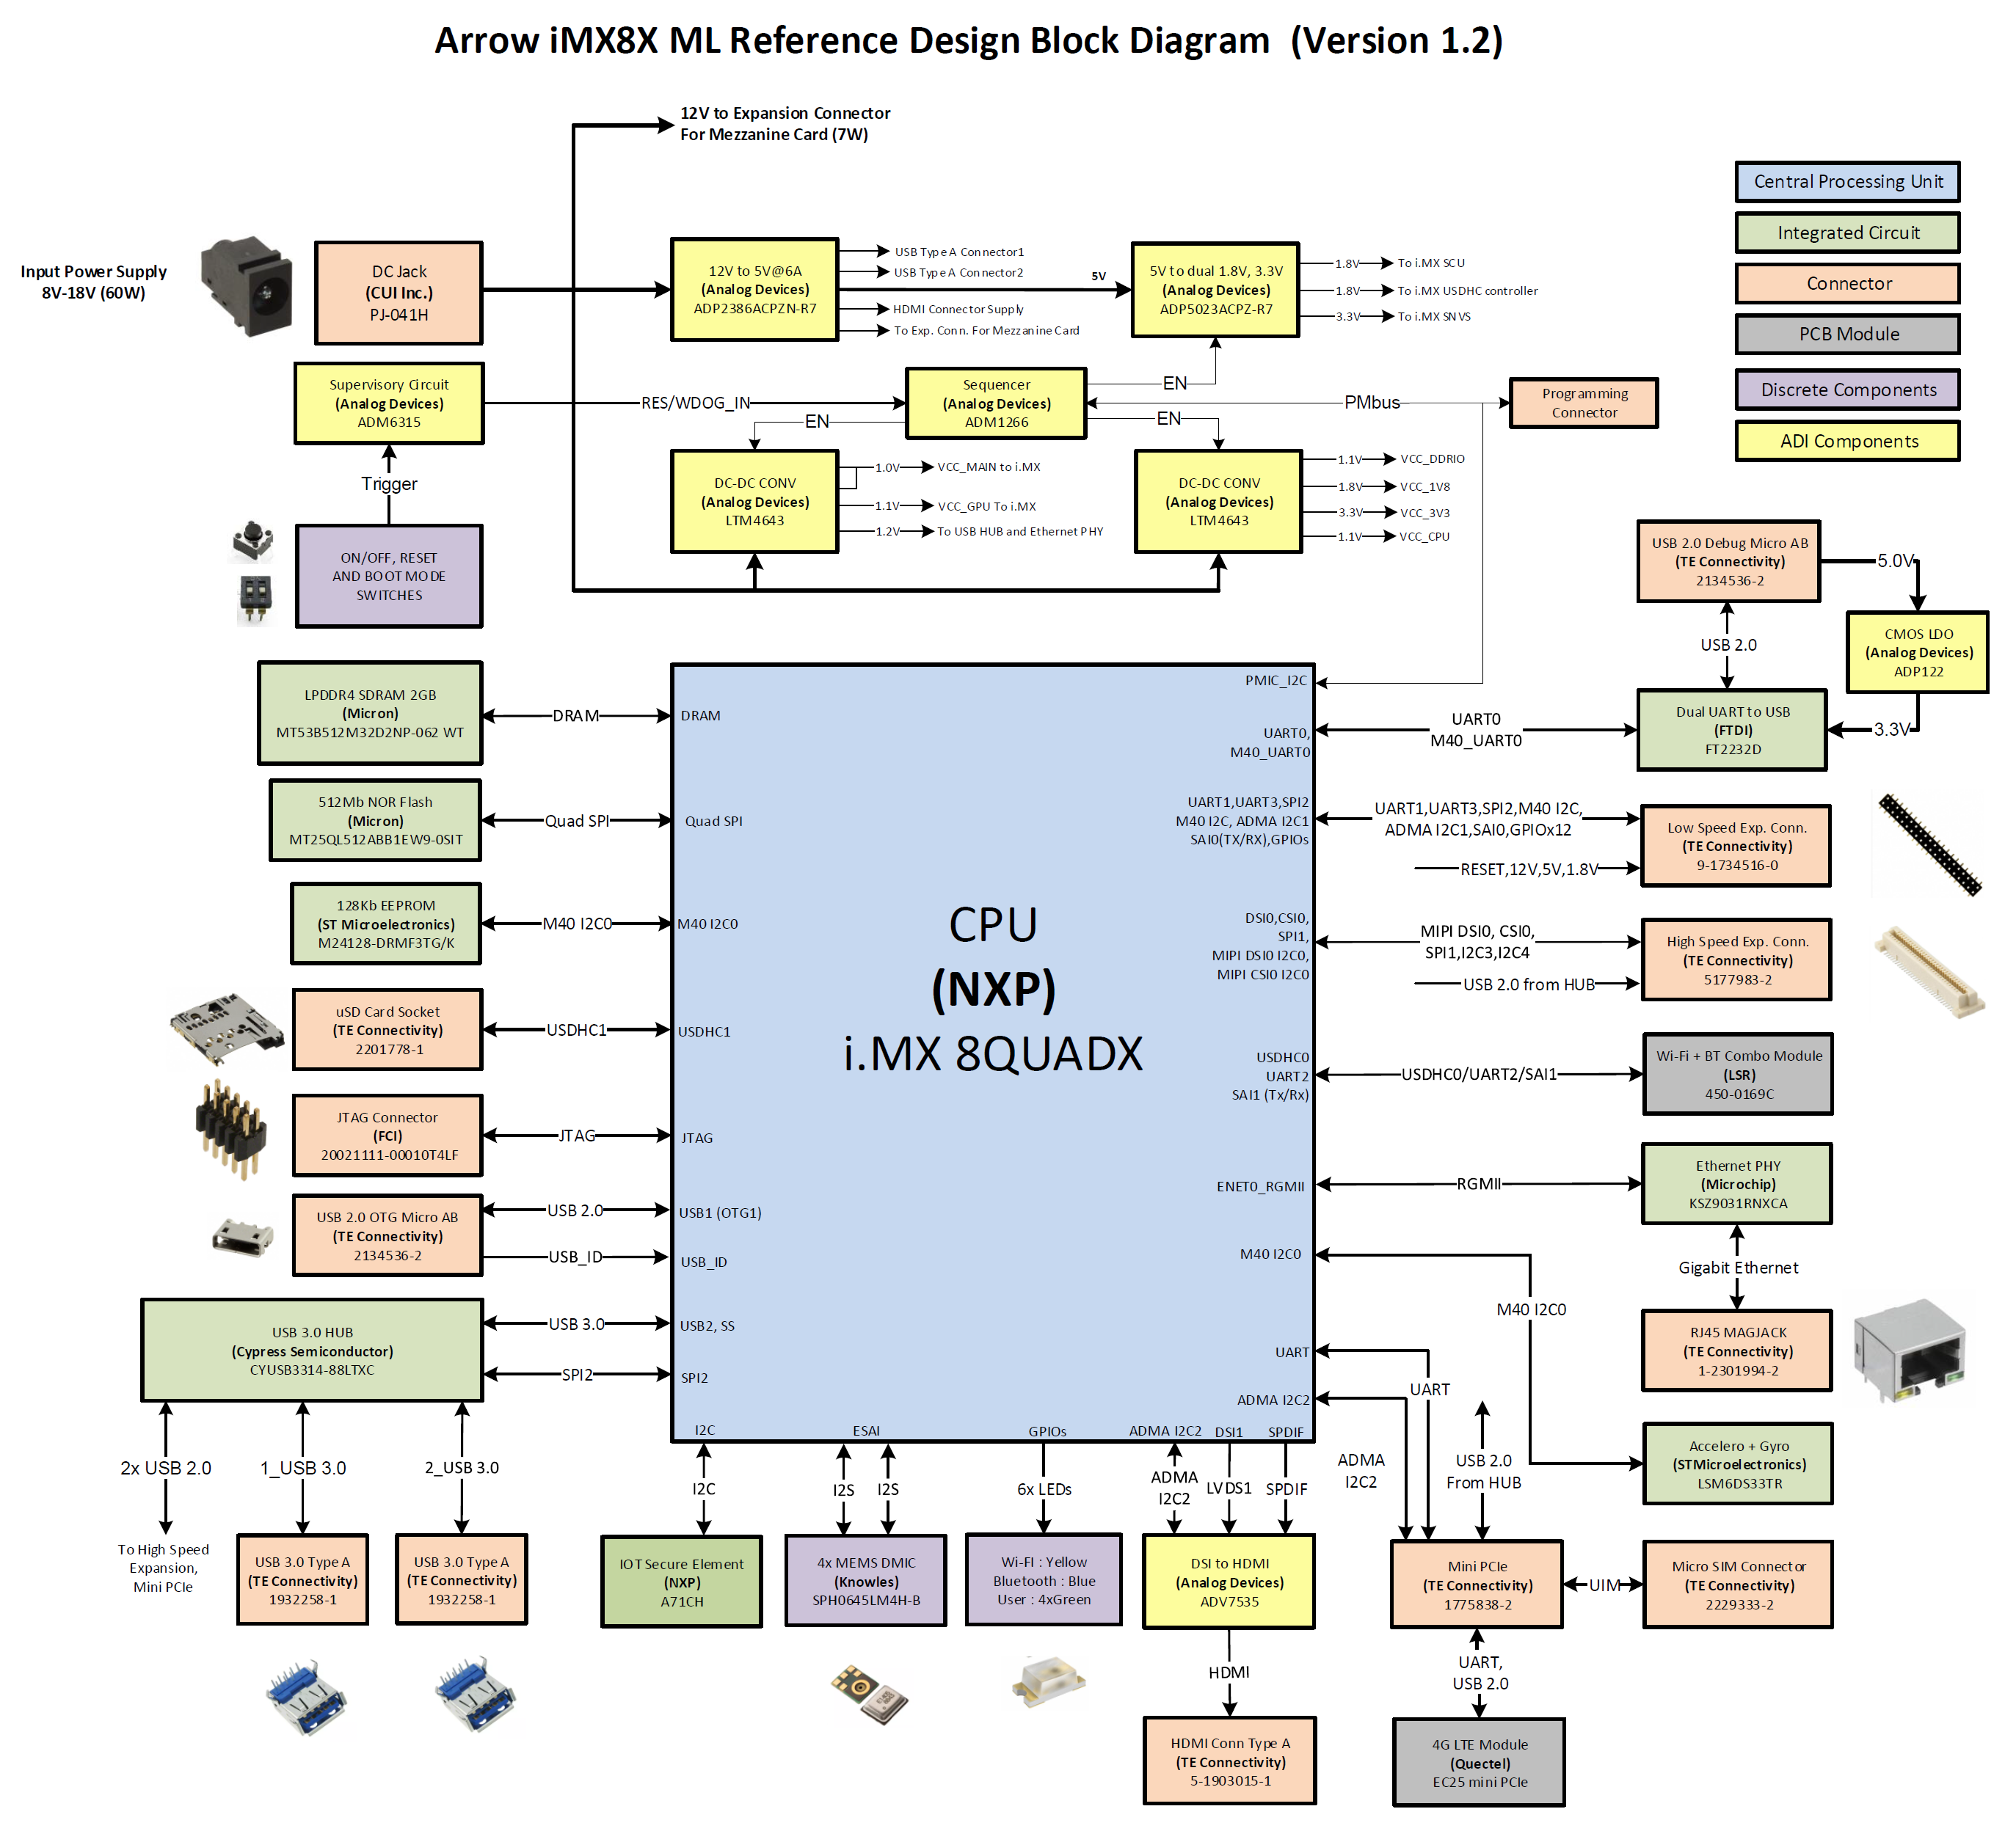

Figure 01 : Top Level Block Diagram of the Arrow iMX8X ML Reference Design

Hardware Features
Following are the hardware level features of the Arrow iMX8X ML Reference Design system:

Sr. No | Feature | Configuration
1 | CPU | i.MX 8QUADX
2 | RAM | 2GB LPDDR4 RAM
3 | Flash | SD card (Up to 64GB), NOR (512Mb)
4 | Wi-Fi | Wi-Fi 802.11a/b/g/n/ac
5 | Bluetooth | Bluetooth 4.2
6 | Display | HDMI Type A ( Converted from MIPI DSI)  MIPI DSI at High speed Expansion Connector
7 | Camera | MIPI CSI at High speed Expansion Connector
8 | USB | 2x USB 3.0 Type A connectors  1x USB 2.0 Micro AB USB connector  1x USB 2.0 at High speed Expansion Connector
9 | IOT Security | I2C based Plug & Trust Secure Element
10 | Debug | 2x UART port converted to USB
11 | JTAG | 10 Pin ARM JTAG Connector
12 | Power Input | 60W@12V typical (8VDC to 18VDC)
13 | Power Supply | I.MX8 QUADX will use PMIC or regulators for processor power supplies. Additional regulators to generate all other required power supplies.
14 | Ethernet | 1X Gigabit Ethernet
15 | Audio | 3X On-Board Microphones
16 | Sensors | Accelerometer and Gyroscope
17 | Cellular | Through Mini-PCIe Interface, Micro-Sim Connector on board
18 | Others | I2C,UART,SPI,GPIOs and Power Supply(12V,5V,1.8V) at Expansion connectors as per 96Boards CE specifications
19 | User Interfaces | On/Off and Reset Keys, Boot mode switch, Notification LEDs
20 | Operating Temperature | 0°C to 55°C
Table 02. Arrow iMX8X ML Reference Design Product Specification

Future Enhancements
NA.

SOW and functional RequirEment

eInfochips Scope of Work
This section lists all major Hardware interfaces of the board. Functional requirements from each of the interfaces with their acceptance criteria mentioned individually in tables.

The “Requirement Description” and “Acceptance Criteria” have to be defined and agreed by both EIC and Arrow.

Requirement 01: Application Processor- NXP i.MX 8QUADX
Term | Description
Requirement ID | HW_RQ01
Requirement  Description | - Design shall use 32 or 64 bit processor (As per 96boards Spec).  - Design shall use NXP based iMX8X processor for the reference design (As per SoW).  - The iMX8 QuadX shall drive and control all peripheral interfaces connected with it and run necessary algorithms to suffice all requirements, mentioned in subsequent sections of this document (Derived Requirement).  - The design shall support maximum operating frequency of the cores:  Cortex-A35 Speed: 1.2 GHz Max.  Cortex-M4F Speed: 266 MHz Max (Derived Requirement)
Process/ Implementation | - Default boot mode for the Processor will be from SD Card on uSDHC port.  - The hardware design will take reference of user guide and other reference documents available with NXP.
Remarks | --
Acceptance criteria | I.MX8 QUADX should meet the processing and performance requirements of the system. Refer interface specific acceptance criteria below for more details.
Table 03. Functional Requirement Specification- Application Processor I.MX8 QUADX

Requirement 02: Memory LPDDR4 (2GB)
Term | Description
Requirement ID | HW_RQ02
Requirement  Description | - The design shall feature minimum 0.5GB RAM (As per 96boards Spec).  - The iMX8X based reference design shall have 2GB LPDDR4 memory on the board to support the Processor (As per SoW).  - The LPDDR4 memory shall support 1200MHz frequency (Derived Requirement).  - The timing requirement of DDR interface shall meet the specification (Derived Requirement).
Process/ Implementation | 32-bit LPDDR4 memory will be interfaced with processor on its DRAM controller.
Remarks | DDR3L Memory part from ISSI or Kingston Part can be identified for back up.
Acceptance criteria | Processor should perform read and write operations with LPDDR4 memory without any errors within specified operating temperature of the product at 1200MHz speed
Table 04. Functional Requirement Specification- LPDDR4 Memory

Requirement 03: Micro SD Card Memory Support (Up to 64GB)
Term | Description
Requirement ID | HW_RQ03
Requirement  Description | - The design shall support flash memory for storage in form of SD Card Memory (As per 96boards Spec and SoW).  - The Processor shall support boot from SD Card Memory (Derived Requirement).  - The design shall support Micro SDHC socket for up to 64GB on board (Derived Requirement).  - The read write speed and timing specification of SDHC signals shall meet the SD Version 3.0 standards (Derived Requirement).  - The SD Cards shall operate on SDR50, SDR104 and DDR50 speeds (Derived Requirement).
Process/ Implementation | Micro SD card connector to be interfaced on SDHC0 port of the processor
Remarks | --
Acceptance criteria | Processor should be able to perform write, read and erase operations on SD card memories without any errors and lags.  Data rate should be comparable with MEK Development Kit (MCIMX8QXP-CPU) based of IMX8X.
Table 05. Functional Requirement Specification- Primary Storage Memory (Micro SD card)

Requirement 04: DSI to HDMI conversion
Term | Description
Requirement ID | HW_RQ04
Requirement  Description | - The design shall feature minimum one Display output port (Over HDMI or MHL or USB Micro AB) (As per 96boards specs and SoW).  - The iMX8X Reference design shall implement DSI to HDMI conversion to support HDMI Display port (Derived Requirement - Requirement based on architecture feasibility study).  - The bridge chip shall support all HDMI features and multiplex the Audio in HDMI signals which comes on a separate interface from the processor (Derived Requirement).
Process/ Implementation | - DSI1 port of the processor will be interfaced with the bridge chip for conversion to HDMI  - The bridge chip configuration to be done using I2C interface of the processor I.MX8 QUADX  - S/PDIF ports of iMX 8X will be used to transmit digital audio to the bridge chip
Remarks | --
Acceptance criteria | The bridge chip should perform the proper conversion of 24-bit Parallel RGB Display signals to HDMI format.
Table 06. Functional Requirement Specification- DSI to HDMI conversion

Requirement 05: HDMI Display Interface Port
Term | Description
Requirement ID | HW_RQ05
Requirement  Description | - The design shall have at least one display output port (As per 96boards standard and SoW).  - The interface shall support all HDMI features (Derived Requirement).
Process/ Implementation | The Bridge chip to drive the HDMI signals to the HDMI Type A connector (Refer Requirement 04)
Remarks | --
Acceptance criteria | End user should be able to Drive HDMI Display with audio from the available HDMI Type A port of the board
Table 07. Functional Requirement Specification- HDMI Out Port (HDMI Type A Connector)

Requirement 06: IEEE 802.11 a/b/g/n/ac Dual Band Wi-Fi
Term | Description
Requirement ID | HW_RQ06
Requirement  Description | - The design shall feature 802.11 a/b/g/n/ac Dual Band Wi-Fi Interface (As per 96boards standard).  - The iMX8X Reference Design board shall use off-the-shelf dual band Wi-Fi/BT module with 802.11 a/b/g/n/ac modes supported (As per SoW).  - Wi-Fi modes and data rates shall be as per 802.11 a/b/g/n/ac standards (Derived Requirement).
Process/ Implementation | The Host Interface for WLAN signals will be SDIO1, which will be connected with uSDHC1 port of the Processor
Remarks | Practical data rates and coverage area may differ according to the Antenna, obstacles, mechanical enclosure etc.
Acceptance criteria | - User should be able to connect the board to Wi-Fi Network from up to 10m distance from Router Antennas  - Concurrent WLAN + BT operation  - Throughput for each configuration should be comparable with MEK Development Kit (MCIMX8QXP-CPU) based of IMX8X (as applicable).
Table 08. Functional Requirement Specification- IEEE 802.11 Dual Band Wi-Fi

Requirement 07: Bluetooth 4.2
Term | Description
Requirement ID | HW_RQ07
Requirement  Description | - The design shall feature Bluetooth version 4.0 or above (As per 96boards standard).  - The iMX8X Reference Design board shall use off-the-shelf Wi-Fi/BT module with Bluetooth 2.1+EDR, Bluetooth 3.0, Bluetooth 4.2 (As per SoW).  - The design shall support Audio over Bluetooth (As per the 96Boards standard).  - Data transfer rates shall meet the supported BT standards (Derived Requirement).  - Wi-Fi and BT co-existence shall be supported by the device (As per SoW).
Process/ Implementation | - The Wi-Fi + BT combo module to use UART and SAI(I2S) interfaces of the processor  - UART interface will be used for configuration and I2S to be used for Audio Data transfer over Bluetooth
Remarks | Practical data rates and coverage may differ according to the Antenna, obstacles, mechanical enclosure etc.
Acceptance criteria | - User should be able to pair the device with any other BT device, the BT coverage range of the board will be 5 meters  - Board should support audio transfer to the BT audio devices like BT headsets  - There should be co-existence between Wi-Fi and BT.
Table 09. Functional Requirement Specification- Bluetooth 4.2

Requirement 08: Board Power Supply- (Input and Regulation)
Term | Description
Requirement ID | HW_RQ08
Requirement  Description | - The board shall be powered from 60W Input power (8V-18V) coming from DC jack (As per 96boards standard).  - Input DC Jack Power shall be only source for the system (As per SoW).  - The design shall generate all the necessary power for interface and peripherals (Derived Requirements).  - The device shall meet line and load regulation condition (Derived Requirement).
Process/ Implementation | - Necessary protection circuitry (OVP, OCP) will be added in the design.  - Step down converter to generate 5V supply from external supply for regulators supplying power to processor.  - I.MX8 QUADX will use PMIC or regulators for processor power supplies.  - Additional regulators will be planed for 5V Supply to Expansion connectors, USB connectors and other components, 1.8V and 3.3V for the peripherals.
Remarks | --
Acceptance criteria | - The Power Supply section of the board should provide all the necessary power to different components of the board  - Current and Voltage requirements for each power rail has to meet for full load condition
Table 10. Functional Requirement Specification- Power Supply (Input and Regulation)

Requirement 09: USB 2.0 Micro AB OTG Port
Term | Description
Requirement ID | HW_RQ09
Requirement  Description | - The design shall have at least one USB 2.0 connector and micro AB if OTG supported (As per 96boards standard).  - The design shall support USB 2.0 on micro AB USB connector with OTG support (As per SoW).  - The design shall support USB as a booting interface for the iMX8X processor (As per SoW).  - The device shall be able to transfer data over the USB port as per the USB 2.0 standard data rates (Derived Requirement)
Process/ Implementation | USB0 2.0 port of the iMX 8X will be used for the OTG and Boot from USB requirements
Remarks | The factors limiting the USB data rates are the end USB device, PCB Layout etc.
Acceptance criteria | - The USB port should be able to perform OTG, Boot from USB and other read-write operations.  - Throughput should be comparable with MEK Development Kit (MCIMX8QXP-CPU) based of IMX8X (as applicable).
Table 11. Functional Requirement Specification- USB 2.0 OTG Port

Requirement 10: 2 x USB 3.0 Ports( Type A)
Term | Description
Requirement ID | HW_RQ10
Requirement  Description | - As per 96boards standard, the design shall feature two type A USB connectors  - The design shall support two USB 3.0 type-A connector to interface any other USB device with the board  - The device shall be able to transfer data over USB 3.0 at its specified data rates.
Process/ Implementation | - A USB 3.0 HUB will be interfaced on USB1 3.0 port of the iMX8X processor and will generate USB 3.0 downstream ports  - Two USB 3.0 downstream ports from Hub will be used for two USB 3.0 Type A connectors
Remarks | Since the USB 3.0 ports are downstream ports from USB 3.0 Hub, the speed will get divided among number of connected USB devices
Acceptance criteria | - The USB 3.0 ports should be able to detect USB 3.0 devices.  - The ports should provide specified power to the connected USB devices as per the USB 3.0 standard.  - Throughput should be comparable with MEK Development Kit (MCIMX8QXP-CPU) based of IMX8X (as applicable).
Table 12. Functional Requirement Specification- 2 x USB 3.0 Ports (Type A)

Requirement 11: Gigabit Ethernet (1Gbps)
Term | Description
Requirement ID | HW_RQ11
Requirement  Description | - The board may feature Ethernet interface if Extended B Version (85x100 mm form factor) of CE standard is targeted (As per 96boards standard).  - The design shall have Gigabit Ethernet interface for connecting the board with Ethernet network (As per SoW).  - The board shall be able to communicate with Ethernet network at the maximum rate of 1Gbps (Derived Requirement).
Process/ Implementation | - The processor has RGMII port for interfacing Ethernet PHY chips with it.  - The design will use RJ45 connector with magnetics.
Remarks | The actual speed may vary depending on RJ45 cable and the Ethernet Network
Acceptance criteria | The board should be able to communicate with Ethernet network at the maximum rate of 1Gbps
Table 13. Functional Requirement Specification- Gigabit Ethernet (1Gbps)

Requirement 12: User Interface- Switches and LEDs
Term | Description
Requirement ID | HW_RQ12
Requirement  Description | - The board shall have six LEDs, ON/OFF and Reset Switch on the board (As per 96boards standard).  - The design shall have Boot mode selection switch to select different booting interface for the processor (As per SoW).
Process/ Implementation | - Push button switch used to RESET processor  - Toggle DIP switches used for boot mode selection  - Yellow LED used for Wi-Fi (as per 96boards)  - Blue LED Used for Bluetooth (as per 96boards)  - Four Green LED used for User (as per 96boards)
Remarks | --
Acceptance criteria | - User should be able to properly turn on, turn off and reset the board  - User should be able to use the LEDs for different indications  - User should be able to select desired boot mode through switches.
Table 14. Functional Requirement Specification- User Interface- Switches and LEDs

Requirement 13: Low Speed Expansion Connector (40- Pin)
Term | Description
Requirement ID | HW_RQ13
Requirement  Description | - The board shall have 40-pin Low Speed Expansion Connector providing GPIOs, I2C, UART interfaces for future expansion (As per 96boards standard).  - The connector pinout shall be as per Appendix 13.1 (As per 96boards standard).
Process/ Implementation | As per 96boards Standard.
Remarks | --
Acceptance criteria | - A user should be able to interface and use the mezzanine card with the design as per the application  - The below listed interfaces on Low Speed Expansion Connectors will be validated using Mezzanine boards listed in section 3.3 or with eInfochips proprietary mezzanine board.  - UART0(Full UART)  - I2C0 and I2C1  - Power and Reset Functionality  - SPIO0  - PCM/I2S  - GPIOs with their Alternate functions  - Power Supply Requirements  - The performance/throughput of these interfaces should be comparable to that of Development kit or other 96Board CE/Mezzanine card
Table 15. Functional Requirement Specification- Low speed Expansion connector (40- Pin)

Requirement 14: High Speed Expansion Connector (60- Pin)
Term | Description
Requirement ID | HW_RQ14
Requirement  Description | - The board shall have 60-pin High Speed Expansion Connector providing MIPI CSI, DSI, SPI and USB interfaces for future expansion (As per 96boards standard).  - The connector pinout shall be as per Appendix 13.2 (As per 96boards standard).
Process/ Implementation | As per 96boards Standard.
Remarks | --
Acceptance criteria | - A user should be able to interface and use the mezzanine card with the design as per the application  - The below listed interfaces on High Speed Expansion Connectors will be validated using Mezzanine boards listed in section 3.3 or with eInfochips proprietary mezzanine board  - DSI0  - CSI0  - I2C2  - CAM_MCLK0  - USB  - SPI1  - Since the eInfochips Mezzanine test board use SDIO signals in same pins where the iMX 8X ML RD will utilizes SPI signals. This SPI interface has to be validated using some other peripheral board.  - The performance/throughput of these interfaces should be comparable to that of Development kit or other 96Board CE/Mezzanine card.
Table 16. Functional Requirement Specification- High speed Expansion connector (60-Pin)

Requirement 15: Microphone Array for Voice Recognition
Term | Description
Requirement ID | HW_RQ15
Requirement  Description | - The device shall feature 4 microphones for voice recognition application (As per meeting notes)  - The board shall be able to record audio from all microphones simultaneously and effectively support noise and echo cancellation algorithms (As per meeting notes)
Process/ Implementation | - Three Digital I2S microphones will be interfaced at ESAI port of iMX 8X  - The data coming from these three microphones will be processed by the internal Audio DSP of the processor
Remarks | The resultant effect of noise and echo cancellation processing depends on the placement of microphones and on the enclosure design.
Acceptance criteria | The board should be able to record audio from all microphones simultaneously and effectively support noise cancellation algorithm.
Table 17. Functional Requirement Specification- Microphone Array for Voice Recognition

Requirement 16: Accelerometer and Gyroscope
Term | Description
Requirement ID | HW_RQ16
Requirement  Description | - The design shall feature Accelerometer and Gyroscope sensors to detect vibration and other inertial measurements (As per meeting notes).
Process/ Implementation | - A MEMS Accelero+Gyro Combo sensor chipset will be used in the design  - The MEMS sensor will communicate with Processor over I2C/SPI interface
Remarks | --
Acceptance criteria | - User should be able to detect the MEMS sensor from the firmware (Alpha Phase).  - User should be able to read the respective sensor output data (Beta Phase).

Table 18. Functional Requirement Specification- Accelerometer and Gyroscope

Requirement 17: JTAG for Debugging
Term | Description
Requirement ID | HW_RQ17
Requirement  Description | - The board may have JTAG interface for debugging purpose (As per 96boards standard – Not Mandatory)  - 10-Pin connector shall be used if opted for JTAG interface on board (As per 96boards standard).
Process/ Implementation | The 10-pin JTAG connector with 0.05” pitch should be used as per 96boards standard.
Remarks | NXP/Arrow/EIC has to identify the supported JTAG emulator
Acceptance criteria | User should be able to debug the system using supported JTAG emulator

Table 19. Functional Requirement Specification- JTAG for Debugging

Requirement 18: Debug UART Port
Term | Description
Requirement ID | HW_RQ18
Requirement  Description | - Design may support UART for debugging (Not mandatory as per 96boards standard).  - User shall be able to access the two debug UART ports of the iMX 8X (Derived Requirement).  - The design shall convert the UART signals into USB 2.0 for directly connecting the board with PC (Derived requirement).
Process/ Implementation | - iMX 8X processor has two dedicated UART ports, one dedicated for M40 core and one for System Control Unit(SCU) these two UART ports will be used for debug purpose.  - The two UART ports will be converted to USB using CP2105 IC and the USB signals will be terminated on USB micro AB connector.
Remarks | --
Acceptance criteria | User should be able to access the UART interfaces of the processor through the PC using USB Cable
Table 20. Functional Requirement Specification- Debug UART Port

Requirement 19: I2C based EEPROM
Term | Description
Requirement ID | HW_RQ19
Requirement  Description | 1. The design shall have I2C based EEPROM on the board for storage of MAC addresses, serial number and other such IDs (As per meeting notes).
Process/ Implementation | I2C based 128Kb EEPROM will be interfaced with the processor
Remarks | --
Acceptance criteria | User should be able to store details like Ethernet MAC Address, Serial numbers etc.
Table 21. Functional Requirement Specification- Debug UART Port

Requirement 20: SPI based NOR Flash
Term | Description
Requirement ID | HW_RQ20
Requirement  Description | 1. The design shall have SPI based NOR Flash Memory on the board as local storage memory of the device (As per meeting notes).
Process/ Implementation | SPI based 512Mb NOR Flash Memory will be interfaced with the processor  The processor will be able to boot from SPI NOR Flash in a particular boot mode
Remarks | --
Acceptance criteria | User shall be able to use the on-board memory for OS storage and processor booting purpose
Table 22. Functional Requirement Specification- Debug UART Port

Requirement 21: 4G/LTE Cellular Module
Term | Description
Requirement ID | HW_RQ21
Requirement  Description | 1. The design shall feature 4G LTE Module interfacing support through mini PCIe connector
Process/ Implementation | - Design will support USB 2.0 based cellular module with UART being control interface  - The design will have 52-pin mini PCIe female socket and micro SIM card connectors on the board
Remarks | The design will not support voice over audio due to unavailability of digital audio interfaces from the processor
Acceptance criteria | User shall be able to transfer data over cellular network using the interface
Table 23. Functional Requirement Specification- 4G/LTE Cellular Module

Requirement 22: I2C based IOT Secure Connect Element
Term | Description
Requirement ID | HW_RQ22
Requirement  Description | 1. The design shall feature an I2C based device to deploy secure IoT connections.
Process/ Implementation | - I2C based chipset will be interfaced with the processor.
Remarks | --
Acceptance criteria | User shall be able to securely store and provide credentials, securely connect IoT devices to cloud services and perform cryptographic node authentication.
Table 24. Functional Requirement Specification- I2C based IOT Security Element

Arrow Scope of Work
As per SOW document.

EXTERNAL INTERFACE

User Interface
User interface as per requirement HW_RQ12.

Hardware Interface
All mezzanine cards complying with 96Boards mezzanine specifications shall interface with the board.

Software Interface
As per the Software Requirement Specification document.

STATUTORY, REGULATORY & OTHER RequirEments
Requirements identified from 96Boards Spec:
- If multiple in-specification supplies are connected there shall not be a safety issue and there shall be no damage to the board.
- A minimum of 1 current sense resistor shall be placed to permit basic power measurement functions.
- A single ground pin (for voltage measurement). The Low speed expansion connector may be documented as being usable for the ground pin requirement.
- It shall be possible to configure the board to power up automatically if external power is removed and then re-applied

Requirements identified from SoW:
- Pre-compliance testing for the design shall comply with FCC Part 15 Subpart C.
- The PCB shall have black Solder mask finish.
- Total cost of the system shall fall under $65.
- EOL of the components shall be from 5-10 years minimum.
- The component vendors shall be selected from Arrow line card.
Refer the Vendor List A, Vendor List B and Vendor List C sheets in document eI_Arrow_iMX8XML_RD_CriticalPartsSelection from Appendix C.

Mechanical constraint
- The board form factor shall comply 96Boards CE Specification, Extended B version (Refer Appendix D for tentative component placement on the board)
- Off-the-shelf enclosure or simple customized enclosure shall be identified for the board.
- Major Component’s placement shall be as per the enclosure selection.

Special usaGE requirements

Environment
Operating temperature Range: 0°C to 55°C

Installation
NA, Not in Scope of Work

Safety & Essential performance Requirement
NA, Not in Scope of Work

User Training
NA, Not in Scope of Work

User Manual
NA, Not in Scope of Work

REQUIREMent Management
New functionality or change of existing functionality after the Requirements baseline shall be driven through change management. Impact analysis will be done. Refer Change Management Procedure for further details.

ASsumptions
As per SOW Document

Queries on requirement
A Query Tracking Sheet (QTS) will be used throughout the project to track and resolve the queries, which arise during the execution of the project

https://arrowelectronics.sharepoint.com/:f:/r/sites/i.MX8-BoardDesigns/Shared%20Documents/i.MX8%20Board%20Designs/Machine%20Learning%20Board/Project%20Management?csf=1&e=dXX3y6

Risk Analysis
- Complying with 96board.ai is not identified yet and may impact both schedule and cost if not identified before architecture phase (15/07/2018).
- Considering number of interfaces and peripherals, meeting total BOM cost under $65 will be challenging.

Identified risks will be recorded in internal Project Monitoring System (PMS) tool and will be circulated to Arrow if needed.

Appendix

APPENDIX A: Low Speed Expansion Connector Pinout
The signals listed in the below pinout table will be used for the Low Speed Expansion Connector, the pinouts meet the 96Boards specification and are finalized based on the available ports from the iMX 8X processor.
Pin No. | Signal | Voltage Level | Remark
1 | GND
2 | GND
3 | UART0_CTS | 1.8 V
4 | PWR_BTN_N | 1.8 V
5 | UART0_TxD | 1.8 V
6 | RST_BTN_N | 1.8 V
7 | UART0_RxD | 1.8 V
8 | SPI0_SCLK | 1.8 V
9 | UART0_RTS | 1.8 V
10 | SPI0_DIN | 1.8 V
11 | UART1_TxD ( Optional) | 1.8 V | NC if Not Used
12 | SPI0_CS | 1.8 V
13 | UART1_RxD ( Optional) | 1.8 V | NC if Not Used
14 | SPI0_DOUT | 1.8 V
15 | I2C0_SCL | 1.8 V
16 | PCM_FS | 1.8 V
17 | I2C0_SDA | 1.8 V
18 | PCM_CLK | 1.8 V
19 | I2C1_SCL | 1.8 V
20 | PCM_DO | 1.8 V
21 | I2C1_SDA | 1.8 V
22 | PCM_DI | 1.8 V
23 | GPIO-A | 1.8 V | Capable of waking up the SoC from sleep.
24 | GPIO-B | 1.8 V
25 | GPIO-C | 1.8 V
26 | GPIO-D | 1.8 V
27 | GPIO-E | 1.8 V
28 | GPIO-F | 1.8 V | DSI_BLCTL
29 | GPIO-G | 1.8 V | DSI_VSYNC
30 | GPIO-H | 1.8 V | DSI_RST
31 | GPIO-I | 1.8 V | CSI0_RST
32 | GPIO-J | 1.8 V | CSI0_PWDN
33 | GPIO-K | 1.8 V | CSI1_RST
34 | GPIO-L | 1.8 V | CSI1_PWDN
35 | 1V8 |  | 100 mA Max Current
36 | SYS_DCIN |  | 9-18V Input Power Supply
37 | 5V0
38 | SYS_DCIN |  | 9-18V Input Power Supply
39 | GND
40 | GND
Table 25. Low Speed Expansion Connector Pinouts

APPENDIX B: High Speed Expansion Connector Pinout
The signals listed in the below pinout table will be used for the High Speed Expansion Connector, the pinouts meet the 96Boards specification and are finalized based on the available ports from the iMX 8X processor.

Pin# | Signal | Voltage Level | Remark
1 | SPI1_DOUT | 1.8 V
2 | CSI0_C+ | 1.2 V
3 | NC |  | NC as SDIO is not used
4 | CSI0_C- | 1.2 V
5 | NC |  | NC as SDIO is not used
6 | GND
7 | SPI1_CS | 1.8 V
8 | CSI0_D0+ | 1.2 V
9 | SPI1_SCLK | 1.8 V
10 | CSI0_D0- | 1.2 V
11 | SPI1_DIN | 1.8 V
12 | GND
13 | GND
14 | CSI0_D1+ | 1.2 V
15 | CLK0/CSI0_MCLK | 1.8 V | SoC Programmable CAM MCLK Clock 0
16 | CSI0_D1- | 1.2 V
17 | CLK1/CSI1_MCLK(Optional) | 1.8 V | Optional if CSI1 is not available. NC or GPIO if not used.
18 | GND
19 | GND
20 | CSI0_D2+ | 1.2 V
21 | DSI_CLK+ | 1.2 V
22 | CSI0_D2- | 1.2 V
23 | DSI_CLK- | 1.2 V
24 | GND
25 | GND
26 | CSI0_D3+ | 1.2 V
27 | DSI_D0+ | 1.2 V
28 | CSI0_D3- | 1.2 V
29 | DSI_D0- | 1.2 V
30 | GND
31 | GND
32 | I2C2_SCL
33 | DSI_D1+ | 1.2 V
34 | I2C2_SDA
35 | DSI_D1- | 1.2 V
36 | I2C3_SCL(Optional) |  | Optional if CSI1 is not available. NC if not used.
37 | GND
38 | I2C3_SDA(Optional) |  | Optional if CSI1 is not available. NC if not used.
39 | DSI_D2+ | 1.2 V
40 | GND
41 | DSI_D2- | 1.2 V
42 | CSI1_D0+(Optional) | 1.2 V | NC if Not Used
43 | GND
44 | CSI1_D0-(Optional) | 1.2 V | NC if Not Used
45 | DSI_D3+ | 1.2 V
46 | GND
47 | DSI_D3- | 1.2 V
48 | CSI1_D1+(Optional) | 1.2 V | NC if Not Used
49 | GND
50 | CSI1_D1-(Optional) | 1.2 V | NC if Not Used
51 | USB_D+ | USB
52 | GND
53 | USB_D- | USB
54 | CSI1_C+(Optional) | 1.2 V | NC if Not Used
55 | GND
56 | CSI1_C-(Optional) | 1.2 V | NC if Not Used
57 | HSIC_STR(Optional) |  | NC if Not Used
58 | GND
59 | HSIC_DATA(Optional) |  | NC if Not Used
60 | RESERVED |  | Not used, pulled up to 1.8V
Table 26. High Speed Expansion Connector Pinouts

APPENDIX C: Selection of Major Components
The critical parts identified in the architecture phase in agreement with customer is listed in below spreadsheet.

Refer SVN for latest copy – Critical Parts List Not accessible to customer (Copy will be shared separately).

APPENDIX D: Tentative Placement as per 96Boards standard
The below image shows the board dimension with fixed placement locations of necessary connectors. The component placement and layout design of the board will meet the 96Boards Extended B criteria.

The detailed activity of placement strategy which includes all major components of the board will be carried out in document eI_Arrow_iMX8XML_RD_PlacementDiagram.
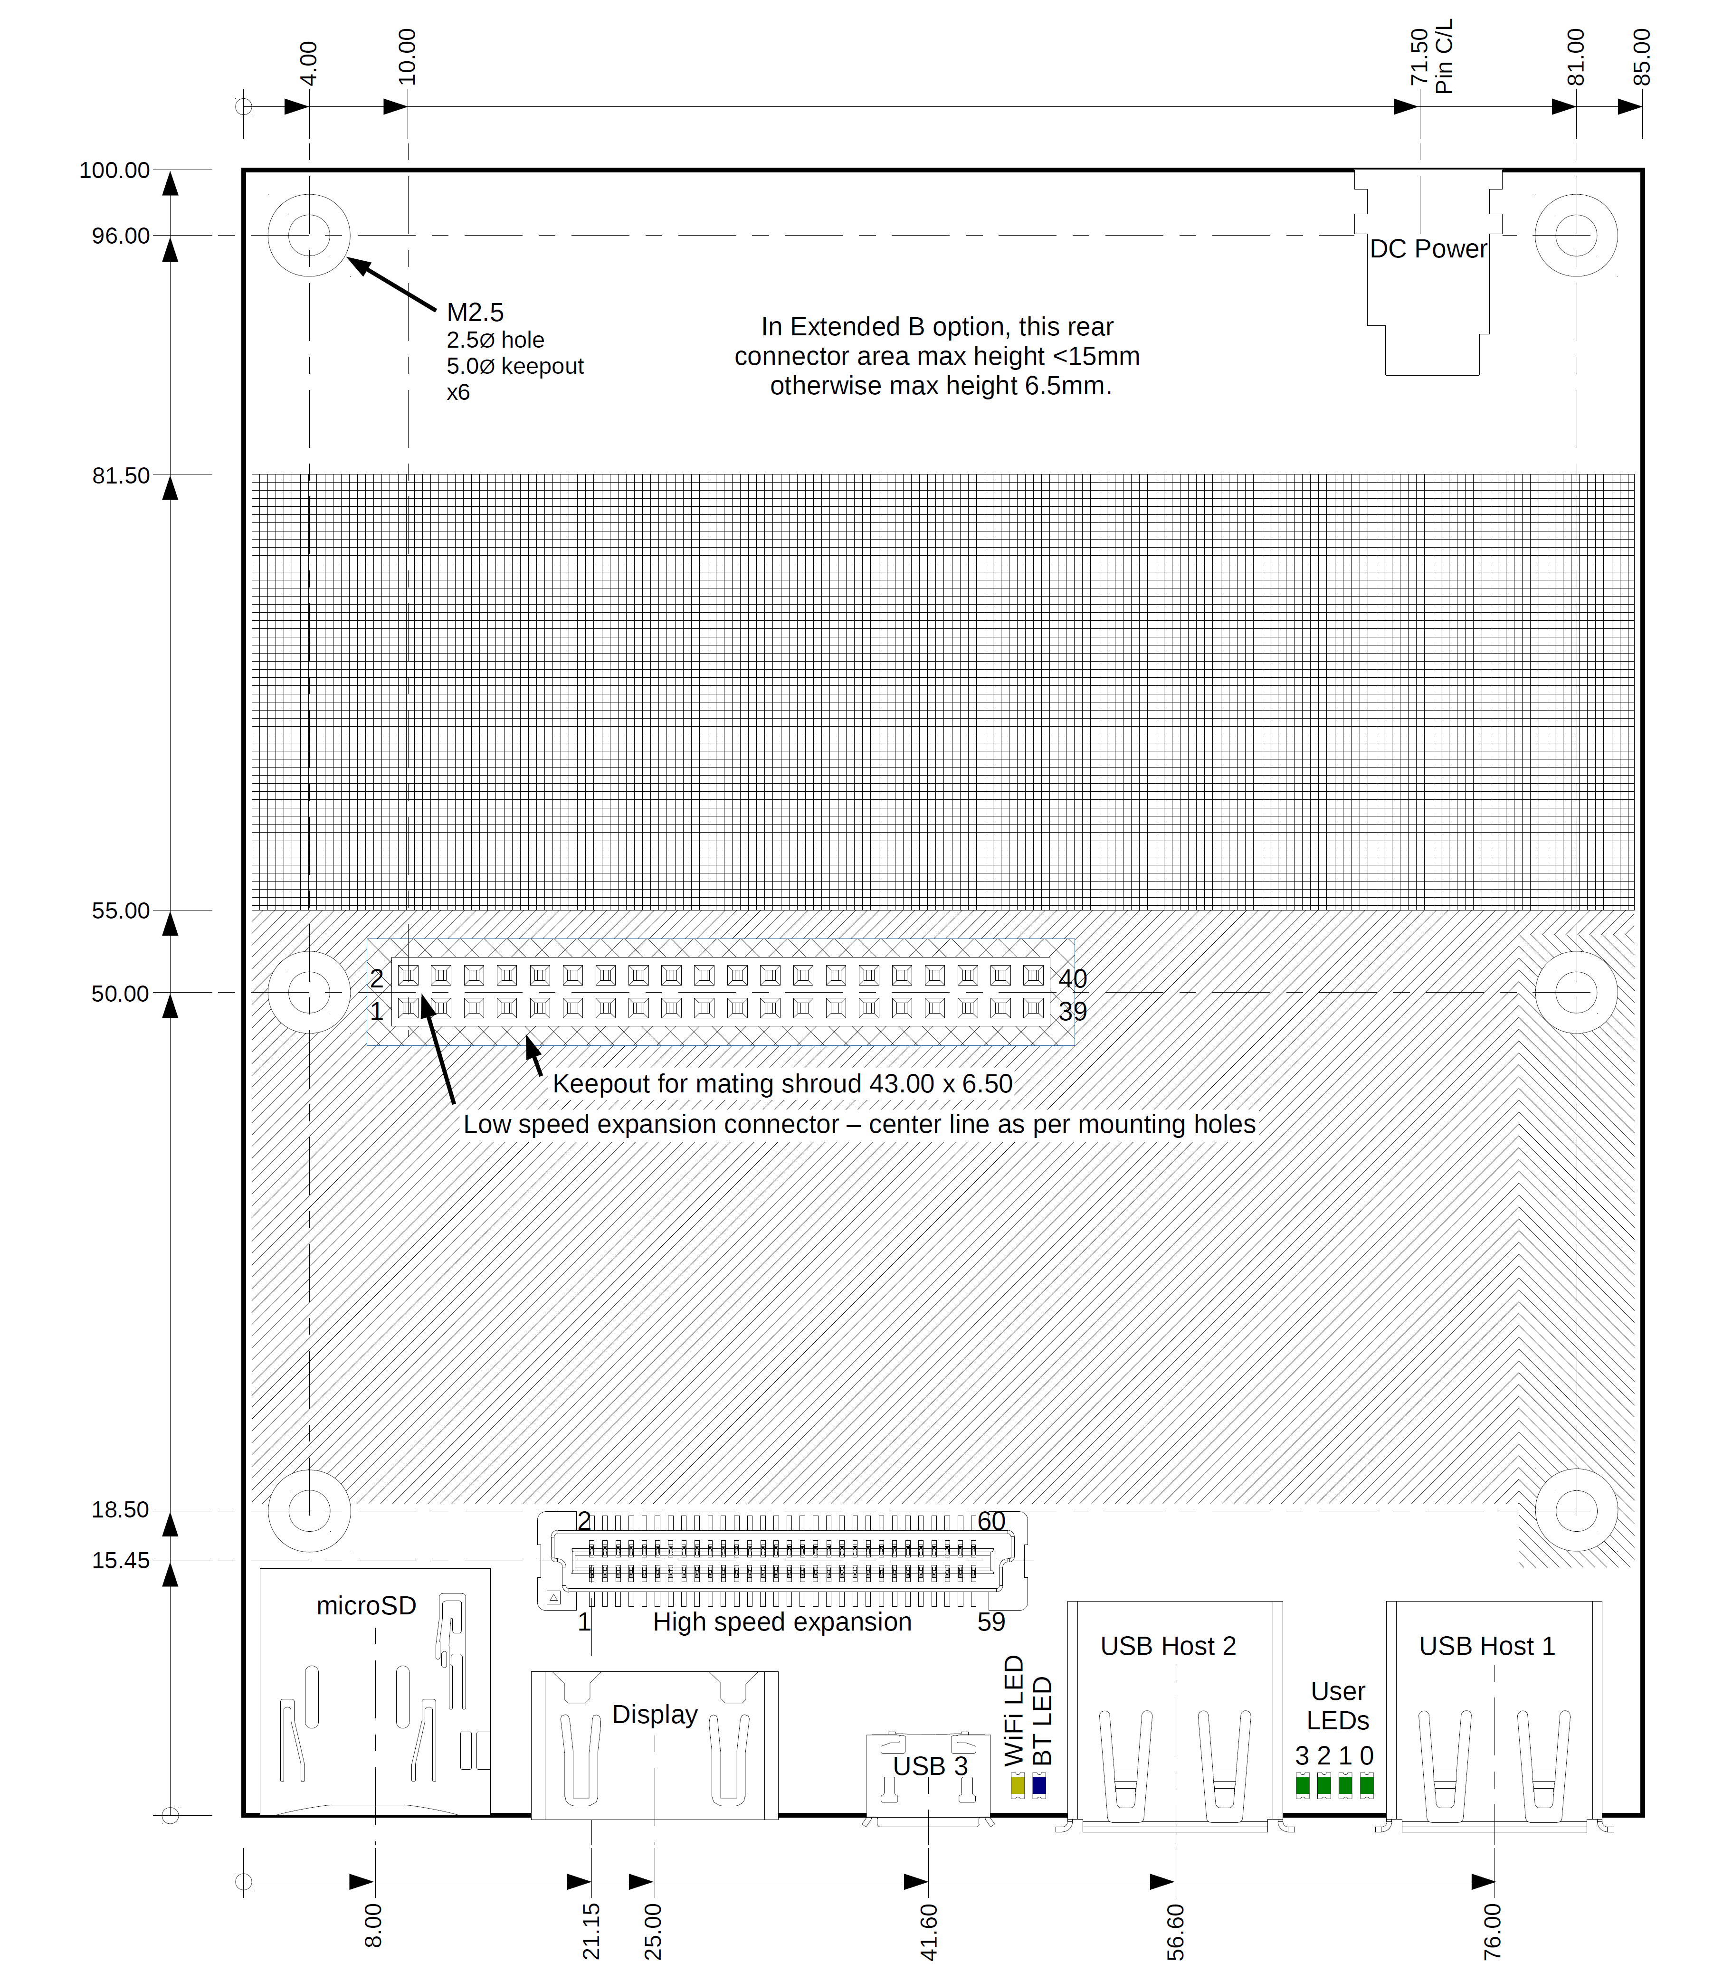
Figure 02 : 96Boards Extended B Dimensions

APPENDIX E: eI Proprietary Mezzanine Board – Block Diagram
The below block diagram show the peripherals on the eInfochips Proprietary Mezzanine Test board.
This board will be used to test the signals available on Low Speed and High Speed Expansion Connectors.
Since the eInfochips Mezzanine test board used SDIO interface and the iMX 8X ML Reference design shall use SPI interface on the same pins, the SPI interface of iMX 8X RD has to be validated by some other device/peripheral.
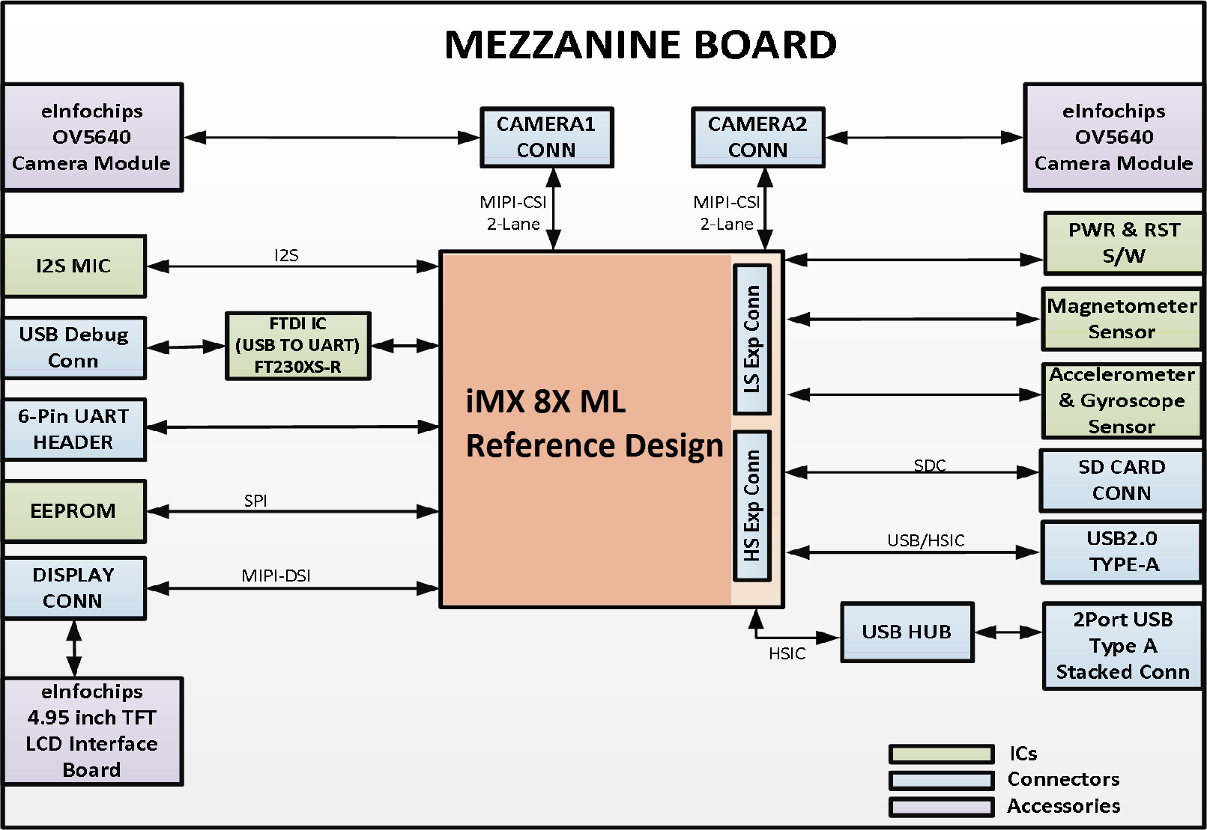
Figure 03 : Mezzanine Test Board- Block Diagram

