

Hardware Requirement Specifications
i.MX8M HMI Platform

Version  Status  Date | 2.0  Baseline  25-March-2019

Confidentiality Notice
Copyright (c) 2026 eInfochips. - All rights reserved
This document is authored by eInfochips and is eInfochips intellectual property, including the copyrights in all countries in the world. This document is provided under a license to use only with all other rights, including ownership rights, being retained by eInfochips. This file may not be distributed, copied, or reproduced in any manner, electronic or otherwise, without the express written consent of eInfochips.

Contents
1. Document Details 5
1.1 Document History 5
1.2 Definition, Acronyms and Abbreviations 6
1.3 References 7
2. introduction 8
3. System Overview & APPLICATION 9
3.1 Design Objective 9
3.2 Product – overview 9
3.3 Module Overview 10
3.4 Design Variants 11
4. Hardware Overview 12
4.1 Hardware Block Diagram 12
4.1.1 Hardware Features 13
4.1.2 Future Enhancements 13
5. SOW and functional RequirEment 14
5.1 eInfochips Scope of Work 14
5.1.1 Requirement 01: Application Processor- NXP i.MX 8M QUAD 14
5.1.2 Requirement 02: DRAM Memory- 2GB LPDDR4 14
5.1.3 Requirement 03: Micro SD Card Memory Support (up to 64 GB) 15
5.1.4 Requirement 04: HDMI Display interface port 15
5.1.5 Requirement 05: Wi-Fi (IEEE 802.11 a/b/g/n/ac) 15
5.1.6 Requirement 06: Bluetooth (BT 4.2) 16
5.1.7 Requirement 07: ZigBee 17
5.1.8 Requirement 08: USB 2.0 Micro AB OTG Port 17
5.1.9 Requirement 09: 2 x USB 3.0 Ports( Type A) 17
5.1.10 Requirement 10: Low Speed Expansion Connector (40- Pin) 18
5.1.11 Requirement 11: High Speed Expansion Connector (60- Pin) 19
5.1.12 Requirement 12: MIC-IN with Headphone Out 19
5.1.13 Requirement 13: JTAG for Debugging 20
5.1.14 Requirement 14: CAN interface 20
5.1.15 Requirement 15: Board Power Supply input 20
5.1.16 Requirement 16: User Interface- Switches and LEDs 21
5.1.17 Requirement 17: NOR Flash (QSPI interface) 21
5.1.18 Requirement 18: Gigabit Ethernet 22
5.1.19 Requirement 19: EEPROM 22
5.1.20 Requirement 20: HDMI Display port over DSI 22
5.1.21 Requirement 21: A2B Master 23
5.2 Arrow Scope of Work 23
6. External Interface 24
6.1 User Interface 24
6.2 Hardware Interface 24
6.3 Software Interface 24
7. STATUTORY, REGULATORY & OTHER RequirEment 25
7.1 Requirements identified from 96Boards Spec: 25
7.2 Requirements identified from SOW 25
8. Mechanical constraint 26
9. Special usaGE requirements 27
9.1 Environment 27
9.2 Installation 27
9.3 Safety & Essential performance Requirement 27
9.4 User Training 27
9.5 User Manual 27
10. REQUIREMent Management 28
11. ASsumptions 29
12. Queries on requirement 30
13. Risk Analysis 31
14. Appendix 32
14.1 APPENDIX A: Low Speed Expansion Connector Pinout 32
14.2 APPENDIX B: High Speed Expansion Connector Pinout 33
14.3 APPENDIX C: Major Component List 34
14.4 APPENDIX D: JTAG interface Pin out 34
14.5 APPENDIX E: Extended Form Factor B connector placement 35

FIGURES

Figure 1 : Top Level Block Diagram of the i.MX8M HMI Platform requirement 10
Figure 2 : Hardware Block Diagram of the i.MX8M HMI Platform 12

TABLES

Table 1: Mezzanine card details 11
Table 2: Design Variants 11
Table 3: i.MX8M HMI Platform Hardware Features 13
Table 4: Functional Requirement Specification: Application Processor 14
Table 5: Functional Requirement Specification: DRAM Memory 14
Table 6: Functional Requirement Specification: micro SD card Memory 15
Table 7: Functional Requirement Specification: HDMI Display interface port 15
Table 8: Functional Requirement Specification: Wi-Fi (IEEE 802.11 a/b/g/n/ac) 16
Table 9: Functional Requirement Specification: Bluetooth (BT 4.2) 16
Table 10: Functional Requirement Specification: ZigBee 17
Table 11: Functional Requirement Specification: USB port 17
Table 12: Functional Requirement Specification: 2 x USB 3.0 Ports (Type A) 18
Table 13: Functional Requirement Specification: Low Speed Expansion Connector (40- Pin) 18
Table 14: Functional Requirement Specification: High Speed Expansion Connector (60- Pin) 19
Table 15: Functional Requirement Specification: MIC-IN with Headphone Out 19
Table 16: Functional Requirement Specification: JTAG for Debugging 20
Table 17: Functional Requirement Specification: CAN interface 20
Table 18: Functional Requirement Specification: Board Power Supply 21
Table 19: Functional Requirement Specification: User Interface- Switches and LEDs 21
Table 20: Functional Requirement Specification: NOR (QSPI interface) 22
Table 21: Functional Requirement Specification: Gigabit Ethernet 22
Table 22: Functional Requirement Specification: EEPROM 22
Table 23: Functional Requirement Specification: HDMI Display port over DSI 23
Table 23: Functional Requirement Specification: A2B Master 23

Document Details

Document History

Version | Author |  | Reviewer |  | Approver
Version | Name | Date  (DD-MM-YYYY) | Name | Date  (DD-MMM-YYYY) | Name | Date  (DD-MM-YYYY)
Draft 0.1 | Anirudha Chougule | 16-07-2018 | Roma Bhagat, Kinjan Patel | 20-07-2018
Draft 0.2 | Roma Bhagat | 23-07-2018 | eInfochips Internal Team | 24-07-2018
Draft 0.3 | Anirudha Chougule | 30-07-2018 | eInfochips Internal Team | 1-08-2018
Draft 0.4 | Roma Bhagat | 3- 08-2018 | Einfochips Internal team | 3-08-2018
Draft 0.5 | Roma Bhagat | 7-08-2018 | Kinjan Patel | 8-8-2018
Draft 0.6 | Roma Bhagat | 10-08-2018 | Prajose John/ Lukasz | 10-08-2018
Draft 0.7 | Roma Bhagat | 10-8-2018 | Prajose John
Baseline 1.0 | Roma Bhagat | 10-08-2018 | Prajose John | 10-08-2018 | Lukasz | 10-08-2018
Draft 1.1 | Anirudha Chougule | 20-08-2018 | Kinjan Patel | 21-08-2018
Baseline 1.2 | Anirudha Chougule | 30-08-2018 | Kinjan Patel | 31-08-2018 | Lukasz | 05-09-2018
Draft 2.0 | Vaidehi Patel | 16-01-2019 | Anirudha Chougule / Kinjan Patel | 30-01-2019 | Lukasz | 04-02-2019
Baseline 2.0 | Vaidehi Patel | 25-03-2019

Version | Description of Change
Draft 0.1 | Initial Draft
Draft 0.2 | Incorporated review comments:  - Added pointers for scope, out of scope and assumptions to SOW.  - Added variants with Wi-Fi/BT, RAM.  - Trivial correction with Template and numbering  - Remove part numbers from requirements and add sheet in Appendix with critical parts.  - Remove MIC Array section, added in Mezzanine section  - Added use case, test criteria section in Appendix section  - Block diagram updated  - Naming convention for requirement ID changed as per review comment  The review comments listed in Design Review Tracker sheet
Draft 0.3 | Incorporated review comments:  - Template formatted as per QEG comment  - Section 7 updated to add 96board spec requirements  - Updated Appendix A & B  - Added separate modules for Wi-Fi+BT and ZigBee/Thread as per discussion with Client  - Updated Major Component list  - Incorporated Lukasz comments as per 26th July 2018
Draft 0.4 | Incorporated review comments:  - Formatting and references addition  - Update on BT Acceptance criteria  - Remove mezzanine card section in requirements  The review comments listed in Design Review tracker sheet
Draft 0.5 | Incorporated Lukasz comments:  - Add section for LVDS Display
Draft 0.6 | Modification in block diagram, major list of components & UART on Low speed expansion connector with regards to Murata WiFi + BLE module
Draft 0.7 | Clearly mentioned WiFi (Dual band) antenna and BT antenna is single antenna based on Lukasz comment on 5GHz antenna
Baseline 1.0 | Baselined as per Client approval
Draft 1.1 | DSI to LVDS display feature changed to DSI to HDMI Display
Baseline 1.2 | - Updated block diagram and Major component list  - Changed Audio jack to 2 nos.
Draft 2.0 | Beta phase changes:  - CAN transceiver changed to ADM3054(Analog Devices)  - Automotive Audio Bus Requirement Added  - Audio Jack for Lineout removed  - Operating Temperature changed from 0°C-70°C to 0°C-55°C as per alpha boards testing  - SAI interface for Bluetooth is now used for A2B application as Bluetooth Audio is supported over UART
Baseline 2.0 | Baselined as per Client approval

Definition, Acronyms and Abbreviations
Definition/ Acronym/ Abbreviation | Description
UART | Universal Asynchronous Receiver / Transmitter
GPIO | General purpose Input/output
CRN | Change request Note
JTAG | Joint Test Action Group
EDVT | Engineering design validation testing
LED | Light Emitting Diode
PCB | Printed Circuit Board
QTS | Query Tracker Sheet
HRS | Hardware Requirement Specifications
BLE | Bluetooth Low Energy
LTE | Long Term Evolution
TBD | To Be Decided
SDIO | Secure Digital Input Output
SPI | Serial Peripheral Interface
RoHS | Restriction of Hazardous Substances
USB | Universal Serial Bus
BT | Bluetooth
DSI | Display Serial Interface
CSI | Camera Serial Interface
LPDDR | Low Power Double Data Rate
MIPI | Mobile Industry Processor Interface
DRAM | Dynamic Random Access Memory
SOW | Scope of Work
HDMI | High-Definition Multimedia Interface
HMI | Human Machine Interface
A2B | Automotive Audio Bus

References

# | Document | Version | Remarks
 | eInfochips SOW#4_iMX8_HMI_Platfrom-Rev1-NC | 1.0 | Initial reference
 | 96BoardsCESpecificationv1.0-EA1 | 1.0, January 2015 | 96Boards Consumer Edition  Low Cost Hardware Platform Specification
 | QTS | 0.5 | Query tracking sheet
 | Major list of components | 0.13 | Major list of components approved by Arrow Europe

introduction
The purpose of this document is to enlist all the hardware requirement specifications and top level architecture for i.MX8M HMI Platform for 96 Boards Consumer Edition Specifications that will comply to extended form factor B.

This document lists all HW interfaces, features, and requirements of the board and specifications described in this document are to be baselined before start of the design and development cycle for this project. This document covers the requirements of top level interfaces, primarily to identify major parts of the design, requirements of individual interfaces, and top-level acceptance criteria of individual interfaces. Any change in specifications during the course of the project will be managed via change management system based on CRN.

Terms like ‘the processor’ and ‘iMX8M’ will be used to mention the iMX8M QUAD processor. And terms like ‘the board’ and ‘the design’ will be used to denote The iMX8X HMI Reference Design.

System Overview & APPLICATION
i.MX8M HMI Platform will be a Reference design based on i.MX8M processor and comply with 96board Consumer Edition Extended-B form factor. The 96Boards community defines all the Hardware features and requirements of the design, which intend to support developers and OEMs requiring low cost off-the shelf CPU modules.

This board will be used to demonstrate
- Home automation control panel with sensor aggregation (BLE/ZigBee/Thread), streaming data to cloud as a gateway.
- Industrial HMI panel (SCADA like) to display information from sensors and monitor/control process, display charts, process overview, etc.
- Support Alexa to control actuators
- Multi-display demo - one from local memory, one received over RTSP/RTP, h.265

This Board will support various mezzanines to interface Camera, Display, Sensors, LTE Module, and Audio interface.
In all cases key design and distribution goals are:
- Easy to extend with off the shelf parts available to community and OEMs
- Easy to purchase globally
- Enable a third party ecosystem to develop around expansion (mezzanine boards/peripherals/displays etc. that can be used on any 96Boards CE compliant board

Please refer the link https://linaro.co/ce-specification to know all HW requirements of 96Boards CE standard.

Design Objective
eInfochips (EIC) to develop the i.MX8Mprocessor based reference design for Arrow Electronics. Refer subsequent sections of this document for additional details on different Hardware features of the design.

Design & Development of i.MX 8M processor based Single Board Computer Platform features,
- 96board Consumer Edition Extended-B form factor baseboard
- Integration & support 5”, 7”, 10” touch panels
- Integration & support camera accessory card
- Alexa integration support
- Control and capture of BLE/ZigBee enabled sensors
- Cloud Connectivity over LTE mezzanine or Wi-Fi
- Off the shelf open frame enclosure

Product – overview
Below diagram depicts High Level architecture of this platform that includes,
1. 96Boards Extended-B form factor
2. i.MX8M Processor having 4x Cortex-A35 cores and 1x M4 core
3. 2GB LPDDR4 RAM
4. Micro SDHC Socket for up to 64GB on-board or expansion flash storage
5. Wi-Fi 802.11a/b/g/n/ac and Bluetooth 4.2
6. On Board Connectors and I/O expansion
- 2x USB Type A (USB3.0)
- 1x USB Micro-AB OTG (USB2.0)
- 2x HDMI Type A for Display output
- 40 Pin Expansion Connector for low speed interfaces
- 60 pin Expansion Connector for high speed interface
- Board power from DC Jack connector
- 1x Mic-In with Headphone Out
- 1x Gigabit Ethernet
- 1x Isolated CAN interface
- A2B Master
7. Apart from these on-board interfaces, the platform will support below mezzanines over High Speed and Low Speed connectors
- LTE mezzanine
- UART mezzanine
- Camera Mezzanine
- HMI Display Mezzanine

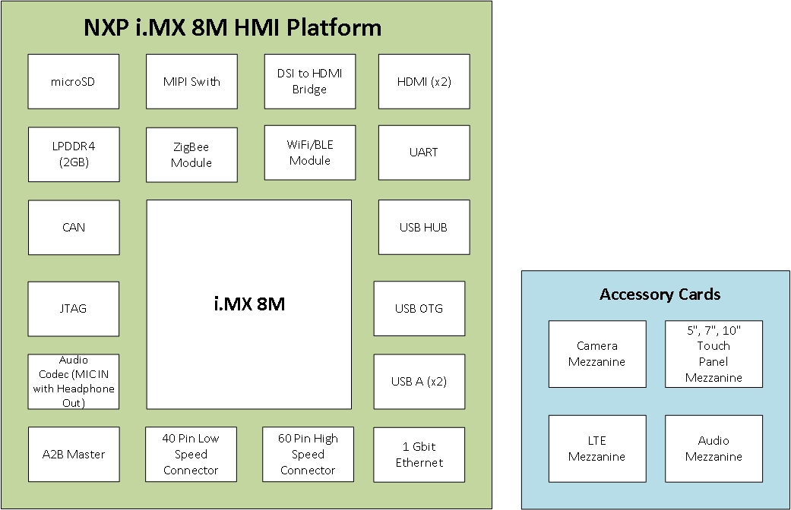

Figure 1 : Top Level Block Diagram of the i.MX8M HMI Platform requirement

Module Overview
The i.MX8M based design is Reference Board complying with 96Boards CE standard. Different Mezzanine cards can be interfaced with the board as per the end application.

Arrow will provide the necessary Mezzanine cards during bring-up of the board to validate all the interfaces available on High Speed and Low Speed Expansion connectors.

Some of the mezzanine cards are,
Camera Board | https://www.96boards.org/product/d3camera/
Audio Board | https://www.96boards.org/product/audio-mezzanine/
LTE | https://www.96boards.org/product/shiratech-lte/
UART | https://www.96boards.org/product/uartserial/
Zigbee Sensors | ISW-ZPR1-WP13 Zigbee PIR w/Pet Immunity: https://us.boschsecurity.com/en/products/intrusionalarmsystems/premiseswireless/zigbee/zigbee_products_56458
Bluetooth sensors | SHT31 Smart Gadget: https://www.sensirion.com/en/environmental-sensors/humidity-sensors/digital-humidity-sensors-for-various-applications/  Thunder Board Sense2: https://www.silabs.com/products/development-tools/thunderboard/thunderboard-sense-two-kit
Display | TBD
MIC Array | TBD
HDMI Display | https://www.arrow.com/en/products/96boards-display-7/linksprite-technologies-inc
Table 1: Mezzanine card details

Design Variants
This section describes different possible configurations of the board. As of now, the selected Wi-Fi/BT module and LPDDR4 memory supports pin compatible parts.

The design can have possible variants as shown in below table or can have a fixed version out of the possible configurations.

Feature/ Interface | Possible Configurations
Wi-Fi/BT Module | - 802.11 b/g/n (2.4 GHz Only) + BT  - 802.11 a/b/g/n/ac (2.4 GHz and 5.0 GHz) + BT
LPDDR4 RAM | - 2 GB LPDDR4  - 3 GB LPDDR4  - 4 GB LPDDR4
Table 2: Design Variants

Hardware Overview

Hardware Block Diagram
The following figure shows the top-level block diagram of the hardware design of the i.MX8M HMI Platform.
Refer SVN for latest copy - Arrow iMX8M HMI Platform Block Diagram (Not accessible to customer, Separate copy will be shared.)

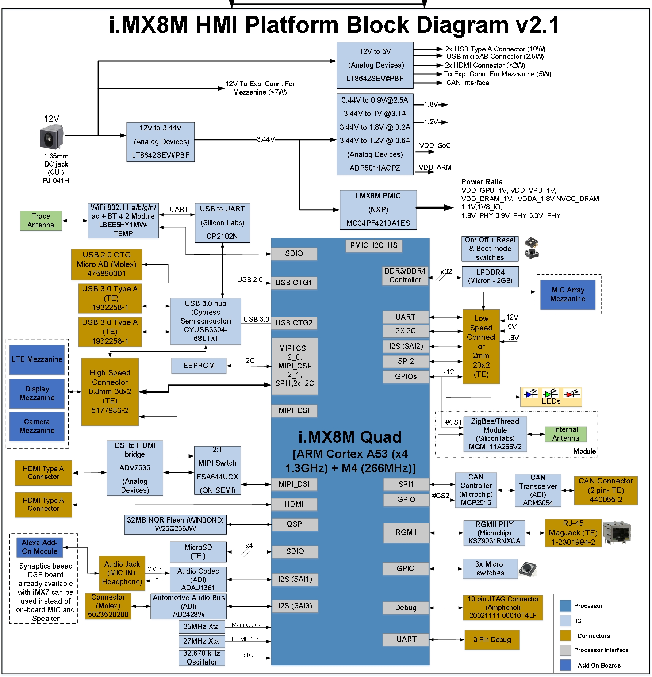
Figure 2 : Hardware Block Diagram of the i.MX8M HMI Platform

Hardware Features
Following are the hardware level features of the i.MX8M HMI Platform:

Sr. No. | Feature | Configuration
1 | CPU | i.MX 8M QUAD
2 | RAM | 2GB LPDDR4
3 | Flash | SD Card (up to 64GB)
3 | Flash | NOR Flash (32MB)
4 | Wi-Fi | 802.11 a/b/g/n/ac
5 | Bluetooth | BT 4.2
6 | Display | 2x HDMI Type A  MIPI DSI at High speed Expansion Connector
7 | Camera | MIPI CSI at High speed Expansion Connector
8 | USB | 2x USB 3.0 Type A connectors  1x USB 2.0 Micro AB USB connector  1x USB 2.0 at High speed Expansion Connector
9 | Debug | JTAG
10 | Power Input | 12V DC jack
11 | Power Supply | PMIC PF4210 and additional regulators to generate all other required Power supplies
12 | Ethernet | Gigabit Ethernet
13 | LTE | LTE mezzanine supported on High speed expansion connector
14 | MIC Array | MIC Array mezzanine supported on Low speed expansion connector
15 | Audio | Mic-In with Headphone out
16 | A2B | A2B Master Connector
17 | ZigBee | ZigBee and Thread protocol module
18 | CAN | CAN controller MCP2515 and transceiver ADM3054 with isolation of 5kV
19 | Low Speed Expansion Connector | I2C,I2S,UART,SPI,GPIOs and Power Supply(12V,5V,1.8V) at Expansion connectors as per 96Boards CE specifications
20 | High Speed Expansion connector | MIPI-CSI, MIPI- DSI, USB, SDIO/ SPI and power supply at Expansion connectors as per 96Board CE specifications
21 | Operating Temperature | 0°C to 55°C
22 | User Interfaces | On-Off/ Reset Key, Boot mode switches, Notification LEDs, 3 micro-switches
Table 3: i.MX8M HMI Platform Hardware Features

Future Enhancements
NA

SOW and functional RequirEment

eInfochips Scope of Work
This section lists all major Hardware interfaces of the board. Functional requirements from each of the interfaces with their acceptance criteria mentioned individually in tables.

The “Requirement Description” and “Acceptance Criteria” have to be defined and agreed by both EIC and Arrow.

Refer 14.3 for major list of components

Requirement 01: Application Processor- NXP i.MX 8M QUAD
Term | Description
Requirement ID | HW_RQ01
Requirement  Description | - Design shall use 32 or 64-bit processor, as per 96boards Spec.  - Design shall use NXP based i.MX8M processor for the HMI Platform (As per discussion)  - The i.MX8M Quad shall drive and control all peripheral interfaces connected with it and run necessary algorithms to suffice all requirements, mentioned in subsequent sections of this document. (Derived Requirement)  - The design shall support maximum operating frequency of the cores:  Cortex-A53 Speed: 1.3 GHz Max.  Cortex-M4 Speed: 266 MHz Max.
Process/ Implementation | - Default boot mode for the Processor will be from SD Card on uSDHC port.  - The hardware design will use reference documents available from NXP.
Remarks | --
Acceptance criteria | i.MX8M QUAD should meet the processing and performance requirements of the system. Refer interface specific acceptance criteria for more details.
Table 4: Functional Requirement Specification: Application Processor

Requirement 02: DRAM Memory- 2GB LPDDR4
Term | Description
Requirement ID | HW_RQ02
Requirement  Description | 1. The design shall feature minimum 0.5GB RAM, as per 96boards Spec.  2. The i.MX8Mbased reference design shall have 2GB LPDDR4 memory on the board to support the Processor (As per Discussion).  3. The LPDDR4 memory shall support 1600MHz frequency (Maximum supported by processor).  4. The timing requirement of DDR interface shall meet the specification.
Process/ Implementation | 32-bit LPDDR4 memory will be interfaced with processor on its DRAM controller.
Remarks | --
Acceptance criteria | Processor should perform read and write operations with LPDDR4 memory without any errors within specified operating temperature of the product up to 1600MHz speed.
Table 5: Functional Requirement Specification: DRAM Memory

Requirement 03: Micro SD Card Memory Support (up to 64 GB)
Term | Description
Requirement ID | HW_RQ03
Requirement  Description | 1. The design shall support flash memory for storage in form of SD Card Memory as per 96boards Spec.  2. The Processor shall support boot from SD Card Memory  3. The design shall support Micro SDHC socket up to 64GB on board  4. The read write speed and timing specification of SDHC signals shall meet the SD Version 3.0 standards  5. The SD Cards shall operate on SDR50, SDR104 and DDR50 speeds
Process/ Implementation | 4-bit Micro SD card connector to be interfaced on SDHC1 port of the processor. Placement of connector is same as per 96board specification. Refer section 14.5 Appendix D
Remarks | --
Acceptance criteria | Processor should be able to perform write, read and erase operations on SD card memories without any errors and lags.  Data rate should be comparable with MCIMX8M-EVK (Development kit for i.MX8M CPU) based on i.MX8M.
Table 6: Functional Requirement Specification: micro SD card Memory

Requirement 04: HDMI Display interface port
Term | Description
Requirement ID | HW_RQ04
Requirement  Description | The design shall support minimum one Display output port over HDMI (as per 96board specification)  The interface shall support all HDMI features (as per SOW)
Process/ Implementation | Type A HDMI connector will be interfaced on HDMI 2.0a interface of the processor. HDMI/ audio will be available on Type A connector. Placement of HDMI connector will be as per 96board spec. Please refer 14.5 Appendix D
Remarks | --
Acceptance criteria | End user should be able to Drive HDMI Display with audio from the available HDMI Type A port of the board.  Performance/ resolution will be comparable with i.MX8M EVK
Table 7: Functional Requirement Specification: HDMI Display interface port

Requirement 05: Wi-Fi (IEEE 802.11 a/b/g/n/ac)
Term | Description
Requirement ID | HW_RQ05
Requirement  Description | - As per 96boards standard, the design shall feature 802.11 g/n Wi-Fi Interface  - The i.MX8M HMI Platform board shall use off-the-shelf certified dual band Wi-Fi/BT module with 802.11a/b/g/n/ac modes supported  - Wi-Fi modes and data rates shall be as per 802.11 a/b/g/n/ac standards
Process/ Implementation | - A single module supporting 802.11 a/b/g/n/ac and BT 4.2 will be interfaced to processor  - Wi-Fi will be interface over SDIO interface  - Single On-board antenna (for 2.4GHz and 5GHz) shared with BT 4.2 will be used for wireless communication
Remarks | Practical data rates and coverage may differ according to the Antenna, obstacles, mechanical enclosure etc.
Acceptance criteria | - User should be able to connect the board to Wi-Fi Network in Station mode  - Device should support WLAN and Bluetooth coexistence  - Throughput for each configuration should be comparable with that of MCIMX8M-EVK (Development kit for i.MX8M CPU) and external evaluation kit of similar chipset of standard 802.11 a/b/g/n/ac
Table 8: Functional Requirement Specification: Wi-Fi (IEEE 802.11 a/b/g/n/ac)

Requirement 06: Bluetooth (BT 4.2)
Term | Description
Requirement ID | HW_RQ06
Requirement  Description | - As per 96boards standard, the design shall feature Bluetooth version 4.0 or above  - The i.MX8M HMI Platform board shall use off-the-shelf certified module with BT 4.2  - The design shall support audio over Bluetooth as per 96Boards standards  - Data transfer rates shall meet the supported BT standards  - One on one support on Bluetooth
Process/ Implementation | - A single module supporting 802.11 a/b/g/n/ac and BT 4.2 will be interfaced to processor.  - UART interface with flow control derived from USB to UART bridge will be used for configuration and Audio Data transfer over Bluetooth  - Single On-board antenna shared with WLAN (2.4GHz & 5GHz) will be used for wireless communication  - Bluetooth will support data rate of 1Mbps (BR), 2Mbps (EDR2), 3Mbps (EDR3)
Remarks | - Practical data rates and coverage may differ according to the Antenna, obstacles, mechanical enclosure etc.  - As per 96boards specification, Bluetooth to support audio streaming. Bluetooth sensors will be connected one on one.
Acceptance criteria | User should be able to pair the device with any other BT device. The BT coverage range of the board will be 5 meters.  User should be able to pair the device with any other BT device and the board shall support audio transfer to the BT audio devices like BT headsets.  Application should be able to control and communicate with the external Bluetooth sensors.
Table 9: Functional Requirement Specification: Bluetooth (BT 4.2)

Requirement 07: ZigBee
Term | Description
Requirement ID | HW_RQ07
Requirement  Description | The board shall feature a ZigBee module that supports ZigBee and Thread protocol for connecting to sensors
Process/ Implementation | - A single module supporting ZigBee/Thread protocol will be interfaced to processor  - ZigBee will be interfaced on SPI interface of processor.  - Module will have integrated antenna for wireless communication  - Will support data rate of up to 250kbps
Remarks | Actual data rates and coverage may differ according to the Antenna, obstacles, mechanical enclosure etc.
Acceptance criteria | - ZigBee will work as a coordinator  - Application is to control and communicate with the external ZigBee sensors.  A ZigBee Sensor or actuator (like Bulb) will be connected and controlled through Alexa command (Bulb Onn/OFF)  - The device shall support ZigBee and Thread protocol
Table 10: Functional Requirement Specification: ZigBee

Requirement 08: USB 2.0 Micro AB OTG Port
Term | Description
Requirement ID | HW_RQ08
Requirement  Description | - The design shall support USB 2.0 on micro AB USB connector with OTG support.  - The design shall support USB as a booting and debugging interface for the iMX8M processor.  - The device shall be able to transfer data over the USB port as per the USB 2.0 standard data rates
Process/ Implementation | USB OTG1 port having USB 2.0 support of the iMX8M will be used for the OTG and Boot from USB requirements. Placement of USB port will be as per 96board spec. Please refer 14.5 Appendix D
Remarks | --
Acceptance criteria | - The USB port shall be able to perform OTG  - Throughput should be comparable with MCIMX8M-EVK Development Kit based of IMX8M (as applicable)
Table 11: Functional Requirement Specification: USB port

Requirement 09: 2 x USB 3.0 Ports( Type A)
Term | Description
Requirement ID | HW_RQ09
Requirement  Description | - As per 96boards standard, the design shall feature two type A USB connector’s  - The design shall support two USB 3.0 type-A connector to interface any other USB device with the board  - The device shall be able to transfer data over USB 3.0 at its specified data rates.
Process/ Implementation | - USB 3.0 HUB will be interfaced on USB2 3.0 port of the i.MX8M processor and will generate 4 USB 3.0 downstream ports  - Two USB 3.0 downstream ports from Hub will be used for two external USB 3.0 Type A connectors  - One USB 3.0 downstream port will be on HS connector  - Placement of connectors will be as per 96board spec. Refer 14.5 Appendix D
Remarks | Since the USB 3.0 ports are downstream ports from USB 3.0 Hub, the speed will get divided among number of connected USB devices
Acceptance criteria | - The USB 3.0 ports shall be able to detect USB 3.0 devices  - Throughput should be comparable with MCIMX8M-EVK Development Kit based of IMX8M (as applicable  - The ports should provide specified power to the connected USB devices as per the 96board specification.
Table 12: Functional Requirement Specification: 2 x USB 3.0 Ports (Type A)

Requirement 10: Low Speed Expansion Connector (40- Pin)
Term | Description
Requirement ID | HW_RQ10
Requirement  Description | - As per 96boards standard, the board shall have 40-pin Low Speed Expansion Connector for terminating signals like GPIOs, I2C, I2S, SPI, UART (as per 96board specification)  - The pinout for the connector shall be as per Refer Appendix A in section 14 for Pin Out detail.
Process/ Implementation | As per 96boards Standard.
Remarks | Refer Table 1 for mezzanine cards
Acceptance criteria | - A user shall be able to interface and use the mezzanine card with the design as per the application  - The below listed interfaces on Low Speed Expansion Connectors will be validated using Mezzanine boards listed in section 3.3 or with eInfochips proprietary mezzanine board.  - UART0  - I2C0 and I2C1  - Power and Reset Functionality  - SPIO0  - PCM/I2S  - GPIOs with their Alternate functions  - Power Supply Requirements  - The performance/throughput of these interfaces should be comparable to that of Development kit or other 96Board CE/Mezzanine card  - The signals terminating on Low Speed Expansion Connectors will be validated using mezzanine cards
Table 13: Functional Requirement Specification: Low Speed Expansion Connector (40- Pin)

Requirement 11: High Speed Expansion Connector (60- Pin)
Term | Description
Requirement ID | HW_RQ11
Requirement  Description | - As per 96boards standard, the board shall have 60-pin High Speed Expansion Connector for terminating signals like MIPI CSI, DSI. SPI, USB, I2C.  - The pinout for the connector shall be followed as mentioned in the specification. Refer Appendix B in section 14 for Pin Out detail.
Process/ Implementation | As per 96boards Standard.
Remarks | Refer Table 1 for mezzanine cards
Acceptance criteria | - A user should be able to interface and use the mezzanine card with the design as per the application  - The below listed interfaces on High Speed Expansion Connectors will be validated using Mezzanine boards listed in section 3.3 or with eInfochips proprietary mezzanine board  - DSI0  - CSI0  - I2C2  - I2C3  - USB  - SPI1  - The performance/throughput of these interfaces should be comparable to that of Development kit or other 96Board CE/Mezzanine card
Table 14: Functional Requirement Specification: High Speed Expansion Connector (60- Pin)

Requirement 12: MIC-IN with Headphone Out
Term | Description
Requirement ID | HW_RQ12
Requirement  Description | 1. i.MX8M reference design shall provide MIC IN with Headphone Out support  2. i.MX8M shall be able to interface and integrate with off the shelf ready Alexa kit
Process/ Implementation | - MIC IN with Headphone out will be interfaced to processor through Audio Codec on I2S interface  - There will be one Audio Jack.  - One MIC IN with Headphone out  - Microphone array and speaker for Alexa integration will be interfaced to processor through Synaptics DSP board over Headphone audio jack and USB cable through audio codec interface
Remarks | --
Acceptance criteria | - Should be able to demonstrate Alexa board detection with application processor.  - Should be able to control sensor-actuator using off the shelf Alexa platform.  - Should be able to detect MIC-In audio and record audio.
Table 15: Functional Requirement Specification: MIC-IN with Headphone Out

Requirement 13: JTAG for Debugging
Term | Description
Requirement ID | HW_RQ13
Requirement  Description | - The board may have JTAG interface for debugging purpose (As per 96boards standard – Not Mandatory)  - 10-Pin connector shall be used if opted for JTAG interface on board (As per 96boards standard).
Process/ Implementation | JTAG interface shall use the 10 pin JTAG connector (0.05” pitch).
Remarks | Supported JTAG Emulator has to be identified
Acceptance criteria | User should be able to debug the system using supported JTAG emulator
Table 16: Functional Requirement Specification: JTAG for Debugging

Requirement 14: CAN interface
Term | Description
Requirement ID | HW_RQ14
Requirement  Description | - i.MX8M shall provide CAN interface for industrial, CAN interface shall have 1kV isolation
Purpose | To have CAN bus support on the platform for industrial applications
Process/ Implementation | Standalone CAN controller will be interfaced with processor over SPI interface and CAN bus signals will be terminated on 2-pin terminal through CAN transceiver
Acceptance criteria | Should be able to have error-free data transmission over CAN interface at 500kbps in master mode.
Table 17: Functional Requirement Specification: CAN interface

Requirement 15: Board Power Supply input
Term | Description
Requirement ID | HW_RQ15
Requirement  Description | - As per 96boards standard, the board shall be powered from 8V-18Vsupply provided through DC jack  - Input DC Jack Power shall be only source for the system  - The design shall generate all the necessary power for interface and peripherals  - The device shall meet line and load regulation condition  - One current sense resistor shall be placed to permit basic power measurement
Process/ Implementation | - Necessary protection circuitry (OVP, OCP) will be added in the design.  - 1 Buck converter to generate 3.3V supply for PF4210 PMIC  - Buck converter to generate 0.9V supply for i.MX8M  - i.MX8M uses PMIC PF4210 for generation Major Processor Power Supply  - 1 other External buck converter shall give 5V Supply to Expansion connectors, USB connectors and other components  - 1 integrated u-module to generate 0.9V and 1V for i.MX8M  - Total power consumption of the board will be measured using single 1% sense resistor.  - Current sensing using 1% current sense resistors will be supported on PMIC supply: VDD_CORE, VDD_ARM & VDD_DRAM
Remarks | DC jack PJ-041H- CUI is to be used as input power source
Acceptance criteria | - The Power Supply section of the board should provide all the necessary power to different components of the board  - Current and Voltage requirements for each power rail should be met for full load condition  - Should be able to measure board power consumption through sense resistor
Table 18: Functional Requirement Specification: Board Power Supply

Requirement 16: User Interface- Switches and LEDs
Term | Description
Requirement ID | HW_RQ16
Requirement  Description | 1. As per 96boards standard, the board shall have 6 LEDs, ON/OFF and Reset Switch on the board  2. The design shall have Boot mode selection switch to select different booting interface for the processor  3. the board shall have user micro-switches on GPIO’s
Process/ Implementation | - One Push button switch used to RESET  - One push button switch used for Turn On/ OFF processor  - Toggle DIP switches used for boot mode selection  - Yellow LED used for Wi-Fi (as per 96boards)  - Blue LED Used for Bluetooth (as per 96boards)  - Four Green LED used for User (as per 96boards)  - GPIO’s from microprocessor will be used to drive the LED’s  - 3Micro-switches will be on interruptible GPIO of i.MX8M processor
Remarks | --
Acceptance criteria | - User shall be able to properly turn on, turn off and reset the board  - User shall be able to use the LEDs for different indications  - User shall be able to select desired mode of booting
Table 19: Functional Requirement Specification: User Interface- Switches and LEDs

Requirement 17: NOR Flash (QSPI interface)
Term | Description
Requirement ID | HW_RQ17
Requirement  Description | The design shall have SPI based NOR Flash Memory on the board as local storage memory of the device
Process/ Implementation | QSPI based 32MB NOR Flash Memory will be interfaced with the processor
Remarks | Depending upon BOM cost, NOR flash will be mounted on board
Acceptance criteria | Processor should be able to use the on-board memory for storage and processor booting purpose based on silicon revision support
Table 20: Functional Requirement Specification: NOR (QSPI interface)

Requirement 18: Gigabit Ethernet
Term | Description
Requirement ID | HW_RQ_18
Requirement  Description | - The board may feature Ethernet interface if Extended B Version (85x100 mm form factor) of CE standard is targeted (As per 96boards standard).  - The design shall have Gigabit Ethernet interface for connecting the board with Ethernet network.  - The board shall be able to communicate with Ethernet network at the maximum rate of 1Gbps
Process/ Implementation | - The processor has RGMII port for interfacing Ethernet PHY chip with it.  - The design will use RJ45 connector with magnetics
Remarks | The actual speed may vary depending on RJ45 cable and the Ethernet Network
Acceptance criteria | The board shall be able to communicate with Ethernet network at the maximum rate of 1Gbps
Table 21: Functional Requirement Specification: Gigabit Ethernet

Requirement 19: EEPROM
Term | Description
Requirement ID | HW_RQ19
Requirement  Description | Design shall have I2C based EEPROM for storing board related data like MAC addresses, serial number and other ID’s
Process/ Implementation | A EEPROM memory of 512kb will be interfaced to processor on I2C interface
Remarks
Acceptance criteria | User should be able to store details like Ethernet MAC Address, Serial numbers etc.
Table 22: Functional Requirement Specification: EEPROM

Requirement 20: HDMI Display port over DSI
Term | Description
Requirement ID | HW_RQ20
Requirement  Description | Design shall have interface and connector to support 2nd HDMI display, preferably 10” for Dual Display application
Process/ Implementation | - The processor has MIPI DSI port for interfacing.  - Using MIPI Switch MIPI-DSI bus will be routed to high speed expansion connector as well as on-board HDMI connector  - For 2nd HDMI display port, MIPI DSI to HDMI Bridge IC will be used.  - Type A HDMI connector will be used for 10” display and one of the USB port will be used for Touch Panel support  - Audio support will not be provided for this Display port
Remarks | --
Acceptance criteria | End user should be able to use Dual HDMI Displays with available HDMI connector of the board
Table 23: Functional Requirement Specification: HDMI Display port over DSI

Requirement 21: A2B Master
Term | Description
Requirement ID | HW_RQ21
Requirement  Description | Design shall have interface and connector to support Automotive Audio Bus (A2B) application
Process/ Implementation | - The processor has I2S interface for A2B application  - Using I2S interface A2B IC will be routed to on board connector
Remarks | --
Acceptance criteria | End user should be able to use A2B Master application with on board connector
Table 24: Functional Requirement Specification: A2B Master

Arrow Scope of Work
As per SOW document.

External Interface

User Interface
User interface as per requirement HW_RQ16.

Hardware Interface
Refer section Table 1 for mezzanine cards complying with 96Boards mezzanine specifications shall be interfaced with the design.

Software Interface
Software Interface requirements to be fulfilled as per the Software Requirement Specification document.

STATUTORY, REGULATORY & OTHER RequirEment

Requirements identified from 96Boards Spec:

- If multiple in-specification supplies are connected there shall not be a safety issue and there shall be no damage to the board.
- A minimum of 1 current sense resistor shall be placed to permit basic power measurement functions.
- A single ground pin (for voltage measurement). The Low speed expansion connector may be documented as being usable for the ground pin requirement.
- It shall be possible to configure the board to power up automatically if external power is removed and then re-applied

Requirements identified from SOW
- Pre-compliance testing for the design shall comply with FCC part15 subpart C, CE & RED

- The PCB shall have black solder mask finish

- Total cost of the system shall fall under $65-75 for 5K qty

- The component vendor’s preference shall be selected from Arrow Line card

- All components selected shall be RoHS compliant

- EOL of major components shall be 5-10years minimum.

- The component vendors shall be selected from Arrow line card.
Refer the Vendor List A, Vendor List B and Vendor List C sheets in document eI_Arrow_iMX8M_HMI_CriticalPartsSelection from Appendix

Mechanical constraint
- The i.MX8M HMI Platform board shall be designed as per 96 boards Consumer Edition extended form factor B having dimension 85 x 100 x 15mm. Refer section APPENDIX E: Extended Form Factor B connector placement.
- Placement of major connectors will be as per 96boards Consumer Edition extended form factor B. Refer section APPENDIX E: Extended Form Factor B connector placement.
- Off the Shelf Enclosure will be use. It is agreed to use Open Frame Enclosure
- Major Component’s placement as per the enclosure selection

Special usaGE requirements

Environment
Operating Temperature: 0°C to 55°C

Installation
NA, Not in Scope of Work

Safety & Essential performance Requirement
NA, Not in Scope of Work

User Training
NA, Not in Scope of Work

User Manual
NA, Not in Scope of Work

REQUIREMent Management
New functionality or change of existing functionality after the Requirements baseline shall be driven through change management. Impact analysis will be done. Refer Change Management Procedure for further details.

ASsumptions
As per SOW

Following additional assumptions:
- Shiratech LTE Mezzanine card and Display Mezzanine card will be interfaced on High Speed connector and at any given time only one of the two will be interfaced to i.MX8M HMI Platform
- Display and camera mezzanine card will be interfaced on high Speed connector and at any given time only one of the two will be interfaced to i.MX8M HMI Platform.
- Bluetooth sensors will be connected one on one and not in a mesh.
- Synaptics DSP board will be used for basic functional testing for Alexa platform.
- MIC array board mezzanine and audio mezzanine card will be interfaced on Low speed connector and at any given time only one of the two will be interfaced to i.MX8M HMI platform.
- Bluetooth/ Zigbee sensors suggested by Arrow are to be used for testing will be Bosch’s ISW-ZPR1-WP13, Silicon Lab’s SLTB004A Development platform and Sensirion’s SHT31 Smart Gadget.

Queries on requirement
A Query Tracking Sheet (QTS) will be used throughout the project to track and resolve the queries which arise during the execution of the project.
Refer Arrow SharePoint for latest QTS

Risk Analysis
Identified risks will be recorded in internal Project Monitoring System (PMS) tool and will be circulated to Arrow if needed.

Below risks identified:
- Considering number of interfaces and peripherals, meeting total BOM cost will be challenging

Appendix

APPENDIX A: Low Speed Expansion Connector Pinout

Pin No. | Signal | Voltage level | Remarks
1 | GND
2 | GND
3 | UART0_CTS | 1.8V
4 | PWR_BTN_N | 1.8V
5 | UART0_TxD | 1.8V
6 | RST_BTN_N | 1.8V
7 | UART0_RxD | 1.8V
8 | SPI0_SCLK | 1.8V
9 | UART0_RTS | 1.8V
10 | SPI0_DIN | 1.8V
11
12 | SPI0_CS | 1.8V
13
14 | SPI0_DOUT | 1.8V
15 | I2C0_SCL | 1.8V
16 | PCM_FS | 1.8V
17 | I2C0_SDA | 1.8V
18 | PCM_CLK | 1.8V
19 | I2C1_SCL | 1.8V
20 | PCM_DO | 1.8V
21 | I2C1_SDA | 1.8V
22 | PCM_DI | 1.8V
23 | GPIO-A | 1.8V
24 | GPIO-B | 1.8V
25 | GPIO-C | 1.8V
26 | GPIO-D | 1.8V
27 | GPIO-E | 1.8V
28 | GPIO-F | 1.8V
29 | GPIO-G | 1.8V
30 | GPIO-H | 1.8V
31 | GPIO-I | 1.8V
32 | GPIO-J | 1.8V
33 | GPIO-K | 1.8V
34 | GPIO-L | 1.8V
35 | +1V8 | 1.8V
36 | SYS_DCIN | 12V | 12V
37 | +5V | 5V
38 | SYS_DCIN | 12V | 12V
39 | GND
40 | GND

APPENDIX B: High Speed Expansion Connector Pinout

Pin No. | Signal | Voltage level | Remarks
1 | SPI1_DOUT | 1.8V
2 | CSI0_C+ | 1.2V
3 |  |  | NC
4 | CSI0_C- | 1.2V
5 |  |  | NC
6 | GND
7 | SPI1_CS | 1.8V
8 | CSI0_D0+ | 1.2V
9 | SPI1_SCLK | 1.8V
10 | CSI0_D0- | 1.2V
11 | SPI1_DIN | 1.8V
12 | GND
13 | GND
14 | CSI0_D1+ | 1.2V
15 | CSI0_MCLK | 1.8V
16 | CSI0_D1- | 1.2V
17 | CSI1_MCLK | 1.8V
18 | GND
19 | GND
20 | CSI0_D2+ | 1.2V
21 | DSI_CLK+ | 1.2V
22 | CSI0_D2- | 1.2V
23 | DSI_CLK- | 1.2V
24 | GND
25 | GND
26 | CSI0_D3+ | 1.2V
27 | DSI_D0+ | 1.2V
28 | CSI0_D3- | 1.2V
29 | DSI_D0- | 1.2V
30 | GND
31 | GND
32 | I2C2_SCL | 1.8V
33 | DSI_D1+ | 1.2V
34 | I2C2_SDA | 1.8V
35 | DSI_D1- | 1.2V
36 | I2C3_SCL | 1.8V
37 | GND
38 | I2C3_SDA | 1.8V
39 | DSI_D2+ | 1.2V
40 | GND
41 | DSI_D2- | 1.2V
42 | CSI1_D0+ | 1.2V
43 | GND
44 | CSI1_D0- | 1.2V
45 | DSI_D3+ | 1.2V
46 | GND
47 | DSI_D3- | 1.2V
48 | CSI1_D1+ | 1.2V
49 | GND
50 | CSI1_D1- | 1.2V
51 | USB_D+
52 | GND
53 | USB_D-
54 | CSI1_C+ | 1.2V
55 | GND
56 | CSI1_C- | 1.2V
57 |  |  | NC
58 | GND
59 |  |  | NC
60 | RESERVED

APPENDIX C: Major Component List


Refer SVN for latest copy – Critical Parts List Not accessible to customer (Copy will be shared separately).

APPENDIX D: JTAG interface Pin out

Pin No. | Signal | Voltage level | Remarks
1 | Vtref | 1.8V
2 | TMS | 1.8V
3 | GND | 1.8V
4 | TCK | 1.8V
5 | GND | 1.8V
6 | TDO | 1.8V
7 | KEY | 1.8V
8 | TDI | 1.8V
9 | GNDdetect | 1.8V
10 | nRESET | 1.8V

APPENDIX E: Extended Form Factor B connector placement
